Supplimentary information
Title: Divergent drivers of the spatial variabilities in CO₂, CH₄, N₂O, and N₂ concentrations along the Rhine river and the Mittelland canal in Germany
Authors: Ricky Mwangada Mwanake*ª (email: ricky.mwanake2@kit.edu), Hannes Imhof ª (email; hannes.imhof@kit.edu), Ralf Kiese ª (email; ralf.kiese@kit.edu)
ªKarlsruhe Institute of Technology, Institute for Meteorology and Climate Research, Atmospheric Environmental Research (IMK-IFU), Kreuzeckbahnstrasse 19, Garmisch-Partenkirchen 82467, Germany
*Corresponding author: Ricky Mwangada Mwanake

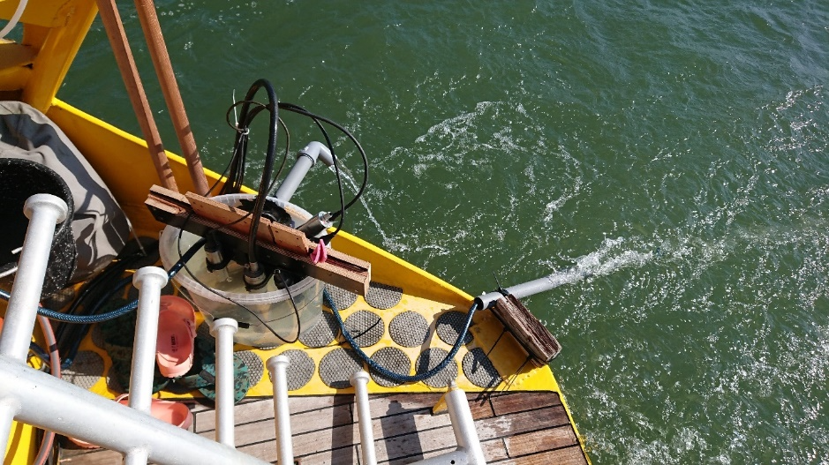
Figure S1. Mounting position of the bucket at the stem of the ALDEBARAN.

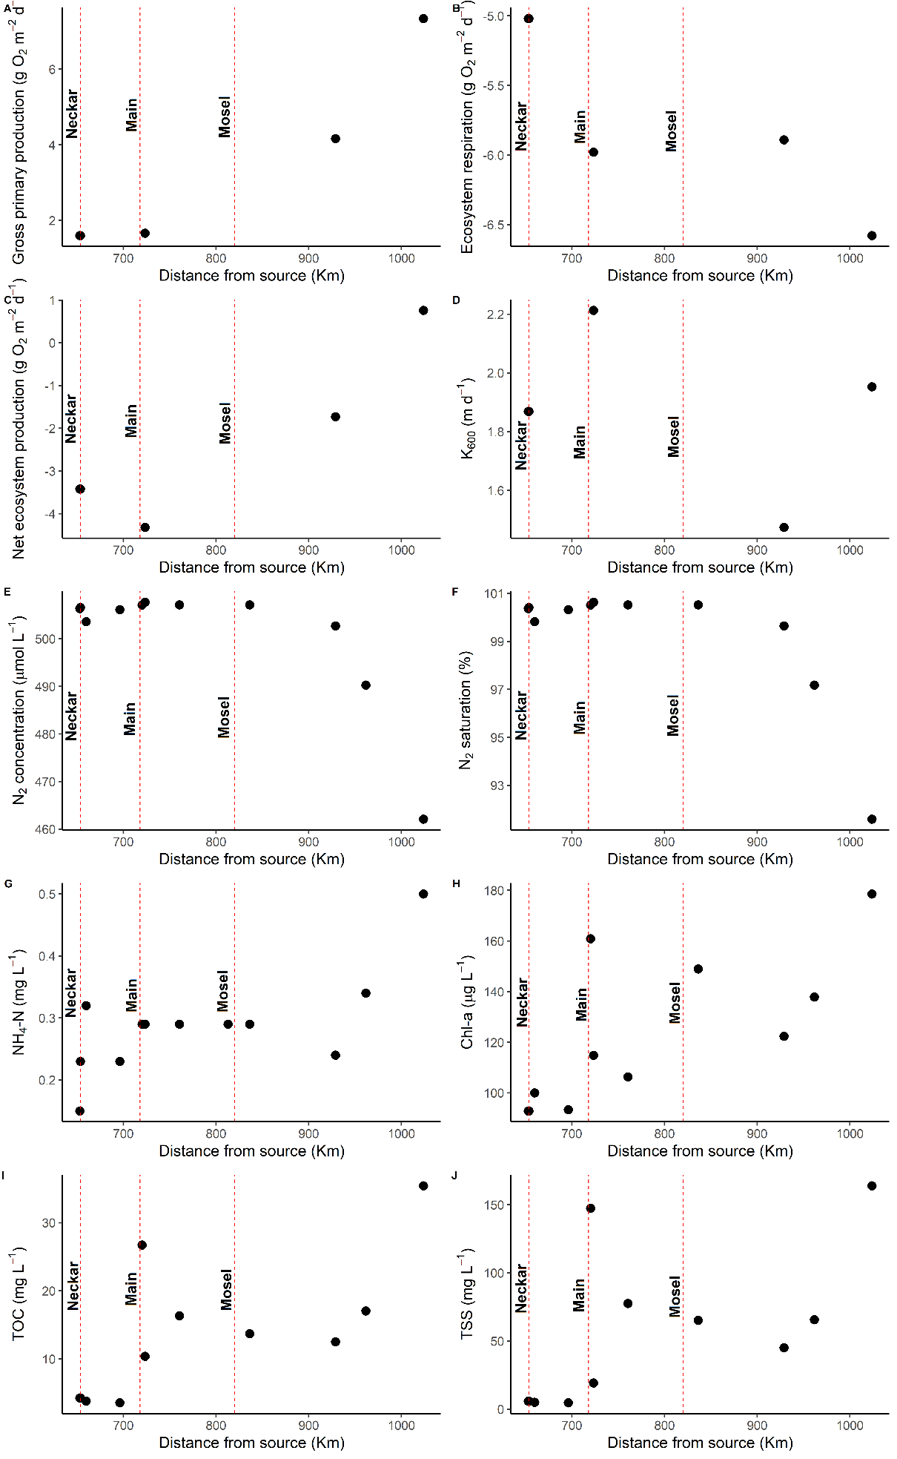
Figure S2: Longitudinal trends of selected water-physicochemical variables, N₂ concentrations, GPP, ER, NEP, and k₆₀₀ along the Rhine mainstem.
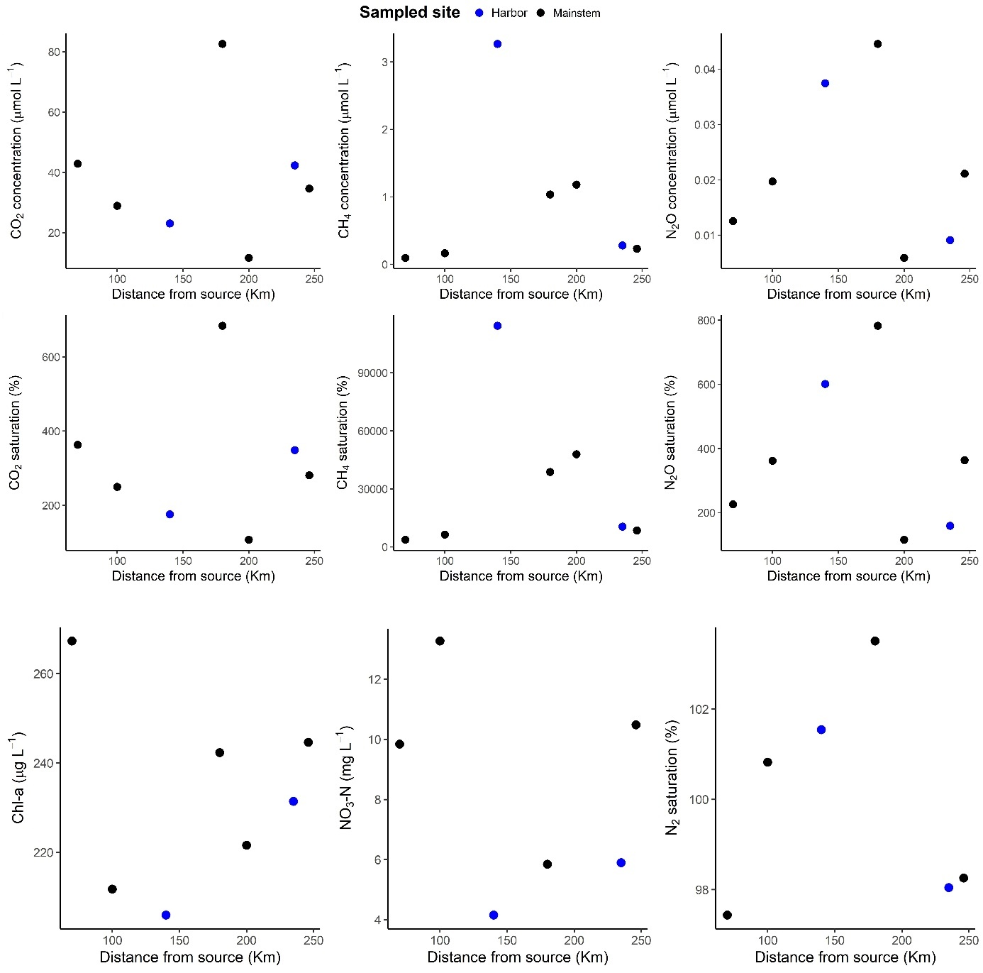
Figure S3: Longitudinal trends of GHG concentrations and % saturations, as well as selected water quality parameters along the Mittelland canal. Blue-colored points indicate harbor sites, while black-colored points indicate sites along the mainstem.

