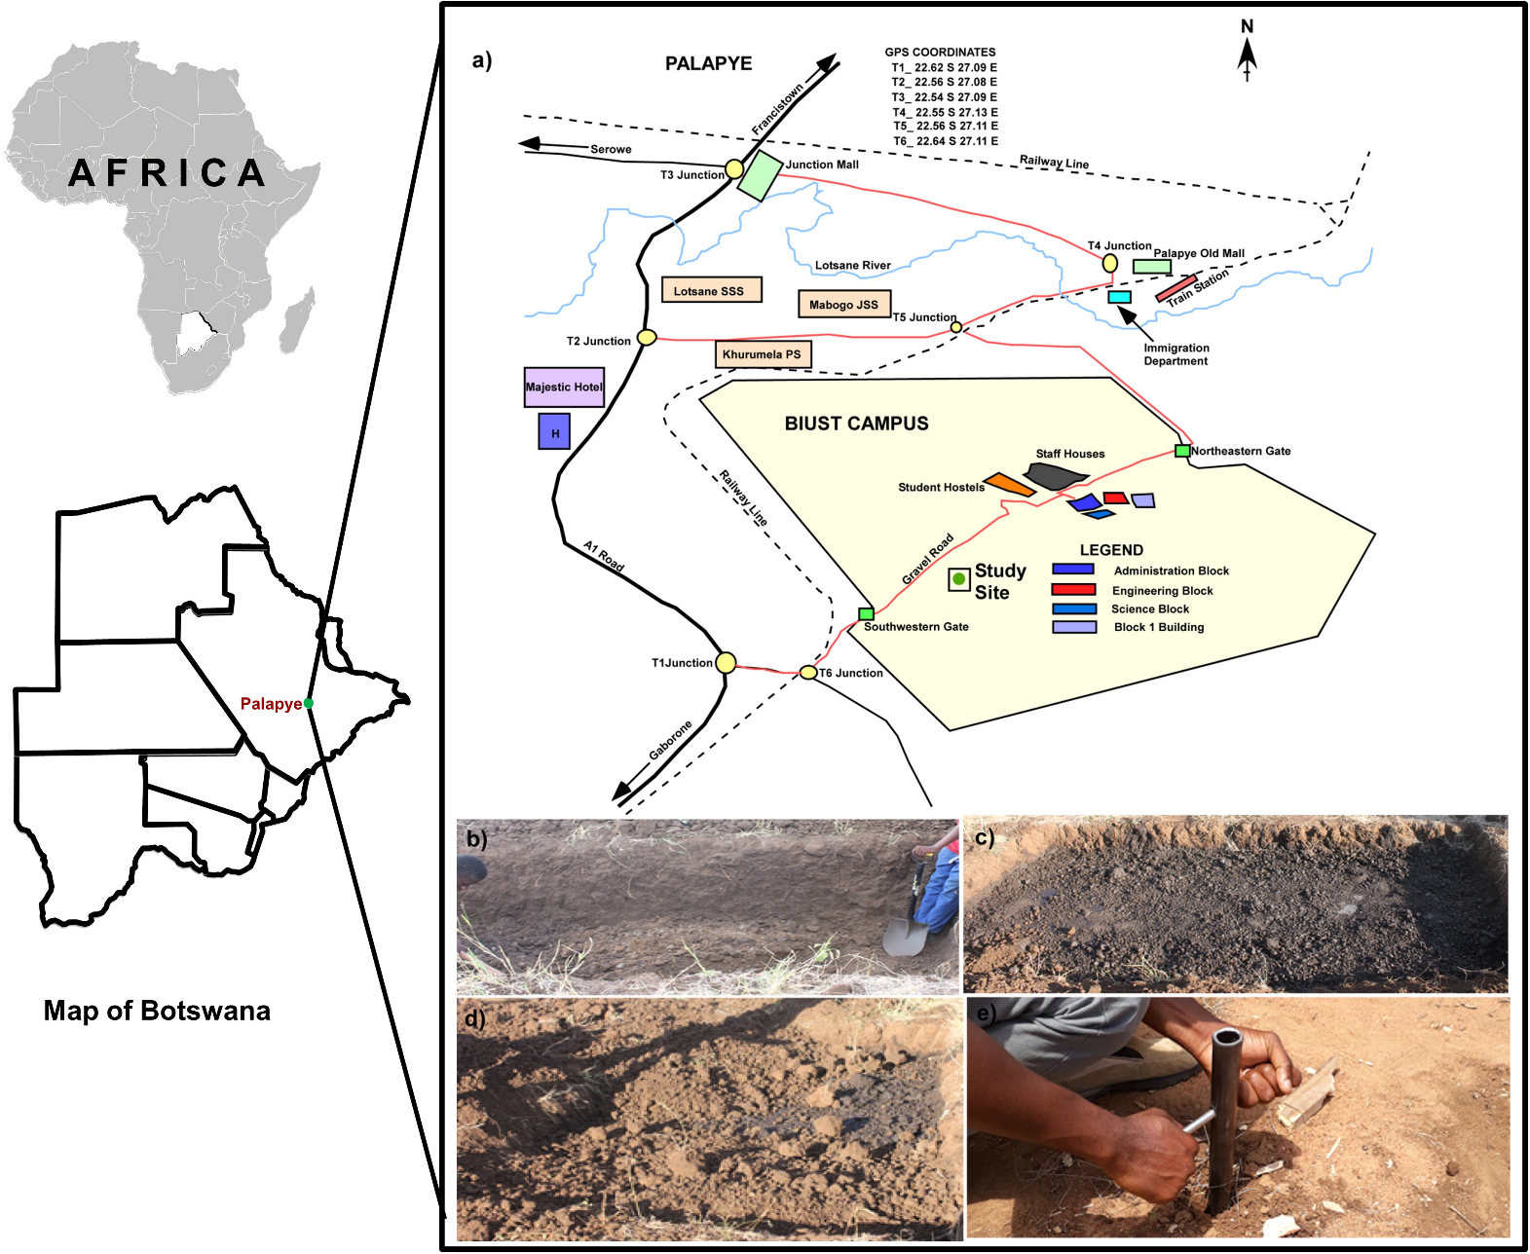
Figure S1. (a) A map showing the location of the study area, (b) excavation of the pit of dimensions 2 m width by 4 m length and 2 m depth, (c) the refill of the pit with the same excavated material and engine oil spillage surface at a depth of 0.3 m from the ground surface, (d) burial of the engine oil with the initial excavated material of the area up to the ground level and, (e) photograph of a standard auger planted into the uncontaminated zone of the study area.

Table S1:
Sample ID: 2019 | Sample ID: 2017 | Depth | Description
EESD1 (C1) | * | 0-10 | Control 1
EESD2 (C2) | * | 42-48 | Control 2
EESD3 (C4) | * | 70-80 | Control 4
EESD4 (T1A) | EESD9 (T1B) | 0-10 | Above Oil Zone 1
EESD5 (T2A) | EESD11 (T2B) | 42-48 | Above Oil Zone 2
EESD6 (T3A) | EESD12 (T3B) | 61-67 | Oil zone
EESD7 (T4A) | EESD13 (T4B) | 70-80 | Below oil zone
* Samples were not collected

