Supplementary to: Diazotroph connectomics in Gulf Stream eddies supports N₂ fixation in the North Atlantic

Cora Hoerstmann^{1,2}, Borja M. Aguiar-González³, Stéphanie Barrillon¹, Cécile Carpaneto Bastos^{1,2}, Olivier Grosso¹, M. D. Pérez-Hernández⁴, Andrea M. Doglioli¹, Anne A. Petrenko¹, Mar Benavides^{1,2}

1) Aix Marseille Univ, Université de Toulon, CNRS, IRD, MIO UM 110, 13288, Marseille, France
2) Turing Center for Living Systems, Aix-Marseille University, 13009 Marseille, France
3) Oceanografía Física y Geofísica Aplicada (OFYGA), ECOAQUA, Universidad de Las Palmas de Gran Canaria, Canary Islands, 35017, Spain
4) Unidad Océano y Clima, Instituto de Oceanografía y Cambio Global, IOCAG, Universidad de Las Palmas de Gran Canaria, ULPGC, Unidad Asociada ULPGC-CSIC, Canary Islands, Spain

Table S1: N₂ fixation rates (mean (minimum quantifiable rate MQR)) during the FIGURE-CARING cruise. Underway (UW) samples were not replicated except UW37 and, therefore, have no MQR.
Station | Depth (m) | Latitude (°N) | Longitude (°E) | N₂ fixation (MQR) nmol N l^{–1} d^{–1}
ST0 | 75 | 33.493 | –68.998 | 29.25 (3.04)
ST0 | 25 | 33.493 | –68.998 | 9.62 (2.28)
ST0 | 5 | 33.493 | –68.998 | 7.59 (2.04)
ST1 | 10 | 35.101 | –70.996 | 28.02 (2.85)
ST1 | 5 | 35.101 | –70.996 | 23.99 (3.74)
ST1 | 60 | 35.101 | –70.996 | 24.28 (4.99)
ST1 | 30 | 35.101 | –70.996 | 26.29 (4.40)
ST2 | 30 | 35.587 | –71.730 | 18.32 (4.35)
ST2 | 5 | 35.587 | –71.730 | 23.14 (3.42)
ST2 | 100 | 35.587 | –71.730 | 0.13 (1.06)
ST2 | 75 | 35.587 | –71.730 | 3.22 (3.37)
ST3 | 75 | 36.108 | –72.144 | 3.53 (3.08)
ST3 | 35 | 36.108 | –72.144 | 18.91 (3.02)
ST3 | 5 | 36.108 | –72.144 | 18.90 (3.82)
ST3 | 100 | 36.108 | –72.144 | 1.33 (2.68)
ST6 | 75 | 36.889 | –73.003 | 15.92 (3.73)
ST6 | 35 | 36.889 | –73.003 | 21.41 (4.81)
ST6 | 5 | 36.889 | –73.003 | 21.72 (4.29)
ST6 | 100 | 36.889 | –73.003 | 4.36 (2.31)
ST8 | 100 | 37.346 | –73.547 | 0.16 (0.78)
ST8 | 75 | 37.346 | –73.547 | 0.24 (1.24)
ST8 | 35 | 37.346 | –73.547 | 47.46 (1.68)
ST8 | 5 | 37.346 | –73.547 | 35.68 (3.02)
FIG UW 16 | 5 | 35.741 | –71.793 | 36.89 (-)
FIG UW 19 | 5 | 35.565 | –71.549 | 33.98 (-)
FIG UW 22 | 5 | 35.473 | –71.217 | 10.42 (-)
FIG UW 25 | 5 | 35.170 | –71.253 | 29.53 (-)
FIG UW 28 | 5 | 35.0158 | –70.774 | 11.77 (-)
FIG UW 31 | 5 | 34.7601347 | –70.164 | 11.93 (-)
FIG UW 34 | 5 | 34.5410157 | –69.565 | 4.20 (-)
FIG UW 37 | 5 | 34.3078034 | –68.972 | 16.79 (6.3)
FIG UW 40 | 5 | 34.3078034 | –68.972 | 44.94 (-)
FIG UW 43 | 5 | 34.0664012 | –68.372 | 46.70 (-)
FIG UW 46 | 5 | 33.8460792 | –67.799 | 39.71 (-)
FIG UW 49 | 5 | 33.6130847 | –67.210 | 22.34 (-)

Table S2: Cyclonic eddies identified by the NRT Eddy Atlas. Included in analysis refers to eddies that occurred during the summer months (i.e., excluding eddies that disappeared before May or only started to occur September or later in the year).

Table S3: Anticyclonic eddies identified by NRT the Eddy Atlas. Included in analysis refers to eddies that occurred during the summer months (i.e., excluding eddies that disappeared before May or only started to occur September or later in the year).

Table S4: Compiled N₂ fixation data in the western North Atlantic. Each datapoint is classified to lay within or outside a mesoscale structure based on a linked SSH satellite product.

Table S5: Minimum Quantifiable Rate (MQR) of each sample calculated based on triplicate ¹⁵N₂ fixation measurements.

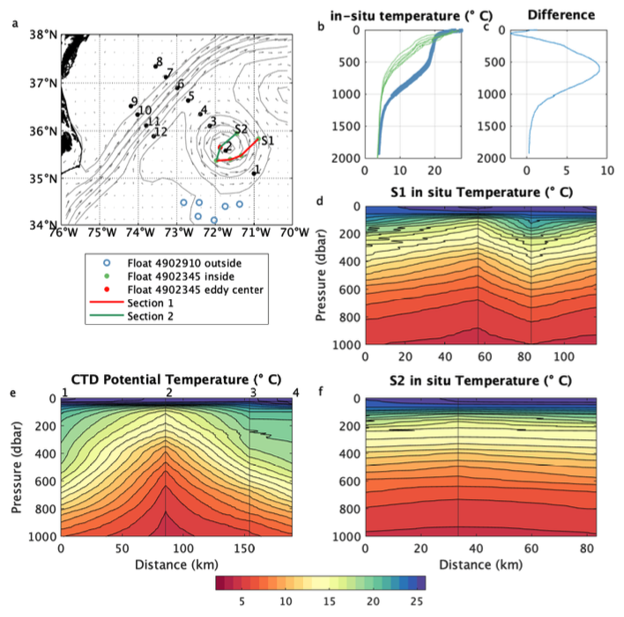
Fig. S1: (a) Averaged AVISO sea surface height (grey contours) and geostrophic velocities (grey arrows) for the extent of the survey together with the location of the FIGURE-CARING stations (black dots) and Argo profiles (red and green dots for the profiles of the 4902345 float inside the eddy and blue circle for the profiles of the 4902910 float outside the eddy) . Synthetic Argo vertical sections inside the eddy are shown as red and green lines and named S1 and S2 respectively. (b) vertical profiles of the 4902345 Argo float inside the eddy (green) and of the 4902910 Argo float outside the eddy (blue). (c) Difference between the averaged vertical profile of each Argo float. (d) and (f) vertical sections S1 and S2 shown in (a) of in-situ temperature inside the eddy. The vertical line shows the location of each profile. (e) Vertical section of potential temperature from the FIGURE-CARING SBE 911 Plus CTD dataset across the eddy. Numbers on the top axis denote the location of each CTD station.
.
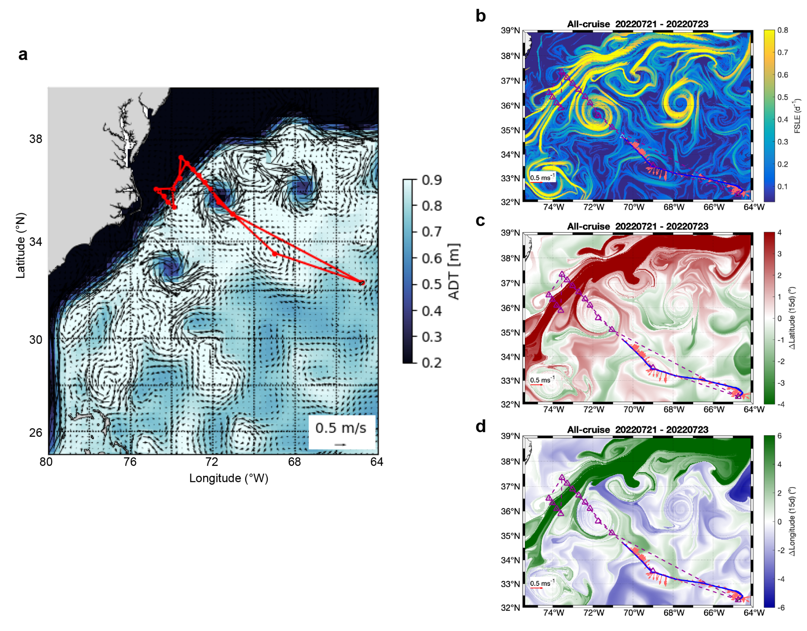
Fig. S2: Example figure of satellite product from the software package SPASSO showing (a) ADT and geostrophic currents on the 25th of July 2022. This information was used prior to and during the sampling campaign to adjust the cruise track (red line) to follow the targeted eddies. (b)–(d) Lagrangian diagnostics using satellite products on the 23rd of July 2022 with ADCP at 43 m depth mapped as vectors from the 21st to the 23rd of July 2022 on top with (b) Finite Lyapunov Exponent (FSLE), (c) delta latitudinal, and (d) delta longitudinal displacement over 15 days. ADCP measurements agreed well with the identification of fine-scale structures using SPASSO.
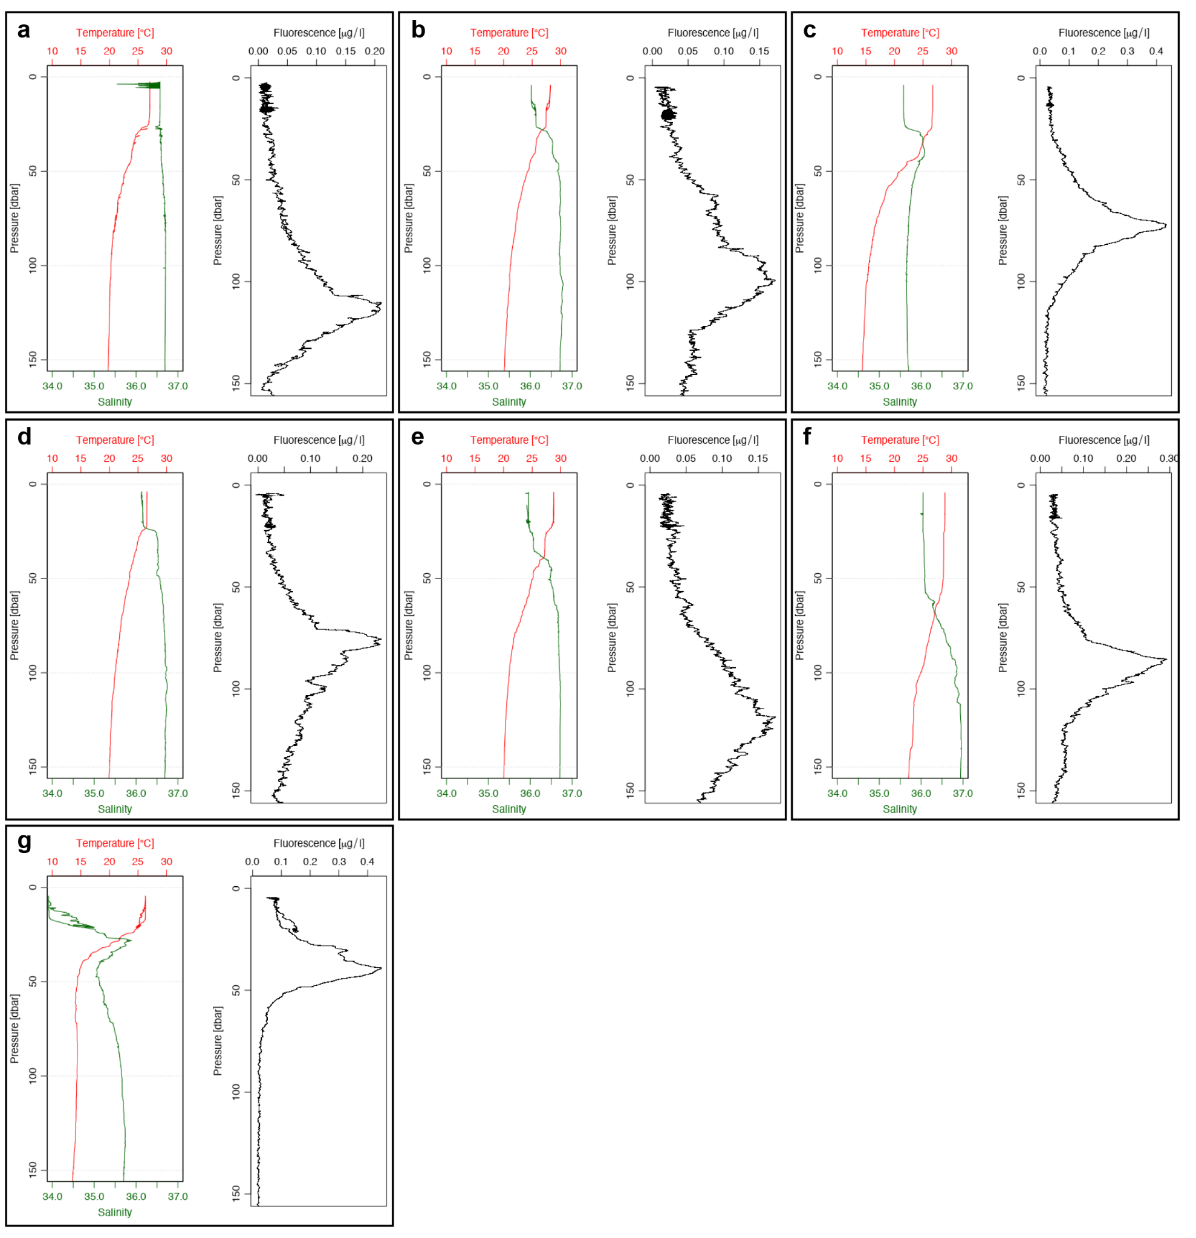
Fig. S3: Temperature, salinity, and fluorescence profiles derived from CTD sensors in the upper 150m of each station (a) Station 0, (b) Station 1, (c) Station 2, (d) Station 3, (e) Station 4, (f) Station 6, (g) Station 8.

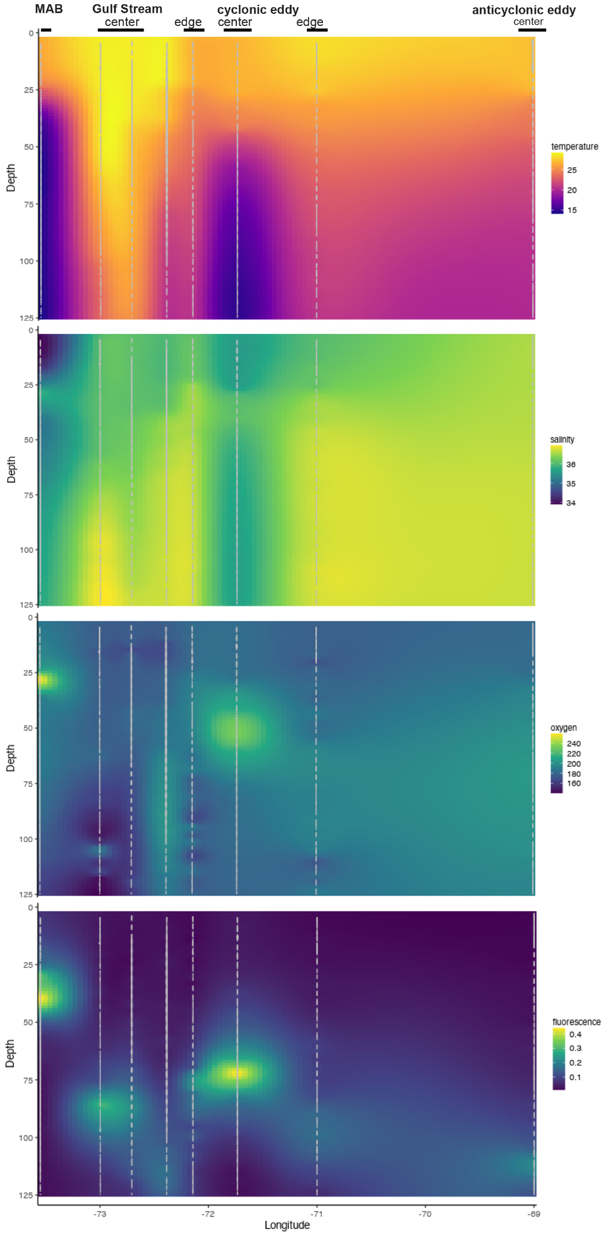
Fig. S4: Section plots of the upper 150m of the FIGURE-CARING expedition (No. 2215) transect. Data derived from the CTD sensors. (a) conservative Temperature in °C, (b) absolute salinity, (c) oxygen in mol kg^{–1}, and (d) fluorescence in Biospherical/Licor.

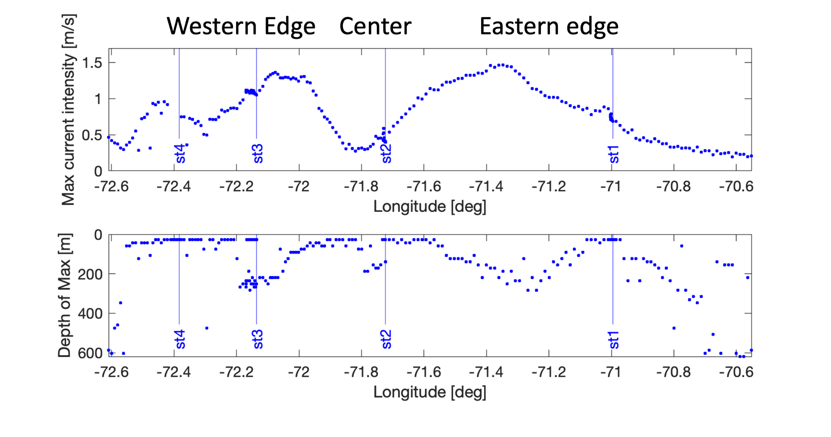
Fig. S5: Maximum current intensity over depth as measured by ADCP across the cyclonic eddy plotted against longitude in °East (top). Depth of maximum current intensity against longitude (bottom).

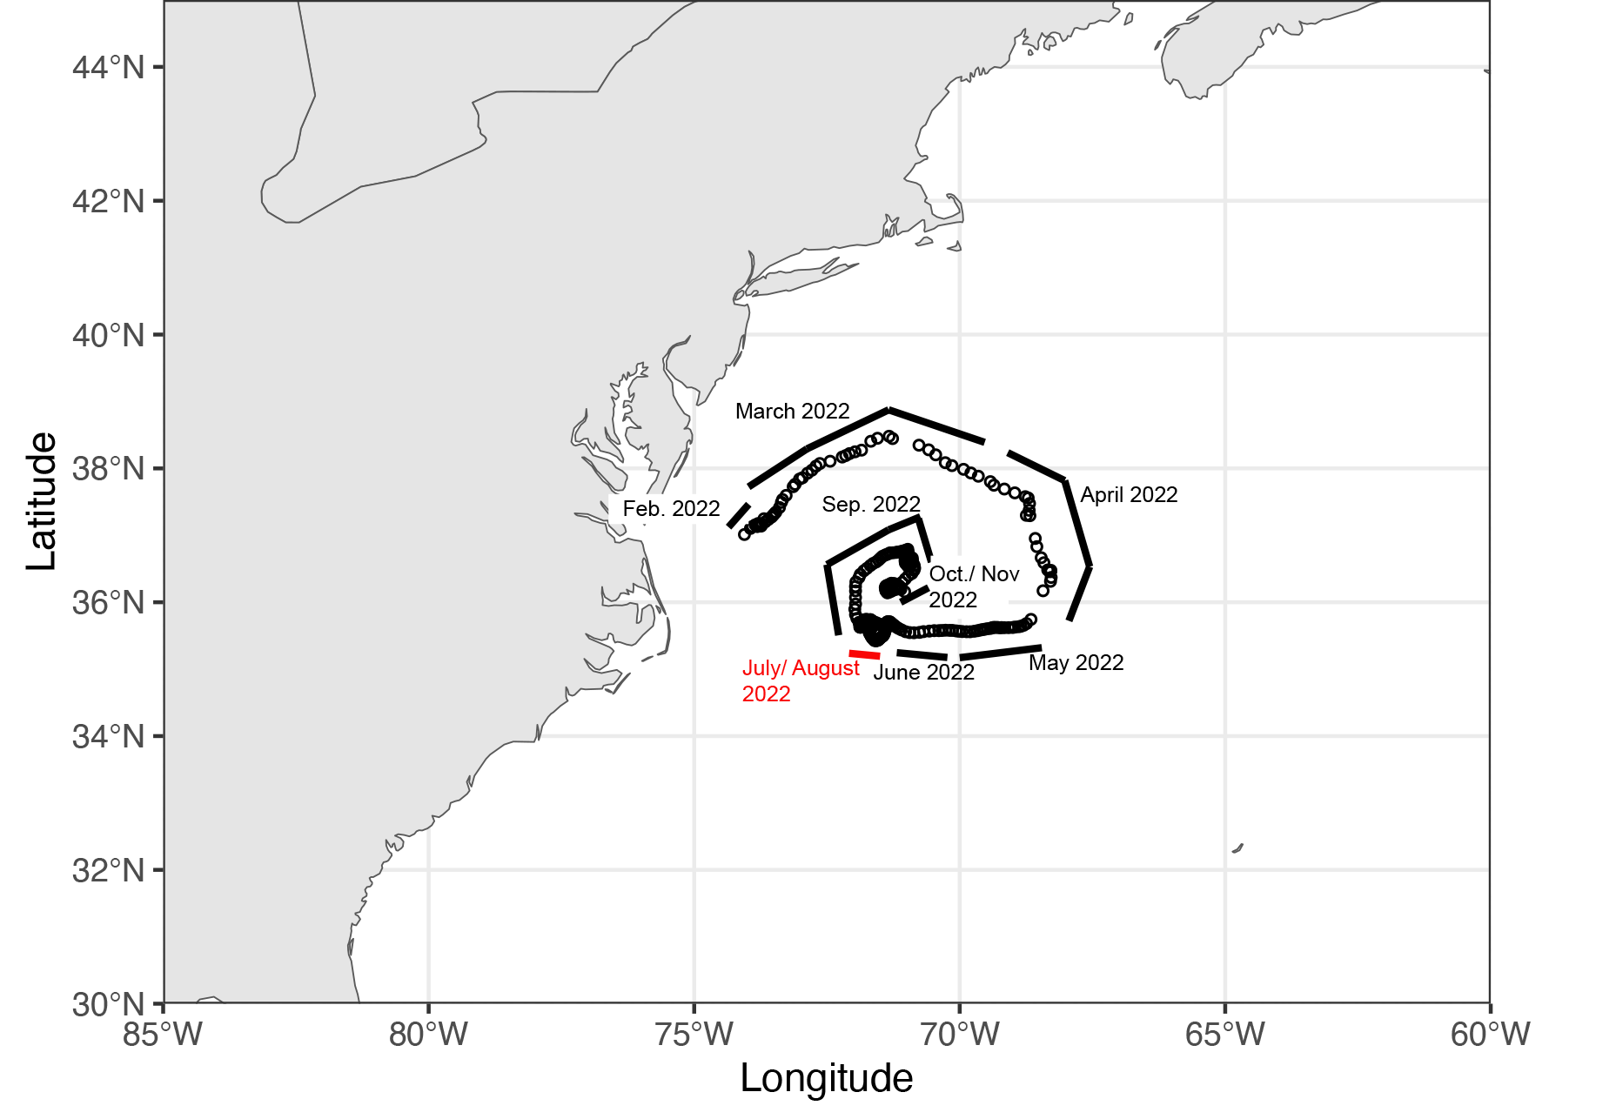
Fig. S6: Path of the cyclonic eddy track derived from the global Mesoscale Eddy Trajectory Atlases (META3.1exp DT all satellites, Pegliasco et al. 2022). Path during the FIGURE survey is marked in red.

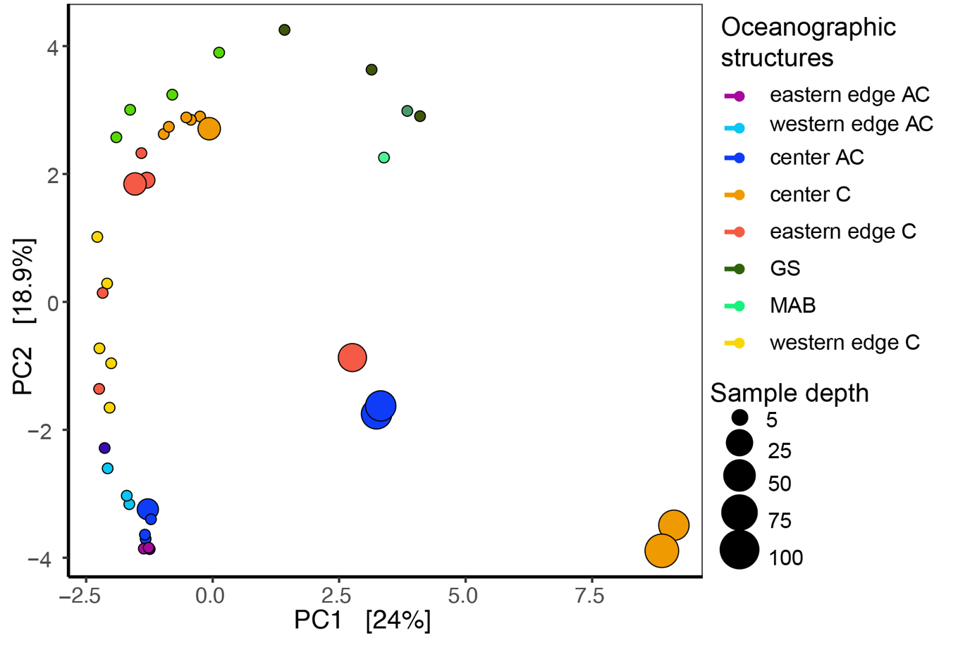
Fig. S7: PCA of 16S rRNA gene sequences. Samples are color-coded according to oceanographic structure, and the size corresponds to sampling depth (m).

Fig. S8: Hierarchical cluster analysis (ward2) of nifH gene sequences and 16S rRNA gene sequences. Branches are color-coded according to physical structure. Sample 1208 (ST0, 75m) clustered with sample 1230 (ST1, 30m) in the nifH cluster analysis and with 1233 (ST1, 60m) in the 16S cluster analysis.

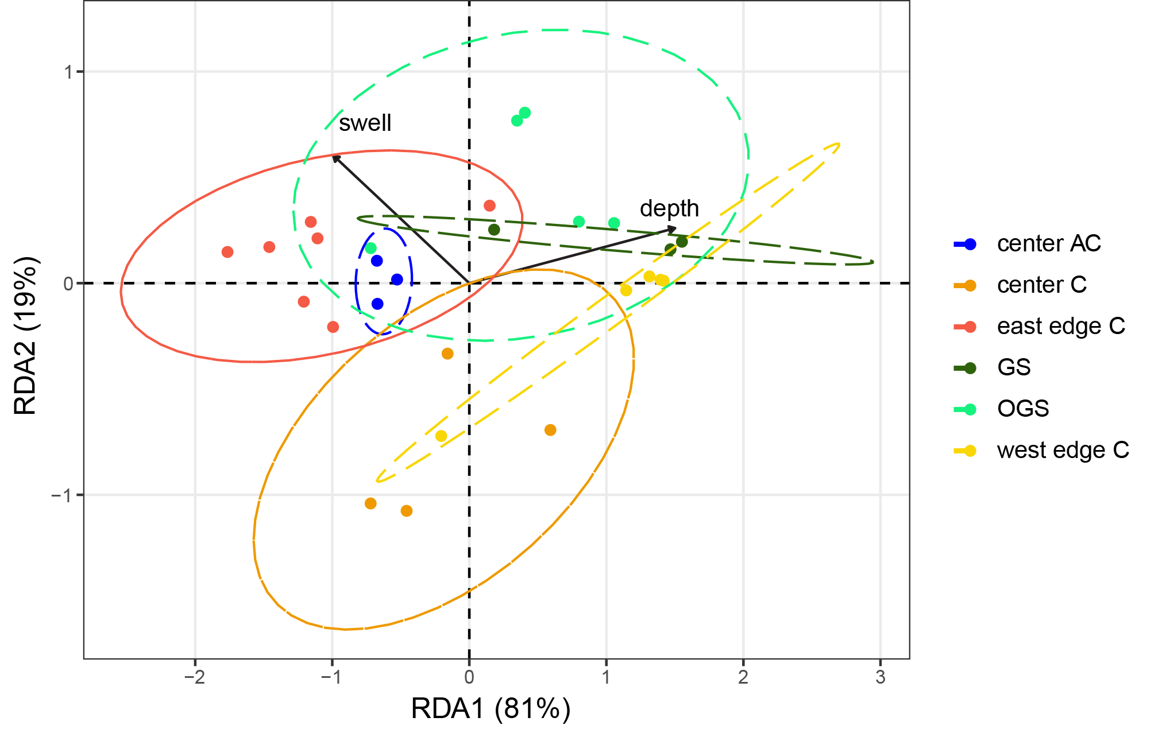
Fig. S9: Redundancy analysis (RDA) of nifH sequences. Significant explanatory variables were identified using stepwise permutational analysis prior to redundancy analysis.

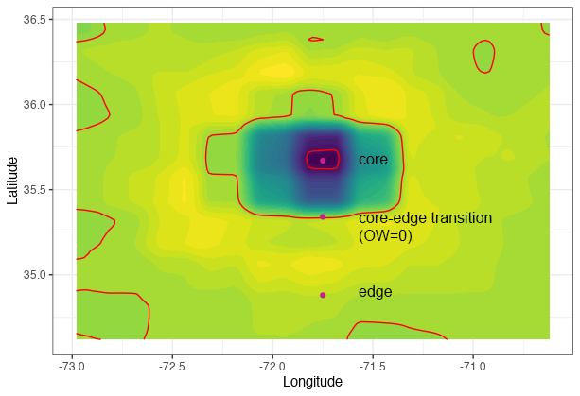
Fig. S10: Okubo-Weiss parameter derived from SPASSO to identify eddy core, transition between core and edge and edge of the cyclonic eddy.

