Supplementary 1. Clinical characteristics of 8,197 GEJ cancer patients diagnosed from 2010 to 2019
 | With  LiverM  (N=1558) | Without LiverM  (N=6639) | P-value
Age
<50 | 149(9.6%) | 496 (7.5%) | <0.001
50-60 | 349 (22.4%) | 1156 (17.4%)
>=60 | 1060 (68.0%) | 4987 (75.1%)
Sex  Female  Male | 278 (17.8%)  1280 (82.2%) | 1435 (21.6%)  5204 (78.4%) | 0.001
Race  American Indian/Alaska Native  Black  White  Chinese  Japanese | 13 (0.8%)  123 (7.9%)  1395 (89.5%)  17 (1.1%)  10 (0.6%) | 48 (0.7%)  354 (5.3%)  6078 (91.6%)  88 (1.3%)  71 (1.1%) | 0.001
Grade  Grade I  Grade II  Grade III  Grade IV | 54 (3.5%)  549 (35.2%)  926 (59.4%)  29 (1.9%) | 438 (6.6%)  2310 (34.8%)  3779 (56.9%)  112 (1.7%) | <0.001
T  T1a  T1b  T1NOS  T2  T3  T4a  T4b  T4NOS  TX | 97 (6.2%)  25 (1.6%)  267 (17.1%)  29 (1.9%)  228(14.6%)  40(2.6%)  104(6.7%)  21(1.3%)  747(47.9%) | 584 (8.8%)  521 (7.8%)  626 (9.4%)  749 (11.3%)  2717 (40.9%)  252(3.8%)  210(3.2%)  46(0.7%)  934(14.1%) | <0.001
N  N0  N1  N2  N3  NX | 517(33.2%)  674(43.3%)  87(5.6%)  72(4.6%)  208(13.4%) | 2940(44.3%)  2275(34.3%)  716(10.8%)  383(5.8%)  325(4.9%) | <0.001
Bone metastases  No  Yes | 1370(87.9%)  188(12.1%) | 6407(96.5%)  232(3.5%) | <0.001
Lung metastases  No  Yes | 1226(78.7%)  332(21.3%) | 6411(96.6%)  228(3.4%) | <0.001
Continue
Brain metastases  No  Yes | 1522(97.7%)  36(2.3%) | 6582(99.1%)  57(0.9%) | <0.001
Surgery  No  Yes | 1503(96.5%)  55(3.5%) | 3395(51.1%)  3244(48.9%) | <0.001
Chemotherapy  No/Unkown  Yes | 528(33.9%)  1030(66.1%) | 2351(35.4%)  4288(64.6%) | 0.270
Radiation  None/Unknown  Yes | 1208(77.5%)  350(22.5%) | 3335(50.2%)  3304(49.8%) | <0.001
Regional lymph node dissection  1 to 3 regional lymph nodes removed  4 or more regional lymph nodes removed | 6(0.4%)  39(2.5%) | 148(2.2%)  2685(40.4%) | <0.001
Yes  No/Unknown | 1(0.1%)  1512(97%) | 3769(56.8%)  37(0.6%)
LiverM: liver metastases

Supplementary 2. Univariable and multivariable logistic regression for analyzing the risk factors for developing liver metastases in GEJ cancer patients
Subject characteristics | Univariable  OR (95%CI) | P-value | Multivariable  OR (95%CI) | P-value
Age
<50 | Reference |  | Reference
50-60 | 1.004(0.84-1.21) | 0.96 | 1.12(0.90-1.41) | 0.39
>=60 | 0.71(0.60-0.83) | <0.001 | 0.71(0.58-0.87) | 0.005
Sex  Female  Male | Reference  1.27(1.13-1.43) | 0.001 | Reference  1.45(1.27-1.67) | <0.001
Race  American Indian/Alaska Native  Black  White  Chinese  Japanese | Reference  1.28(0.76-2.26)  0.85(0.52-1.46)  0.71(0.36-1.41)  0.52(0.24-1.10) | 0.45  0.60  0.41  0.16
Grade  Grade I  Grade II  Grade III  Grade IV | Reference  1.92(1.51-2.49)  1.99(1.57-2.56)  2.10(1.38-3.17) | <0.001  <0.001  0.003 | Reference  1.52(1.14-2.04)  1.20(0.90-1.60)  1.58(0.96-2.57) | 0.02  0.30  0.13
T  T1a  T1b  T1NOS  T2  T3  T4a  T4b  T4NOS  TX | Reference  0.29(0.19-0.42)  2.57(2.07-3.20)  0.23(0.16-0.33)  0.51(0.41-0.61)  0.96(0.68-1.33)  2.98(2.28-3.90)  2.75(1.70-4.36)  4.82(3.96-5.89) | <0.001  <0.001  <0.001  <0.001  0.82  <0.001  <0.001  <0.001 | Reference  0.6(0.40-0.93)  1.36(1.06-1.75)  0.27(0.18-0.40)  0.52(0.40-0.67)  0.72(0.49-1.04)  1.25(0.92-1.70)  0.97(0.56-1.63)  1.91(1.52-2.42) | 0.06  0.04  <0.001  <0.001  0.15  0.22  0.92  <0.001
N  N0  N1  N2  N3  NX | Reference  1.68(1.51-1.87)  0.69(0.56-0.84)  1.07(0.85-1.33)  3.64(3.08-4.29) | <0.001  0.002  0.63  <0.001 | Reference  1.76(1.54-2.00)  1.82(1.44-2.33)  2.41(1.79-3.23)  1.26(1.04-1.51) | <0.001  <0.001  <0.001  0.04
Bone metastases  No  Yes | Reference  3.80(3.20-4.48) | <0.001 | Reference  1.34(1.11-1.62) | 0.01
Lung metastases  No  Yes | Reference  7.61(6.55-8.86) | <0.001 | Reference  3.25(2.75-3.85) | <0.001
Brain metastases  No  Yes | Reference  2.73(1.91-3.87) | <0.001 | Reference  0.96(0.64-1.44) | 0.88
Surgery  No  Yes | Reference  0.04(0.03-0.05) | <0.001 | Reference  0.14(0.09-0.21) | <0.001
Chemotherapy  No/Unkown  Yes | Reference  1.07(0.97-1.18) | 0.2
Radiation  None/Unknown  Yes | Reference  0.29(0.26-0.32) | <0.001 | Reference  0.41(0.36-0.46) | <0.001
Regional lymph node dissection  No/Unknown  1-3  4 or more  Yes | Reference  0.10(0.05-0.18)  0.04(0.03-0.05)  0.07(0.01-0.25) | <0.001  <0.001  0.008 | Reference  0.49(0.21-1.03)  0.48(0.30-0.79)  0.45(0.04-2.06) | 0.14  0.01  0.46

Supplementary 3. The calibration curves of the predicting nomogram for liver metastasis in GEJ cancer patients
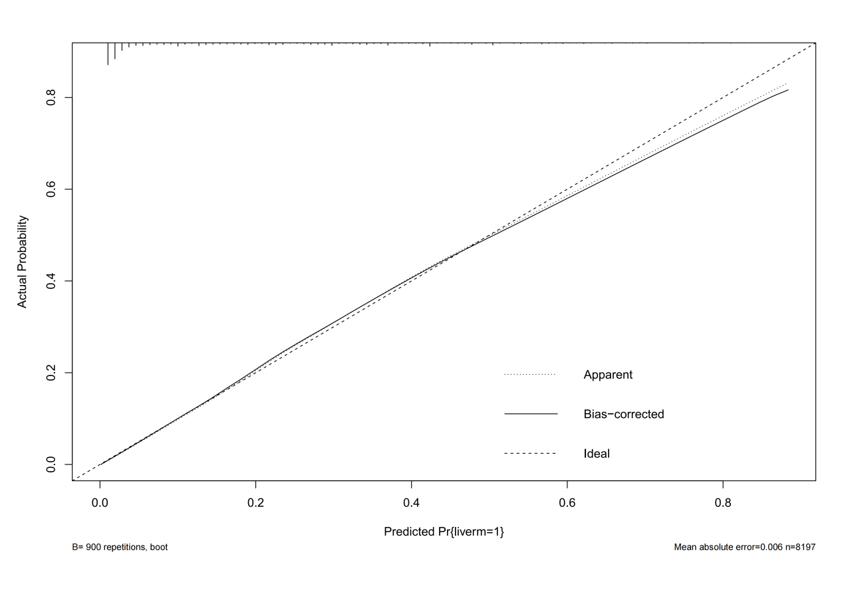

Supplementary 4. Comparison of area under the receiver operating characteristic curves between nomogram and other risk factors, including T stage, N stage, bone metastases, lung metastases.

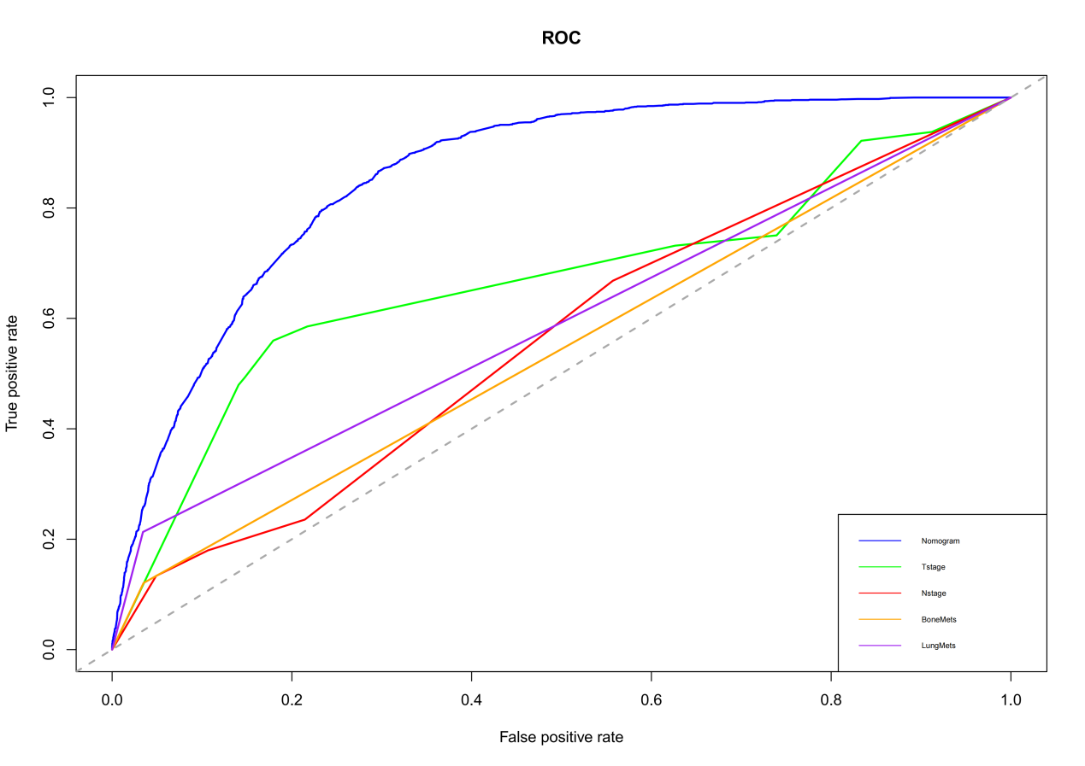

Supplementary 5. Univariable and multivariable Cox regression for analyzing the prognostic factors for GEJ cancer patients with liver metastases.
Subject characteristics | Univariable  HR(95%CI) |  | P-value |  |  | Multivariable  HR(95%CI) | P-value
Age
<50 | Reference |  |  |  |  | Reference
50-60  >=60 | 1.13(0.96-1.33)  1.34(1.16-1.55) |  | 0.23  0.001 |  |  | 0.93(0.79-1.10)  1.01(0.87-1.18) | 0.49  0.91
Sex  Female  Male | Reference  1.02(0.91-1.13) |  | 0.82 |  |  | Reference
Race  American Indian/Alaska Native  Black  White  Chinese  Japanese | Reference  0.76(0.47-1.23)  0.62(0.39-0.98)  0.85(0.46-1.56)  0.81(0.41-1.62) |  | 0.34  0.09  0.66  0.62 |  |  | Reference
Grade  Grade I  Grade II  Grade III  Grade IV | Reference  1.18(0.93-1.50)  1.45(1.15-1.83)  1.57(1.07-2.31) |  | 0.25  0.01  0.06 |  |  | Reference  1.28(1.00-1.62)  1.62(1.28-2.05)  2.12(1.43-3.13) | 0.09  <0.001  0.001
T  T1a  T1b  T1NOS  T2  T3  T4a  T4b  T4NOS  TX | Reference  1.62(1.12-2.35)  1.26(1.04-1.54)  0.93(0.66-1.34)  0.94(0.77-1.16)  1.34(0.99-1.84)  1.42(1.12-1.80)  1.04(0.70-1.55)  1.40(1.18-1.69) |  | 0.03  0.04  0.77  0.65  0.11  0.01  0.87  0.00 |  |  | Reference  1.51(1.03-2.19)  1.09(0.89-1.33)  0.96(0.67-1.37)  1.03(0.84-1.27)  1.27(0.92-1.75)  1.34(1.05-1.70)  1.13(0.76-1.69)  1.08(0.90-1.30) | 0.07  0.49  0.85  0.81  0.22  0.04  0.61  0.50
N  N0  N1  N2  N3  NX | Reference  0.99(0.90-1.09)  0.73(0.60-0.89)  0.77(0.62-0.95)  1.50(1.31-1.72) |  | 0.83  0.01  0.04  <0.001 |  |  | Reference  0.99(0.89-1.09)  0.90(0.74-1.11)  0.97(0.77-1.23)  1.28(1.11-1.48) | 0.83  0.42  0.84  0.00
Bone metastases  No  Yes | Reference  1.16(1.02-1.32) |  | 0.06 |  |  | Reference
Lung metastases  No  Yes |  | Reference  1.32(1.19-1.47) |  | <0.001 | Reference  1.35(1.22-1.50) |  | <0.001
Brain metastases  No  Yes  Surgery  No  Yes  Chemotherapy  No  Yes  Radiation  No  Yes  Regional lymph node dissection  No/Unknown  1-3  4 or more  Yes |  | Reference  1.11(0.83-1.46)  Reference  0.58(0.46-0.73)  Reference  0.25(0.22-0.27)  Reference  0.91(0.82-1.00)  Reference  1.13(0.57-2.21)  0.52(0.39-0.68)  1.26(0.24-6.51) |  | 0.56  <0.001  <0.001  0.11  0.77  <0.001  0.82 | Reference  Reference  Reference  0.23(0.21-0.26)  Reference  Reference |  | <0.001

Supplementary 6. The calibration curves of the nomogram for the 12 (A), 24 (B), and 36 months (C) in GEJ cancer patients.

Supplementary 6A. The calibration curve of the nomogram for the 12 months in GEJ cancer patients.

A.
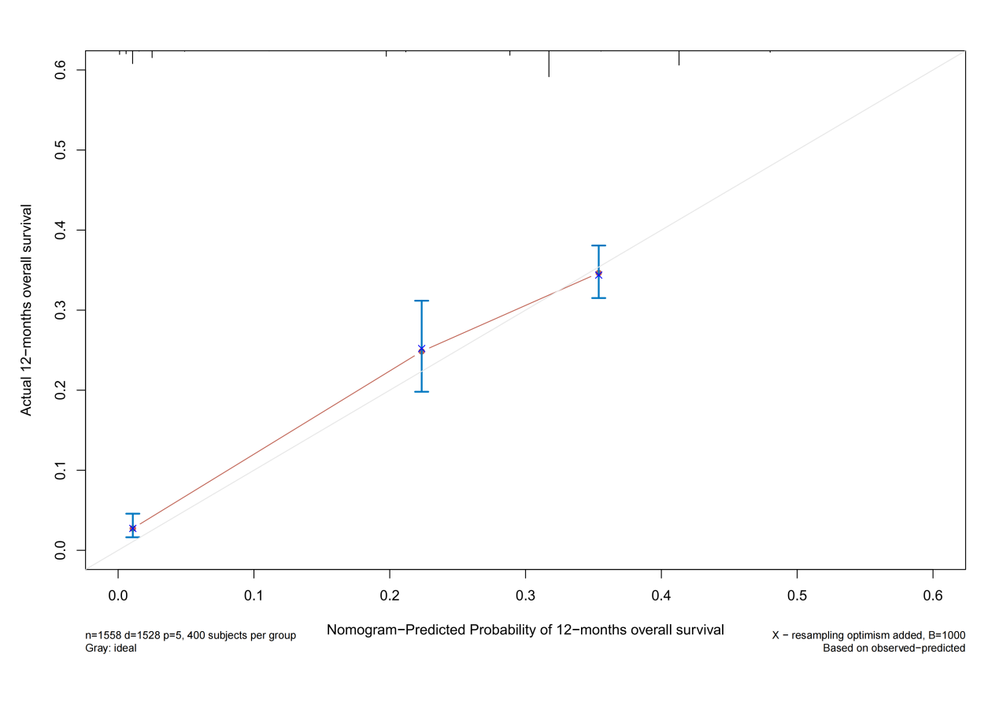

Supplementary 6B The calibration curve of the nomogram for the 24 months in GEJ cancer patients.

B.

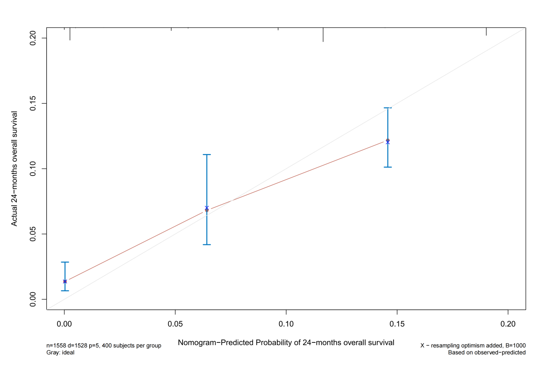

Supplementary 6C The calibration curve of the nomogram for the 36 months in GEJ cancer patients.

C.
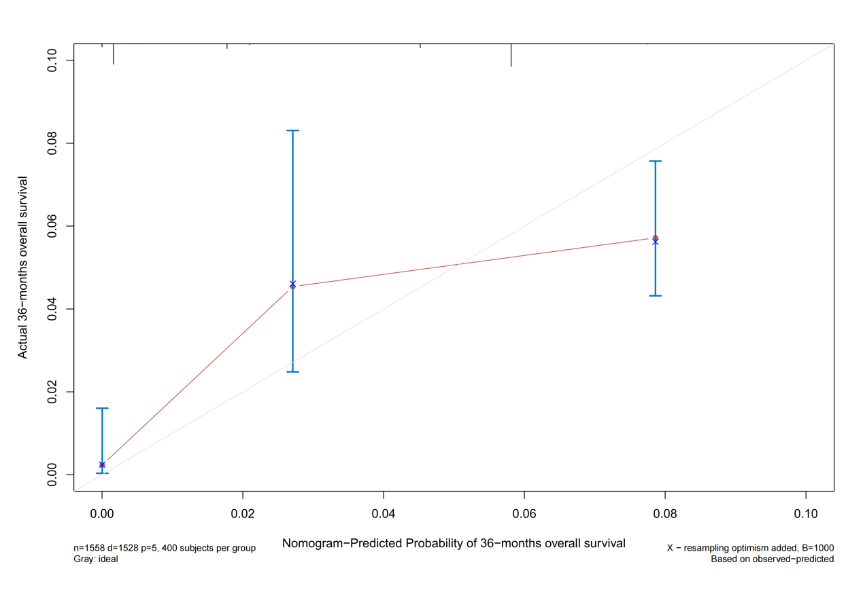

Supplementary 7. Time-dependent ROC curve analysis of the nomogram for the 12, 24 and 36 months.

