Supplementary Information
BioMetals
Synthesis, theoretical analysis, and biological properties of a novel tridentate Schiff base palladium (II) complex
Samira Jahangiryª, Maryam Lashanizadeganª, Pouneh Sadat Pourhosseini^{b}, Mansoureh Zahedi-Tabrizi^{c}

ª Department of Inorganic Chemistry, Faculty of Chemistry, Alzahra University, Tehran, Iran.
^{b} Unaffiliated author, Tehran 1667836465, Iran.
^{c} Department of Physical Chemistry and Nanochemistry, Faculty of Chemistry, Alzahra University, Tehran, Iran.

Theoretical computational details
All density functional theory (DFT) calculations were performed at B3LYP computational level using the Gaussian 03 software package [1]. The Los Alamos National Laboratory 2 Double Zeta (LANL2DZ) [2] and 6-311G(d) basis sets were applied for the Pd atom and all other atoms respectively. The complex was fully optimized without any symmetry restrictions, and positive frequencies confirmed the convergence of the optimization process to the local minimum on the potential energy surface. The natural bond orbital (NBO) [3] calculations were performed on the optimized molecular structure using the POP=NBO keyword in the Gaussian program package. The Mercury [4] and Avogadro [5] software packages were used for molecular graphics and visualization of the highest occupied molecular orbital (HOMO) and lowest unoccupied molecular orbital (LUMO) profiles and molecular electrostatic potential (MESP) maps.
The optimization process was initiated from the planar configuration of chelating ligands at the B3LYP/GenECP computational level. Considering the importance of relativistic effects in the electronic structure of heavy metal atoms, the LANL2DZ basis set was used for the Pd ion in the understudy complex. LANL effective core potentials (ECPs) have been extensively used in theoretical calculations of Pd and transition metal complexes [6]. The theoretical studies focused on the structural parameters, with a particular emphasis on the chelating bond length and bond angles. As the hydrogen atoms interactions do not play an important role in the chelating ligands’ electronic structure, the 6-311G(d) basis set [7] was employed for other atoms to reduce the computational cost.
The NBO analysis, which was employed in the Pd quantum mechanical investigations at the aforementioned basis set [9] was used to evaluate the charge distribution in the complex. The computed natural atomic charges (NACs) over the atoms of chelated rings and Pd atom is presented in Table 1. Decreasing the oxidation state of the metal ion from 2+ to about 1+ could approve the formation of dative covalent bonds or coordinate bonds. Another critical point in the charge distribution is the difference between the charge over the hydrogen atom of water ligand (H7) and the free H₂O molecule. To study the dative bond of H₂O molecule with Pd ion, the NBO analysis was performed on the optimized structure of the free H₂O molecule at the B3LYP/6-311G(d) computational level. In the case of the H₂O ligand, decreasing the oxygen atom’s NAC of the free H₂O molecule from -0.869(e) to -0.839(e), and increasing the NAC of the H atom of free H₂O from 0.435(e) to 0.507(e) in the complex displays the weak dative covalent bond character of this chelating ligand in the complex. The most chelating bond length in the complex (2.121Å) also confirms this result.

Table S1. The calculated coordination bond length and bond angles (Å, º), and the natural atomic charges (NAC (e)) over the Pd atom and chelated ring atoms of the optimized structure of complex by DFT method.
Parameter | B3LYP/GenECP | atom | NAC
Pd-O2 | 2.031 | Pd | 0.764
Pd-O3 | 2.056 | O2 | -0.639
Pd-N4 | 1.946 | O3 | -0.611
Pd-O5 | 2.121 | N4 | -0.444
$∠$O2-Pd-N4 | 81.21 | O5 | -0.839(-0.869)^{b}
$∠$O5-Pd-O3 | 96.08 | O6 | -0.510
$∠$O2-Pd-O3 | 172.21 | H7 | 0.507(0.435)^{b}
N4-O3-O5-O2 | 1.28ª | H8 | 0.225
ª Dihedral angle; ^{b} Free H₂O calculated at B3LYP/6-311G(d).

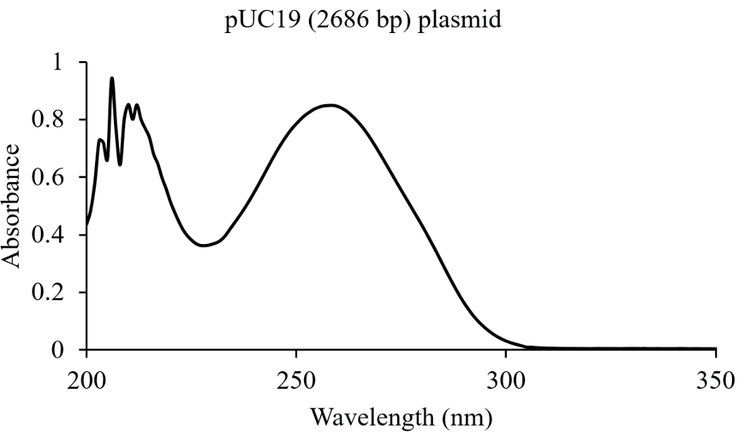
Figure S1: UV-vis. spectrum of pUC19 (2686 bp) plasmid DNA.
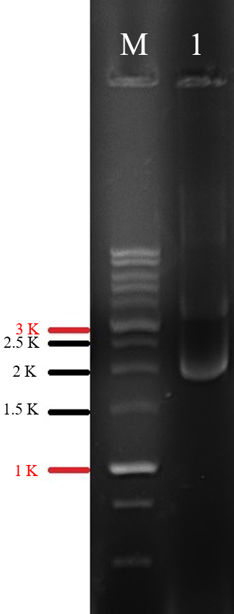
Figure S2: Gel electrophoresis of pUC19 plasmid. The ladder was DM3100 (SMOBIO); the gel was run at 4 V, 2 h.

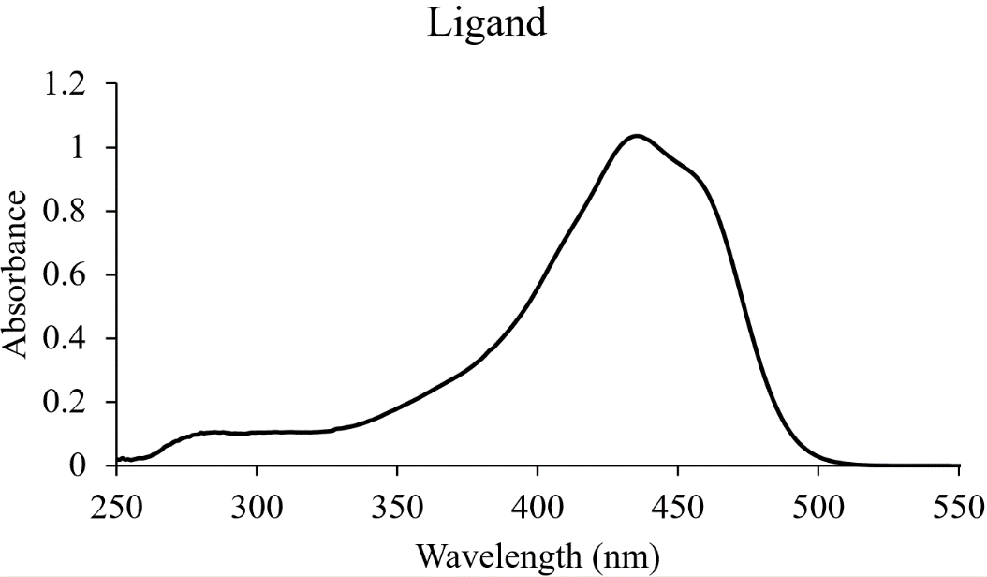
Figure S3: UV-vis. spectrum of curcumin derived Schiff base

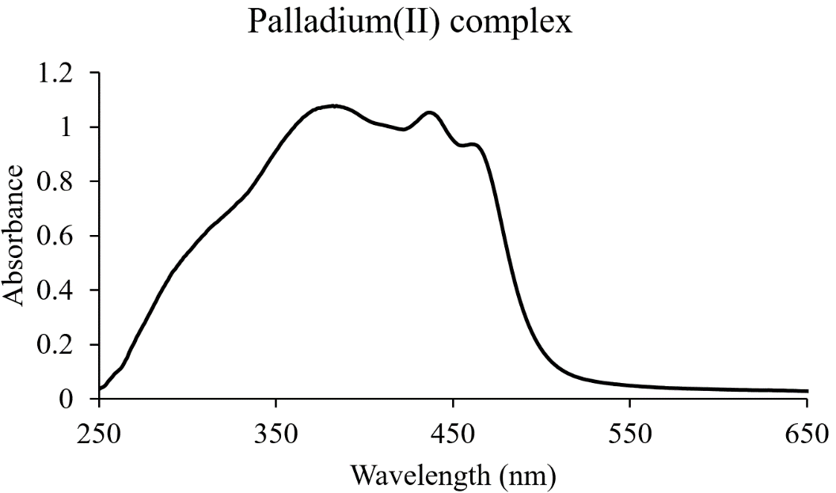
Figure S4: UV-vis. spectrum of Palladium (II) complex
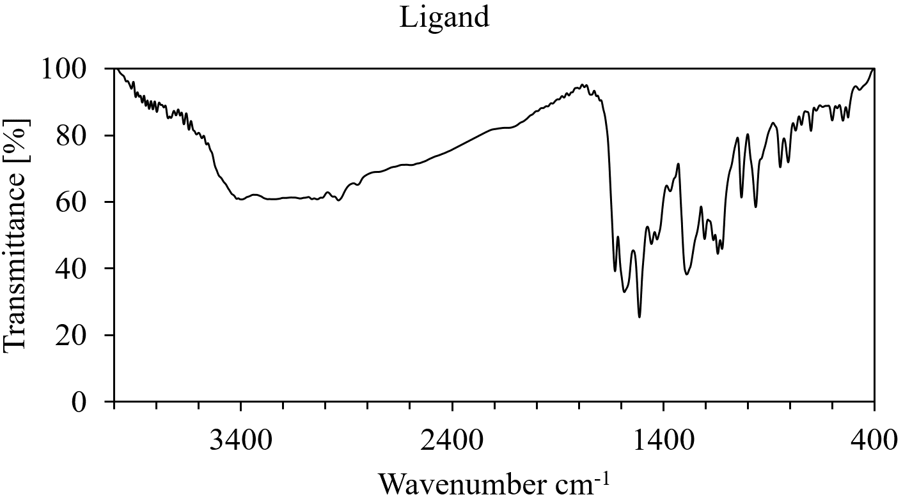
Figure S5: FT-IR spectrum of curcumin derived Schiff base

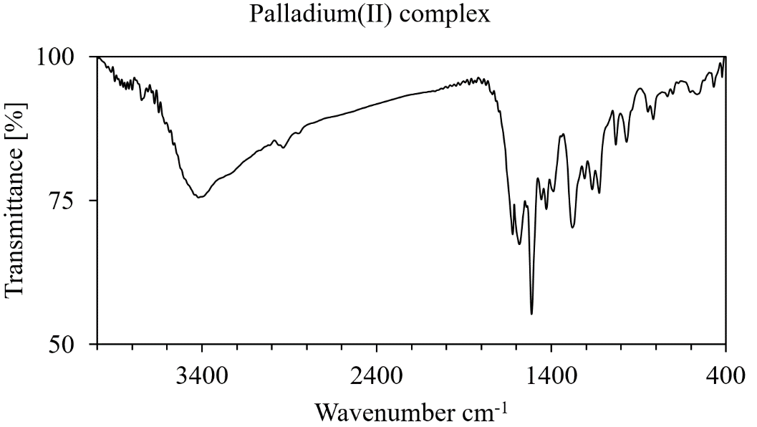
Figure S6: FT-IR spectrum of palladium (II) complex
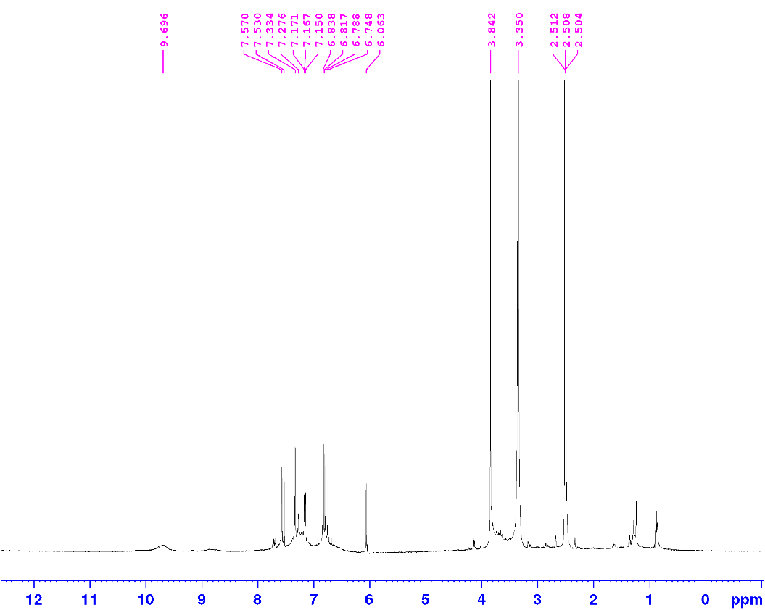
Figure S7: H¹NMR spectrum of curcumin derived Schiff base
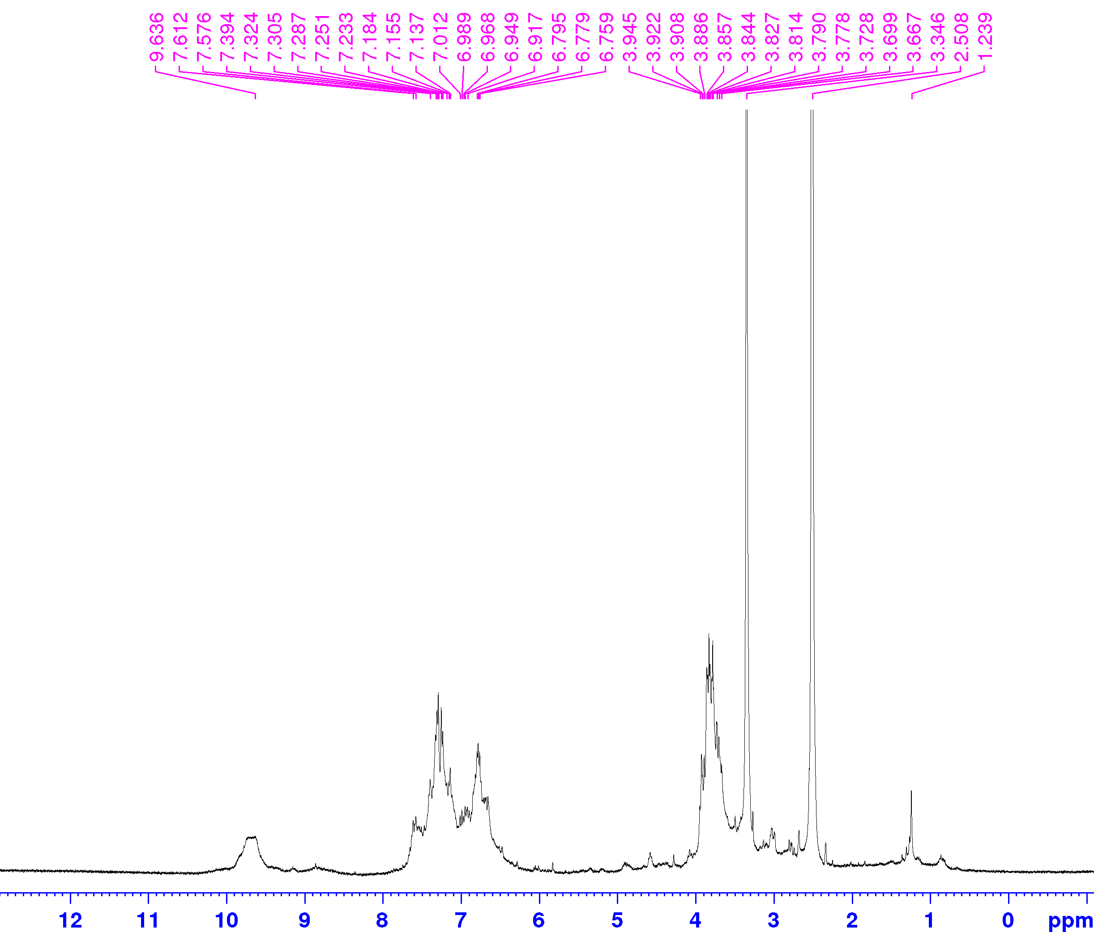
Figure S8: H¹NMR spectrum of palladium (II) complex
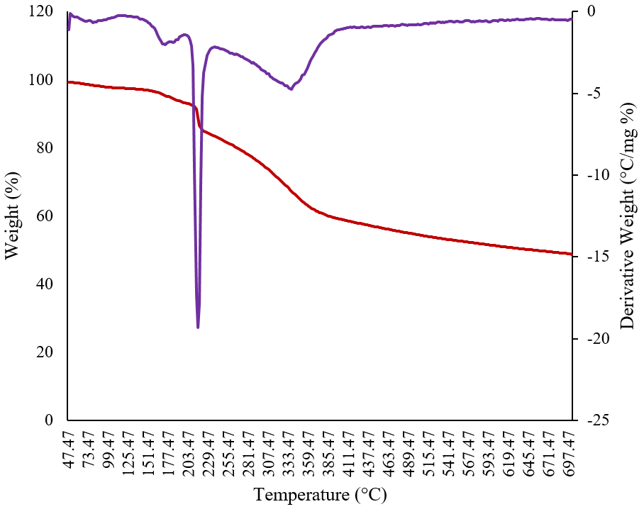
Figure S9: TGA and DTA of palladium (II) complex

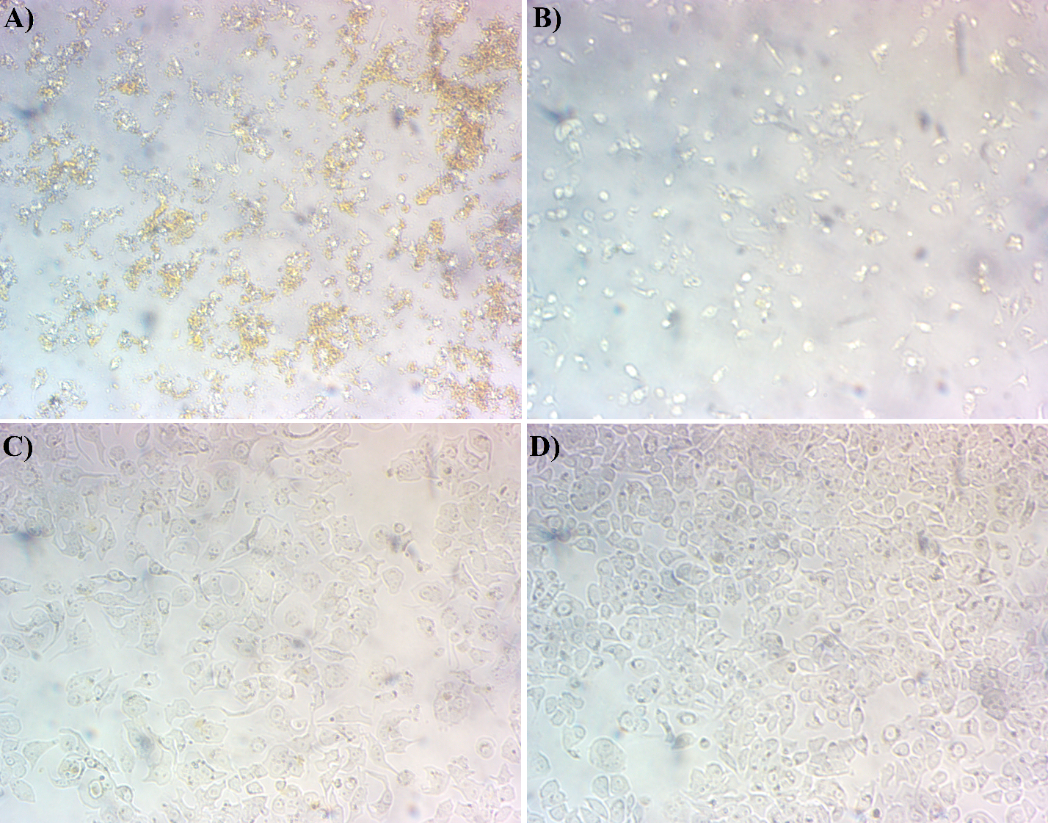
Figure S10: Effect of different concentrations of the complex on MCF-7 cells. (A) 784 μM, (B) 156 μM, (C) 20 mg/ml, and (D) control.

References

[1] Frisch MJ, Trucks GW, Schlegel HB, Scuseria GE, Robb MA,Cheeseman JR, Zakrzewski VG, Montgomery JA Jr, Stratmann RE, Burant JC, Dapprich S, Millam JM, Daniels AD, Kudin KN,Strain MC, Farkas O, Tomasi J, Barone V, Cossi M, Cammi R, Mennucci B, Pomelli C, Adamo C, Clifford S, Ochterski J, Petersson GA, Ayala PY, Cui Q, Morokuma K, Malick DK,
Rabuck AD, Raghavachari K, Foresman JB, Cioslowski J, Ortiz JV, Baboul AG, Stefanov BB, Liu G, Liashenko A, Piskorz P, Komaromi I, Gomperts R, Martin RL, Fox DJ, Keith T, Al-Laham MA, Peng CY, Nanayakkara A, Gonzalez C, Challacombe M, Gill PMW, Johnson B, Chen W, Wong MW, Andres JL, Gonzalez C, Head-Gordon M, Replogle ES, Pople JA Gaussian 03, Revision A.7, Gaussian, Inc., Pittsburgh, PA, 2003.

[2] Hay PJ, Wadt WR. Ab initio effective core potentials for molecular calculations. Potentials for the transition metal atoms Sc to Hg. The Journal of chemical physics. 1985 Jan 1;82(1):270-83. https://doi.org/10.1063/1.448799
[3] Glendening E, Reed A, Carpenter J, Weinhold, F. NBO version 3.1. Pittsburgh, PA: Gaussian. Inc: 1992.
[4] Macrae CF, Edgington PR, McCabe P, Pidcock E, Shields GP, Taylor R, Towler M, Streek JV. Mercury: visualization and analysis of crystal structures. Journal of applied crystallography. 2006 Jun 1;39(3):453-7. https://doi.org/10.1107/S002188980600731X
[5] Hanwell MD, Curtis DE, Lonie DC, Vandermeersch T, Zurek E, Hutchison GR. Avogadro: an advanced semantic chemical editor, visualization, and analysis platform. Journal of cheminformatics. 2012 Dec;4(1):1-7. https://doi.org/10.1186/1758-2946-4-17
[6] Manjunatha KB, Supriya S, Nawaz SS, Ranjan P, Chakraborty T, Poornesh P, Dileep R. Nonlinear optical and quantum chemical studies of Palladium benzimidazole Schiff base complex. Materials Science in Semiconductor Processing. 2022 Nov 15;151:107012.https://doi.org/10.1016/j.mssp.2022.107012
[7] Soltani-Ghockhaneh S, Vakili M, Tayyari SF, Berenji AR, Darugar V. Conformation, molecular structure, and vibrational assignment of bis (3, 5-heptanedionato) copper (II). Journal of Molecular Structure. 2019 Dec 5;1197:443-9. https://doi.org/10.1016/j.molstruc.2019.07.076
[8] Hussain R, Saeed M, Mehboob MY, Khan SU, Khan MU, Adnan M, Ahmed M, Iqbal J, Ayub K. Density functional theory study of palladium cluster adsorption on a graphene support. RSC advances. 2020;10(35):20595-607. https://doi.org/10.1039/D0RA01059F

