Additional file 3. Process of multi-panel review for preventable trauma death rate.

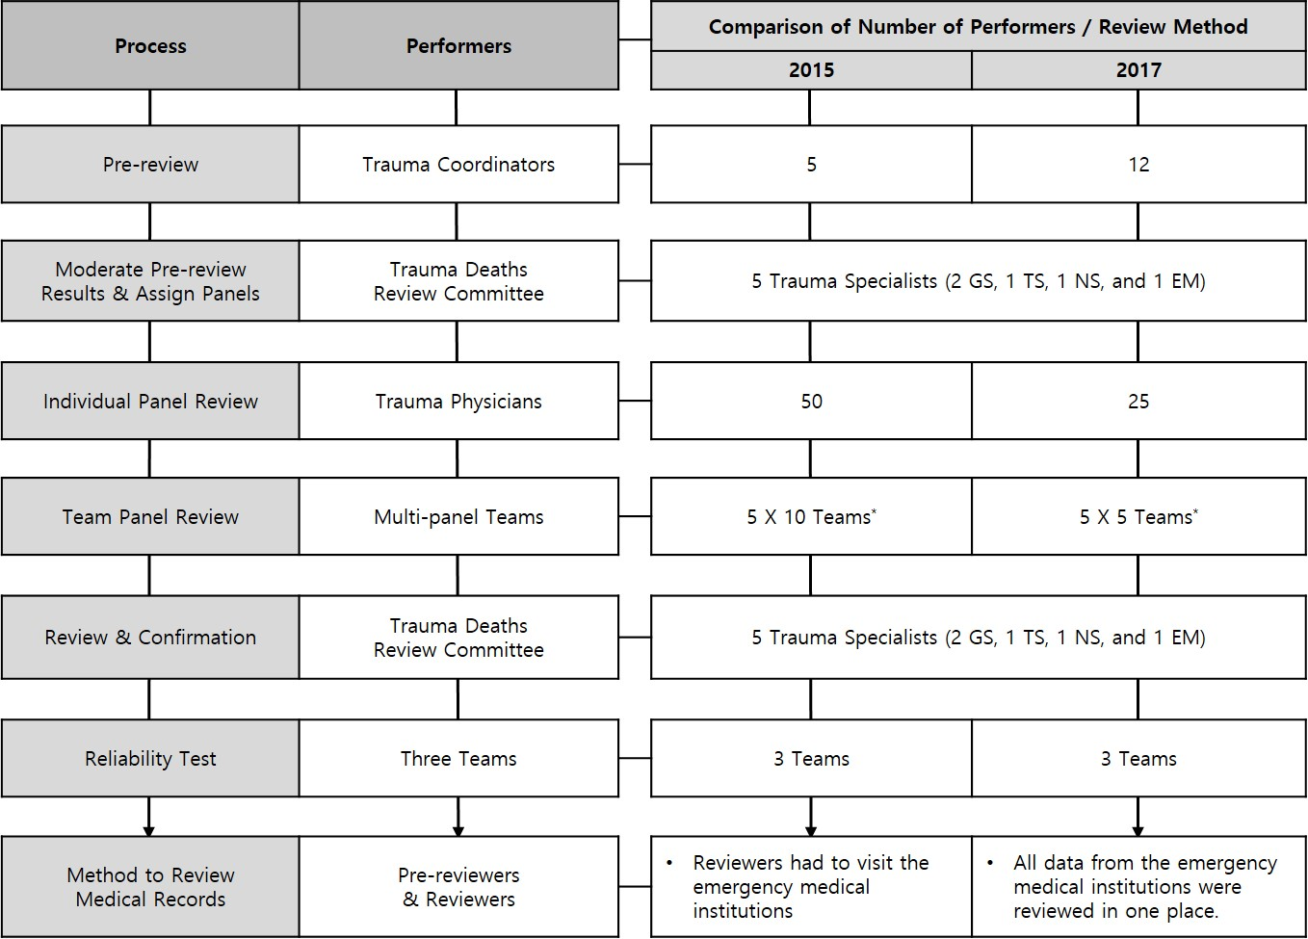

*One team comprised two general surgeons, one thoracovascular surgeon, one neurosurgeon, and one mergency physician.
GS, general surgeon; TS, thoracovascular surgeon; NS, neurosurgeon; EM, emergency physician.

