Supplementary materials
Figure caption
Fig. S1. The structures of the ionic liquids. (Page 2)
Fig. S2. Effect of ionic liquids on soil enzyme activity. (Page 3-9)
Fig. S3. The rarefaction curves for edaphon. (Page 10)
Fig. S4. The pan analysis for edaphon. (Page 11)
Fig. S5. The core analysis for edaphon. (Page 12)
Fig. S6. The α-diversity indices of bacterial community. (Page 13-15)
Fig. S7. The LEfSe multi-level species difference discriminant analysis. (Page 16-22)

Table caption
Table S1 Summary of the data in 16S sequence (Page 23)
Table S2 Summary of the alpha diversity data (Page 24)
Table S3 Summary the abundance of Kyoto Encyclopedia of Genes and Genomes (KEGG) (Page 25)
Table S4 Summary the abundance of Cluster of Orthologous Groups of proteins (COG) (Page 26-27)
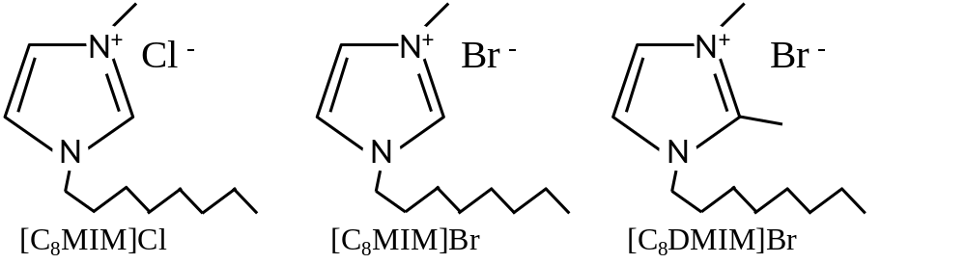
Fig. S1. The structures of the ionic liquids.

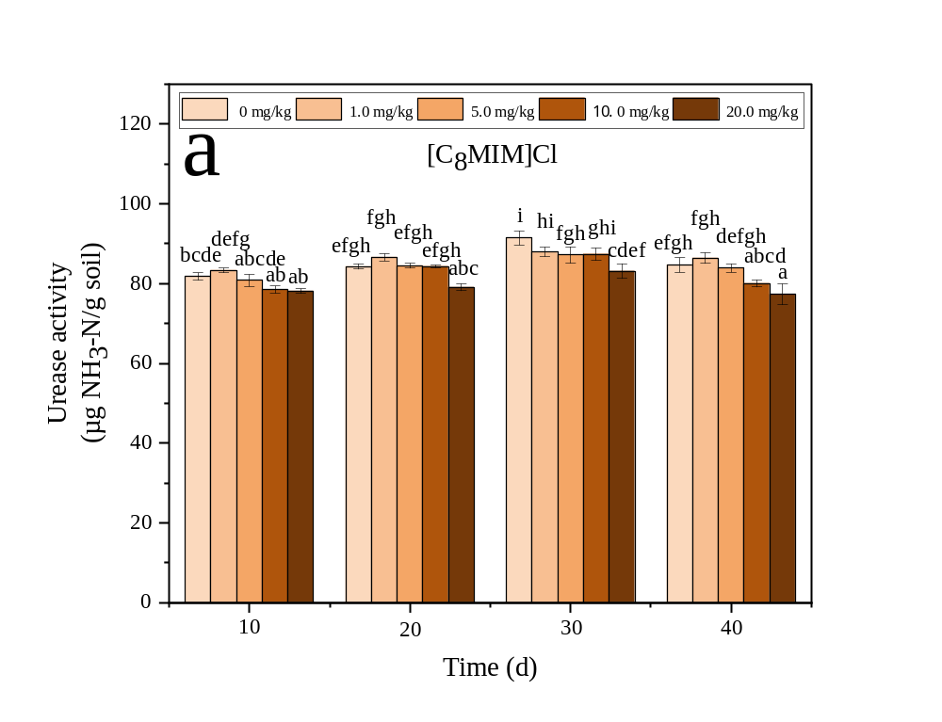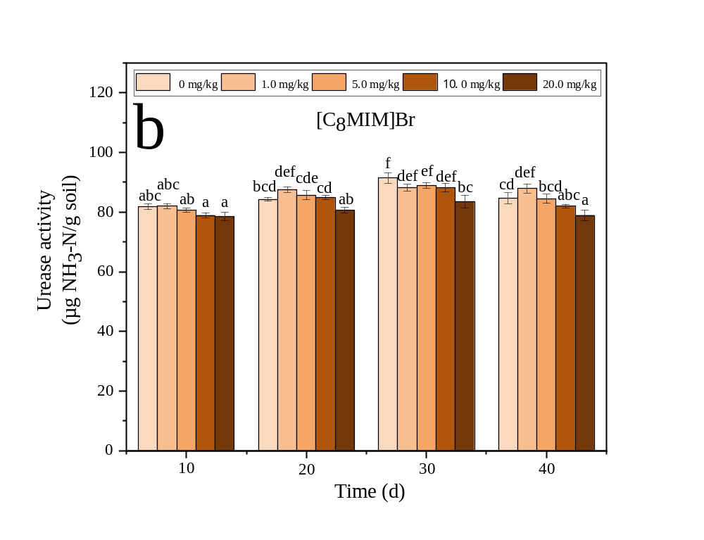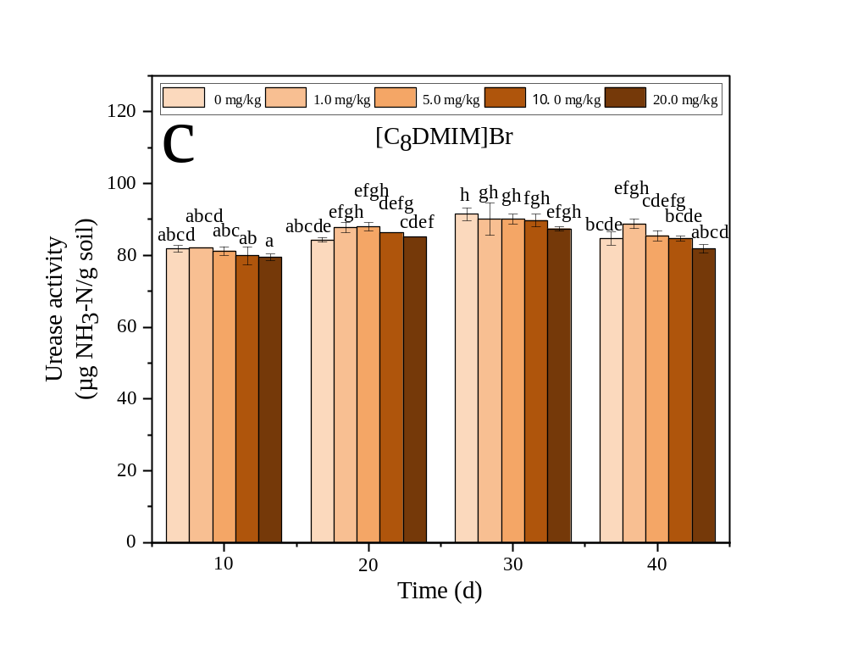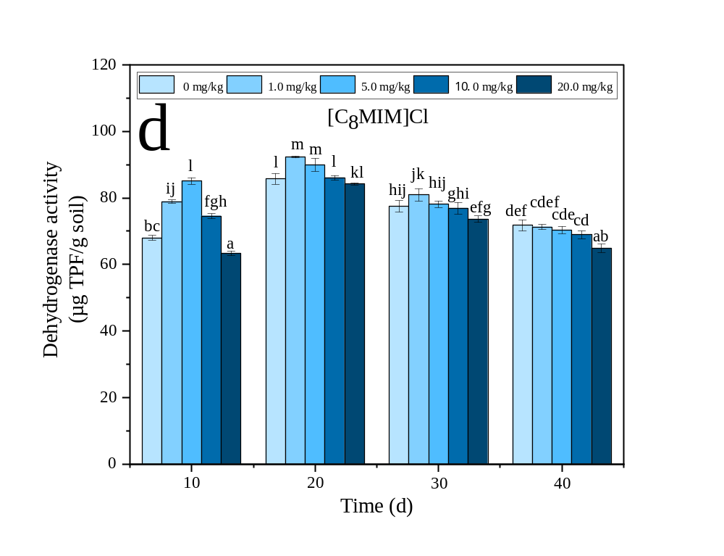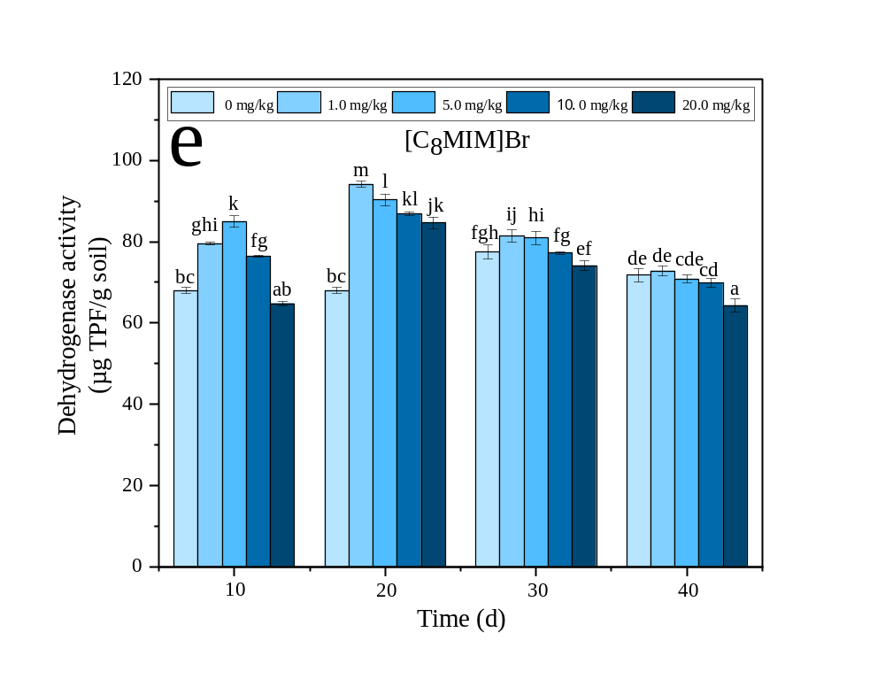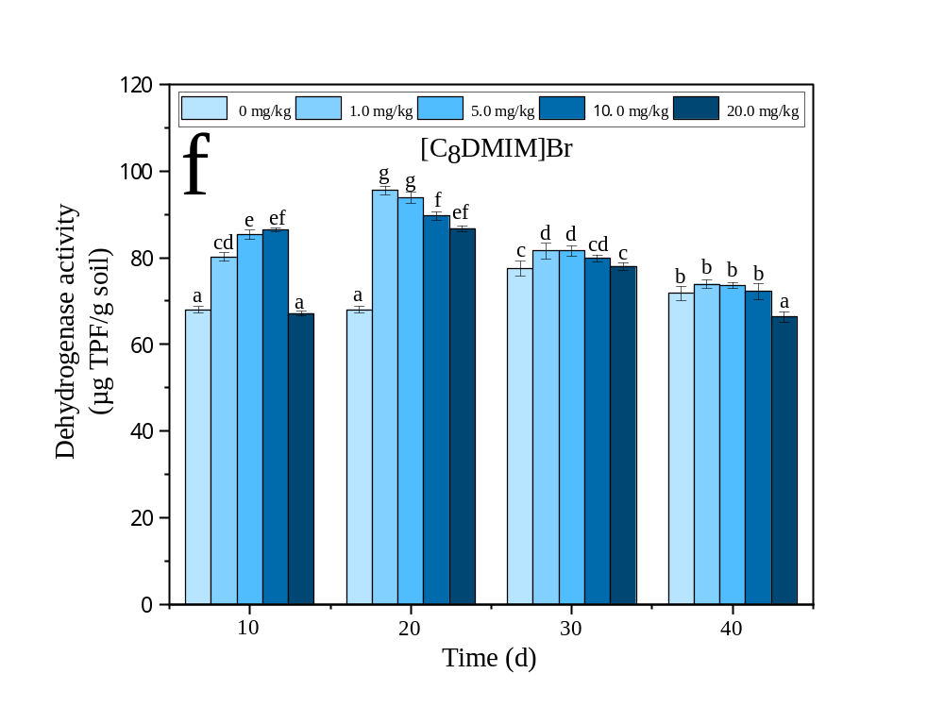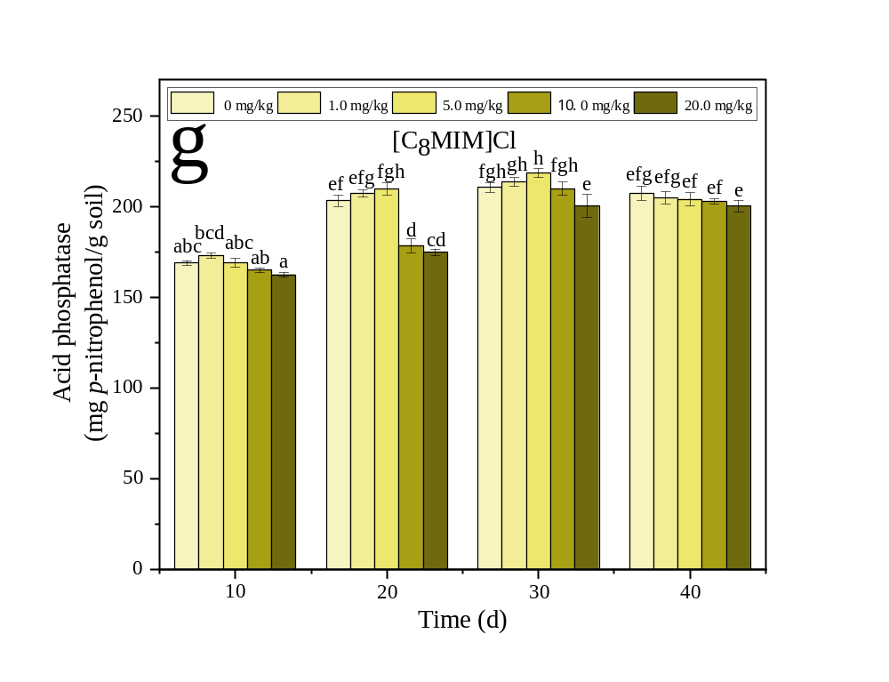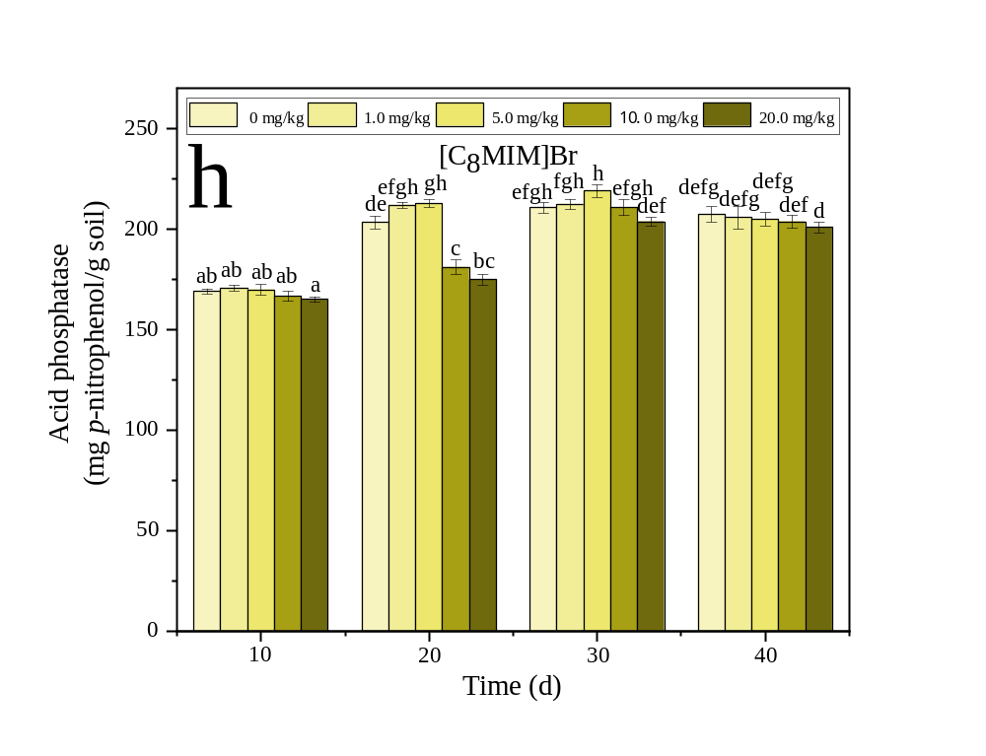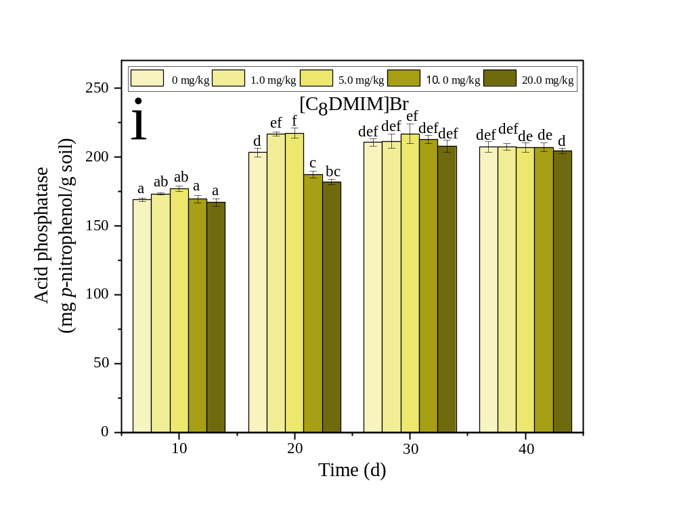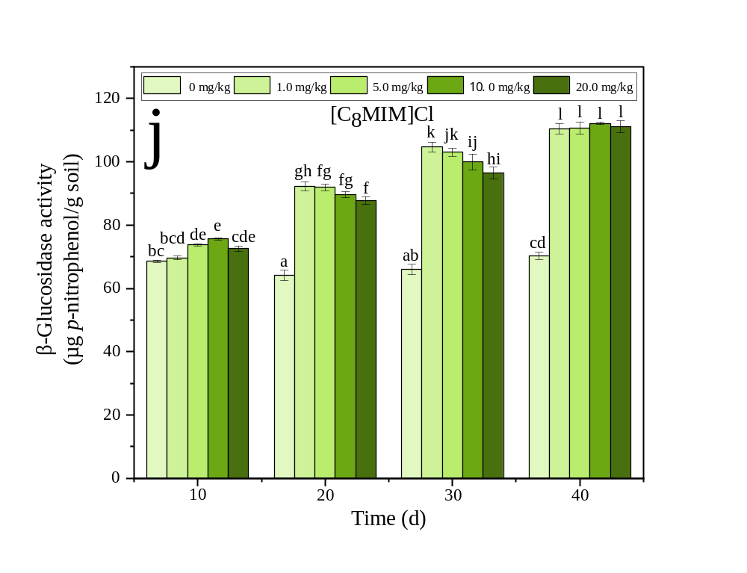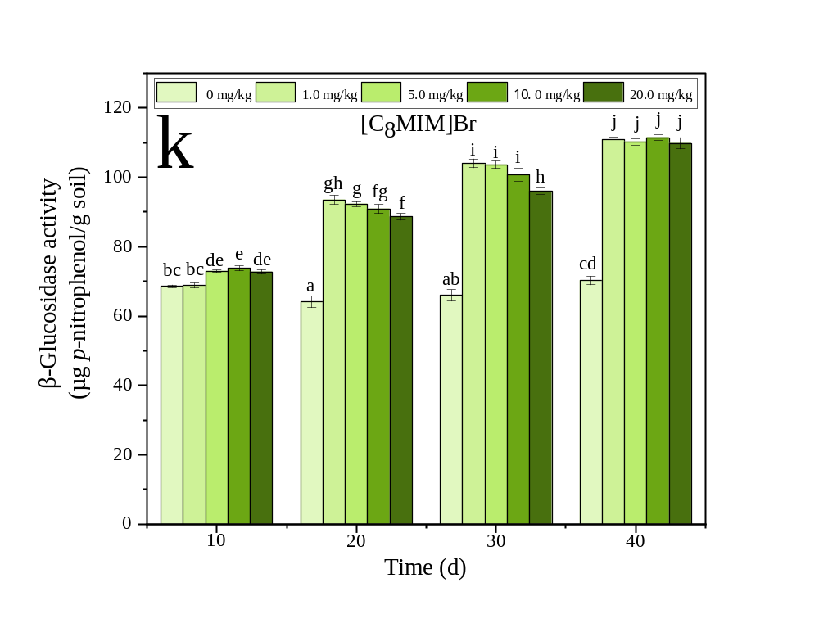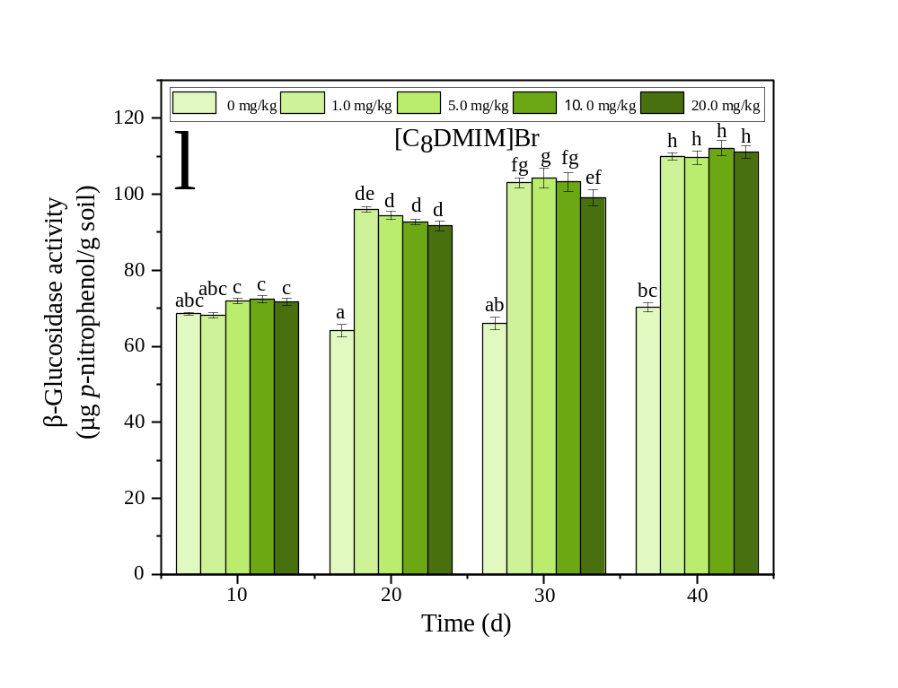
Fig. S2. Effect of ionic liquids on soil enzyme activity. Note: The bars represent M ± SD. The different letters indicate significant differences compared to other treatment at p < 0.05 according to a Turkey’s multiple range test.

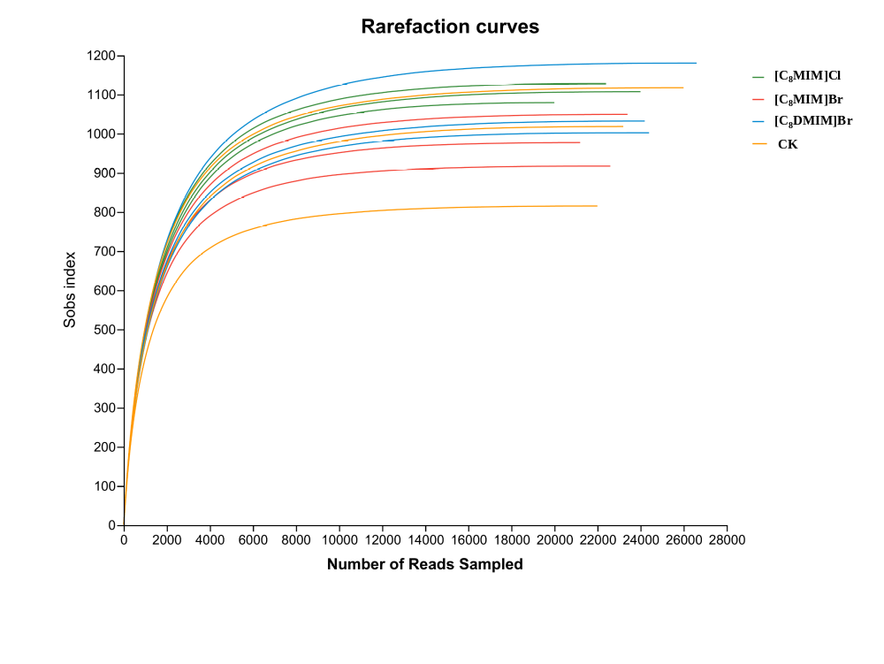
Fig. S3. The rarefaction curves for edaphon.
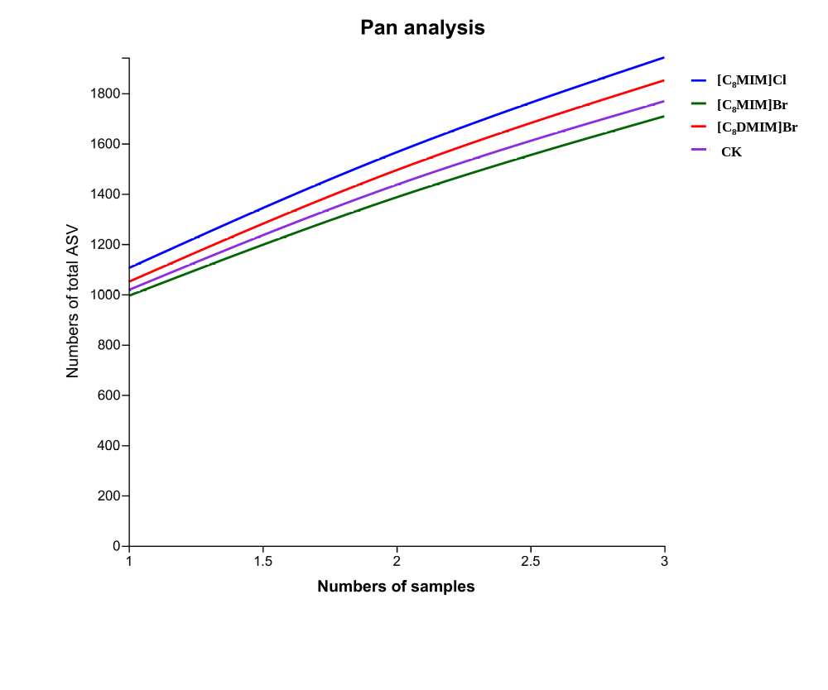
Fig.S4. The pan analysis for edaphon.
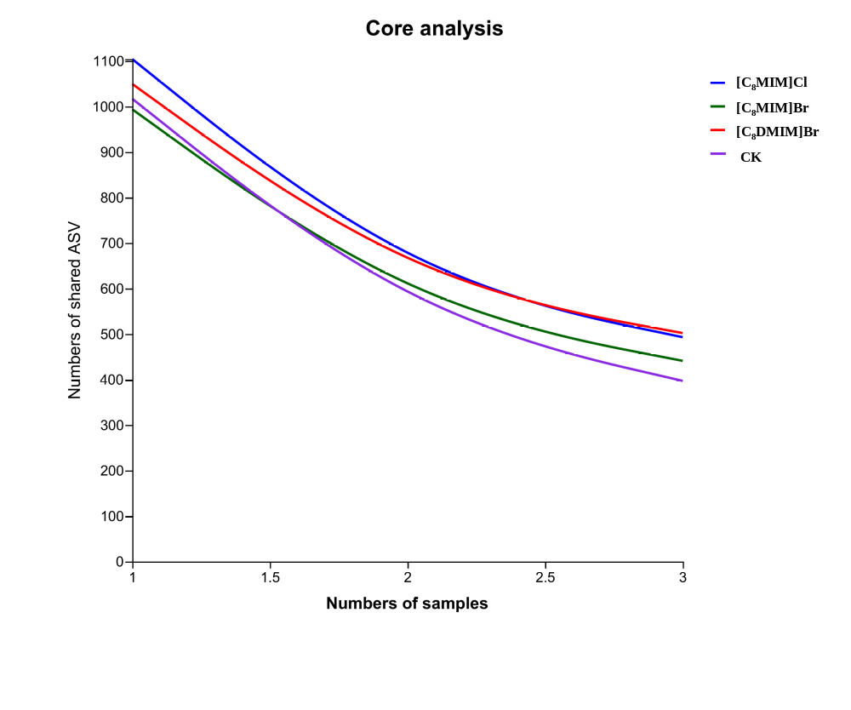
Fig. S5. The core analysis for edaphon.
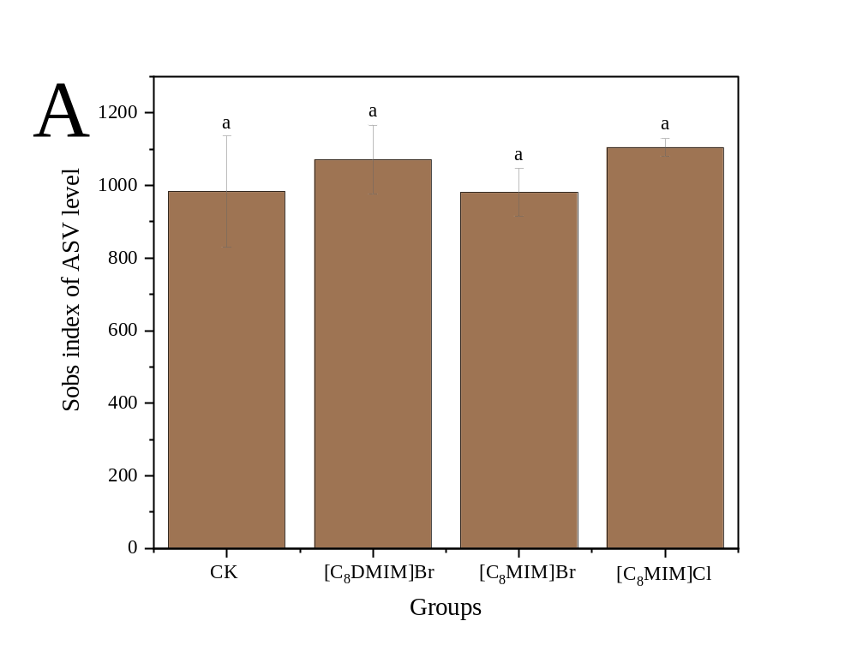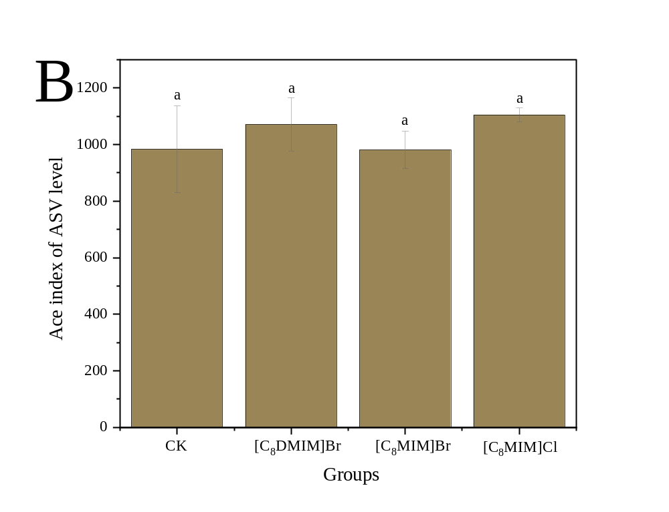
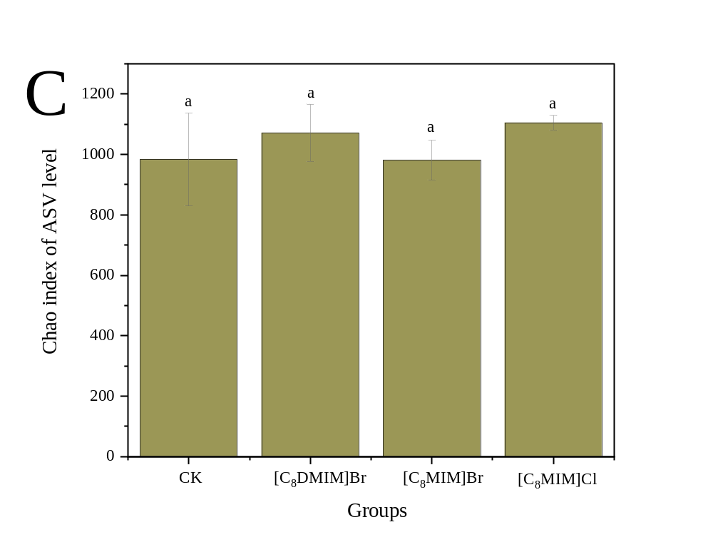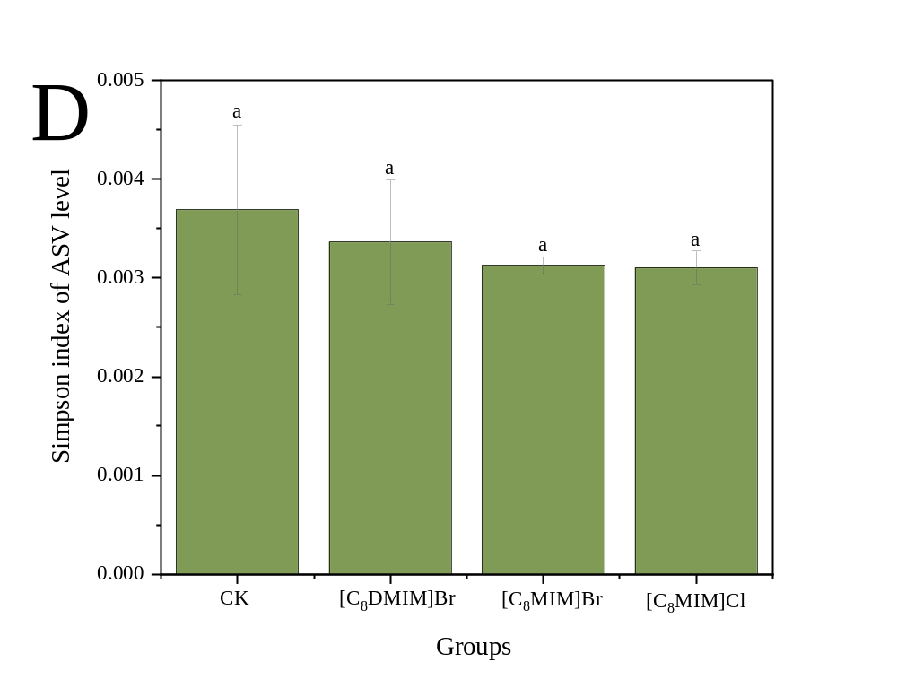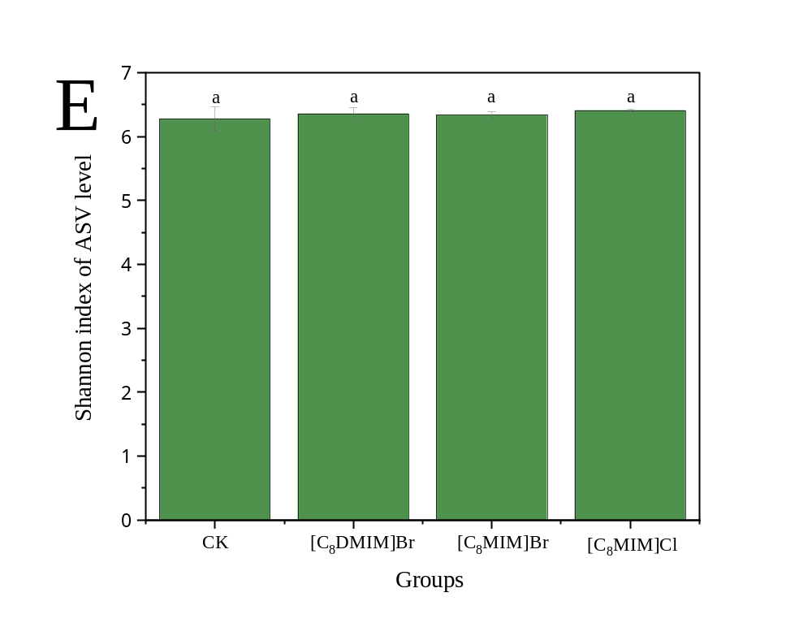
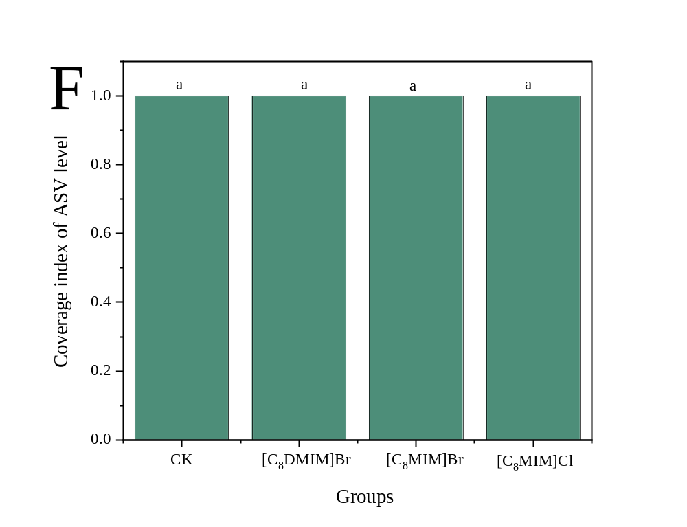
Fig.S6. The α-diversity indices of bacterial community.

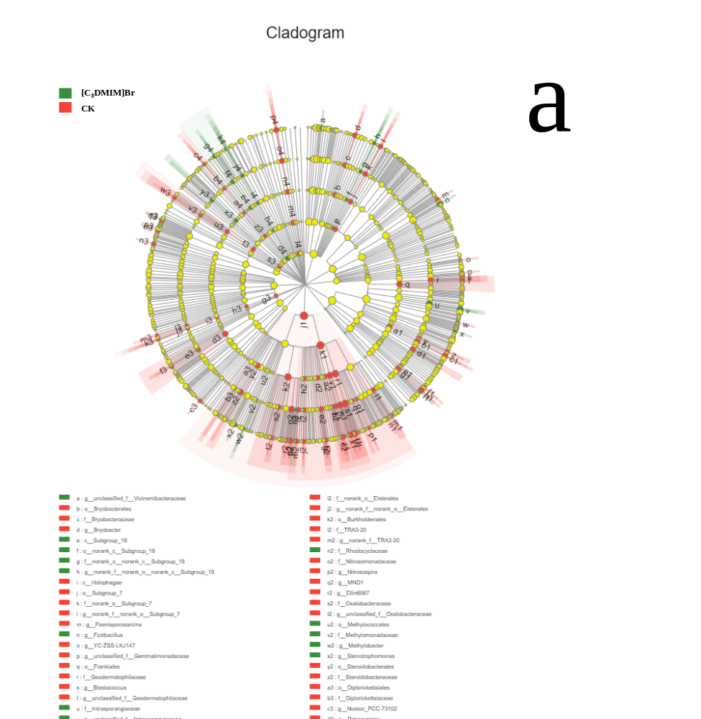

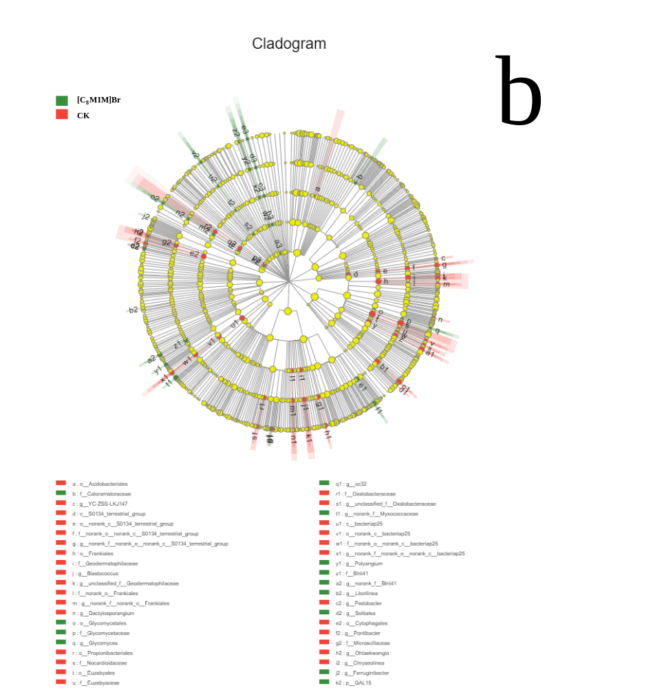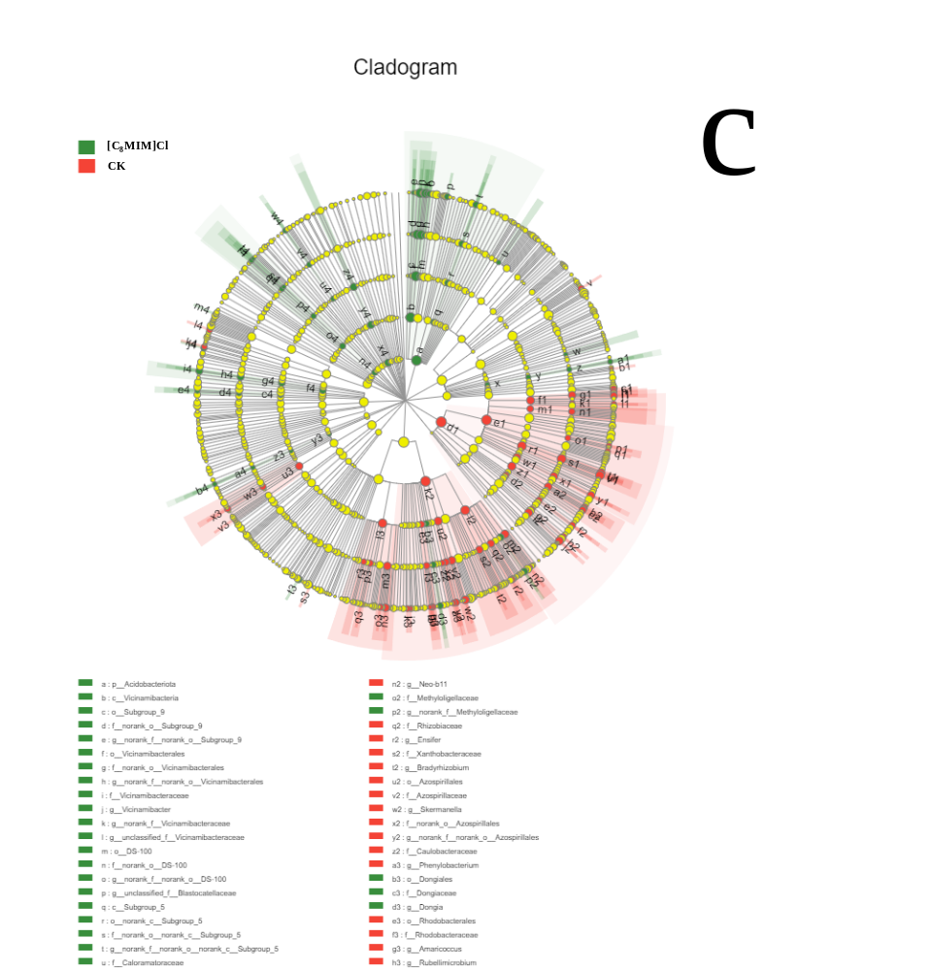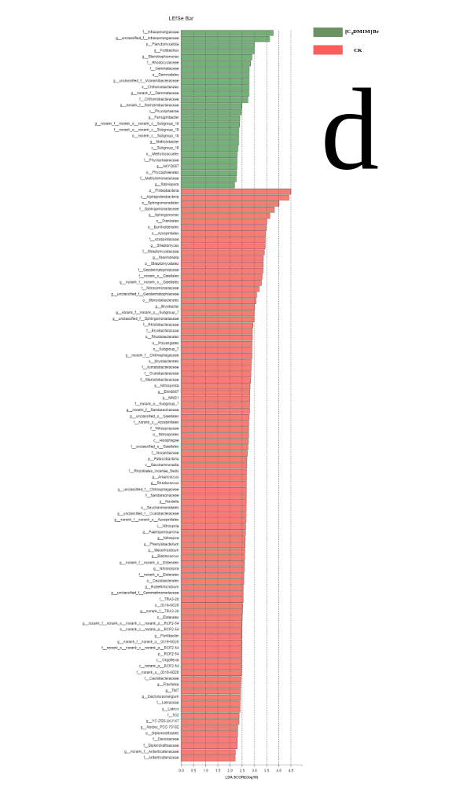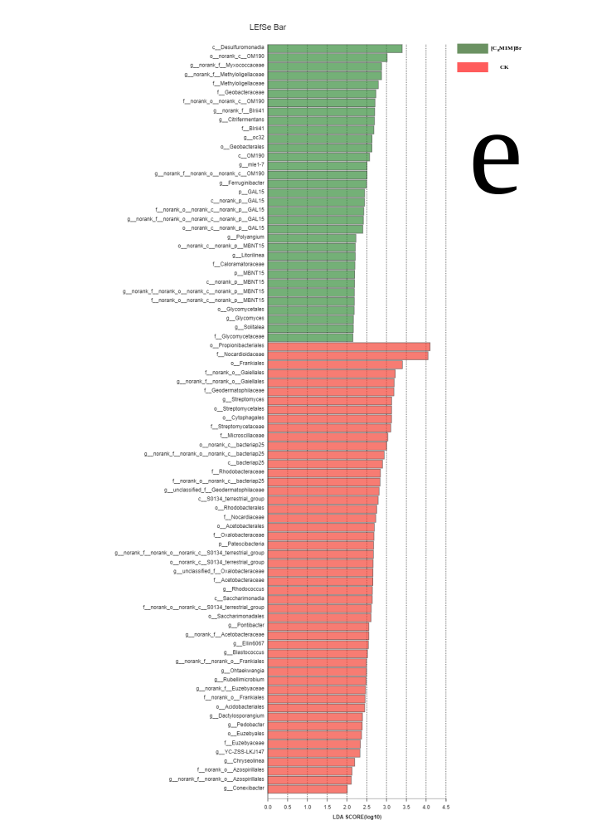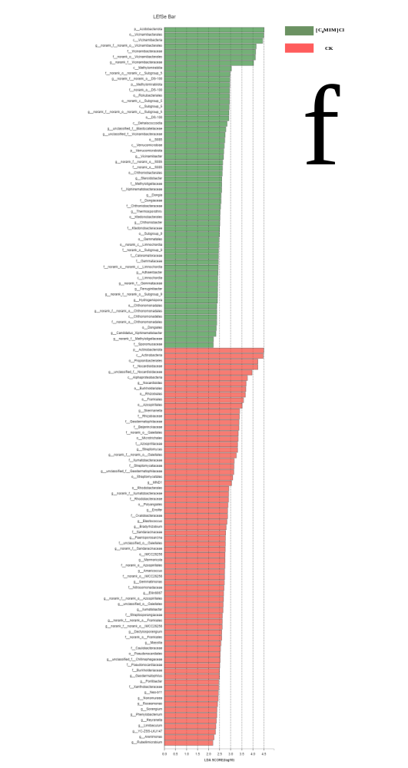
Fig. S7. The LEfSe multi-level species difference discriminant analysis. Note: a-c: Nodes with different colors indicate microbial groups that are significantly enriched in the corresponding group and have a significant impact on the differences between groups, and the light yellow node indicates a group of microorganisms that have no significant difference in different groups or have no significant influence on the difference between groups. d-f: Different colored columns indicate different groups, and the LDA discriminant histogram counts the microbial groups that have significant effects in multiple groups. The greater the LDA score, the greater the influence of species abundance on the difference effect.
Table S1 Summary of the data in 16S sequence
Sample name | Seq_num | Base_num | Mean_length | Min_length | Max_length
[C₈MIM]Br_1 | 56774 | 23736051 | 418.0796 | 216 | 504
[C₈MIM]Br_2 | 52874 | 22094673 | 417.8741 | 296 | 462
[C₈MIM]Br_3 | 49200 | 20587611 | 418.4474 | 306 | 509
[C₈DMIM]Br_1 | 52554 | 22037185 | 419.3246 | 246 | 510
[C₈DMIM]Br_2 | 55362 | 23103956 | 417.3252 | 262 | 510
[C₈DMIM]Br_3 | 57605 | 24072892 | 417.8959 | 240 | 489
[C₈MIM]Cl_1 | 40320 | 16873910 | 418.4998 | 361 | 500
[C₈MIM]Cl_2 | 49213 | 20585009 | 418.284 | 328 | 504
[C₈MIM]Cl_3 | 44899 | 18801366 | 418.748 | 322 | 464
CK_1 | 56800 | 23740546 | 417.9674 | 211 | 503
CK_2 | 58496 | 24382859 | 416.8295 | 203 | 471
CK_3 | 50850 | 21240828 | 417.7154 | 250 | 530

Table S2 Summary of the alpha diversity data
Sample/Estimators | sobs | ace | chao | shannon | simpson | coverage
CK_1 | 1117 | 1117 | 1117 | 6.456607 | 0.002856 | 1
CK_2 | 815 | 815 | 815 | 6.083378 | 0.004573 | 1
CK_3 | 1018 | 1018 | 1018 | 6.289594 | 0.003639 | 1
[C₈DMIM]Br_1 | 1032 | 1032 | 1032 | 6.371527 | 0.002915 | 1
[C₈DMIM]Br_2 | 1002 | 1002 | 1002 | 6.253959 | 0.004082 | 1
[C₈DMIM]Br_3 | 1180 | 1180 | 1180 | 6.443214 | 0.003091 | 1
[C₈MIM]Br_1 | 917 | 917 | 917 | 6.289862 | 0.003119 | 1
[C₈MIM]Br_2 | 977 | 977 | 977 | 6.336531 | 0.003215 | 1
[C₈MIM]Br_3 | 1049 | 1049 | 1049 | 6.386017 | 0.003044 | 1
[C₈MIM]Cl_1 | 1079 | 1079 | 1079 | 6.394788 | 0.002984 | 1
[C₈MIM]Cl_2 | 1107 | 1107 | 1107 | 6.397498 | 0.003297 | 1
[C₈MIM]Cl_3 | 1128 | 1128 | 1128 | 6.43176 | 0.003028 | 1

Table S3 Summary the abundance of Kyoto Encyclopedia of Genes and Genomes (KEGG)
KEGG Name | CK | [C₈DMIM]Br | [C₈MIM]Br | [C₈MIM]Cl
Metabolism | 57352671 | 54772549 | 46769118 | 43645537
Genetic Information Processing | 4834590 | 4550812 | 3936875 | 3719869
Environmental Information Processing | 3686769 | 3577415 | 3015983 | 2767728
Cellular Processes | 2948841 | 2799426 | 2388136 | 2220965
Human Diseases | 2435629 | 2279367 | 1953795 | 1825462
Organismal Systems | 1307114 | 1248264 | 1056899 | 980861.8

Table S4 Summary the abundance of Cluster of Orthologous Groups of proteins (COG)
COG Description | CK | [C₈DMIM]Br | [C₈MIM]Br | [C₈MIM]Cl
RNA processing and modification | 8800.97 | 8386.49 | 6576.91 | 5699.35
Chromatin structure and dynamics | 24092.17 | 28623.63 | 25277.49 | 24592.62
Energy production and conversion | 3199858 | 3359977 | 2866024 | 2672064
Cell cycle control, cell division, chromosome partitioning | 460218.8 | 488631.2 | 419889.9 | 395778.7
Amino acid transport and metabolism | 4567739 | 4937007 | 4205292 | 3917064
Nucleotide transport and metabolism | 1336121 | 1451963 | 1241874 | 1163168
Carbohydrate transport and metabolism | 2621680 | 2829100 | 2358892 | 2157034
Coenzyme transport and metabolism | 1921977 | 2037476 | 1747425 | 1637084
Lipid transport and metabolism | 1930088 | 1974122 | 1664800 | 1545434
Translation, ribosomal structure and biogenesis | 3012028 | 3303096 | 2866241 | 2717053
Transcription | 2710467 | 2762018 | 2301133 | 2096525
Replication, recombination and repair | 2058512 | 2179662 | 1855175 | 1731969
Cell wall/membrane/envelope biogenesis | 2630322 | 2876358 | 2506761 | 2398333
Cell motility | 430735 | 431557.4 | 379327 | 370079.2
Posttranslational modification, protein turnover, chaperones | 1841768 | 1974558 | 1712718 | 1631283
Inorganic ion transport and metabolism | 2595707 | 2680888 | 2254888 | 2074341
Secondary metabolites biosynthesis, transport and catabolism | 923326.6 | 909808.2 | 759840.4 | 698443.3
Function unknown | 8302515 | 8623990 | 7273517 | 6761476
Signal transduction mechanisms | 1711014 | 1796852 | 1531862 | 1441556
Intracellular trafficking, secretion, and vesicular transport | 727390 | 796091 | 706275 | 682625.8
Defense mechanisms | 783267.5 | 859021.7 | 734562.5 | 692907.1
Extracellular structures | 612 | 449 | 396.5 | 357
Cytoskeleton | 5116.11 | 4994.9 | 4419.33 | 3936.71

