Supplementary Information
Hierarchical First-order and Second-order Topological States in Symmetry-Controllable Grain Boundary
Won-Jun Jang^{1†}, Heeyoon Noh^{2†}, Seoung-Hun Kang³, Wonhee Ko⁴, Moon Jip Park5^{5,6*}, and Hyo Won Kim^{1*}

¹Samsung Advanced Institute of Technology, Suwon 16678, Korea
²Yonsei University, Seoul 03722, Korea
³Materials Science and Technology Division, Oak Ridge National Laboratory, Oak Ridge, TN 37831, United States
⁴The Department of Physics and Astronomy, University of Tennessee at Knoxville, Knoxville, Tennessee 37996, United States
⁵Center for Theoretical Physics of Complex Systems, Institute for Basic Science (IBS) Daejeon 34126, Republic of Korea
⁶Department of Physics, Hanyang University, Seoul 04763, Korea

†W. –J. J. and H. N. contributed equally to this work.
*Correspondence and requests for materials should be addressed to M. J. P. and H. W. K. (email: moonjippark@hanyang.ac.kr, hyowon98.kim@samsung.com)

Table of Lists

- Supplementary Note 1: Methods
Scanning Tunneling Microscopy/Spectroscopy Measurement
Computational Method
- Supplementary Note 2: Details of the GB formation process
- Supplementary Note 3: Theory of topological GBs
Defect classifications of grain boundary
Symmetry classifications of topological states
Theoretical modeling of grain boundary

Supplementary Note 1: Methods

Scanning Tunneling Microscopy/Spectroscopy Measurement
We performed the experiments in a commercial low-temperature STM instrument (RHK) at 4.2 K in an ultrahigh vacuum (pressure < 1.0 10⁻¹⁰ Torr). 1T’-MoTe₂ single crystal samples were purchased from HQ Graphene. The sample was cleaved in an ultrahigh vacuum chamber (~ 10⁻¹⁰ Torr) at room temperature and then transferred to the low-temperature STM sample stage, where the temperature was kept at 4.2 K.

Computational Method
Density Functional Theory calculations were carried out using the Vienna ab initio simulation package (VASP) employing the generalized gradient approximation (GGA) with Perdew-Burke-Ernzerhof (PBE) exchange-correlation functional form and the projector-augmented wave methods¹⁻⁵. For all calculations, wave functions were expanded in plane waves with the cutoff energy of 350 eV, and the atomic positions were relaxed until the residual forces were less than 0.02 eV/Å or until the change of the total energy was less than 1.0 × 10⁻⁶ eV. All calculations were performed using a 1T’-MoTe₂ monolayer, and a vacuum of at least 20 Å was applied to the cell to prevent interaction between the slabs.

Supplementary Note 2: Details of the GB formation process
As mentioned in the main text, the optimized conditions are V_{p} = –2.5 ~ –3 V, D = –0.1 ~ –0.2 nm, T1 = 0.5 ~ 3 s, T2 = 200 ms, and T3 = 20 ms. Here, we describe three experimental parameters: (1) applied voltage pulse (V_{p}); (2) depth of surface indentation (D, which is defined as the distance after the tunneling current reaches 100 nA. For delicate control of D, we used z-spectroscopy before every switching process, and D was varied from a few angstroms to 30 nm); (3) time to lower the tip to the surface (T1, varied from 0.5 to 10 s). With –2.0 V < V_{p} < 0 V, only holes are created without any grain formation. Similarly, with –2.0 < V_{p} < –2.5 V, G2 and/or G3 are occasionally formed, but not the diamond shape as shown in Fig. 1c and 1f. Finally, with V_{p} < –4 V, larger holes with the diameters of several hundreds of nanometres and adsorbate clusters are mainly created. Without the tip pulse, the switching process does not occur, even with D = –30 nm. Positive voltage pulses also lead to domain switching, but a larger threshold voltage is required (Fig. S2).
Adjusting the values of D and T1 for pressing down the surface is essential to form the diamond-shaped structure and is related to the strength of the applied tensile strain. Without pressing the surface, holes are mainly acquired, and domains and GBs are obtained with less than 1% possibility. Moreover, even when switching occurs, only half of the diamond shape is constructed (Supplementary Fig. S3). Only holes are created when the tip slightly touches the surface with a small D (D = –70 pm) (Supplementary Fig. S4). If the speed at which the tip presses down the surface is excessively low or high (T1 < 0.5 s or T1 > 5 s), the phase-switching process does not occur, and only holes are formed (Supplementary Fig. S5).

Supplementary Note 3: Theory of topological GBs
Defect classifications of grain boundary
1T’ phase of MoTe₂ is obtained by the dimerization of adjacent Mo chains in 1T phase of MoTe2 (See Supplementary Fig. S9). The dimerization lowers the underlying symmetry by breaking the originally retained C₃-rotational symmetry, which gives rise to the six distinct orientations of 1T’ phases, where each orientation forms the two sets of the triplet C₃-symmetric partners, respectively. The structural distortion of the six different orientations can be represented by the local vector order parameter $\vec{M}$ that describes the distortion direction of the Mo atoms.
$\vec{M}=(\cos{\frac{2πm}{6}},\sin{\frac{2πm}{6}})$, where $m=0,1,2,3,4,5.$ (1)
While each domain is characterized by the vector order parameters, the grain boundaries (GB) between different distinct domains are characterized by relative angles $θ$ of the vector order parameters (directions of the dimerization). In general, $θ={60}^{∘}$ and${ 120}^{∘}$ angle GBs are allowed. Furthermore, the junction between the two domains can have additional half-lattice translations that give rise to the further symmetry distinctions of the GBs. The GB can be classified into symmorphic and non-symmorphic types (See Fig. 2 in the main text). In the case of 60-degree GB, the symmorphic and non-symmorphic GBs have mirror and glide reflection symmetry, respectively. The symmorphic and non-symmorphic 120-degree GB retain C₂ rotation or screw rotation symmetry along the direction of the boundary, respectively.

Symmetry classifications of topological states
Each domain of MoTe₂ belongs to the quantum spin Hall insulator phase characterized by non-trivial Z₂ invariant. Along the GB, the pair of helical edge modes are localized, where each helical edge originates from the bulk of a single domain. Without further symmetry protection, the double helical edge modes can be gapped out by hybridizing each other. However, the additional NonSymC2 symmetry gives rise to the Young–Kane type non-symmorphic band degeneracy, which protects the band crossings of the double-helical edge states. The protection of the edge states is evidently observed from the typical bow-tie type band crossings in the calculated LDOS spectra (Supplementary Fig. S10).
In contrast to the NonSymC2-type GB, the SymC2-type boundary does not have the symmetry protection of the edge mode. As a result, we observe the gapped spectra (Supplementary Fig. S11). The reminiscent of the gapped edge states are observed from the higher energy. However, the gapped boundary states give rise to the higher-order topological classification. We can consider the product of the SymC₂ symmetry and the time-reversal symmetry, which forms the effective time-reversal symmetry with T² = 1 algebra, acting on each spin space. Within the spin space, the additional approximate inversion symmetry of Te atoms near the GB gives Z₂ classification of the gapped one–dimensional edge (AI class). The corresponding symmetry classification is formally equivalent to that of the SSH model. Physically, the dimerization of the Mo chain along the GB gives rise to the alternating hopping term in a similar manner to the SSH chain (shown by the purple stripes in Fig.2e in the main text).

Theoretical modeling of grain boundary
To model the GBs of the quantum spin Hall insulator, we adopt the Bernevig-Hughes-Zhang model, where the bulk Hamiltonian is given as,
$$h\left(k\right)=sink_{x}σ_{x}I_{2}+sink_{y}σ_{y}τ_{z}+\left(2+m-cosk_{x}-cosk_{y}\right)σ_{z}I_{2}, (2)$$
here $σ_{i}$ represents i-th Pauli matrix. m is the topological mass, and the quantum spin Hall phase occurs at $-2<m<0$. We consider the two identical quantum spin Hall insulators ($N_{x}×N_{y}$) with the additional dimerization potential,
$$H_{0}\left(k\right)=\sum_{α=L,R}{\left[\sum_{k}{c_{L,k}^{†}h\left(k\right)c_{L,k}+c_{R,k}^{†}h\left(k\right)c_{R,k}+\sum_{i,j=1}^{N_{x},N_{y}}{m{\left(-1\right)}^{j}}c_{α,(ij)}^{†}I_{2}τ_{y}c_{α,(ij)}}\right]}, (3)$$
where i,j are the coordinate indices of x- and y-directions, respectively. $c_{L,k}^{†}$ ($c_{R,k}$) is creation (annihilation) operators of the left (right) side of the domain with momentum $k$. The last term in Eq. (3) models the alternating mass term along the domain wall. We note that the specific form of the mass term does not change the result as long as it does not break the time-reversal symmetry.
Finally, the effective tunneling between the two domains determines the underlying symmetry of the GB (Supplementary Fig. S10d and S11d). In the case of the NonSymC2-type boundaries, we consider the addition of the following tunneling term:
$$H_{T-NS}=\sum_{j=1}^{N_{y}}{Tc_{R,(1j)}^{†}c_{L,(Nj)}+Tc_{L,(N(j-1))}^{†}c_{R,(1j)}}+h.c. (4)$$
Fig. S10a and b show the calculated LDOS spectrum in the presence of the non-symmorphic tunneling. Despite the presence of finite tunneling between the edge states, we observe robust band crossings near zero energy. The band crossings are observed near the GB, indicating that the crossings originated from the edge states of the quantum spin Hall insulator phase. In addition, the bow-tie type band crossings clearly confirm the Young-Kane type topological protection of the edge states enriched by the NonSymC2 symmetry.
By changing the tunneling network between the two domains, we can model the SymC2-type GBs. We add the following tunneling term,
$$H_{T-S}=\sum_{j=1}^{N_{y}}{Tc_{R,(1j)}^{†}c_{L,(Nj)}+T^{*}c_{L,(Nj)}^{†}c_{R,(1j)}}. (5)$$
In contrast to the NS-GB, there exists no topological protection of the edge states. Accordingly, we observe the immediate gap opening as the finite tunneling amplitude is turned on (Supplementary Fig. S11a and b).

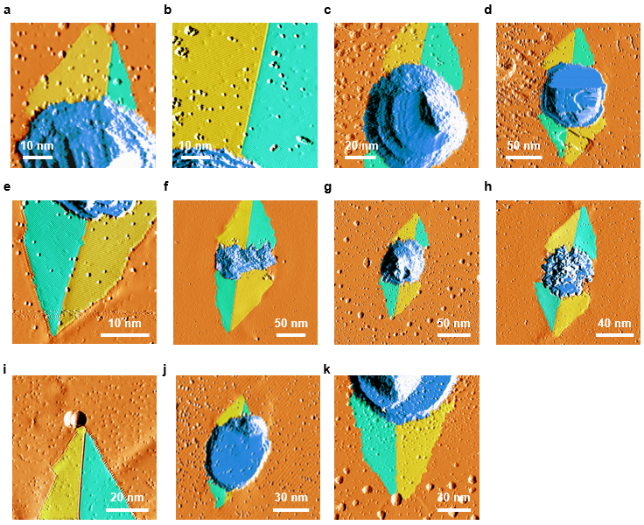
Fig. S1. Derivative STM images after creation of grain boundaries (GBs) with the optimized condition. T1 = 0.5 ~ 3 s, T2 = 200ms, T3 = 20 ms and D = ~ – 0.2 nm.
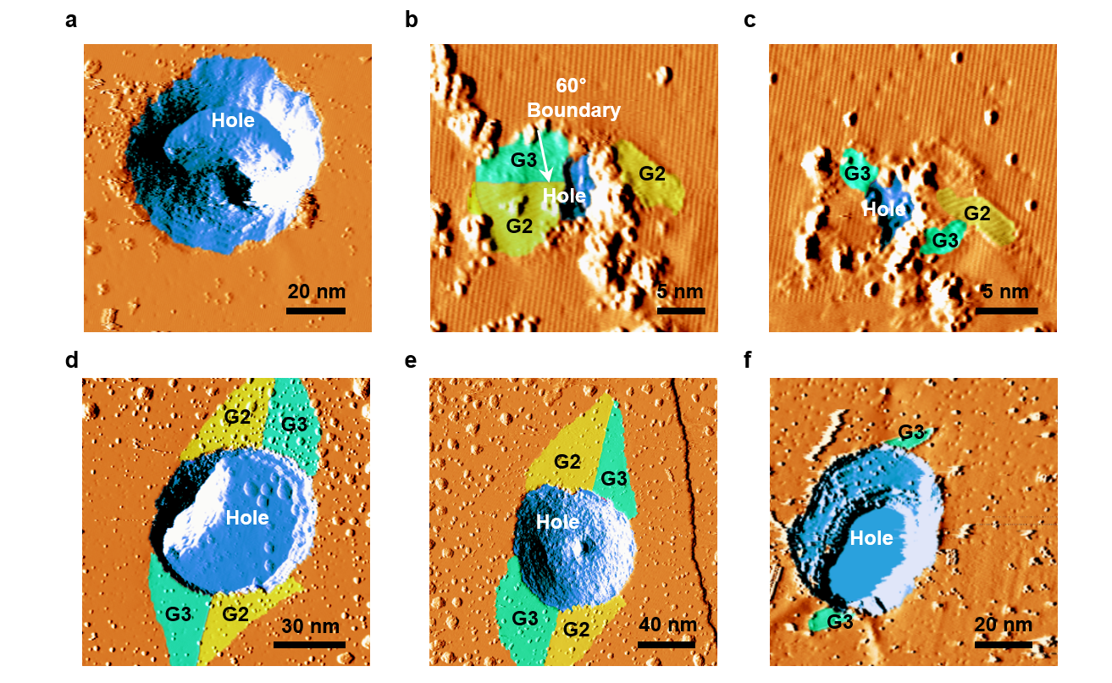
Fig. S2. Voltage pulse (V_{p}) dependence for the grain–switching process. Derivative STM images of the 1T’-MoTe₂ were obtained after the switching process with the bias voltages of a, – 2.0 V, b,c, – 2.2 V, d,e, – 3.5 V, f, 3.0 V. a,b,e, T1 = 0.5 s, c,d, T1 = 3 s. f, T1 = 1s.

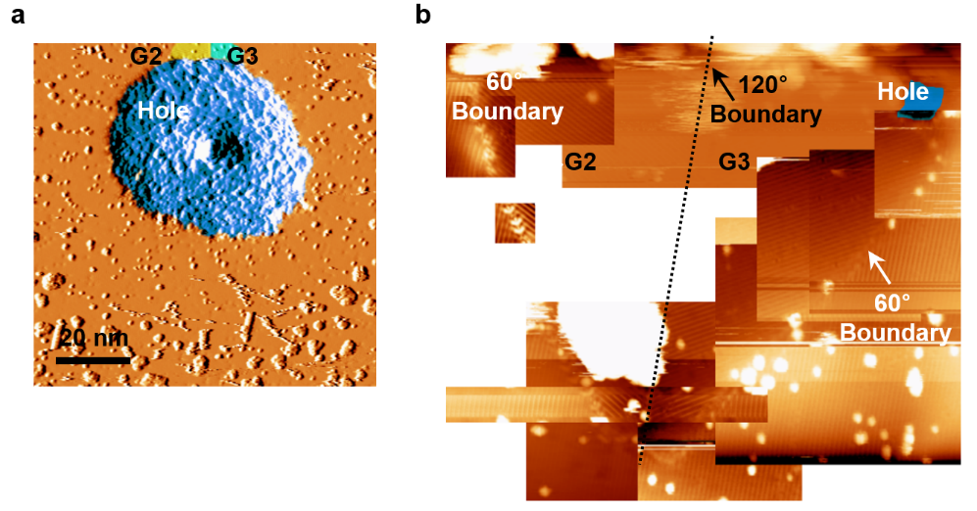
Fig. S3. Grain and GBs formed without touching the surface. a, Derivative STM image of the 1T’–MoTe₂ after the switching process with T1 = 0.5 s, V_{p} = – 2.5 V, and T3 = 20 ms. b, STM image gathering eleven pieces. Here, we applied a tip pulse without pressing.
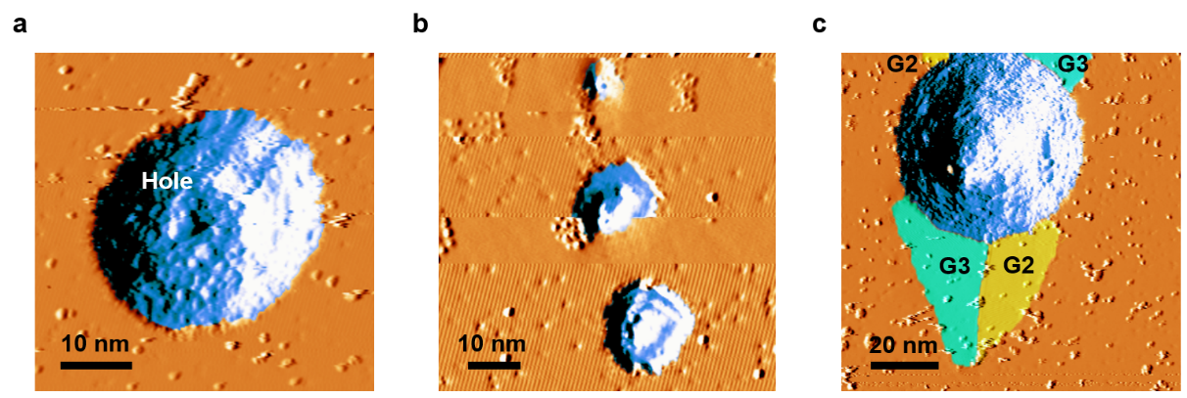
Fig. S4. Depth (D) dependence for the GB formation process. Derivative STM images of the 1T’-MoTe₂ after the switching process. a, D = 0 pm. b, D = – 70 pm. Here, we repeated the switching process three times and obtained three holes. c, D = – 200 pm. All cases were obtained with T1 = 0.5 s, V_{p} = – 2.5 V, and T3 = 20 ms.

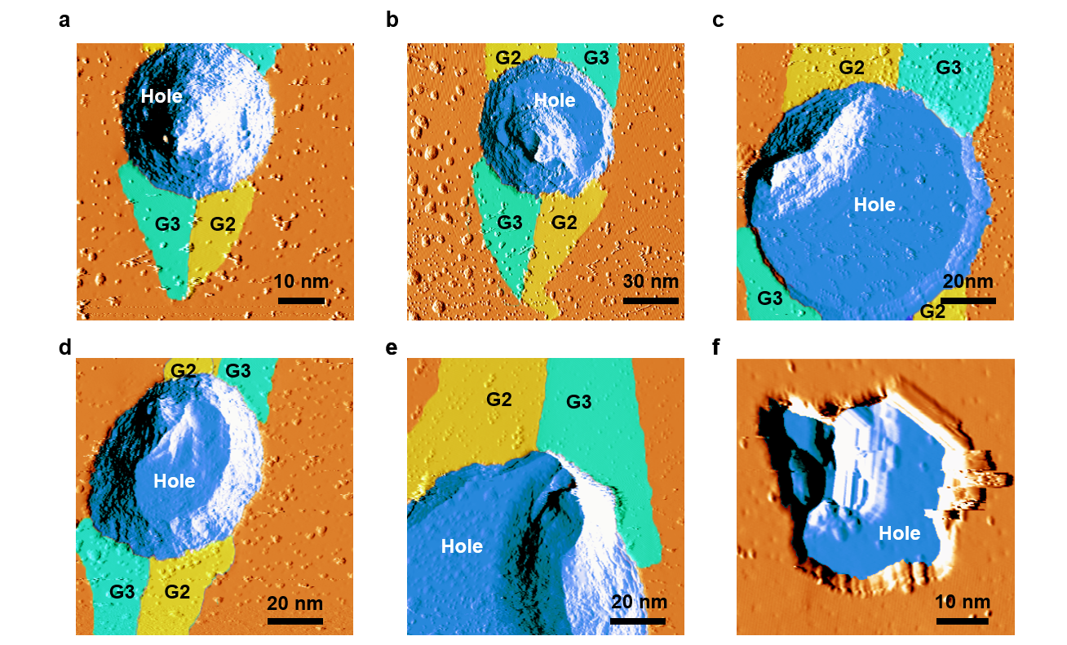
Fig. S5. T1 dependence for the GB formation process. Derivative STM images of the 1T’-MoTe₂ after the switching process with T1 of a, 0.5 ms, b, 1 s, c,d, 3 s, e, 5s and f, 10s. All cases were obtained with V_{p} = – 2.5 V, T3 = 20 ms. In the case of T1 = 10s, we could not observe the domain–switching.
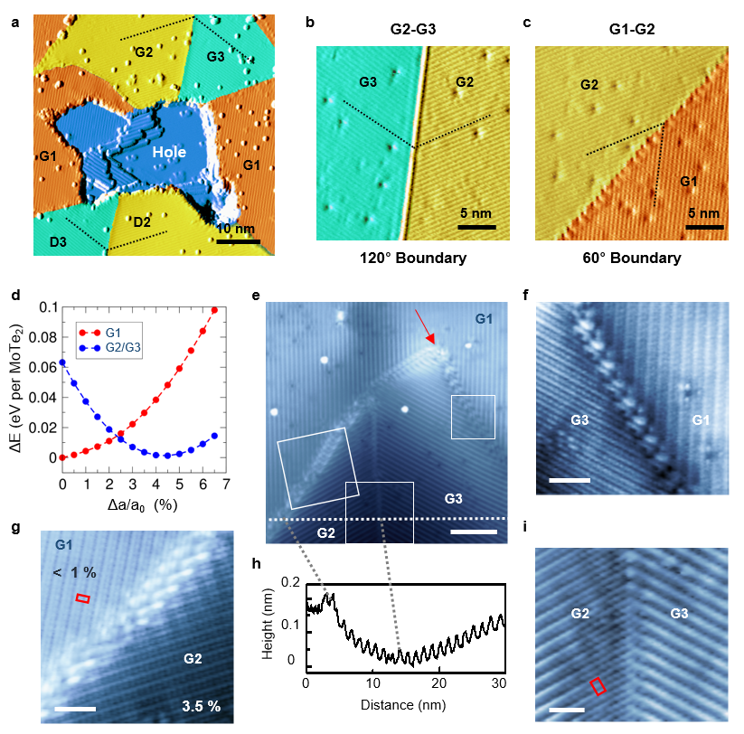
Fig. S6. Full geometric characterizations of the GBs. a, Derivative STM image of the 1T’–MoTe₂ obtained after the GB formation process. b, c, Close-up views of derivative STM images in Fig. 1d in the main text. which show G2–G3 (120˚) and G1–G2 (60˚) domain boundaries, respectively. d, DFT-calculated potential energy curves of the different domains of 1T’–MoTe₂ uniaxially strained along the a axis, where a_{o} is the lattice constant at equilibrium without any constraints. e, STM image of the 1T’–MoTe₂ surface obtained after the GB formation process (V_{s} = –0.1 V, I = 0.2 nA). The scale bar is 6 nm. f, g, i, Close-up views of STM image in e near G1–G3, G1–G2, and G2–G3, respectively (V_{s} = –50 mV, I = 0.45 nA). The red rectangle represents the primitive unit cell of the 1T’ phase. Scale bars are 2 nm.

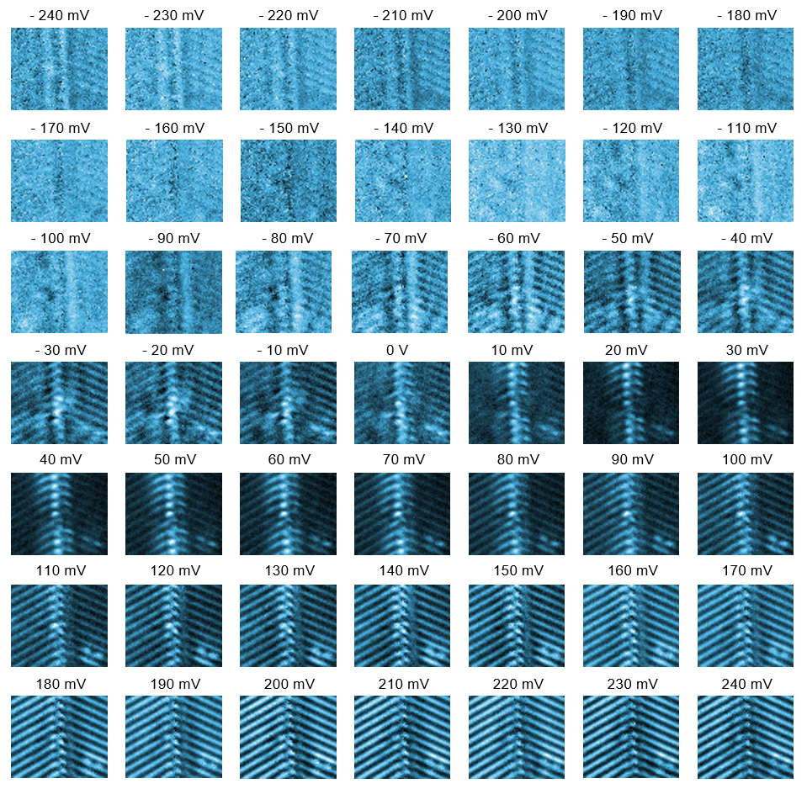
Fig. S7. dI/dV maps obtained over the area in Fig. 3a in the main text.

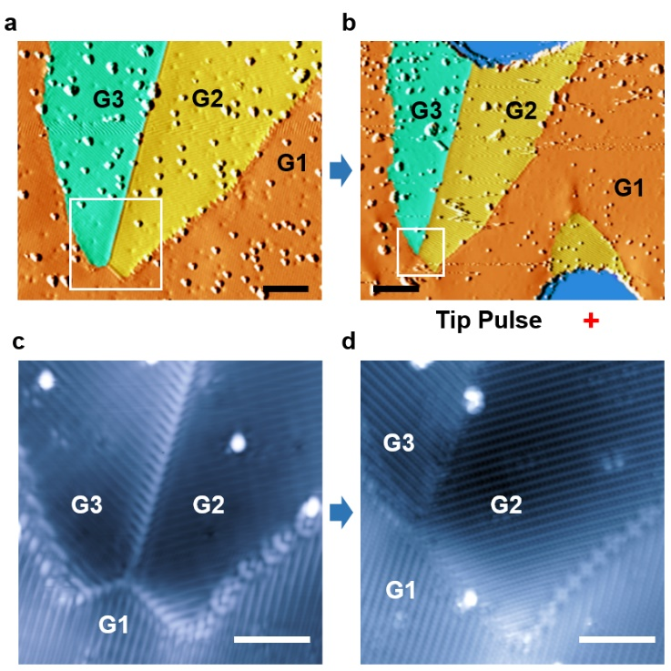
Fig. S8. Ferroelastic switching. a, Derivative STM image of the 1T’–MoTe₂ obtained after the GB formation process. The scale bar is 10 nm. b, Derivative STM image taken after an additional GB formation process is performed at the red cross. Strained areas, mainly near boundaries and apexes where all domains meet together, are more easily switched, even by weak stimulation. G2 and G3 return to G1. The scale bar is 20 nm. c, d, Close-up views of STM images in a, b, respectively. Scale bars in c, d is 5 nm. (c, V_{s} = 0.2 V, I = 0.1 nA, d, V_{s} = 0.1 V, I = 0.1 nA.)

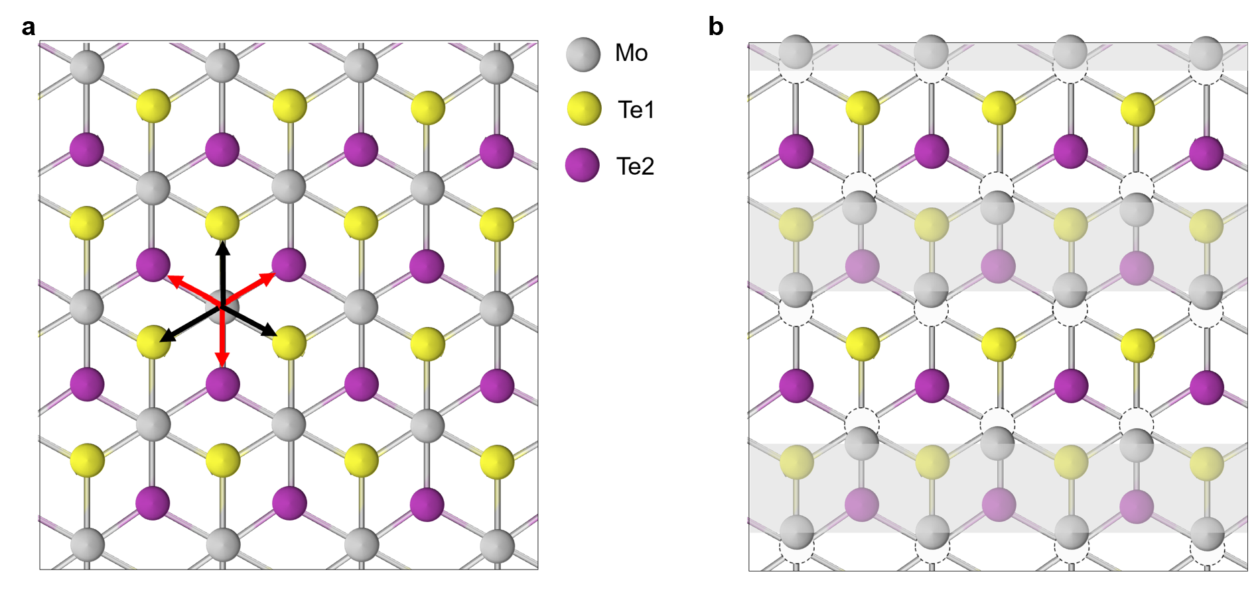
Fig. S9. Illustration of the atomic structure 1T’-MoTe₂. a, Possible direction of Mo dimerization in 1T-MoTe₂. Six distinct orientations exist where the three of them (red and black arrows) form C₃-rotational symmetric partners. b, Illustration of the Mo chain dimerization through the lattice distortion.

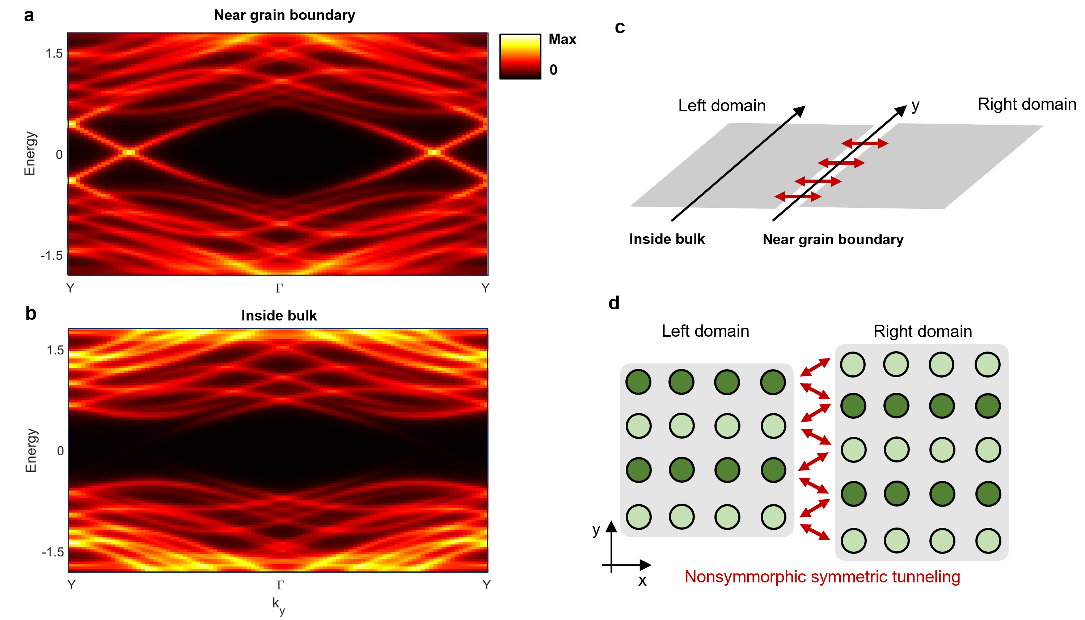
Fig. S10. Local density of states in non-symmorphic GB. a, Local density of states (LDOS) calculated near the non-symmorphic grain boundary. The gapless metallic states originated from the non-trivial Z2 index of the quantum spin Hall insulator phase of MoTe₂. In general, the double helical edge mode originated from the left, and the right side of the domain can be trivially gapped out. Non-symmorphic symmetry further protects the gapless crossings characterized by the bow-tie types band structure. b, LDOS calculated deep inside the bulk of the domain. The gapless spectrum vanished since the non-symmorphic band crossing occurs in localized edge states. c, Schematic figure of the grain boundary geometry used in the numerical calculation. d, Schematic illustration of the grain boundary and non-symmmorphic symmetric tunneling.
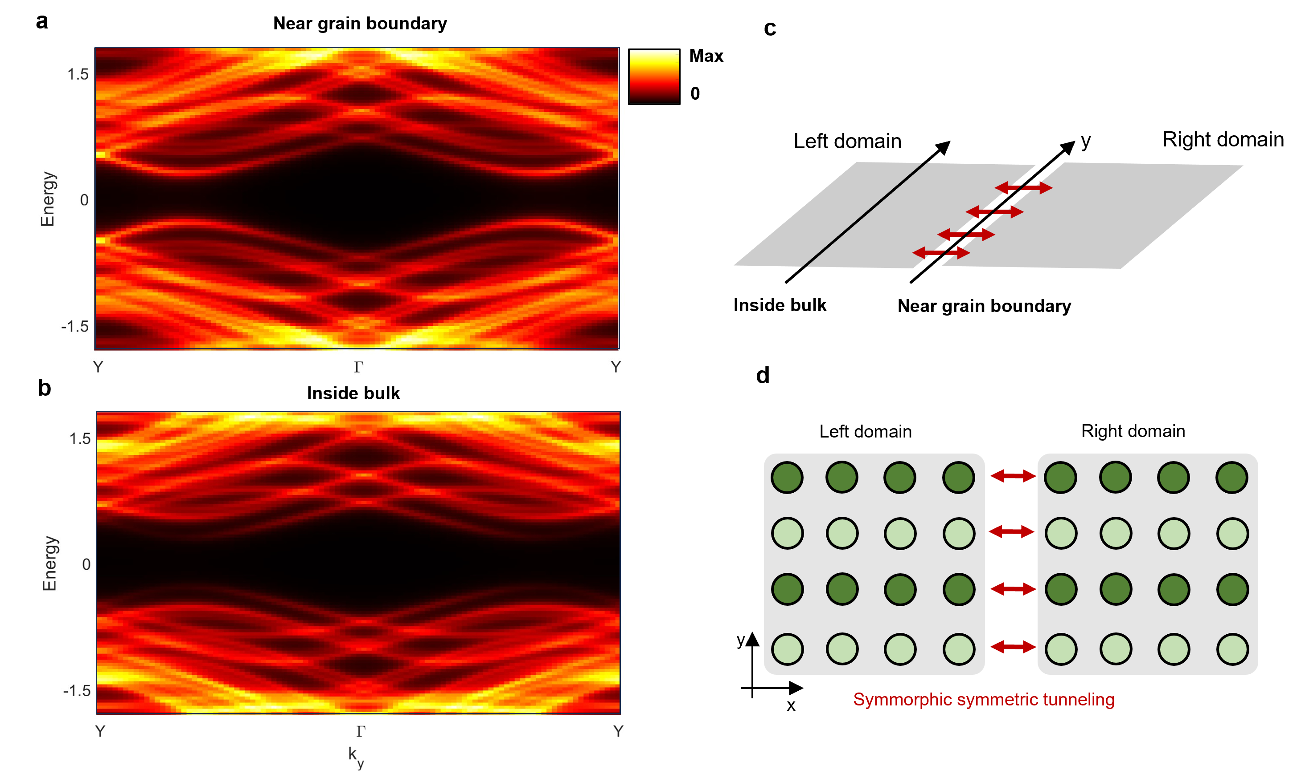
Fig. S11. Local density of states in symmorphic GB a-b, Local density of states (LDOS) calculated near the symmorphic grain boundary and deep inside the bulk. The reminiscent of the gapless metallic states are observed away from the zero energy. Unlike the non-symmorhpic grain boundary, the topological protection of the gapless state is removed. c, Schematic figure of the grain boundary geometry used in the numerical calculation. d, Schematic illustration of the grain boundary and non-symmmorphic symmetric tunneling.

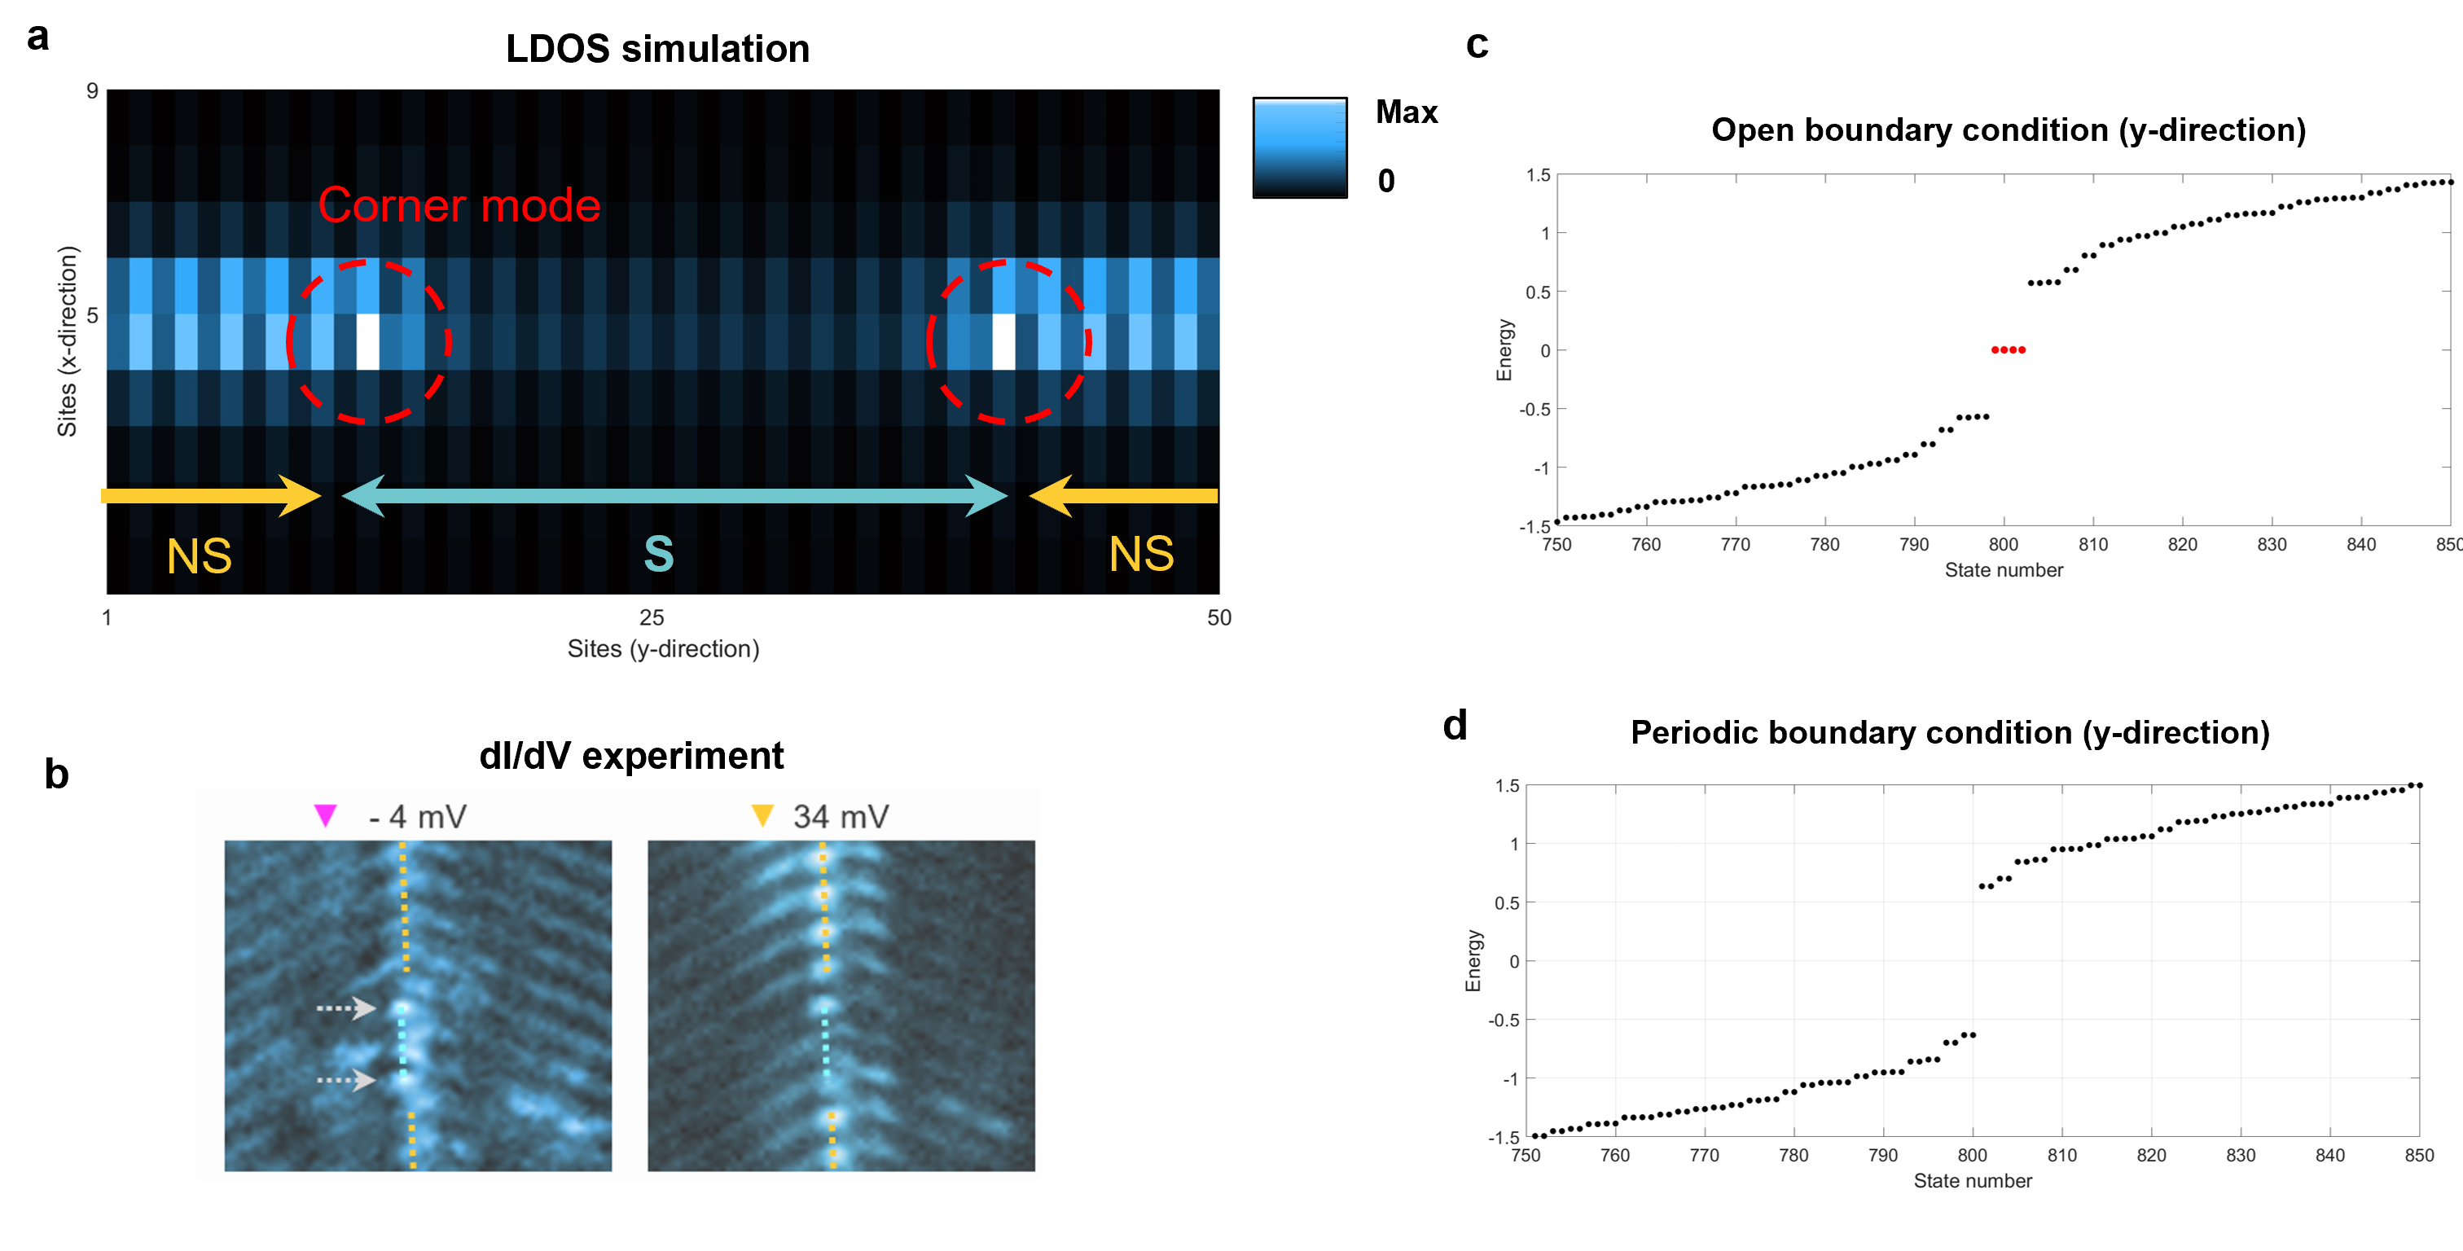
Fig. S12 Topological corner mode in GBs. A, Numerically calculated NS-S-NS junction of the grain boundaries. Due to the non-trivial band gap of the SymC2-type boundary, we find the emergence of the higher-order topological boundary states at the end of the SymC2-type grain boundaries. b, Corresponding dI/dV data from the STM measurement (same as Fig. 3b in the main text) c-d, Energy spectral of the SymC2-type GB in the open and periodic boundary conditions, respectively. In the open boundary condition, the one-dimensional boundary harbors the additional zero-dimensional higher-order topological states (red dots). A total of four states appear, and two of them are localized at each end of the chain.

References

1. Kresse, G. & Furthmüller, J. Efficiency of Ab-initio Total Energy Calculations for Metals and Semiconductors Using a Plane-wave Basis Set. Comp. Mater. Sci. 6, 15-50 (1996).
2. Kresse, G. & Furthmüller, J. Efficient iterative schemes for ab initio total-energy calculations using a plane-wave basis set. Phys. Rev. B 54, 11169-11186 (1996).
3. Perdew, J. P., Burke, K. & Ernzerhof, M. Generalized gradient approximation made simple. Phys. Rev. Lett. 77, 3865-3868 (1996).
4. Perdew, J. P., Burke, K. & Ernzerhof, M. Generalized Gradient Approximation Made Simple [Phys. Rev. Lett. 77, 3865 (1996)]. Phys. Rev. Lett. 78, 1396-1396 (1997).
5. Kresse, G. & Joubert, D. From ultrasoft pseudopotentials to the projector augmented-wave method. Phys. Rev. B 59, 1758-1775 (1999).

