Table 1: General characteristics of the antibiotic metronidazole

molecular structure | 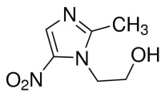
Chemical structure | C₆H₉N₃O₃
Molecular weight | 171.2 g/mol
Solubility in water | 9.5 g/L
pk_{a} | 2.55
melting point | 159-163 c̊

