Supplementary
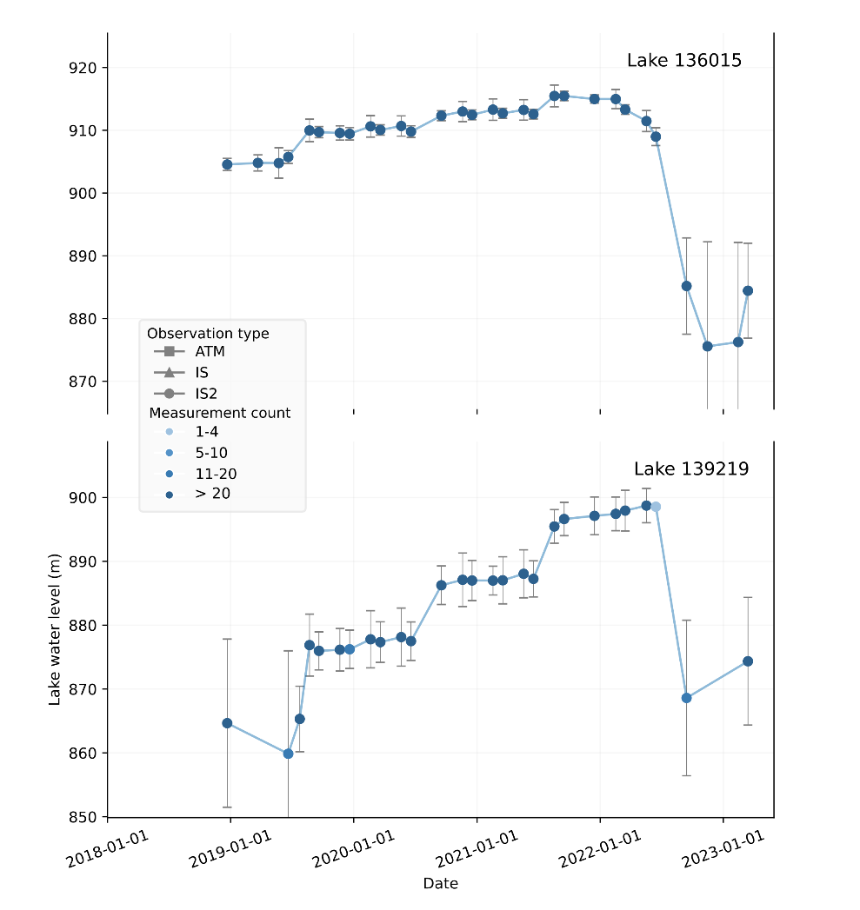
Fig. S1. Histogram showing the number of lakes and the number of observations within six groups defined by the maximum water level difference (dWL).
Fig. S2. Water level changes of two lakes dammed by A.B. Drachmann Glacier with simultaneous GLOFs
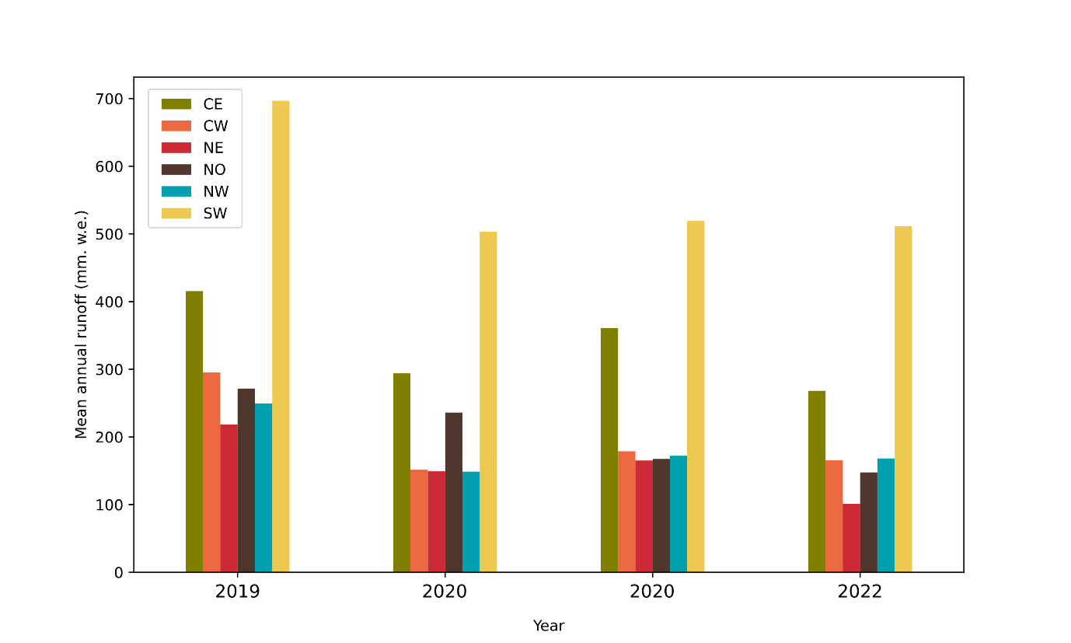
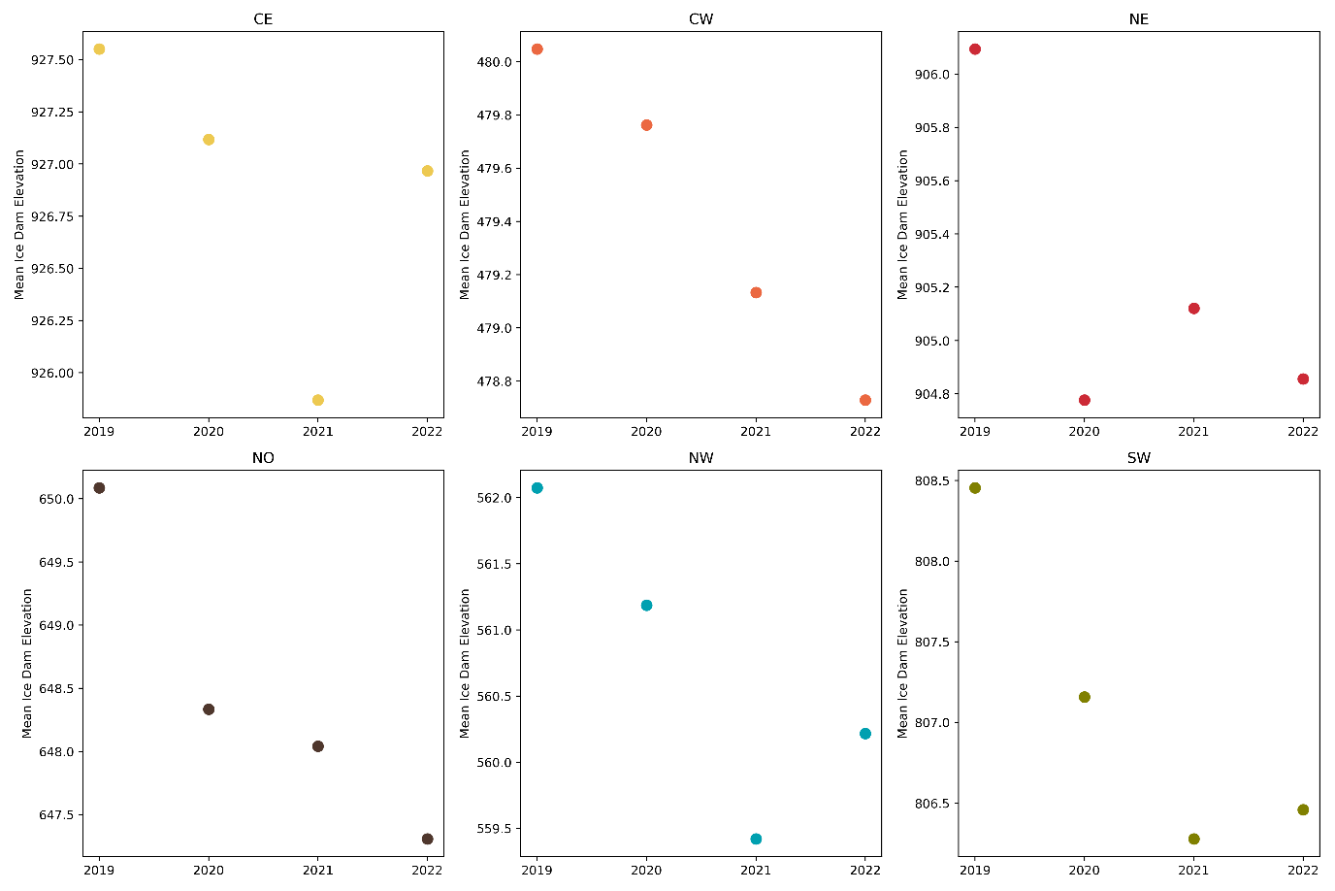
Fig. S3. Annual changes in mean ice dam elevation for all regions except SE.
Fig. S4. Mean annual runoff from 2019 to 2022 shown for all regions except SE.

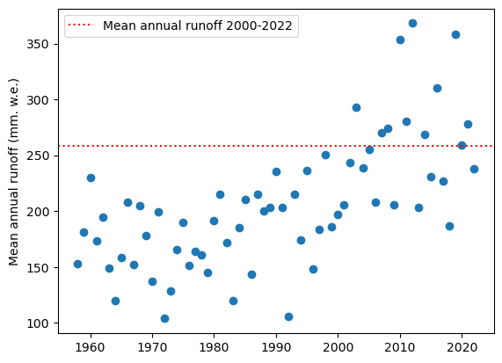
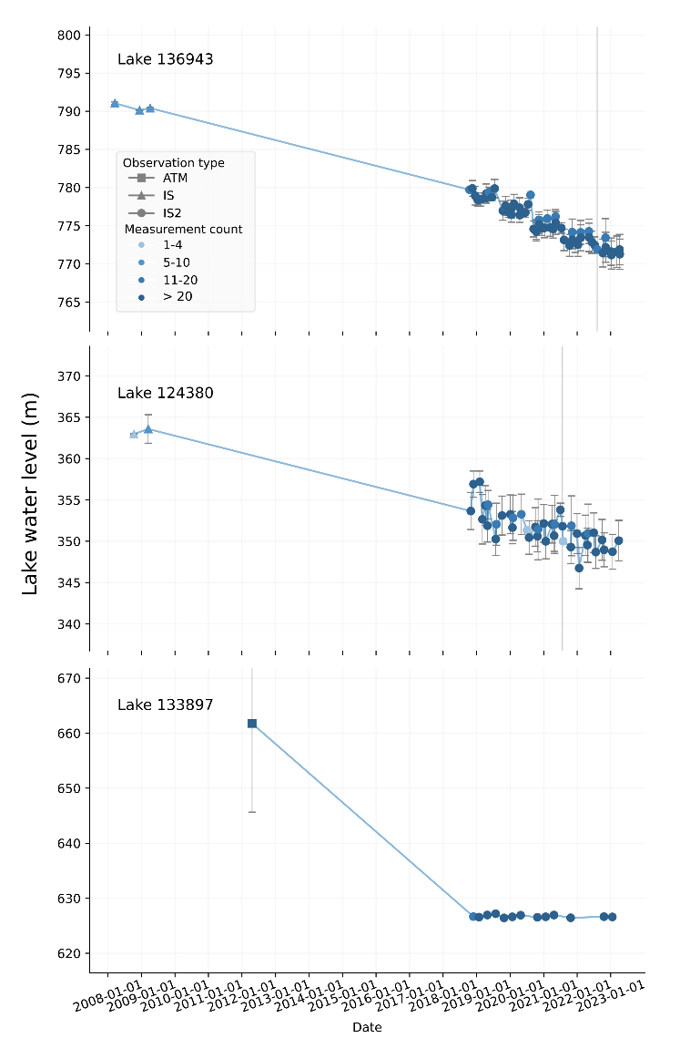
Fig. S5. Time series of the mean annual runoff for Greenland from 1958 to 2022 including the 2000-2022 mean annual runoff.
Fig. S6. Three examples of lakes with falling water level
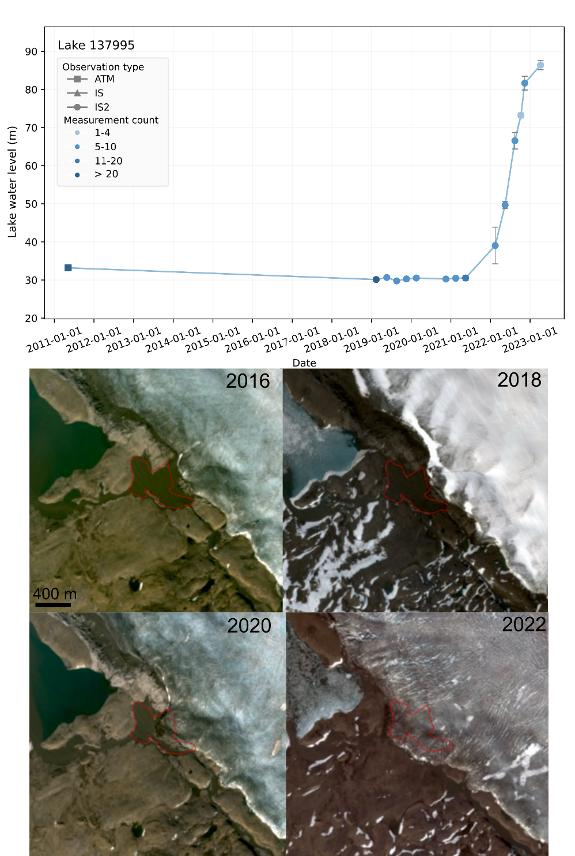
Fig. S7 Water level time series and optical Sentinel-2 images of lake 137995. The time series show a sudden and rapid increase in water level, due to a fast advance of the damming glacier. The damming glacier is now covering the entire lake area.

