Supplementary Material
Meeting global climate objectives requires scaling up gross carbon removal
Gaurav Ganti^{1,2,3,*}, Thomas Gasser³, Mai Bui^{4,5}, Oliver Geden⁶, William F. Lamb^{7,8}, Jan C. Minx^{7,8}, Carl-Friedrich Schleussner^{1,2,3}, Matthew J. Gidden^{1,3,*}
¹ Climate Analytics, Berlin, Germany
² Geography Department and IRI THESys, Humboldt-Universität zu Berlin, Berlin, Germany
³ International Institute for Applied Systems Analysis, Laxenburg, Austria
⁴ Centre for Environmental Policy, Imperial College London, UK
⁵ Centre for Process Systems Engineering, Imperial College London, UK
⁶ German Institute for International and Security Affairs, Berlin, Germany
⁷ Mercator Research Institute on Global Commons and Climate Change, Berlin, Germany.
⁸ Priestley Centre for Climate Futures, University of Leeds, Leeds, UK.
* Corresponding authors: gaurav.ganti@climateanalytics.org, gidden@iiasa.ac.at

- Global mitigation contributions in C2 and C3 scenarios
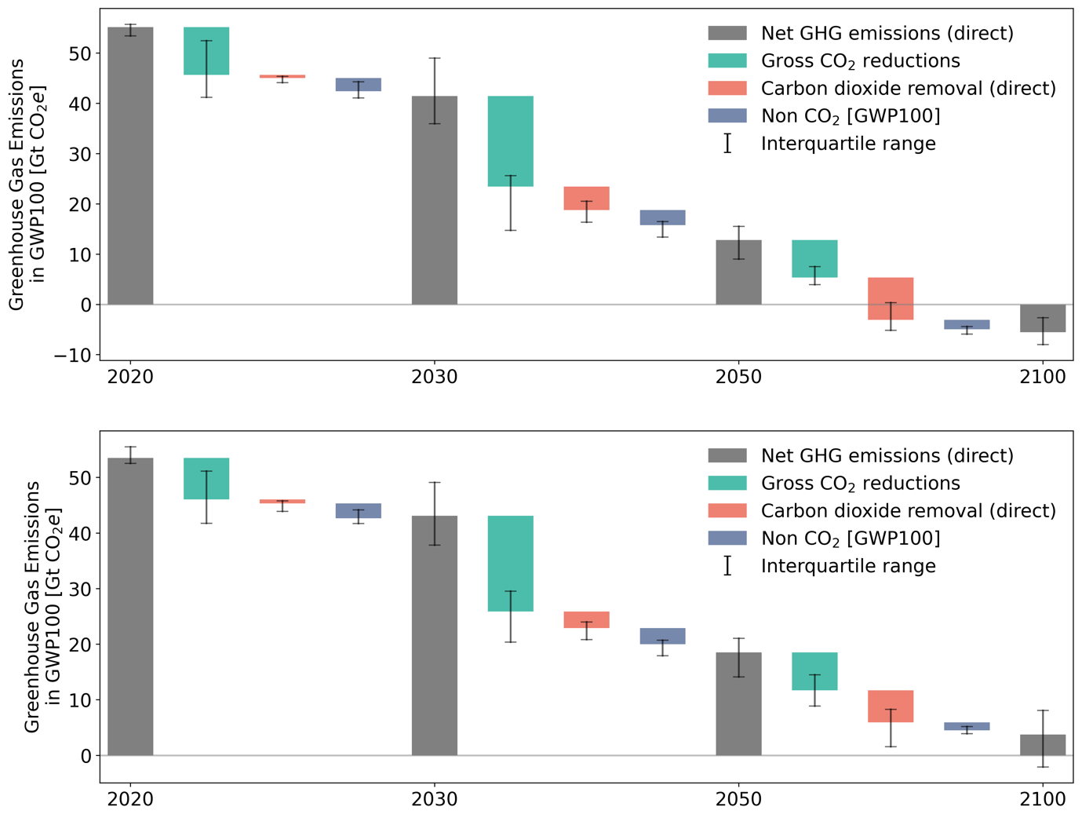
Figure S1: Global characteristics of gross emission reductions and gross CDR in deep mitigation pathways. (a) Contributions of gross CO₂ reductions, gross CDR (direct) and non-CO₂ reductions to overall kyoto greenhouse gas emission reductions in C2 pathways and (b) C3 pathways.

Table S1: Contributions of different mitigation options to net GHG reductions over different timeframes.

Category | C1 |  |  | C2 |  |  | C3
 | 25% | 50% | 75% | 25% | 50% | 75% | 25% | 50% | 75%
gross_2020_2030 | 64 | 70 | 77 | 61 | 72 | 78 | 52 | 64 | 75
nonco2_2020_2030 | 16 | 20 | 24 | 15 | 18 | 24 | 18 | 25 | 31
cdr_2020_2030 | 5 | 10 | 14 | 3 | 6 | 13 | 2 | 8 | 15
gross_2030_2050 | 63 | 68 | 74 | 65 | 71 | 75 | 64 | 73 | 79
nonco2_2030_2050 | 6 | 9 | 12 | 10 | 13 | 14 | 11 | 14 | 16
cdr_2030_2050 | 14 | 20 | 31 | 12 | 18 | 25 | 8 | 14 | 22

- Regional mitigation portfolios

Table S2: Contribution of gross reductions and removals to regional net GHG reductions.

Category | region | variable | 2020-2030 | 2030-2050 | 2050-2100
C1 | R5ASIA | AR6 Reanalysis|OSCARv3.2|Carbon Removal|Total | 7.0% (3.0-17.0) | 12.5% (4.0-20.0) | -5.5% (-30.0-18.5)
C1 | R5ASIA | AR6 Reanalysis|OSCARv3.2|Emissions|CO2|Gross | 78.0% (66.75-82.0) | 79.0% (71.0-85.25) | 80.0% (60.0-123.5)
C1 | R5ASIA | AR6 Reanalysis|OSCARv3.2|Emissions|NonCO2|Direct Only | 16.0% (14.75-19.25) | 9.0% (8.0-10.25) | 21.5% (-11.5-37.0)
C2 | R5ASIA | AR6 Reanalysis|OSCARv3.2|Carbon Removal|Total | 4.0% (2.0-11.0) | 9.0% (4.0-18.25) | 27.0% (10.75-32.0)
C2 | R5ASIA | AR6 Reanalysis|OSCARv3.2|Emissions|CO2|Gross | 81.0% (71.25-83.25) | 80.0% (73.0-81.0) | 52.0% (45.0-68.0)
C2 | R5ASIA | AR6 Reanalysis|OSCARv3.2|Emissions|NonCO2|Direct Only | 15.0% (6.25-21.0) | 12.0% (9.75-14.0) | 22.5% (17.0-26.0)
C3 | R5ASIA | AR6 Reanalysis|OSCARv3.2|Carbon Removal|Total | 4.0% (-0.0-15.0) | 7.0% (4.0-12.0) | 21.0% (11.0-42.0)
C3 | R5ASIA | AR6 Reanalysis|OSCARv3.2|Emissions|CO2|Gross | 75.0% (59.5-85.0) | 80.0% (74.0-83.0) | 64.0% (44.0-77.0)
C3 | R5ASIA | AR6 Reanalysis|OSCARv3.2|Emissions|NonCO2|Direct Only | 16.0% (3.5-29.0) | 13.0% (11.0-16.0) | 19.0% (8.0-24.0)
C1 | R5LAM | AR6 Reanalysis|OSCARv3.2|Carbon Removal|Total | 18.0% (14.0-28.5) | 32.0% (22.0-42.0) | 79.5% (48.75-136.0)
C1 | R5LAM | AR6 Reanalysis|OSCARv3.2|Emissions|CO2|Gross | 60.0% (52.75-71.0) | 57.0% (50.5-65.0) | 8.5% (-20.5-62.5)
C1 | R5LAM | AR6 Reanalysis|OSCARv3.2|Emissions|NonCO2|Direct Only | 16.5% (14.0-21.0) | 11.0% (9.0-13.0) | 13.5% (4.75-24.75)
C2 | R5LAM | AR6 Reanalysis|OSCARv3.2|Carbon Removal|Total | 14.0% (8.0-25.25) | 31.0% (21.0-48.0) | 80.0% (55.0-95.0)
C2 | R5LAM | AR6 Reanalysis|OSCARv3.2|Emissions|CO2|Gross | 73.0% (64.0-80.0) | 56.0% (38.0-65.0) | 7.0% (-7.0-26.25)
C2 | R5LAM | AR6 Reanalysis|OSCARv3.2|Emissions|NonCO2|Direct Only | 11.0% (2.0-17.5) | 12.0% (11.0-14.0) | 15.0% (9.0-18.0)
C3 | R5LAM | AR6 Reanalysis|OSCARv3.2|Carbon Removal|Total | 13.0% (8.0-25.0) | 25.0% (16.0-36.0) | 70.0% (26.5-99.5)
C3 | R5LAM | AR6 Reanalysis|OSCARv3.2|Emissions|CO2|Gross | 72.0% (59.0-81.0) | 60.0% (51.0-69.0) | 15.0% (-8.5-52.5)
C3 | R5LAM | AR6 Reanalysis|OSCARv3.2|Emissions|NonCO2|Direct Only | 13.0% (6.0-20.0) | 13.0% (11.0-17.0) | 15.0% (8.0-21.0)
C1 | R5MAF | AR6 Reanalysis|OSCARv3.2|Carbon Removal|Total | 14.0% (11.0-20.5) | 34.0% (24.75-42.0) | 8.0% (-18.25-71.0)
C1 | R5MAF | AR6 Reanalysis|OSCARv3.2|Emissions|CO2|Gross | 66.0% (51.5-74.0) | 60.0% (49.0-68.5) | 37.5% (15.25-104.0)
C1 | R5MAF | AR6 Reanalysis|OSCARv3.2|Emissions|NonCO2|Direct Only | 18.5% (15.0-24.0) | 5.0% (0.75-8.25) | 13.0% (0.75-29.25)
C2 | R5MAF | AR6 Reanalysis|OSCARv3.2|Carbon Removal|Total | 11.0% (-2.0-16.25) | 36.0% (29.0-43.0) | 55.0% (47.0-87.25)
C2 | R5MAF | AR6 Reanalysis|OSCARv3.2|Emissions|CO2|Gross | 73.0% (62.0-78.5) | 56.5% (48.5-65.25) | 38.0% (11.0-47.0)
C2 | R5MAF | AR6 Reanalysis|OSCARv3.2|Emissions|NonCO2|Direct Only | 17.5% (11.75-26.25) | 9.0% (4.0-13.0) | 9.0% (2.5-12.0)
C3 | R5MAF | AR6 Reanalysis|OSCARv3.2|Carbon Removal|Total | 8.0% (1.0-20.0) | 32.0% (14.0-43.0) | 53.0% (28.5-86.5)
C3 | R5MAF | AR6 Reanalysis|OSCARv3.2|Emissions|CO2|Gross | 73.0% (52.5-83.0) | 61.0% (46.0-77.0) | 39.0% (13.0-65.5)
C3 | R5MAF | AR6 Reanalysis|OSCARv3.2|Emissions|NonCO2|Direct Only | 21.0% (7.0-32.0) | 9.0% (1.0-14.5) | 1.0% (-10.0-10.0)
C1 | R5OECD90+EU | AR6 Reanalysis|OSCARv3.2|Carbon Removal|Total | 3.0% (2.0-6.0) | 21.5% (13.0-33.0) | 42.5% (-28.25-73.75)
C1 | R5OECD90+EU | AR6 Reanalysis|OSCARv3.2|Emissions|CO2|Gross | 76.5% (73.0-82.0) | 71.0% (62.75-77.0) | 52.0% (22.0-105.0)
C1 | R5OECD90+EU | AR6 Reanalysis|OSCARv3.2|Emissions|NonCO2|Direct Only | 17.5% (14.0-23.0) | 7.0% (5.0-14.0) | 8.0% (2.0-19.25)
C2 | R5OECD90+EU | AR6 Reanalysis|OSCARv3.2|Carbon Removal|Total | 2.0% (-0.0-4.0) | 15.0% (8.75-25.5) | 48.0% (34.0-66.0)
C2 | R5OECD90+EU | AR6 Reanalysis|OSCARv3.2|Emissions|CO2|Gross | 78.0% (75.0-84.0) | 73.0% (67.0-79.0) | 47.0% (30.75-60.0)
C2 | R5OECD90+EU | AR6 Reanalysis|OSCARv3.2|Emissions|NonCO2|Direct Only | 18.0% (15.0-21.0) | 11.0% (9.0-14.0) | 6.0% (2.0-8.0)
C3 | R5OECD90+EU | AR6 Reanalysis|OSCARv3.2|Carbon Removal|Total | 2.0% (1.0-4.0) | 11.0% (7.0-24.5) | 35.0% (24.0-66.0)
C3 | R5OECD90+EU | AR6 Reanalysis|OSCARv3.2|Emissions|CO2|Gross | 74.0% (68.0-78.0) | 74.0% (66.0-80.0) | 58.0% (29.0-69.0)
C3 | R5OECD90+EU | AR6 Reanalysis|OSCARv3.2|Emissions|NonCO2|Direct Only | 23.0% (19.0-28.5) | 10.0% (7.0-15.0) | 5.0% (2.0-8.0)
C1 | R5REF | AR6 Reanalysis|OSCARv3.2|Carbon Removal|Total | 3.0% (0.0-4.0) | 16.0% (10.0-27.5) | 32.0% (-13.75-70.5)
C1 | R5REF | AR6 Reanalysis|OSCARv3.2|Emissions|CO2|Gross | 70.0% (65.75-78.0) | 68.5% (60.0-71.0) | 40.5% (25.0-99.25)
C1 | R5REF | AR6 Reanalysis|OSCARv3.2|Emissions|NonCO2|Direct Only | 28.0% (17.75-33.25) | 14.0% (11.0-18.0) | 10.5% (2.0-29.75)
C2 | R5REF | AR6 Reanalysis|OSCARv3.2|Carbon Removal|Total | 4.5% (1.0-8.0) | 10.5% (7.0-14.25) | 31.0% (21.0-67.0)
C2 | R5REF | AR6 Reanalysis|OSCARv3.2|Emissions|CO2|Gross | 71.0% (56.0-79.25) | 71.0% (65.0-75.0) | 54.5% (26.0-62.0)
C2 | R5REF | AR6 Reanalysis|OSCARv3.2|Emissions|NonCO2|Direct Only | 20.0% (16.75-38.25) | 18.0% (14.75-22.0) | 14.5% (2.0-19.0)
C3 | R5REF | AR6 Reanalysis|OSCARv3.2|Carbon Removal|Total | 4.0% (-2.0-8.0) | 8.0% (5.0-14.5) | 39.0% (19.0-71.0)
C3 | R5REF | AR6 Reanalysis|OSCARv3.2|Emissions|CO2|Gross | 66.0% (55.0-76.0) | 70.0% (64.0-76.0) | 47.0% (23.0-64.0)
C3 | R5REF | AR6 Reanalysis|OSCARv3.2|Emissions|NonCO2|Direct Only | 27.0% (18.0-40.0) | 18.0% (15.0-25.0) | 14.0% (6.5-19.0)

