Supplementary materials
Monitoring corn stover processing by the fungus Ustilago maydis

Stefan Robertz^{a, d}, Magnus Philipp^{b, d, 1}, Kerstin Schipper^{b, d}, Paul Richter^{c, d}, Katharina Miebach^{c, d}, Jorgen Magnus^{c, d}, Markus Pauly^{a, d} and Vicente Ramírez^{a, d,}
ª Institute for Plant Cell Biology and Biotechnology, Cluster of Excellence on Plant Sciences, Heinrich Heine University Düsseldorf, 40225 Düsseldorf, Germany
^{b} Institute for Microbiology, Heinrich Heine University Düsseldorf, 40225 Düsseldorf, Germany
^{c} Aachener Verfahrenstechnik – Chair of Biochemical Engineering, RWTH Aachen University, 52074 Aachen, Germany
^{d} Bioeconomy Science Center (BioSC), Forschungszentrum Jülich, 53435 Jülich, Germany

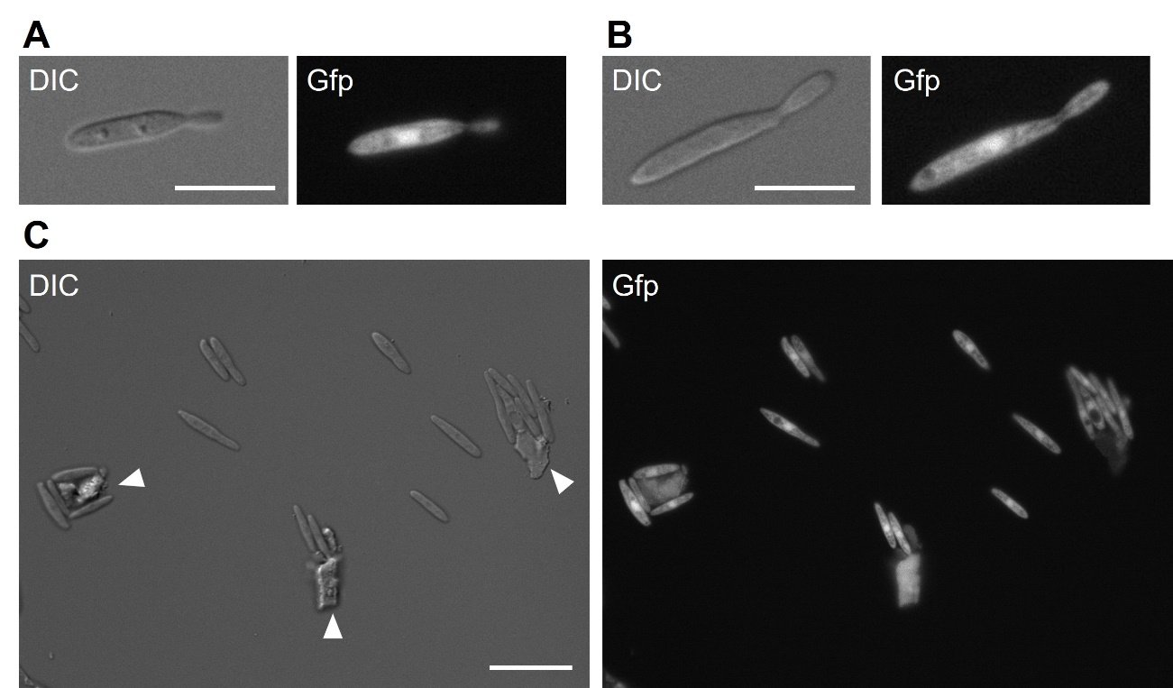
Figure S1: Growth of U. maydis ^{Gfp}P_{oma}bgl1 on corn stover.
The used strain produced cytoplasmic Gfp accumulating in the cytosol and nucleus. (A) Cultivation of U. maydis with glucose as single carbon source visualized 16 h post inoculation (dividing cell). Scale bar, 10 µm. (B) Cultivation of U. maydis with corn stover as single carbon source visualized 16 h post inoculation (dividing cell). Scale bar, 10 µm. (C) Cultivation of U. maydis with corn stover as single carbon source visualized 16 h post inoculation (culture overview). White arrowheads indicate autofluorescent biomass particles. Scale bar, 20 µm.

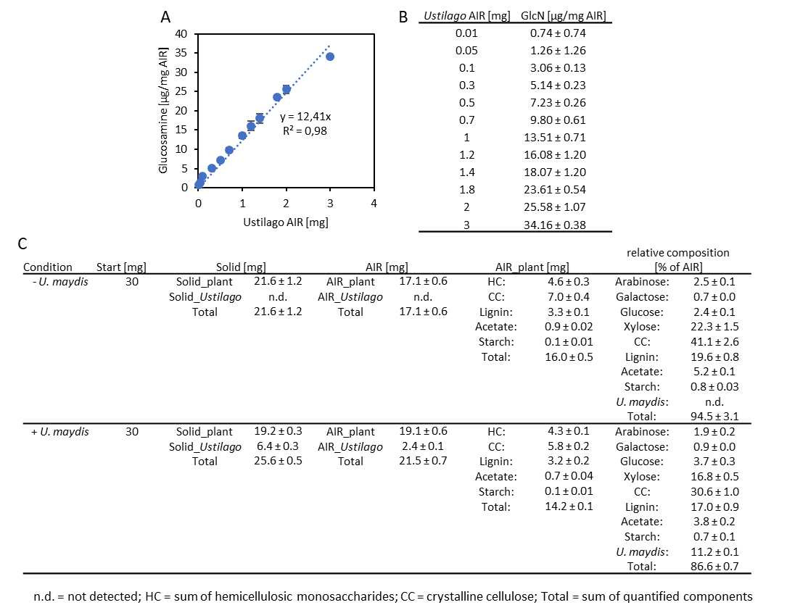
Figure S2: Glucosamine content in Ustilago maydis AIR and detailed mass balance of corn stover -/+ Ustilago maydis.
(A) Linear regression of glucosamine concentration detected per mg Ustilago maydis AIR. (B) Correlation of Ustilago maydis AIR to glucosamine concentration. Values are shown as mean ± SD of 3 U. maydis replicates. (C) Mass balance in glass flasks. Data are shown as mean ± SD of 3 technical plant replicates.

Table S1: Soluble carbohydrates of B73 and bm3 material before (raw) and after autoclaving in µg/mg material.
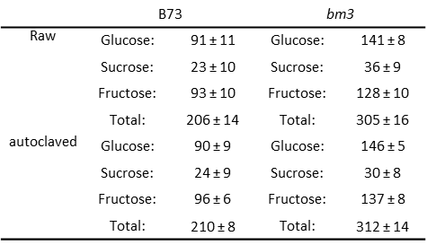
Values are mean ± SD of 4 biological replicates for B73 and 6 biological replicates for bm3. No statistically significant differences between the raw and autoclaved material detected by a two-tailed students t-Test at p-value < 0.05.

Corresponding author; Institute for Plant Cell Biology and Biotechnology, Heinrich Heine University, 40225 Düsseldorf, Germany; Email: ramirezg@hhu.de ¹ Present address: Institute for Biotechnology and Foodscience, Norwegian University of Science and Technology, Gløshaugen, 7034 Trondheim, Norway

