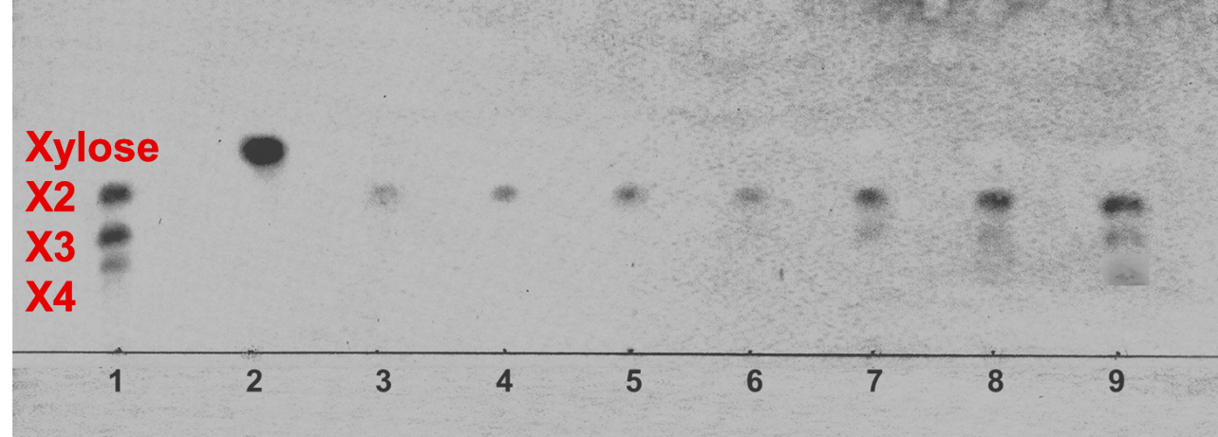
Figure S1: TLC analysis on effect of different pretreatment of CCB (Lanes 1-Commercial xylan; 2- Standard Xylose; 3- untreated CCB; 4-US+ZnO; 5- PC; 6- US 20 for 30 min ; 7- US 20 for 60 min; 8- SP 20 for 30 min; 9- SP 20 for 60 min)

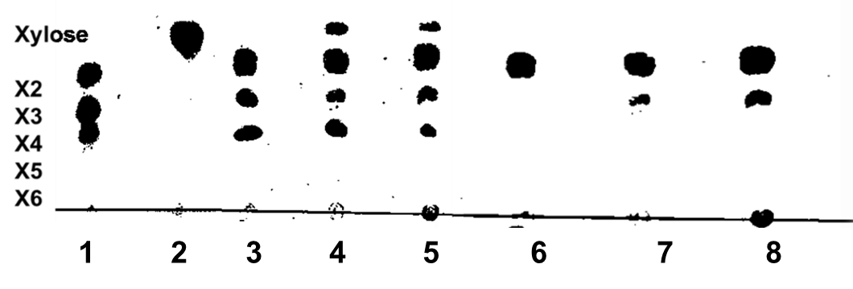

Figure S2: TLC analysis of varying sonication amplitude on CCB xylan extraction
Lane1: commercial xylan; Lane2: Standard Xylose; Lane (3-5): SP 50, 70 and 90 respectively; Lane (6-8): US 50, 70 and 90 respectively.

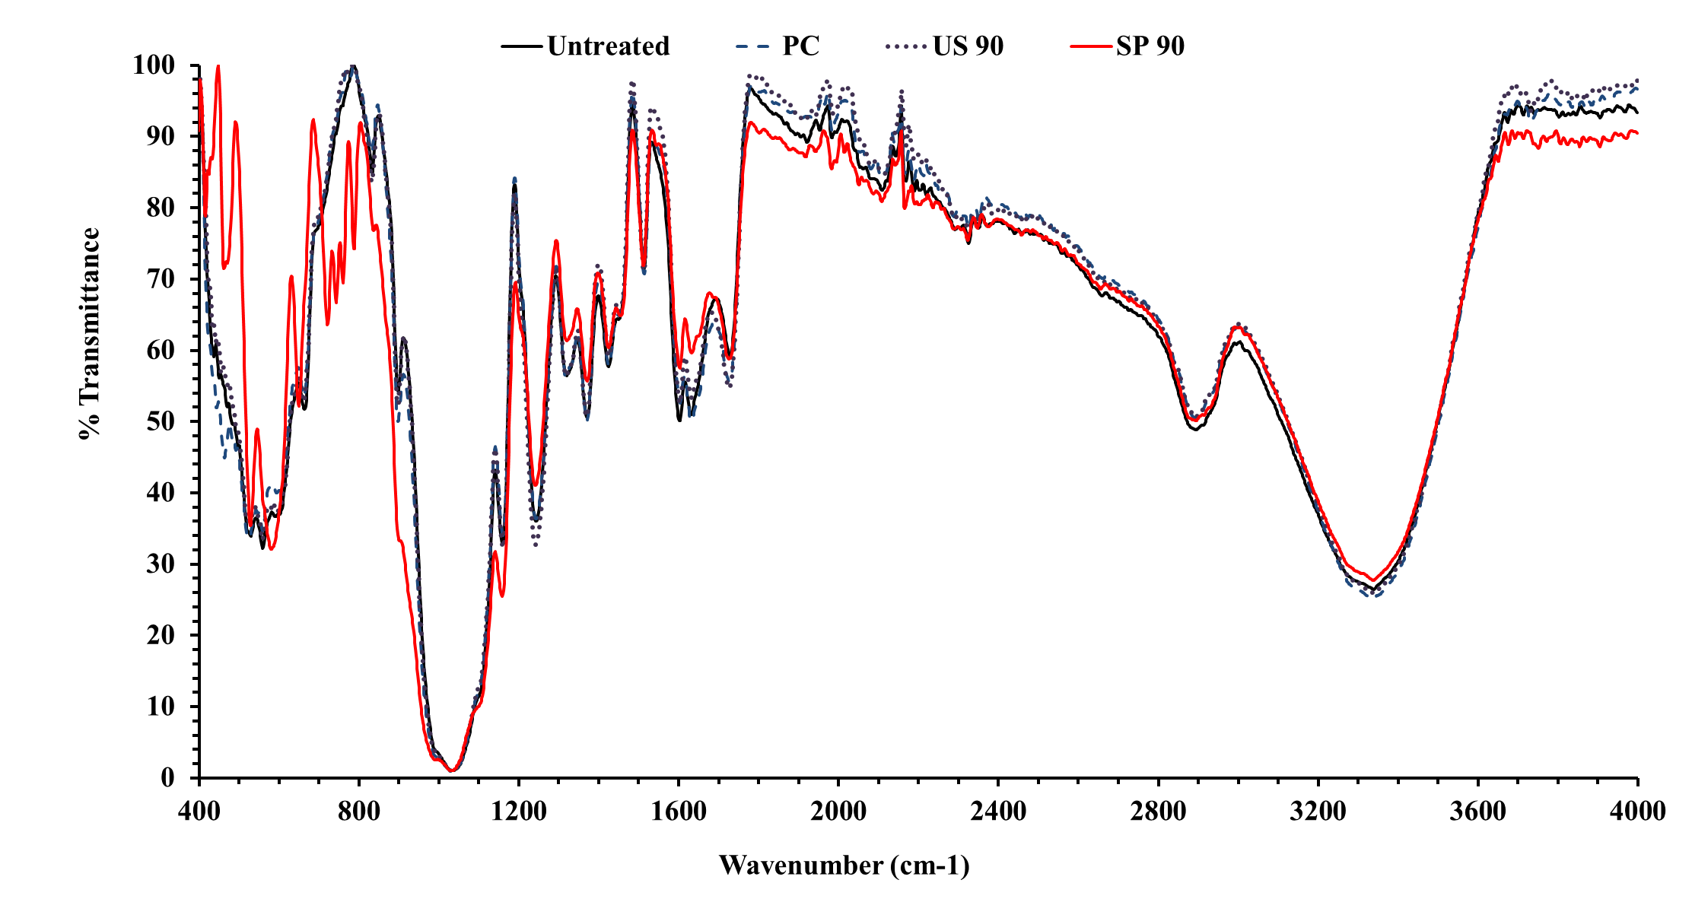
Figure S3 : FTIR spectra of untreated and preated CCB with wavelength range of 400-4000cm⁻¹
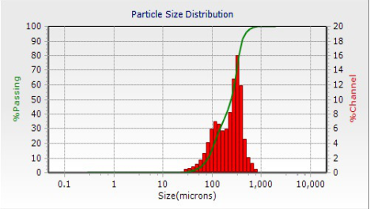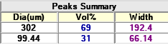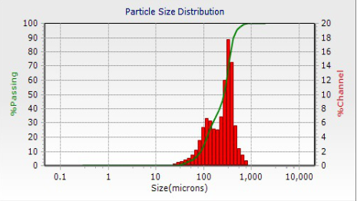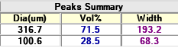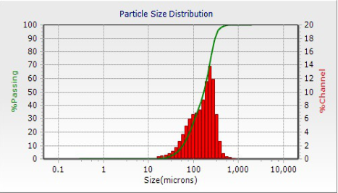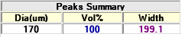
(b)
(a)
(c)

Figure S4: Particle size distribution of CCB (a) untreated, (b) PC (c) US and SP 90 pretreated

Table S1: Particle size of CCB before and after pretreatment
Treatment | Size of CCB particle (μm)
Untreated | 417±1.5
PC | 401±1.4
US 90 & SP 90 | 170±1.2

