List of Supplementary Figures

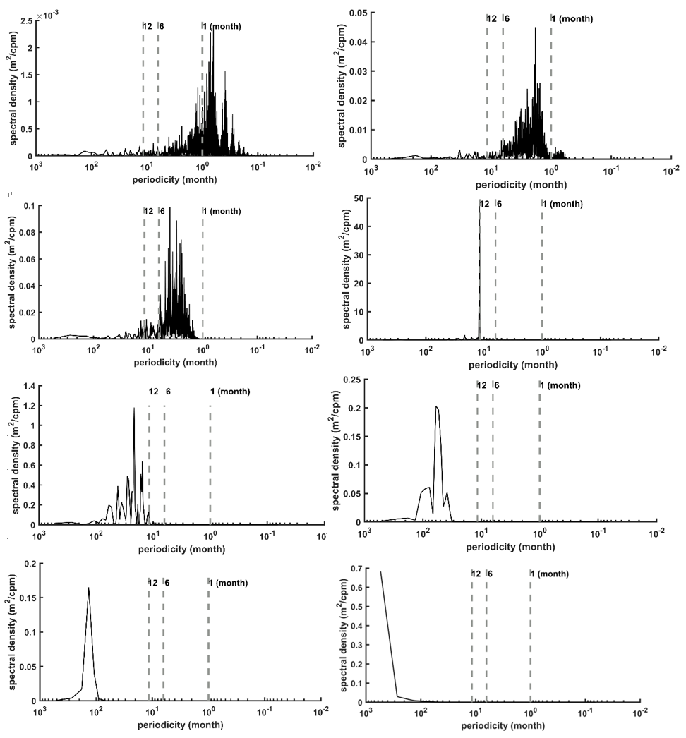
Figure S1. Power Spectral Density of Each Intrinsic Mode Function from the daily EA domain-averaged Hs (1980-2021) which decomposed by Empirical Mode Decomposition capturing the various temporal scale.

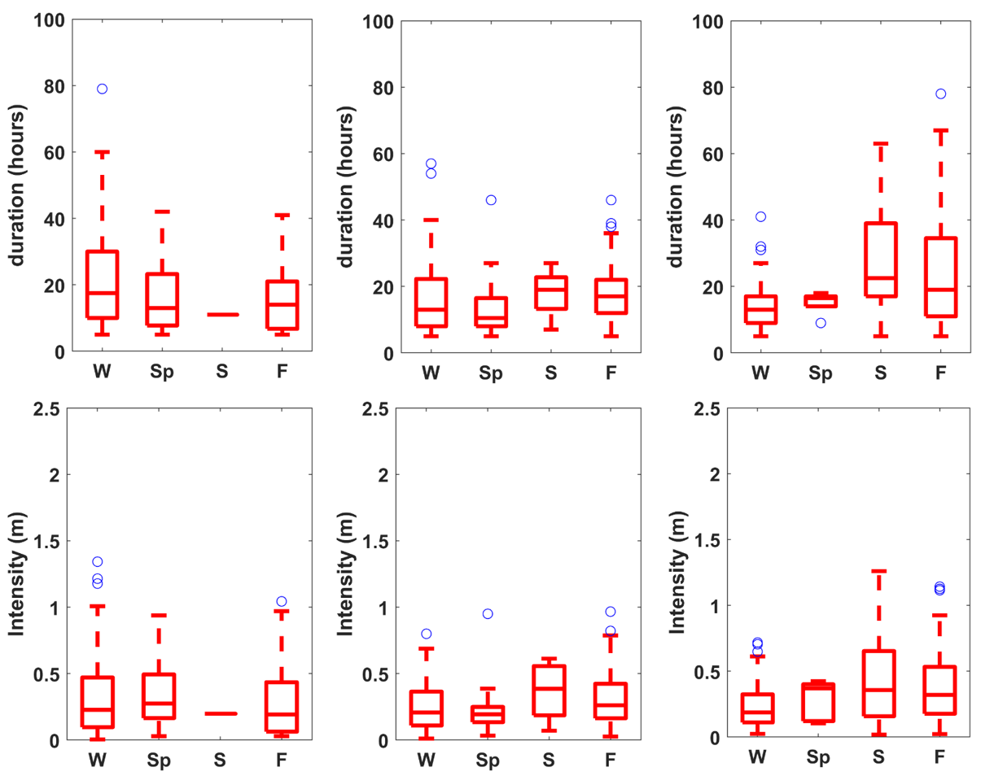
Figure S2. Boxplot of seasonal distribution of extreme wave duration (upper panel) and intensity (lower panel) in the surrounding waters of Korean Peninsula. The East Sea (left panel), the Yellow Sea (mid panel) and The East China Sea (right panel).

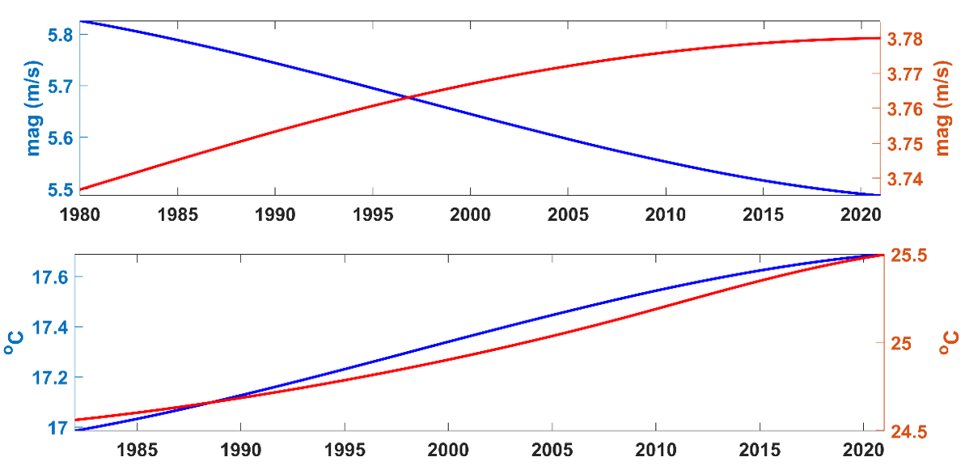
Figure S3. Seasonal long-term trend of EA domain-averaged wind speed (upper panel) and SST (lower panel). Blue and red line indicate winter and summer season respectively.

