Supplementary/ Additional Files

Additional File 1: Sample Size Stratified by Age and Sex
 | Group 1 |  | Group 2
Age band (mos.) | Female | Male | Female | Male | Total
0-2 | 1 | 1 | 1 | 1 | 4
3-5 | 1 | 1 | 1 | 1 | 4
6-8 | 1 | 1 | 1 | 1 | 4
9-11 | 1 | 1 | 1 | 1 | 4
12-17 | 1 | 1 | 1 | 1 | 4
18-23 | 1 | 1 | 1 | 1 | 4
24-29 | 1 | 1 | 1 | 1 | 4
30-41 | 1 | 1 | 1 | 1 | 4
Total | 8 | 8 | 8 | 8 | 32

Additional File 2: GSED LF Kit materials
GSED Long Form List of Kit Material
S.No | Material Name | Material Picture | Item Number
1 | Spoon | 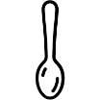 | A9, A7,A8,A12,A16,B25,C4,C6,C10,C21,C32,C41
2 | Rattle | 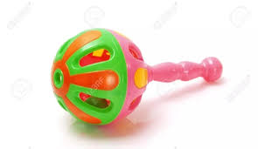 | A9,A7,A16,A17, A20, C2,C5,C6,
3 | Small safe food items (cheerios, rice puff, raisin rice |  | A13, A19, A27
4 | Block |  | A16, B25, C8, C10, C11, C41, C50
5 | Plastic Bottle | 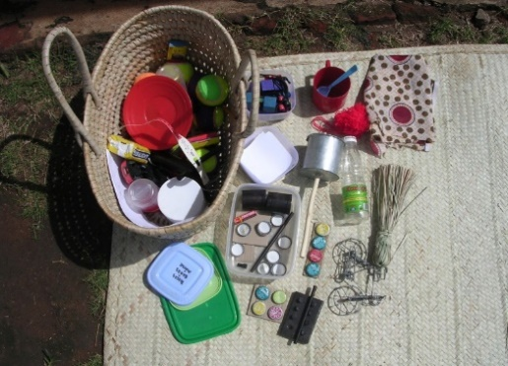 | A16, B18, B19, B 30, B33, B36, C21, C32, C38,
6 | Ball | 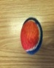 | A20, A21, A24, A30. A33, A34, A35, A36, A37, A38, A49, B12, B14, B18, B19, B30, B33, B36, C3, C9, C29
7 | Cup | 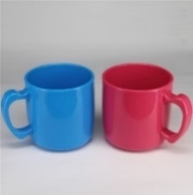 | A20, A24, B12, B16, C4, C8, C12, C16, C21, C22, C29, C32, C50
8 | Blocks | 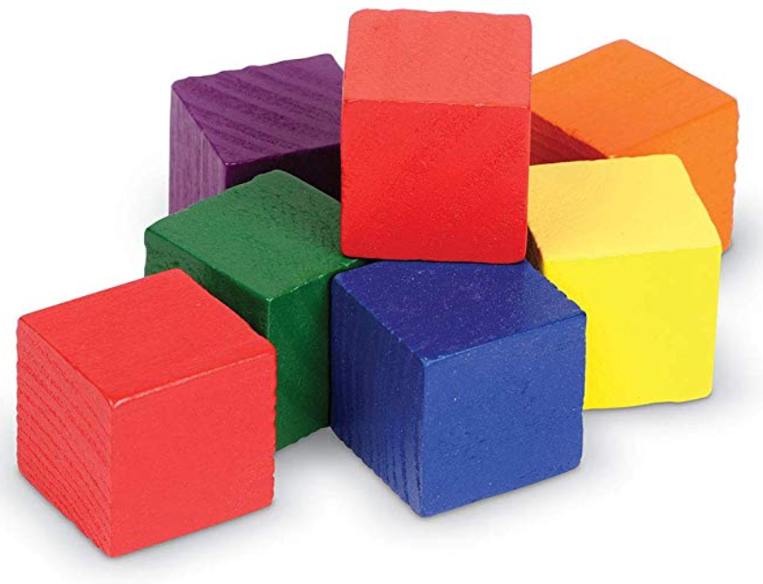 | A23, A26, C12, C13, C16, C17, C20, C25, C26, C28, C34, C35, C37, C39, C44, C45, C48 and C52
9 | Interesting object Car | 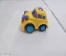 | A34, B8, B18, B19, B30, B33, B36, C9, C29
10 | A4 size paper |  | A42, C15, C19, C23, C33, C43, C47, C51, C53 and C54
11 | 2 meter (7feets) shoe less | 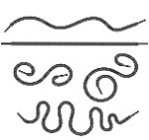 | A43, A44, C10
12 | Beans beg | 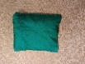 | A44
13 | Cloth | 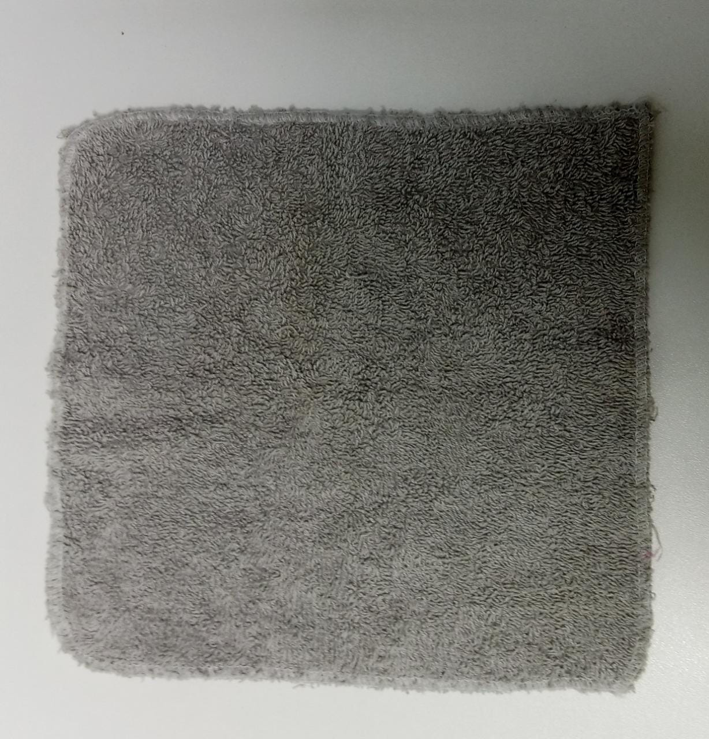 | A44, B18, B19, B30, B33,B36,C9, C21, C24, C32, C39
14 | Comb | 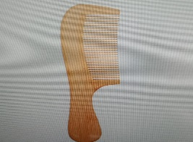 | B18, 19, 30, 33,36
15 | Crayon/Pencil | 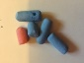 | B18, B19, B30, B33, B36, C15, C19, C23,C33, C43, C47, C51, C53, C54
16 | Shoes | 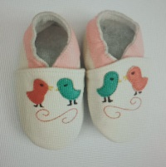 | B18, B19, B30, B33, B36
17 | Cutouts of colored Cups | 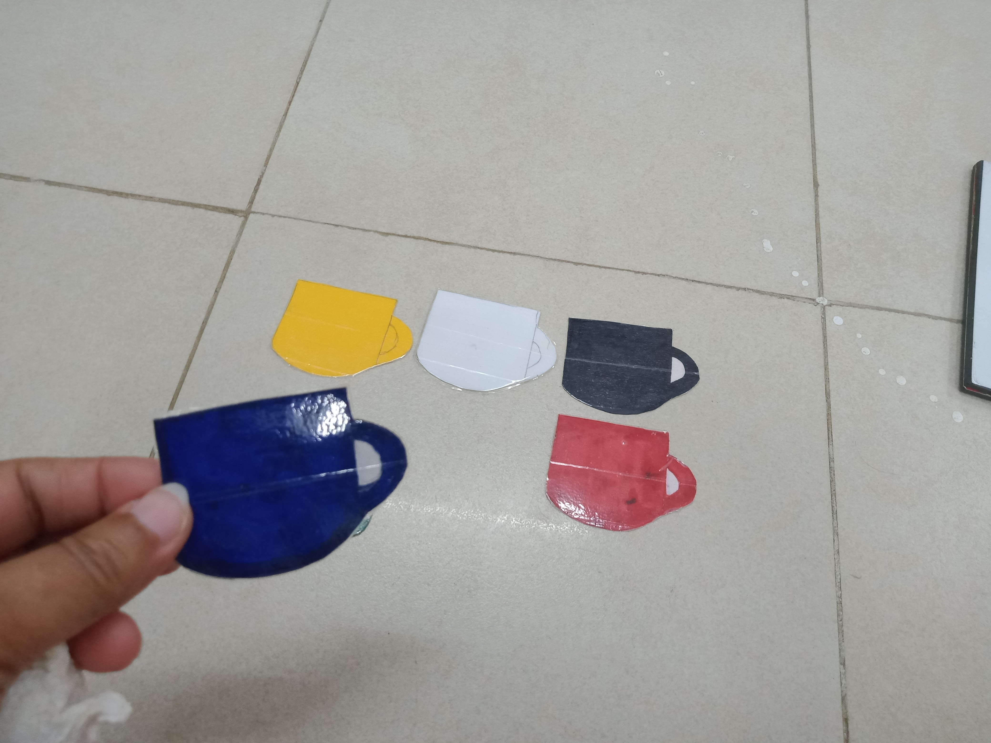 | B47
18 | Blocks and laminated Board | 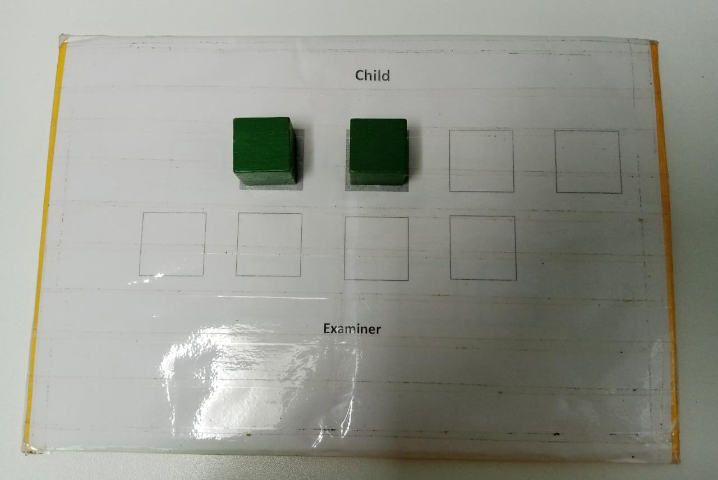 | B50, B51, B52
19 | Small Squeeze toy (handmade) | 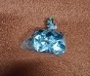 | C14
20 | Jar | 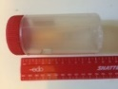 | C17, C25
21 | Pegs with pegboard, Timer | 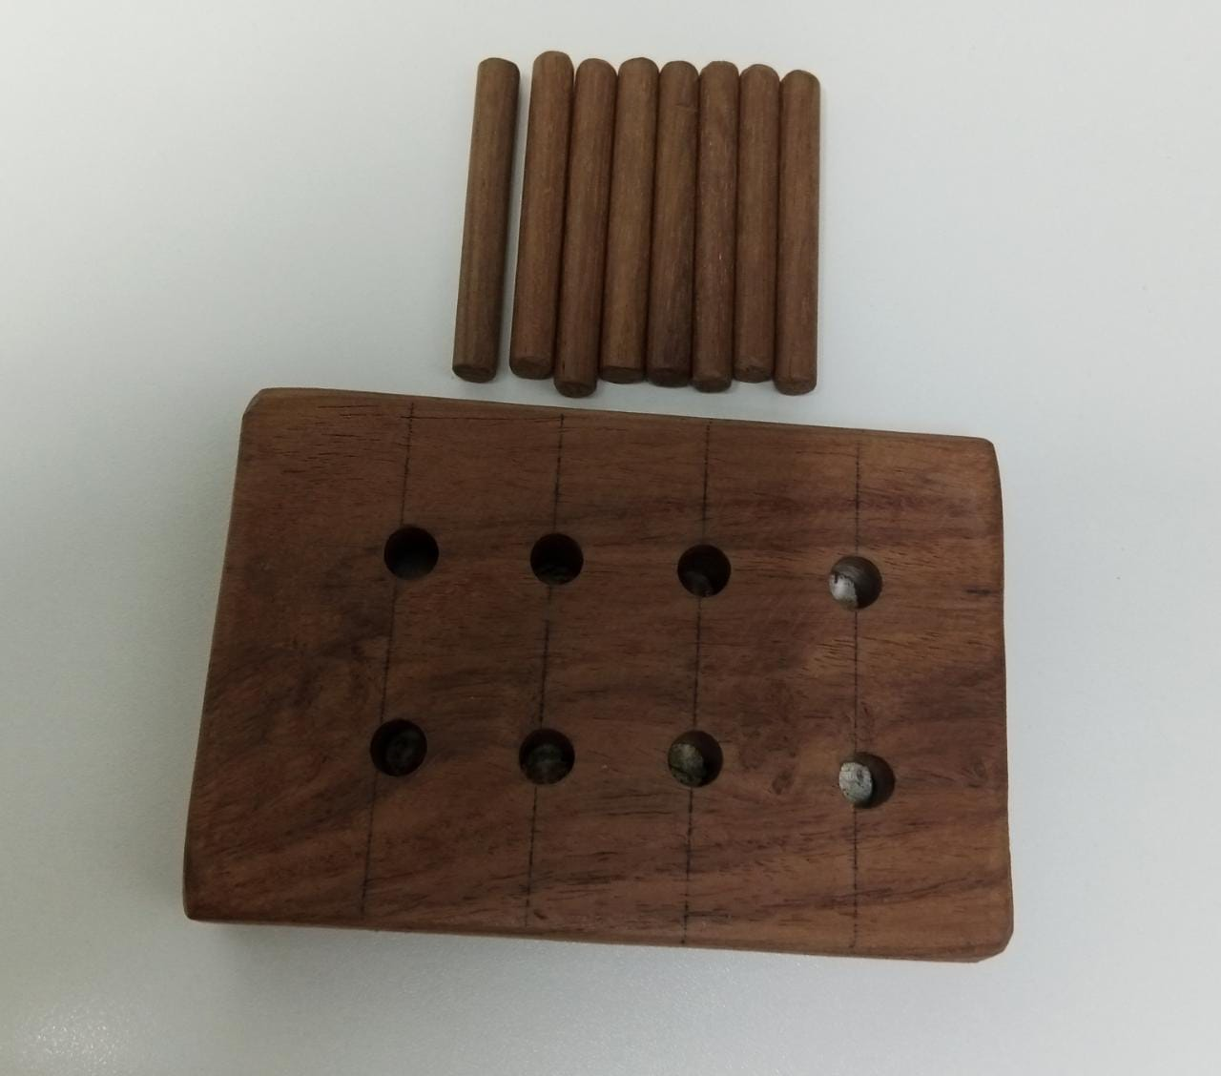 | C18, C27, C42
22 | Plate | 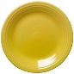 | B18, B19, B30, B33, B36, C21, C32, C39
23 | Shape Board and Shape and timer | 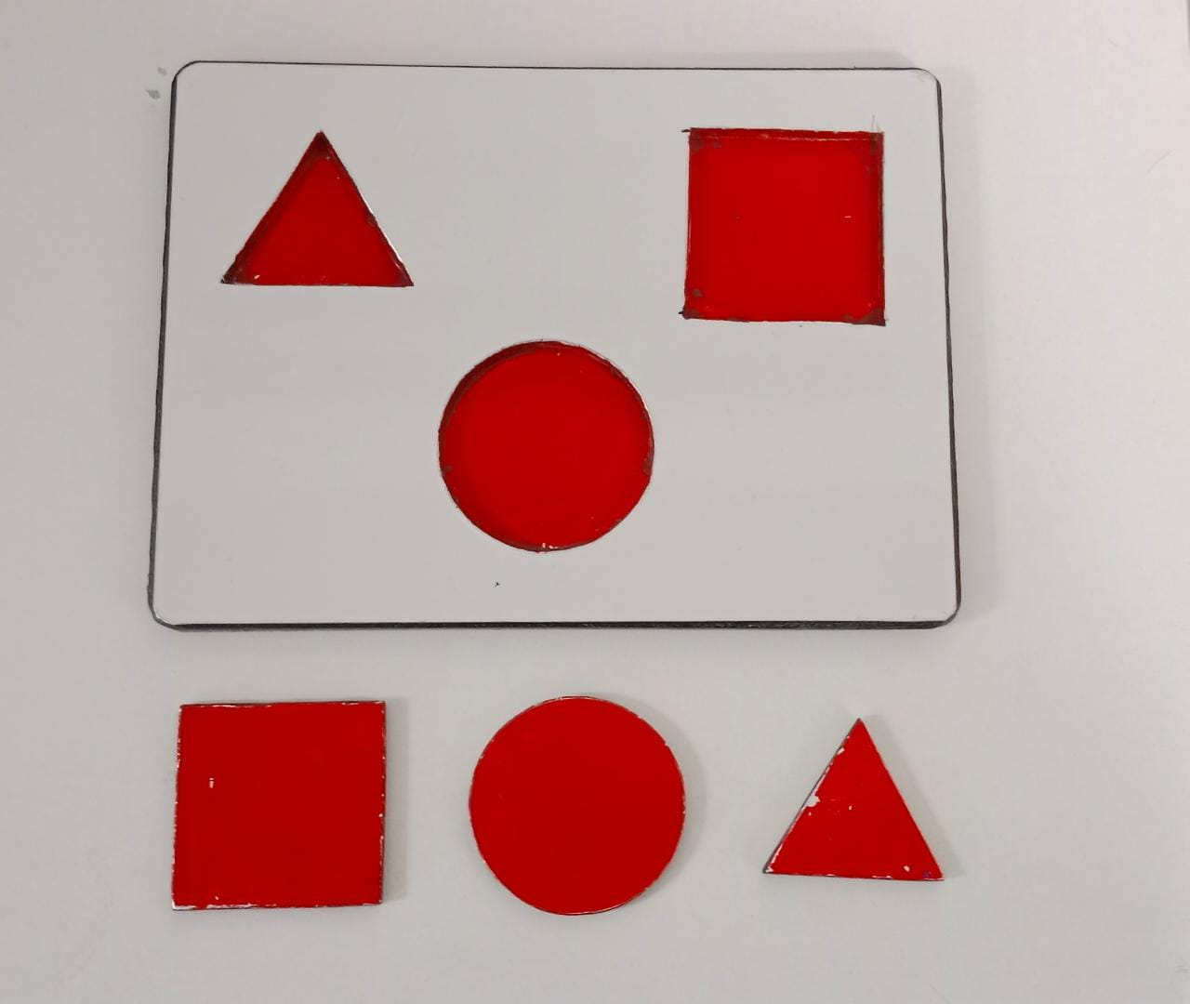 | C30, C31, C36, C40
24 | 2 Sticks of different length | 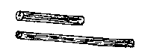 | C46, C47
25 | Cups small and Large 2 Blue & 2 Red | 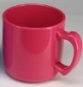  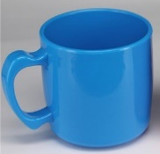 | C49

Additional File 3: Questions from Comprehensive Exit Interview
S. No | Items
1 | Did you feel uncomfortable with any of the questions?
2 | Did you feel uncomfortable with how any questions were administered?
3 | Did you feel uncomfortable about where any questions were administered?
4 | Did you ever feel like you wanted to stop answering questions?
5 | Do you feel that the order in which we administered the various questionnaires to you and your child was acceptable?
6 | Do you feel the visits were a burden or significant disruption to your day?
7 | Did you ever feel that some of the questions were inappropriate or unnecessary?
8 | Did you think the visits were too short, too long, or just about right?

For explanation of Groups, please refer to Table 2 Summary of Visit Schedules

