Additional files
- ERC form

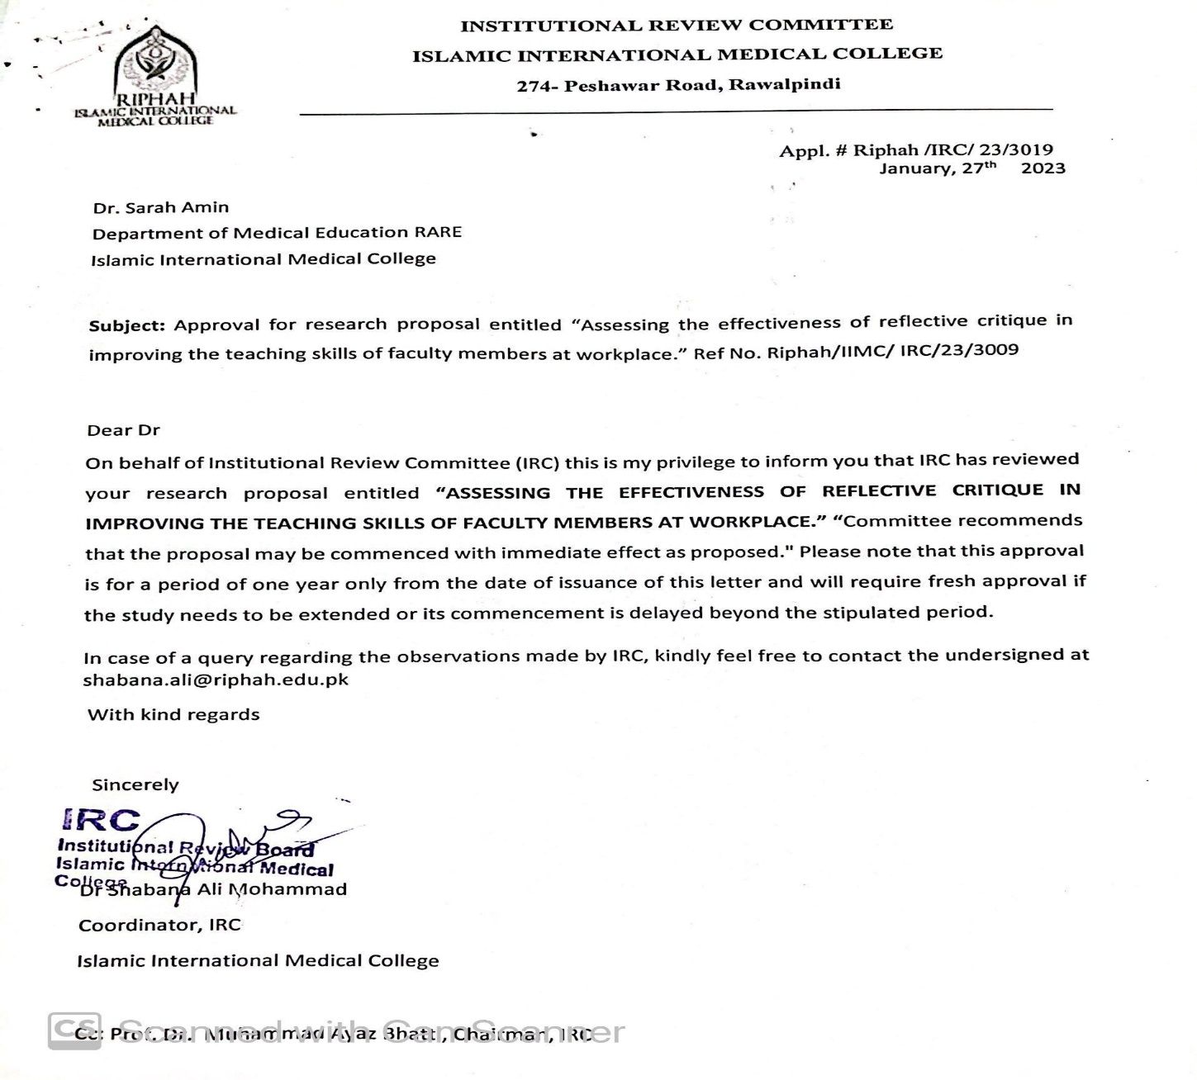

- Inclusion criteria & Exclusion Criteria
- Faculty members with a minimum qualification of CHPE.
- Faculty from both basic and clinical side were included. (Medical college, IIMC)
- Faculty with more than 05 years of teaching experience were included.

Exclusion criteria
- Non CHPE & MHPE faculty will not be included in the studies.
- Faculty with less than 05 years of teaching experience will be excluded.
- Faculty who did not give consent was not involved in studies.

- Consent form for studies

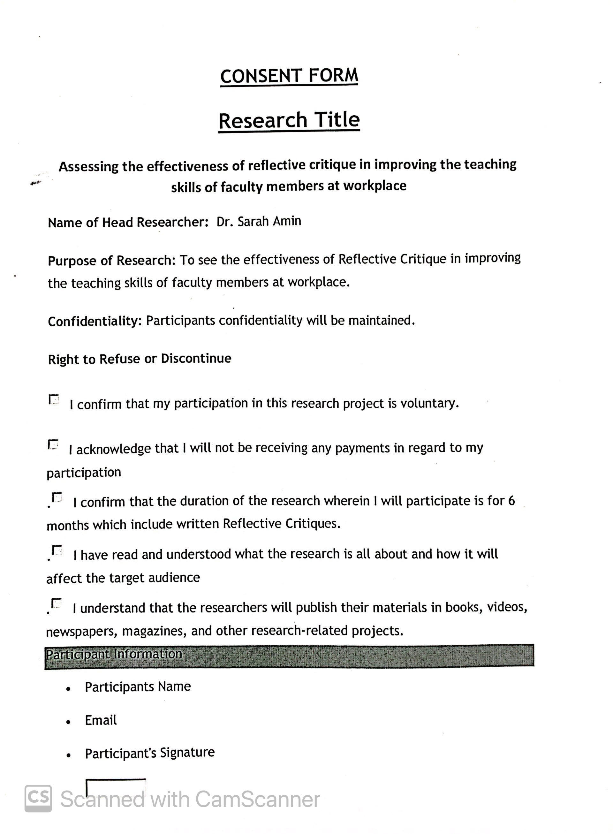

- G-Power calculator

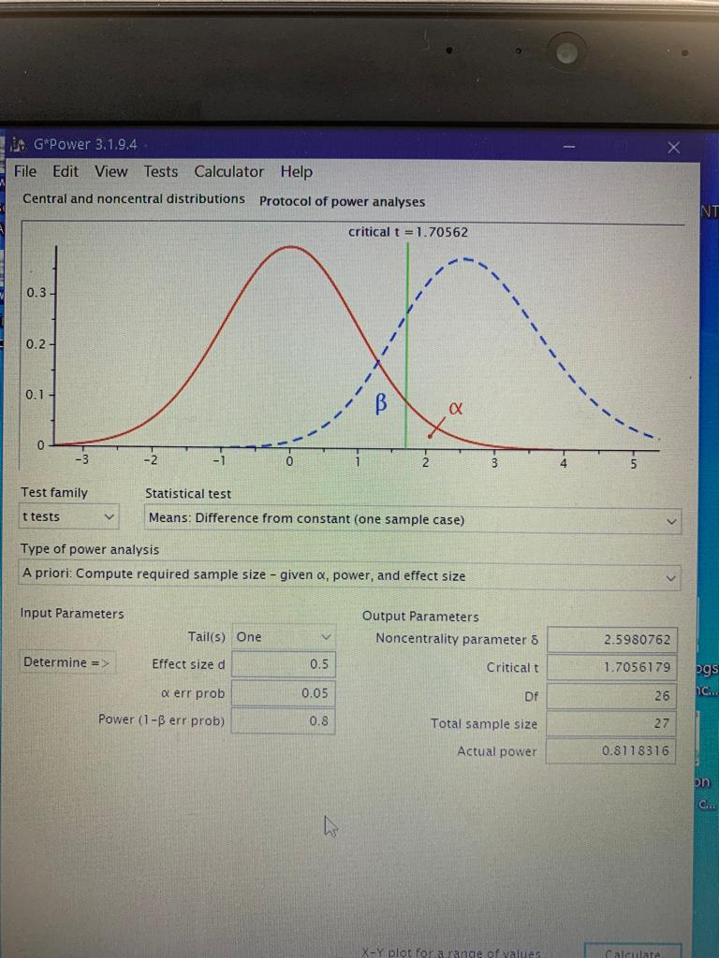

- What, so what & now what model

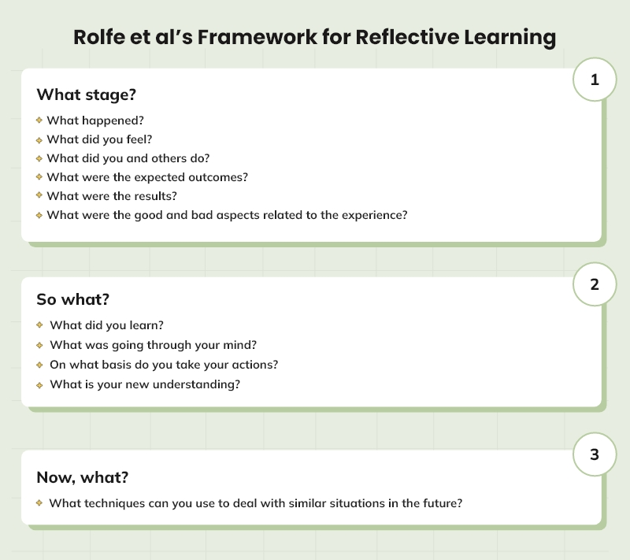
- REFLECT Rubric

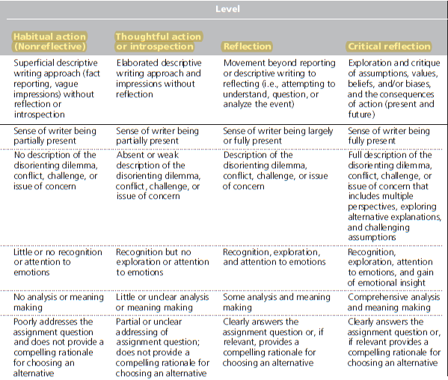

- Interview questions

Theory / Themes | Questions
Experiential learning theory | How did you feel about the experience of Case based learning workshop? What was the most important or relevant part of this experience?  Did you feel that the experience was a positive or negative one and why?
Transformative learning theory | Were there any environmental or other factors that influenced the experience?  How do you think this project will impact you, your students, discipline & your institution and your future action plan?
Reflective Critique & personal and professional development | How did the Reflective Critique writing change you personally & professionally?  Can you explain this with an example.
FDP & behavior change at workplace | Did this experience influence the way you do things now and if so, have you changed anything since that experience?  Have any of your previous beliefs changed as a result of the experience? If so how

