Supplementary

b)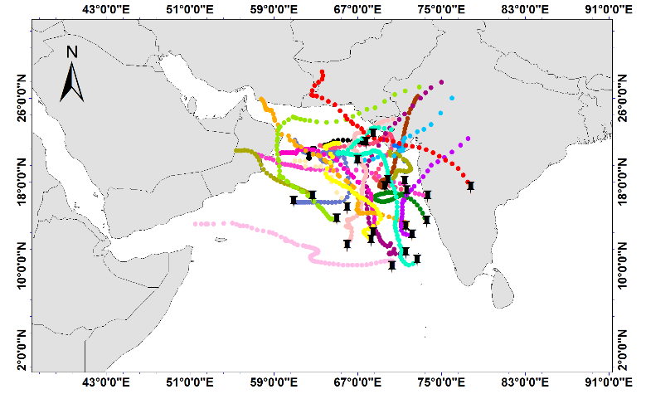 | a)  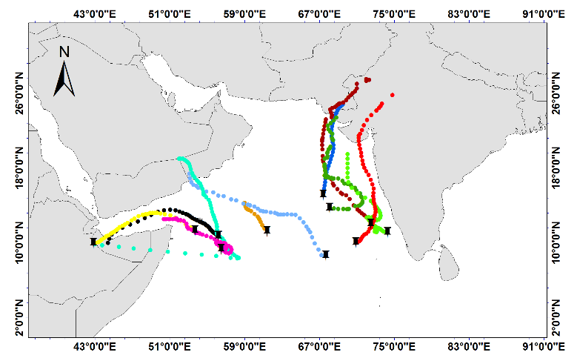
d)  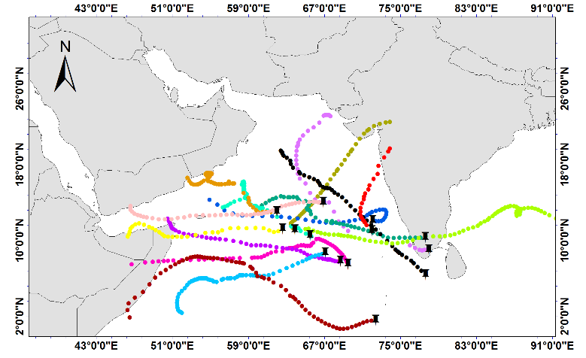 | c)  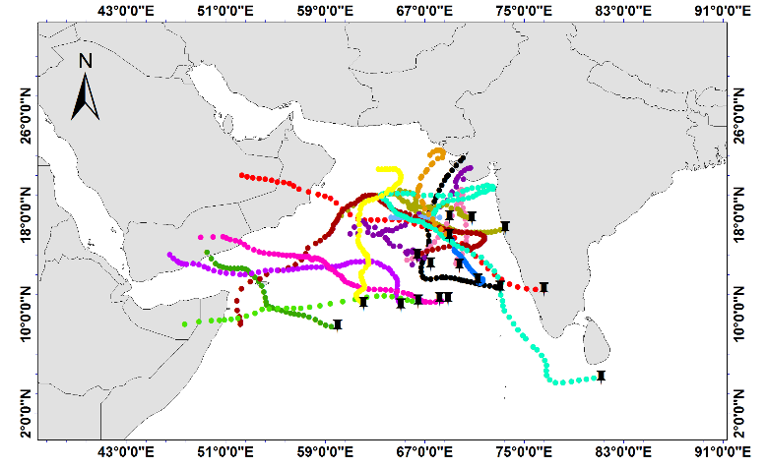
e)
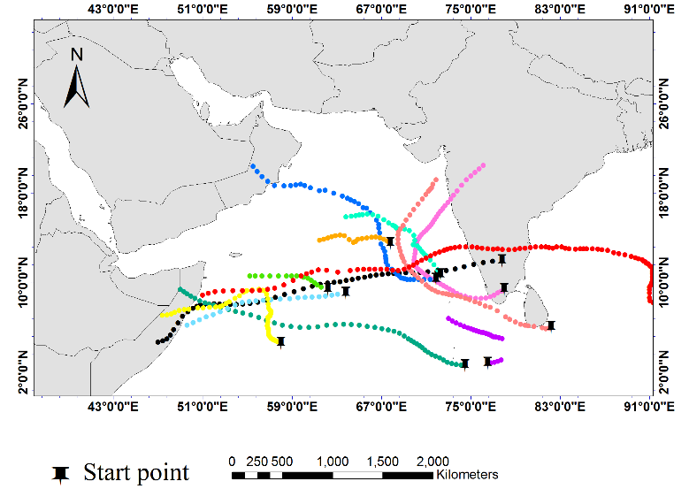
Fig1. The origin points and path of cyclones in the Arabian Sea in the period 1980-2023 (a) May, (b) June, (c) October, (d) November and (d) December

20211001  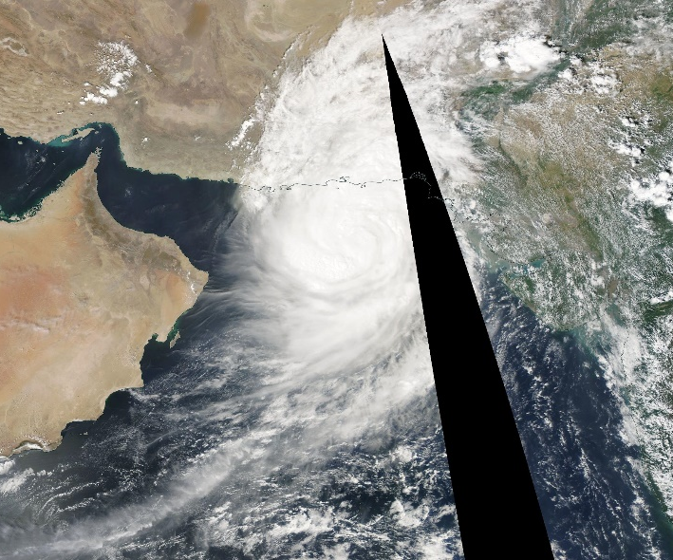 | 20210930  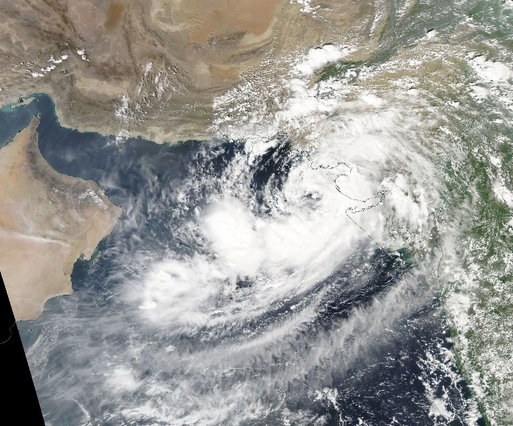
20211003  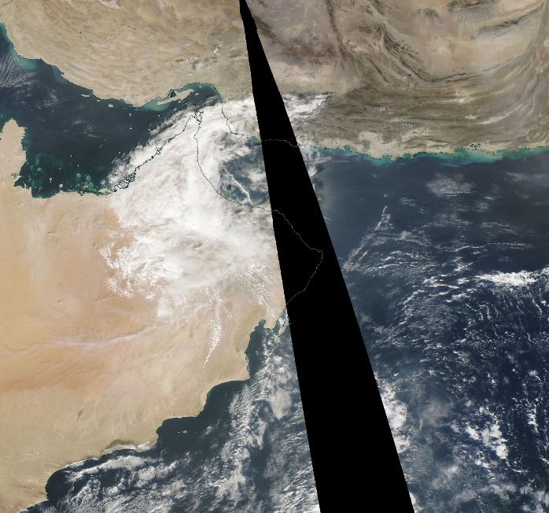 | 20211002  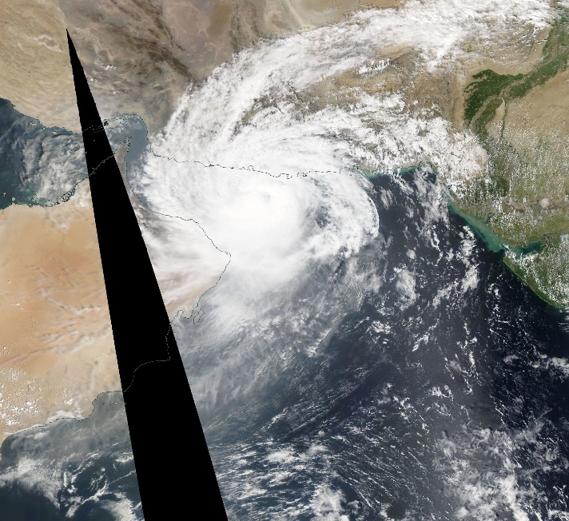
Fig2. The true color image of the MADIS sensor of the Terra satellite on 30th September to 03th October 2021

b)optical thickness  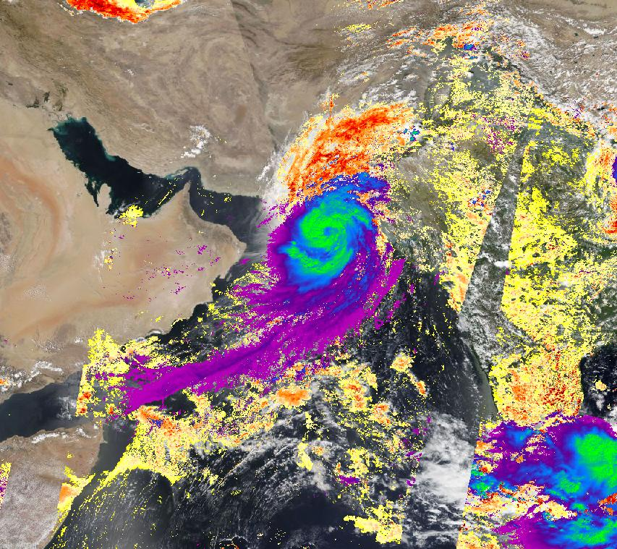 | a) Effective radius 20211001  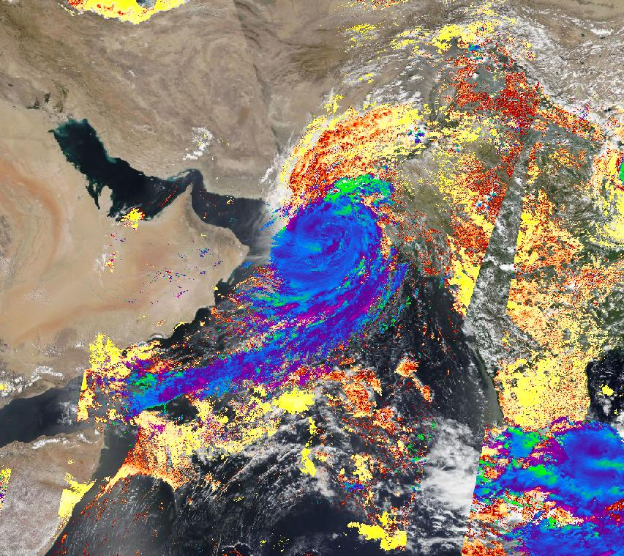
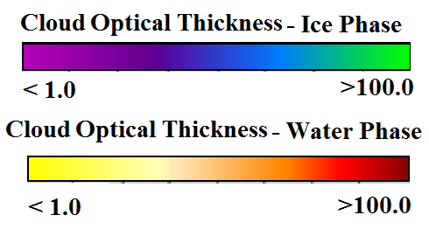 | 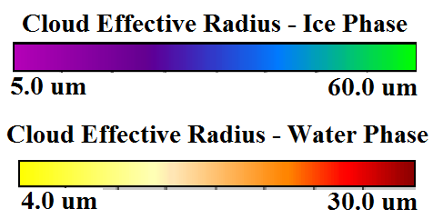
Fig3. a) Effective radius in two phases of water and ice and b) COD product of Terra satellite's MADIS sensor on 1th October 2023

b)  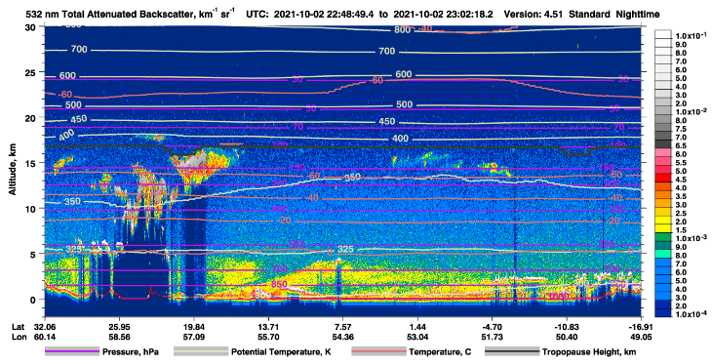 | a)  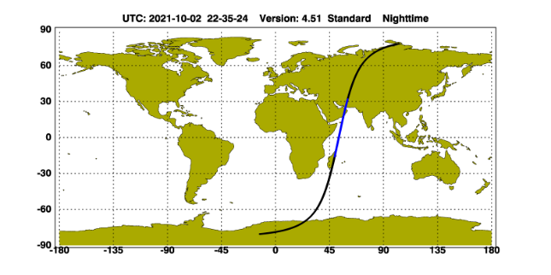
d)  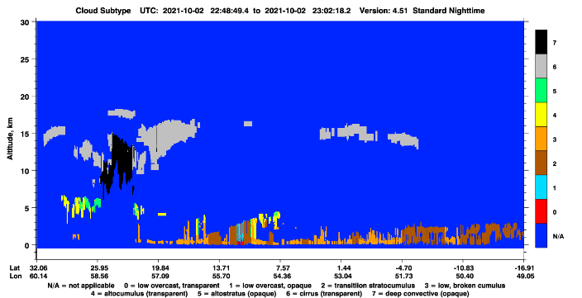 | c)  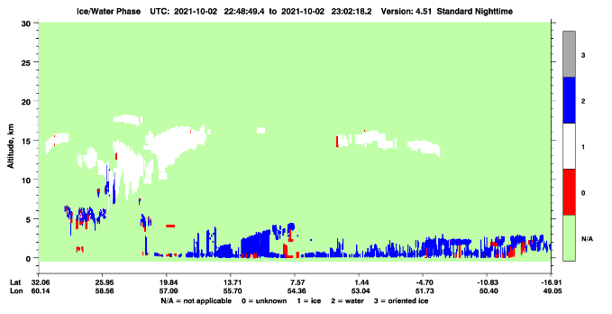
Fig4. Calipso satellite products a) trajectory, b) TAB, c) cloud phase and d) type of aerosols on 2th October 2021 around 2200 UTC

c) 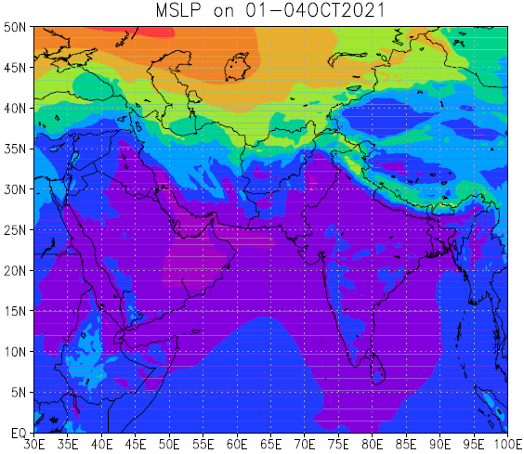 | b) 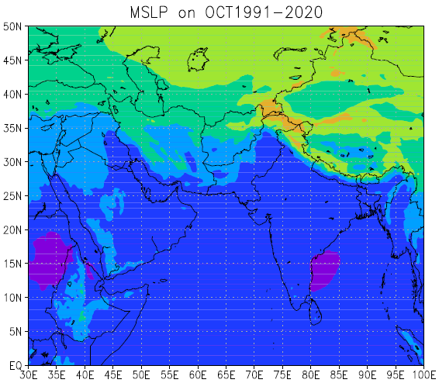 | a) 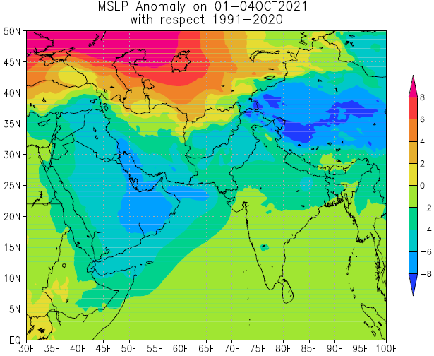
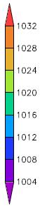 |  | 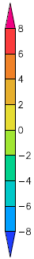
Fig5. Mean sea level pressure (hPa) a) Anomaly, b) long-term and c) mean in the Shaheen TC, October 2023

c) 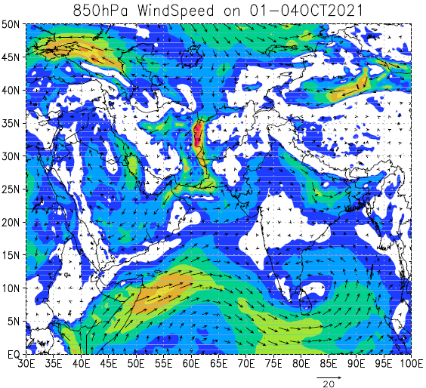 | b) 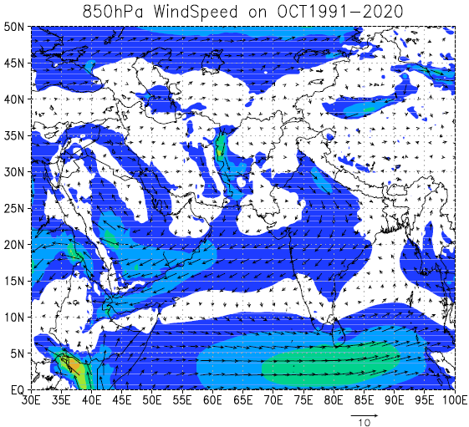 | a) 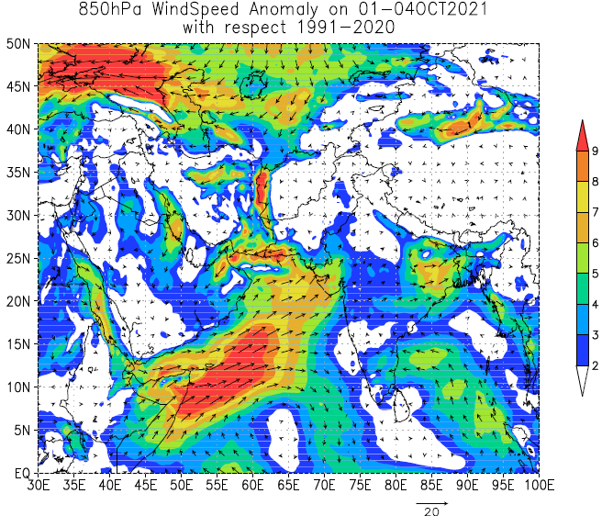
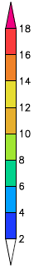 |  | 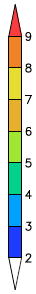
Fig6. 850 hPa wind (m/s) a) Anomaly, b) long-term and c) mean of the TC Shaheen, October 2021

b)  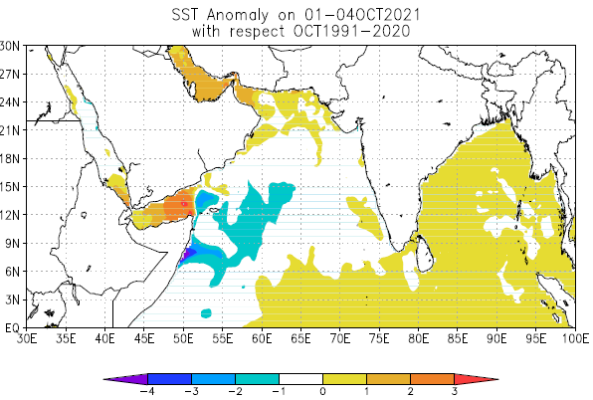 | a)  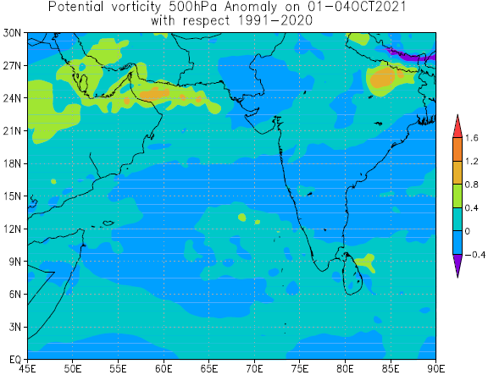
Fig7. Anomaly of a) 500 hPa potential vorticity and b) SST in the TC Shaheen, October 2021

b)  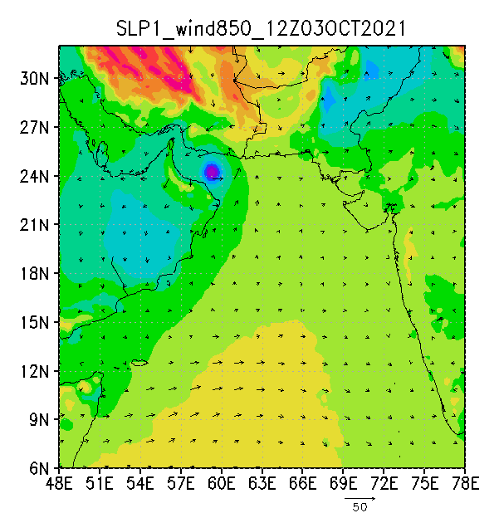 | a)  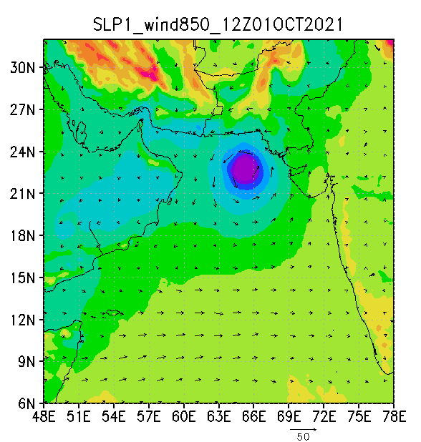

Fig. MSLP and 850 hPa wind of WRF output at 1200 UTC on a) 1th and b) 3th October 2021

b)  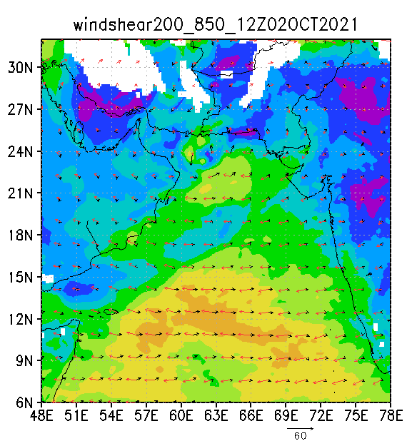 | a)  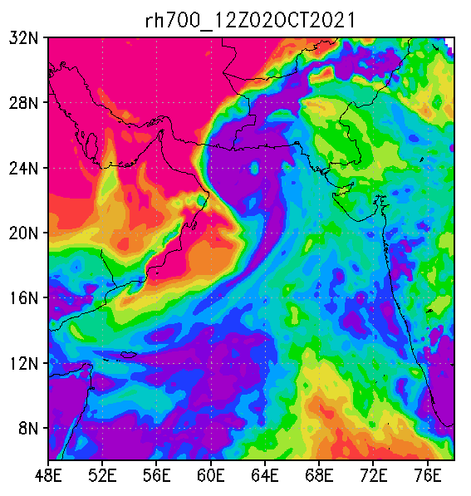
 | 
Fig9. a) 700 hPa Relative humidity (%) at 0000 UTC b) wind Shear (m/s) between 850 (black vectors) and 200 hPa (red vectors) and their differences (shaded) at 1200 UTC, 02th October 2021

b)  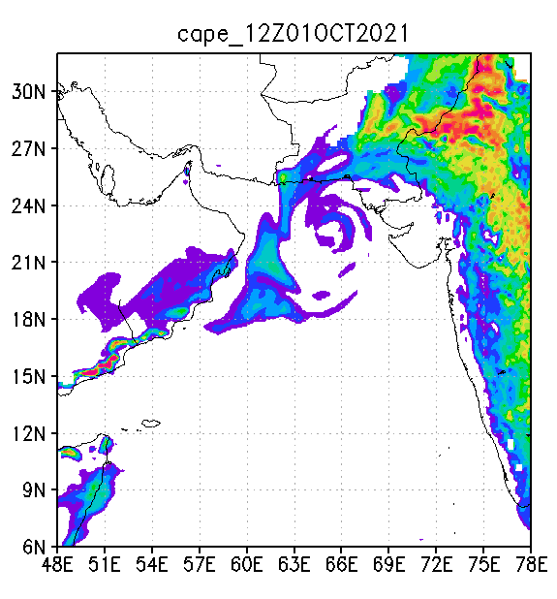 | a)  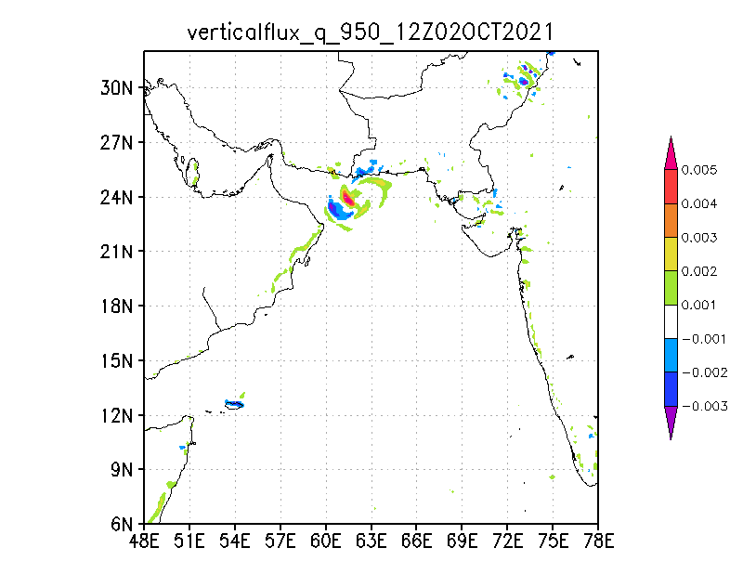
 | 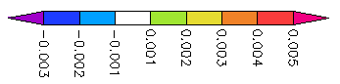
Fig10. a) Vertical flux of RH at 950 hPa at 1200 UTC on 02th October 2021 and b) CAPE at 1200 UTC on 01th October 2021

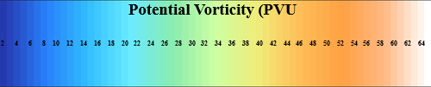 | b)  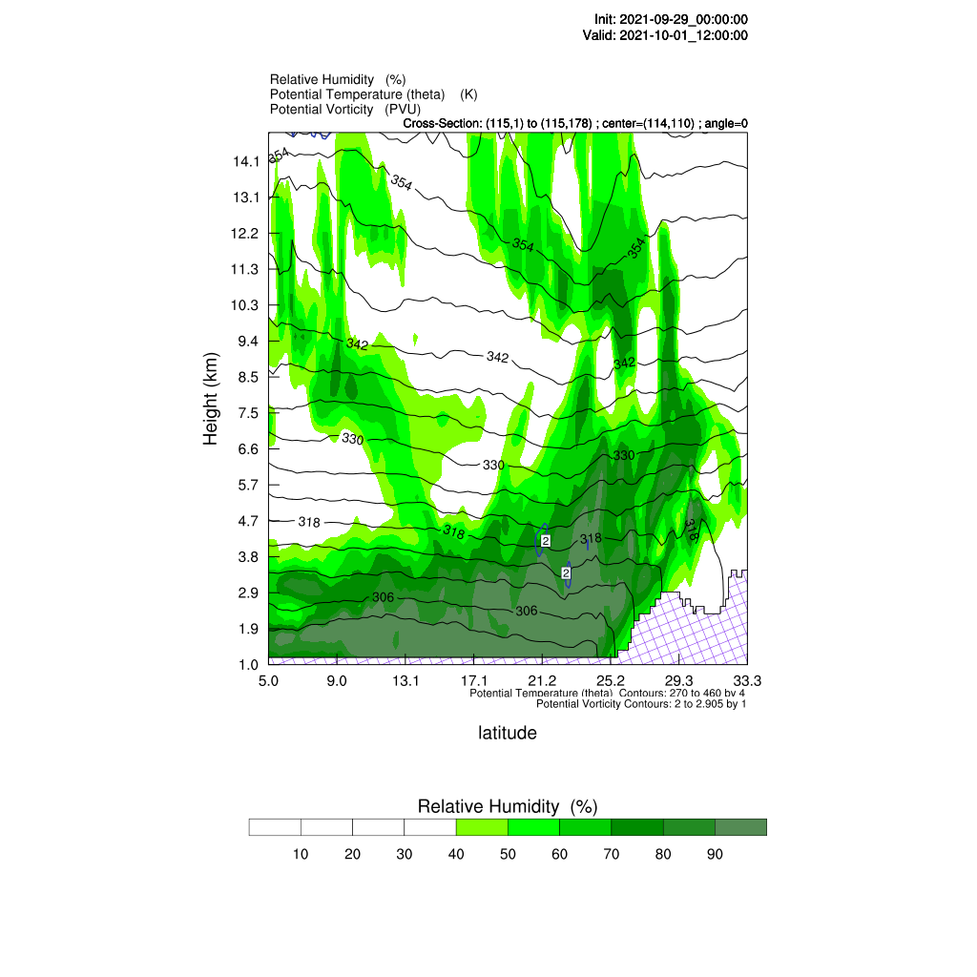 | a)  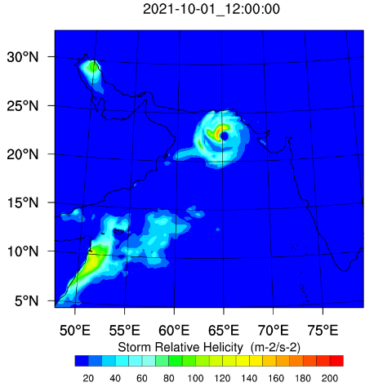
 | d)  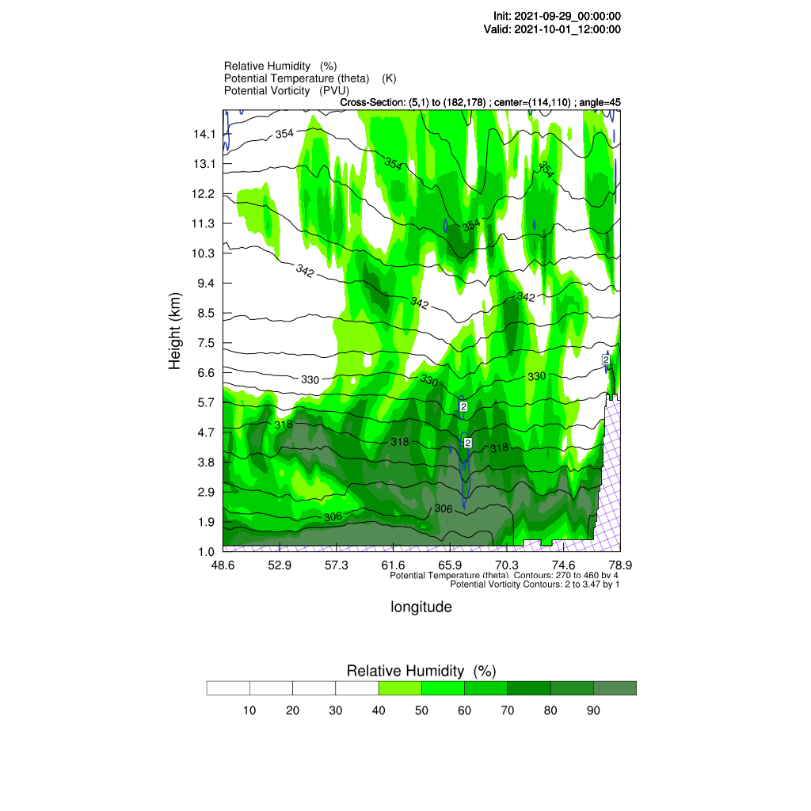 | c)  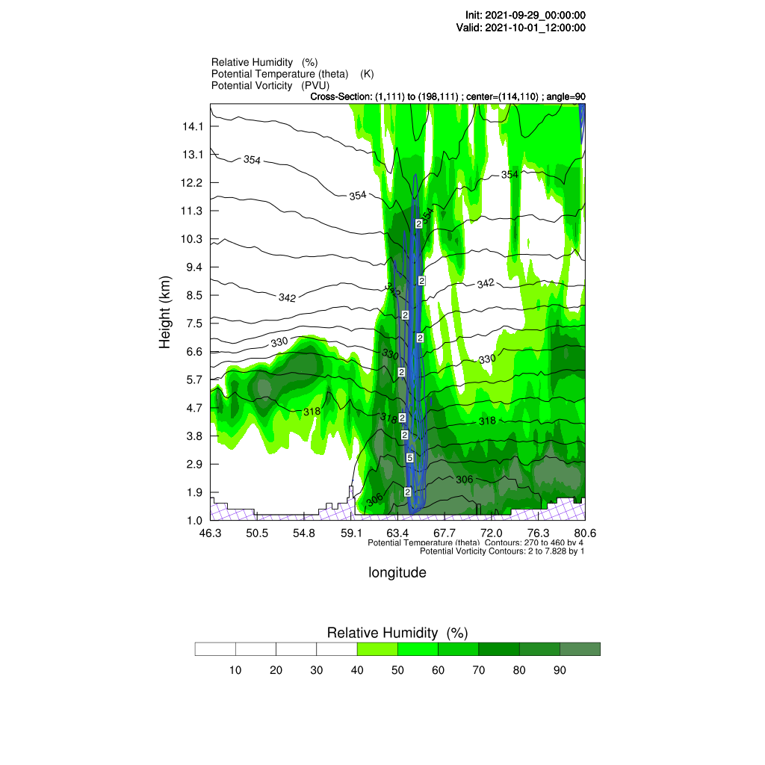
Fig11. (a) Helicity in m2/s2, (b), (c), (d) Vertical cross-section of potential vorticity in PVU (color lines), potential temperature in Kelvin (black color lines), and relative humidity in percentage (shaded green areas) at 00 UTC on 1 October, 2021 for Shaheen TC correspondingly refer to the three different directions: north-south (0 degrees), west-east (90 degrees), and northwest-southeast (45 degrees) at center of TC (latitude:22.5֯ and longitude: 65.5֯)

a)  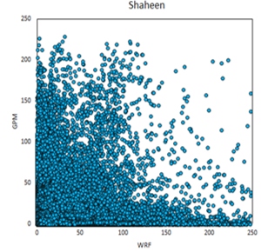 | b)  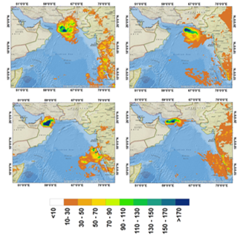
Fig13. a) Daily rainfall scatter diagram of GPM data and WRF model output on 29th June -04 October 2021 and b) Cumulative daily rainfall of GPM satellite data and WRF model output on 01th and 03rd October 2023

20180524  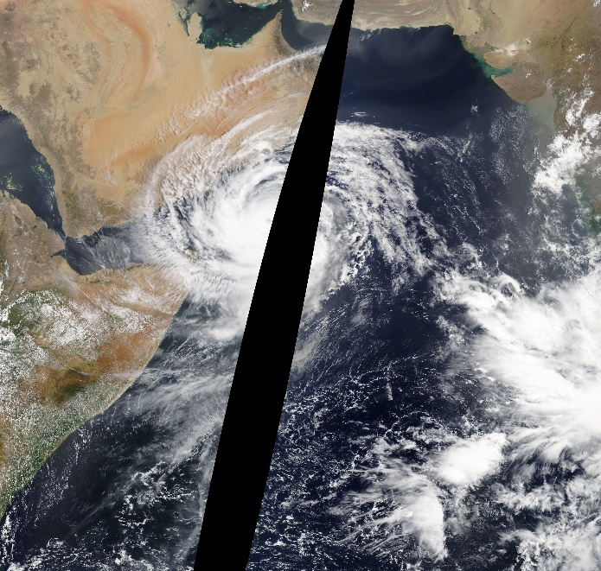 | 20180523  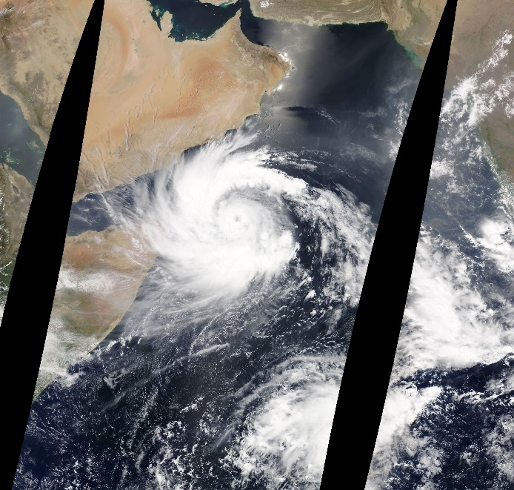
20180526  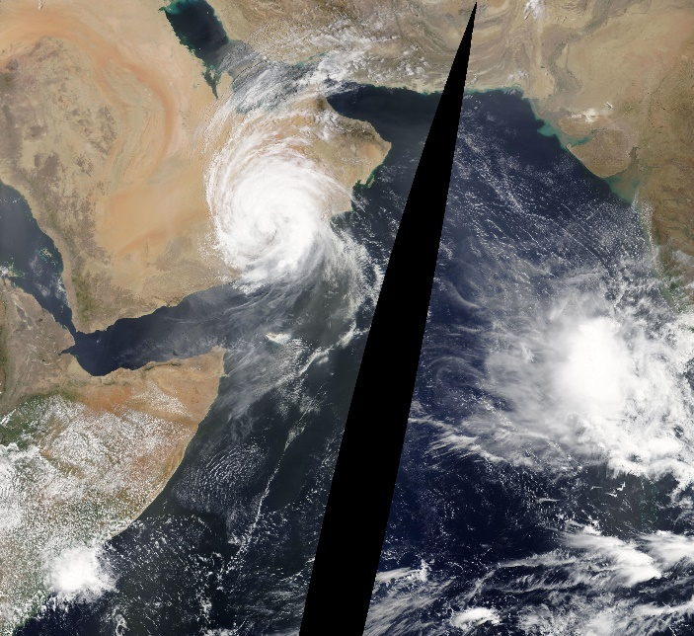 | 20180525  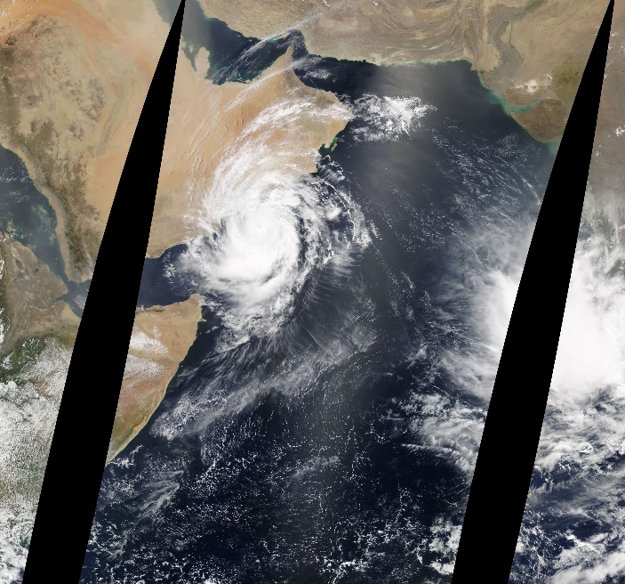
Fig13. The true color image of the MADIS sensor of the Terra satellite on 23th to 26th May 2018

b)optical thickness  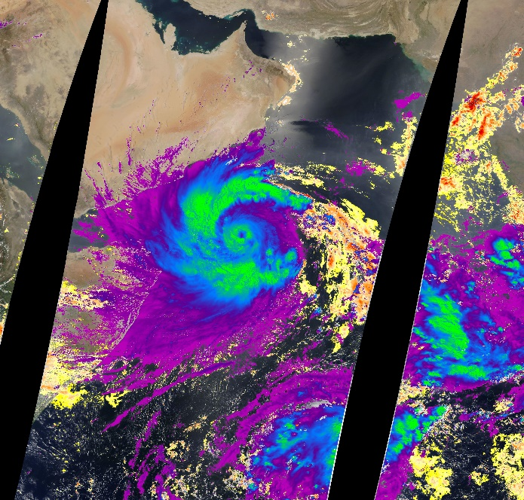 | a)Effective radius 20180523  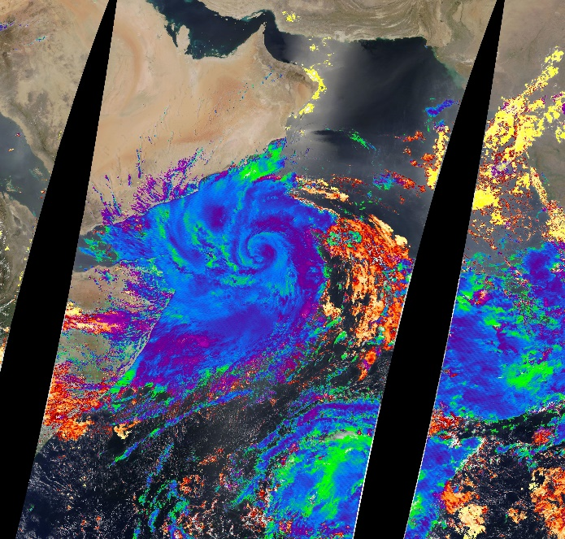
Fig14. a) Effective radius in two phases of water and ice and b) COD product of Terra satellite's MADIS sensor on 23th May 2018

b)  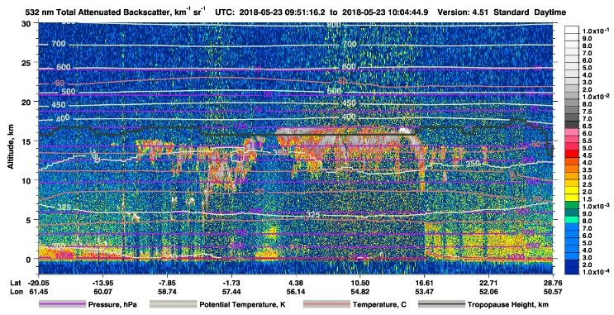 | a)  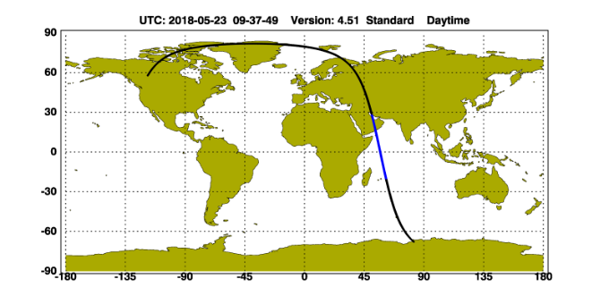
d)  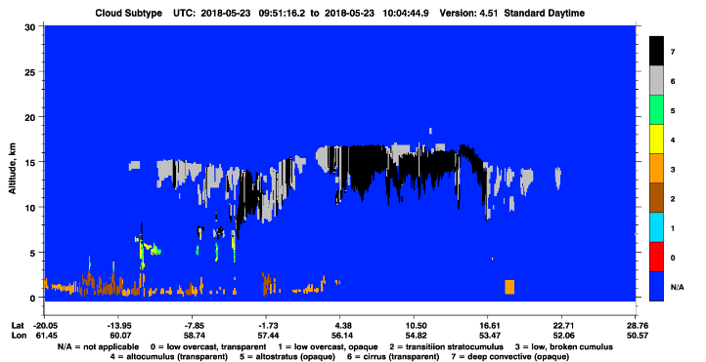 | c)  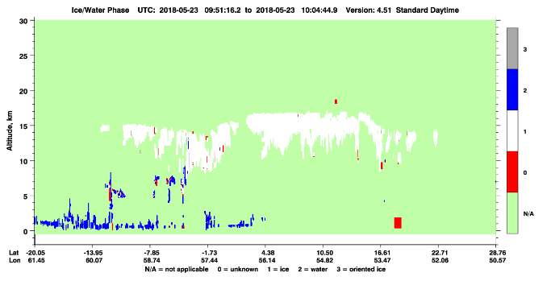
Fig15. Calipso satellite products a) trajectory, b) TAB, c) cloud phase and d) type of aerosols on 23th May 2018 around 0900 UTC

c) 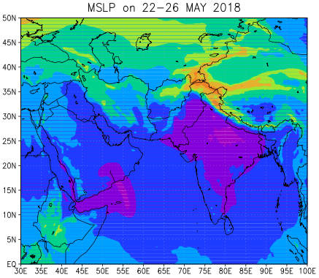 | b) 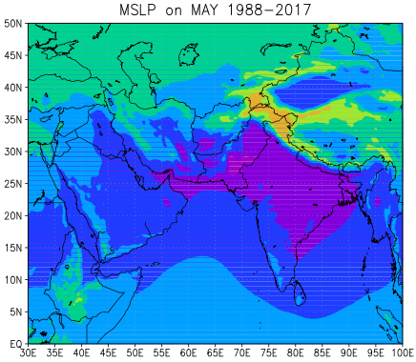 | a) 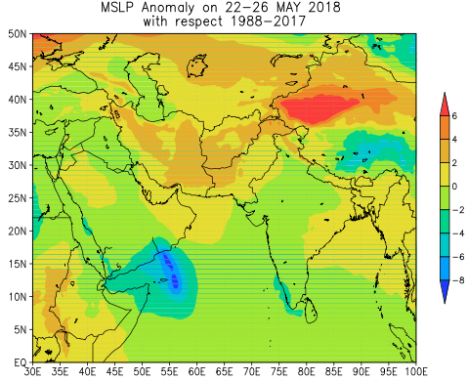
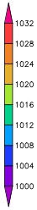 |  | 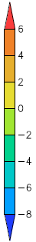
Fig16. Mean sea level pressure (hPa) a) Anomaly, b) long-term and c) mean in the Mekunu TC, May 2018

c) 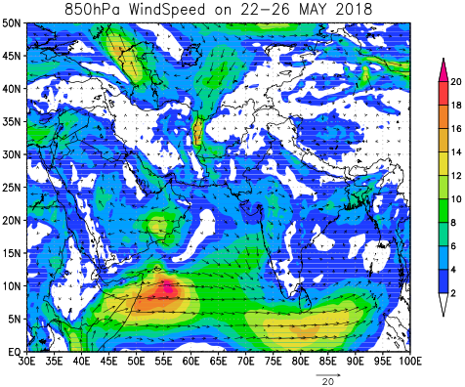 | b) 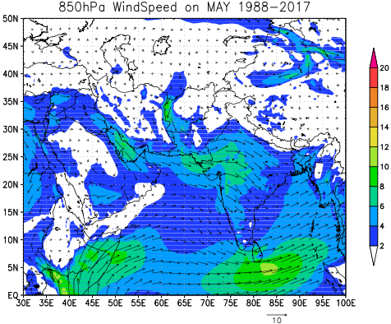 | a) 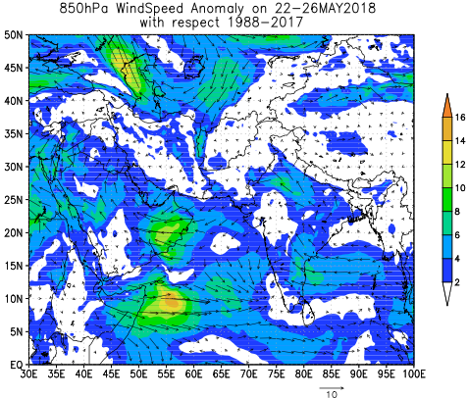
 |  | 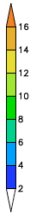
Fig6. 850 hPa wind (m/s) a) Anomaly, b) long-term and c) mean of the TC Mekunu, May 2018

b)  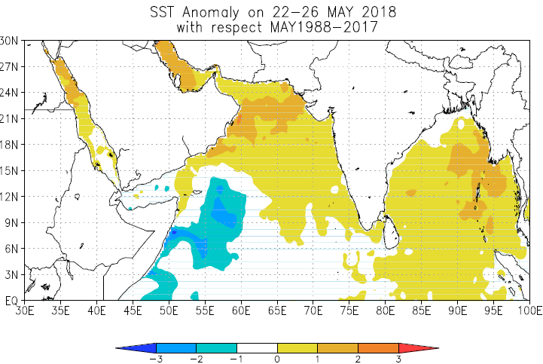 | a)  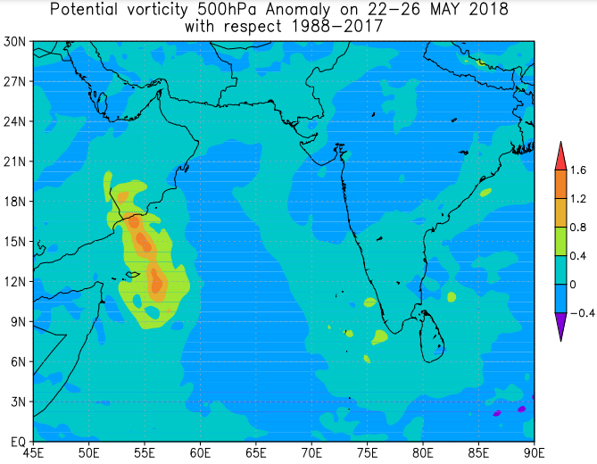  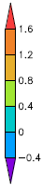
Fig18. Anomaly of a) 500 hPa potential vorticity and b) SST in the TC Mekunu, May 2018

b)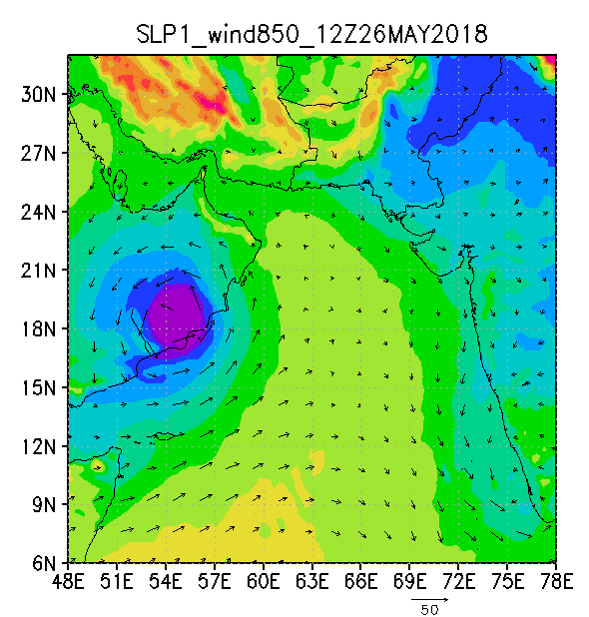 | a)  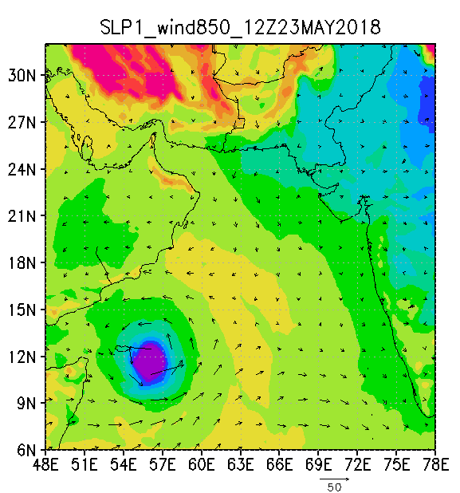
Fig19. MSLP and 850 hPa wind of WRF output at 1200 UTC on a) 23th and b) 26th May 2018

b)  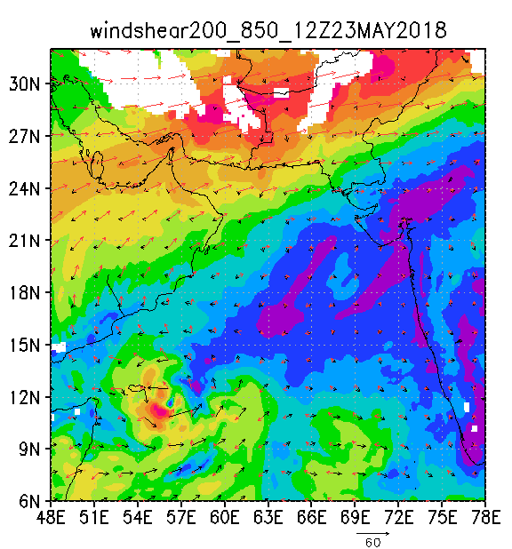 | a)  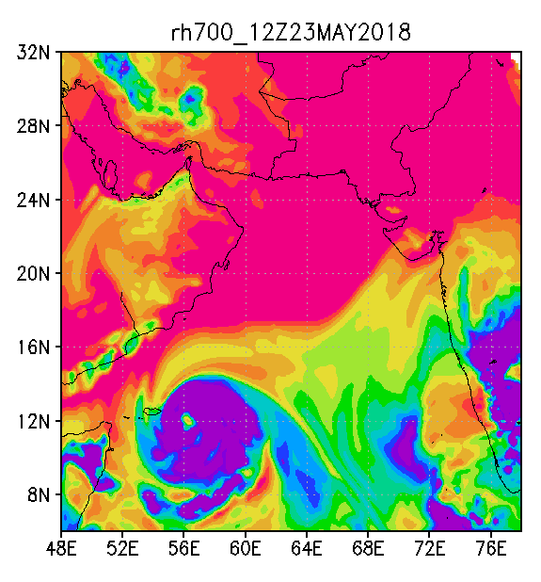
Fig20. a) 700 hPa Relative humidity (%) at 0000 UTC b) wind Shear (m/s) between 850 (black vectors) and 200 hPa (red vectors) and their differences (shaded) at 1200 UTC, 23th May 2018

b)  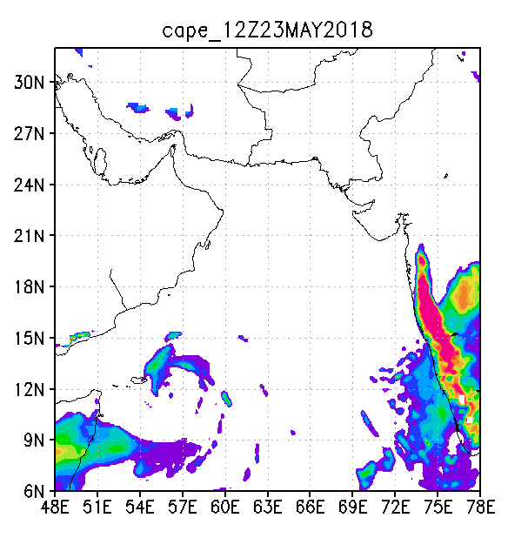 | a)  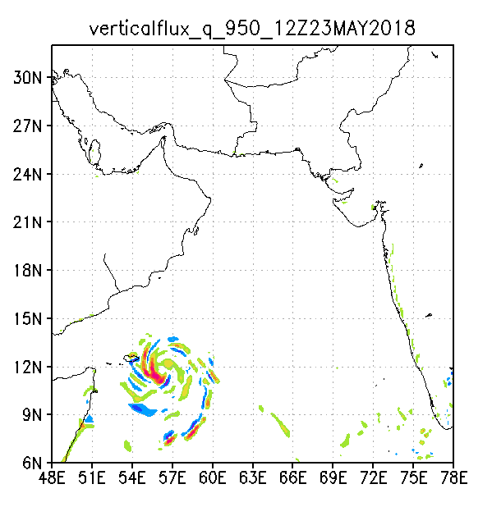
Fig21. a) Vertical flux of RH at 950 hPa and b) CAPE at 1200 UTC on 23th May 2018

 | b)  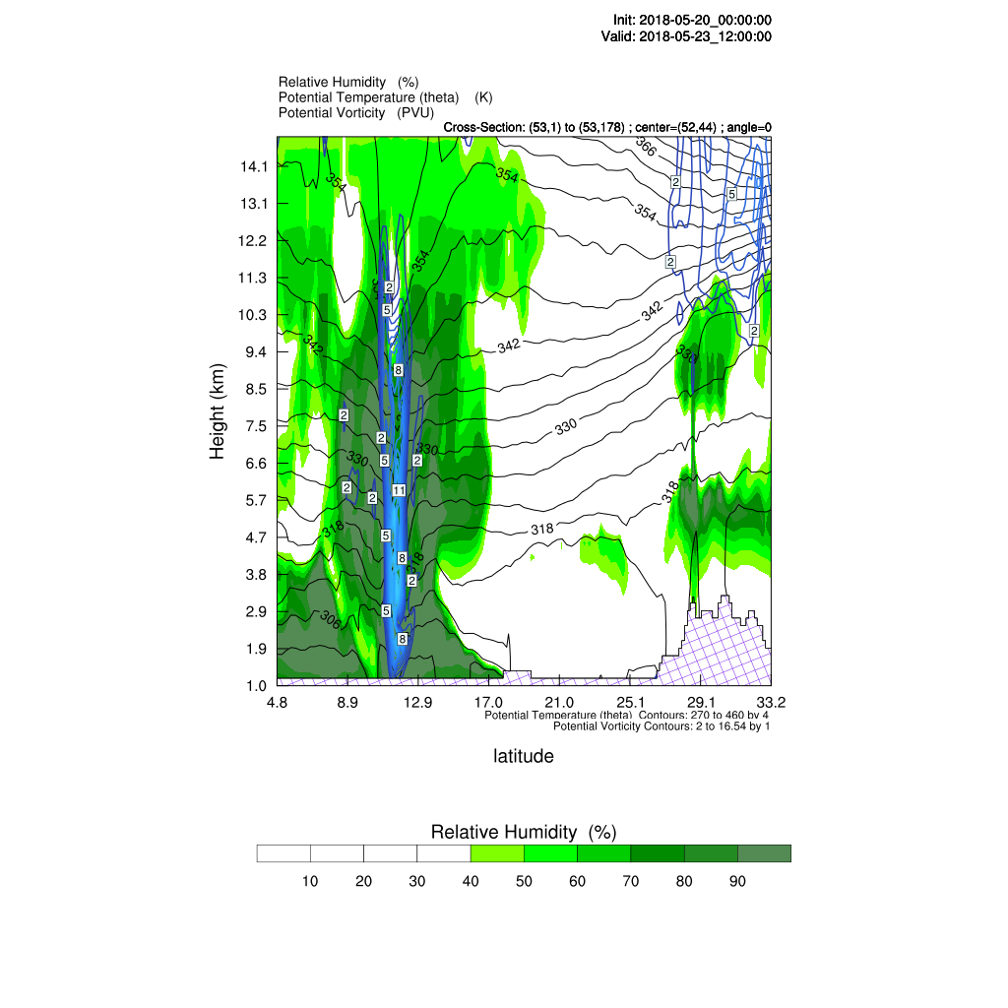 | a)  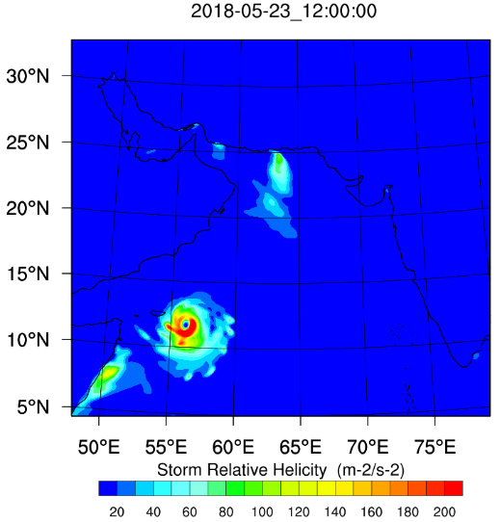
 | d)  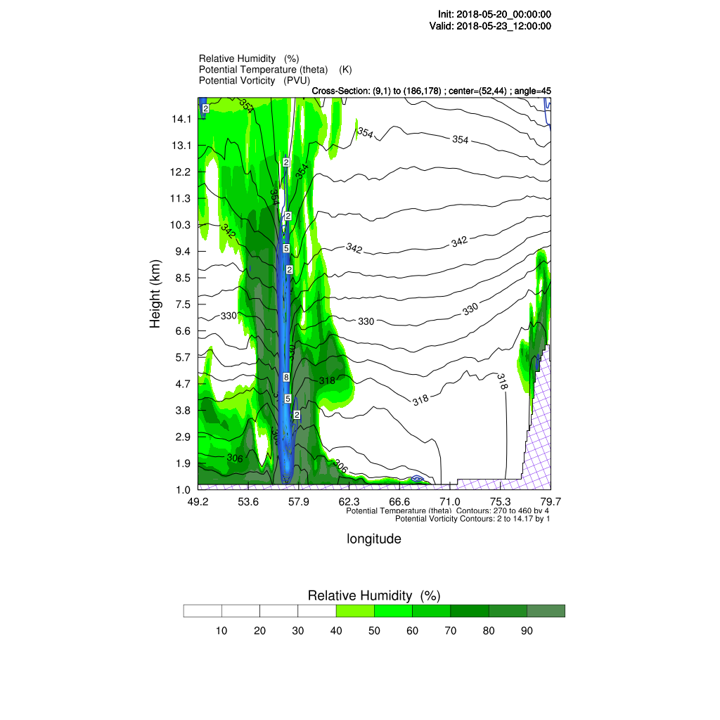 | c)  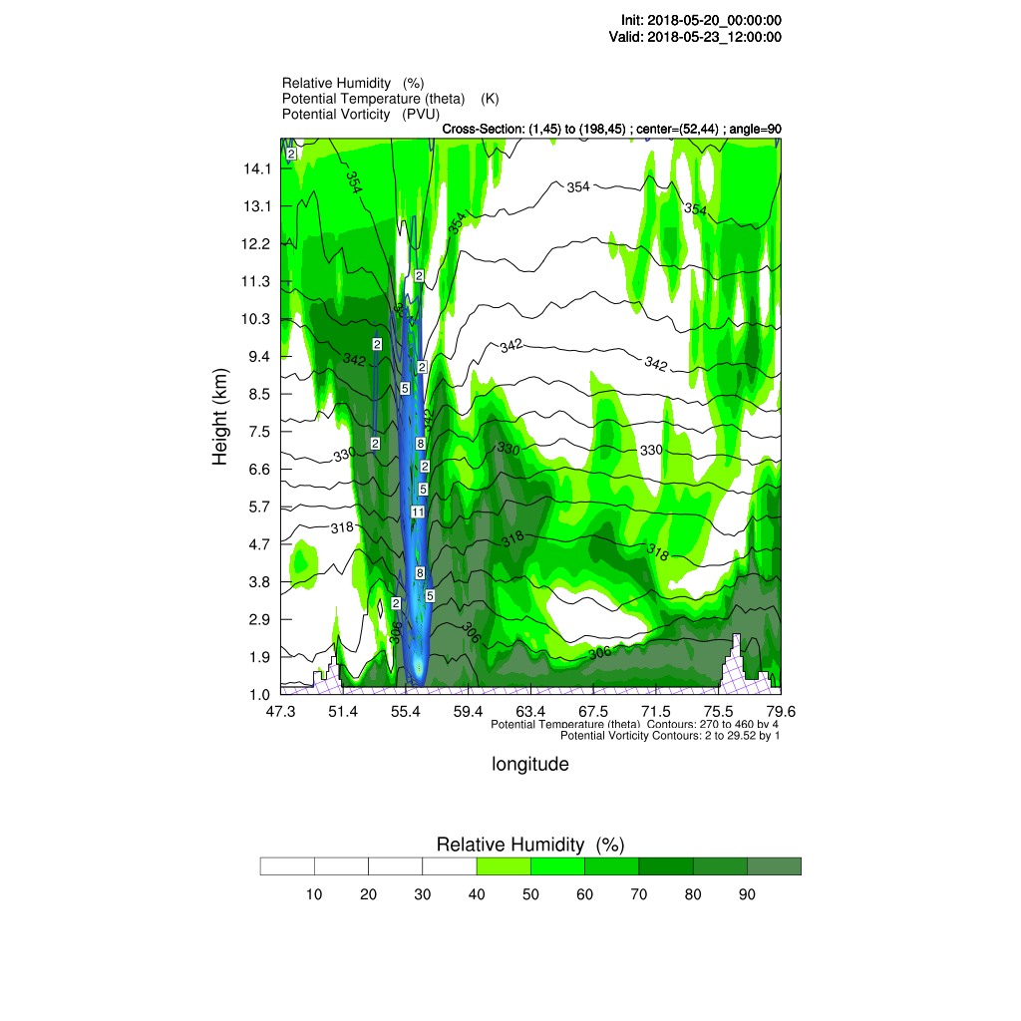
Fig22. (a) Helicity in m2/s2, (b), (c), (d) Vertical cross-section of potential vorticity in PVU (color lines), potential temperature in Kelvin (black color lines), and relative humidity in percentage (shaded green areas) at 00 UTC on 23 May, 2018 for Mekunu TC correspondingly refer to the three different directions: north-south (0 degrees), west-east (90 degrees), and northwest-southeast (45 degrees) at center of TC (latitude:10.5֯ and longitude: 56.5֯)

a)  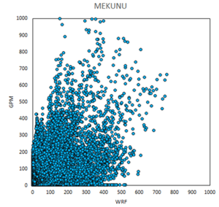 | b)  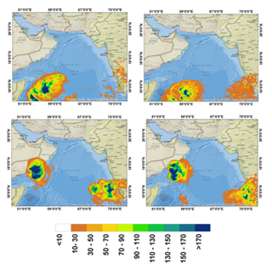
Fig23. a) Daily rainfall scatter diagram of GPM data and WRF model output on 20th – 26th May 2018 and b) Cumulative daily rainfall of GPM satellite data and WRF model output on 21th and 25rd May 2018

