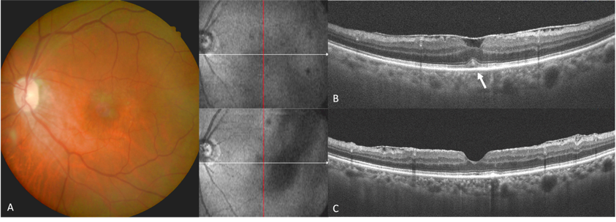
Supplementary Figure. 1 Imaging of a patient with the cotton ball sign: A) Baseline color fundus imaging. B) Preoperative OCT revealed ERM and the cotton ball sign (white arrow), a dome-shaped hyperreflective area. C) Postoperative OCT displayed the disappearance of the cotton ball sign, restoring the ellipsoid zone and retinal pigment epithelium.

