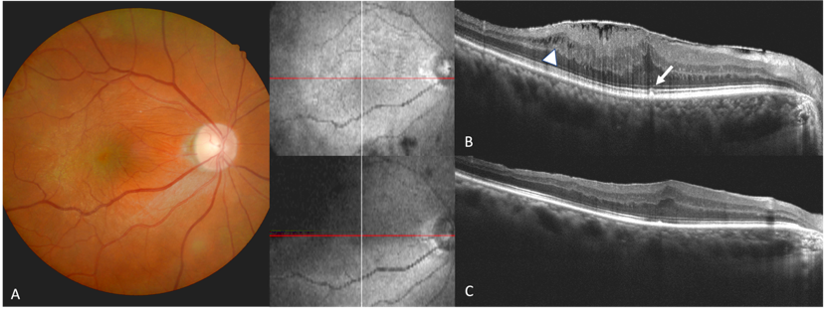
Supplementary Figure. 2 Imaging of a patient with MME. A) Baseline color fundus imaging. B) Preoperative OCT revealed ERM, the cotton ball sign (white arrow), and a small ellipsoidal-like area of MME (white arrowhead). C) Postoperative OCT demonstrated subsided MME with foveal ellipsoid zone restoration after ERM surgery."

