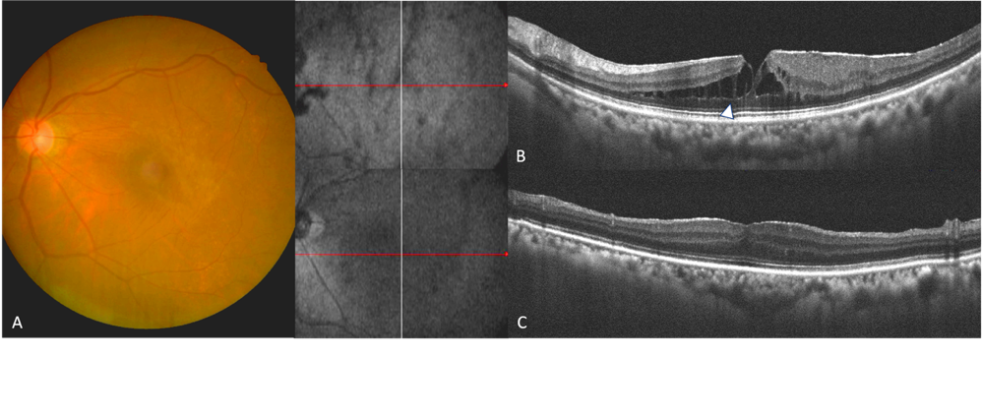
Supplementary Figure. 3 Imaging of a patient with ERM-foveoschisis. A) Baseline color fundus imaging. B) OCT before ERM surgery showed the presence of ERM, and ERM-foveoschisis (white arrowhead). C) OCT after ERM surgery showed restoration of the foveal microstructure.

