Supplementary Online Content
eFigure 1. Scatter plot of systemic inflammatory regulators-associated SNPs with risk of sensorineural hearing loss.
eFigure 2. MR leave-one-out sensitivity analysis of systemic inflammatory regulators-associated SNPs with risk of sensorineural hearing loss.
eFigure 3. Funnel of systemic inflammatory regulators-associated SNPs with risk of sensorineural hearing loss.
eFigure 4. Forest plot of systemic inflammatory regulators-associated SNPs with risk of sensorineural hearing loss.
eFigure 5. MR leave-one-out sensitivity analysis of sensorineural hearing loss-associated SNPs with risk of systemic inflammatory regulators.
eFigure 6. Scatter plot of sensorineural hearing loss-associated SNPs with risk of systemic inflammatory regulators.
eFigure 7. Funnel of sensorineural hearing loss-associated SNPs with risk of systemic inflammatory regulators.
eFigure 8. Forest plot of sensorineural hearing loss-associated SNPs with risk of systemic inflammatory regulators.
eTable 1 the sample size for each cytokine analyzed in this study acquired form the GWAS.
eTable 2 Odds ratio for association of genetically predicted systemic inflammatory regulators with SNHL.
eTable 3 Results of heterogeneity horizontal pleiotropy test and statistical power.
eTable 4 Odds ratio for association of genetically predicted SNHL with systemic inflammatory regulators.
eTable 5 Results of heterogeneity horizontal pleiotropy test and statistical power.

eTable 2 Odds ratio for association of genetically predicted systemic inflammatory regulators with SNHL

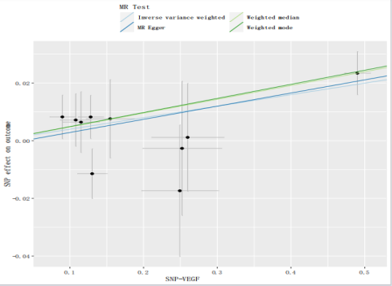
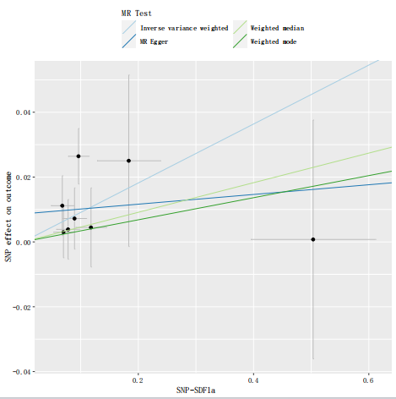
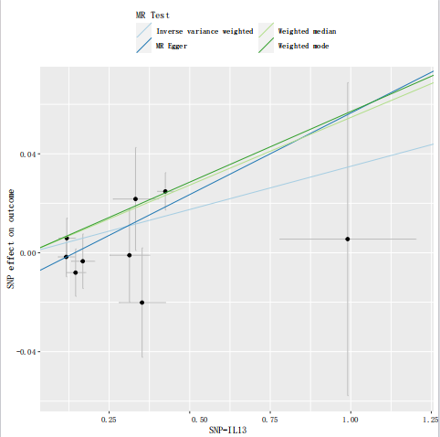
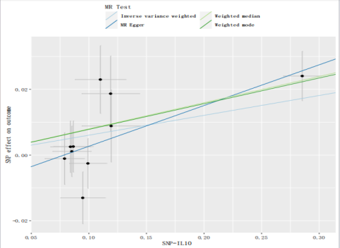
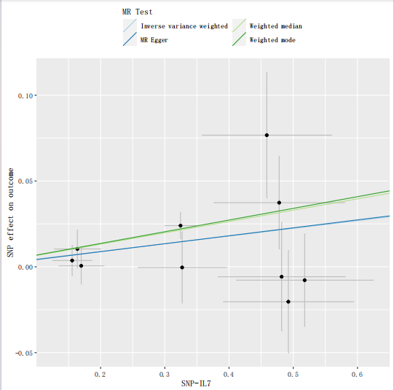
A
B
C
D
E
eFigure 1. Scatter plot of systemic inflammatory regulators-associated SNPs with risk of sensorineural hearing loss. The genetic relationship between VEGF, SDF1a, IL13, IL10, IL7 and sensorineural hearing loss, denoted as A to E, respectively. Abbreviations: VEGF, Vascular endothelial growth factor levels; SDF1a, Stromal-cell-derived factor 1 alpha levvels; IL, interleukin; SD, standard deviation.

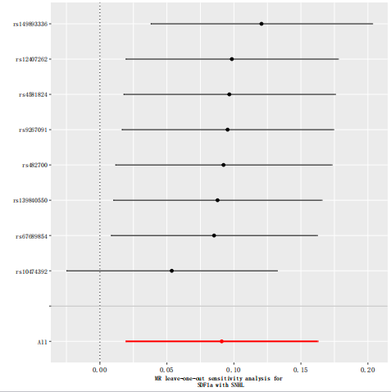
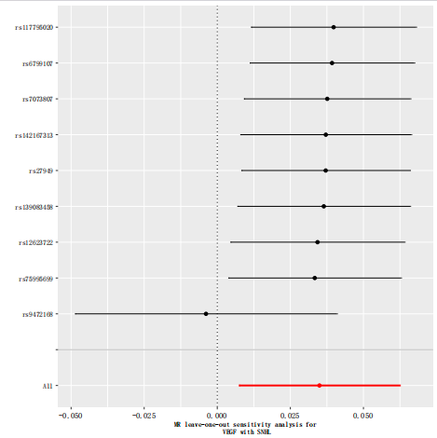
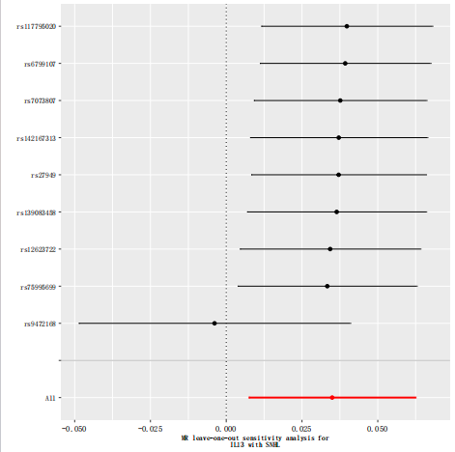
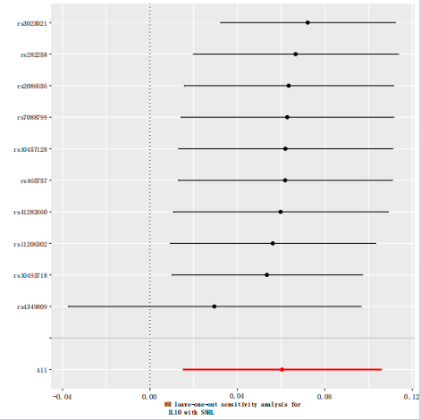
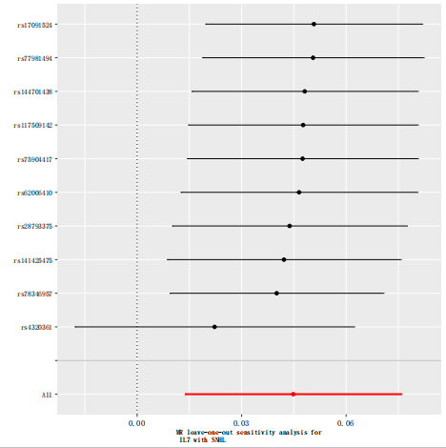
A
B
C
D
E
eFigure 2. MR leave-one-out sensitivity analysis of systemic inflammatory regulators-associated SNPs with risk of sensorineural hearing loss. The genetic relationship between VEGF, SDF1a, IL13, IL10, IL7 and sensorineural hearing loss, denoted as A to E, respectively. Abbreviations: VEGF, Vascular endothelial growth factor levels; SDF1a, Stromal-cell-derived factor 1 alpha levvels; IL, interleukin.
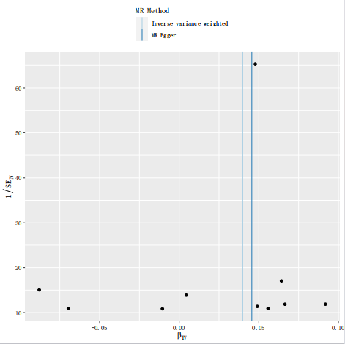
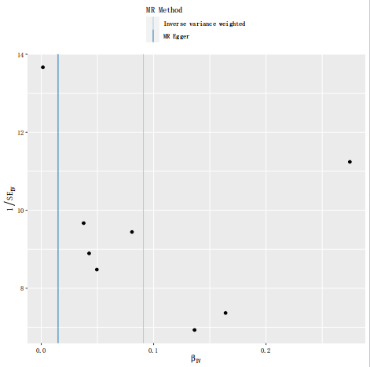
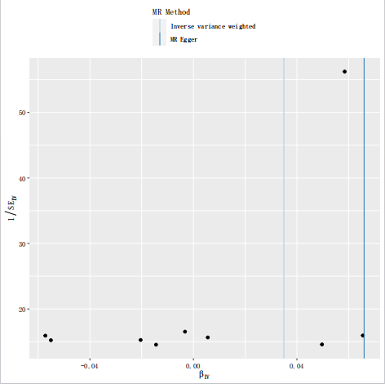
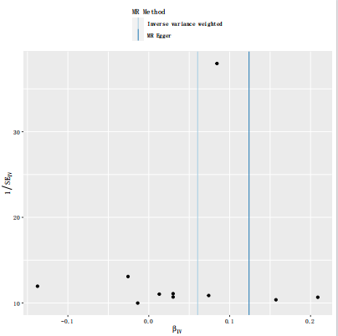
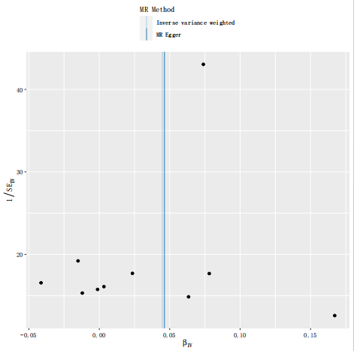
A
B
C
D
E
eFigure 3. Funnel of systemic inflammatory regulators-associated SNPs with risk of sensorineural hearing loss. The genetic relationship between VEGF, SDF1a, IL13, IL10, IL7 and sensorineural hearing loss, denoted as A to E, respectively. Abbreviations: VEGF, Vascular endothelial growth factor levels; SDF1a, Stromal-cell-derived factor 1 alpha levvels; IL, interleukin;

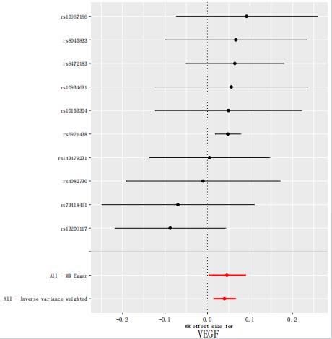
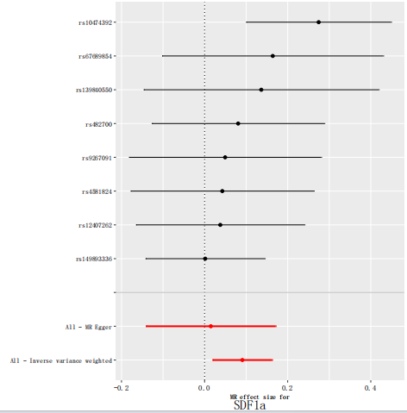
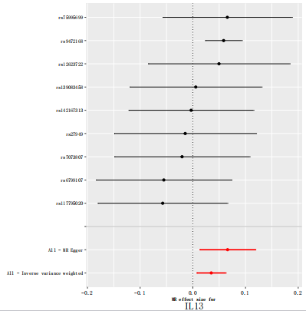
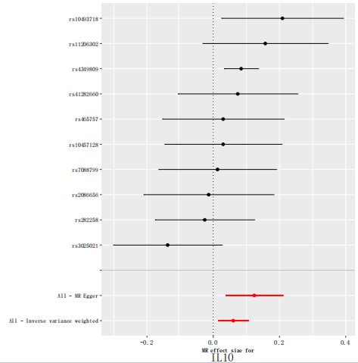
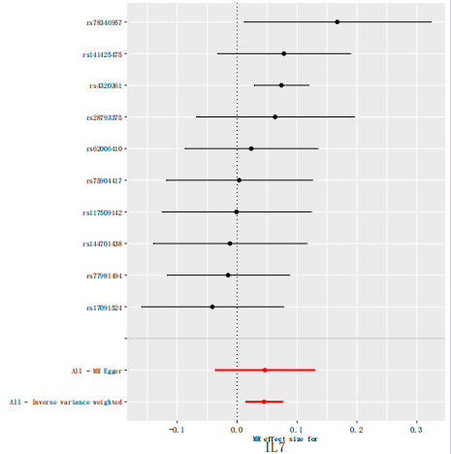
A
B
C
D
E
eFigure 4. Forest plot of systemic inflammatory regulators-associated SNPs with risk of sensorineural hearing loss. The genetic relationship between VEGF, SDF1a, IL13, IL10, IL7 and sensorineural hearing loss, denoted as A to E, respectively. Abbreviations: VEGF, Vascular endothelial growth factor levels; SDF1a, Stromal-cell-derived factor 1 alpha levvels; IL, interleukin;

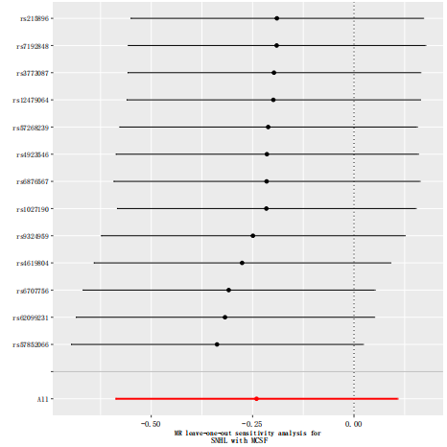
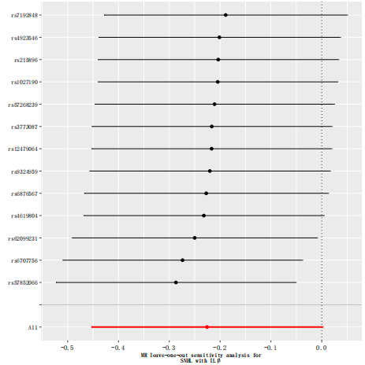
A
B
eFigure 5. MR leave-one-out sensitivity analysis of sensorineural hearing loss-associated SNPs with risk of systemic inflammatory regulators. The genetic relationship between MCSF, ILβ and sensorineural hearing loss, denoted as A to B, respectively. Abbreviations: MCSF, Macrophage colony-stimulating factor; IL, interleukin.

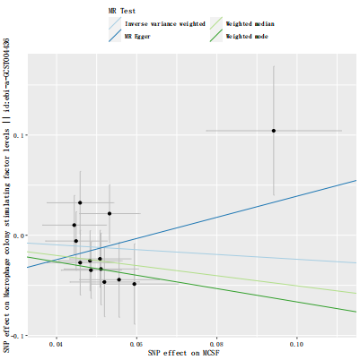
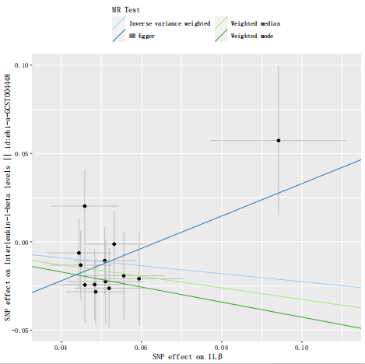
A
B
eFigure 6. Scatter plot of sensorineural hearing loss-associated SNPs with risk of systemic inflammatory regulators. The genetic relationship between MCSF, ILβ and sensorineural hearing loss, denoted as A to B, respectively. Abbreviations: MCSF, Macrophage colony-stimulating factor; IL, interleukin.

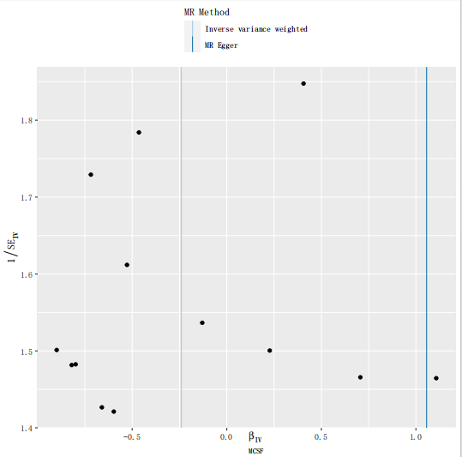
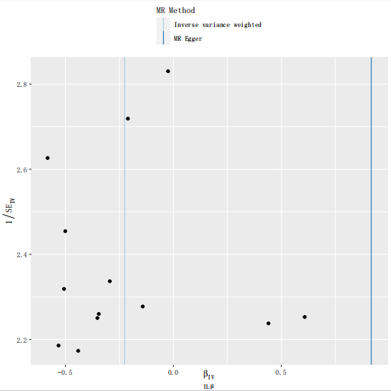
A
B
eFigure 7. Funnel of sensorineural hearing loss-associated SNPs with risk of systemic inflammatory regulators. The genetic relationship between MCSF, ILβ and sensorineural hearing loss, denoted as A to B, respectively. Abbreviations: MCSF, Macrophage colony-stimulating factor; IL, interleukin.

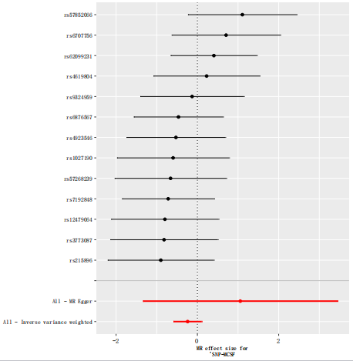
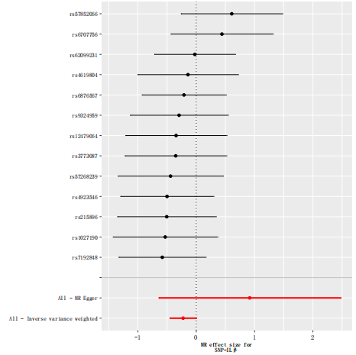
eFigure 8. Forest plot of sensorineural hearing loss-associated SNPs with risk of systemic inflammatory regulators. The genetic relationship between MCSF, ILβ and sensorineural hearing loss, denoted as A to B, respectively. Abbreviations: MCSF, Macrophage colony-stimulating factor; IL, interleukin.
A
B

eTable 1 the sample size for each cytokine analyzed in this study acquired form the GWAS
Cytokines | Abbreviation | Sample size | Number
Cutaneous T-cell attracting (CCL27) | CTACK | 3,631 | GCST004420
Beta nerve growth factor | βNGF | 3,531 | GCST004421
Vascular endothelial growth factor | VEGF | 7,118 | GCST004422
Macrophage migration inhibitory factor (glycosylation-inhibiting factor) | MIF | 3,494 | GCST004423
TNF-related apoptosis inducing ligand | TRAIL | 8,186 | GCST004424
Tumor necrosis factor-beta | TNFβ | 1,559 | GCST004425
Tumor necrosis factor-alpha | TNFα | 3,454 | GCST004426
Stromal cell-derived factor-1 alpha (CXCL12) | SDF1α | 5,998 | GCST004427
Stem cell growth factor beta | SCGFβ | 3,682 | GCST004428
Stem cell factor | SCF | 8,290 | GCST004429
Interleukin-16 | IL-16 | 3,483 | GCST004430
Regulated on activation, normal T cell expressed and secreted (CCL5) | RANTES | 3,421 | GCST004431
Platelet derived growth factor BB | PDGFbb | 8,293 | GCST004432
Macrophage inflammatory protein-1β (CCL4) | MIP1β | 8,243 | GCST004433
Macrophage inflammatory protein-1α (CCL3) | MIP1α | 3,522 | GCST004434
Monokine induced by interferon-gamma (CXCL9) | MIG | 3,685 | GCST004435
Macrophage colony-stimulating factor | MCSF | 840 | GCST004436
Monocyte specific chemokine 3 (CCL7) | MCP3 | 843 | GCST004437
Monocyte chemotactic protein-1 (CCL2) | MCP1 | 8,293 | GCST004438
Interleukin-12p70 | IL-12p70 | 8,270 | GCST004439
Interferon gamma-induced protein 10 (CXCL10) | IP10 | 3,685 | GCST004440
Interleukin-18 | IL-18 | 3,636 | GCST004441
Interleukin-17 | IL-17 | 7,760 | GCST004442
Interleukin-13 | IL-13 | 3,557 | GCST004443
Interleukin-10 | IL-10 | 7,681 | GCST004444
Interleukin-8 (CXCL8) | IL-8 | 3,526 | GCST004445
Interleukin-6 | IL-6 | 8,189 | GCST004446
Interleukin-1 receptor antagonist | IL1ra | 3,638 | GCST004447
Interleukin-1-beta | IL-1β | 3,309 | GCST004448
Hepatocyte growth factor | HGF | 8,292 | GCST004449
Interleukin-9 | IL-9 | 3,634 | GCST004450
Interleukin-7 | IL-7 | 3,409 | GCST004451
Interleukin-5 | IL-5 | 3,364 | GCST004452
Interleukin-4 | IL-4 | 8,124 | GCST004453
Interleukin-2 receptor, alpha subunit | IL2rα | 3,677 | GCST004454
Interleukin-2 | IL-2 | 3,475 | GCST004455
Interferon-gamma | IFN-γ | 7,701 | GCST004456
Growth regulated oncogene-α (CXCL1) | GROα | 3,505 | GCST004457
Granulocyte colony-stimulating factor | GCSF | 7,904 | GCST004458
Basic fibroblast growth factor | bFGF | 7,565 | GCST004459
Eotaxin (CCL11) | Eotaxin | 8,153 | GCST004460

eTable 2 Odds ratio for association of genetically predicted systemic inflammatory regulators with SNHL
exposure | id.outcome | method | nsnp | b | se | pval | lo_ci | up_ci | or | or_lci95 | or_uci95
CTACK | SNHL | Inverse variance weighted | 8 | 0.002996917 | 0.017994214 | 0.867724991 | -0.032271742 | 0.038265575 | 1.003001412 | 0.968243434 | 1.039007131
CTACK | SNHL | MR Egger | 8 | 0.027252775 | 0.034568721 | 0.460487367 | -0.040501919 | 0.095007469 | 1.027627528 | 0.960307321 | 1.099667068
CTACK | SNHL | Weighted median | 8 | 0.010206469 | 0.023056732 | 0.658006145 | -0.034984725 | 0.055397664 | 1.010258733 | 0.965620166 | 1.056960847
CTACK | SNHL | Weighted mode | 8 | 0.011077422 | 0.026310842 | 0.686365115 | -0.040491828 | 0.062646673 | 1.011139004 | 0.960317012 | 1.064650603
βNGF | SNHL | Inverse variance weighted | 7 | -0.024086233 | 0.026099894 | 0.356086456 | -0.075242026 | 0.027069559 | 0.976201525 | 0.927518976 | 1.027439268
βNGF | SNHL | MR Egger | 7 | 0.040364505 | 0.137043398 | 0.780183453 | -0.228240555 | 0.308969564 | 1.041190224 | 0.795932771 | 1.362020915
βNGF | SNHL | Weighted median | 7 | -0.00052031 | 0.032767279 | 0.987330974 | -0.064744177 | 0.063703558 | 0.999479826 | 0.937307217 | 1.065776411
βNGF | SNHL | Weighted mode | 7 | 0.011421459 | 0.03808787 | 0.77439274 | -0.063230766 | 0.086073684 | 1.011486933 | 0.938726822 | 1.089886632
VEGF | SNHL | Inverse variance weighted | 10 | 0.039891268 | 0.013204648 | 0.002519397 | 0.014010158 | 0.065772379 | 1.040697611 | 1.01410876 | 1.067983594
VEGF | SNHL | MR Egger | 10 | 0.045623281 | 0.022075143 | 0.072597406 | 0.002356002 | 0.088890561 | 1.046680033 | 1.002358779 | 1.092961037
VEGF | SNHL | Weighted median | 10 | 0.047826242 | 0.015154958 | 0.001600504 | 0.018122524 | 0.077529959 | 1.048988369 | 1.018287733 | 1.080614606
VEGF | SNHL | Weighted mode | 10 | 0.048861936 | 0.014303589 | 0.00767562 | 0.020826902 | 0.07689697 | 1.050075363 | 1.021045296 | 1.079930806
MIF | SNHL | Inverse variance weighted (multiplicative random effects) | 6 | 0.009703069 | 0.04349676 | 0.823476611 | -0.07555058 | 0.094956719 | 1.009750296 | 0.92723283 | 1.099611261
MIF | SNHL | MR Egger | 6 | 0.045494123 | 0.079167544 | 0.596297738 | -0.109674263 | 0.200662508 | 1.046544854 | 0.896125989 | 1.222212216
MIF | SNHL | Weighted median | 6 | 0.00751688 | 0.036079751 | 0.834962972 | -0.063199432 | 0.078233191 | 1.007545202 | 0.938756237 | 1.081374796
MIF | SNHL | Weighted mode | 6 | 0.005641445 | 0.057491764 | 0.925644453 | -0.107042412 | 0.118325303 | 1.005657388 | 0.898487565 | 1.125610216
TRAIL | SNHL | Inverse variance weighted (multiplicative random effects) | 14 | -0.013687611 | 0.017869486 | 0.443690144 | -0.048711804 | 0.021336583 | 0.986405638 | 0.952455584 | 1.021565835
TRAIL | SNHL | MR Egger | 14 | -0.029247956 | 0.02242119 | 0.216535092 | -0.073193489 | 0.014697576 | 0.971175626 | 0.92942098 | 1.014806117
TRAIL | SNHL | Weighted median | 14 | -0.023049874 | 0.018422343 | 0.210864731 | -0.059157666 | 0.013057919 | 0.977213745 | 0.942558148 | 1.013143546
TRAIL | SNHL | Weighted mode | 14 | -0.025105601 | 0.018754123 | 0.203618631 | -0.061863681 | 0.01165248 | 0.975206924 | 0.940011019 | 1.011720635
TNFβ | SNHL | Inverse variance weighted | 4 | -0.005955844 | 0.021353724 | 0.780311114 | -0.047809143 | 0.035897454 | 0.994061856 | 0.953315717 | 1.036549547
TNFβ | SNHL | MR Egger | 4 | -0.025703041 | 0.039018555 | 0.577760698 | -0.102179409 | 0.050773328 | 0.974624471 | 0.902867555 | 1.052084388
TNFβ | SNHL | Weighted median | 4 | -0.016429261 | 0.022450959 | 0.464300191 | -0.060433141 | 0.027574619 | 0.983704963 | 0.941356705 | 1.027958318
TNFβ | SNHL | Weighted mode | 4 | -0.027494878 | 0.025044382 | 0.352488082 | -0.076581866 | 0.02159211 | 0.972879666 | 0.926277081 | 1.021826907
TNFα | SNHL | Inverse variance weighted | 4 | 0.011540246 | 0.033642385 | 0.73157816 | -0.054398829 | 0.07747932 | 1.011607091 | 0.947054319 | 1.080559887
TNFα | SNHL | MR Egger | 4 | 0.028641205 | 0.06737349 | 0.71212606 | -0.103410836 | 0.160693245 | 1.029055308 | 0.901756423 | 1.174324684
TNFα | SNHL | Weighted median | 4 | 0.007753291 | 0.037275856 | 0.835230785 | -0.065307386 | 0.080813969 | 1.007783426 | 0.936779466 | 1.084169189
TNFα | SNHL | Weighted mode | 4 | -0.040912452 | 0.060964085 | 0.55021133 | -0.160402059 | 0.078577155 | 0.959913165 | 0.851801246 | 1.081746814
SDF1α | SNHL | Inverse variance weighted | 8 | 0.090905175 | 0.036537967 | 0.012847646 | 0.019290759 | 0.16251959 | 1.095165151 | 1.019478028 | 1.176471365
SDF1α | SNHL | MR Egger | 8 | 0.014992833 | 0.079603306 | 0.856815454 | -0.141029646 | 0.171015312 | 1.015105789 | 0.868463565 | 1.186508917
SDF1α | SNHL | Weighted median | 8 | 0.04565619 | 0.052081389 | 0.380686787 | -0.056423333 | 0.147735713 | 1.046714478 | 0.945138943 | 1.159206493
SDF1α | SNHL | Weighted mode | 8 | 0.034083329 | 0.063066999 | 0.605660141 | -0.089527989 | 0.157694647 | 1.034670821 | 0.914362672 | 1.17080863
SCGFβ | SNHL | Inverse variance weighted | 14 | 0.006524395 | 0.015333301 | 0.670468631 | -0.023528874 | 0.036577664 | 1.006545725 | 0.976745771 | 1.037254859
SCGFβ | SNHL | MR Egger | 14 | 0.054128767 | 0.025148841 | 0.052424114 | 0.004837039 | 0.103420495 | 1.055620522 | 1.004848757 | 1.108957622
SCGFβ | SNHL | Weighted median | 14 | 0.030874156 | 0.019540876 | 0.114111879 | -0.007425961 | 0.069174273 | 1.031355706 | 0.992601544 | 1.071622948
SCGFβ | SNHL | Weighted mode | 14 | 0.033753115 | 0.022781886 | 0.162281562 | -0.010899382 | 0.078405612 | 1.034329215 | 0.989159801 | 1.081561264
SCF | SNHL | Inverse variance weighted | 9 | 0.010616134 | 0.029461267 | 0.718591351 | -0.047127949 | 0.068360216 | 1.010672685 | 0.95396533 | 1.070750941
SCF | SNHL | MR Egger | 9 | -0.045027446 | 0.069259321 | 0.536354337 | -0.180775714 | 0.090720822 | 0.955971244 | 0.834622532 | 1.094963273
SCF | SNHL | Weighted median | 9 | 0.013031831 | 0.039111009 | 0.738982501 | -0.063625748 | 0.089689409 | 1.013117115 | 0.938356116 | 1.093834496
SCF | SNHL | Weighted mode | 9 | -0.002194818 | 0.050556059 | 0.966435907 | -0.101284693 | 0.096895057 | 0.997807589 | 0.903675726 | 1.101744747
IL-16 | SNHL | Inverse variance weighted | 10 | 0.026454178 | 0.015835077 | 0.094799479 | -0.004582572 | 0.057490928 | 1.026807196 | 0.995427912 | 1.059175662
IL-16 | SNHL | MR Egger | 10 | 0.009391267 | 0.028529079 | 0.750470512 | -0.046525728 | 0.065308261 | 1.009435503 | 0.954540002 | 1.067488038
IL-16 | SNHL | Weighted median | 10 | 0.035757181 | 0.02056213 | 0.082037876 | -0.004544595 | 0.076058956 | 1.036404157 | 0.995465716 | 1.079026188
IL-16 | SNHL | Weighted mode | 10 | 0.036354998 | 0.022430531 | 0.139515409 | -0.007608844 | 0.080318839 | 1.037023922 | 0.99242003 | 1.083632517
RANTES | SNHL | Inverse variance weighted | 9 | -0.000283441 | 0.021617375 | 0.989538675 | -0.042653495 | 0.042086614 | 0.9997166 | 0.958243369 | 1.042984812
RANTES | SNHL | MR Egger | 9 | -0.109678304 | 0.054505801 | 0.08408848 | -0.216509674 | -0.002846935 | 0.896122368 | 0.805324744 | 0.997157114
RANTES | SNHL | Weighted median | 9 | -0.002991973 | 0.029844688 | 0.920144697 | -0.061487562 | 0.055503615 | 0.997012498 | 0.940364642 | 1.057072838
RANTES | SNHL | Weighted mode | 9 | -0.010166351 | 0.050535887 | 0.845585617 | -0.10921669 | 0.088883988 | 0.989885152 | 0.896536126 | 1.092953853
PDGFbb | SNHL | Inverse variance weighted | 13 | -0.033777735 | 0.018295083 | 0.064852444 | -0.069636098 | 0.002080628 | 0.966786364 | 0.932733182 | 1.002082794
PDGFbb | SNHL | MR Egger | 13 | 0.001941818 | 0.03553747 | 0.957403931 | -0.067711623 | 0.071595259 | 1.001943705 | 0.934529931 | 1.074220475
PDGFbb | SNHL | Weighted median | 13 | -0.027436842 | 0.024542386 | 0.263593887 | -0.075539918 | 0.020666234 | 0.972936129 | 0.927242716 | 1.02088126
PDGFbb | SNHL | Weighted mode | 13 | -0.024708336 | 0.025371201 | 0.349342585 | -0.074435889 | 0.025019217 | 0.975594417 | 0.928266985 | 1.025334825
MIP1β | SNHL | Inverse variance weighted | 17 | -0.012378205 | 0.010539867 | 0.240227843 | -0.033036344 | 0.008279935 | 0.98769809 | 0.967503396 | 1.008314309
MIP1β | SNHL | MR Egger | 17 | -0.015261078 | 0.015918201 | 0.352899625 | -0.046460753 | 0.015938597 | 0.984854782 | 0.954602026 | 1.016066294
MIP1β | SNHL | Weighted median | 17 | -0.009401706 | 0.014567401 | 0.518672208 | -0.037953812 | 0.0191504 | 0.990642352 | 0.962757408 | 1.019334945
MIP1β | SNHL | Weighted mode | 17 | -0.010764249 | 0.012006156 | 0.383244952 | -0.034296314 | 0.012767816 | 0.989293478 | 0.966285138 | 1.012849673
MIP1α | SNHL | Inverse variance weighted | 7 | -0.012762291 | 0.024252011 | 0.598723968 | -0.060296232 | 0.03477165 | 0.987318802 | 0.941485594 | 1.035383252
MIP1α | SNHL | MR Egger | 7 | -0.053438652 | 0.066805181 | 0.460057559 | -0.184376806 | 0.077499502 | 0.947964095 | 0.831622385 | 1.080581694
MIP1α | SNHL | Weighted median | 7 | -0.009741345 | 0.033793672 | 0.773148148 | -0.075976941 | 0.056494251 | 0.990305948 | 0.926837578 | 1.058120532
MIP1α | SNHL | Weighted mode | 7 | -0.004816533 | 0.050057719 | 0.926479545 | -0.102929662 | 0.093296597 | 0.995195048 | 0.902190429 | 1.097787288
MIG | SNHL | Inverse variance weighted | 14 | -0.001211733 | 0.017770005 | 0.94563453 | -0.036040944 | 0.033617477 | 0.998789 | 0.964600798 | 1.03418893
MIG | SNHL | MR Egger | 14 | 0.011249892 | 0.04150795 | 0.790973907 | -0.07010569 | 0.092605475 | 1.01131341 | 0.93229528 | 1.097028845
MIG | SNHL | Weighted median | 14 | -0.018887349 | 0.023271151 | 0.41700927 | -0.064498805 | 0.026724106 | 0.981289899 | 0.937537235 | 1.027084398
MIG | SNHL | Weighted mode | 14 | -0.03305412 | 0.047825057 | 0.501629549 | -0.126791231 | 0.060682992 | 0.967486198 | 0.880917561 | 1.06256202
MCSF | SNHL | Inverse variance weighted | 7 | -0.027981111 | 0.025649836 | 0.275321954 | -0.078254789 | 0.022292568 | 0.972406735 | 0.924728785 | 1.022542904
MCSF | SNHL | MR Egger | 7 | -0.030998927 | 0.052157041 | 0.578156121 | -0.133226727 | 0.071228874 | 0.969476614 | 0.875266623 | 1.073826969
MCSF | SNHL | Weighted median | 7 | -0.054951077 | 0.027356588 | 0.044569354 | -0.10856999 | -0.001332164 | 0.946531454 | 0.897116103 | 0.998668723
MCSF | SNHL | Weighted mode | 7 | -0.080802951 | 0.049799537 | 0.155809067 | -0.178410043 | 0.016804141 | 0.922375427 | 0.836599312 | 1.016946125
MCP3 | SNHL | Inverse variance weighted | 2 | -0.038454582 | 0.026632851 | 0.148773353 | -0.090654969 | 0.013745806 | 0.962275409 | 0.913332784 | 1.013840714
MCP1 | SNHL | Inverse variance weighted (multiplicative random effects) | 14 | 0.02289913 | 0.028896783 | 0.428100883 | -0.033738566 | 0.079536825 | 1.023163328 | 0.966824233 | 1.082785433
MCP1 | SNHL | MR Egger | 14 | -0.021206329 | 0.06921168 | 0.764552612 | -0.156861222 | 0.114448563 | 0.979016944 | 0.854822682 | 1.121254965
MCP1 | SNHL | Weighted median | 14 | 0.022248501 | 0.02889588 | 0.441327132 | -0.034387424 | 0.078884425 | 1.022497844 | 0.966197104 | 1.082079254
MCP1 | SNHL | Weighted mode | 14 | 0.019375505 | 0.02783658 | 0.498656731 | -0.035184193 | 0.073935202 | 1.019564428 | 0.965427575 | 1.076737032
IL-12p70 | SNHL | Inverse variance weighted (multiplicative random effects) | 10 | 0.04571077 | 0.022926737 | 0.046176579 | 0.000774365 | 0.090647174 | 1.046771609 | 1.000774665 | 1.094882634
IL-12p70 | SNHL | MR Egger | 10 | 0.076896803 | 0.038529227 | 0.081041223 | 0.001379518 | 0.152414087 | 1.079930625 | 1.00138047 | 1.1646424
IL-12p70 | SNHL | Weighted median | 10 | 0.054520008 | 0.018210743 | 0.002754926 | 0.018826951 | 0.090213065 | 1.056033605 | 1.019005295 | 1.094407438
IL-12p70 | SNHL | Weighted mode | 10 | 0.059119231 | 0.018968377 | 0.01238382 | 0.021941211 | 0.09629725 | 1.060901725 | 1.02218369 | 1.101086313
IP10 | SNHL | Inverse variance weighted | 9 | -0.016497295 | 0.021019247 | 0.432532061 | -0.05769502 | 0.024700429 | 0.98363804 | 0.943937786 | 1.025008012
IP10 | SNHL | MR Egger | 9 | -0.008708719 | 0.040984887 | 0.83778291 | -0.089039098 | 0.07162166 | 0.991329092 | 0.914809806 | 1.074248836
IP10 | SNHL | Weighted median | 9 | 0.007753604 | 0.029004183 | 0.78921734 | -0.049094595 | 0.064601802 | 1.007783741 | 0.952091062 | 1.066734169
IP10 | SNHL | Weighted mode | 9 | 0.009755022 | 0.035871116 | 0.79254975 | -0.060552364 | 0.080062409 | 1.009802757 | 0.94124448 | 1.083354676
IL-18 | SNHL | Inverse variance weighted | 15 | -0.021057762 | 0.016903582 | 0.212853489 | -0.054188783 | 0.012073259 | 0.979162405 | 0.947253264 | 1.012146435
IL-18 | SNHL | MR Egger | 15 | -0.050992889 | 0.03699419 | 0.191339323 | -0.123501501 | 0.021515723 | 0.950285428 | 0.883820315 | 1.021748855
IL-18 | SNHL | Weighted median | 15 | -0.014094734 | 0.020568002 | 0.493170514 | -0.054408019 | 0.026218551 | 0.986004131 | 0.947045615 | 1.02656528
IL-18 | SNHL | Weighted mode | 15 | -0.016235595 | 0.030587267 | 0.603879145 | -0.076186638 | 0.043715447 | 0.983895492 | 0.926643244 | 1.044685045
IL-17 | SNHL | Inverse variance weighted | 10 | -0.055805646 | 0.028506616 | 0.050272461 | -0.111678614 | 6.73E-05 | 0.945722923 | 0.894331637 | 1.000067324
IL-17 | SNHL | MR Egger | 10 | -0.039988892 | 0.058865987 | 0.516103902 | -0.155366225 | 0.075388442 | 0.960800112 | 0.856101594 | 1.078302928
IL-17 | SNHL | Weighted median | 10 | -0.074357834 | 0.037263998 | 0.04599561 | -0.147395271 | -0.001320397 | 0.928339443 | 0.86295281 | 0.998680474
IL-17 | SNHL | Weighted mode | 10 | -0.097658349 | 0.047839569 | 0.071606095 | -0.191423904 | -0.003892794 | 0.906958714 | 0.825782462 | 0.996114773
IL-13 | SNHL | Inverse variance weighted | 9 | 0.034953774 | 0.014032113 | 0.012738973 | 0.007450832 | 0.062456716 | 1.035571838 | 1.007478659 | 1.064448384
IL-13 | SNHL | MR Egger | 9 | 0.065959894 | 0.026983138 | 0.044465418 | 0.013072942 | 0.118846845 | 1.068183875 | 1.013158767 | 1.126197422
IL-13 | SNHL | Weighted median | 9 | 0.054707987 | 0.016983193 | 0.001276098 | 0.021420929 | 0.087995045 | 1.056232136 | 1.021652004 | 1.091982712
IL-13 | SNHL | Weighted mode | 9 | 0.057095446 | 0.01754559 | 0.011629154 | 0.02270609 | 0.091484801 | 1.05875686 | 1.022965836 | 1.095800122
IL-10 | SNHL | Inverse variance weighted | 10 | 0.060432662 | 0.023110008 | 0.008922756 | 0.015137046 | 0.105728277 | 1.062296062 | 1.015252191 | 1.11151981
IL-10 | SNHL | MR Egger | 10 | 0.123965075 | 0.04417276 | 0.022971221 | 0.037386466 | 0.210543684 | 1.131976336 | 1.038094131 | 1.234348973
IL-10 | SNHL | Weighted median | 10 | 0.079725866 | 0.024370949 | 0.001070359 | 0.031958807 | 0.127492925 | 1.082990143 | 1.032474973 | 1.135976832
IL-10 | SNHL | Weighted mode | 10 | 0.078185918 | 0.025721249 | 0.014023798 | 0.02777227 | 0.128599566 | 1.081323677 | 1.028161515 | 1.137234645
IL-8 | SNHL | Inverse variance weighted | 4 | -0.003102317 | 0.03245679 | 0.92385178 | -0.066717625 | 0.060512991 | 0.99690249 | 0.935459315 | 1.062381399
IL-8 | SNHL | MR Egger | 4 | 0.049892622 | 0.085630706 | 0.619068246 | -0.117943562 | 0.217728805 | 1.051158219 | 0.88874621 | 1.243249859
IL-8 | SNHL | Weighted median | 4 | -0.005145374 | 0.036735603 | 0.888608605 | -0.077147156 | 0.066856409 | 0.994867841 | 0.925753613 | 1.069141948
IL-8 | SNHL | Weighted mode | 4 | -0.021425599 | 0.051351159 | 0.704565186 | -0.122073871 | 0.079222673 | 0.978802298 | 0.885082984 | 1.082445326
IL-6 | SNHL | Inverse variance weighted | 5 | 0.017196238 | 0.039620541 | 0.664271524 | -0.060460022 | 0.094852497 | 1.017344944 | 0.941331401 | 1.099496664
IL-6 | SNHL | MR Egger | 5 | -0.022278068 | 0.084920341 | 0.810041743 | -0.188721936 | 0.1441658 | 0.977968255 | 0.828016716 | 1.155075604
IL-6 | SNHL | Weighted median | 5 | 0.024997548 | 0.049215882 | 0.611512059 | -0.071465581 | 0.121460676 | 1.025312606 | 0.931028322 | 1.129144963
IL-6 | SNHL | Weighted mode | 5 | 0.059791945 | 0.068751597 | 0.433549833 | -0.074961184 | 0.194545075 | 1.06161565 | 0.927779498 | 1.214758237
IL1ra | SNHL | Inverse variance weighted | 6 | -0.019878256 | 0.026859108 | 0.45924317 | -0.072522108 | 0.032765597 | 0.980318014 | 0.930045185 | 1.0333083
IL1ra | SNHL | MR Egger | 6 | -0.049695841 | 0.071458844 | 0.525062642 | -0.189755176 | 0.090363494 | 0.951518793 | 0.827161618 | 1.094572082
IL1ra | SNHL | Weighted median | 6 | -0.004859182 | 0.03276409 | 0.88209958 | -0.069076798 | 0.059358435 | 0.995152605 | 0.933255005 | 1.061155527
IL1ra | SNHL | Weighted mode | 6 | 0.00020067 | 0.043784949 | 0.996520473 | -0.085617829 | 0.08601917 | 1.00020069 | 0.917944976 | 1.08982722
IL-1β | SNHL | Inverse variance weighted | 4 | -0.001785053 | 0.039519576 | 0.963972734 | -0.079243421 | 0.075673315 | 0.998216539 | 0.923815021 | 1.078610151
IL-1β | SNHL | MR Egger | 4 | 0.181497341 | 0.118586037 | 0.265539467 | -0.050931292 | 0.413925974 | 1.199011349 | 0.950343965 | 1.512745141
IL-1β | SNHL | Weighted median | 4 | 0.026032449 | 0.038987348 | 0.504315332 | -0.050382753 | 0.102447651 | 1.026374253 | 0.950865409 | 1.107879304
IL-1β | SNHL | Weighted mode | 4 | 0.026796726 | 0.037570301 | 0.527172358 | -0.046841063 | 0.100434515 | 1.027158987 | 0.954239049 | 1.105651236
HGF | SNHL | Inverse variance weighted | 7 | 0.022772447 | 0.044939997 | 0.612344239 | -0.065309947 | 0.110854841 | 1.023033719 | 0.936777068 | 1.117232718
HGF | SNHL | MR Egger | 7 | -0.03620372 | 0.111662252 | 0.758891768 | -0.255061734 | 0.182654293 | 0.964443797 | 0.774868661 | 1.20039935
HGF | SNHL | Weighted median | 7 | 0.000335676 | 0.047645161 | 0.994378682 | -0.093048839 | 0.093720191 | 1.000335732 | 0.911148999 | 1.098252403
HGF | SNHL | Weighted mode | 7 | -0.076278973 | 0.082407575 | 0.390349414 | -0.23779782 | 0.085239874 | 0.926557686 | 0.788362066 | 1.088978252
IL-9 | SNHL | Inverse variance weighted | 6 | 0.016040953 | 0.026931326 | 0.551426227 | -0.036744447 | 0.068826352 | 1.0161703 | 0.963922437 | 1.071250173
IL-9 | SNHL | MR Egger | 6 | -0.006977065 | 0.062665372 | 0.916711124 | -0.129801194 | 0.115847064 | 0.993047218 | 0.878270019 | 1.122824139
IL-9 | SNHL | Weighted median | 6 | 0.023768722 | 0.033755688 | 0.481345747 | -0.042392427 | 0.089929871 | 1.024053449 | 0.958493568 | 1.094097553
IL-9 | SNHL | Weighted mode | 6 | 0.028090976 | 0.043311961 | 0.54521957 | -0.056800467 | 0.11298242 | 1.028489248 | 0.944782565 | 1.119612249
IL-7 | SNHL | Inverse variance weighted | 10 | 0.044807602 | 0.015845175 | 0.004686338 | 0.01375106 | 0.075864145 | 1.045826626 | 1.01384604 | 1.078816002
IL-7 | SNHL | MR Egger | 10 | 0.046274371 | 0.042350489 | 0.306354588 | -0.036732588 | 0.12928133 | 1.047361737 | 0.963933868 | 1.138010236
IL-7 | SNHL | Weighted median | 10 | 0.065968485 | 0.020863355 | 0.001567268 | 0.02507631 | 0.10686066 | 1.068193053 | 1.025393365 | 1.112779189
IL-7 | SNHL | Weighted mode | 10 | 0.068091421 | 0.023592897 | 0.017998298 | 0.021849343 | 0.1143335 | 1.070463167 | 1.022089788 | 1.121125958
IL-5 | SNHL | Inverse variance weighted (multiplicative random effects) | 5 | 0.012774497 | 0.048905877 | 0.793933828 | -0.083081022 | 0.108630017 | 1.01285644 | 0.920276581 | 1.114749835
IL-5 | SNHL | MR Egger | 5 | -0.099762383 | 0.112037336 | 0.438828436 | -0.319355561 | 0.119830794 | 0.905052448 | 0.726617146 | 1.127306089
IL-5 | SNHL | Weighted median | 5 | -0.021569638 | 0.03953976 | 0.585397539 | -0.099067568 | 0.055928293 | 0.978661324 | 0.905681511 | 1.057521849
IL-5 | SNHL | Weighted mode | 5 | -0.051500812 | 0.053962637 | 0.393936517 | -0.15726758 | 0.054265955 | 0.949802878 | 0.854475388 | 1.055765351
IL-4 | SNHL | Inverse variance weighted | 8 | -0.032009598 | 0.033684847 | 0.341976602 | -0.098031898 | 0.034012701 | 0.968497286 | 0.906619984 | 1.034597747
IL-4 | SNHL | MR Egger | 8 | -0.047411561 | 0.081435997 | 0.581636507 | -0.207026115 | 0.112202992 | 0.953694813 | 0.812998418 | 1.118739933
IL-4 | SNHL | Weighted median | 8 | -0.016494378 | 0.04147103 | 0.690827346 | -0.097777596 | 0.06478884 | 0.983640909 | 0.906850568 | 1.066933707
IL-4 | SNHL | Weighted mode | 8 | 0.016828839 | 0.068895703 | 0.814030301 | -0.118206739 | 0.151864417 | 1.016971241 | 0.888512343 | 1.164002407
IL2rα | SNHL | Inverse variance weighted | 5 | -0.005016493 | 0.027295236 | 0.854181027 | -0.058515156 | 0.04848217 | 0.994996068 | 0.943163945 | 1.049676656
IL2rα | SNHL | MR Egger | 5 | -0.037513938 | 0.047113508 | 0.484076582 | -0.129856414 | 0.054828538 | 0.963180993 | 0.878221522 | 1.056359473
IL2rα | SNHL | Weighted median | 5 | -0.017438264 | 0.022166783 | 0.431466585 | -0.060885159 | 0.02600863 | 0.982712902 | 0.940931292 | 1.026349806
IL2rα | SNHL | Weighted mode | 5 | -0.018528934 | 0.023862765 | 0.480822811 | -0.065299952 | 0.028242085 | 0.981641672 | 0.93678643 | 1.028644674
IL-2 | SNHL | Inverse variance weighted | 9 | -0.004454276 | 0.019188207 | 0.816432288 | -0.042063161 | 0.033154609 | 0.99555563 | 0.958809219 | 1.033710348
IL-2 | SNHL | MR Egger | 9 | -0.057712476 | 0.03739198 | 0.166632306 | -0.131000758 | 0.015575805 | 0.943921308 | 0.87721711 | 1.01569774
IL-2 | SNHL | Weighted median | 9 | -0.026098592 | 0.026755837 | 0.329344307 | -0.078540031 | 0.026342848 | 0.974239033 | 0.924465052 | 1.026692888
IL-2 | SNHL | Weighted mode | 9 | -0.034230536 | 0.034351775 | 0.348202958 | -0.101560015 | 0.033098944 | 0.966348701 | 0.903426959 | 1.033652807
IFN-γ | SNHL | Inverse variance weighted | 9 | -0.029897045 | 0.031101337 | 0.336412175 | -0.090855666 | 0.031061575 | 0.970545451 | 0.9131495 | 1.03154902
IFN-γ | SNHL | MR Egger | 9 | -0.082844811 | 0.061291708 | 0.218535211 | -0.202976558 | 0.037286937 | 0.920493987 | 0.816297377 | 1.037990816
IFN-γ | SNHL | Weighted median | 9 | -0.016836738 | 0.042083383 | 0.689097273 | -0.099320168 | 0.065646692 | 0.983304208 | 0.905452765 | 1.067849371
IFN-γ | SNHL | Weighted mode | 9 | -0.011250792 | 0.057342162 | 0.849342464 | -0.12364143 | 0.101139846 | 0.988812261 | 0.883696651 | 1.106431361
GROα | SNHL | Inverse variance weighted | 9 | 0.001229658 | 0.012610142 | 0.922318677 | -0.02348622 | 0.025945536 | 1.001230414 | 0.976787435 | 1.026285051
GROα | SNHL | MR Egger | 9 | 0.030276065 | 0.028791673 | 0.327943777 | -0.026155615 | 0.086707744 | 1.030739045 | 0.974183481 | 1.090577905
GROα | SNHL | Weighted median | 9 | 0.002439248 | 0.015601213 | 0.875757255 | -0.02813913 | 0.033017625 | 1.002442225 | 0.972253088 | 1.033568756
GROα | SNHL | Weighted mode | 9 | 0.003247525 | 0.015791761 | 0.842203403 | -0.027704326 | 0.034199377 | 1.003252804 | 0.972675919 | 1.0347909
GCSF | SNHL | Inverse variance weighted | 7 | 0.034637762 | 0.03212198 | 0.280891145 | -0.02832132 | 0.097596843 | 1.035244635 | 0.972075969 | 1.102518208
GCSF | SNHL | MR Egger | 7 | 0.030550249 | 0.056665993 | 0.61292837 | -0.080515098 | 0.141615595 | 1.031021696 | 0.922640973 | 1.152133678
GCSF | SNHL | Weighted median | 7 | 0.03668112 | 0.042598029 | 0.389183521 | -0.046811017 | 0.120173257 | 1.037362174 | 0.954267721 | 1.127692215
GCSF | SNHL | Weighted mode | 7 | 0.013391378 | 0.071397868 | 0.857403706 | -0.126548443 | 0.153331199 | 1.013481444 | 0.881131463 | 1.165710997
bFGF | SNHL | Inverse variance weighted | 5 | 0.047270478 | 0.041654033 | 0.256444224 | -0.034371427 | 0.128912383 | 1.048405542 | 0.96621256 | 1.137590448
bFGF | SNHL | MR Egger | 5 | 0.218573835 | 0.144678553 | 0.228018122 | -0.064996129 | 0.502143799 | 1.244300886 | 0.937071091 | 1.652259589
bFGF | SNHL | Weighted median | 5 | 0.057112884 | 0.054476999 | 0.294461134 | -0.049662034 | 0.163887802 | 1.058775322 | 0.951550962 | 1.178082129
bFGF | SNHL | Weighted mode | 5 | 0.080152026 | 0.072345448 | 0.330033554 | -0.061645052 | 0.221949103 | 1.083451768 | 0.940216556 | 1.248507831
Eotaxin | SNHL | Inverse variance weighted | 15 | 0.033840981 | 0.020507992 | 0.098915072 | -0.006354683 | 0.074036646 | 1.034420101 | 0.993665465 | 1.076846267
Eotaxin | SNHL | MR Egger | 15 | 0.025655234 | 0.049097228 | 0.610084819 | -0.070575333 | 0.121885801 | 1.025987162 | 0.931857537 | 1.129625093
Eotaxin | SNHL | Weighted median | 15 | 0.019220147 | 0.026355217 | 0.46583472 | -0.032436078 | 0.070876371 | 1.019406043 | 0.968084329 | 1.073448509
Eotaxin | SNHL | Weighted mode | 15 | 0.015715688 | 0.027095931 | 0.57113067 | -0.037392337 | 0.068823714 | 1.015839829 | 0.963298124 | 1.071247346
Abbreviations: IVW, inverse variance weighting.VEGF, Vascular endothelial growth factor levels; SDF1a, Stromal-cell-derived factor 1 alpha levvels; IL, interleukin; OR: odds ratio; CI: confidence interval

eTable 3 Results of heterogeneity horizontal pleiotropy test and statistical power
exposure | id.outcome | method | Q | Q_df | Q_pval | egger_intercept | se | pval
CTACK | SNHL | MR Egger | 2.038449589 | 6 | 0.916128627 | -0.007059015 | 0.00858989 | 0.442623966
CTACK | SNHL | Inverse variance weighted | 2.713774904 | 7 | 0.910158645
βNGF | SNHL | MR Egger | 7.032998562 | 5 | 0.218197709 | -0.009689625 | 0.020170165 | 0.651228689
βNGF | SNHL | Inverse variance weighted | 7.357611308 | 6 | 0.289037367
VEGF | SNHL | MR Egger | 6.525691344 | 8 | 0.588559377 | -0.001719409 | 0.005306509 | 0.754232821
VEGF | SNHL | Inverse variance weighted | 6.63067955 | 9 | 0.675508925
MIF | SNHL | MR Egger | 14.38841419 | 4 | 0.006153221 | -0.011752358 | 0.020960759 | 0.604931645
MIF | SNHL | Inverse variance weighted | 15.51922233 | 5 | 0.008359571
TRAIL | SNHL | MR Egger | 22.17987114 | 12 | 0.035552645 | 0.007678769 | 0.00680205 | 0.281007064
TRAIL | SNHL | Inverse variance weighted | 24.5353615 | 13 | 0.026547931
TNFβ | SNHL | MR Egger | 3.398446688 | 2 | 0.182825461 | 0.006975992 | 0.010914071 | 0.588147302
TNFβ | SNHL | Inverse variance weighted | 4.092653378 | 3 | 0.251631484
TNFα | SNHL | MR Egger | 3.254236859 | 2 | 0.196494973 | -0.003929066 | 0.012420426 | 0.781708946
TNFα | SNHL | Inverse variance weighted | 3.417063288 | 3 | 0.331679105
SDF1α | SNHL | MR Egger | 5.574615574 | 6 | 0.472484667 | 0.008636901 | 0.008046421 | 0.324359802
SDF1α | SNHL | Inverse variance weighted | 6.726769039 | 7 | 0.45787216
SCGFβ | SNHL | MR Egger | 10.64408904 | 12 | 0.559641081 | -0.012875969 | 0.005667696 | 0.042298968
SCGFβ | SNHL | Inverse variance weighted | 15.8052421 | 13 | 0.259806861
SCF | SNHL | MR Egger | 4.505685903 | 7 | 0.720032487 | 0.007568791 | 0.008526018 | 0.404155608
SCF | SNHL | Inverse variance weighted | 5.293748208 | 8 | 0.725767939
IL-16 | SNHL | MR Egger | 8.833211094 | 8 | 0.356560988 | 0.005295651 | 0.007274239 | 0.487371423
IL-16 | SNHL | Inverse variance weighted | 9.418394634 | 9 | 0.399582456
RANTES | SNHL | MR Egger | 3.837301251 | 7 | 0.798314916 | 0.025277448 | 0.0116319 | 0.066311431
RANTES | SNHL | Inverse variance weighted | 8.559726659 | 8 | 0.380785489
PDGFbb | SNHL | MR Egger | 10.65625856 | 11 | 0.472493719 | -0.006291209 | 0.005368365 | 0.26599252
PDGFbb | SNHL | Inverse variance weighted | 12.02961811 | 12 | 0.443303909
MIP1β | SNHL | MR Egger | 14.02821552 | 15 | 0.523390279 | 0.001148017 | 0.004750351 | 0.812308602
MIP1β | SNHL | Inverse variance weighted | 14.08661988 | 16 | 0.592260822
MIP1α | SNHL | MR Egger | 4.228906913 | 5 | 0.516951574 | 0.007457432 | 0.011412223 | 0.542312976
MIP1α | SNHL | Inverse variance weighted | 4.655916889 | 6 | 0.58863854
MIG | SNHL | MR Egger | 15.08984693 | 12 | 0.236559715 | -0.003135369 | 0.009360104 | 0.74342926
MIG | SNHL | Inverse variance weighted | 15.23094452 | 13 | 0.293158139
MCSF | SNHL | MR Egger | 11.94801026 | 5 | 0.035507146 | 0.001108384 | 0.016141977 | 0.947917921
MCSF | SNHL | Inverse variance weighted | 11.95927687 | 6 | 0.062883478
MCP3 | SNHL | MR Egger | 0.144904964 | 1 | 0.703452699 | 0.004543517 | 0.006545151 | 0.464686549
MCP3 | SNHL | Inverse variance weighted | 27.0465053 | 12 | 0.007608944
MCP1 | SNHL | MR Egger | 28.16454202 | 13 | 0.008583393 | 0.006703717 | 0.009518151 | 0.494682409
MCP1 | SNHL | Inverse variance weighted | 15.15971066 | 8 | 0.056113378
IL-12p70 | SNHL | MR Egger | 17.08018214 | 9 | 0.047475038 | -0.007066662 | 0.007019575 | 0.343550215
IL-12p70 | SNHL | Inverse variance weighted | 7.072055409 | 7 | 0.421416273
IP10 | SNHL | MR Egger | 7.121744185 | 8 | 0.523556259 | -0.001665132 | 0.007508331 | 0.830822896
IP10 | SNHL | Inverse variance weighted | 21.35685275 | 13 | 0.066163782
IL-18 | SNHL | MR Egger | 22.72081104 | 14 | 0.064967028 | 0.007562571 | 0.008299766 | 0.378787303
IL-18 | SNHL | Inverse variance weighted | 10.95685662 | 8 | 0.204155767
IL-17 | SNHL | MR Egger | 11.09059245 | 9 | 0.269550384 | -0.003063968 | 0.009805242 | 0.762663768
IL-17 | SNHL | Inverse variance weighted | 6.098887277 | 7 | 0.528251489
IL-13 | SNHL | MR Egger | 7.908748602 | 8 | 0.442434311 | -0.009461076 | 0.007032631 | 0.220472544
IL-13 | SNHL | Inverse variance weighted | 9.188573111 | 8 | 0.326638886
IL-10 | SNHL | MR Egger | 12.27615609 | 9 | 0.198184876 | -0.009720129 | 0.005928458 | 0.139725549
IL-10 | SNHL | Inverse variance weighted | 0.414490413 | 2 | 0.812820317
IL-8 | SNHL | MR Egger | 0.861756766 | 3 | 0.834645569 | -0.007931239 | 0.01185927 | 0.572493724
IL-8 | SNHL | Inverse variance weighted | 1.253657473 | 3 | 0.740165852
IL-6 | SNHL | MR Egger | 1.529855632 | 4 | 0.821340084 | 0.005931148 | 0.011285697 | 0.63557408
IL-6 | SNHL | Inverse variance weighted | 1.729601164 | 4 | 0.785333774
IL1ra | SNHL | MR Egger | 1.932360019 | 5 | 0.858422948 | 0.005538366 | 0.012299622 | 0.675829788
IL1ra | SNHL | Inverse variance weighted | 1.724241315 | 2 | 0.422265651
IL-1β | SNHL | MR Egger | 4.312993339 | 3 | 0.229589786 | -0.035912344 | 0.022320223 | 0.248899707
IL-1β | SNHL | Inverse variance weighted | 10.83030061 | 5 | 0.054850394
HGF | SNHL | MR Egger | 11.56894849 | 6 | 0.072305501 | 0.009724233 | 0.016652211 | 0.584598159
HGF | SNHL | Inverse variance weighted | 2.315953551 | 4 | 0.677865986
IL-9 | SNHL | MR Egger | 2.481439697 | 5 | 0.779287659 | 0.005872884 | 0.014436789 | 0.704981259
IL-9 | SNHL | Inverse variance weighted | 9.582956215 | 8 | 0.295524674
IL-7 | SNHL | MR Egger | 9.584661598 | 9 | 0.385142612 | -0.000441067 | 0.011689577 | 0.970826172
IL-7 | SNHL | Inverse variance weighted | 9.90566881 | 3 | 0.019385241
IL-5 | SNHL | MR Egger | 13.9691268 | 4 | 0.007394245 | 0.022683615 | 0.020447756 | 0.348211965
IL-5 | SNHL | Inverse variance weighted | 3.557926091 | 6 | 0.736247614
IL-4 | SNHL | MR Egger | 3.601079427 | 7 | 0.824406195 | 0.002336556 | 0.011247838 | 0.84230836
IL-4 | SNHL | Inverse variance weighted | 6.672327714 | 3 | 0.083108532
IL2rα | SNHL | MR Egger | 8.322625777 | 4 | 0.080449799 | 0.01538571 | 0.017861355 | 0.452367228
IL2rα | SNHL | Inverse variance weighted | 4.89693794 | 7 | 0.672538831
IL-2 | SNHL | MR Egger | 7.650831654 | 8 | 0.468299068 | 0.010767045 | 0.006488181 | 0.140979087
IL-2 | SNHL | Inverse variance weighted | 7.425067402 | 7 | 0.386001895
IFN-γ | SNHL | MR Egger | 8.490924233 | 8 | 0.387040281 | 0.008427131 | 0.008406815 | 0.349527242
IFN-γ | SNHL | Inverse variance weighted | 2.944940819 | 7 | 0.89004849
GROα | SNHL | MR Egger | 4.204289036 | 8 | 0.838237324 | -0.010215739 | 0.009103258 | 0.298787212
GROα | SNHL | Inverse variance weighted | 5.719912852 | 5 | 0.33443344
GCSF | SNHL | MR Egger | 5.729325306 | 6 | 0.45418388 | 0.000721595 | 0.007955215 | 0.931246984
GCSF | SNHL | Inverse variance weighted | 0.731419067 | 3 | 0.865790152
bFGF | SNHL | MR Egger | 2.260048919 | 4 | 0.688051908 | -0.019311742 | 0.015619613 | 0.304291393
bFGF | SNHL | Inverse variance weighted | 16.78292847 | 13 | 0.209418314
Eotaxin | SNHL | MR Egger | 16.82709077 | 14 | 0.265509416 | 0.001321443 | 0.007144716 | 0.856119422
Eotaxin | SNHL | Inverse variance weighted
Abbreviations: SNHL, sensorineural hearing loss; MR, Mendelian randomization

eTable 4 Odds ratio for association of genetically predicted SNHL with systemic inflammatory regulators.
exposure | outcome | method | nsnp | b | se | pval | lo_ci | up_ci | or | or_lci95 | or_uci95
SNHL | CTACK | Inverse variance weighted | 13 | -0.070441892 | 0.146549561 | 0.630751467 | -0.357679031 | 0.216795246 | 0.931981893 | 0.699297492 | 1.242089753
SNHL | CTACK | MR Egger | 13 | -0.279047277 | 1.006115003 | 0.786653438 | -2.251032683 | 1.692938129 | 0.756504137 | 0.105290437 | 5.435427255
SNHL | CTACK | Weighted median | 13 | -0.015807684 | 0.196469023 | 0.935872273 | -0.400886968 | 0.3692716 | 0.984316602 | 0.669725757 | 1.446680469
SNHL | CTACK | Weighted mode | 13 | 0.034284567 | 0.339767082 | 0.921291363 | -0.631658913 | 0.700228047 | 1.034879057 | 0.53170901 | 2.01421199
SNHL | βNGF | Inverse variance weighted | 13 | -0.157712034 | 0.1484547 | 0.288073203 | -0.448683245 | 0.133259177 | 0.854095697 | 0.638468304 | 1.142546081
SNHL | βNGF | MR Egger | 13 | -0.840988871 | 1.028637469 | 0.430952497 | -2.857118309 | 1.175140568 | 0.431283829 | 0.057434029 | 3.238598154
SNHL | βNGF | Weighted median | 13 | -0.280021745 | 0.198859368 | 0.159089746 | -0.669786106 | 0.109742616 | 0.755767307 | 0.511818041 | 1.115990796
SNHL | βNGF | Weighted mode | 13 | -0.316923603 | 0.294255918 | 0.302641201 | -0.893665202 | 0.259817996 | 0.728386399 | 0.409153371 | 1.296694061
SNHL | VEGF | Inverse variance weighted | 13 | -0.092141944 | 0.104991829 | 0.380155065 | -0.297925929 | 0.113642041 | 0.911975691 | 0.742356325 | 1.120351013
SNHL | VEGF | MR Egger | 13 | -0.515038147 | 0.711101495 | 0.484012818 | -1.908797077 | 0.878720783 | 0.597477802 | 0.148258623 | 2.407817615
SNHL | VEGF | Weighted median | 13 | -0.165520854 | 0.142922565 | 0.246816858 | -0.445649082 | 0.114607373 | 0.84745219 | 0.640408464 | 1.121433046
SNHL | VEGF | Weighted mode | 13 | -0.289497503 | 0.241049646 | 0.252925689 | -0.761954809 | 0.182959804 | 0.748639663 | 0.466753122 | 1.200766141
SNHL | MIF | Inverse variance weighted | 13 | 0.12485246 | 0.168933097 | 0.459867813 | -0.20625641 | 0.45596133 | 1.132981281 | 0.813624428 | 1.577689334
SNHL | MIF | MR Egger | 13 | -1.042097766 | 1.159632757 | 0.388089681 | -3.314977969 | 1.230782437 | 0.352713994 | 0.036334849 | 3.423907481
SNHL | MIF | Weighted median | 13 | -0.096591915 | 0.213487139 | 0.650945985 | -0.515026708 | 0.321842878 | 0.907926442 | 0.597484637 | 1.379667983
SNHL | MIF | Weighted mode | 13 | -0.12064579 | 0.365910842 | 0.747300563 | -0.837831042 | 0.596539461 | 0.886347857 | 0.432647902 | 1.815824184
SNHL | TRAIL | Inverse variance weighted | 13 | 0.111929845 | 0.097524418 | 0.251087899 | -0.079218015 | 0.303077705 | 1.118434394 | 0.923838492 | 1.354019674
SNHL | TRAIL | MR Egger | 13 | -0.952888945 | 0.665021394 | 0.179697687 | -2.256330877 | 0.350552986 | 0.385625362 | 0.104734063 | 1.41985249
SNHL | TRAIL | Weighted median | 13 | 0.165399934 | 0.127698913 | 0.195239627 | -0.084889936 | 0.415689804 | 1.179864893 | 0.918613385 | 1.51541572
SNHL | TRAIL | Weighted mode | 13 | 0.138358549 | 0.214740452 | 0.531500173 | -0.282532737 | 0.559249834 | 1.148387229 | 0.753871962 | 1.749359698
SNHL | TNFβ | Inverse variance weighted | 12 | -0.174362186 | 0.231854129 | 0.452030617 | -0.628796279 | 0.280071907 | 0.839992609 | 0.533233279 | 1.323224957
SNHL | TNFβ | MR Egger | 12 | 0.886810826 | 2.841940739 | 0.761416159 | -4.683393022 | 6.457014674 | 2.42737597 | 0.009247583 | 637.1560961
SNHL | TNFβ | Weighted median | 12 | -0.088186835 | 0.301647103 | 0.770018262 | -0.679415156 | 0.503041487 | 0.915589797 | 0.506913371 | 1.653743468
SNHL | TNFβ | Weighted mode | 12 | 0.234353049 | 0.526969092 | 0.665146324 | -0.798506371 | 1.267212469 | 1.264090699 | 0.450000596 | 3.550940395
SNHL | TNFα | Inverse variance weighted | 13 | -0.066674002 | 0.150335517 | 0.657403159 | -0.361331615 | 0.227983612 | 0.935500123 | 0.696747908 | 1.256064741
SNHL | TNFα | MR Egger | 13 | 0.161985595 | 1.026253132 | 0.877441705 | -1.849470544 | 2.173441734 | 1.175843303 | 0.157320439 | 8.788479658
SNHL | TNFα | Weighted median | 13 | -0.137248236 | 0.198086772 | 0.4883916 | -0.525498308 | 0.251001837 | 0.871753799 | 0.591260661 | 1.285312445
SNHL | TNFα | Weighted mode | 13 | -0.168027986 | 0.288745375 | 0.571388418 | -0.73396892 | 0.397912949 | 0.845330177 | 0.480000122 | 1.48871443
SNHL | SDF1α | Inverse variance weighted | 13 | 0.028555692 | 0.123876585 | 0.817689844 | -0.214242414 | 0.271353799 | 1.028967315 | 0.807152696 | 1.31173908
SNHL | SDF1α | MR Egger | 13 | -0.503818594 | 0.867342365 | 0.573032518 | -2.20380963 | 1.196172442 | 0.604218982 | 0.110381842 | 3.307433272
SNHL | SDF1α | Weighted median | 13 | 0.092045595 | 0.148494618 | 0.535351198 | -0.199003857 | 0.383095047 | 1.096414812 | 0.819546733 | 1.466817441
SNHL | SDF1α | Weighted mode | 13 | 0.156783269 | 0.29987788 | 0.610614423 | -0.430977377 | 0.744543914 | 1.169742067 | 0.649873613 | 2.105480936
SNHL | SCGFβ | Inverse variance weighted | 13 | -0.204013598 | 0.178611998 | 0.253363978 | -0.554093114 | 0.146065919 | 0.815451283 | 0.574593116 | 1.157272471
SNHL | SCGFβ | MR Egger | 13 | 1.372421081 | 1.182223988 | 0.270263713 | -0.944737935 | 3.689580097 | 3.944890041 | 0.388781443 | 40.02803555
SNHL | SCGFβ | Weighted median | 13 | -0.128627556 | 0.213538384 | 0.546932739 | -0.547162788 | 0.289907677 | 0.879301395 | 0.578589064 | 1.33630411
SNHL | SCGFβ | Weighted mode | 13 | -0.132622523 | 0.390443277 | 0.739974917 | -0.897891346 | 0.632646299 | 0.875795622 | 0.407427879 | 1.882585879
SNHL | SCF | Inverse variance weighted | 13 | -0.022957607 | 0.097040881 | 0.812985233 | -0.213157734 | 0.16724252 | 0.977303914 | 0.808028674 | 1.182040899
SNHL | SCF | MR Egger | 13 | -0.446886738 | 0.662803967 | 0.514080519 | -1.745982513 | 0.852209037 | 0.639616348 | 0.174473482 | 2.344820931
SNHL | SCF | Weighted median | 13 | 0.015339968 | 0.126811664 | 0.903717536 | -0.233210893 | 0.26389083 | 1.01545823 | 0.791986532 | 1.30198605
SNHL | SCF | Weighted mode | 13 | 0.1002374 | 0.202698513 | 0.629871735 | -0.297051685 | 0.497526485 | 1.105433317 | 0.743005609 | 1.644648173
SNHL | IL-16 | Inverse variance weighted | 13 | -0.132666808 | 0.171916836 | 0.440297005 | -0.469623807 | 0.204290191 | 0.875756839 | 0.625237434 | 1.226654066
SNHL | IL-16 | MR Egger | 13 | -1.476367515 | 1.162508722 | 0.230297364 | -3.75488461 | 0.80214958 | 0.228466083 | 0.023403151 | 2.230330053
SNHL | IL-16 | Weighted median | 13 | -0.337321783 | 0.216817945 | 0.119759581 | -0.762284954 | 0.087641389 | 0.713679153 | 0.466599051 | 1.091596593
SNHL | IL-16 | Weighted mode | 13 | -0.39447594 | 0.358741457 | 0.293072707 | -1.097609196 | 0.308657316 | 0.674033181 | 0.333667865 | 1.361595694
SNHL | RANTES | Inverse variance weighted | 13 | 0.061536601 | 0.154407335 | 0.690236465 | -0.241101776 | 0.364174979 | 1.06346942 | 0.785761651 | 1.439326044
SNHL | RANTES | MR Egger | 13 | -0.47233219 | 1.087645975 | 0.672487764 | -2.604118301 | 1.659453921 | 0.623546343 | 0.073968326 | 5.25643963
SNHL | RANTES | Weighted median | 13 | 0.183289392 | 0.207982056 | 0.37816898 | -0.224355439 | 0.590934223 | 1.201161964 | 0.799031077 | 1.80567453
SNHL | RANTES | Weighted mode | 13 | 0.068421544 | 0.357265111 | 0.851324619 | -0.631818073 | 0.768661161 | 1.070816609 | 0.53162439 | 2.156876609
SNHL | PDGFbb | Inverse variance weighted | 13 | -0.052943714 | 0.121739505 | 0.663639763 | -0.291553144 | 0.185665716 | 0.948433394 | 0.747102308 | 1.204019708
SNHL | PDGFbb | MR Egger | 13 | -0.358907873 | 0.862068201 | 0.685173617 | -2.048561548 | 1.330745801 | 0.698438693 | 0.128920216 | 3.783864347
SNHL | PDGFbb | Weighted median | 13 | -0.103132903 | 0.135464452 | 0.44646108 | -0.36864323 | 0.162377423 | 0.902007086 | 0.691672135 | 1.176304122
SNHL | PDGFbb | Weighted mode | 13 | -0.310355862 | 0.224432743 | 0.191903481 | -0.750244039 | 0.129532314 | 0.733185997 | 0.472251291 | 1.138295894
SNHL | MIP1β | Inverse variance weighted | 13 | 0.056459721 | 0.097281285 | 0.561661095 | -0.134211596 | 0.247131039 | 1.058083996 | 0.874405024 | 1.280346877
SNHL | MIP1β | MR Egger | 13 | 0.139697631 | 0.66331693 | 0.837046275 | -1.160403551 | 1.439798814 | 1.149926045 | 0.313359699 | 4.219846759
SNHL | MIP1β | Weighted median | 13 | 0.0901238 | 0.13272294 | 0.497114356 | -0.170013163 | 0.350260763 | 1.094309751 | 0.843653712 | 1.419437638
SNHL | MIP1β | Weighted mode | 13 | 0.089873888 | 0.229919374 | 0.702727518 | -0.360768086 | 0.540515862 | 1.094036304 | 0.697140657 | 1.716892313
SNHL | MIP1α | Inverse variance weighted | 13 | 0.10919312 | 0.148705577 | 0.462771591 | -0.18226981 | 0.40065605 | 1.115377732 | 0.833376457 | 1.492803731
SNHL | MIP1α | MR Egger | 13 | -0.580258153 | 1.014005388 | 0.578664278 | -2.567708714 | 1.407192407 | 0.559753846 | 0.076711111 | 4.084471758
SNHL | MIP1α | Weighted median | 13 | 0.113942185 | 0.196973001 | 0.562949543 | -0.272124897 | 0.500009267 | 1.12068733 | 0.761759113 | 1.648736549
SNHL | MIP1α | Weighted mode | 13 | 0.13532025 | 0.316492013 | 0.676541582 | -0.485004095 | 0.755644594 | 1.144903381 | 0.615694675 | 2.128983412
SNHL | MIG | Inverse variance weighted | 13 | 0.15947754 | 0.14526586 | 0.272277766 | -0.125243546 | 0.444198625 | 1.172897918 | 0.882282 | 1.559240159
SNHL | MIG | MR Egger | 13 | -0.651566826 | 0.993120997 | 0.525258456 | -2.59808398 | 1.294950327 | 0.521228462 | 0.074416024 | 3.650814624
SNHL | MIG | Weighted median | 13 | 0.258399156 | 0.19554234 | 0.186351822 | -0.124863831 | 0.641662143 | 1.294855565 | 0.88261708 | 1.899635723
SNHL | MIG | Weighted mode | 13 | 0.310768313 | 0.297562522 | 0.316892555 | -0.27245423 | 0.893990857 | 1.364473054 | 0.761508282 | 2.444867323
SNHL | MCSF | Inverse variance weighted | 13 | -0.240284614 | 0.177353401 | 0.175470098 | -0.58789728 | 0.107328052 | 0.786404008 | 0.555494106 | 1.113299414
SNHL | MCSF | MR Egger | 13 | 1.056362891 | 1.220827335 | 0.405358707 | -1.336458684 | 3.449184467 | 2.875892013 | 0.262774591 | 31.47471317
SNHL | MCSF | Weighted median | 13 | -0.505220926 | 0.253085221 | 0.045906909 | -1.001267958 | -0.009173893 | 0.60337226 | 0.367413281 | 0.990868058
SNHL | MCSF | Weighted mode | 13 | -0.666032968 | 0.405678186 | 0.126564822 | -1.461162213 | 0.129096276 | 0.513742574 | 0.231966524 | 1.137799662
SNHL | MCP3 | Inverse variance weighted | 13 | 0.337746236 | 0.267549075 | 0.206815261 | -0.18664995 | 0.862142423 | 1.401784736 | 0.829734134 | 2.36822901
SNHL | MCP3 | MR Egger | 13 | 0.641946306 | 1.853269091 | 0.73558771 | -2.990461113 | 4.274353725 | 1.900175606 | 0.050264254 | 71.8337
SNHL | MCP3 | Weighted median | 13 | 0.362748666 | 0.354299533 | 0.305907344 | -0.331678419 | 1.057175752 | 1.437274578 | 0.71771809 | 2.878230661
SNHL | MCP3 | Weighted mode | 13 | 0.371334347 | 0.594638651 | 0.544009056 | -0.794157409 | 1.536826104 | 1.449667685 | 0.451961893 | 4.649808814
SNHL | MCP1 | Inverse variance weighted | 13 | 0.06235577 | 0.097402778 | 0.522052518 | -0.128553676 | 0.253265216 | 1.064340938 | 0.879366361 | 1.288224889
SNHL | MCP1 | MR Egger | 13 | -0.393204293 | 0.664889099 | 0.566218179 | -1.696386928 | 0.909978342 | 0.674890858 | 0.183344767 | 2.484268728
SNHL | MCP1 | Weighted median | 13 | 0.067538025 | 0.129397843 | 0.601711489 | -0.186081748 | 0.321157798 | 1.069870941 | 0.830205725 | 1.378723123
SNHL | MCP1 | Weighted mode | 13 | 0.050066577 | 0.185334639 | 0.791641179 | -0.313189317 | 0.41332247 | 1.051341089 | 0.731111488 | 1.511832468
SNHL | IL-12p70 | Inverse variance weighted | 13 | -0.049255302 | 0.097320222 | 0.61277536 | -0.240002937 | 0.141492333 | 0.951938067 | 0.786625551 | 1.151991672
SNHL | IL-12p70 | MR Egger | 13 | -0.579922144 | 0.663328954 | 0.40066145 | -1.880046893 | 0.720202606 | 0.55994196 | 0.15258295 | 2.054849493
SNHL | IL-12p70 | Weighted median | 13 | -0.139049609 | 0.129512099 | 0.282983235 | -0.392893322 | 0.114794105 | 0.870184859 | 0.675100762 | 1.121642473
SNHL | IL-12p70 | Weighted mode | 13 | -0.144489874 | 0.209176317 | 0.502861746 | -0.554475456 | 0.265495708 | 0.865463676 | 0.574373467 | 1.304077257
SNHL | IP10 | Inverse variance weighted | 12 | 0.148921173 | 0.154046906 | 0.333680947 | -0.153010762 | 0.450853108 | 1.160581501 | 0.858120487 | 1.569650697
SNHL | IP10 | MR Egger | 12 | -0.391509099 | 1.004421612 | 0.70486787 | -2.360175459 | 1.577157261 | 0.676035899 | 0.094403658 | 4.841174037
SNHL | IP10 | Weighted median | 12 | 0.021858212 | 0.205969263 | 0.915484239 | -0.381841543 | 0.425557967 | 1.022098853 | 0.682603208 | 1.530444119
SNHL | IP10 | Weighted mode | 12 | -0.004872181 | 0.352640052 | 0.989223942 | -0.696046684 | 0.686302321 | 0.995139668 | 0.498552348 | 1.986357027
SNHL | IL-18 | Inverse variance weighted | 13 | -0.050067937 | 0.181364702 | 0.7825003 | -0.405542752 | 0.305406878 | 0.951164803 | 0.666614906 | 1.357177097
SNHL | IL-18 | MR Egger | 13 | -2.180074154 | 1.12640919 | 0.079054967 | -4.387836167 | 0.027687859 | 0.113033148 | 0.012427591 | 1.02807473
SNHL | IL-18 | Weighted median | 13 | -0.150371996 | 0.213171451 | 0.48055885 | -0.56818804 | 0.267444048 | 0.860387856 | 0.566551077 | 1.306620519
SNHL | IL-18 | Weighted mode | 13 | -0.241071218 | 0.331953474 | 0.481629467 | -0.891700027 | 0.409557591 | 0.785785662 | 0.40995822 | 1.506151303
SNHL | IL-17 | Inverse variance weighted | 13 | 0.012959782 | 0.100421116 | 0.897314642 | -0.183865605 | 0.209785169 | 1.013044124 | 0.832047619 | 1.233413056
SNHL | IL-17 | MR Egger | 13 | 0.405751063 | 0.683095337 | 0.564535169 | -0.933115797 | 1.744617922 | 1.500428994 | 0.393326274 | 5.723714155
SNHL | IL-17 | Weighted median | 13 | 0.038126261 | 0.132851875 | 0.774125159 | -0.222263415 | 0.298515936 | 1.038862392 | 0.800704419 | 1.347857017
SNHL | IL-17 | Weighted mode | 13 | 0.089111686 | 0.223403241 | 0.696986594 | -0.348758666 | 0.526982038 | 1.093202745 | 0.705563386 | 1.693812724
SNHL | IL-13 | Inverse variance weighted | 13 | 0.105127541 | 0.148168429 | 0.478005707 | -0.185282579 | 0.395537661 | 1.11085228 | 0.830869464 | 1.485182501
SNHL | IL-13 | MR Egger | 13 | -0.282591948 | 1.011267462 | 0.785088989 | -2.264676173 | 1.699492277 | 0.753827326 | 0.103863663 | 5.471168846
SNHL | IL-13 | Weighted median | 13 | 0.021605027 | 0.193928032 | 0.911293254 | -0.358493915 | 0.401703969 | 1.021840106 | 0.698727878 | 1.494368888
SNHL | IL-13 | Weighted mode | 13 | -0.104527053 | 0.347859704 | 0.768948545 | -0.786332073 | 0.577277966 | 0.900750429 | 0.455512522 | 1.781183385
SNHL | IL-10 | Inverse variance weighted | 13 | 0.084643757 | 0.100799245 | 0.401061978 | -0.112922764 | 0.282210277 | 1.088329288 | 0.893219646 | 1.32605753
SNHL | IL-10 | MR Egger | 13 | -0.059176618 | 0.689232238 | 0.933121566 | -1.410071806 | 1.291718569 | 0.942540284 | 0.244125753 | 3.639035118
SNHL | IL-10 | Weighted median | 13 | 0.114538575 | 0.130895906 | 0.381554547 | -0.1420174 | 0.37109455 | 1.121355896 | 0.86760616 | 1.449320099
SNHL | IL-10 | Weighted mode | 13 | 0.172401737 | 0.194659737 | 0.393204292 | -0.209131347 | 0.553934821 | 1.188155063 | 0.811288668 | 1.740086494
SNHL | IL-8 | Inverse variance weighted | 13 | -0.151322173 | 0.148440819 | 0.308007985 | -0.442266177 | 0.139621832 | 0.859570724 | 0.642578573 | 1.149838885
SNHL | IL-8 | MR Egger | 13 | 0.324543688 | 1.010771037 | 0.754163714 | -1.656567544 | 2.305654921 | 1.383399241 | 0.190792745 | 10.03074544
SNHL | IL-8 | Weighted median | 13 | -0.236496311 | 0.19984231 | 0.236644867 | -0.62818724 | 0.155194617 | 0.789388794 | 0.533558138 | 1.16788523
SNHL | IL-8 | Weighted mode | 13 | -0.264780734 | 0.307377742 | 0.405892012 | -0.867241109 | 0.337679641 | 0.767374191 | 0.420108987 | 1.401691388
SNHL | IL-6 | Inverse variance weighted | 13 | -0.036377684 | 0.097836106 | 0.710024871 | -0.228136451 | 0.155381084 | 0.964276033 | 0.796015635 | 1.168103021
SNHL | IL-6 | MR Egger | 13 | -0.490718353 | 0.668597895 | 0.478330974 | -1.801170228 | 0.819733521 | 0.61218647 | 0.165105564 | 2.269894878
SNHL | IL-6 | Weighted median | 13 | -0.154972834 | 0.127394122 | 0.223800833 | -0.404665312 | 0.094719645 | 0.856438444 | 0.667200077 | 1.099350603
SNHL | IL-6 | Weighted mode | 13 | -0.175527868 | 0.205160181 | 0.408996751 | -0.577641823 | 0.226586087 | 0.839014015 | 0.561220264 | 1.254310585
SNHL | IL1ra | Inverse variance weighted | 13 | 0.110283355 | 0.146446743 | 0.45141316 | -0.176752261 | 0.397318971 | 1.116594418 | 0.837987361 | 1.487830429
SNHL | IL1ra | MR Egger | 13 | 1.04765737 | 0.999358035 | 0.316974349 | -0.911084378 | 3.006399119 | 2.850964535 | 0.402087972 | 20.21447878
SNHL | IL1ra | Weighted median | 13 | 0.075342374 | 0.186436139 | 0.686125262 | -0.290072459 | 0.440757207 | 1.078253254 | 0.748209351 | 1.553883385
SNHL | IL1ra | Weighted mode | 13 | -0.043071809 | 0.30130309 | 0.888700569 | -0.633625865 | 0.547482247 | 0.957842606 | 0.530664192 | 1.728894603
SNHL | IL-1β | Inverse variance weighted | 13 | -0.225640876 | 0.116160695 | 0.052077926 | -0.453315838 | 0.002034086 | 0.798004633 | 0.635517382 | 1.002036156
SNHL | IL-1β | MR Egger | 13 | 0.916546468 | 0.796028583 | 0.273980317 | -0.643669555 | 2.476762491 | 2.500639422 | 0.525361041 | 11.90266699
SNHL | IL-1β | Weighted median | 13 | -0.32605569 | 0.153262638 | 0.033384287 | -0.62645046 | -0.025660921 | 0.721764991 | 0.534485616 | 0.974665523
SNHL | IL-1β | Weighted mode | 13 | -0.4267117 | 0.240696095 | 0.101618713 | -0.898476045 | 0.045052645 | 0.652651685 | 0.407189726 | 1.04608293
SNHL | HGF | Inverse variance weighted | 13 | -0.015653878 | 0.097184004 | 0.87203462 | -0.206134527 | 0.174826771 | 0.984468007 | 0.813723601 | 1.191039876
SNHL | HGF | MR Egger | 13 | -0.629823171 | 0.663252528 | 0.362713771 | -1.929798126 | 0.670151785 | 0.532685987 | 0.145177503 | 1.954533967
SNHL | HGF | Weighted median | 13 | -0.090770081 | 0.128521203 | 0.480023097 | -0.342671639 | 0.161131477 | 0.913227655 | 0.709871268 | 1.174839423
SNHL | HGF | Weighted mode | 13 | -0.098659815 | 0.204298202 | 0.637842563 | -0.49908429 | 0.301764661 | 0.906050881 | 0.60708632 | 1.352242954
SNHL | IL-9 | Inverse variance weighted | 13 | -0.150808671 | 0.146476098 | 0.303207818 | -0.437901823 | 0.136284481 | 0.860012229 | 0.645389142 | 1.146007865
SNHL | IL-9 | MR Egger | 13 | -0.307617966 | 0.996918643 | 0.763414717 | -2.261578507 | 1.646342574 | 0.735196134 | 0.104185897 | 5.18797047
SNHL | IL-9 | Weighted median | 13 | -0.042047086 | 0.18937134 | 0.824286555 | -0.413214912 | 0.329120741 | 0.958824633 | 0.661520099 | 1.389745645
SNHL | IL-9 | Weighted mode | 13 | -0.023034105 | 0.33656871 | 0.946564097 | -0.682708776 | 0.636640565 | 0.977229155 | 0.505246537 | 1.890120465
SNHL | IL-7 | Inverse variance weighted | 13 | -0.033707629 | 0.150889509 | 0.823229813 | -0.329451066 | 0.262035808 | 0.966854144 | 0.719318483 | 1.299573077
SNHL | IL-7 | MR Egger | 13 | 0.486967047 | 1.024784825 | 0.643947395 | -1.52161121 | 2.495545303 | 1.627372981 | 0.21835978 | 12.12834534
SNHL | IL-7 | Weighted median | 13 | -0.063544471 | 0.198957979 | 0.74943353 | -0.453502109 | 0.326413168 | 0.938432386 | 0.635399014 | 1.385987896
SNHL | IL-7 | Weighted mode | 13 | 0.18815175 | 0.362213056 | 0.612893568 | -0.52178584 | 0.89808934 | 1.207016667 | 0.593459777 | 2.454908134
SNHL | IL-5 | Inverse variance weighted | 13 | -0.065824474 | 0.153975494 | 0.66901542 | -0.367616442 | 0.235967494 | 0.936295194 | 0.6923827 | 1.266133152
SNHL | IL-5 | MR Egger | 13 | 1.320337571 | 1.033845264 | 0.227861051 | -0.705999147 | 3.346674289 | 3.744685261 | 0.493615134 | 28.40809923
SNHL | IL-5 | Weighted median | 13 | -0.124023743 | 0.208510291 | 0.551971325 | -0.532703914 | 0.284656427 | 0.883358867 | 0.587015582 | 1.329305236
SNHL | IL-5 | Weighted mode | 13 | -0.33639097 | 0.34724112 | 0.351789003 | -1.016983565 | 0.344201626 | 0.714343764 | 0.361684293 | 1.410863073
SNHL | IL-4 | Inverse variance weighted | 13 | -0.093849355 | 0.098315338 | 0.339792712 | -0.286547418 | 0.098848708 | 0.910419902 | 0.750851474 | 1.103899276
SNHL | IL-4 | MR Egger | 13 | -0.357891581 | 0.669566113 | 0.603622523 | -1.670241163 | 0.954458002 | 0.699148872 | 0.188201673 | 2.597262489
SNHL | IL-4 | Weighted median | 13 | -0.150142809 | 0.130523487 | 0.250015152 | -0.405968844 | 0.105683226 | 0.860585068 | 0.666330927 | 1.111469736
SNHL | IL-4 | Weighted mode | 13 | -0.206691206 | 0.208277666 | 0.340600354 | -0.614915431 | 0.201533019 | 0.813270744 | 0.540686618 | 1.223276628
SNHL | IL2rα | Inverse variance weighted (multiplicative random effects) | 13 | -0.145400468 | 0.228157087 | 0.523940992 | -0.592588358 | 0.301787422 | 0.864675949 | 0.552894343 | 1.352273733
SNHL | IL2rα | MR Egger | 13 | -1.739691395 | 1.557604383 | 0.287838427 | -4.792595985 | 1.313213195 | 0.175574575 | 0.008290906 | 3.718101525
SNHL | IL2rα | Weighted median | 13 | -0.253233918 | 0.219923801 | 0.249542185 | -0.684284568 | 0.177816732 | 0.776286273 | 0.504451001 | 1.194606368
SNHL | IL2rα | Weighted mode | 13 | -0.460715326 | 0.403180533 | 0.275449089 | -1.250949171 | 0.329518518 | 0.630832233 | 0.286232984 | 1.390298564
SNHL | IL-2 | Inverse variance weighted | 13 | -0.051244476 | 0.149641288 | 0.732013186 | -0.344541402 | 0.242052449 | 0.950046378 | 0.708545217 | 1.273861004
SNHL | IL-2 | MR Egger | 13 | 0.242810829 | 1.018343548 | 0.815925717 | -1.753142525 | 2.238764183 | 1.274827441 | 0.173228712 | 9.38173002
SNHL | IL-2 | Weighted median | 13 | 0.007560987 | 0.200372669 | 0.96989927 | -0.385169445 | 0.400291419 | 1.007589644 | 0.680335347 | 1.492259508
SNHL | IL-2 | Weighted mode | 13 | 0.029590676 | 0.313278604 | 0.926306733 | -0.584435388 | 0.64361674 | 1.03003283 | 0.557420499 | 1.903352376
SNHL | IFN-γ | Inverse variance weighted | 13 | -0.036195328 | 0.100859968 | 0.719694488 | -0.233880864 | 0.161490209 | 0.964451891 | 0.791456101 | 1.175260951
SNHL | IFN-γ | MR Egger | 13 | -0.179329807 | 0.685526178 | 0.79846762 | -1.522961115 | 1.164301502 | 0.835830192 | 0.218065214 | 3.203684335
SNHL | IFN-γ | Weighted median | 13 | -0.015696898 | 0.138345019 | 0.909664315 | -0.286853134 | 0.255459339 | 0.984425656 | 0.750621961 | 1.291054516
SNHL | IFN-γ | Weighted mode | 13 | 0.029861797 | 0.225130281 | 0.896674526 | -0.411393553 | 0.471117147 | 1.030312132 | 0.662726062 | 1.60178262
SNHL | GROα | Inverse variance weighted | 12 | -0.039517867 | 0.155343972 | 0.799194706 | -0.343992053 | 0.264956319 | 0.96125278 | 0.708934562 | 1.303374042
SNHL | GROα | MR Egger | 12 | 0.115288634 | 1.057806954 | 0.915367718 | -1.958012996 | 2.188590264 | 1.122197295 | 0.141138585 | 8.922625702
SNHL | GROα | Weighted median | 12 | -0.210583286 | 0.217343248 | 0.332596432 | -0.636576051 | 0.215409479 | 0.810111581 | 0.529100941 | 1.240369698
SNHL | GROα | Weighted mode | 12 | -0.400170717 | 0.391661323 | 0.328855754 | -1.167826911 | 0.367485477 | 0.670205621 | 0.31104213 | 1.444098825
SNHL | GCSF | Inverse variance weighted | 13 | 0.099601366 | 0.099237964 | 0.315541594 | -0.094905043 | 0.294107775 | 1.104730447 | 0.90945929 | 1.341928522
SNHL | GCSF | MR Egger | 13 | -0.24048447 | 0.674092713 | 0.728026106 | -1.561706187 | 1.080737248 | 0.786246856 | 0.209777845 | 2.946851309
SNHL | GCSF | Weighted median | 13 | 0.15735168 | 0.129949417 | 0.225945733 | -0.097349177 | 0.412052537 | 1.170407151 | 0.907239164 | 1.509913761
SNHL | GCSF | Weighted mode | 13 | 0.135324066 | 0.21153036 | 0.534366066 | -0.279275438 | 0.549923571 | 1.14490775 | 0.756331552 | 1.733120552
SNHL | bFGF | Inverse variance weighted | 13 | 0.021523895 | 0.101451856 | 0.831983216 | -0.177321743 | 0.220369533 | 1.021757205 | 0.837510278 | 1.246537282
SNHL | bFGF | MR Egger | 13 | -0.746392468 | 0.689045393 | 0.301880526 | -2.096921439 | 0.604136503 | 0.474073708 | 0.122833999 | 1.82967161
SNHL | bFGF | Weighted median | 13 | 0.028996593 | 0.131528495 | 0.82551398 | -0.228799257 | 0.286792444 | 1.029421087 | 0.795488206 | 1.332147689
SNHL | bFGF | Weighted mode | 13 | 0.032596629 | 0.221803165 | 0.885602226 | -0.402137573 | 0.467330832 | 1.033133719 | 0.668888718 | 1.595729235
SNHL | Eotaxin | Inverse variance weighted | 13 | 0.048709541 | 0.098021039 | 0.619238803 | -0.143411695 | 0.240830777 | 1.049915349 | 0.866397304 | 1.272305714
SNHL | Eotaxin | MR Egger | 13 | 0.653987937 | 0.668978395 | 0.349286435 | -0.657209718 | 1.965185592 | 1.923195137 | 0.518295509 | 7.136236895
SNHL | Eotaxin | Weighted median | 13 | 0.043208223 | 0.142713313 | 0.762070953 | -0.236509871 | 0.322926317 | 1.044155289 | 0.78937809 | 1.381163579
SNHL | Eotaxin | Weighted mode | 13 | -0.081628253 | 0.215749866 | 0.711781303 | -0.504497991 | 0.341241485 | 0.921614503 | 0.603808617 | 1.406692896
Abbreviations: IVW, inverse variance weighting.VEGF, Vascular endothelial growth factor levels; SDF1a, Stromal-cell-derived factor 1 alpha levvels; IL, interleukin; OR: odds ratio; CI: confidence interval

eTable 5 Results of heterogeneity horizontal pleiotropy test and statistical power
exposure | outcome | method | Q | Q_df | Q_pval | egger_intercept | se | pval
SNHL | CTACK | MR Egger | 7.542835121 | 11 | 0.753575739 | 0.01072229 | 0.051162645 | 0.837832119
SNHL | CTACK | Inverse variance weighted | 7.58675581 | 12 | 0.816533399
SNHL | βNGF | MR Egger | 11.37150441 | 11 | 0.412684905 | 0.035145395 | 0.052336821 | 0.515741958
SNHL | βNGF | Inverse variance weighted | 11.83767774 | 12 | 0.458802545
SNHL | VEGF | MR Egger | 7.717551081 | 11 | 0.738359508 | 0.021765988 | 0.036198462 | 0.559830205
SNHL | VEGF | Inverse variance weighted | 8.079107882 | 12 | 0.778918204
SNHL | MIF | MR Egger | 14.03782949 | 11 | 0.230907281 | 0.059968004 | 0.05895808 | 0.330941729
SNHL | MIF | Inverse variance weighted | 15.35809053 | 12 | 0.222435153
SNHL | TRAIL | MR Egger | 7.270244052 | 11 | 0.77679533 | 0.054762565 | 0.033831622 | 0.133806183
SNHL | TRAIL | Inverse variance weighted | 9.890368513 | 12 | 0.625578061
SNHL | TNFβ | MR Egger | 6.281451001 | 10 | 0.791088632 | -0.052768886 | 0.140849929 | 0.715746253
SNHL | TNFβ | Inverse variance weighted | 6.421810753 | 11 | 0.843791014
SNHL | TNFα | MR Egger | 2.906515457 | 11 | 0.991904487 | -0.011758847 | 0.052205863 | 0.825922402
SNHL | TNFα | Inverse variance weighted | 2.957248505 | 12 | 0.995838391
SNHL | SDF1α | MR Egger | 17.66886959 | 11 | 0.089588902 | 0.027381167 | 0.044127142 | 0.547565024
SNHL | SDF1α | Inverse variance weighted | 18.28732501 | 12 | 0.107240782
SNHL | SCGFβ | MR Egger | 15.54510685 | 11 | 0.158876249 | -0.081049118 | 0.060128612 | 0.204784606
SNHL | SCGFβ | Inverse variance weighted | 18.11275348 | 12 | 0.112309582
SNHL | SCF | MR Egger | 5.261191662 | 11 | 0.917860152 | 0.021800412 | 0.033717177 | 0.531171334
SNHL | SCF | Inverse variance weighted | 5.679240472 | 12 | 0.931380502
SNHL | IL-16 | MR Egger | 14.13780589 | 11 | 0.225461709 | 0.069066451 | 0.059115643 | 0.267372409
SNHL | IL-16 | Inverse variance weighted | 15.8921661 | 12 | 0.19622513
SNHL | RANTES | MR Egger | 12.27250867 | 11 | 0.343512152 | 0.0274554 | 0.055329934 | 0.629510409
SNHL | RANTES | Inverse variance weighted | 12.54721958 | 12 | 0.402790432
SNHL | PDGFbb | MR Egger | 18.57436377 | 11 | 0.069174974 | 0.015734156 | 0.043852473 | 0.726538273
SNHL | PDGFbb | Inverse variance weighted | 18.79174397 | 12 | 0.093679751
SNHL | MIP1β | MR Egger | 10.9786299 | 11 | 0.44505534 | -0.004280731 | 0.033743979 | 0.901341138
SNHL | MIP1β | Inverse variance weighted | 10.99472313 | 12 | 0.52937097
SNHL | MIP1α | MR Egger | 4.659192303 | 11 | 0.946542463 | 0.035455878 | 0.051582674 | 0.506089748
SNHL | MIP1α | Inverse variance weighted | 5.131656365 | 12 | 0.953436246
SNHL | MIG | MR Egger | 9.025963936 | 11 | 0.619495639 | 0.041701466 | 0.050514083 | 0.426606027
SNHL | MIG | Inverse variance weighted | 9.707482507 | 12 | 0.641605733
SNHL | MCSF | MR Egger | 10.68807009 | 11 | 0.469753612 | -0.066633689 | 0.062071806 | 0.306034675
SNHL | MCSF | Inverse variance weighted | 11.84045866 | 12 | 0.458576292
SNHL | MCP3 | MR Egger | 9.319617577 | 11 | 0.592416129 | -0.015633714 | 0.094247066 | 0.502896341
SNHL | MCP3 | Inverse variance weighted | 9.34713379 | 12 | 0.673029349
SNHL | MCP1 | MR Egger | 6.537005302 | 11 | 0.835243951 | 0.023428859 | 0.03382547 | 0.4357982
SNHL | MCP1 | Inverse variance weighted | 7.016754877 | 12 | 0.856504334
SNHL | IL-12p70 | MR Egger | 5.497118652 | 11 | 0.904727333 | 0.027290736 | 0.033744039 | 0.598033373
SNHL | IL-12p70 | Inverse variance weighted | 6.151206942 | 12 | 0.908268583
SNHL | IP10 | MR Egger | 7.859109607 | 10 | 0.642596718 | 0.027670791 | 0.050819361 | 0.082349425
SNHL | IP10 | Inverse variance weighted | 8.155582346 | 11 | 0.699302911
SNHL | IL-18 | MR Egger | 13.82963875 | 11 | 0.242564045 | 0.109476008 | 0.057276241 | 0.572735467
SNHL | IL-18 | Inverse variance weighted | 18.42275088 | 12 | 0.103444283
SNHL | IL-17 | MR Egger | 6.900354067 | 11 | 0.807094647 | -0.020206074 | 0.034758182 | 0.705719773
SNHL | IL-17 | Inverse variance weighted | 7.238301968 | 12 | 0.841472044
SNHL | IL-13 | MR Egger | 9.408699748 | 11 | 0.584222619 | 0.019937466 | 0.051440599 | 0.836794374
SNHL | IL-13 | Inverse variance weighted | 9.558919795 | 12 | 0.654594182
SNHL | IL-10 | MR Egger | 6.556230618 | 11 | 0.833799017 | 0.007394772 | 0.035057025 | 0.643418658
SNHL | IL-10 | Inverse variance weighted | 6.60072441 | 12 | 0.882833241
SNHL | IL-8 | MR Egger | 5.900459901 | 11 | 0.879922552 | -0.024475755 | 0.051424462 | 0.506346387
SNHL | IL-8 | Inverse variance weighted | 6.126993529 | 12 | 0.909545403
SNHL | IL-6 | MR Egger | 6.010685179 | 11 | 0.872650355 | 0.023361778 | 0.034008627 | 0.363387726
SNHL | IL-6 | Inverse variance weighted | 6.482567356 | 12 | 0.889832005
SNHL | IL1ra | MR Egger | 3.464482681 | 11 | 0.983056428 | -0.048206501 | 0.050839345 | 0.369318413
SNHL | IL1ra | Inverse variance weighted | 4.363589576 | 12 | 0.975946565
SNHL | IL-1β | MR Egger | 6.612678966 | 11 | 0.829526652 | -0.058730184 | 0.040492889 | 0.17486151
SNHL | IL-1β | Inverse variance weighted | 8.716288812 | 12 | 0.72695307
SNHL | HGF | MR Egger | 9.565061798 | 11 | 0.569881162 | 0.0315866 | 0.033742773 | 0.87653533
SNHL | HGF | Inverse variance weighted | 10.44134446 | 12 | 0.577301292
SNHL | IL-9 | MR Egger | 6.304391473 | 11 | 0.852302013 | 0.008065723 | 0.050721497 | 0.617635815
SNHL | IL-9 | Inverse variance weighted | 6.329678771 | 12 | 0.89855971
SNHL | IL-7 | MR Egger | 6.683811577 | 11 | 0.824080696 | -0.026791009 | 0.052154987 | 0.20243417
SNHL | IL-7 | Inverse variance weighted | 6.947679416 | 12 | 0.861051652
SNHL | IL-5 | MR Egger | 10.48248957 | 11 | 0.487578633 | -0.071310193 | 0.052607798 | 0.697766556
SNHL | IL-5 | Inverse variance weighted | 12.31988643 | 12 | 0.420343166
SNHL | IL-4 | MR Egger | 7.815213972 | 11 | 0.729754882 | 0.013581356 | 0.034066715 | 0.323044462
SNHL | IL-4 | Inverse variance weighted | 7.974151257 | 12 | 0.787147104
SNHL | IL2rα | MR Egger | 26.88152115 | 11 | 0.004788373 | 0.081969371 | 0.079224429 | 0.775774136
SNHL | IL2rα | Inverse variance weighted | 29.49757162 | 12 | 0.00332169
SNHL | IL-2 | MR Egger | 10.56047301 | 11 | 0.480784843 | -0.015125604 | 0.051812886 | 0.836675034
SNHL | IL-2 | Inverse variance weighted | 10.64569465 | 12 | 0.559501612
SNHL | IFN-γ | MR Egger | 7.916301263 | 11 | 0.72078127 | 0.007364914 | 0.034889546 | 0.885231604
SNHL | IFN-γ | Inverse variance weighted | 7.960861211 | 12 | 0.788181425
SNHL | GROα | MR Egger | 10.72302184 | 10 | 0.379500406 | -0.008004581 | 0.054059897 | 0.620083432
SNHL | GROα | Inverse variance weighted | 10.74653137 | 11 | 0.464736006
SNHL | GCSF | MR Egger | 7.730795155 | 11 | 0.737196585 | 0.017496875 | 0.03430312 | 0.283830668
SNHL | GCSF | Inverse variance weighted | 7.990963064 | 12 | 0.785836195
SNHL | bFGF | MR Egger | 6.161423832 | 11 | 0.862379234 | 0.039511523 | 0.035066994 | 0.379987416
SNHL | bFGF | Inverse variance weighted | 7.430975763 | 12 | 0.827869559
SNHL | Eotaxin | MR Egger | 9.661247477 | 11 | 0.561090788 | -0.031126317 | 0.034030782 | 0.379987416
SNHL | Eotaxin | Inverse variance weighted | 10.49783547 | 12 | 0.572371583
Abbreviations: SNHL, sensorineural hearing loss; MR, Mendelian randomization

