Supplementary materials
Association Between Glycemic traits and Oesophageal cancer: a Multivariable Mendelian randomization study

Yuxing Chen ¹, Qingpeng Zeng ¹, Muyu Li ¹, Keqin Chen ² and Jun Zhao ^{1*}

Supplemental Table 1 Characteristics of data used for Primary MR analysis.
Supplemental Table 2 SNPs of body mass index for the multivariable Mendelian randomization
Supplemental Fig. 1 Leave-one-out analysis of MR estimates on the association of 2hGlu with oesophageal cancer
Supplemental Fig. 2 Leave-one-out analysis of MR estimates on the association of fasting glucose with oesophageal cancer
Supplemental Fig. 3 Leave-one-out analysis of MR estimates on the association of fasting insulin with oesophageal cancer
Supplemental Fig. 4 Leave-one-out analysis of MR estimates on the association of HbA1c with oesophageal cancer
Supplemental Fig. 5 Leave-one-out analysis of MR estimates on the association of insulin fold change with oesophageal cancer
Supplemental Fig. 6 Leave-one-out analysis of MR estimates on the association of insulin sensitivity index with oesophageal cancer
Supplemental Fig. 7 Leave-one-out analysis of MR estimates on the association of proinsulin with oesophageal cancer

Supplemental tables:
Supplemental Table 1. the details of the data sources
Data source | Outcome and Exposure | Sample size | number of SNPs
Finngen  （finn-b-C3_OESOPHAGUS_EXALLC） | Oesophageal cancer | 287,703 | 201,675,176
IEU OPEN GWAS  （ebi-a-GCST007517) | Type 2 diabetes | 298,957 | 131,045
MAGIC | 2-hour glucose | 144,060 | 30,098,704
MAGIC | Fasting insulin | 144,060 | 32,635,792
MAGIC | Fasting glucose | 144,060 | 34,064,006
MAGIC | HbA1c | 144,060 | 33,811,879
MAGIC | Insulin fold change | 55,172 | 9,477,725
MAGIC | Insulin sensitivity index | 55,535 | 9,483,229
MAGIC | Fasting proinsulin values | 45,826 | 9,531,732

Supplemental Table 2. SNPs of body mass index (BMI) (id: ukb-b-2303)

SNP | Effect allele | Other allele | eaf | beta | se | pval
rs1064213 | A | G | 0.478356 | 0.0148898 | 0.00198654 | 6.60E-14
rs10830963 | G | C | 0.275033 | 0.00729752 | 0.00222779 | 0.00109999
rs10842994 | T | C | 0.195905 | 0.00103948 | 0.00250394 | 0.68
rs10965250 | A | G | 0.170533 | 0.00676675 | 0.00264791 | 0.0109999
rs11063069 | G | A | 0.207437 | -0.00688474 | 0.0024629 | 0.00519996
rs1126930 | C | G | 0.035239 | 0.0316515 | 0.00540129 | 4.60E-09
rs12140153 | T | G | 0.094285 | -0.0335649 | 0.00348403 | 5.70E-22
rs1229984 | C | T | 0.972781 | 0.0389306 | 0.0060392 | 1.10E-10
rs12571751 | G | A | 0.460796 | -0.00549109 | 0.00199736 | 0.00599998
rs13107325 | T | C | 0.074863 | 0.0474012 | 0.00378415 | 5.40E-36
rs13266634 | T | C | 0.30957 | 0.00500963 | 0.00215643 | 0.02
rs1330199 | T | G | 0.483141 | -0.0118963 | 0.00200131 | 2.80E-09
rs13389219 | T | C | 0.392422 | 0.00959884 | 0.00203113 | 2.30E-06
rs1446585 | G | A | 0.244617 | -0.0138437 | 0.0022641 | 9.70E-10
rs1582931 | A | G | 0.473261 | -0.0128525 | 0.00201036 | 1.60E-10
rs1801212 | A | G | 0.7211 | 0.00560846 | 0.00221548 | 0.0109999
rs1801282 | G | C | 0.119532 | 0.0162585 | 0.00305747 | 1.10E-07
rs1805123 | G | T | 0.245266 | -0.0164188 | 0.00231459 | 1.30E-12
rs1919243 | C | T | 0.48751 | 0.0116758 | 0.00201683 | 7.10E-09
rs2191349 | T | G | 0.548581 | -0.000529304 | 0.00200187 | 0.79
rs2237895 | C | A | 0.41564 | -0.00677194 | 0.00201735 | 0.000790005
rs2307111 | C | T | 0.395098 | -0.0278218 | 0.00203702 | 1.80E-42
rs2568958 | A | G | 0.603677 | 0.0224673 | 0.00202721 | 1.50E-28
rs340874 | C | T | 0.56798 | 0.00168984 | 0.00200114 | 0.4
rs34153025 | C | T | 0.022178 | -0.0384479 | 0.00683018 | 1.80E-08
rs34811474 | A | G | 0.230829 | -0.0283368 | 0.00236008 | 3.30E-33
rs35658696 | G | A | 0.052864 | -0.000868536 | 0.00444847 | 0.85
rs35720761 | T | C | 0.128394 | -0.000555837 | 0.00296317 | 0.85
rs41278853 | G | A | 0.092001 | 0.00328192 | 0.00345339 | 0.34
rs4430796 | A | G | 0.516806 | 0.00402777 | 0.00200051 | 0.0439997
rs4457053 | A | G | 0.68068 | 0.00738374 | 0.00213333 | 0.000539995
rs5015480 | T | C | 0.408734 | 0.00356264 | 0.00202598 | 0.0790005
rs516946 | C | T | 0.761777 | 0.00106114 | 0.00233787 | 0.649999
rs5215 | T | C | 0.642423 | 0.0104881 | 0.00207805 | 4.50E-07
rs58542926 | T | C | 0.074654 | -0.00255076 | 0.00379988 | 0.5
rs60980157 | T | C | 0.239784 | -0.00163933 | 0.00237113 | 0.49
rs6265 | T | C | 0.188495 | -0.0401161 | 0.00254555 | 5.90E-56
rs7132908 | A | G | 0.384452 | 0.0294009 | 0.00204917 | 1.10E-46
rs7651090 | G | A | 0.314498 | -0.00296912 | 0.00214136 | 0.17
rs7756992 | G | A | 0.266361 | -0.00846916 | 0.00224887 | 0.00017
rs7903146 | T | C | 0.290696 | -0.0149919 | 0.00219196 | 7.90E-12
rs864745 | C | T | 0.505639 | 0.010806 | 0.00199143 | 5.80E-08
rs9379084 | A | G | 0.115557 | 0.00636552 | 0.0032079 | 0.0470002

The data used in our study were mainly processed by the MRC Integrative Epidemiology Unit (IEU) in 2018 and the FinnGen biobank in 2023. The data of the IEU and the FinnGen biobank may also be partially updated. Therefore, the data from their official website and the data from IEU may not be completely consistent.More information on exposure and outcomes can be obtained on the website provided in the table.

Supplemental Figures:
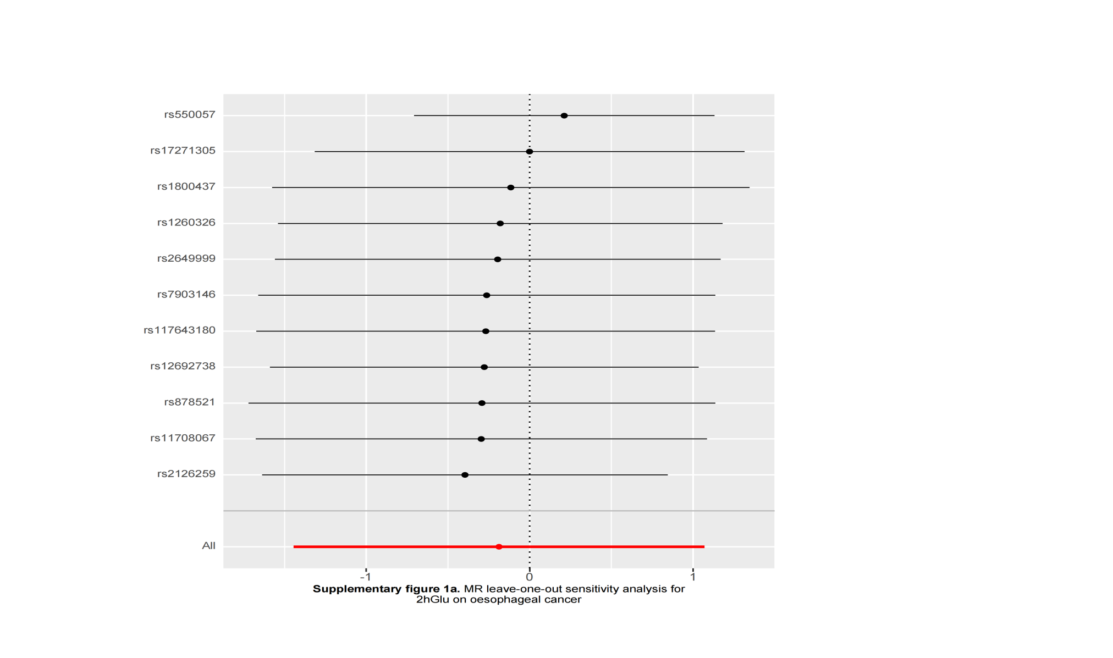
Supplementary Figure 1. MR leave-one-out sensitivity analysis for 2hGlu on oesophageal cancer
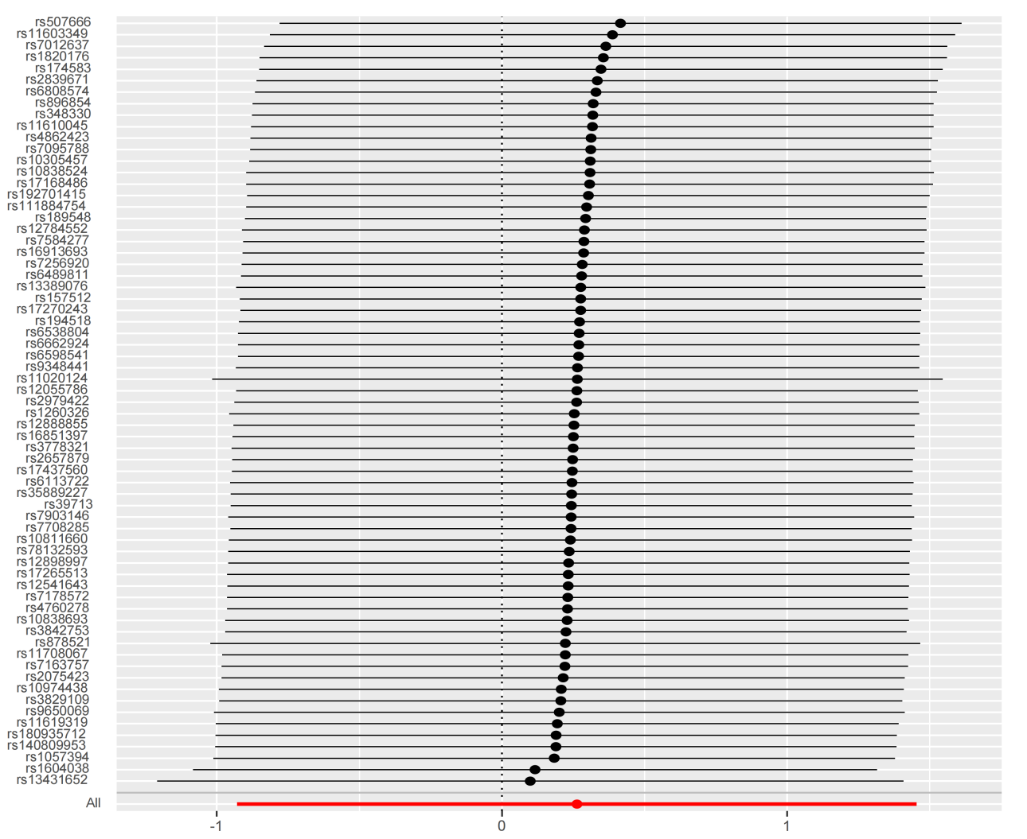
Supplementary Figure 2. MR leave-one-out sensitivity analysis for FG on oesophageal cancer

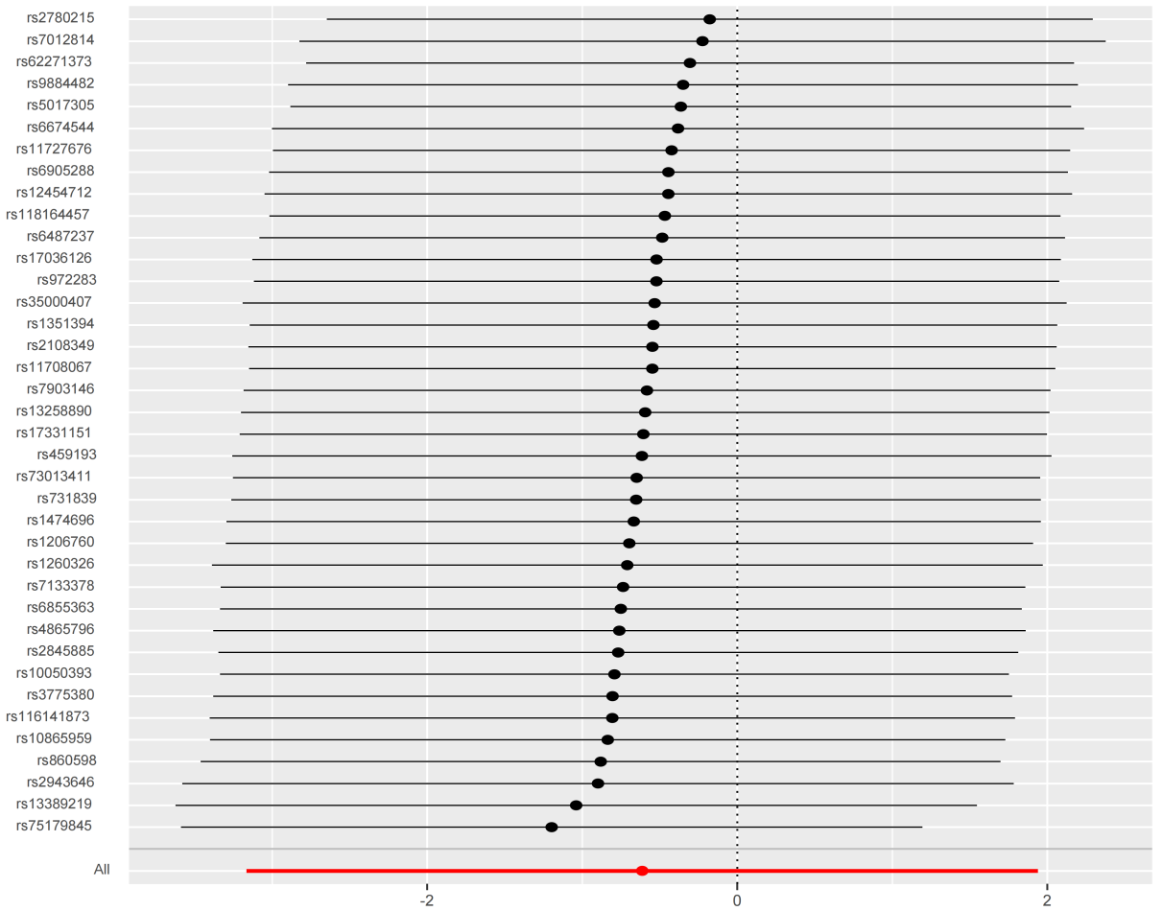
Supplementary Figure 3. MR leave-one-out sensitivity analysis for FI on oesophageal cancer

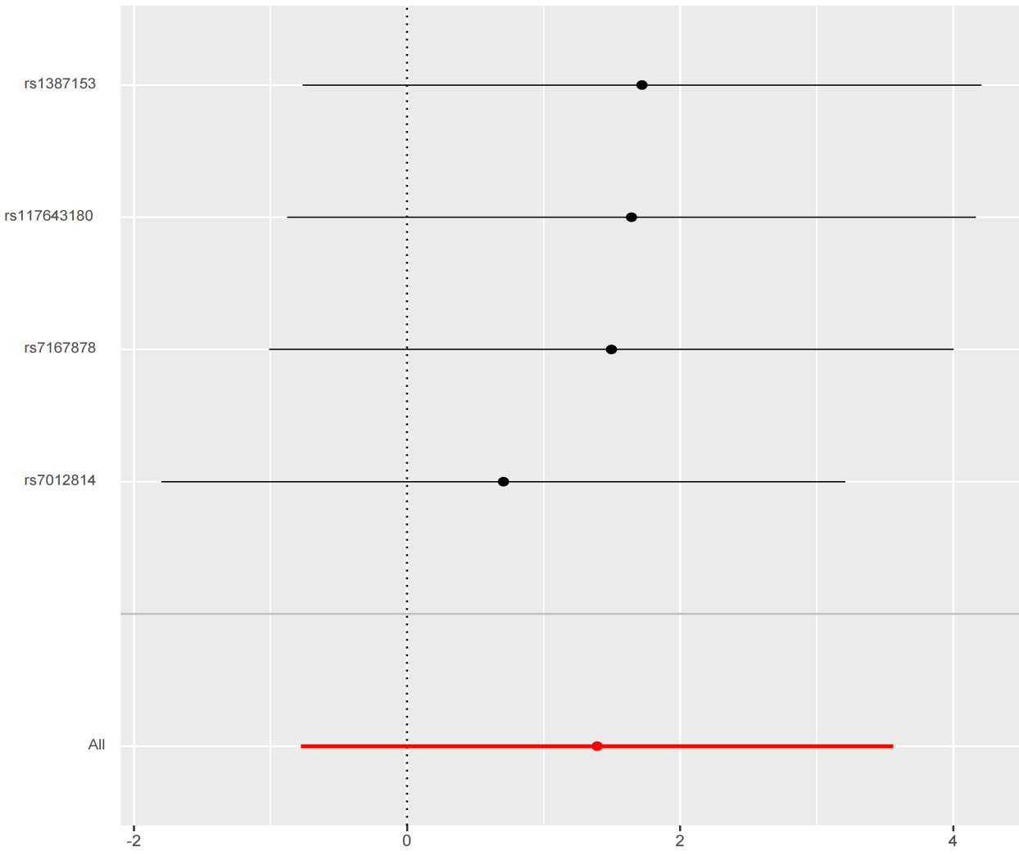
Supplementary Figure 4. MR leave-one-out sensitivity analysis for HbA1C on oesophageal cancer

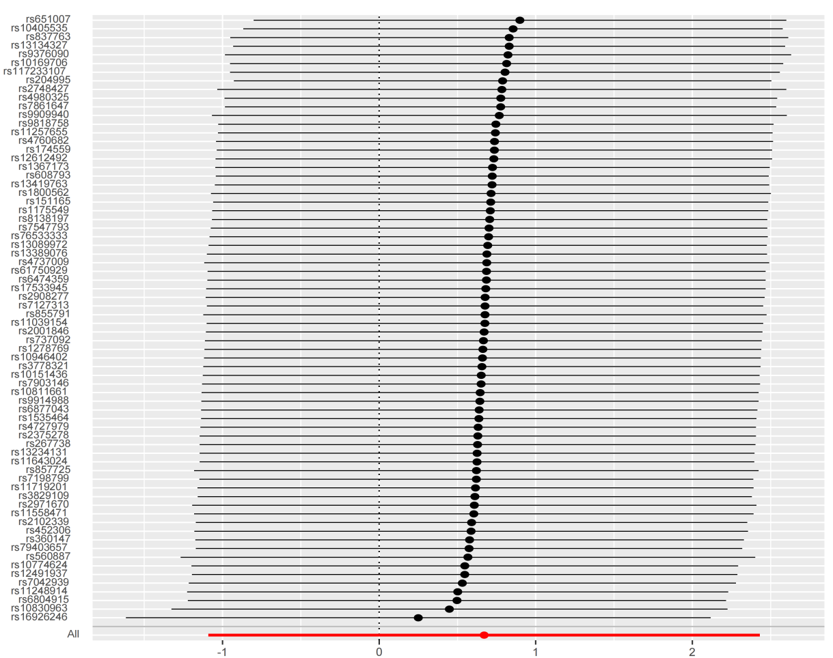
Supplementary Figure 5. MR leave-one-out sensitivity analysis for IFC on oesophageal cancer

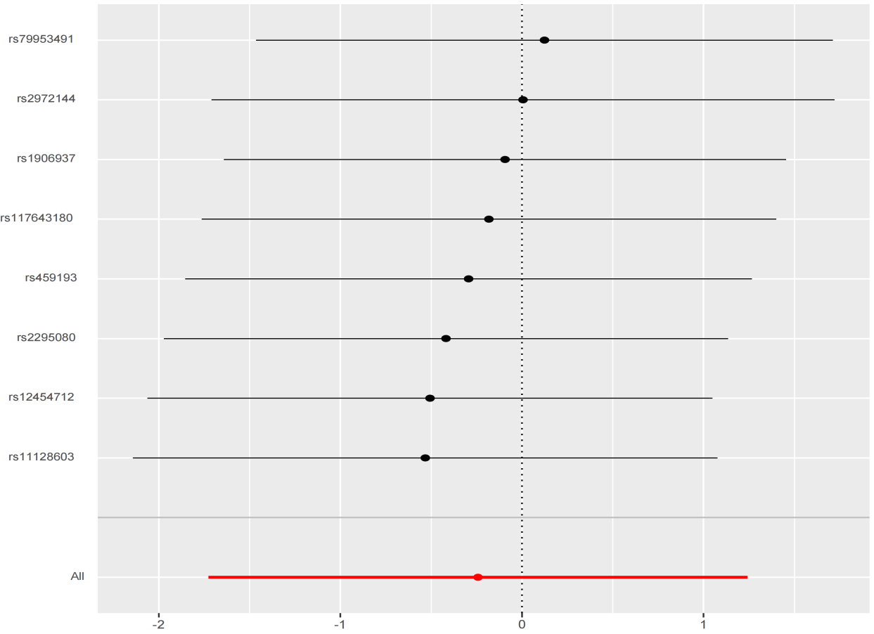
Supplementary Figure 6. MR leave-one-out sensitivity analysis for ISI on oesophageal cancer
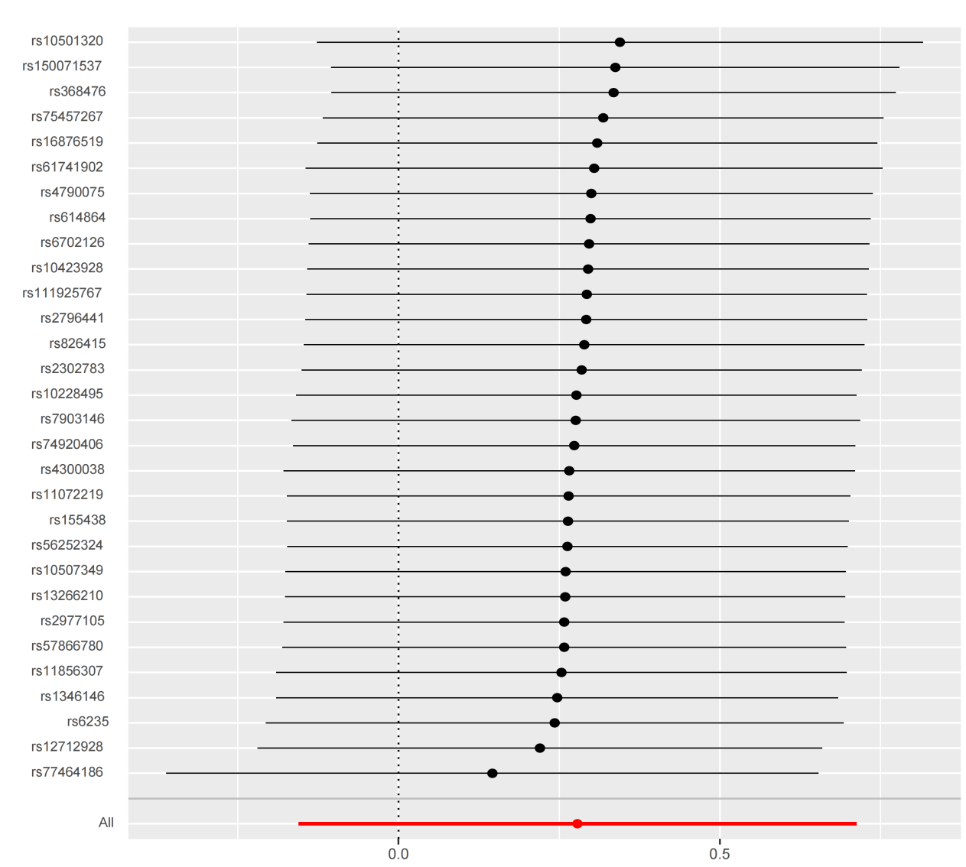
Supplementary Figure 7. MR leave-one-out sensitivity analysis for Pro on oesophageal cancer

