Supplementary Materials
ECDEP: Identifying essential proteins based on evolutionary community discovery and subcellular localization
Chen Ye^{1,2,+}, Qi Wu^{1,2,+}, Shuxia Chen ^{1,2}, Xuemei Zhang^{1,2}, Wenwen Xu^{1,2}, Yunzhi Wu^{1,2}, Youhua Zhang^{1,2} and Yi Yue^{1,2,*}
¹ School of Information and Artificial Intelligence, Anhui Agricultural University, Hefei, Anhui 230036, China.
² Anhui Beidou Precision Agriculture Information Engineering Research Center, Anhui Agricultural University, Hefei 230036, China.
⁺ These authors contributed equally to this work.
* Corresponding author: yyyue@ahau.edu.cn

Figure S1. Dynamic PPI Networks
The process of PPI networks of different species over time and the network status at each moment: the number of existing interactions, the number of existing nodes, the number of interactions that disappeared at that moment, and the number of new interactions that emerged at that moment. a) Dynamic PPI network of three different S. cerevisiae databases (constructed through GSE3431); b) H. sapiens dynamic PPI network (constructed through GSE41828); c) M. musculus dynamic PPI network (constructed through GSE3231); d) C. elegans dynamic PPI network (constructed through GSE77110).
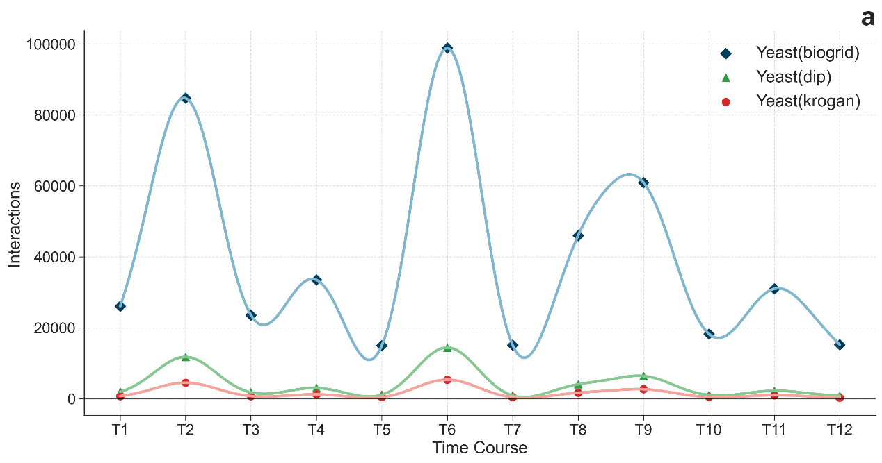
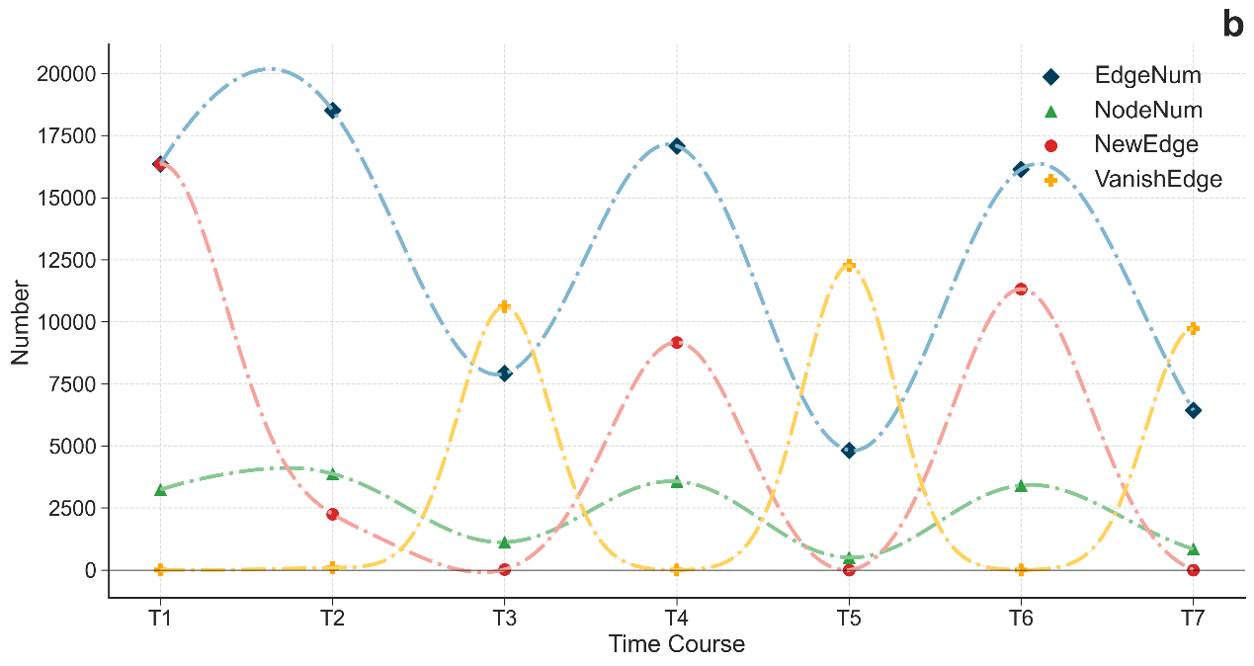
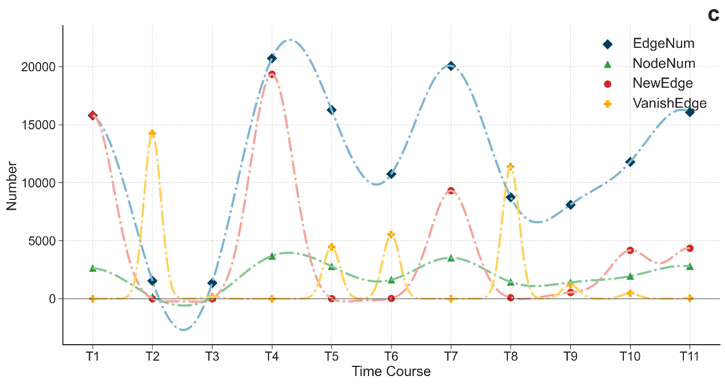
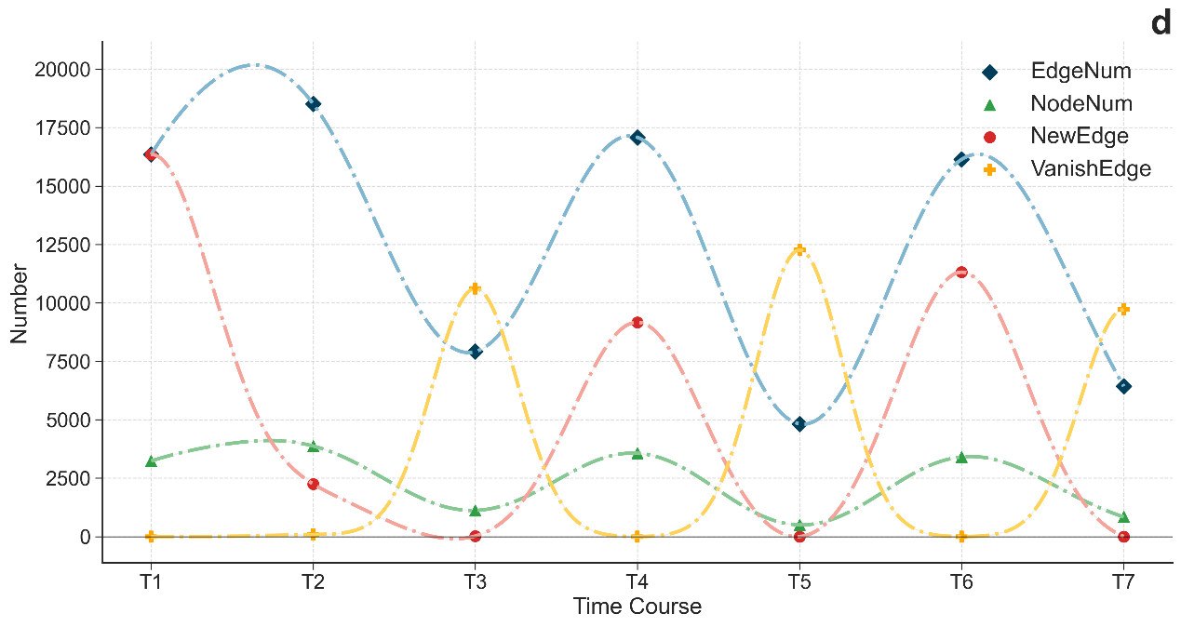

Figure S2. Comparison with Centrality Methods
The ECDEP model was compared with ten different centrality methods on six different datasets/species for other metrics. a) In terms of accuracy indicators, ECDEP outperforms all comparison methods on all datasets; b) ECDEP outperforms all comparison methods on all datasets in terms of precision indicators; c) ECDEP outperformed all comparison methods in terms of Recall metrics across all datasets.
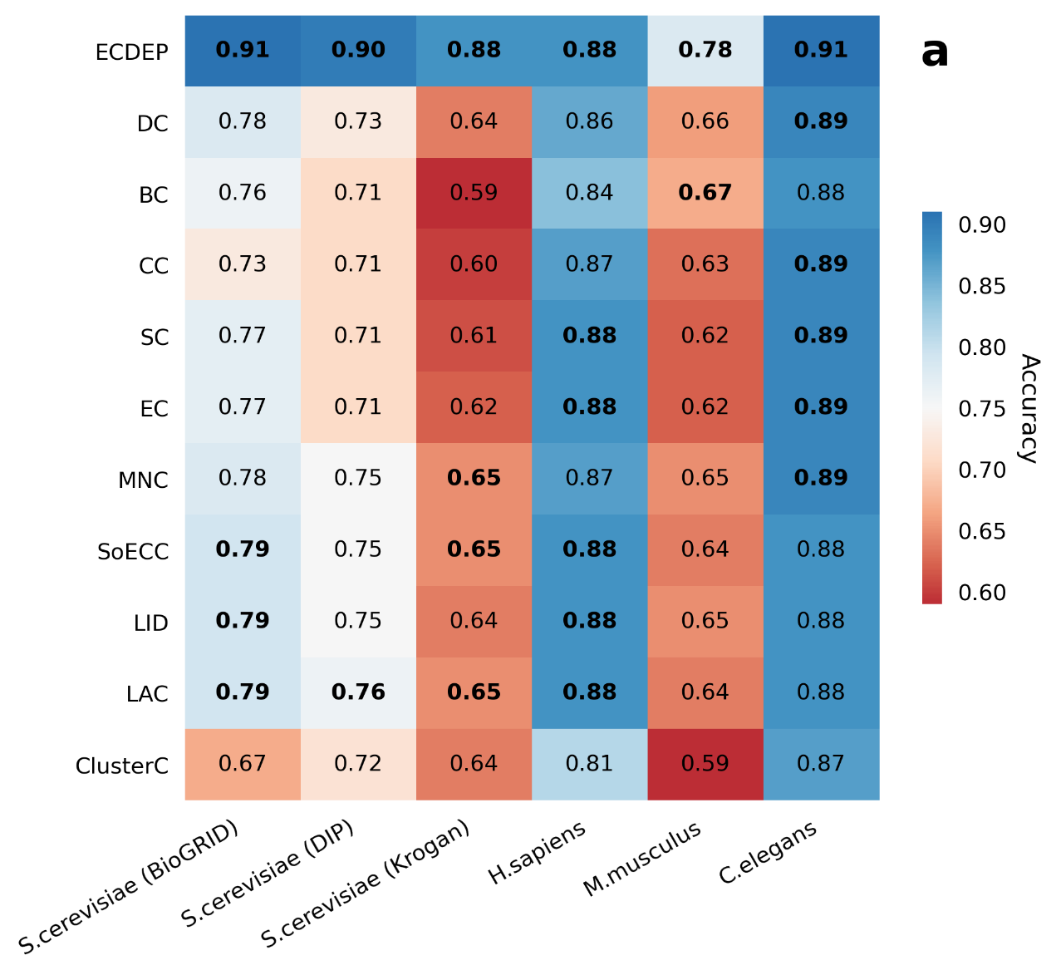
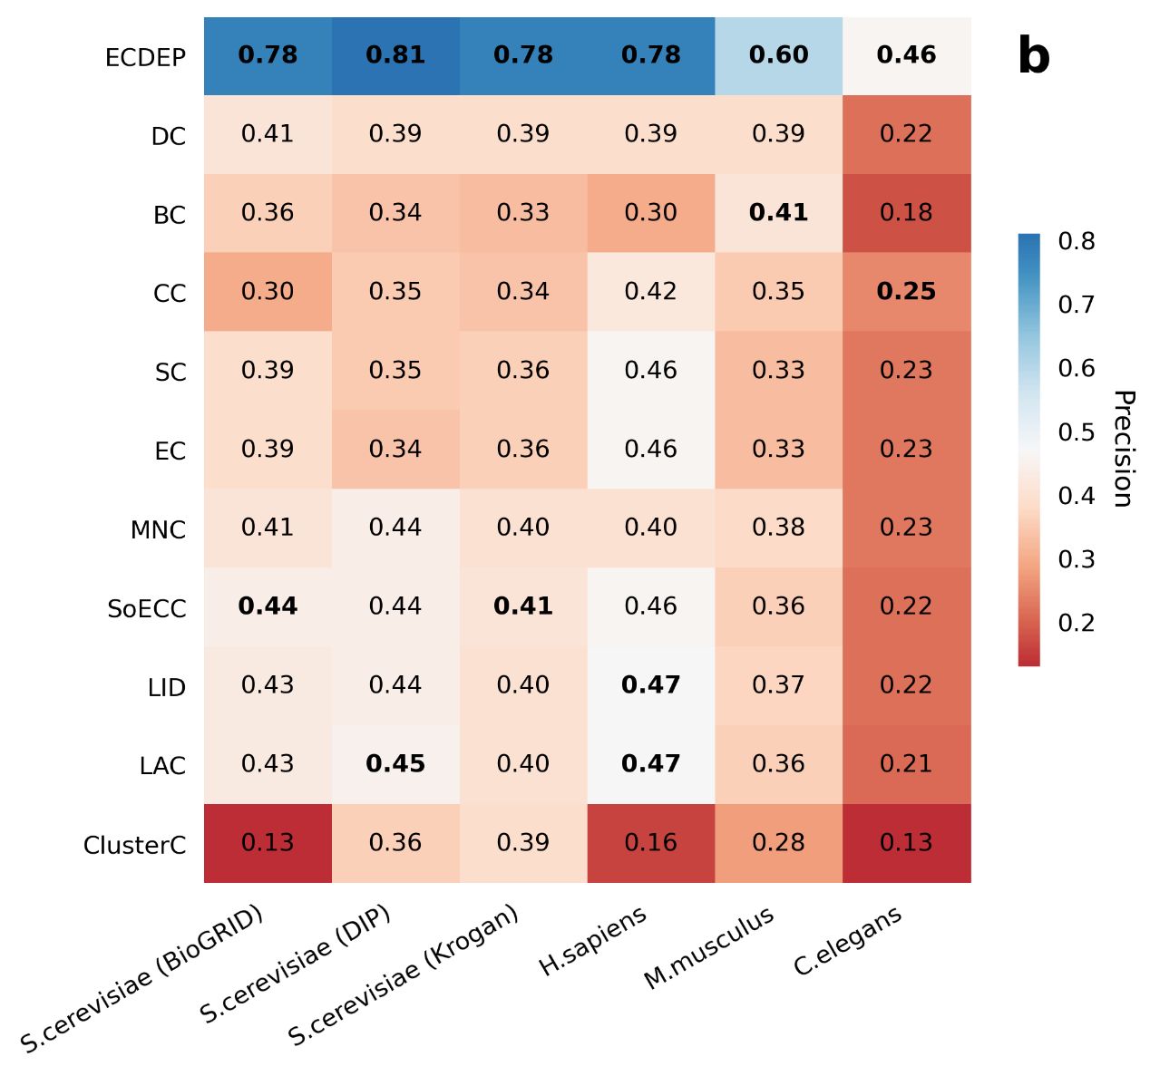
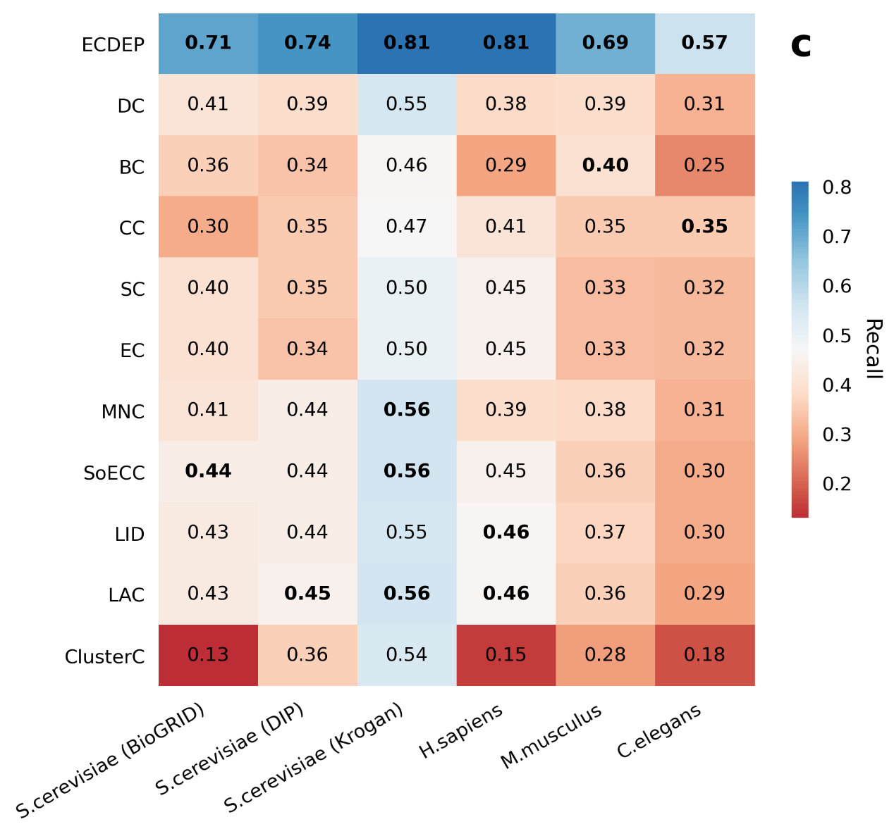

Figure S3. AUC and RP curves of ECDEP compared on S. cerevisiae (BioGRID) dataset
ECDEP achieves an AP value identical to that of MBIEP while displaying a slight reduction of 0.01 in the AUC value compared to MBIEP. Notably, ECDEP outperforms DeepEP with an AUC value that is 0.12 higher and an AP value that is 0.42 higher. Furthermore, our results indicate that ECDEP's performance surpasses that of all shallow machine learning models included in the comparison. It is important to highlight that these models extra utilize subcellular localization data as input, resulting in significantly improved predictive capabilities. This underscores the crucial role of subcellular localization information in enhancing the precision of essential protein prediction tasks.
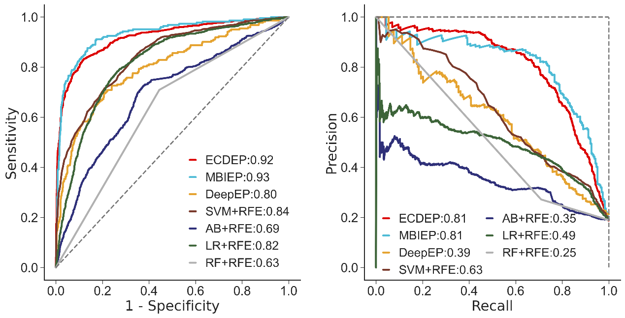

Figure S4. AUC and RP curves of ECDEP compared on S. cerevisiae (Krogan) dataset
ECDEP continues to outperform other models, with AUC and AP values that exceed those of MBIEP by 0.03 and 0.07, DeepEP by 0.15 and 0.43, and the leading SVM-RFE by 0.07 and 0.15, respectively. Additionally, compared to the BioGRID database, the majority of algorithms demonstrated improved performance. The Krogan dataset stands out due to its unique characteristics, all interaction edges are experimentally confirmed, resulting in lower network noise and a higher proportion of essential proteins. This reduces the challenges associated with imbalanced learning in the dataset.
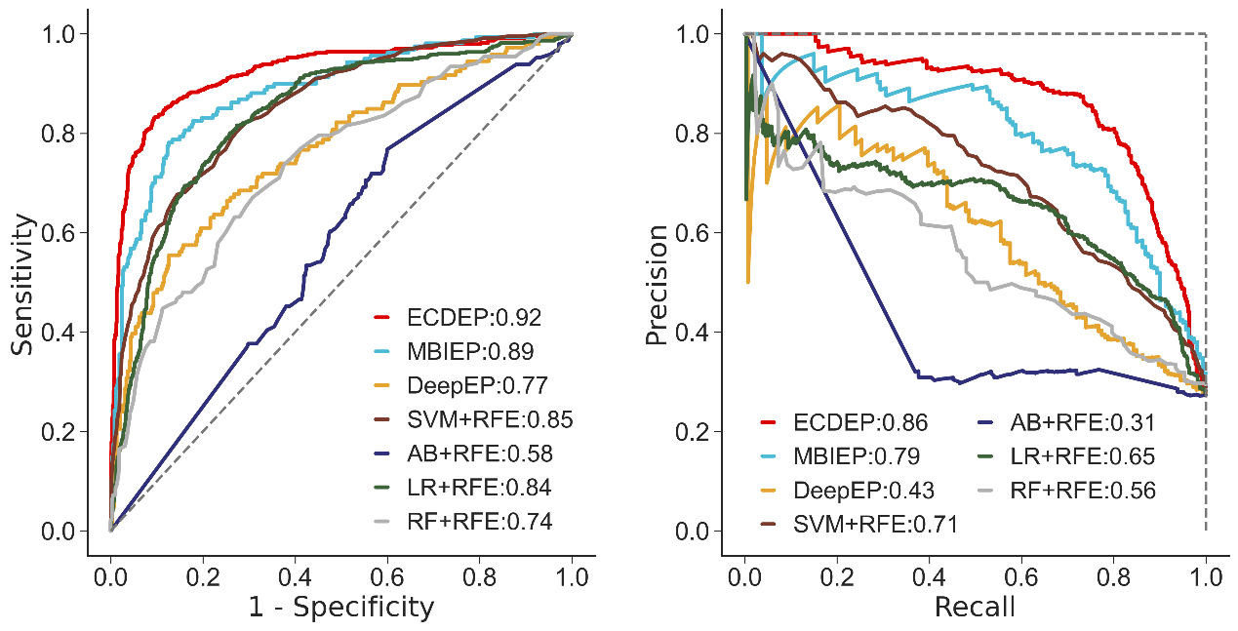

Figure S5. AUC and RP curves of ECDEP compared on M. musculus dataset
Our interest lies in understanding the variations in performance on the M. musculus dataset, given the high biological similarity between M. musculus and H. sapiens, including numerous homologous genes. We initially explored different labeling approaches, including applying the DEG database alone, employing the OEGG dataset alone, selecting the intersection of both databases, and choosing data from both homologous genes and essential proteins in both H. sapiens and M. musculus species. Unfortunately, the experimental results fail to meet our expectations. Therefore, while ECDEP clearly outperforms all comparative methods on the M. musculus dataset, there remains an opportunity for further refinement and enhancement.
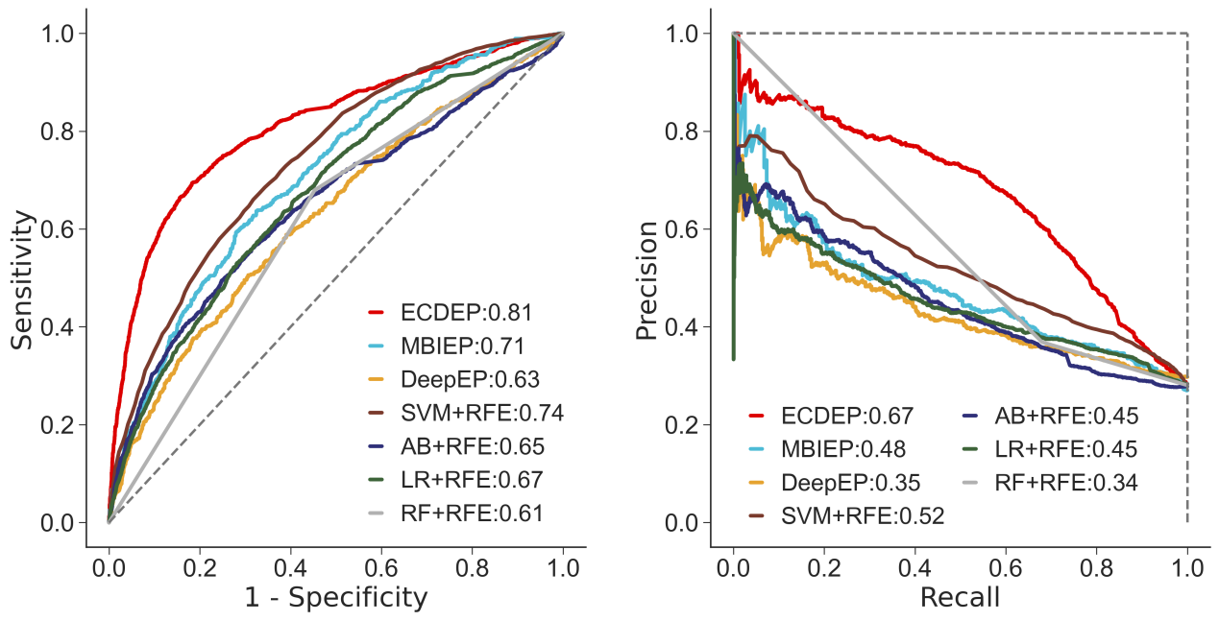

Figure S6. AUC and RP curves of ECDEP compared on C. elegans dataset
All methods experience a significant decline in AP values on the C. elegans dataset, which holds the lowest proportion of essential proteins among all datasets, exacerbating its imbalanced learning challenge. Upon comparison, we find that despite its lower proportion of essential proteins, the C. elegans dataset yields a relatively higher AUC values for the algorithms. This phenomenon can be attributed to the dataset's elevated ratio of negative samples, enabling the models to correctly identify more negative instances. However, the models struggle to accurately detect positive samples, resulting in high AUC but low AP scores. Similarly, while ECDEP maintains its superiority over all comparison algorithms on the C. elegans dataset, its performance has markedly declined, which can be ascribed to the dataset's limited number of positive samples and the inherent differences between species.
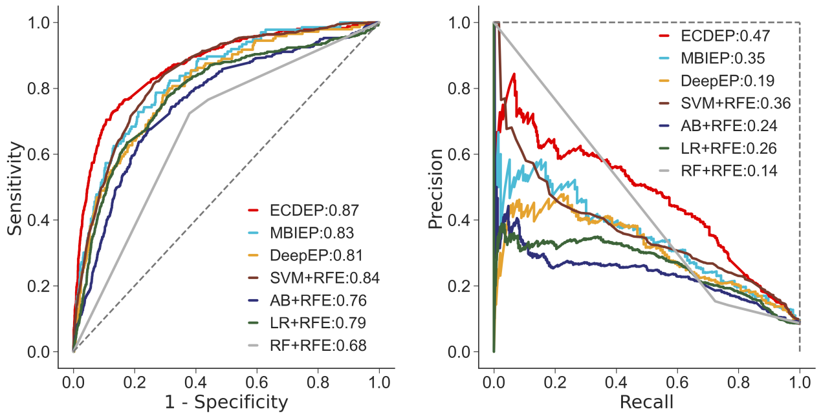

Figure S7. AUC and RP curves of ECDEP compared on S. cerevisiae (DIP) dataset
We further assess the performance of the ECDEP model on two additional S. cerevisiae databases. On the S. cerevisiae (DIP) dataset, ECDEP exhibits superior performance compared to other methods. Specifically, it achieved AUC and AP values that are 0.04 and 0.10 higher than MBIEP, 0.16 and 0.43 higher than DeepEP, and 0.11 and 0.24 higher than the best-performing SVM-RFE among shallow machine learning methods. Notably, compared to the BioGRID dataset, most algorithms demonstrate a modest improvement in performance. It's worth mentioning that the BioGRID dataset possesses a larger network scale and density, presenting a challenge in effectively leveraging its rich and timely interaction data while mitigating noise.
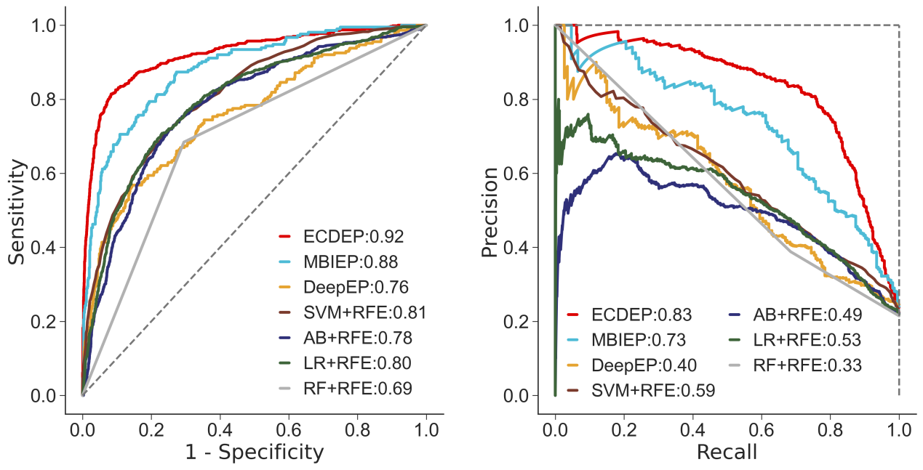

Figure S8. Comparison with machine learning and deep learning methods
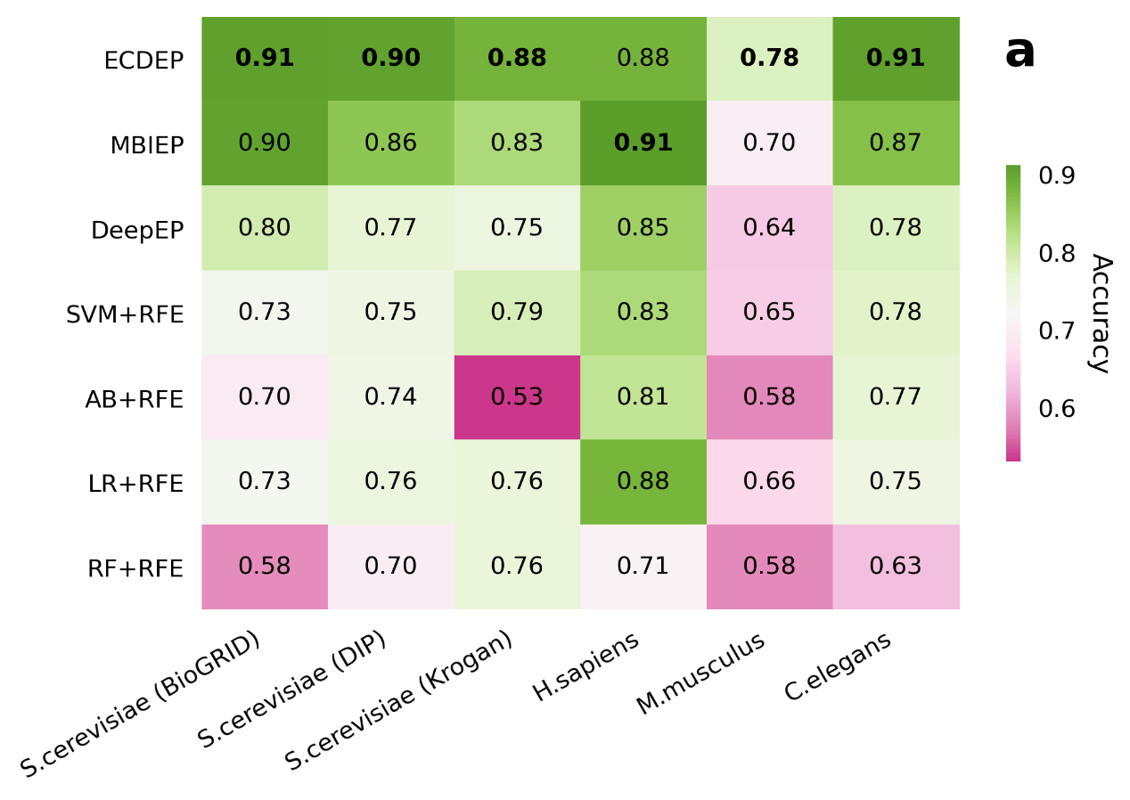
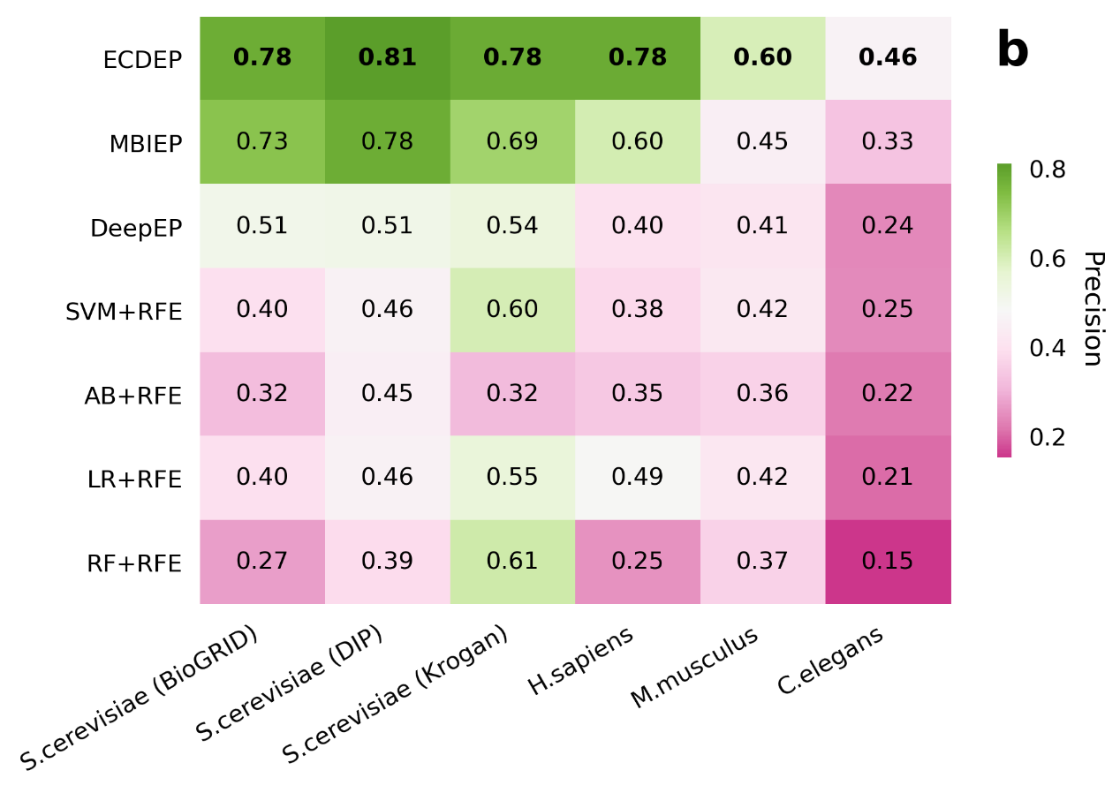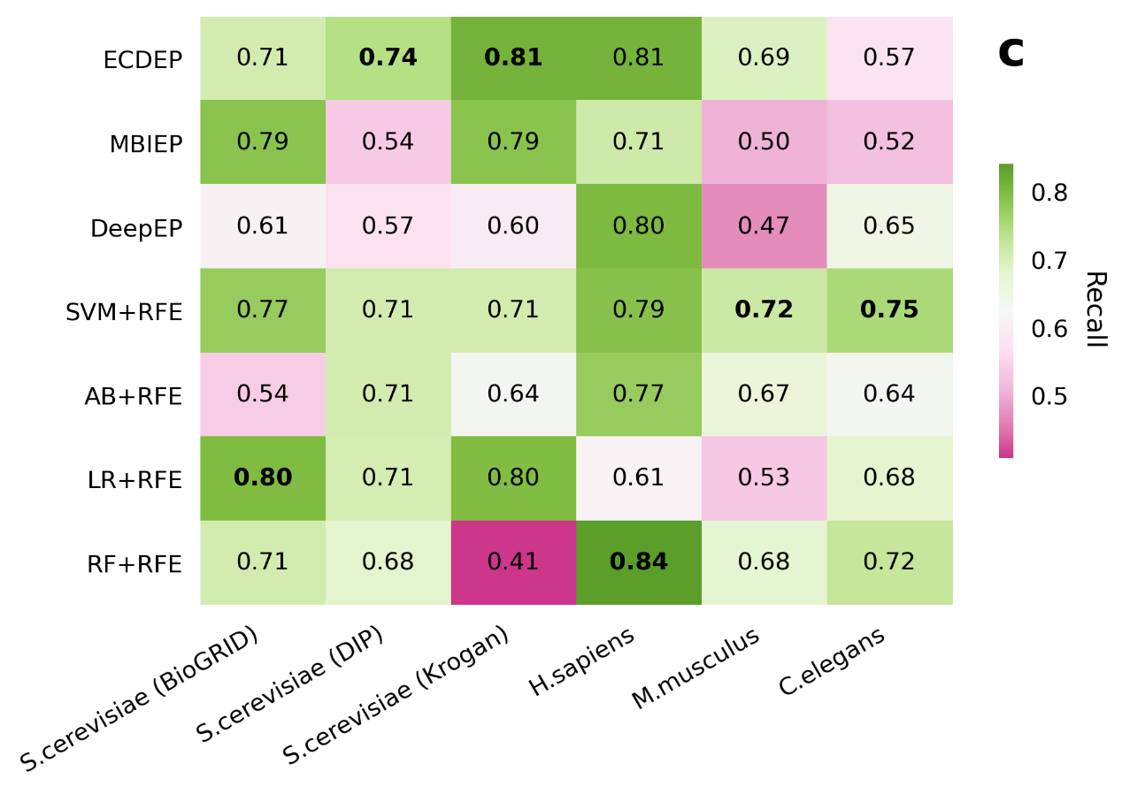

Table S1. Version and sources of databases
Data Type | Database | Download Link | Version
Protein-Protein Interaction Network | BioGRID | https://downloads.thebiogrid.org/BioGRID | 4.4.200
Protein-Protein Interaction Network | BioGRID | https://downloads.thebiogrid.org/BioGRID | 4.4.200
Protein-Protein Interaction Network | Krogan dataset | https://www.yeastgenome.org/reference/S000114782#file | nan
Gene Expression Profiles | Gene Expression Omnibus | https://www.ncbi.nlm.nih.gov/geo/ | nan
Subcellular Localization | COMPARTMENTS database | https://compartments.jensenlab.org/Downloads | 20220630
Essential Proteins | DEG database | http://origin.tubic.org/deg/public/index.php | 20200901
Essential Proteins | OGEE database | https://v3.ogee.info/#/home | 20221007

Table S2. Download links of methods for comparison
Method | Link | Type
DC | https://networkx.org/documentation/stable/reference/algorithms/centrality.html | Centrality Methods
BC |  | Centrality Methods
CC |  | Centrality Methods
EC |  | Centrality Methods
SC |  | Centrality Methods
ClusterC | https://www.nature.com/articles/30918 | Centrality Methods
MNC | https://academic.oup.com/nar/article/36/suppl_2/W438/2506254 | Centrality Methods
SoECC | https://ieeexplore.ieee.org/document/6081844 | Centrality Methods
LAC | https://www.sciencedirect.com/science/article/abs/pii/S1476927111000296 | Centrality Methods
LID | https://ieeexplore.ieee.org/document/7360166 | Centrality Methods
SVM+RFE | https://scikit-learn.org/stable/ | Machine Learning Methods
RF+RFE | https://scikit-learn.org/stable/ | Machine Learning Methods
AB+RFE | https://scikit-learn.org/stable/ | Machine Learning Methods
LR+RFE | https://scikit-learn.org/stable/ | Machine Learning Methods
DeepEP | https://github.com/CSUBioGroup/DeepEP | Deep Learning Methods
MBIEP | https://github.com/LionKingAHAU/MBIEP | Deep Learning Methods
DC: Degree Centrality; BC: Betweenness Centrality; CC: Closeness Centrality; SC: Subgraph Centrality; EC: Eigenvector Centrality; MNC: Maximum Neighborhood Component Centrality; SoECC: Sum of Edge Cluster Coefficient; LID: Local Interaction Density; LAC: Local Average Connectivity; ClusterC: Cluster Coefficient. SVM+RFE: Support Vector Machine with Recursive Feature Elimination; AB+RFE: AdaBoost with Recursive Feature Elimination; LR+RFE: Logistic Regression with Recursive Feature Elimination; RF+RFE: Random Forest with Recursive Feature Elimination.

Table S3. Process of essential proteins for different species
Species | Database | Num | Final Result | Proportion (%)
S. cerevisiae | OGEE | 946 | 1132 | 18.90
S. cerevisiae | DEG | 1109 | 1132 | 18.90
M. musculus | OGEE | 1578 | 2914 | 28.22
M. musculus | DEG | 1908 | 2914 | 28.22
C. elegans | OGEE | 516 | 700 | 8.82
C. elegans | DEG2002 | 294 | 700 | 8.82
C. elegans | DEG2023 | 44 | 700 | 8.82
H. sapiens | DEG | 20 DEG sets | 2161 | 11.32
Proportion column indicates the proportion of essential proteins in the PPI network.

Table S4. Process of gene expression profiles
Species | Accession | Description | Time Course | Our process
S. cerevisiae | GSE3431 | Three consecutive metabolic cycles of yeast | 12 time intervals | Calculate the average of three cycles.
H. sapiens | GSE41828 | TWEAK-treated time course in U2OS cells. | 5 time intervals | Select TWEAK treated group and calculate the average of five replicate samples.
M. musculus | GSE3231 | V6.5 Embryonic Stem Cell and Embryoid Body Time Course. | 11 time intervals | Select embryoid body group and calculate the average expression level of three replicate samples.
C. elegans | GSE77110 | C. elegans time course study on dietary restriction and aging. | 6 time intervals | Select intermittent fasting group.

Table S5. PPI network details for different species and datasets
Database | Species | Proteins | Interactions | Average Degree
BioGRID | H. sapiens | 19093 | 537790 | 28.17
BioGRID | M. musculus | 10170 | 55165 | 5.47
BioGRID | C. elegans | 7934 | 32676 | 4.12
BioGRID | S. cerevisiae | 5988 | 127581 | 21.31
DIP | S. cerevisiae | 4719 | 21913 | 4.64
Krogan | S. cerevisiae | 2674 | 7079 | 2.65

Table S6. Environment, package, and version requirements
Package/Environment | Version | Link
Python | >=3.8 | https://www.python.org/
Numpy | >=1.19.4 | https://numpy.org/
Pandas | >=1.0.5 | https://pandas.pydata.org/
Tensorflow | >=2.4.0 | https://www.tensorflow.org/
Sklearn | >=0.23.1 | https://scikit-learn.org/stable/
Tiles | >=1.0.4 | https://github.com/GiulioRossetti/TILES

Table S7. Hyperparameter settings of ECDEP model
Parameter Name | Range | Recommended Value
Epoch | 10, 20, 30, 40 |  | 20
Batch Size | 32, 64, 128, 512 |  | 64
n_features_to_select | 16, 32, 64, 128 |  | 64
Learning Rate | 0.1, 0.001, 0.002, 0.003, 0.0001 |  | 0.001
Optimizer | RMSprop, SGD, Adam, Adamax, Nadam, Adadelta |  | Adamax
n_features_to_select parameter refers to the number of features that SVM-RFE selects.

Table S8. Experiment on different selections of M. musculus essential protein.
Metrics | DEG | OGEE | Union | Intersection | Conserved Genes
Number | 1578 | 1908 | 2914 | 572 | 785
F1 | 0.43 | 0.26 | 0.64 | 0.05 | 0.37
ACC | 0.79 | 0.66 | 0.78 | 0.92 | 0.87
PRE | 0.44 | 0.21 | 0.60 | 0.09 | 0.30
REC | 0.42 | 0.35 | 0.69 | 0.03 | 0.50
AUC | 0.67 | 0.54 | 0.81 | 0.58 | 0.83
AP | 0.43 | 0.19 | 0.67 | 0.09 | 0.27
F1: F-measure; ACC: Accuracy; PRE: Precision; REC: Recall; AUC: AUC score; AP: AP score; Union: integrate two databases together and remove duplicates; Intersection: select essential genes presented in both databases; Conserved Genes: same essential genes that presented in M. musculus and H. sapiens.

