Supplementary Figures
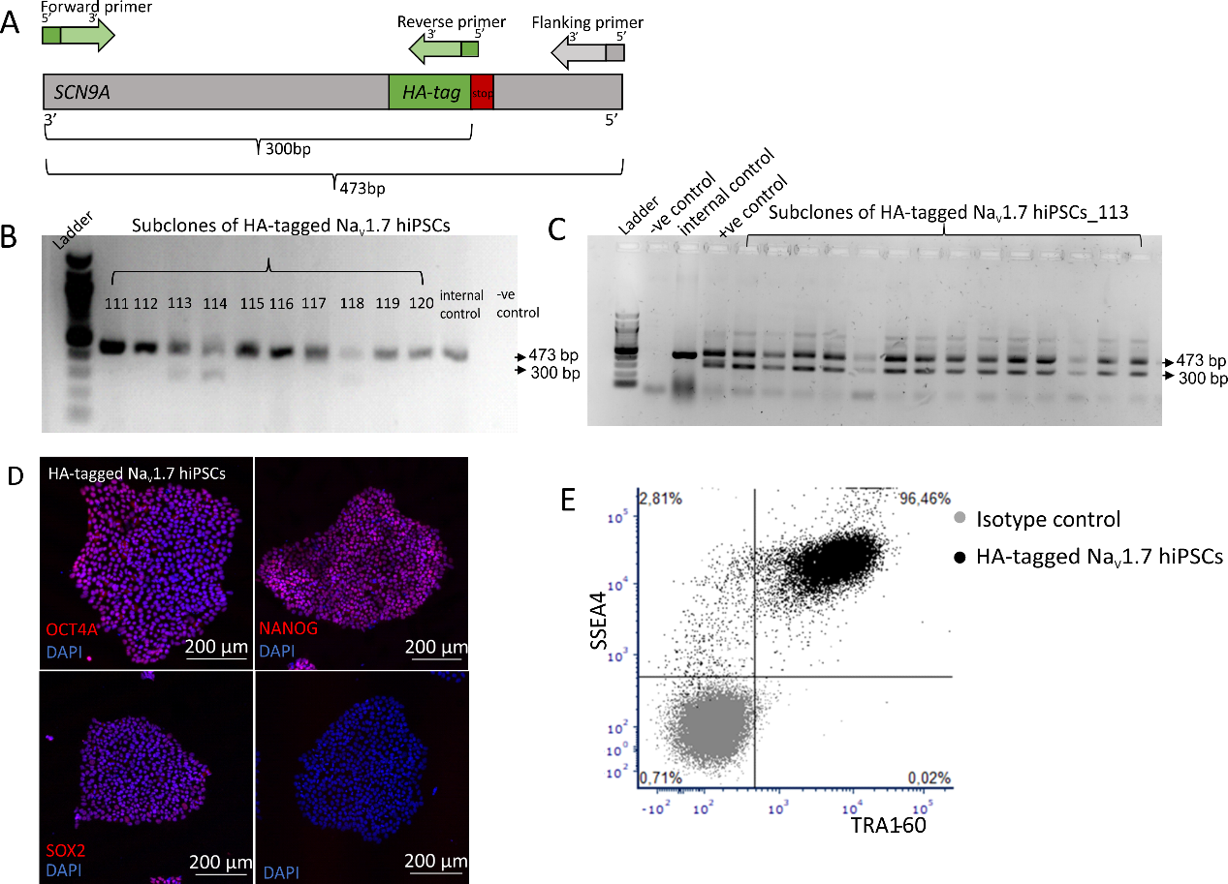
Fig.S1 Detectable HA-tag presents on both gel electrophoresis of subclones and chosen subclones express pluripotency markers in immunostaining and FACS. A. Graphical representation of the HA-tag specific PCR. Forward, Reverse and Flanking primers were designed accordingly for the HA-tag specific PCR. The PCR product contains two DNA fragments: the longer one (473bp) is the end of the coding sequence of SCN9A gene whereas the shorter one(300bp) is specific to the HA-tag. B-C.Agarose gel electrophoresis of HA-tag specific PCR products shows two distinct bands at 300bp and 473bp. -ve control: negative control; +ve control: positive control. D-E. HA-tagged Na_{V}1.7 hiPSCs maintain their pluripotent state after the CRISPR mediated genome editing and subcloning process. D showed the expression of pluripotency markers (OCT4A, SOX2, NANOG) (red) in HA-tagged Na_{V}1.7 hiPSCs. The cell nuclei are stained in blue with DAPI. (scale bar: 200µm) E showed the expression of surface markers (TRA-1-60 and SSEA-4) in 96.89% of live cells.
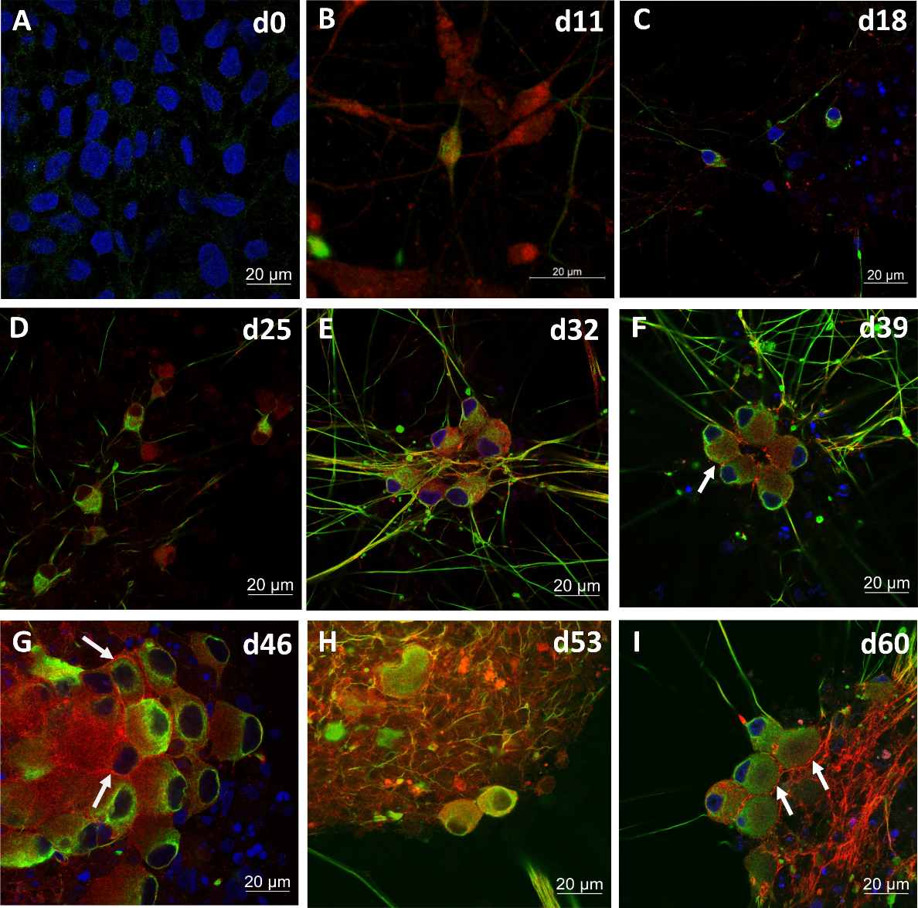
Fig.S2 Confocal microscopy shows the localization and expression of HA-tagged Na_{V}1.7 on iPSC-SNs in SmallMolecule differentiation. A-I.double immunolabelling (peripherin (green) and HA-tag (red)) of hiPSCs colonies at d0 of differentiation (A) to mature sensory neuron ganglia-like structures at d60 of differentiation using confocal imaging (I). The cell nuclei were stained in blue using DAPI (blue). The distinct surface expression of HA-tag is marked with white arrows. All the data represents an overlay of peripherin (green) and HA-tag (red) staining. (scale bar: 20µm)

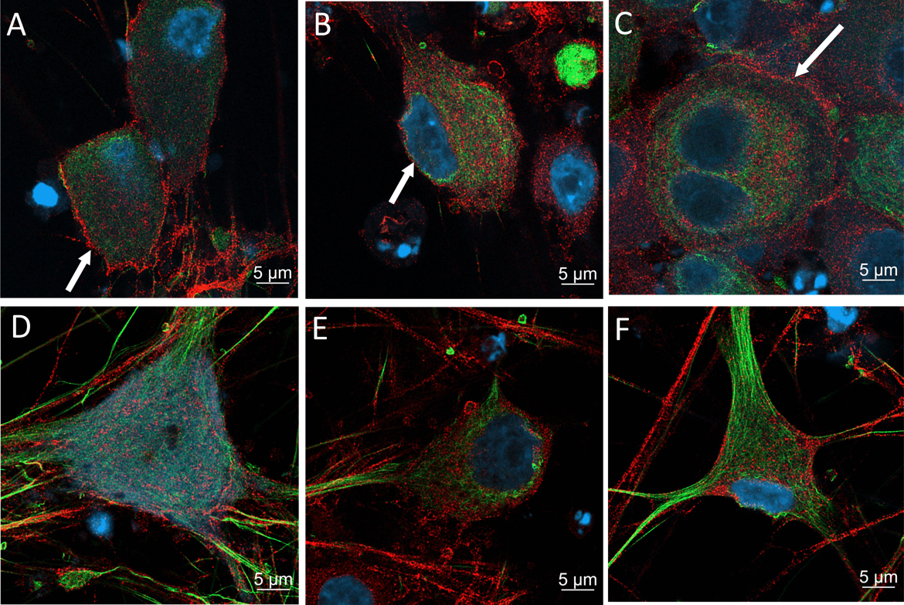
Fig.S3 Localization of HA-tagged Na_{V}1.7 on iPSC-SNs at d49 of NGN1 differentiation visualized by Airyscan microscope. A-F. double immunolabelled (peripherin (green) and HA-tag (red)) iPSC-SNs with or without clear membrane localization at d49 of differentiation using LSM 980 with Airyscan 2. White arrow heads showed clear membrane expressions of HA-tagged Na_{V}1.7 in A-C which could not be found in D-F. The cell nuclei were stained in blue using DAPI (blue). The distinct surface expression of HA-Tag is marked with white arrows. Data represents an overlay of peripherin (green) and HA-tag (red) staining. (scale bar: 5µm)

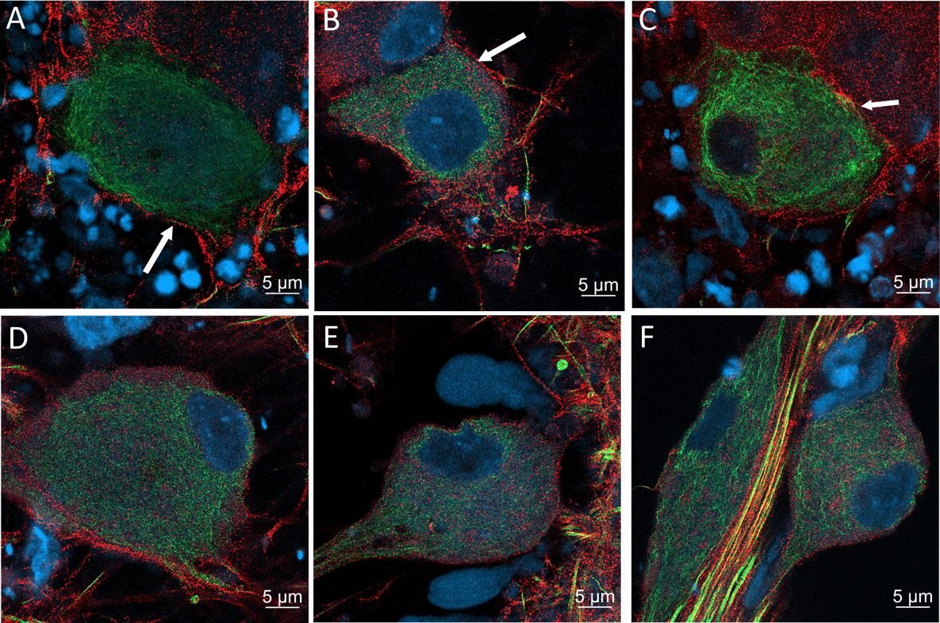
Fig.S4 Localization of HA-tagged Na_{V}1.7 on iPSC-SNs at d56 of NGN1 differentiation visualized by Airyscan microscope. A-F. double immunolabelled (peripherin (green) and HA-tag (red)) iPSC-SNs with or without clear membrane localization at d56 of differentiation using LSM 980 with Airyscan2. White arrow heads showed clear membrane expressions of HA-tagged Na_{V}1.7 in A-C which could not be found in D-F. The cell nuclei were stained in blue using DAPI. The distinct surface expression of HA-tag is marked with white arrows. Data represents an overlay of peripherin (green) and HA-tag (red) staining. (scale bar: 5µm)

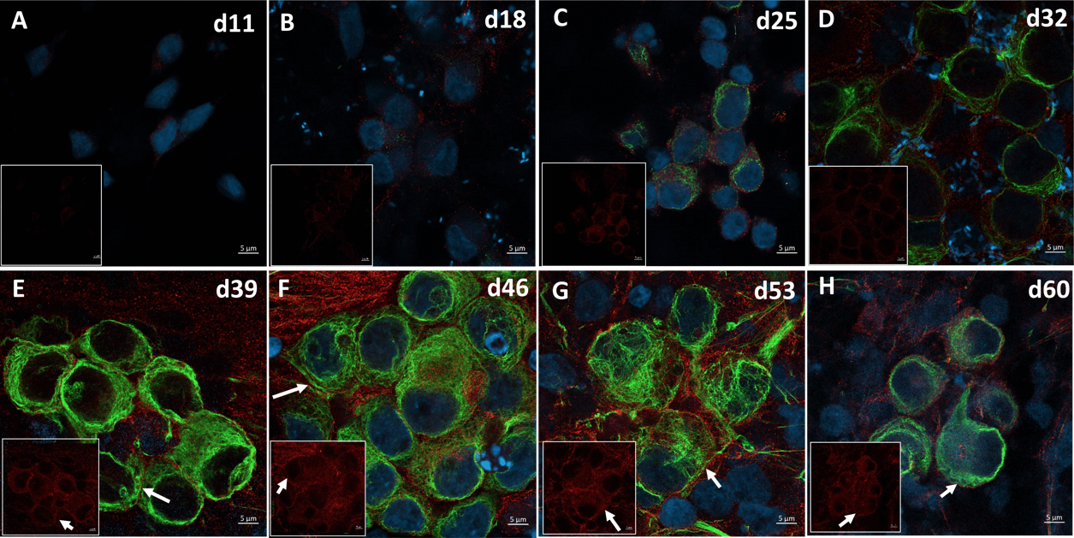
Fig. S5 Na_{V}1.7 protein surface expression start detectable from d39 during small molecule differentiation (Airyscan microscopy).A-H. double immunolabelled (peripherin (green) and HA-tag (red)) iPSC-SNs from d11 of differentiation (A) to mature sensory neurons at d60 of differentiation (H) using LSM 980 with Airyscan 2. The cell nuclei were stained in blue using DAPI (blue). The distinct surface expression of HA-tag is marked with white arrows. Data represents an overlay of peripherin (green) and HA-tag (red) staining. The pictures in white box showed representative picture of expression of HA-tagged Na_{V}1.7 from each time point and a clear surface localization of Na_{V}1.7 from d53-d60 of differentiation. White arrow shows the surface expression of HA-tagged Na_{V}1.7. (scale bar: 5µm)

Supplementary Videos
Video 1 Z-stack video of localization of HA-tagged Na_{V}1.7 on iPSC-SNs at d49 of NGN1 differentiation visualized by Airyscan microscope
Data shows different focal distances of peripherin (green) and HA-tag (red) staining of iPSC-SNs at d49 of NGN1 differentiation using LSM 980 with Airyscan 2. The reliable detection of surface localization of HA-tagged Na_{V}1.7 could be found at several stages. The cell nuclei were stained in blue using DAPI (blue). (scale bar: 5µm)

Video 2 Z-stack video of localization of HA-tagged Na_{V}1.7 on iPSC-SNs at d56 of NGN1 differentiation visualized by Airyscan microscope
Data shows different focal distances of peripherin (green) and HA-tag (red) staining of iPSC-SNs at d56 of NGN1 differentiation using LSM 980 with Airyscan 2. The reliable detection of surface localization of HA-tagged Na_{V}1.7 could be found at several stages. The cell nuclei were stained in blue using DAPI (blue). (scale bar: 5µm)

Supplementary Tables

Table 1 List of primers used in this study
Primers |  | Sequence (5' →3')
HA-tag | Forward primer | CGT GCT TAT AGA CGT TAC CG
HA-tag | Reverse primer | AAT CTG GAA CAT CGT ATG GG
HA-tag | Flanking primer | AAC CAT CTG CTA ATG CTG CC
GAPDH | Forward primer | AGC CAC ATC GCT CAG ACA C
GAPDH | Reverse primer | GCC CAA TAC GAC CAA ATC C
Na_{V}1.7 | Forward primer | CAC AAT CCC AGC CTC ACA GT
Na_{V}1.7 | Reverse primer | CTG AGG AGC TTG ACC GGT TTA
HA-tag | Forward primer | CGT GCT TAT AGA CGT TAC CG
HA-tag | Reverse primer | AAT CTG GAA CAT CGT ATG GG
TUJ1 | Forward primer | CTC AGG GGC CTT TGG ACA TC
TUJ1 | Reverse primer | CAG GCA GTC GCA GTT TTC AC
peripherin | Forward primer | ACA ACC TCG TGC TCT TCC G
peripherin | Reverse primer | TGG CTC TCC ACA CTC ACC T
TRKA | Forward primer | CAG GAC TTC CAG CGT GAG G
TRKA | Reverse primer | GCA GCT TGG CAT CAG GTC
TRPV1 | Forward primer | GCA CAG GAG AGC AAG AAC ATC
TRPV1 | Reverse primer | GTC CAG TTC ACC TCG TCC AC
NGN1 | Forward primer | GCC TCC GAA GAC TTC ACC TAC C
NGN1 | Reverse primer | GGA AAG TAA CAG TGT CTA CAA AGG
SOX10 | Forward primer | ATG TCA GAT GGG AAC CCA GA
SOX10 | Reverse primer | GTC TTT GGG GTG GTT GGA G

Table 2 List of primary antibodies and second antibodies used in this study
Target | Isotype | Dilution | Supplier | Catalogue number
Stemlight™ Pluripotency transcription factor kit | Rabbit IgG | 1:200 | Cell Signaling technologies, USA | 9093
Anti-human TRA-1-60 | Mouse IgM | 1ul/ 100ul for 10⁵ cells | Biolegend ,USA | 330610
Anti-human SSEA-4 | Mouse IgG3 | 1ul/ 100ul for 10⁵ cells | Biolegend ,USA | 330408
PE mouse IgM isotype control | Mouse IgM | 1ul/ 100ul for 10⁵ cells | Biolegend ,USA | 401609
Mouse IgG3  isotype control | Mouse IgG3 | 0,5ul/ 100ul for 10⁵ cells | Biolegend ,USA | 401321
HA-tag | Rabbit IgG | 1:800 | Cell Signaling technologies, USA | 3724S
peripherin | Mouse IgG2a | 1:500 | Santa-Cruz Biotechnology, USA | SC-377093
βIII-tubulin | Chicken IgY | 1:500 | Novus Biologicals, USA | NB100-1612
AF594 Goat Anti-rabbit IgG(H+L) | Goat IgG | 1:500 | Life technologies, USA | A-11037
AF488 Goat Anti-mouse IgG (H+L) | Goat IgG | 1:500 | Life technologies, USA | A-11001
AF555 Goat Anti-rabbit IgG(H+L) | Goat IgG | 1:500 | Life technologies, USA | A-21429
AF633 Goat Anti-chicken IgY(H+L) | Goat IgG | 1:500 | Life technologies, USA | A-21103

Table 3 Sequence of the oligonucleotides used to generate HA-tagged NaV1.7 hiPSC lines
For the donor template, the nucleotide in bold and underlined indicates the silent mutation introduced to disrupt the PAM site. The sequence highlighted in bold red indicates the HA-tag coding sequence and the novel stop codon is indicated in bold blue letter.
Oligo name | 5´ --- 3´ sequence
gRNA_1 | AGACAAAGGGAAAGACAGCA
Donor template (144 nt) | A TAT GAA CAA GAC AGA ACA GAA AAG GAA GAC AAA GGG AAA GAC AGC AAA GAA AGC AAA AAA TAC CCA TAC GAT GTT CCA GAT TAC GCT TAG AGC TTC ATT TTT GAT ATA TTG TTT ACA GCC TGT GAA AGT GAT TTA TTT GTG TT
SCN9A_HA_FRW | CGTGCTTATAGACGTTACCG
SCN9A_HA_REV | AATCTGGAACATCGTATGGG
SCN9A_REV | AACCATCTGCTAATGCTGCC

