Supplementary information

FLT3 signaling inhibition abrogates morphine tolerance and hyperalgesia while preserving analgesia
Antoine Jouvenel^{1,2$}, Adrien Tassou^{1,2$}, Maxime Thouaye^{1,2$}, Jérôme Ruel³, Myriam Antri⁴, Jean-Philippe Leyris⁵, Aurore Giraudin⁴, Sylvie Mallié², Chamroeum Sar^{1,2}, Lucie Diouloufet^{2,5}, Corinne Sonrier^{2,5}, François Daubeuf⁶, Juliette Bertin^{2,5}, Stacy Alves^{1,2}, Stéphanie Ventéo^{1,2}, Nelly Frossard⁶, Patrick Carroll^{1,2}, Ilana Mechaly^{1,2}, Didier Rognan⁶, Pierre Sokoloff⁵, Radhouane Dallel⁴, Patrick Delmas³, Jean Valmier^{1,2}* and Cyril Rivat^{1,2}*.
Adresses: ¹Université de Montpellier, Montpellier, France ; ²Inserm U-1298, Institut des Neurosciences de Montpellier, Montpellier, France ; ³Centre de Recherche en CardioVasculaire et Nutrition, Aix⁻Marseille Université - INSERM 1263 - INRAE 1260, Marseille, France; ⁴NeuroDol INSERM 1107, Clermont-Ferrand, France ; ⁵Biodol Therapeutics, Cap Alpha, Clapiers 34830, France, ⁶Laboratoire d'Innovation Thérapeutique, UMR7200 CNRS/Université de Strasbourg, 67400 Illkirch, France.

$These authors contributed equally: Antoine Jouvenel, Adrien Tassou, Maxime Thouaye.

* Correspondence and requests for materials should be addressed to C.R. (email: cyril.rivat@umontpellier.fr) or to J.V. (email: jean.valmier@umontpellier.fr)

The file contains:
Figs. S1 to S8

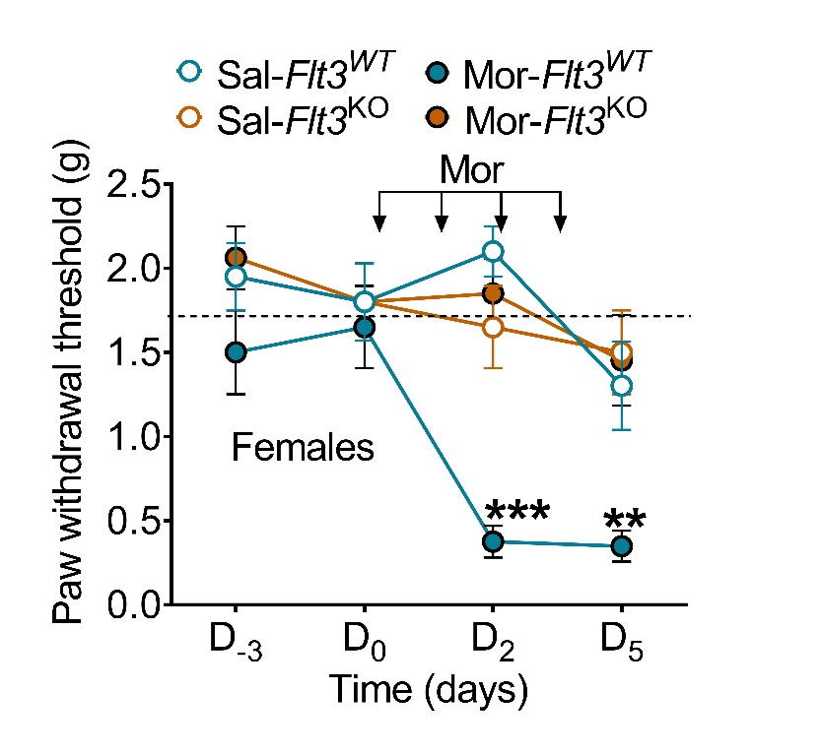

Figure S1: Flt3 deletion prevents OIH in female mice. Baseline nociceptive hypersensitivity of Flt3^{WT} and Flt3^{KO} female mice (n = 8 mice/group) measured by the von Frey « up and down » method after chronic morphine treatment (10mg/kg; subcutaneous, twice a day for 4 days). Data are shown as mean ± SEM. ***P < 0.001. Statistical analyses included two-way repeated ANOVA (A) followed by Bonferroni’s test for multiple comparisons. Mor, morphine; Sal, saline.

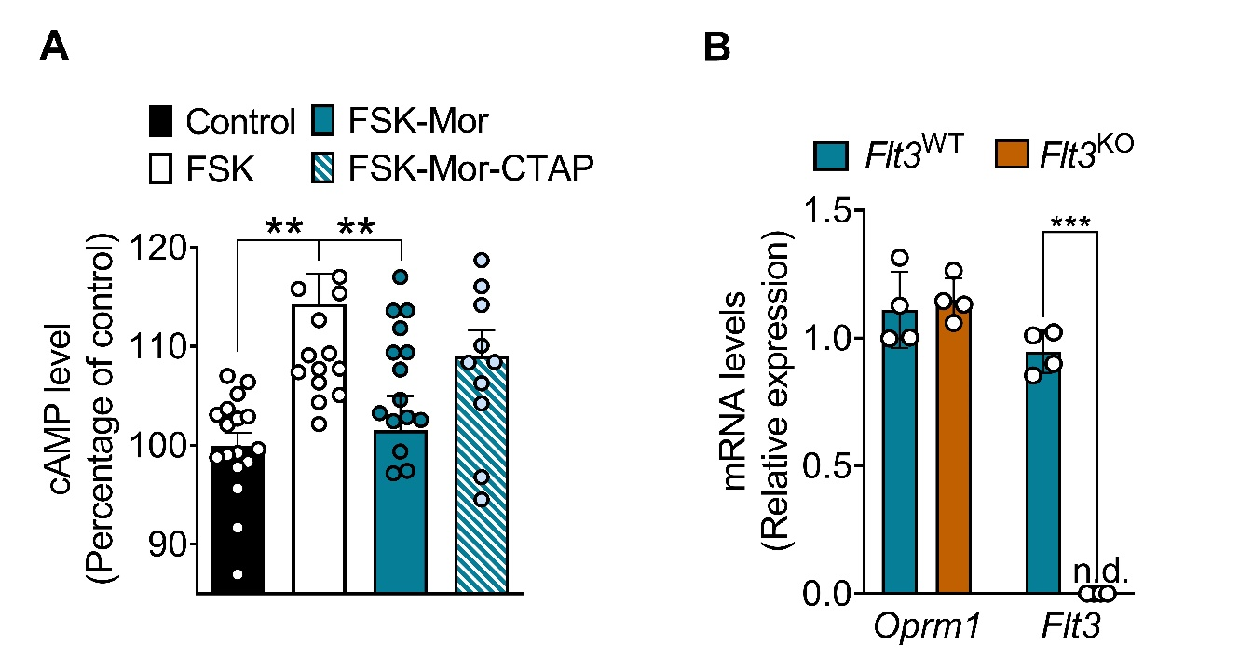
Figure S2: Effects of acute morphine on MOR-induced cAMP production in cultured sensory neurons and of Flt3 deletion on MOR gene expression. (A) cAMP responses to forskolin in primary cultures of adult DRG neurons from Flt3^{WT} in control, morphine and morphine + CTAP conditions (n = 4). (B) Relative quantification of Oprm1 and Flt3 expression in DRG sensory neurons in Flt3^{WT} and Flt3^{KO} animals (n = 4 mice/group). Data are shown as mean ± SEM. **P < 0.01, ***P < 0.001. Statistical analyses included one-way (A) or two-way (B) ANOVA followed by Bonferroni’s test for multiple comparisons. FSK, forskolin; n.d., not detectable; Mor, morphine.
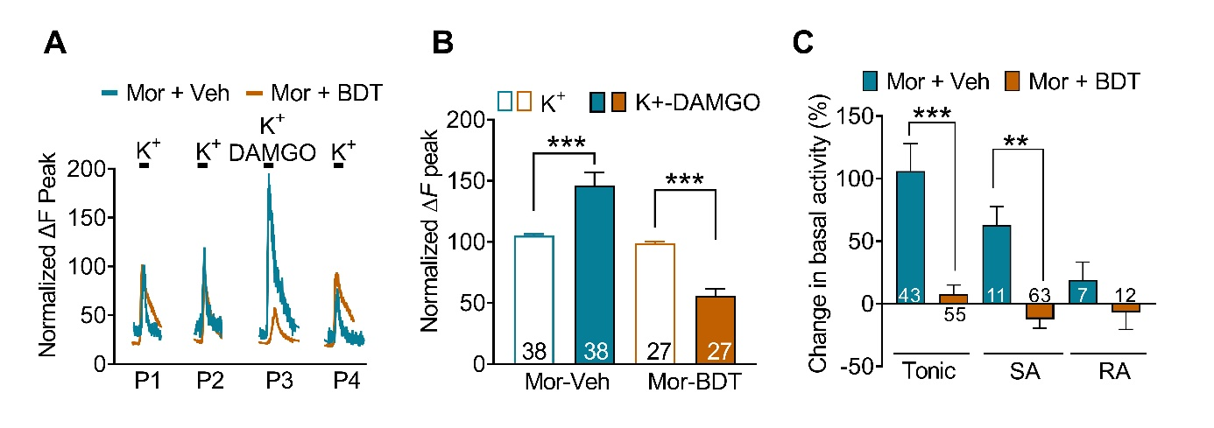
Figure S3: BDT001 inhibits MOR-induced hyperexcitability in mice DRG neurons. (A) Traces of [Ca2+]i responses to repeated bath applications of high K+ (50 mM) alone or combined with DAMGO (1 µM), a MOR selective agonist, in chronic morphine-treated cultured DRG neurons (morphine at 10 µM for 3-4 DIV) with or without BDT001. (B) Results are expressed as response amplitudes normalized to HiK+ alone (ΔF peak) ((n= 4 mice). (C) Ex vivo extracellular recordings of mechanically evoked-activity on fibers from saphenous-nerve preparations from chronic morphine treated mice (10 mg/kg, subcutaneous twice a day for 4 days) with or without BDT001 (5 mg/kg, intraperitoneal, before and after a 10 s-mechanical stimulus applied on the skin (n = 3-7 mice/group). Data are represented as normalized firing of cutaneous mechanoreceptors. Data are shown as mean ± SEM. **P < 0.01, ***P < 0.001. Statistical analyses included mixed-effect model (REML) test followed by Šidák’s for multiple comparisons (B) and one-way ANOVA followed by Bonferroni’s test for multiple comparisons (C). BDT, BDT001; Mor, morphine; Veh, vehicle.

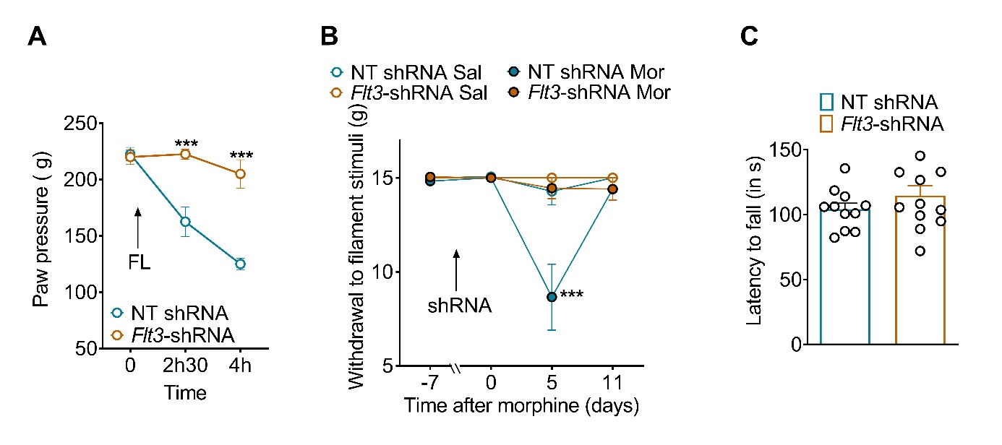
Figure S4: Flt3-targeted shRNA prevents FL (A) or morphine (B)-induced mechanical hyperalgesia and has no effect on motor function in rats. Baseline mechanical hypersensitivity induced by intrathecal FL (A) or baseline mechanical allodynia induced by chronic morphine (B) in AAV9 non-target-shRNA treated rats but not in AAV9 Flt3-shRNA treated rats (n = 6/group). (C) Motor analysis using the rotarod test in AAV9 non-target shRNA and AAV9 Flt3-shRNA treated rats. Data are shown as mean ± SEM. ***P < 0.001. Statistical analyses included two-way repeated ANOVA followed by Bonferroni’s test for multiple comparisons (A, B) and Mann-Whitney test (C). Mor, morphine; NT, non-targeted.

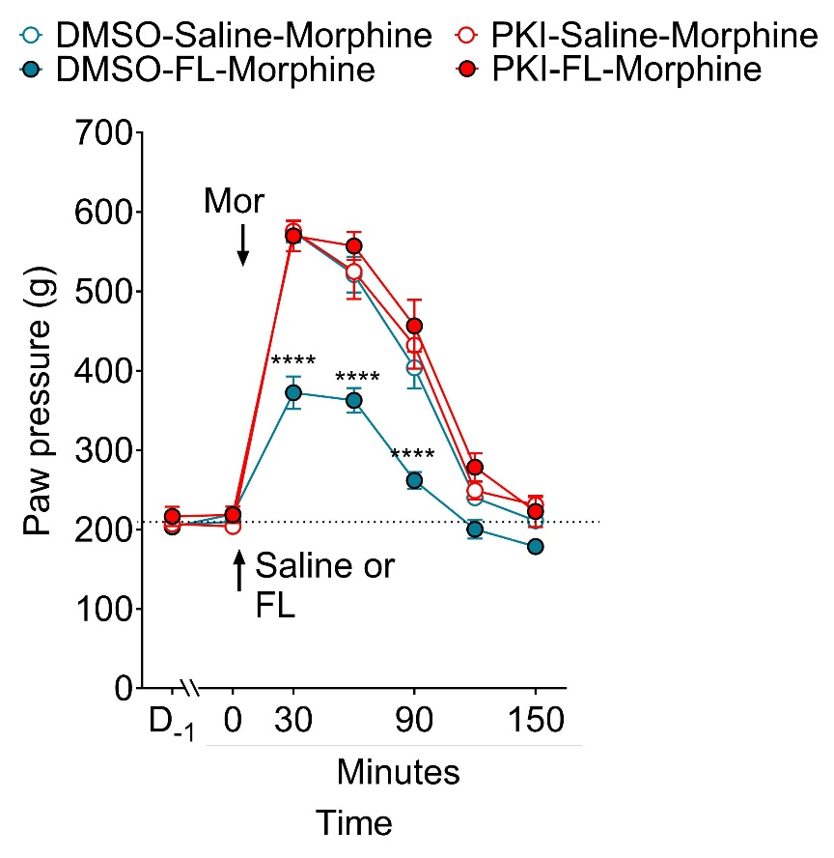

Figure S5: Inhibition of PKA opposes to FL-induced OIT. Mechanical pain sensitivity of rats receiving a single intrathecal injection of PKI14-22 (5 µg/10µl) or DMSO followed 60 minutes later by an injection of FL (138 nM/20 µL) or saline and, 90 minutes an acute morphine injection (2 mg/kg, subcutaneously) (n = 6 rats/group). Data are shown as mean ± SEM. ****P < 0.0001; ***P < 0.001. Statistical analyses included two-way repeated ANOVA followed by Bonferroni’s test for multiple comparisons. Mor: Morphine.

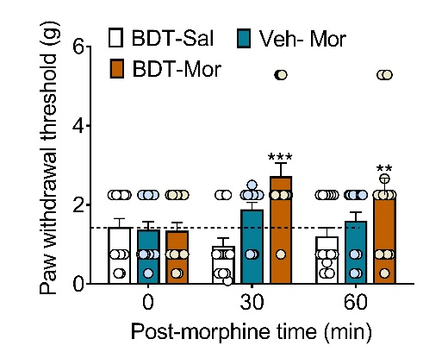

Figure S6: BDT001 potentiates morphine analgesia in mice. The analgesic effects of subcutaneous (s.c.) morphine (5 mg/kg) with or without intraperitoneal (i.p.) BDT001 (BDT, 5 mg/kg) were evaluated using von Frey “up and Down” method in mice (n=8/group). ***P < 0.001; **P < 0.01, Statistical analyses included two-way repeated ANOVA followed by Bonferroni’s test for multiple comparisons.

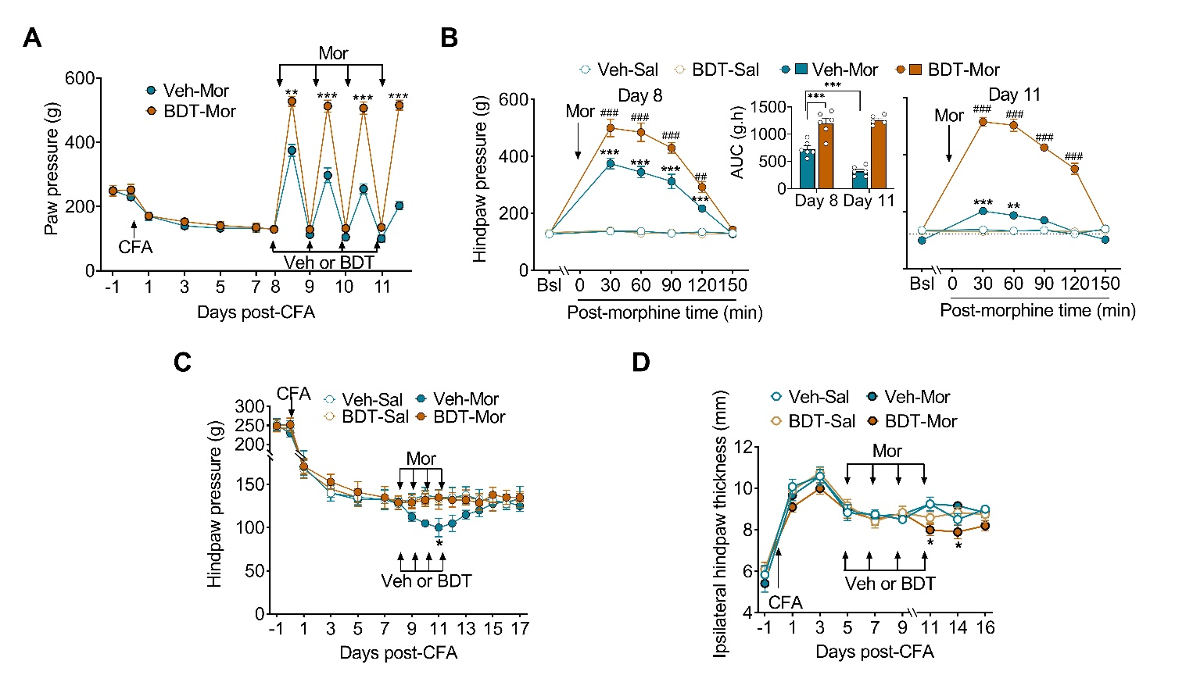
Figure S7: Preventive effects of BDT001 on OIH and OIT in a model of chronic inflammatory pain. Rats received one injection of CFA in the hindpaw and treated with saline (Sal) or morphine (Mor, 5 mg/kg twice a day) and vehicle (Veh) or BDT001 (BDT, 5 mg/kg once a day) was initiated at 8 days after CFA (D₈) and repeated for 4 days. (A), Morphine analgesia progressively decreased, as morphine-induced increase in mechanical pain thresholds vanished, as shown by the maximal morphine effect at 30 min. BDT001-treated animals showed the maintenance of morphine analgesia (n = 6 rats/group). (B) The time-courses of morphine analgesic effect 8 and 11 days after CFA, with the area under the curves of the time-courses shown in the inset. OIT was completely prevented by BDT001. (C) When assessed before the first daily morphine administration, OIH progressively emerged with morphine treatment, as shown by the diminished mechanical pain threshold, both effects were completely prevented by BDT001. (D) BDT001 effects on morphine analgesia occurred without any sign of inflammation, as shown by the limited changes on paw thickness. Data are shown as mean ± SEM (5-6 rats/group). *P < 0.05, **P < 0.01, ***P < 0.001 vs. Veh-Veh alone; ## P < 0.01, ### P < 0.001 vs. Veh-Mor. Statistical analyses included two-way ANOVA followed by Bonferroni’s for multiple comparison test. ). BDT, BDT001; Mor, morphine; Sal, saline; Veh, vehicle.

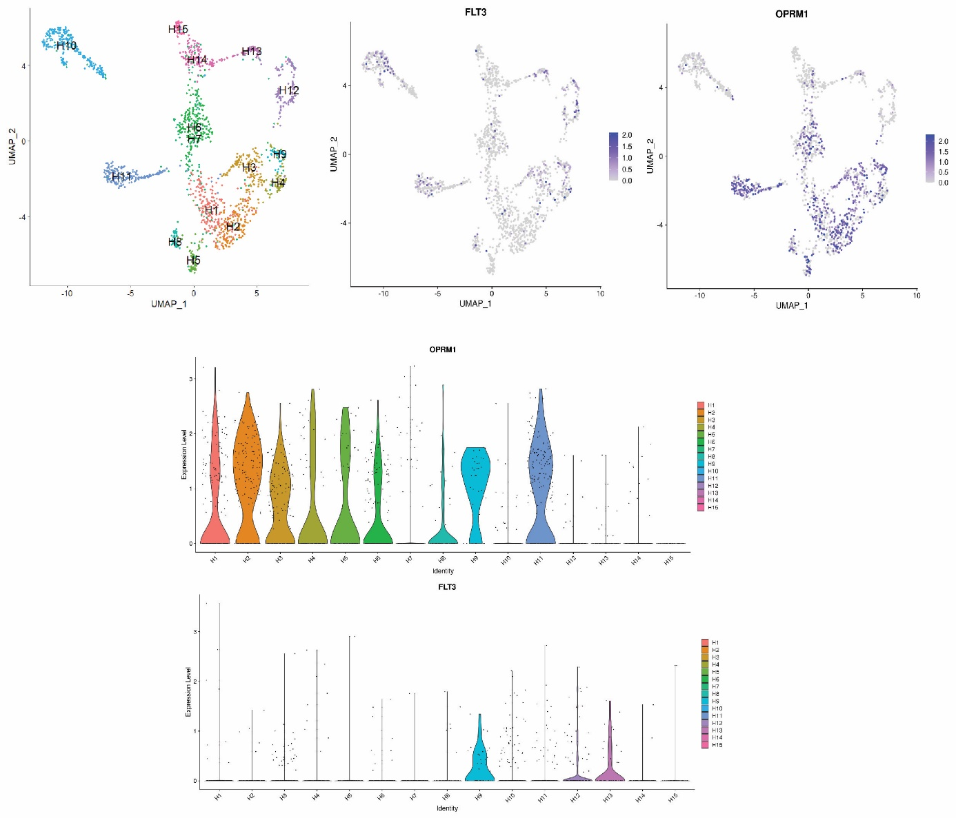

Figure S8: Oprm1 and Flt3 mRNA are co-expressed in human DRG. (A) Universal manifold (UMAP) representation of graph-based co-clustered snRNA sequences from 1837 human DRG neuronal nuclei reveal 15 transcriptomically distinct classes of neurons that have been differentially colored. (B) UMAP representation of Flt3 and Oprm1 mRNA shows clusters co-expression. (C) Violin plots of Oprm1 and Flt3 show their expression distribution across clusters and high co-expression in cluster H9.

