EXTENDED DATA
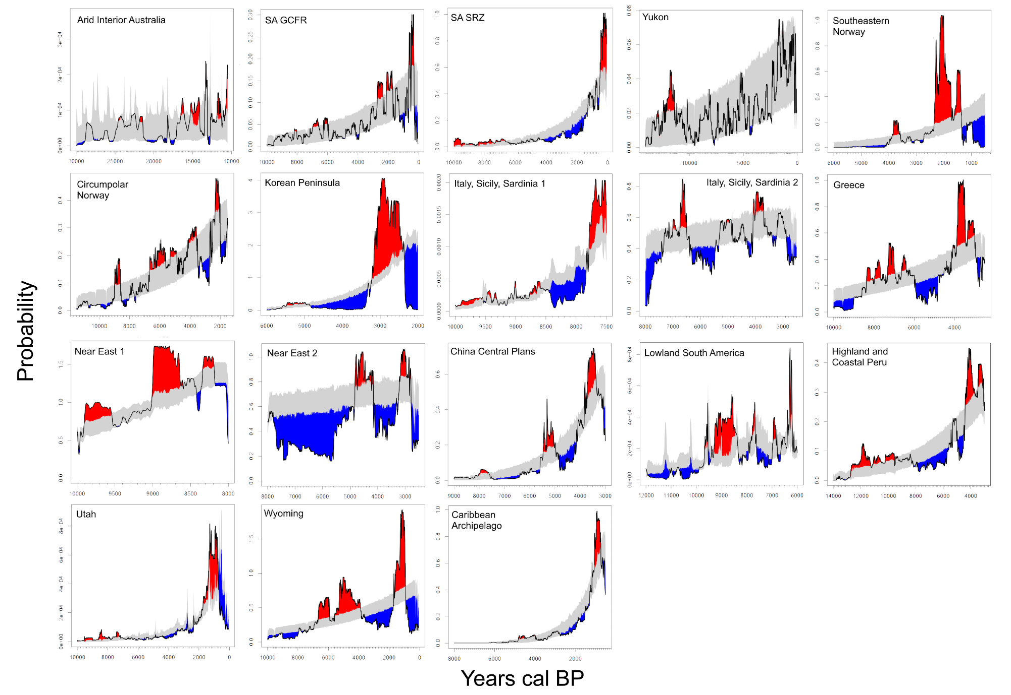
Figure S1: Posterior predictive checks for 16 study regions. Regions shaded in blue indicate period below modelled growth trajectories: downturns.

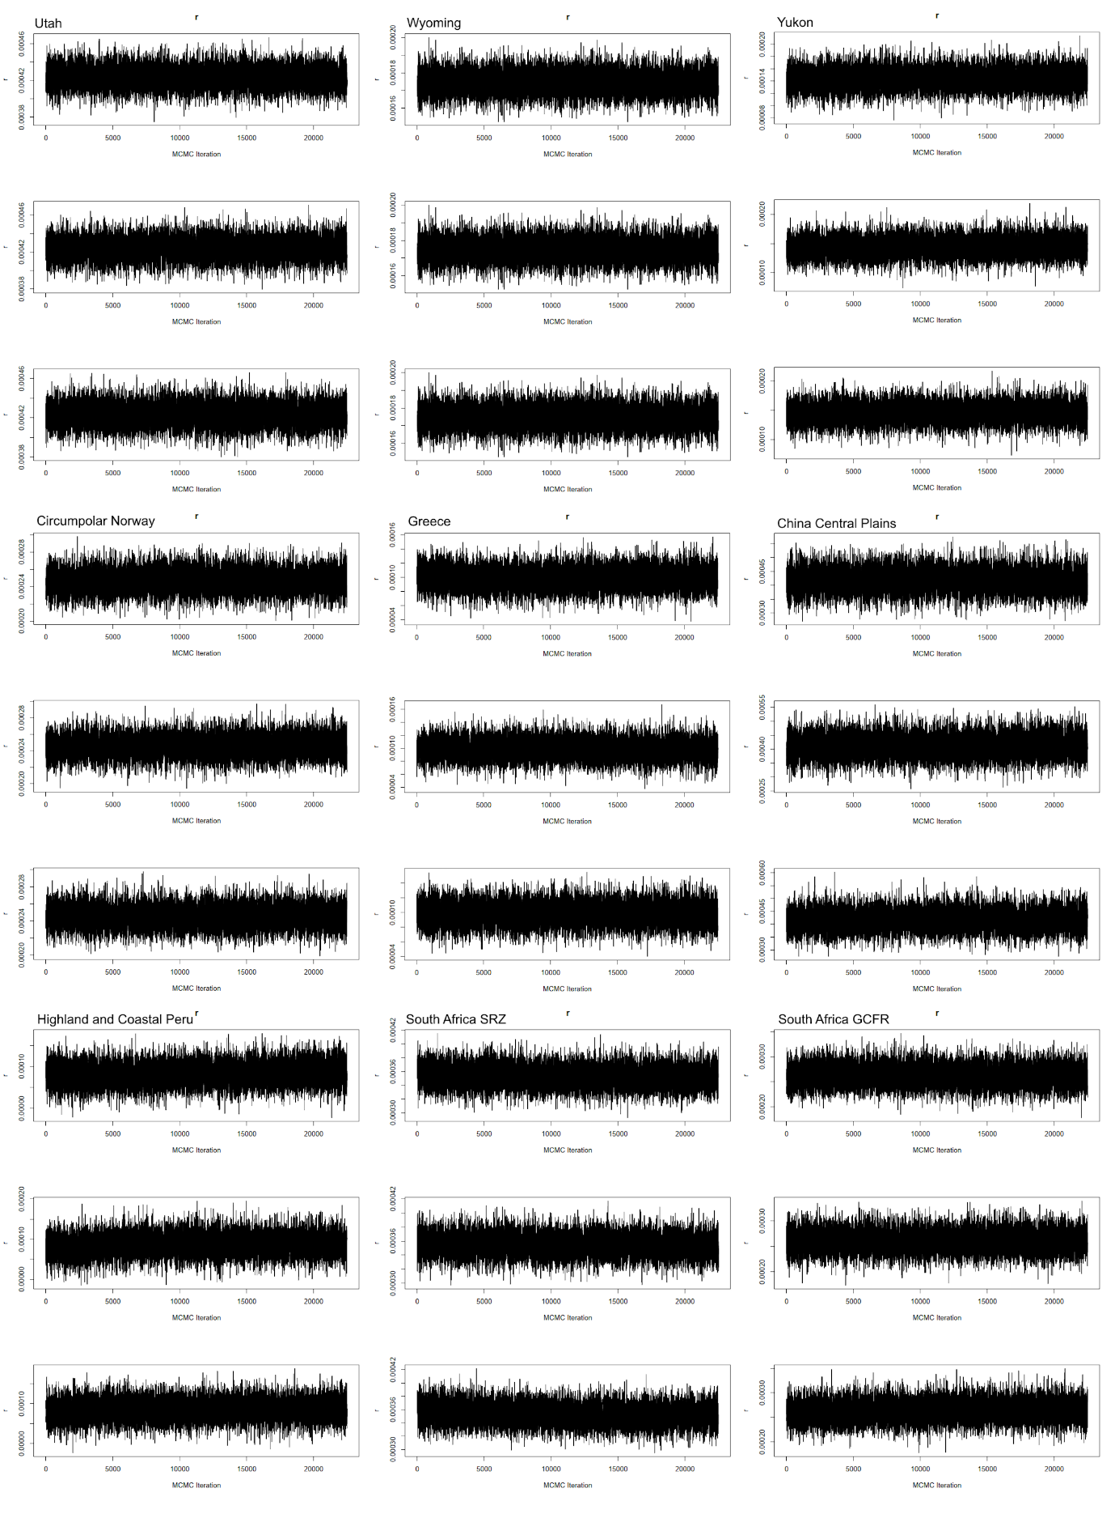
Figure S2: Traceplots of chain mixing for the MCMC of each study region and subset.

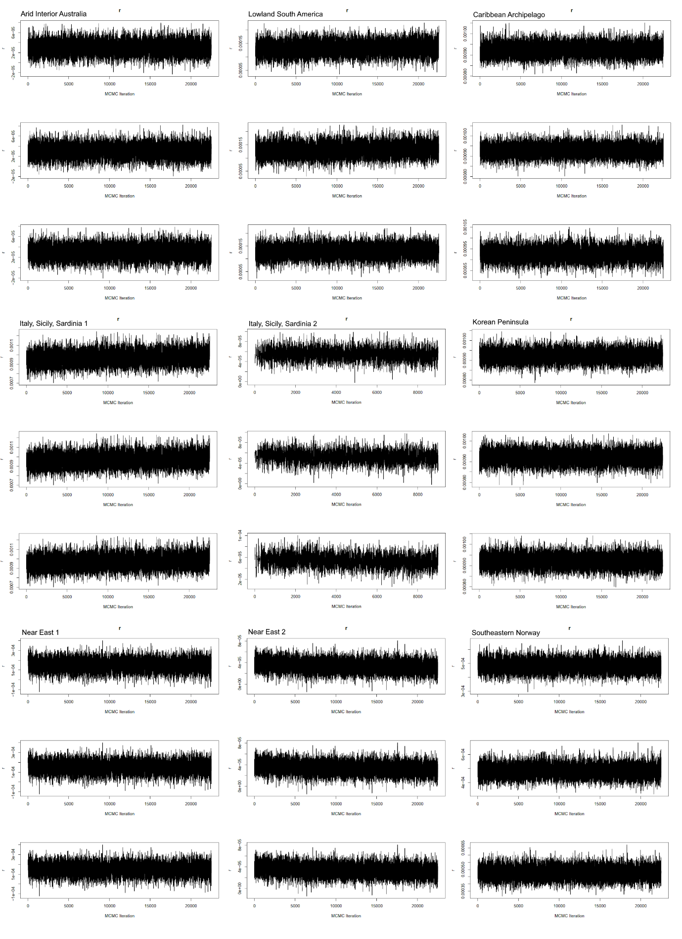
Figure S3: Traceplots of chain mixing for the MCMC of each study region and subset.

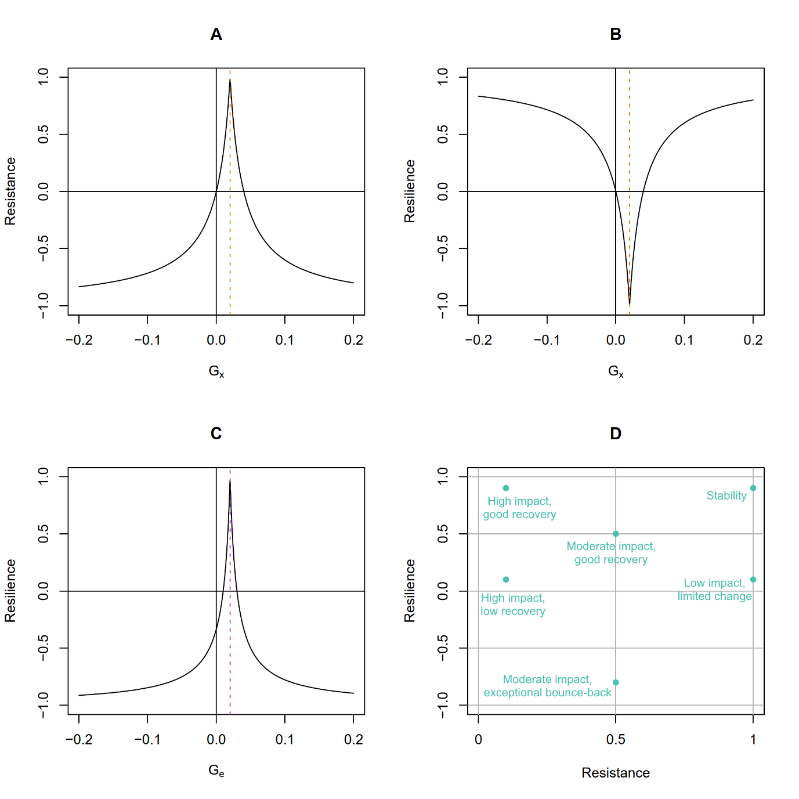
Figure S4: Resistance and Resilience as functions of variation in minima (G_{x}) and end-points (G_{e}) when baselines (G_{b}) are held constant (0.02). (A) Resistance equals zero for two different values of G_{x}, when G_{x} = 0 and when G_{x} is two times G_{b}. Negative resistance is theoretically possible but does not occur on SPDs, (B) Resilience as a function of G_{x}, (C) Resilience with a varying end point (G_{e}), and constant start (G_{b}) and minimum (G_{x} = 0.01). Resilience equals 1 only when G_{e} = G_{b}, (D) Interpretative scatterplot of indicative resistance-resilience outcomes.

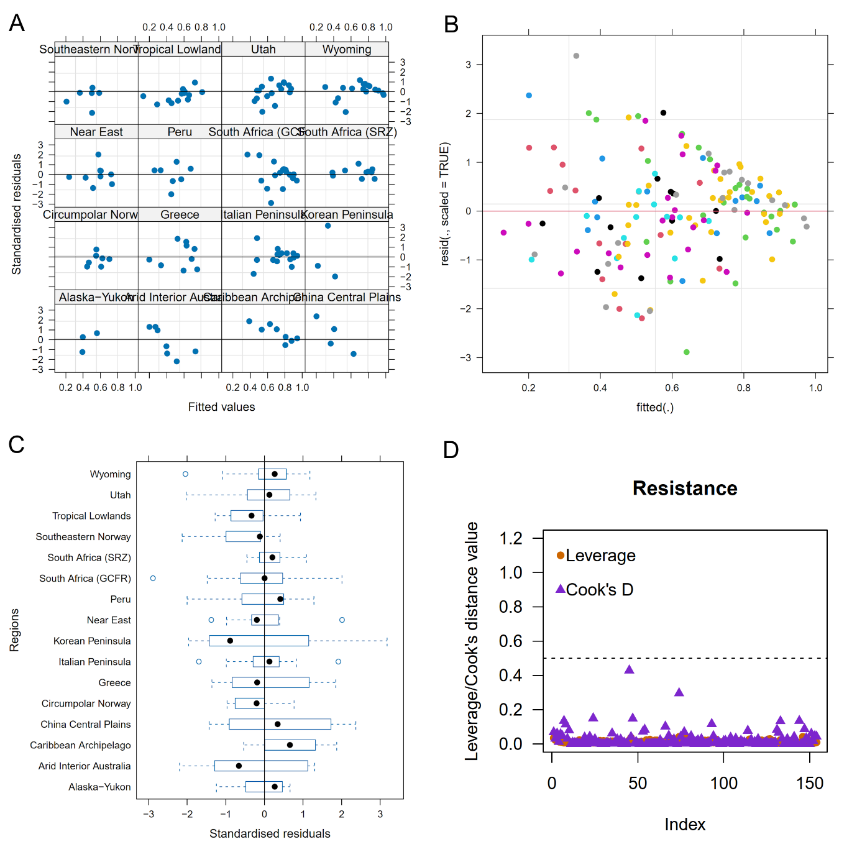
Figure S5: Model diagnostics for Model I (Resistance). (A) Standardised residuals against fitted values for each study region. (B) All residuals versus fitted values. (C) Standardised residuals by study region. (D) Leverage and Cook's Distance for 154 observations.

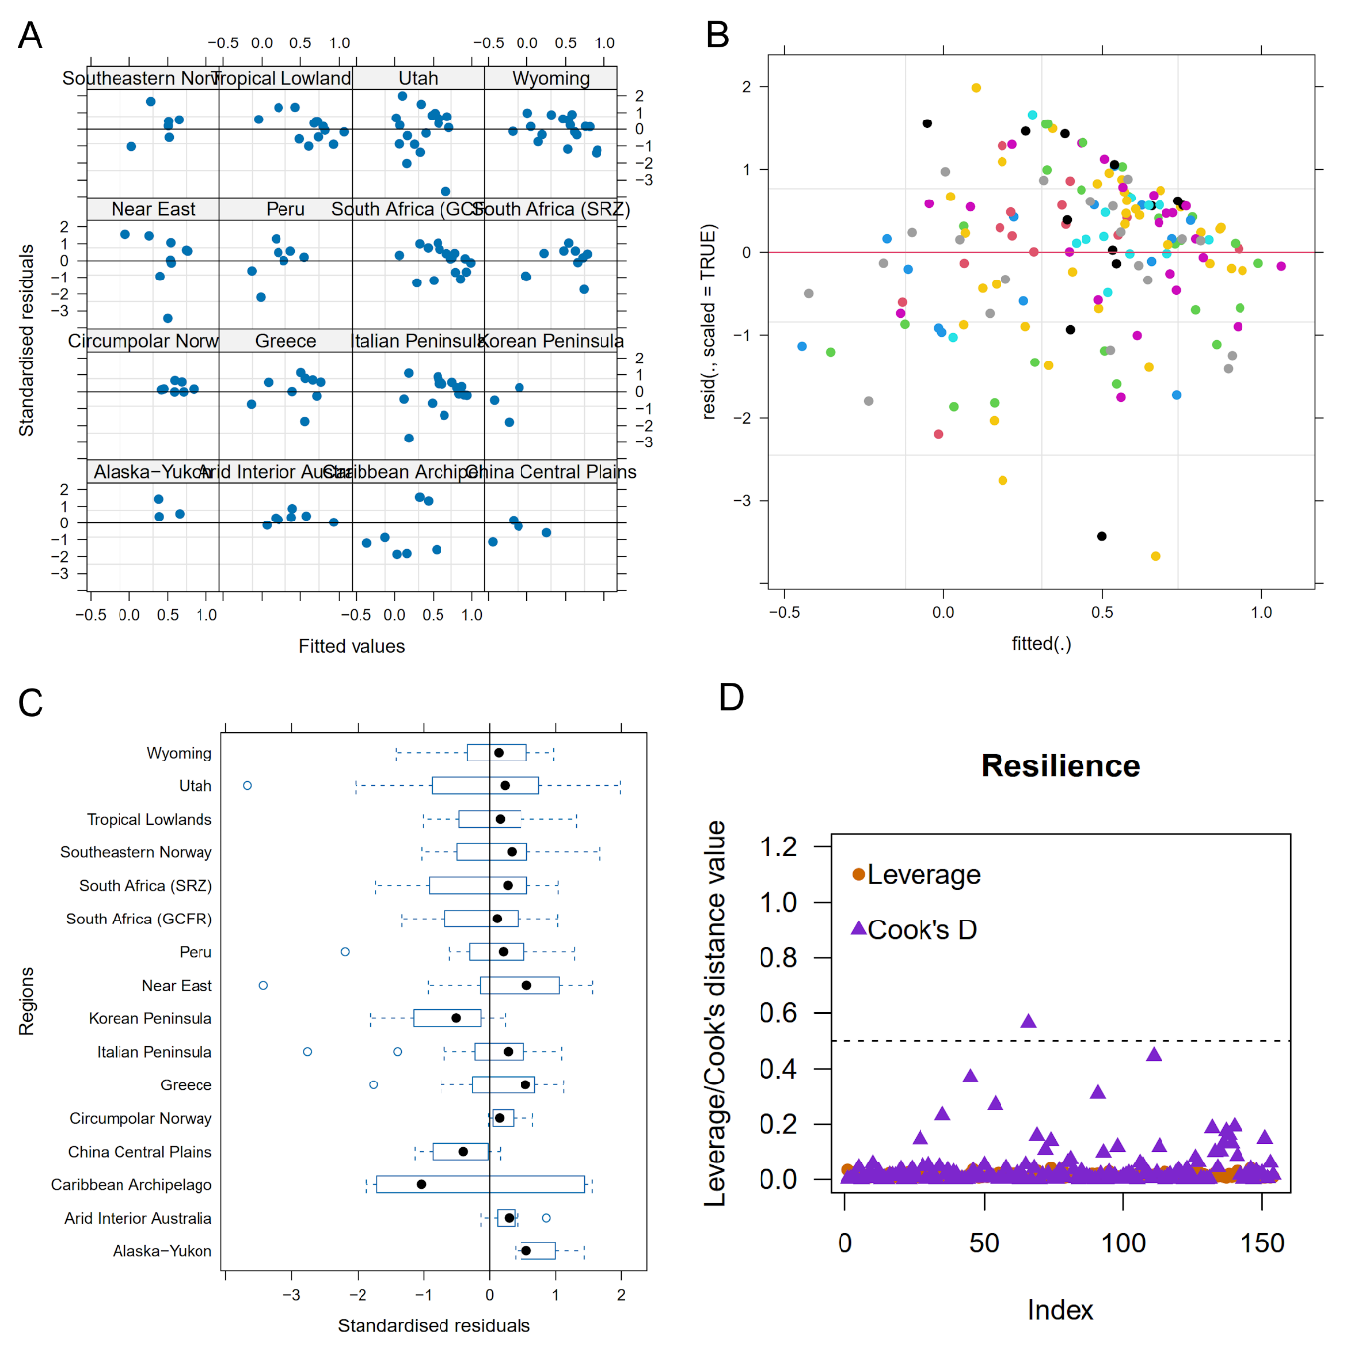
Figure S6: Model diagnostics for Model II (Resilience). (A) Standardised residuals against fitted values for each study region. (B) All residuals versus fitted values. (C) Standardised residuals by study region. (D) Leverage and Cook's Distance for 154 observations.

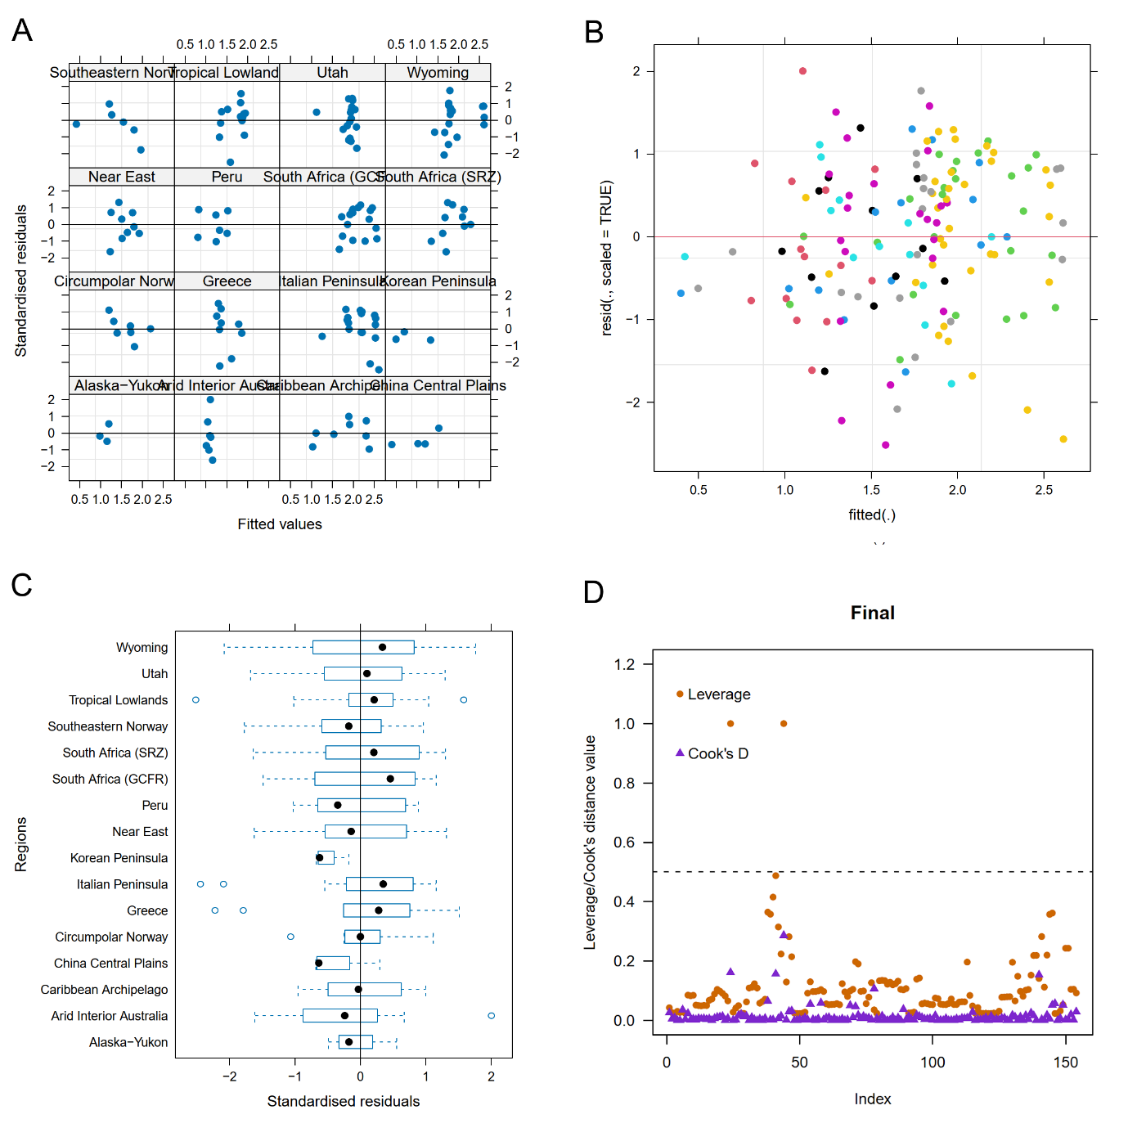
Figure S7: Model diagnostics for Model III. (A) Standardised residuals against fitted values for each study region. (B) All residuals versus fitted values. (C) Standardised residuals by study region. (D) Leverage and Cook's Distance for 154 observations.

Table S1: Summary of attributes of regions used in this study. Locations, number of dates, the use of a null hypothesis significance testing approach in the original study, whether downturns are addressed in the original study, any subdivisions, overall timespan. Full table with bibliographic information at: https://dx.doi.org/10.5281/zenodo.10061467.
Region | Longitude | Latitude | Dates | Revised dates | NHST? | Downturns? | Subdivisions? | Start | End
Circumpolar Norway | 23.35788 | 69.75773 | 735 | 1154 | Yes | Yes | 1 | 12000 | 1500
Arid Interior Australia | 130.2984 | -27.5036 | 233 | 946 | No | Partial | 1 | 30000 | 10500
Greece | 23.9369 | 38.1336 | 2143 | 2137 | Yes | Partial | 1 | 10000 | 2500
China Central Plains | 114.101 | 34.242 | 754 | 754 | Yes | Yes | 1 | 10000 | 3000
Italy, Sicily, and Sardinia | 12.675 | 41.8146 | 4010 | 4629 | Yes | Partial | 2 | 10000 | 2500
Korean Peninsula | 127.566 | 38.50802 | 2190 | 2190 | Yes | Yes | 1 | 6000 | 2000
Lowland South America | -55.574 | -6.85714 | 4047 | 4060 | Yes | Yes | 1 | 12000 | 6000
Near East | 43.52307 | 27.88021 | 10653 | 11071 | Yes | Partial | 2 | 14000 | 2500
Highland and Coastal Peru | -75.2055 | -10.7711 | 1180 | 1180 | Yes | Yes | 1 | 14000 | 3000
Southern Africa Greater Cape Floristic Region | 21.53845 | -31.5833 | 1845 | 2089 | No | Partial | 1 | 10000 | 50
Southern Africa Summer Rainfall Zone | 26.0583 | -27.5175 | 1845 | 2089 | No | Partial | 1 | 10000 | 50
Southeastern Norway | 9.264051 | 59.82167 | 617 | 617 | Yes | Yes | 1 | 6000 | 500
Utah | -111.674 | 39.32648 | 1126 | 2544 | Yes | Yes | 1 | 10000 | 50
Wyoming | -107.552 | 42.99983 | 2570 | 4249 | Yes | Yes | 1 | 10000 | 50
Yukon | -142.36 | 63.0432 | 285 | 272 | Yes | Partial | 1 | 14100 | 50
Caribbean Archipelago | -70.4065 | 18.40969 | 2484 | 2148 | No | No | 1 | 8000 | 500

Table S2: Resistance and resilience metrics extracted from periods of population downturn detected in posterior predictive checks. Full table in repository: https://dx.doi.org/10.5281/zenodo.10061467
UniqID | UniqID.individual | Region | Tstart | Tend | Duration | Resistance | Resilience | Lag | LD | Downturns
100002 | 2 | Arid Interior Australia | 27803 | 27147 | 656 | 0.473645 | 0.007968 | 611 | 0.931402 | 1
100003 | 3 | Arid Interior Australia | 25787 | 25233 | 554 | 0.494109 | 0.299845 | 211 | 0.380866 | 2
100005 | 5 | Arid Interior Australia | 20961 | 20958 | 3 | 0.995877 | 0 | 3 | 1 | 3
100006 | 6 | Arid Interior Australia | 20956 | 19569 | 1387 | 0.544063 | 0.30187 | 843 | 0.607787 | 4
100007 | 7 | Arid Interior Australia | 18824 | 18287 | 537 | 0.258328 | 0.526308 | 414 | 0.77095 | 5
100008 | 8 | Arid Interior Australia | 17896 | 17299 | 597 | 0.11274 | 0.762264 | 414 | 0.693467 | 6
100009 | 9 | Arid Interior Australia | 13070 | 13036 | 34 | 0.484943 | 0.946244 | 25 | 0.735294 | 7
100010 | 10 | Arid Interior Australia | 13023 | 12736 | 287 | 0.055418 | 0.754548 | 144 | 0.501742 | 8
200002 | 2 | South Africa (GCFR) | 5897 | 5727 | 170 | 0.788853 | 0.196325 | 49 | 0.288235 | 1
200003 | 3 | South Africa (GCFR) | 5030 | 5010 | 20 | 0.947126 | 1 | 10 | 0.5 | 2
200004 | 4 | South Africa (GCFR) | 4977 | 4834 | 143 | 0.913584 | -0.27936 | 82 | 0.573427 | 3
200005 | 5 | South Africa (GCFR) | 4144 | 4123 | 21 | 0.780493 | 0.848796 | 7 | 0.333333 | 4
200006 | 6 | South Africa (GCFR) | 4094 | 3902 | 192 | 0.396428 | 0.747472 | 112 | 0.583333 | 5
200007 | 7 | South Africa (GCFR) | 3339 | 3318 | 21 | 0.901053 | 0.807563 | 11 | 0.52381 | 6
200008 | 8 | South Africa (GCFR) | 3305 | 3285 | 20 | 0.905401 | 0.963005 | 12 | 0.6 | 7
200009 | 9 | South Africa (GCFR) | 3272 | 3241 | 31 | 0.875176 | 0.776499 | 18 | 0.580645 | 8
200010 | 10 | South Africa (GCFR) | 1609 | 1598 | 11 | 0.902536 | 0.644759 | 4 | 0.363636 | 9
200011 | 11 | South Africa (GCFR) | 1591 | 1564 | 27 | 0.869457 | 0.495687 | 7 | 0.259259 | 10
200012 | 12 | South Africa (GCFR) | 1546 | 1543 | 3 | 0.990577 | 1 | 1 | 0.333333 | 11
200013 | 13 | South Africa (GCFR) | 1282 | 1175 | 107 | 0.668322 | 0.868362 | 101 | 0.943925 | 12
200014 | 14 | South Africa (GCFR) | 1173 | 903 | 270 | 0.29301 | 0.753923 | 215 | 0.796296 | 13
200015 | 15 | South Africa (GCFR) | 864 | 838 | 26 | 0.849926 | 0.384902 | 5 | 0.192308 | 14
200016 | 16 | South Africa (GCFR) | 833 | 813 | 20 | 0.812297 | 0.961659 | 8 | 0.4 | 15
200017 | 17 | South Africa (GCFR) | 726 | 664 | 62 | 0.466191 | 0.771691 | 54 | 0.870968 | 16
200018 | 18 | South Africa (GCFR) | 522 | 507 | 15 | 0.805992 | 0.933773 | 8 | 0.533333 | 17
200019 | 19 | South Africa (GCFR) | 296 | 50 | 246 | 0.034768 | 0.000959 | 244 | 0.99187 | 18
300001 | 1 | South Africa (SRZ) | 6104 | 6092 | 12 | 0.914094 | 0.716996 | 4 | 0.333333 | 1
300002 | 2 | South Africa (SRZ) | 5999 | 5898 | 101 | 0.61469 | 0.401918 | 13 | 0.128713 | 2
300004 | 4 | South Africa (SRZ) | 4758 | 4752 | 6 | 0.960313 | 0 | 6 | 1 | 3
300006 | 6 | South Africa (SRZ) | 4676 | 4665 | 11 | 0.954413 | 0 | 11 | 1 | 4
300008 | 8 | South Africa (SRZ) | 4218 | 4210 | 8 | 0.986032 | 1 | 4 | 0.5 | 5
300009 | 9 | South Africa (SRZ) | 4152 | 2990 | 1162 | 0.425611 | -0.40514 | 502 | 0.432014 | 6
300010 | 10 | South Africa (SRZ) | 2986 | 2965 | 21 | 0.878701 | 0.787404 | 12 | 0.571429 | 7
300011 | 11 | South Africa (SRZ) | 2873 | 1407 | 1466 | 0.364734 | -0.41702 | 211 | 0.143929 | 8
300014 | 14 | South Africa (SRZ) | 1392 | 1391 | 1 | 0.990341 | 0 | 1 | 1 | 9
300015 | 15 | South Africa (SRZ) | 1387 | 1379 | 8 | 0.969777 | 0.583021 | 4 | 0.5 | 10
300018 | 18 | South Africa (SRZ) | 1360 | 1303 | 57 | 0.820552 | 0.863396 | 48 | 0.842105 | 11
300019 | 19 | South Africa (SRZ) | 954 | 952 | 2 | 0.991302 | 1 | 1 | 0.5 | 12
300020 | 20 | South Africa (SRZ) | 929 | 901 | 28 | 0.777063 | 0.940188 | 7 | 0.25 | 13
300021 | 21 | South Africa (SRZ) | 866 | 805 | 61 | 0.854335 | 0.605981 | 7 | 0.114754 | 14
300022 | 22 | South Africa (SRZ) | 669 | 543 | 126 | 0.629434 | 0.978882 | 36 | 0.285714 | 15
400001 | 1 | Alaska-Yukon | 7794 | 7656 | 138 | 0.130832 | 0.988129 | 105 | 0.76087 | 1
400002 | 2 | Alaska-Yukon | 4414 | 4149 | 265 | 0.452251 | 0.553023 | 34 | 0.128302 | 2
400003 | 3 | Alaska-Yukon | 2438 | 2350 | 88 | 0.698373 | 0.890432 | 81 | 0.920455 | 3
500005 | 5 | Circumpolar Norway | 8519 | 8179 | 340 | 0.243758 | 0.4624 | 204 | 0.6 | 5
500006 | 6 | Circumpolar Norway | 8177 | 8024 | 153 | 0.713033 | 0.867942 | 42 | 0.27451 | 6
500007 | 7 | Circumpolar Norway | 7680 | 7573 | 107 | 0.404023 | 0.921042 | 80 | 0.747664 | 7
500008 | 8 | Circumpolar Norway | 3464 | 3357 | 107 | 0.595052 | 0.696054 | 27 | 0.252336 | 8
500009 | 9 | Circumpolar Norway | 3213 | 2702 | 511 | 0.350358 | 0.51439 | 466 | 0.911937 | 9
500010 | 10 | Circumpolar Norway | 1949 | 1688 | 261 | 0.578156 | 0.576777 | 42 | 0.16092 | 10
500011 | 11 | Circumpolar Norway | 1674 | 1604 | 70 | 0.659937 | 0.897083 | 25 | 0.357143 | 11
600001 | 1 | Korean Peninsula | 6000 | 5742 | 258 | 1 | -1 | 0 | 0 | 1
600002 | 2 | Korean Peninsula | 4838 | 3327 | 1511 | 0.03072 | -0.63848 | 996 | 0.659166 | 2
600003 | 3 | Korean Peninsula | 2360 | 2000 | 360 | 0.003173 | 0 | 360 | 1 | 3
700001 | 1 | Italian Peninsula | 9538 | 9525 | 13 | 0.603265 | 0.197624 | 8 | 0.615385 | 1
700002 | 2 | Italian Peninsula | 9509 | 9493 | 16 | 0.891478 | 0.772149 | 9 | 0.5625 | 2
700003 | 3 | Italian Peninsula | 9283 | 9267 | 16 | 0.842487 | 0.052515 | 8 | 0.5 | 3
700004 | 4 | Italian Peninsula | 9172 | 9145 | 27 | 0.781315 | 0.823742 | 12 | 0.444444 | 4
700005 | 5 | Italian Peninsula | 8515 | 8500 | 15 | 0.905168 | 0.977806 | 5 | 0.333333 | 5
700006 | 6 | Italian Peninsula | 8457 | 7835 | 622 | 0.083619 | -0.0644 | 99 | 0.159164 | 6
700007 | 7 | Italian Peninsula | 7806 | 7799 | 7 | 0.935889 | 0.519229 | 1 | 0.142857 | 7
800001 | 1 | Italian Peninsula | 8000 | 7422 | 578 | 0.881231 | -0.98666 | 34 | 0.058824 | 8
800002 | 2 | Italian Peninsula | 7376 | 7365 | 11 | 0.943795 | 0.822158 | 6 | 0.545455 | 9
800003 | 3 | Italian Peninsula | 6391 | 6370 | 21 | 0.814281 | 0.910558 | 11 | 0.52381 | 10
800004 | 4 | Italian Peninsula | 6345 | 6334 | 11 | 0.969228 | 0.84686 | 5 | 0.454545 | 11
800005 | 5 | Italian Peninsula | 6319 | 5443 | 876 | 0.417001 | 0.648304 | 725 | 0.827626 | 12
800006 | 6 | Italian Peninsula | 5408 | 5326 | 82 | 0.799305 | 0.804827 | 43 | 0.52439 | 13
800008 | 8 | Italian Peninsula | 4755 | 4754 | 1 | 0.996547 | 0 | 1 | 1 | 14
800010 | 10 | Italian Peninsula | 4670 | 4669 | 1 | 0.99491 | 0 | 1 | 1 | 15
800012 | 12 | Italian Peninsula | 4396 | 4372 | 24 | 0.978135 | 0.987107 | 16 | 0.666667 | 16
800013 | 13 | Italian Peninsula | 4353 | 4328 | 25 | 0.888364 | 0.99858 | 13 | 0.52 | 17
800014 | 14 | Italian Peninsula | 4298 | 4143 | 155 | 0.618777 | 0.932999 | 93 | 0.6 | 18
800015 | 15 | Italian Peninsula | 4127 | 4093 | 34 | 0.671502 | 0.779823 | 21 | 0.617647 | 19
800016 | 16 | Italian Peninsula | 3392 | 3227 | 165 | 0.769819 | 0.878693 | 113 | 0.684848 | 20
900001 | 1 | Near East | 9985 | 9965 | 20 | 0.558798 | 0.986929 | 10 | 0.5 | 1
900002 | 2 | Near East | 9475 | 9425 | 50 | 0.998248 | -0.96253 | 6 | 0.12 | 2
900003 | 3 | Near East | 8421 | 8363 | 58 | 0.679138 | 0.485145 | 32 | 0.551724 | 3
900004 | 4 | Near East | 8177 | 8000 | 177 | 0.225574 | 0 | 177 | 1 | 4
1000001 | 1 | Near East | 7789 | 4972 | 2817 | 0.185411 | 0.610061 | 2070 | 0.734824 | 5
1000002 | 2 | Near East | 4961 | 4837 | 124 | 0.679428 | 0.542458 | 101 | 0.814516 | 6
1000003 | 3 | Near East | 4149 | 4108 | 41 | 0.527121 | 0.993476 | 12 | 0.292683 | 7
1000004 | 4 | Near East | 4102 | 3321 | 781 | 0.35899 | 0.879243 | 452 | 0.578745 | 8
1000005 | 5 | Near East | 3304 | 3246 | 58 | 0.723018 | 1 | 25 | 0.431034 | 9
1100001 | 1 | China Central Plains | 7426 | 6394 | 1032 | 0.698174 | -0.92779 | 8 | 0.007752 | 1
1100002 | 2 | China Central Plains | 5904 | 5592 | 312 | 0.631151 | -0.19934 | 214 | 0.685897 | 2
1100003 | 3 | China Central Plains | 4829 | 4150 | 679 | 0.283329 | -0.10977 | 33 | 0.048601 | 3
1100004 | 4 | China Central Plains | 3079 | 3000 | 79 | 0.328387 | 0 | 79 | 1 | 4
1200001 | 1 | Tropical Lowlands | 11928 | 11066 | 862 | 0.038017 | 0.204144 | 731 | 0.848028 | 1
1200002 | 2 | Tropical Lowlands | 11030 | 11005 | 25 | 0.645038 | 0.899931 | 15 | 0.6 | 2
1200003 | 3 | Tropical Lowlands | 10965 | 10793 | 172 | 0.2422 | 0.992403 | 60 | 0.348837 | 3
1200004 | 4 | Tropical Lowlands | 10691 | 9904 | 787 | 0.022327 | 0.768932 | 195 | 0.247776 | 4
1200005 | 5 | Tropical Lowlands | 9536 | 9430 | 106 | 0.34236 | 0.180689 | 46 | 0.433962 | 5
1200006 | 6 | Tropical Lowlands | 8323 | 8237 | 86 | 0.532749 | 0.828156 | 48 | 0.55814 | 6
1200007 | 7 | Tropical Lowlands | 8223 | 8171 | 52 | 0.47951 | 0.860769 | 37 | 0.711538 | 7
1200008 | 8 | Tropical Lowlands | 8077 | 8049 | 28 | 0.921975 | 0.543106 | 12 | 0.428571 | 8
1200009 | 9 | Tropical Lowlands | 8027 | 7933 | 94 | 0.611715 | 0.53598 | 58 | 0.617021 | 9
1200010 | 10 | Tropical Lowlands | 7886 | 7880 | 6 | 0.970724 | 0.338875 | 1 | 0.166667 | 10
1200011 | 11 | Tropical Lowlands | 7615 | 7150 | 465 | 0.214647 | 0.240518 | 355 | 0.763441 | 11
1200012 | 12 | Tropical Lowlands | 7135 | 7001 | 134 | 0.574024 | 0.922681 | 45 | 0.335821 | 12
1200013 | 13 | Tropical Lowlands | 6783 | 6762 | 21 | 0.80248 | 0.990992 | 8 | 0.380952 | 13
1200014 | 14 | Tropical Lowlands | 6751 | 6660 | 91 | 0.589144 | 0.789276 | 69 | 0.758242 | 14
1300001 | 1 | Peru | 14000 | 13762 | 238 | 0.419301 | -0.94822 | 100 | 0.420168 | 1
1300002 | 2 | Peru | 13496 | 13443 | 53 | 0.465385 | 0.612189 | 21 | 0.396226 | 2
1300003 | 3 | Peru | 13299 | 13069 | 230 | 0.033058 | 0.730013 | 166 | 0.721739 | 3
1300004 | 4 | Peru | 8180 | 8006 | 174 | 0.783256 | 0.285709 | 25 | 0.143678 | 4
1300005 | 5 | Peru | 7870 | 5585 | 2285 | 0.34653 | -0.38815 | 155 | 0.067834 | 5
1300006 | 6 | Peru | 5386 | 5328 | 58 | 0.798567 | 0.636439 | 21 | 0.362069 | 6
1300007 | 7 | Peru | 4974 | 4516 | 458 | 0.329622 | 0.417164 | 137 | 0.299127 | 7
1400001 | 1 | Utah | 6188 | 6134 | 54 | 0.526179 | 0.946361 | 16 | 0.296296 | 1
1400002 | 2 | Utah | 6127 | 5996 | 131 | 0.506407 | 0.16572 | 51 | 0.389313 | 2
1400003 | 3 | Utah | 5985 | 5974 | 11 | 0.980897 | 0.840145 | 5 | 0.454545 | 3
1400004 | 4 | Utah | 5937 | 5597 | 340 | 0.254836 | 0.307436 | 307 | 0.902941 | 4
1400005 | 5 | Utah | 5583 | 5471 | 112 | 0.502797 | -0.1249 | 6 | 0.053571 | 5
1400006 | 6 | Utah | 5443 | 5406 | 37 | 0.872599 | 0.835714 | 13 | 0.351351 | 6
1400007 | 7 | Utah | 5325 | 5257 | 68 | 0.386608 | 0.303689 | 28 | 0.411765 | 7
1400008 | 8 | Utah | 5247 | 5233 | 14 | 0.935698 | 0.744276 | 7 | 0.5 | 8
1400009 | 9 | Utah | 5223 | 5217 | 6 | 0.96699 | 0.637105 | 3 | 0.5 | 9
1400010 | 10 | Utah | 5190 | 5052 | 138 | 0.618323 | 0.97652 | 40 | 0.289855 | 10
1400011 | 11 | Utah | 4964 | 4801 | 163 | 0.919357 | -0.25328 | 142 | 0.871166 | 11
1400012 | 12 | Utah | 4757 | 4697 | 60 | 0.815878 | 0.926876 | 24 | 0.4 | 12
1400013 | 13 | Utah | 4674 | 4648 | 26 | 0.844401 | 1 | 14 | 0.538462 | 13
1400014 | 14 | Utah | 4519 | 4466 | 53 | 0.989273 | 0.714215 | 39 | 0.735849 | 14
1400015 | 15 | Utah | 4450 | 4417 | 33 | 0.985633 | -0.89594 | 6 | 0.181818 | 15
1400016 | 16 | Utah | 4407 | 3328 | 1079 | 0.335467 | -0.3098 | 199 | 0.18443 | 16
1400017 | 17 | Utah | 3001 | 2335 | 666 | 0.644224 | -0.70566 | 343 | 0.515015 | 17
1400018 | 18 | Utah | 727 | 50 | 677 | 0.11412 | 0 | 605 | 0.893648 | 18
1500001 | 1 | Wyoming | 10000 | 9596 | 404 | 0.403063 | -0.24489 | 25 | 0.061881 | 1
1500002 | 2 | Wyoming | 9577 | 9557 | 20 | 0.948882 | 0.722477 | 12 | 0.6 | 2
1500003 | 3 | Wyoming | 9522 | 9513 | 9 | 0.949739 | 0.670824 | 7 | 0.777778 | 3
1500004 | 4 | Wyoming | 9489 | 9247 | 242 | 0.590615 | -0.17005 | 28 | 0.115702 | 4
1500005 | 5 | Wyoming | 9242 | 9240 | 2 | 0.999082 | 0 | 2 | 1 | 5
1500006 | 6 | Wyoming | 9237 | 9202 | 35 | 0.929724 | 0.659805 | 22 | 0.628571 | 6
1500007 | 7 | Wyoming | 9177 | 9141 | 36 | 0.77886 | 0.953571 | 17 | 0.472222 | 7
1500008 | 8 | Wyoming | 9023 | 7956 | 1067 | 0.19501 | 0.419103 | 474 | 0.444236 | 8
1500009 | 9 | Wyoming | 7788 | 7580 | 208 | 0.681803 | 0.683352 | 102 | 0.490385 | 9
1500010 | 10 | Wyoming | 7558 | 7544 | 14 | 0.940246 | 0.866895 | 8 | 0.571429 | 10
1500011 | 11 | Wyoming | 7508 | 7431 | 77 | 0.796425 | 0.022374 | 48 | 0.623377 | 11
1500012 | 12 | Wyoming | 7156 | 7105 | 51 | 0.92879 | 0.544647 | 24 | 0.470588 | 12
1500013 | 13 | Wyoming | 7075 | 6988 | 87 | 0.910886 | 0.768927 | 68 | 0.781609 | 13
1500014 | 14 | Wyoming | 3830 | 3818 | 12 | 0.936275 | 0.294285 | 6 | 0.5 | 14
1500015 | 15 | Wyoming | 3798 | 3786 | 12 | 0.90837 | 0.376895 | 7 | 0.583333 | 15
1500016 | 16 | Wyoming | 3779 | 3721 | 58 | 0.931278 | 0.497175 | 36 | 0.62069 | 16
1500017 | 17 | Wyoming | 3634 | 3601 | 33 | 0.925907 | 0.818351 | 21 | 0.636364 | 17
1500018 | 18 | Wyoming | 3593 | 1735 | 1858 | 0.312594 | 0.114523 | 837 | 0.450484 | 18
1500019 | 19 | Wyoming | 915 | 50 | 865 | 0.108788 | 0.05532 | 398 | 0.460116 | 19
1600003 | 3 | Caribbean Archipelago | 3608 | 3602 | 6 | 0.955731 | 0 | 6 | 1 | 1
1600006 | 6 | Caribbean Archipelago | 3449 | 3385 | 64 | 0.959823 | -0.76104 | 3 | 0.046875 | 2
1600007 | 7 | Caribbean Archipelago | 2756 | 1882 | 874 | 0.782087 | -0.86858 | 17 | 0.019451 | 3
1600008 | 8 | Caribbean Archipelago | 1821 | 1512 | 309 | 0.748088 | -0.49275 | 97 | 0.313916 | 4
1600009 | 9 | Caribbean Archipelago | 1489 | 1473 | 16 | 0.853724 | 1 | 10 | 0.625 | 5
1600010 | 10 | Caribbean Archipelago | 1453 | 1417 | 36 | 0.870356 | 0.985943 | 25 | 0.694444 | 6
1600011 | 11 | Caribbean Archipelago | 1403 | 1294 | 109 | 0.92803 | -0.61454 | 18 | 0.165138 | 7
1600012 | 12 | Caribbean Archipelago | 688 | 674 | 14 | 0.970395 | -0.13353 | 6 | 0.428571 | 8
1600013 | 13 | Caribbean Archipelago | 643 | 587 | 56 | 0.691666 | 0.978012 | 23 | 0.410714 | 9
1700002 | 2 | Southeastern Norway | 5286 | 5158 | 128 | 0.341292 | 0.986427 | 81 | 0.632813 | 1
1700003 | 3 | Southeastern Norway | 5144 | 4085 | 1059 | 0 | -0.4076 | 345 | 0.325779 | 2
1700004 | 4 | Southeastern Norway | 3168 | 3068 | 100 | 0.593566 | 0.308624 | 82 | 0.82 | 3
1700005 | 5 | Southeastern Norway | 2882 | 2739 | 143 | 0.474528 | 0.584842 | 85 | 0.594406 | 4
1700006 | 6 | Southeastern Norway | 1349 | 1175 | 174 | 0.055623 | 0.712896 | 53 | 0.304598 | 5
1700007 | 7 | Southeastern Norway | 1166 | 1069 | 97 | 0.561713 | 0.88404 | 9 | 0.092784 | 6
1800001 | 1 | Greece | 10000 | 8972 | 1028 | 0.145163 | -0.45064 | 540 | 0.525292 | 1
1800002 | 2 | Greece | 8956 | 8855 | 101 | 0.913607 | 0.396189 | 51 | 0.50495 | 2
1800003 | 3 | Greece | 8835 | 8777 | 58 | 0.873208 | 0.897153 | 15 | 0.258621 | 3
1800004 | 4 | Greece | 5939 | 4760 | 1179 | 0.160722 | 0.31581 | 567 | 0.480916 | 4
1800005 | 5 | Greece | 4755 | 4699 | 56 | 0.648945 | 0.951557 | 17 | 0.303571 | 5
1800006 | 6 | Greece | 4648 | 4528 | 120 | 0.949613 | -0.18779 | 69 | 0.575 | 6
1800007 | 7 | Greece | 4293 | 4235 | 58 | 0.894221 | 0.602591 | 47 | 0.810345 | 7
1800008 | 8 | Greece | 2933 | 2719 | 214 | 0.308548 | 0.983468 | 175 | 0.817757 | 8
1800009 | 9 | Greece | 2695 | 2639 | 56 | 0.490685 | 1 | 32 | 0.571429 | 9

Table S3: Summary of disturbance categories and sub-types collected from published palaeodemographic studies.
Category | Type | Proxies
Environmental | Aridity | Isotopic geochemistry, sedimentary records, geoarchaeology, climate models
Environmental | Cooling | Sea surface temperature reconstructions, plant micro- and macrofossils, climate models, palaeothermometers
Environmental | Extreme event | Volcanic ash, palaeotsunami records, plant micro- and macrofossils
Environmental | Variability | Hydroclimate records, land use patterns, sedimentary records
Cultural | Social reorganisation | Settlement structure and hierarchy, material culture, social networks, technology, warfare
Cultural | Mobility | Settlement size and duration, relocation frequency, bioarchaeology
Cultural | Colonialism | Archaeological and historical records
Mixed | Combinations of the above environmental and cultural factors | Intersecting or compounding vulnerabilities
Mixed | Carrying capacity | Settlement consolidation/abandonment, subsistence change to tolerant crops, ‘boom-and-bust’, shifts in resource diversity
Unclear |  | Downturns with lack of evidence for a clear driver

Table S4: Initial model diagnostics for Resistance and Resilience with Study Region included as a random effect. Significant terms in bold.
 | Resistance
Predictors | Estimates | CI | p
(Intercept) | 0.43 | 0.14 – 0.71 | 0.003
Region [Arid Interior Australia] | -0.08 | -0.42 – 0.26 | 0.637
Region [Caribbean Archipelago] | 0.42 | 0.09 – 0.76 | 0.013
Region [China Central Plains] | 0.06 | -0.32 – 0.43 | 0.759
Region [Circumpolar Norway] | 0.08 | -0.26 – 0.42 | 0.644
Region [Greece] | 0.17 | -0.16 – 0.50 | 0.302
Region [Italian Peninsula] | 0.33 | 0.02 – 0.64 | 0.036
Region [Korean Peninsula] | -0.08 | -0.48 – 0.32 | 0.684
Region [Near East] | 0.12 | -0.21 – 0.45 | 0.464
Region [Peru] | 0.03 | -0.31 – 0.36 | 0.877
Region [South Africa (GCFR)] | 0.29 | -0.02 – 0.60 | 0.063
Region [South Africa (SRZ)] | 0.3 | -0.03 – 0.62 | 0.072
Region [Southeastern Norway] | -0.09 | -0.44 – 0.26 | 0.611
Region [Tropical Lowlands] | 0.04 | -0.28 – 0.35 | 0.823
Region [Utah] | 0.23 | -0.07 – 0.54 | 0.135
Region [Wyoming] | 0.29 | -0.01 – 0.60 | 0.062
Random Effects
σ2 | 0.06
τ00 Region | 0
N Region | 16
Observations | 154
Marginal R2 / Conditional R2 | 0.258 / NA
 | Resilience
Predictors | Estimates | CI | p
(Intercept) | 0.81 | 0.27 – 1.35 | 0.004
Region [Arid Interior Australia] | -0.3 | -0.94 – 0.35 | 0.367
Region [Caribbean Archipelago] | -0.8 | -1.43 – -0.16 | 0.014
Region [China Central Plains] | -1.12 | -1.84 – -0.40 | 0.002
Region [Circumpolar Norway] | -0.11 | -0.75 – 0.54 | 0.748
Region [Greece] | -0.31 | -0.94 – 0.32 | 0.329
Region [Italian Peninsula] | -0.2 | -0.79 – 0.39 | 0.502
Region [Korean Peninsula] | -1.36 | -2.12 – -0.59 | 0.001
Region [Near East] | -0.31 | -0.93 – 0.32 | 0.334
Region [Peru] | -0.62 | -1.27 – 0.03 | 0.061
Region [South Africa (GCFR)] | -0.17 | -0.76 – 0.42 | 0.566
Region [South Africa (SRZ)] | -0.36 | -0.98 – 0.25 | 0.247
Region [Southeastern Norway] | -0.3 | -0.96 – 0.36 | 0.374
Region [Tropical Lowlands] | -0.14 | -0.74 – 0.46 | 0.653
Region [Utah] | -0.49 | -1.08 – 0.10 | 0.102
Region [Wyoming] | -0.38 | -0.96 – 0.21 | 0.208
Random Effects
σ2 | 0.23
τ00 Region | 0
N Region | 16
Observations | 154
Marginal R2 / Conditional R2 | 0.229 / NA

Table S5: Final model diagnostics for Resistance and Resilience with Study Region included as a random effect and Frequency of downturn as a fixed effect. Significant terms in bold.
 | Resistance
Predictors | Estimates | CI | p
(Intercept) | 0.18 | 0.09 – 0.27 | <0.001
Frequency of downturn | 0.25 | 0.20 – 0.30 | <0.001
Random Effects
σ2 | 0.04
τ00 Region | 0
ICC | 0.06
N Region | 16
Observations | 154
Marginal R2 / Conditional R2 | 0.431 / 0.466
 | Resilience
Predictors | Estimates | CI | p
(Intercept) | -0.24 | -0.45 – -0.03 | 0.025
Frequency of downturn | 0.41 | 0.30 – 0.51 | <0.001
Random Effects
σ2 | 0.18
τ00 Region | 0.05
ICC | 0.21
N Region | 16
Observations | 154
Marginal R2 / Conditional R2 | 0.291 / 0.441

Table S6: Model diagnostics for Rate of downturns with Study Region included as a random effect and Land Use, Change, Disturbance Type, and Pace as a fixed effects. Significant terms in bold.
 | Rate of downturn
Predictors | Estimates | CI | p
(Intercept) | 1.06 | 0.49 – 1.62 | <0.001
Landuse deriv [Agriculture] | 0.80 | 0.36 – 1.25 | 0.001
Landuse deriv [Agropastoralism] | 0.47 | 0.01 – 0.94 | 0.044
Landuse deriv [Low-level food production] | 0.18 | -0.36 – 0.71 | 0.519
Landuse deriv [Maritime forager] | 0.34 | -0.62 – 1.31 | 0.486
Landuse deriv [Mixed] | 0.20 | -0.19 – 0.59 | 0.310
Change deriv [1] | -0.29 | -0.62 – 0.03 | 0.076
Type deriv [Carrying capacity] | 0.07 | -0.52 – 0.65 | 0.822
Type deriv [Colonialism] | -0.46 | -1.79 – 0.86 | 0.490
Type deriv [Cooling] | -0.19 | -0.97 – 0.59 | 0.631
Type deriv [Extreme event] | 0.08 | -0.80 – 0.95 | 0.864
Type deriv [Mobility] | 1.04 | 0.44 – 1.64 | 0.001
Type deriv [Reorganisation] | 0.56 | -0.10 – 1.21 | 0.094
Type deriv [U] | 0.23 | -0.16 – 0.62 | 0.245
Type deriv [Variability] | 0.69 | 0.22 – 1.17 | 0.004
LD | 0.26 | -0.17 – 0.69 | 0.230
Random Effects
σ² | 0.37
τ₀₀ _{Name} | 0.20
ICC | 0.35
N _{Name} | 16
Observations | 154
Marginal R² / Conditional R² | 0.186 / 0.472

Table S7: Convergence (Gelman-Rubin Ȓ) and Effective Sample Size diagnostics for MCMC fits
Region | Ȓ | Upper CI | Effective sample size
Circumpolar Norway | 1.002623 | 1.009287 | 29380
Arid Interior Australia | 1.000626 | 1.00223 | 29500
Greece | 1.004162 | 1.01486 | 29333
China Central Plains | 1.003165 | 1.011655 | 27797
Italy, Sicily, and Sardinia 1 | 1.00056 | 1.00168 | 28913
Italy, Sicily, and Sardinia 2 | 1.008331 | 1.029792 | 10834
Korean Peninsula | 1.002227 | 1.008151 | 29757
Lowland South America | 1.001278 | 1.004562 | 28951
Near East 1 | 1.005172 | 1.011312 | 28652
Near East 2 | 1.008798 | 1.019199 | 26412
Highland and Coastal Peru | 1.00248 | 1.008801 | 22778
Southern Africa Greater Cape Floristic Region | 1.008906 | 1.032177 | 29397
Southern Africa Summer Rainfall Zone | 1.006787 | 1.024687 | 25185
Southeastern Norway | 1.003775 | 1.01364 | 28322
Utah | 1.000845 | 1.00316 | 29660
Wyoming | 1.00006 | 1.00018 | 28909
Yukon | 1.001744 | 1.00636 | 28998
Caribbean Archipelago | 1.003283 | 1.011956 | 28003

