LIST OF TABLES BELOW
Table 1: Observed and predicted anti-malaria activities of the training and test sets
S/No | Compounds Names | Structural representation | pIC₅₀ Observed value (µM) | pIC₅₀ Predicted value (µM) | Residue
1 | 2-ethyl-1H-pyrrole | 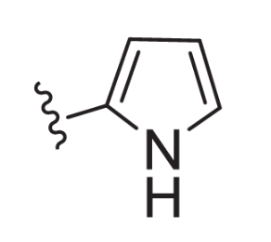 | 0.72 | 0.68 | 0.039
2 | 2-ethyl-3-methylthiophene | 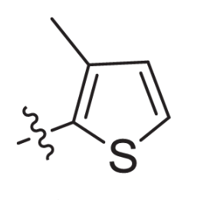 | 0.63 | 0.671 | -0.04
3 | 3-ethyl-1H-indole | 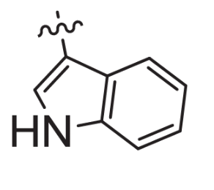 | 0.83 | 0.789 | 0.04
4* | 1-ethyl-4-(propan-2-yl)benzene | 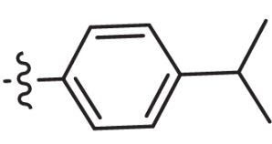 | 0.42 | 0.655* | -0.24
5 | 4-ethyl-N,N-dimethylaniline | 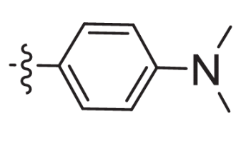 | 0.52 | 0.608 | -0.09
6 | 3-ethylquinoline | 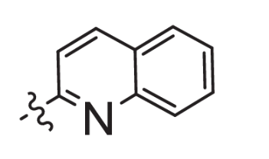 | 0.68 | 0.660 | 0.02
7 | 3-ethylquinoline | 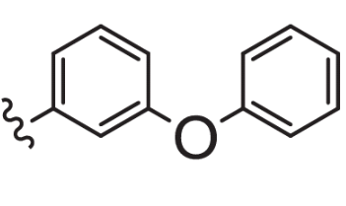 | 0.73 | 0.636 | 0.09
8* | 2-ethylfuran | 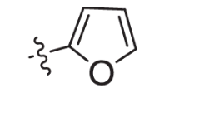 | 0.69 | 0.666* | 0.024
9 | 1-ethyl-4-methoxybenzene | 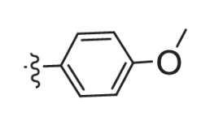 | 0.73 | 0.667 | 0.063
10 | ethylcyclopentane | 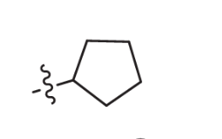 | 0.63 | 0.657 | -0.030
11* | 6-ethyl-2,3-dihydro-1,4-benzodioxine | 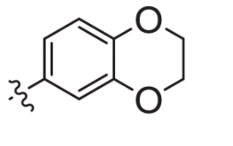 | 0.69 | 0.684* | 0.006
12* | 1-ethyl-4-fluorobenzene | 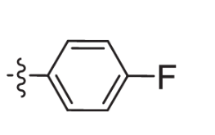 | 0.79 | 0.684* | 0.106
13 | 1-ethylnaphthalene | 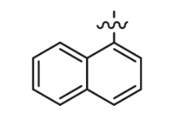 | 0.75 | 0.843 | -0.09
14 | ethylcyclohexane | 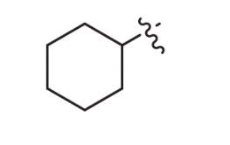 | 0.67 | 0.641 | 0.029
15 | 4-ethylphenol | 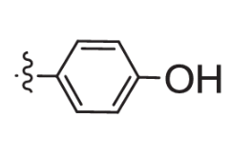 | 0.81 | 0.901 | -0.09
(*) and rows in bold are the selected test sets for the multi-linear regression analysis

Table 2: Anti-plasmodial activity of selected compounds
Compound | Structure | Predicted anti-plasmodium activity (µM)
n16 | 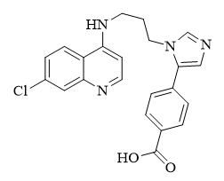 | 0.0050
n17 | 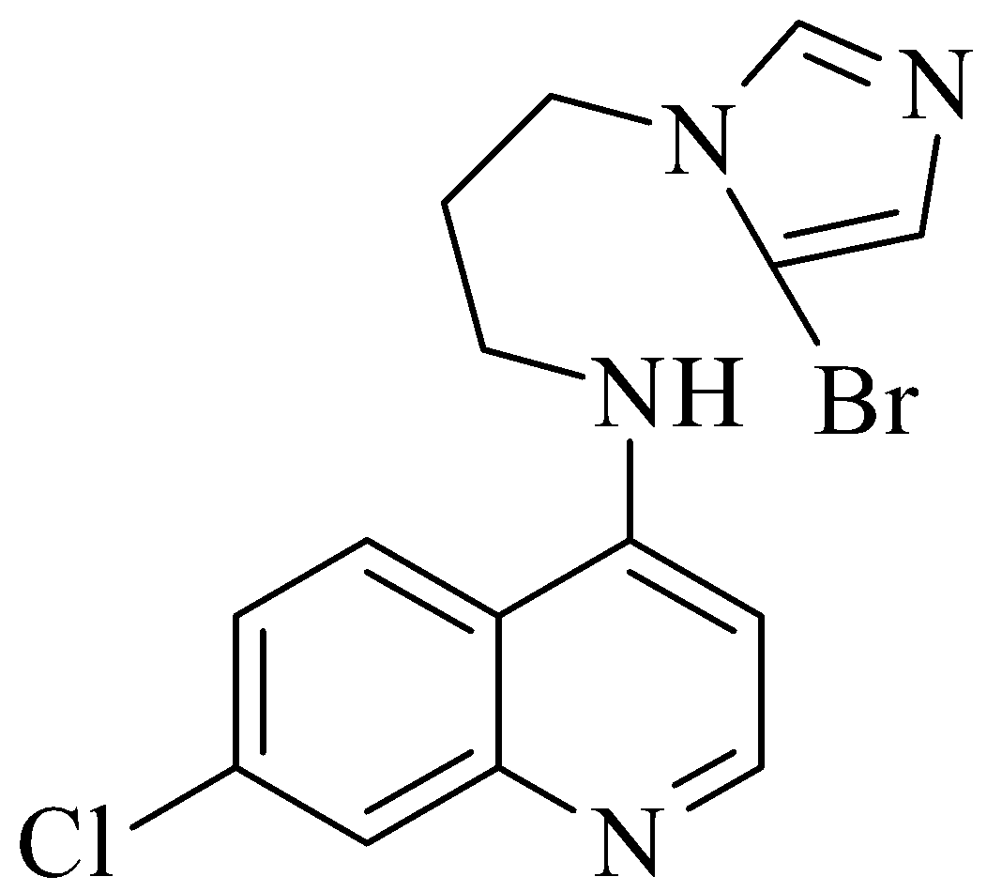 | 0.0051
n18 | 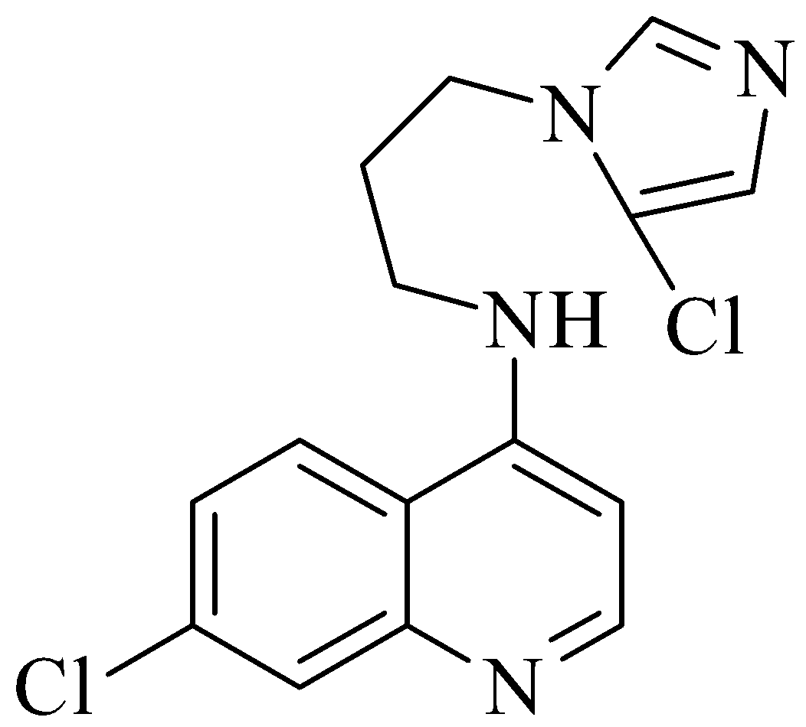 | 0.0054
n19 | 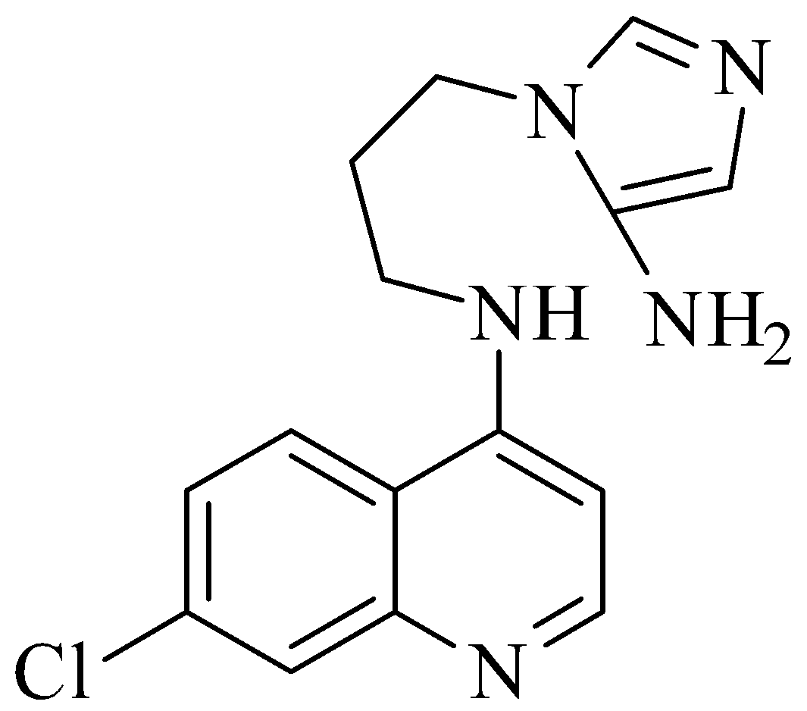 | 0.0057
n20 | 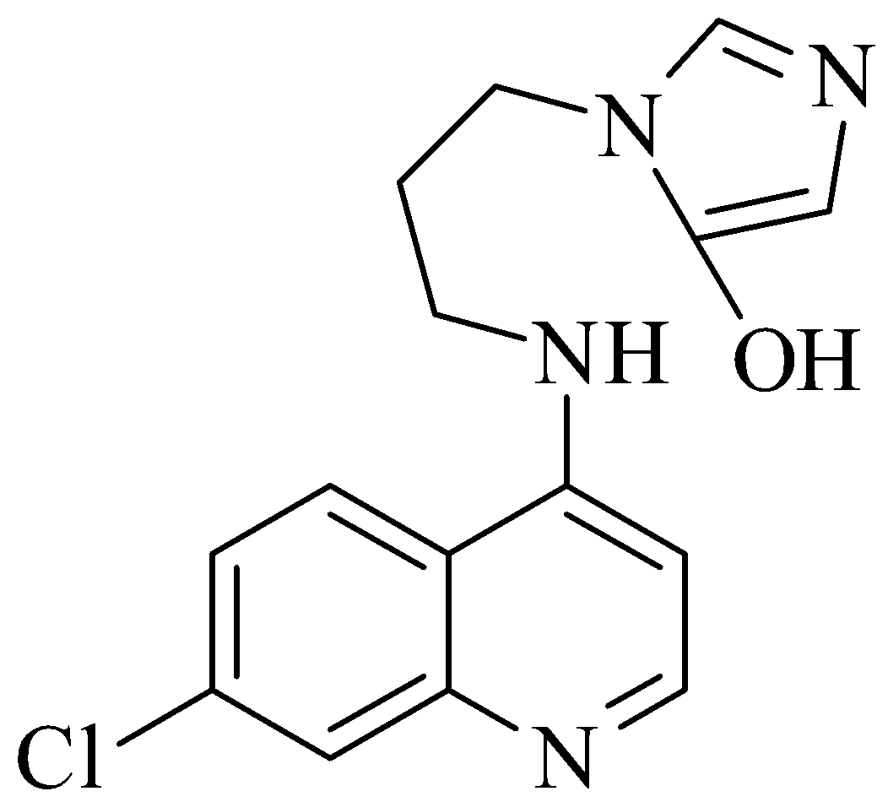 | 0.0049
n21 | 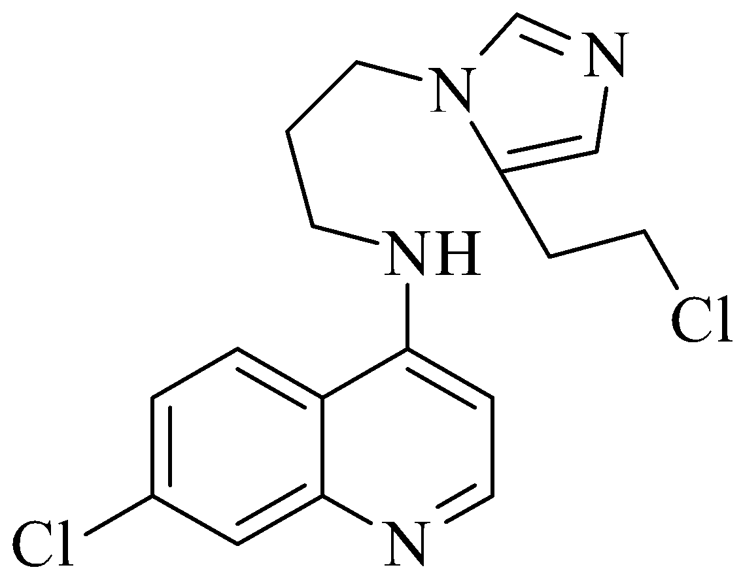 | 0.0055
n22 | 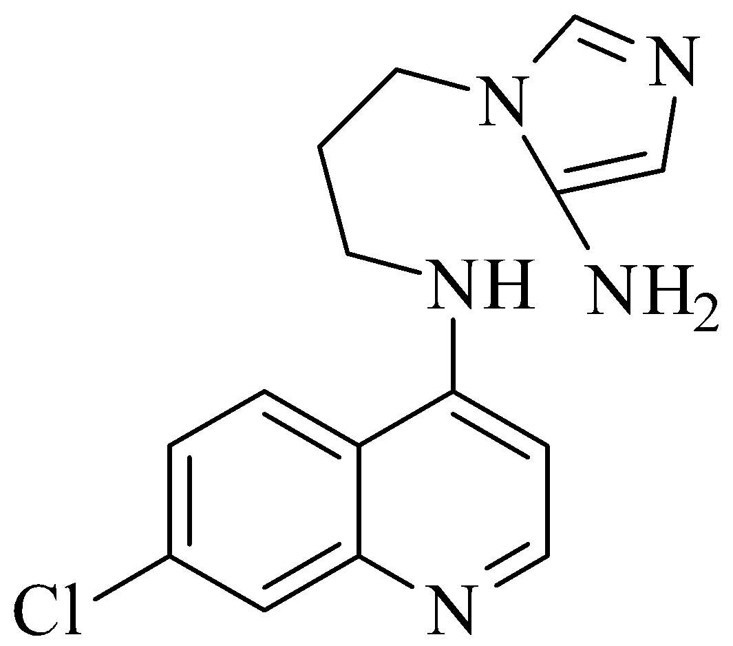 | 0.9197
n23 |  | 0.8971
n24 | 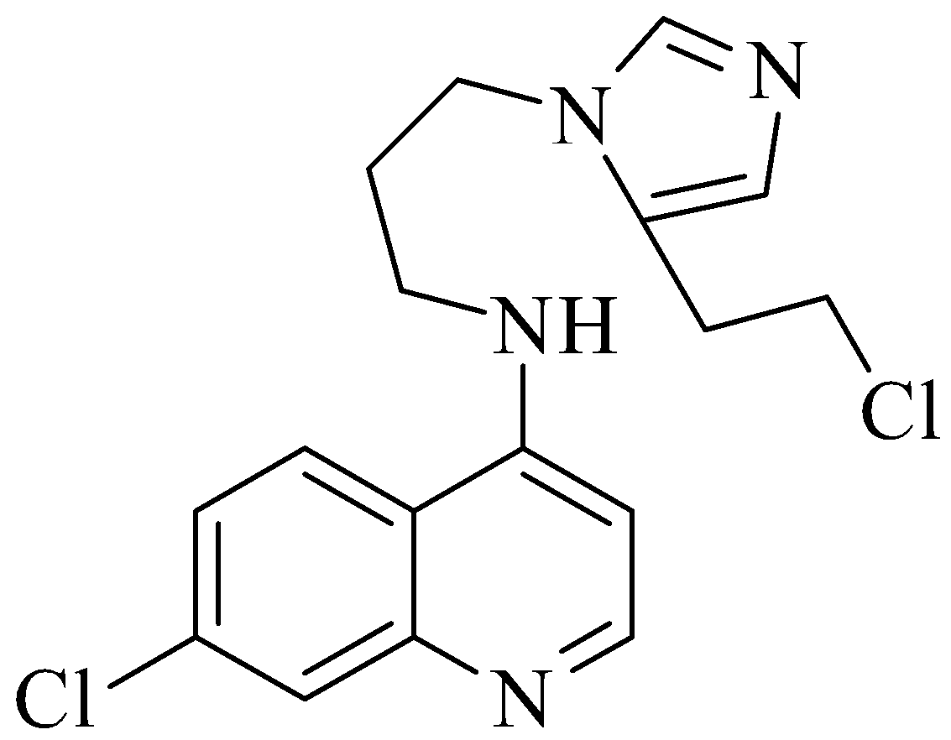 | 0.9271
n25 | 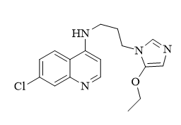 | -0.2372

Table 3: shows the QSAR regression coefficients.
Regression Parameters | Values
R² | 0.9180
R²_{pred} | 0.8276
Root Mean Square Error (RMSE) | 0.2807
p-value | 0.0461
Q² | 0.6672

Table 4: Pharmacokinetics, drug-likeness, and toxicity study of new sets of 4AQI analogs
Compound | Pharmacokinetics, solubility |  |  | Excretion and toxicity |  | Drug likeness
Compound | GIA | BBB | Water solubility (log S) | Clearance | Oral toxicity | Lipinski violations?
Chloroquine® | >90% | Very high | Very soluble  -3.902 | Moderate | Very low | No
4AQI | >90% | High | Very soluble  -3.150 | Moderate | Very low | No
n16 | >90% | Very high | Very soluble  -3.565 | Moderate | Very low | No
n17 | >90% | Very high | Very soluble  -3.642 | Moderate | Very low | No
n18 | >90% | Very high | Very soluble  -3.469 | Moderate | Very low | No
n19 | >90% | High | Very soluble  -2.924 | Moderate | Low | No
n20 | >90% | High | Very soluble  -3.034 | Moderate | Low | No
n21 | >90% | High | Very soluble  -3.987 | Moderate | Very low | No
n22 | >90% | Very high | Very soluble  -3.178 | Moderate | Very low | No
n23 | >90% | High | Very soluble  -2.809 | Moderate | Very low | No
n24 | >90% | High | Very soluble  -1.681 | Moderate | Very low | No
n25 | >90% | High | Very soluble  -3.964 | Moderate | Low | No
GIA= Gastro-intestinal absorption, BBB = Brain-Blood-Barrier penetration, CYP= cytochrome inhibition

Table 5: Molecular docking and active-site validation of the novel inhibitor, O8A, against the Plasmodium falciparum 3D7 receptor (3O8A.pdb).
 | 2D-Structure | 3D-structure | H_bond interactions (Length in Å) | Binding energy (kcal/mol)
O8A from PDB bank | 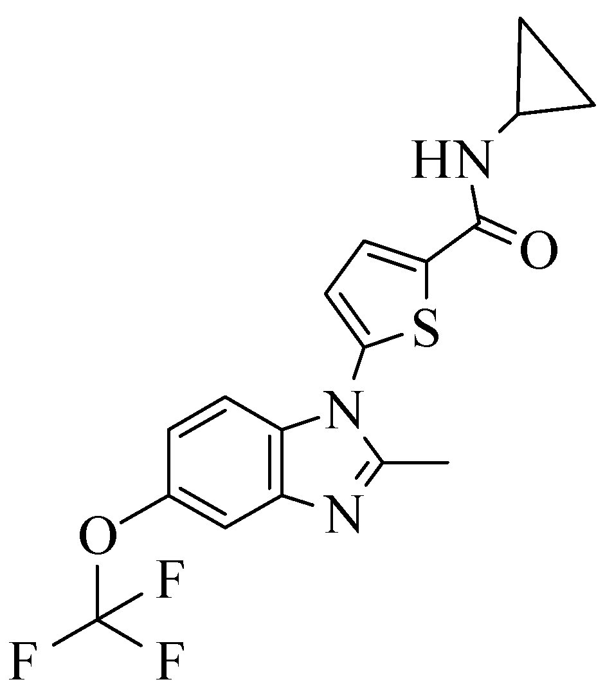 | 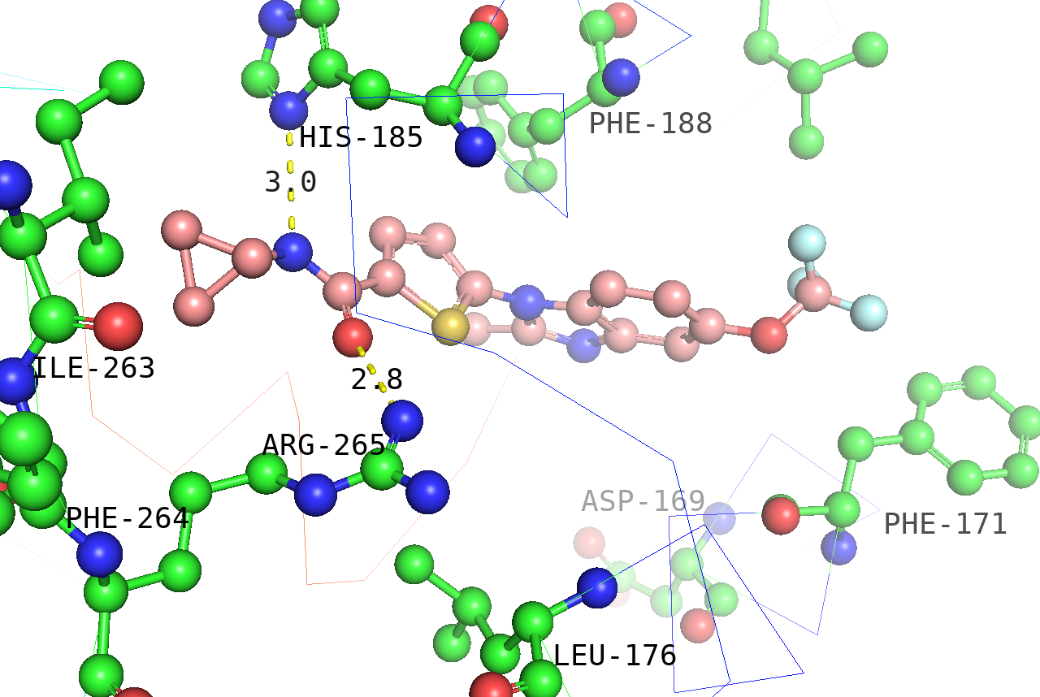 | ARG-265 (2.8), HIS-185 (3.0) | ----
O8A docked against cleaned 3O8A.pdb |  | 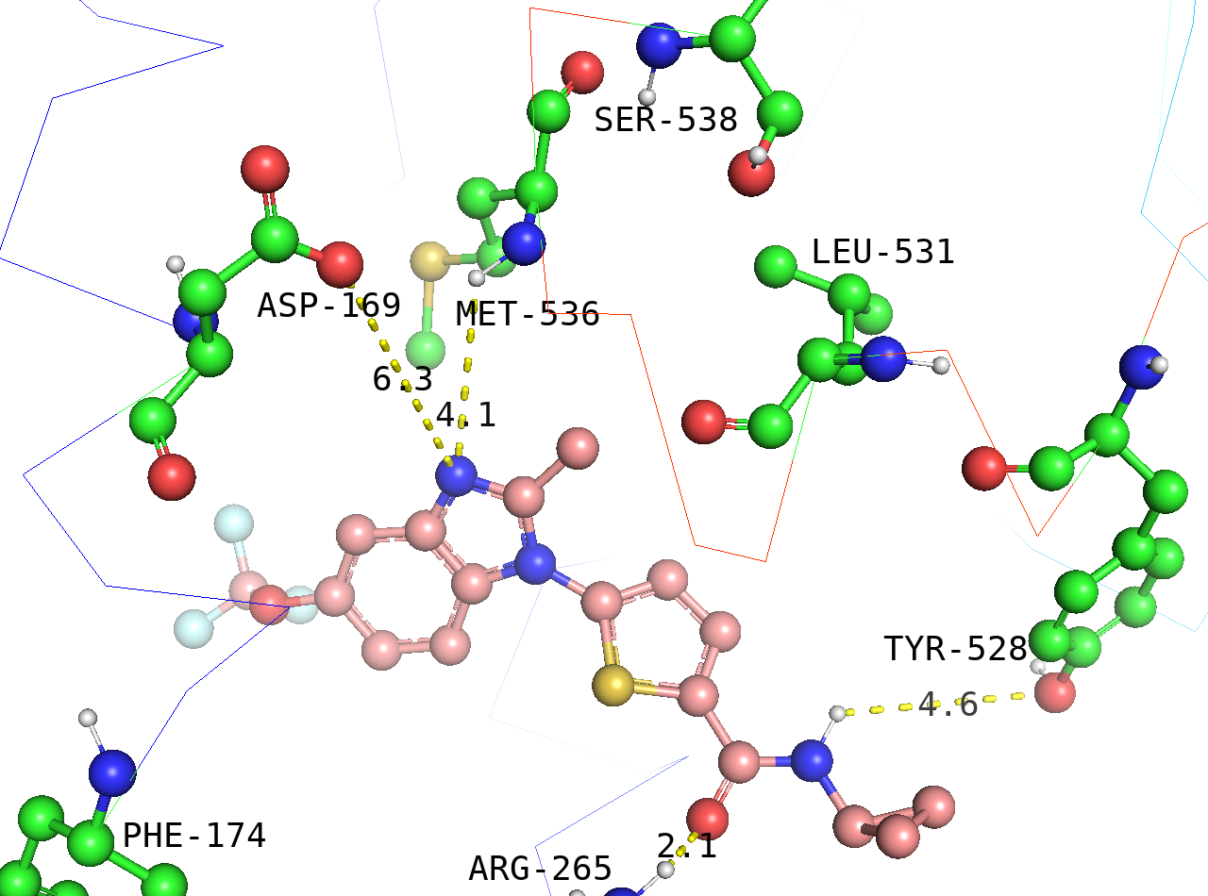 | ARG-265 (2.1), MET-536 (4.1), TYR-528 (4.6), ASP-169 (6.3) | -10.4
h-bond interaction is set at max bond-length cutoff=7.0

Table 6: Binding energy, 3D-interactive structure, and H-bond interactions of selected compounds against Plasmodium falciparum 3D7 receptor (3O8A.pdb).
Code | 2D-Structure | 3D-Structure | H-bond interactions (Length in Å) | Binding energy (kcal/mol)
Chlo | 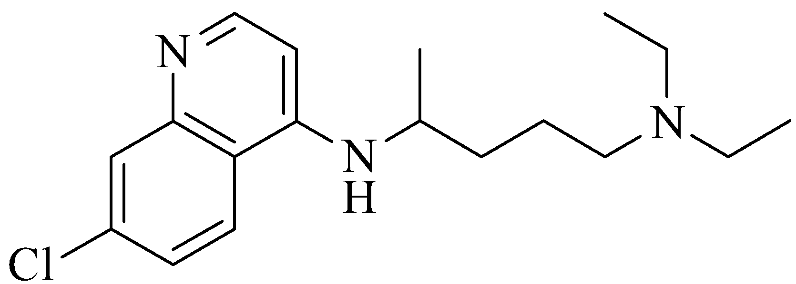 | 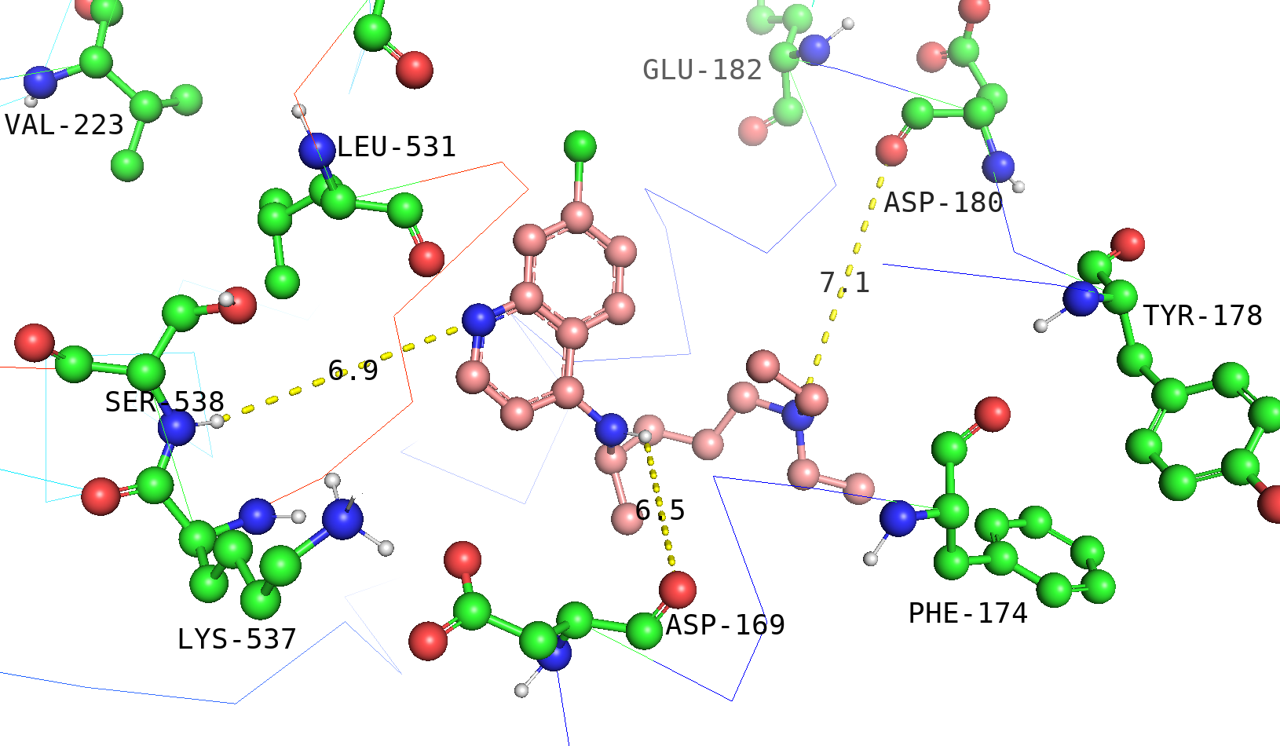 | ASP-169 (6.5), SER-538 (6.9) | -8.1
Frame | 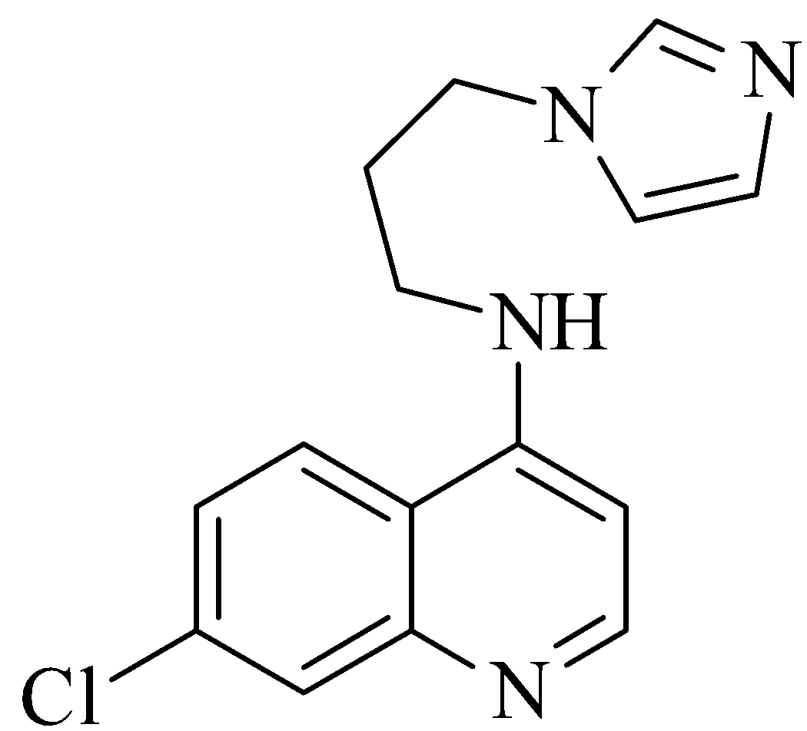 | 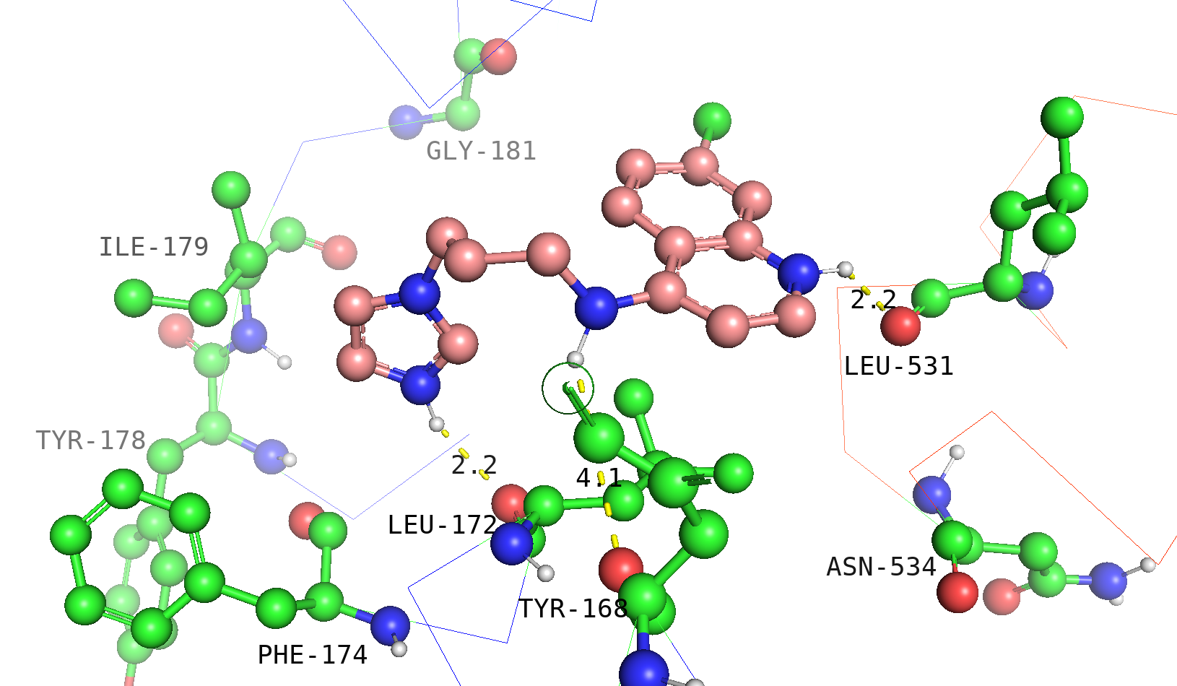 | LEU-172 (2.2), LEU-531 (2.2), TYR-168 (4.1) | -8.9
n16 |  | 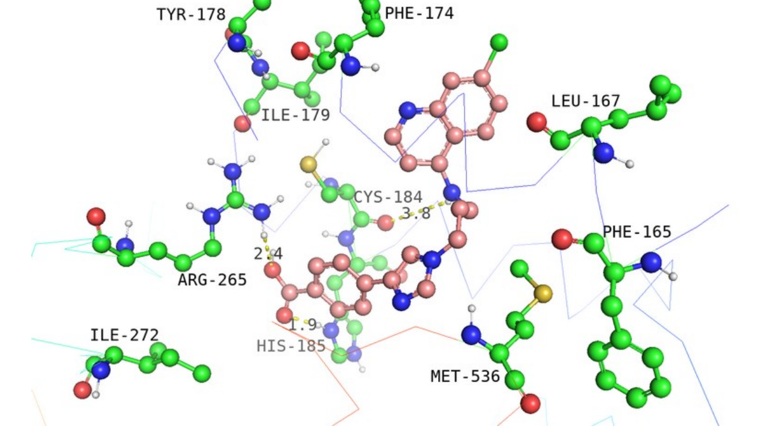 | HIS-185 (1.9), ARG-265 (2.4), CYS-184 (3.8) | -10.1
n17 | 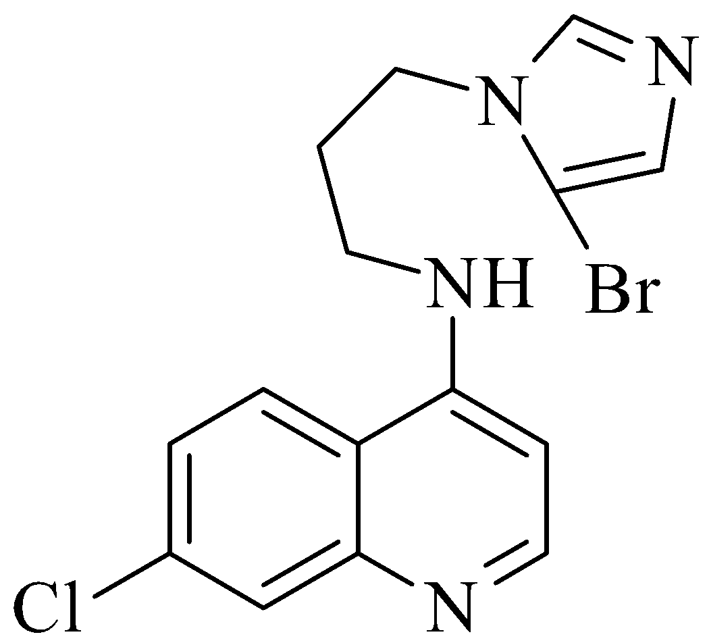 | 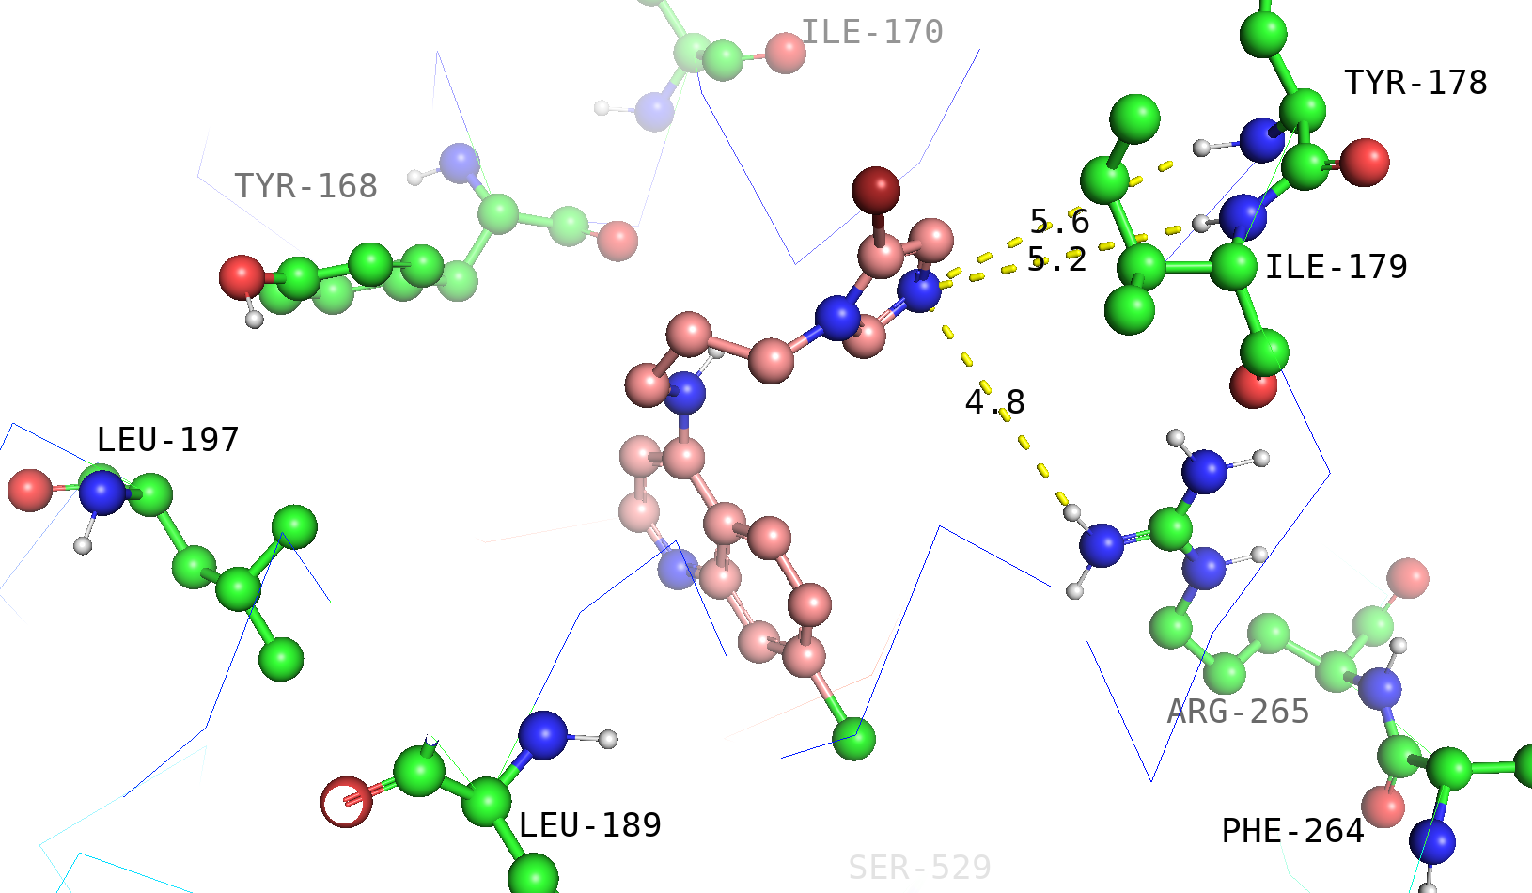 | ARG-265 (4.8), ILE-179 (5.2), TYR-178 (5.6) | -8.9
n18 | 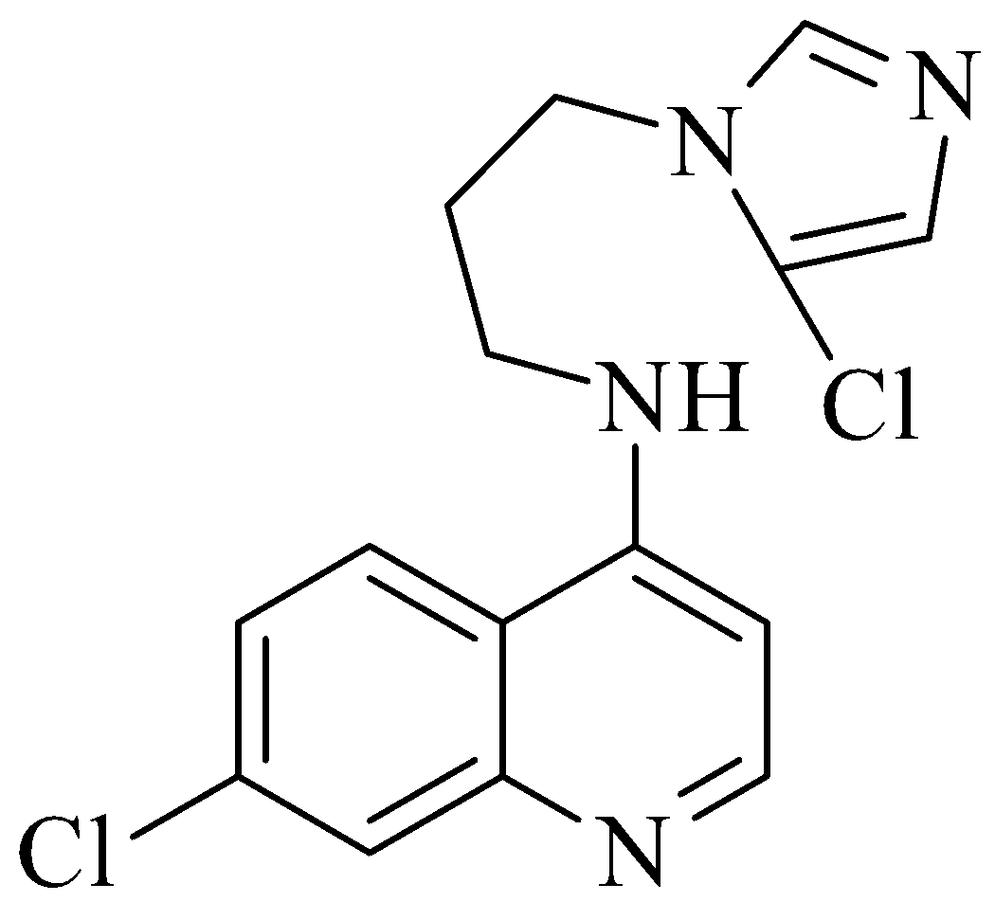 | 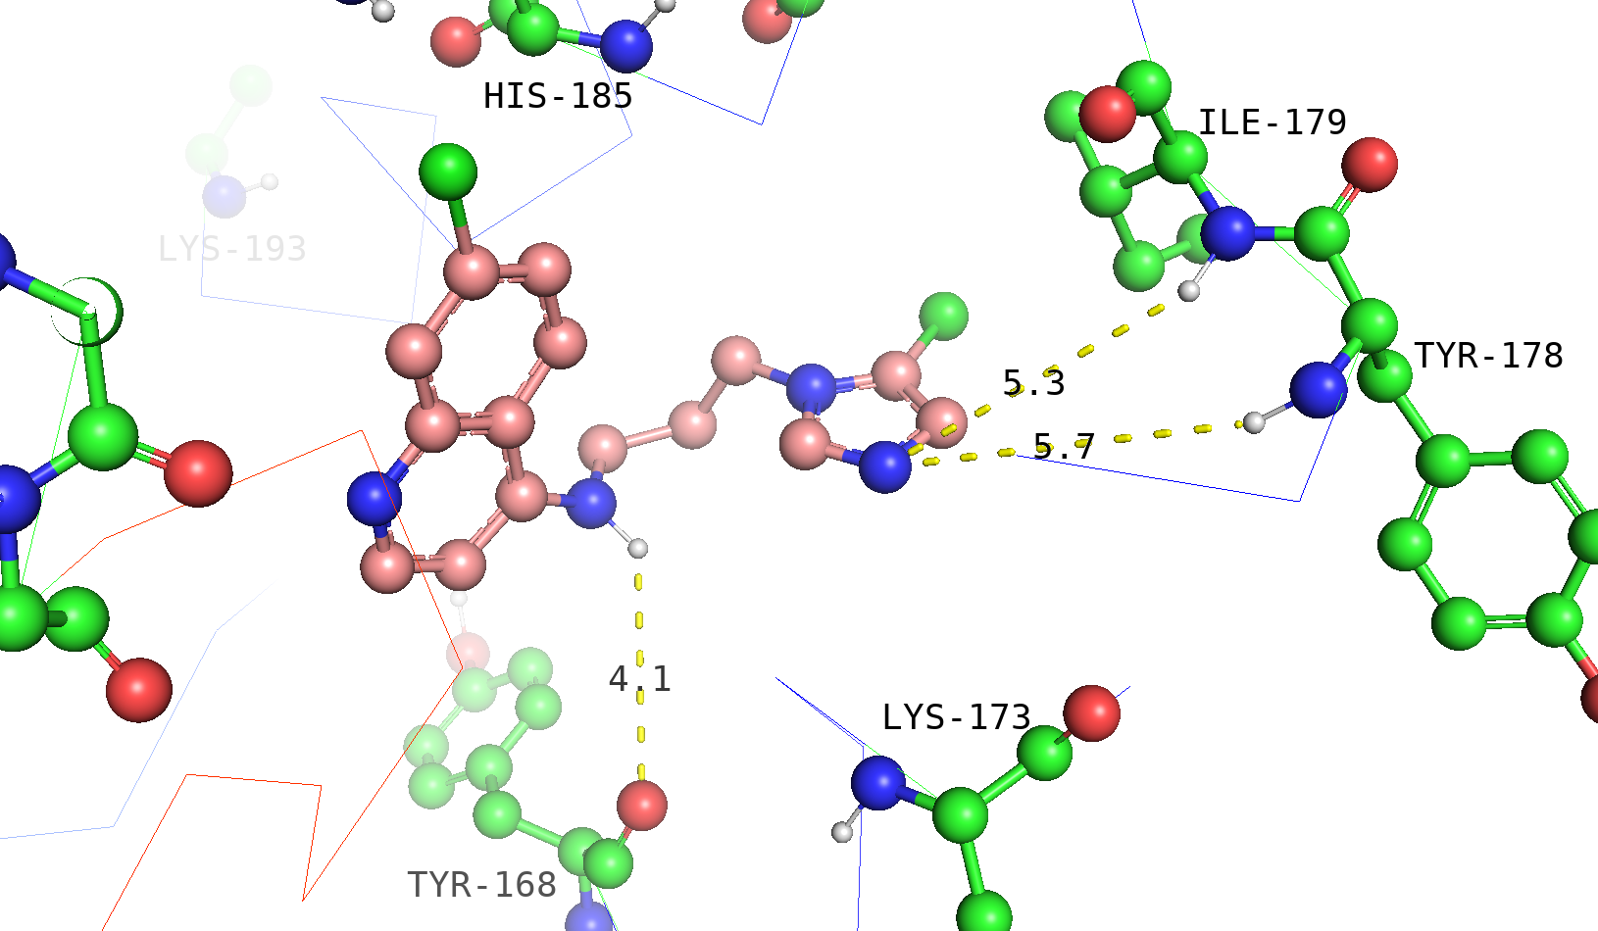 | TYR-168 (4.1), ILE-179 (5.3), TYR-178 (5.7) | -9.1
n19 | 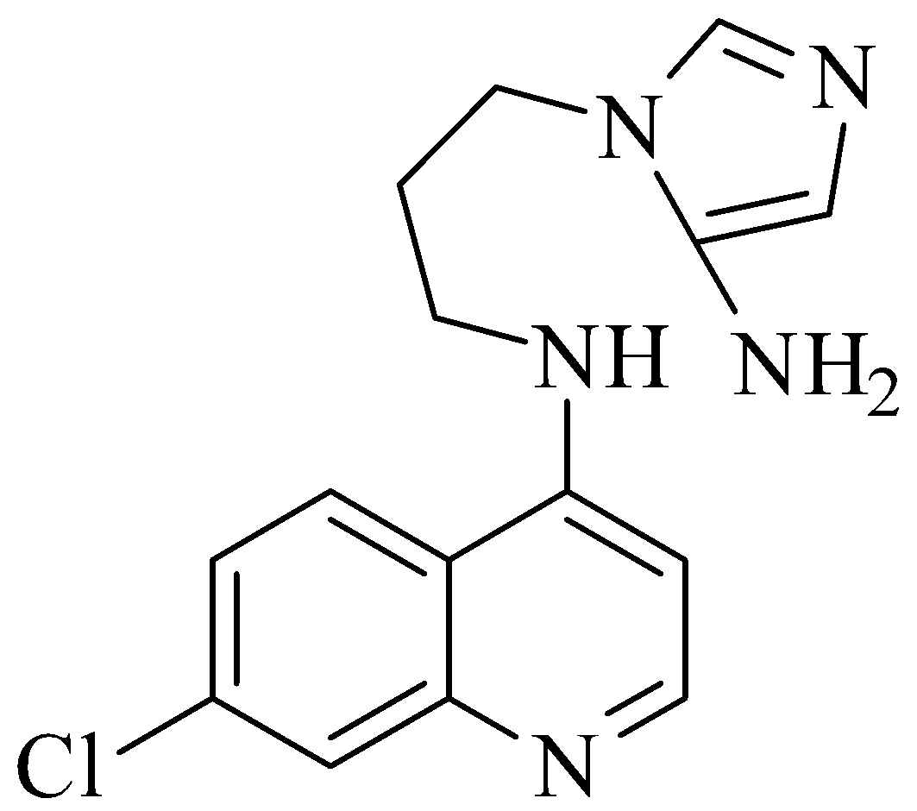 | 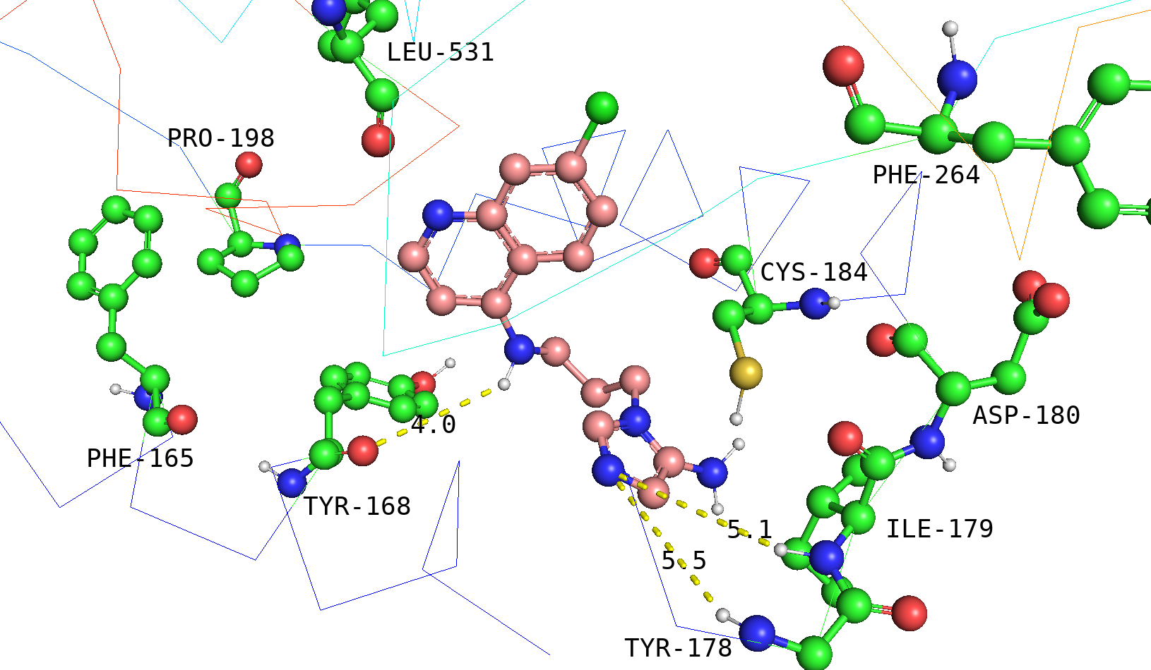 | TYR-168 (4.0), ILE-179 (5.1), TYR-178 (5.5) | -8.2
n20 | 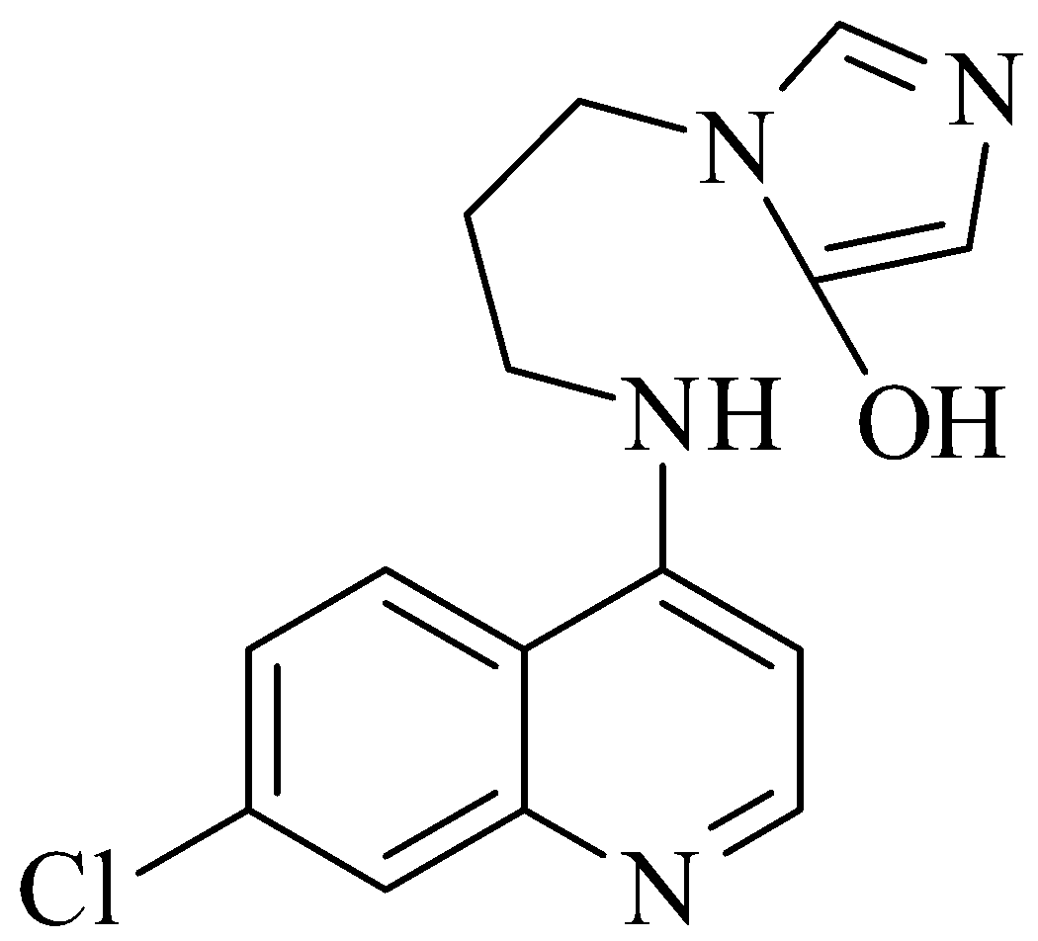 | 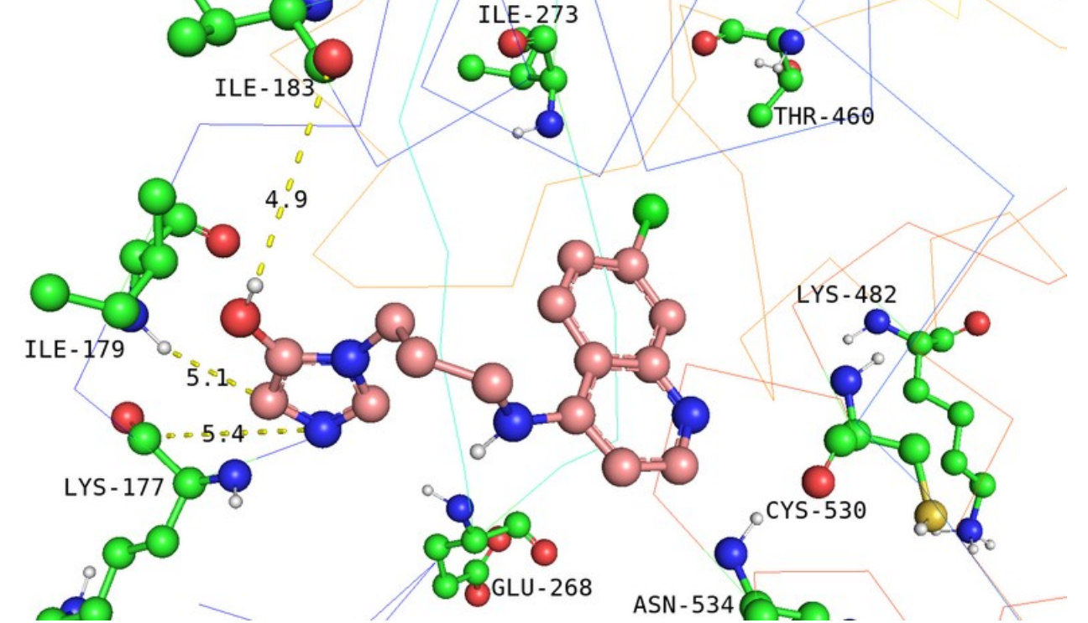 | ILE-183 (4.9), ILE-179 (5.1), LYS-177 (5.4) | -8.9
n21 | 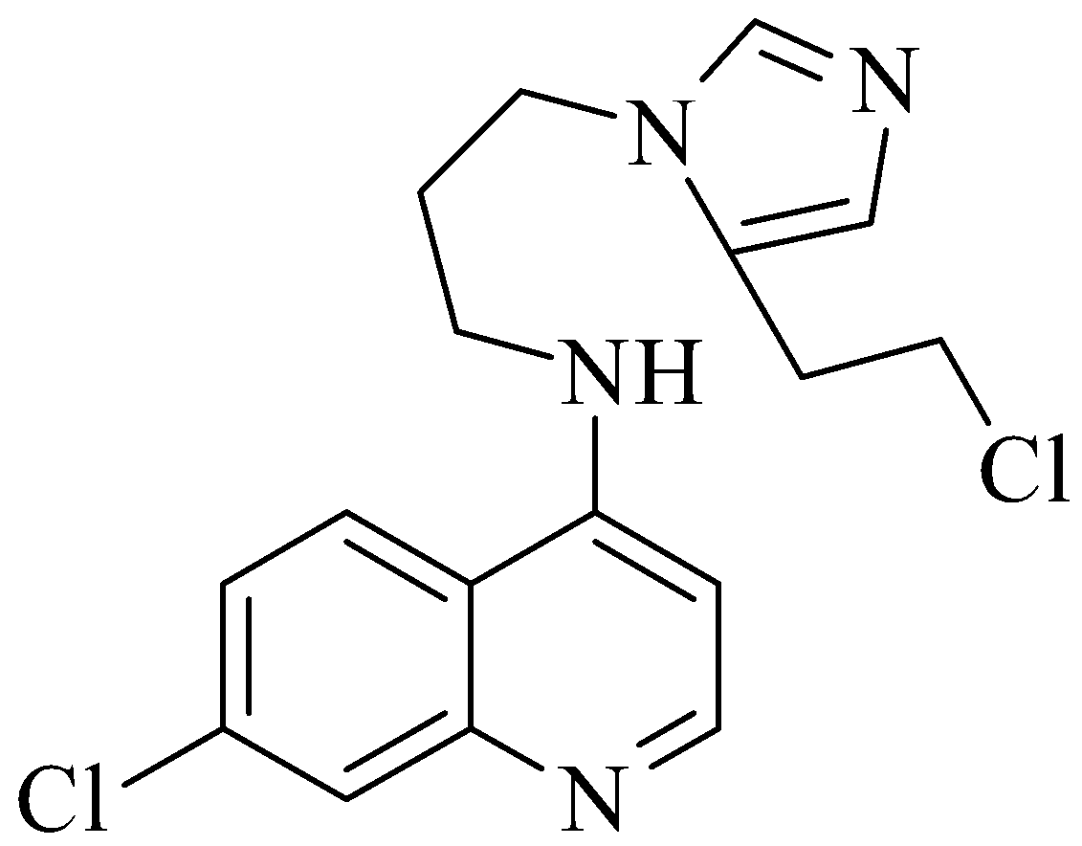 | 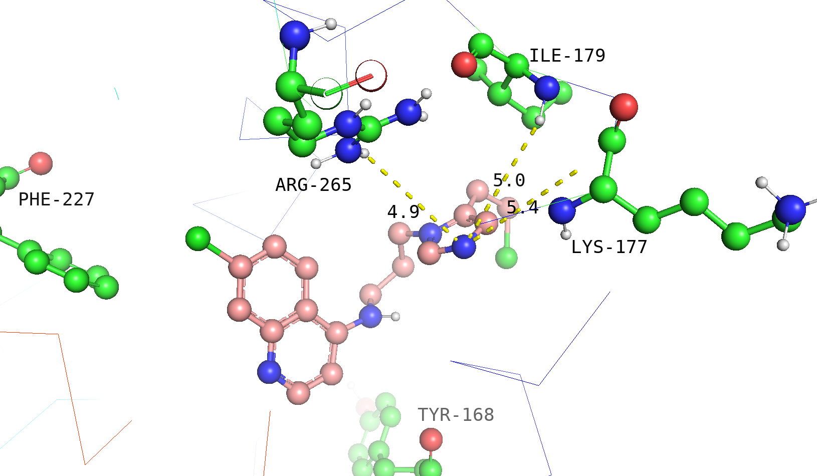 | ARG-265 (4.9), ILE-179 (5.0), LYS-177 (5.4) | -9.5
n22 | 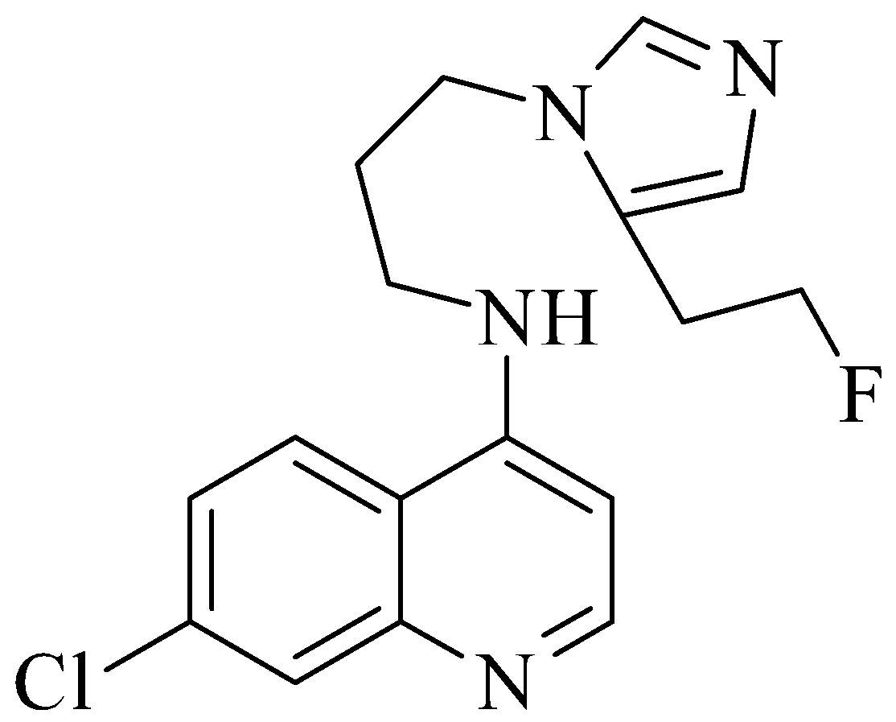 | 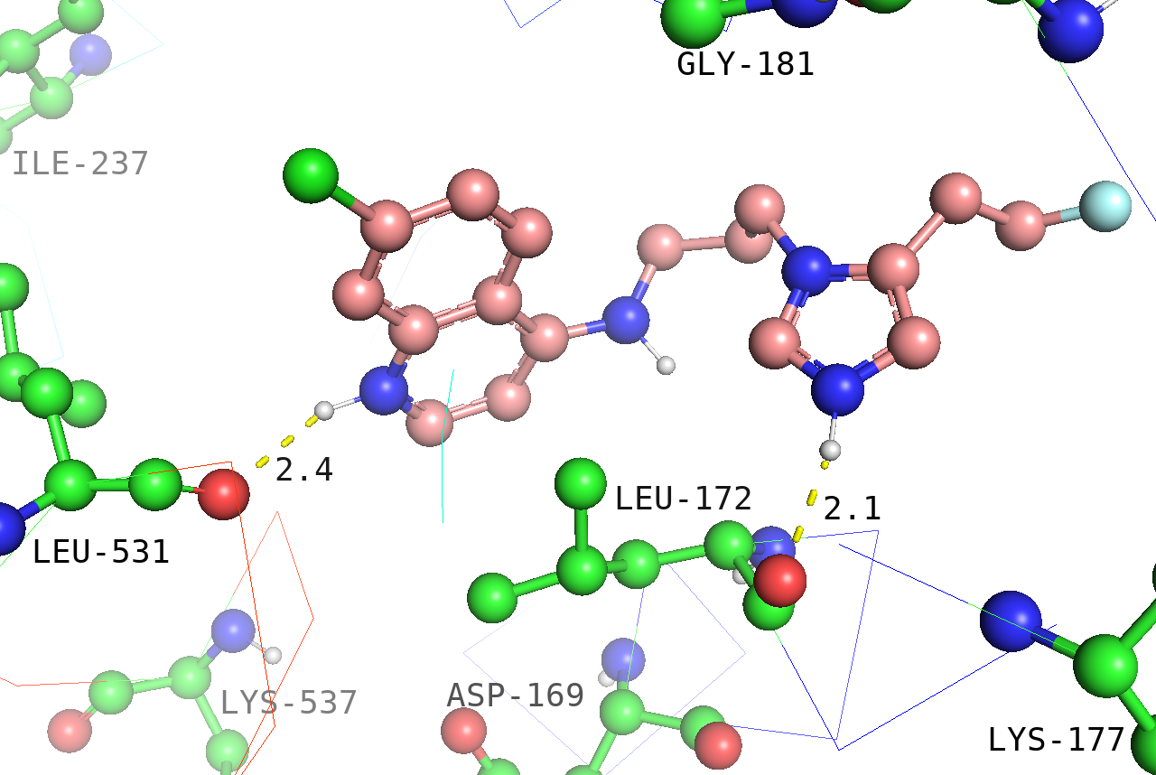 | LEU-172 (2.1), LEU-531 (2.4) | -8.5
n23 | 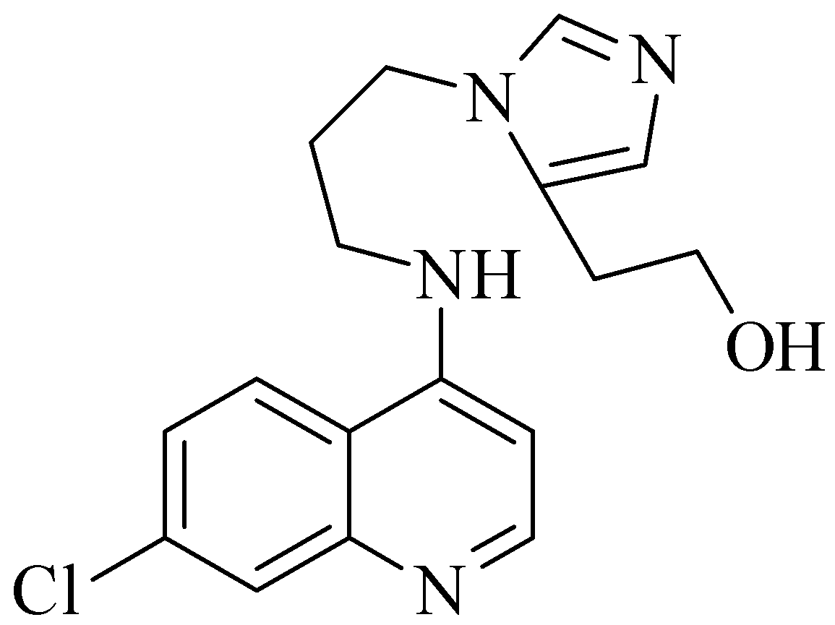 | 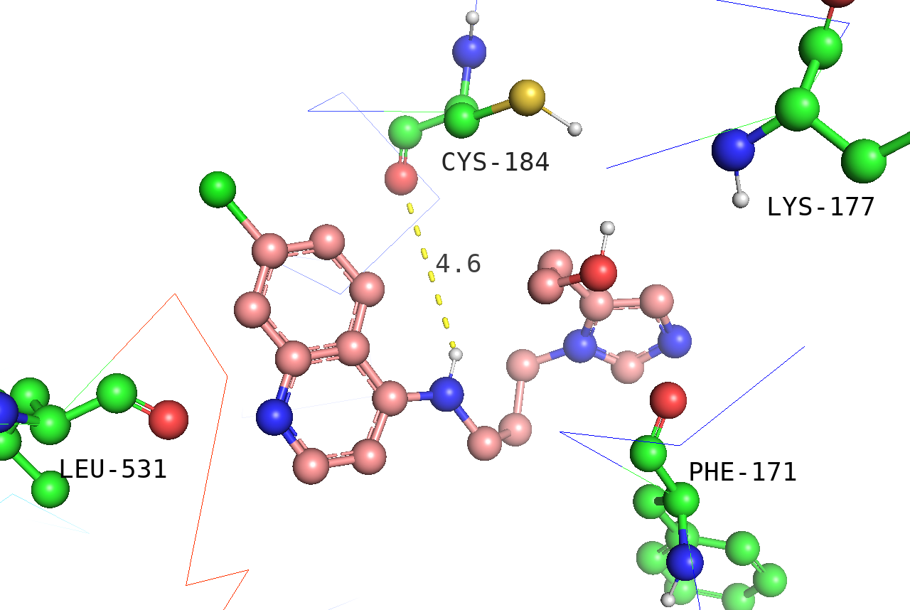 | CYS-184 (4.6) | -8.2
n24 | 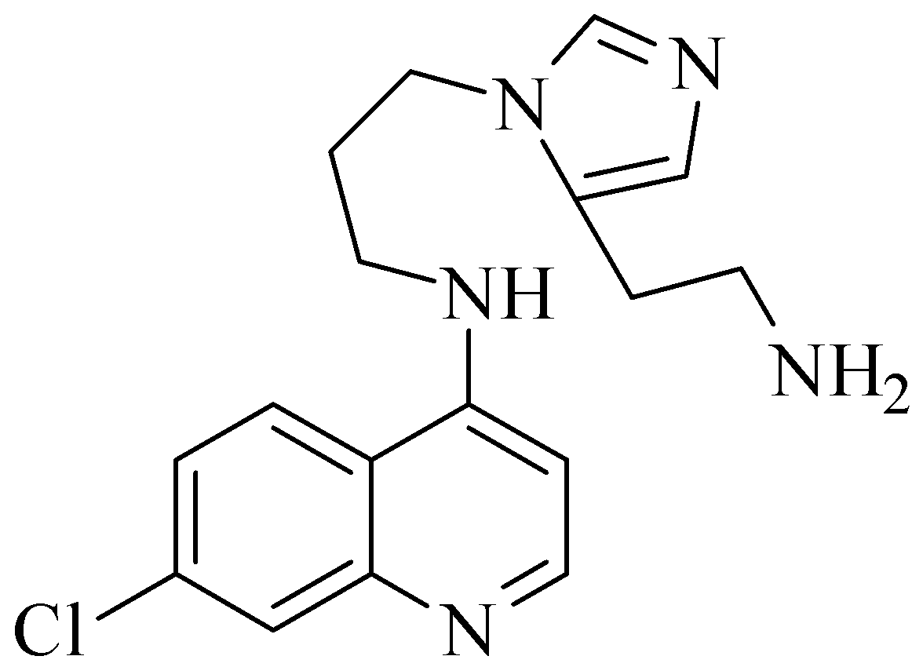 | 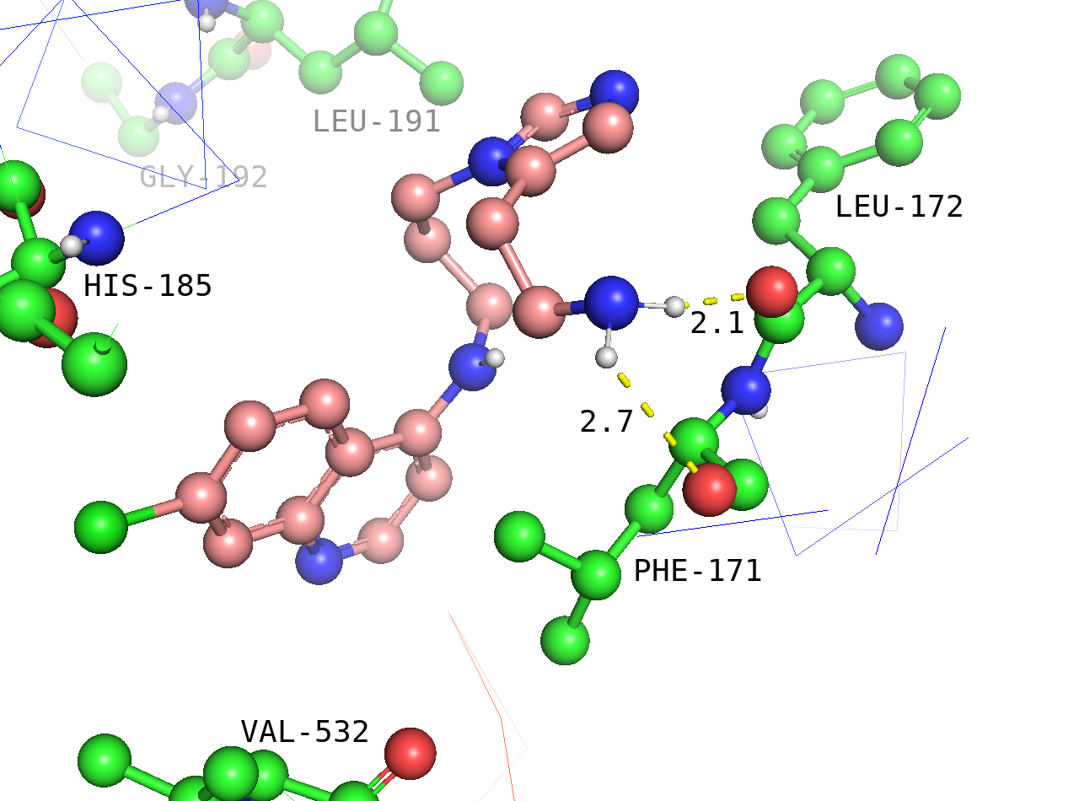 | LEU-172 (2.1), PHE-171 (2.7) | -8.8
n25 |  | 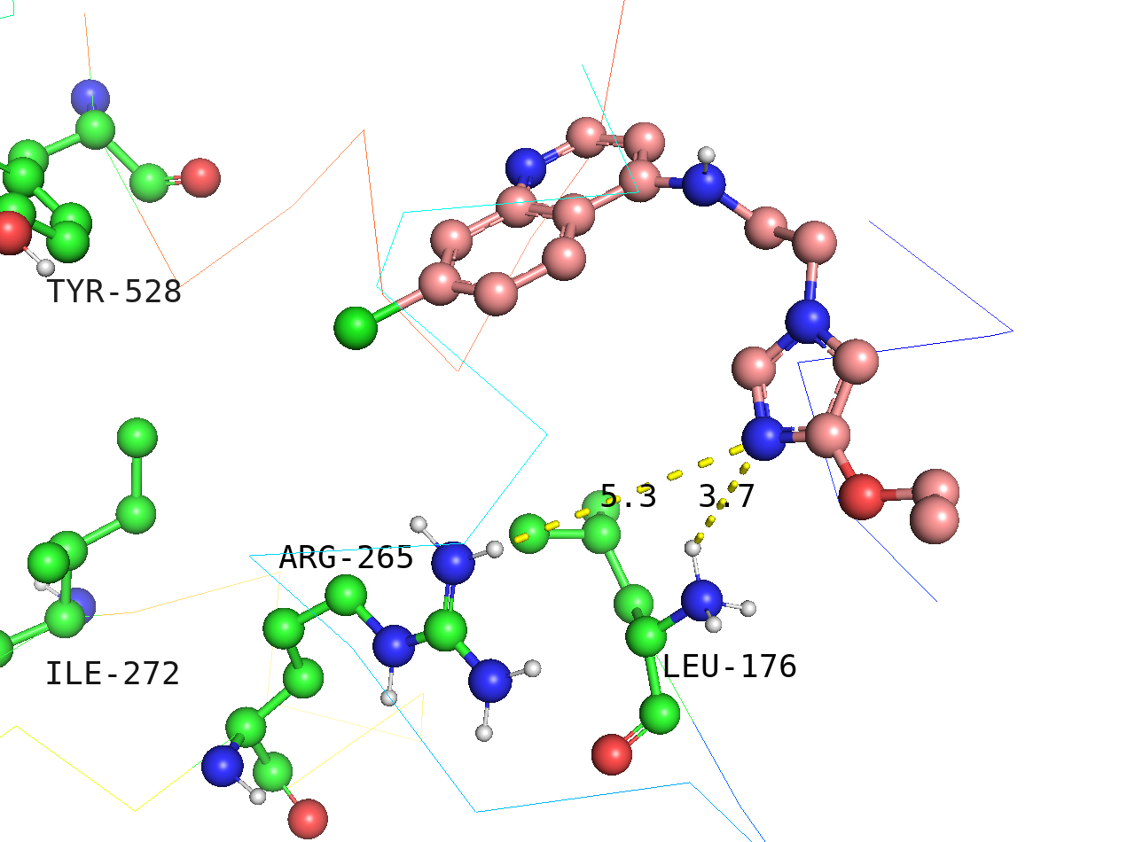 | LEU-176 (3.7), ARG-265 (5.3) | -7.7
h_bond interaction is set at max bond-length cutoff=7.0

