Supplementary Information for
Giant Kerr nonlinearity of terahertz waves mediated by stimulated phonon polaritons in a microcavity chip

Yibo Huang^{1,2}, Yao Lu^{1,2,*}, Wei Li³, Xitan Xu^{1,2}, Xinda Jiang^{1,2}, Ruobin Ma^{1,2}, Lu Chen¹, Ningjuan Ruan³, Qiang Wu^{1,2,*} and Jingjun Xun^{1,*}

¹The Key Laboratory of Weak-Light Nonlinear Photonics, Ministry of Education, TEDA Applied Physics Institute and School of Physics, Nankai University, Tianjin 300457, China
²Shenzhen Research Institute of Nankai University, Shenzhen, Guangdong 518083, China
³Beijing Institute of Space Mechanics & Electricity, China Academy of Space Technology, Beijing, 100094, China

Supplementary Note 1: Sample fabrication

The lithium niobite (LN) Fabry-Perot microcavity utilized in our experiment is fabricated using a chemically assisted femtosecond-laser direct writing technique¹. Fig. S1 depicts the schematic diagram of the experimental laser-machining setup for the sample fabrication. The machining laser (800 nm central wavelength, 500 μJ per pulse, 1 kHz repetition rate, 120 fs pulse duration) first passes through a shutter, which is used to block the laser when moving from one machining region to the next, and then passes through a power control system composed of a half-wave plate (HWP) and a Glan-Taylor prism (GTP). After passing through a dichroic mirror (DM), the laser is focused on a x-cut LN slab coated with 1 μm thick silicon dioxide on both surfaces through an objective, wherein the sample is mounted on an xyz-translation stage with computer-controlled actuators. The air slots are cut out by focusing the laser at multiple depths spanning from the front to the back. To monitor the machining in real time, a beam of incoherent light illuminates the sample and is imaged on a CCD camera.
After the machining, the sample is immersed in hydrofluoric acid solution for 20-30 minutes to remove the coating along with accumulated debris. A microscope image of a microcavity we sued in the experiment is shown in Fig. S2, the width of an air slot is set to be 50 μm and the width of a LN pillar between two slots is also set to be 50 μm, the length of the cavity is set to be 245 μm. The machining error is approximately 2 microns, which has negligible effects on the experiment.

Fig. S1. Schematic diagram of the experimental laser-machining set-up for the sample fabrication. HWP: half-wave plate, GTP: Glan-Taylor prism, DM: dichroic mirror, CL: convex lens, CLS: cold light source.
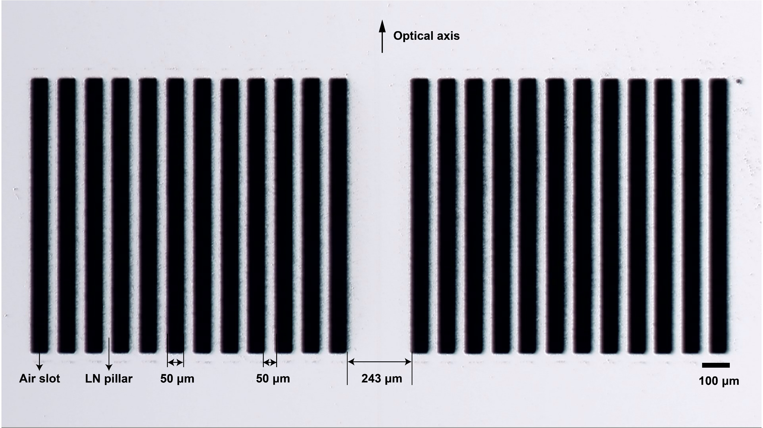
Fig. S2. Microscope image of the microcavity used in the experiment. The air slot and LN pillar are designed to have a width of 50 microns, the cavity is intended to have a length of 245 microns, while the machining error is about 2 microns.

Supplementary Note2: Theoretical analysis of phonon-polariton enhanced optical Kerr nonlinearity with modified Huang equations.

Under an external driving of the THz wave, and along with the contribution of phonon-polaritons, the Vibration equation of ions is written as follows:
$$\begin{aligned}\begin{matrix}\ddot{x}+γ\dot{x}+ω_{0}^{2}x={\left(Nm\right)}^{-1/2}bE-βx^{3}+\left(\frac{q}{m}\right)E_{ex} \\ P={\left(Nm\right)}^{1/2}bx+ϵ_{0}\left(ε_{∞}-1\right)E\end{matrix}\#\left(S1\right)\end{aligned}$$
where x represents the motion amplitude of ions, the electric charge, eigen angular frequency and effective mass of ions are indicated by $q$, $ω_{0}$ and $m$. $E_{ex}$ stands for the corresponding driving THz field, and the strength of the damping force and the anharmonicity (i.e., the nonlinearity) are characterized by parameters $γ$ and $β$, respectively. The contribution of phonon polariton is the term ${\left(Nm\right)}^{-1/2}b_{12}E$, and the values of the coupling coefficients are determined by $b=ω_{0}\sqrt{ϵ_{0}\left(ε_{0}-ε_{∞}\right)}$, $ϵ_{0}$ is the permittivity of vacuum, $ε_{0}$ and $ε_{∞}$ stand for the low- and high-frequency relative permittivity of the material. $E$ represents the macroscopic electric field radiated by the ions. Cooperating with Maxwell’s equations, the polarization P can be eliminated from the above equations:
$$\begin{aligned}ϵ_{0}μ_{0}ε_{∞}\ddot{E}+μ_{0}{\left(Nm\right)}^{1/2}b\ddot{x}-∇^{2}E=0\#\left(S2\right)\end{aligned}$$
Adopting the slow time approximation, that is assuming $x=x_{0}ⅇ^{-jωt}$ and $E=E_{0}ⅇ^{-jωt}$ with $ω$ being the angular frequency of the driving THz field, where $x_{0}$ and $E_{0}$ are independent of t, and assuming $∇^{2}E=-k^{2}E=ϵ_{0}ω^{2}/c^{2}E$, the following equation can be obtained:
$$\begin{aligned}{\left(Nm\right)}^{-1/2}bE=ω_{0}^{2}x\#\left(S3\right)\end{aligned}$$
Here, $c=\frac{1}{\sqrt{ϵ_{0}μ_{0}}}$ indicates the light speed in the vacuum and $μ_{0}$ is the permeability of the vacuum. Finally, a Drude dispersion equation is obtained:
$$\begin{aligned}\ddot{x}+γ\dot{x}=-βx^{3}+\left(\frac{q}{m}\right)E_{ex}\#\left(S4\right)\end{aligned}$$
This equation indicates an impressive delocalization of phonon-polaritons, and that the mobility of phonon-polaritons is comparable to that of the free electrons in a metal. The ionic nonlinearity can be prodigiously enhanced because of phonon-polaritons.
Using the conventional method in nonlinear optics², we seek a solution having the form of a power series in parameter ξ:
$$\begin{aligned}x=ξx^{\left(1\right)}+ξ^{2}x^{\left(2\right)}+ξ^{3}x^{\left(3\right)}+⋯\#\left(S5\right)\end{aligned}$$
We insert this equation into the Drude dispersion equation, while retaining the terms up to $ξ^{3}$, then get three equations:
$$\begin{aligned}{\ddot{x}}^{\left(1\right)}+γ{\dot{x}}^{\left(1\right)}=\frac{qE_{ex}}{m}\#\left(S6\right)\end{aligned}$$
$$\begin{aligned}{\ddot{x}}^{\left(2\right)}+γ{\dot{x}}^{\left(2\right)}=0\#\left(S7\right)\end{aligned}$$
$$\begin{aligned}{\ddot{x}}^{\left(3\right)}+γ{\dot{x}}^{\left(3\right)}+β{\left(x^{\left(1\right)}\right)}^{3}=0\#\left(S8\right)\end{aligned}$$
We can get the solutions as follows:
$$\begin{aligned}x^{\left(1\right)}\left(ω_{n},t\right)=\frac{qE_{0}\left(ω_{n}\right)}{mD\left(ω_{n}\right)}\#\left(S9\right)\end{aligned}$$
$$\begin{aligned}x^{\left(2\right)}\left(ω_{n},t\right)=0\#\left(S10\right)\end{aligned}$$
$$\begin{aligned}x^{\left(3\right)}\left(ω_{q},t\right)=\sum_{mnp}{\frac{bq^{3}E_{0}\left(ω_{m}\right)E_{0}\left(ω_{n}\right)E_{0}\left(ω_{p}\right)}{m^{3}D\left(ω_{q}\right)D\left(ω_{m}\right)D\left(ω_{n}\right)D\left(ω_{p}\right)}e^{-ⅈω_{q}t}}\#\left(S11\right)\end{aligned}$$
Here,$D\left(ω_{n}\right)$=$-ω_{n}^{2}-iγω_{n}$, $ω_{m}$,$ω_{n}$, $ω_{p}$ and $ω_{q}$ are the angular frequency of the driving THz field, and $ω_{q}=ω_{m}+ω_{n}+ω_{p}$. The amplitude of the polarization component oscillation at frequency $ω_{q}$ is given in terms of this amplitude by
$$\begin{aligned}P^{\left(3\right)}=-Nqx^{\left(3\right)}\left(ω_{q},t\right)\#\left(S12\right)\end{aligned}$$
And the definition of the third-order nonlinear susceptibility is
$$\begin{aligned}P^{\left(3\right)}=\sum_{mnp}{ϵ_{0}χ^{\left(3\right)}\left(ω_{q};ω_{m},ω_{n},ω_{p}\right)}E\left(ω_{m}\right)E\left(ω_{n}\right)E\left(ω_{p}\right)\#\left(S13\right)\end{aligned}$$
Based on the equations above, we finally get the third-order nonlinear susceptibility
$$\begin{aligned}χ^{\left(3\right)}\left(ω_{q};ω_{m},ω_{n},ω_{p}\right)=\frac{Nβq^{4}}{m^{3}ϵ_{0}D\left(ω_{q}\right)D\left(ω_{m}\right)D\left(ω_{n}\right)D\left(ω_{p}\right)}\#\left(S14\right)\end{aligned}$$
We assume that the harmonic and anharmonic term in the potential energy should be comparable in magnitude, we can get the parameter
$$\begin{aligned}β=ω_{0}^{2}N^{2/3}\#\left(S15\right)\end{aligned}$$
Take the values for an LN crystal, $ω_{0}=7.6 THz$, $N=6.29×{10}^{27}m^{-3}$ and $γ=0.84 THz$, the reduced mass $m=5 u$, $1 u=1.66×{10}^{-27} kg$, and the charge q= 5 e, where $ⅇ=1.6×{10}^{-19} C$ is the elementary charge. The third-order nonlinear susceptibility at 0.63 THz is calculated to be $\operatorname{Re}\left(χ^{\left(3\right)}\right)=7.25×{10}^{-15}{ m}^{2}∕V^{2}$.

For comparison, if neglecting the contribution of phonon-polaritons, the lattice vibration is described by the classical anharmonic oscillator model:
$$\begin{aligned}\ddot{x}+γ\dot{x}+ω_{0}^{2}x+βx^{3}=\left(\frac{q}{m}\right)E_{ex}\#\left(S16\right)\end{aligned}$$
Using the same method as above, we finally get the third-order nonlinear susceptibility
$$\begin{aligned}χ^{\left(3\right)}\left(ω_{q};ω_{m},ω_{n},ω_{p}\right)=\frac{Nβq^{4}}{m^{3}ϵ_{0}D\left(ω_{q}\right)D\left(ω_{m}\right)D\left(ω_{n}\right)D\left(ω_{p}\right)}\#\left(S17\right)\end{aligned}$$
But here, $D\left(ω_{n}\right)$=$ω_{0}^{2}-ω_{n}^{2}-iγω_{n}$, and the parameters are all the same as above, the third-order nonlinear susceptibility without the contribution of phonon polaritons at 0.63 THz is calculated to be $\operatorname{Re}\left(χ^{\left(3\right)}\right)=4.58×{10}^{-22}{ m}^{2}∕V^{2}$. Our results align more with the enhanced susceptibility of phonon-polaritons rather than mere ionic nonlinearity, suggesting that the giant nonlinearity originates from the strong coupling between phonons and light.

References
1. Sivarajah, P. et al. Chemically assisted femtosecond laser machining for applications in LiNbO₃ and LiTaO₃. Applied Physics A: Materials Science & Processing 112, 615-622 (2013).
2. Boyd, R. W. Nonlinear Optics. 4th edition (Elsevier Science, 2020).

