Supplemental Figure 1a Receiver operating characteristic curve (ROC) for CAR

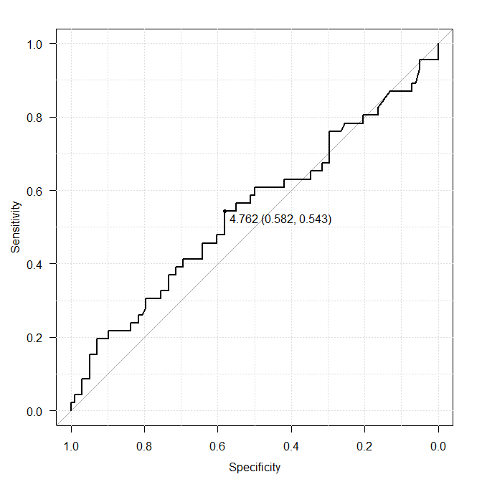
AUC 0.544

Supplemental Figure 1b Recurrence-free survival (RFS) between the low and high CAR group

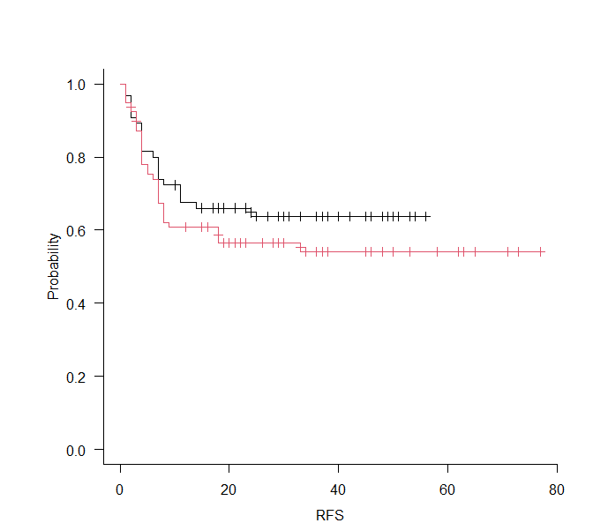
Low CAR group
High CAR group

Supplemental Figure 2a Receiver operating characteristic curve (ROC) for PLR

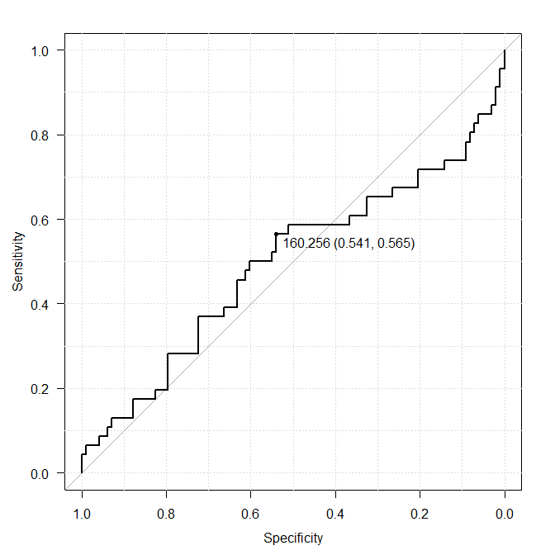
AUC 0.494

Supplemental Figure 2b Recurrence-free survival (RFS) between the low and high PLR group

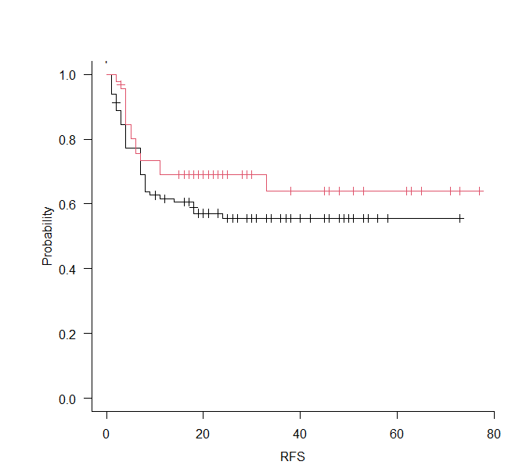
Low PLR group
High PLR group

