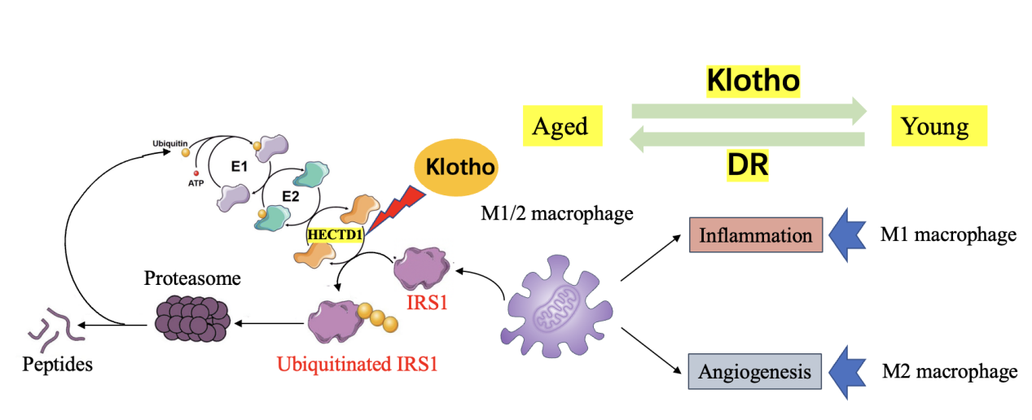
Supplementary Figure. S1: KL can ameliorate diabetes-induced retinal macrophage senescence via the HECTD1/IRS1 pathway. It can inhibit E3 ubiquitin ligase HECTD1 expression, downregulating IRS1 ubiquitination and degradation.

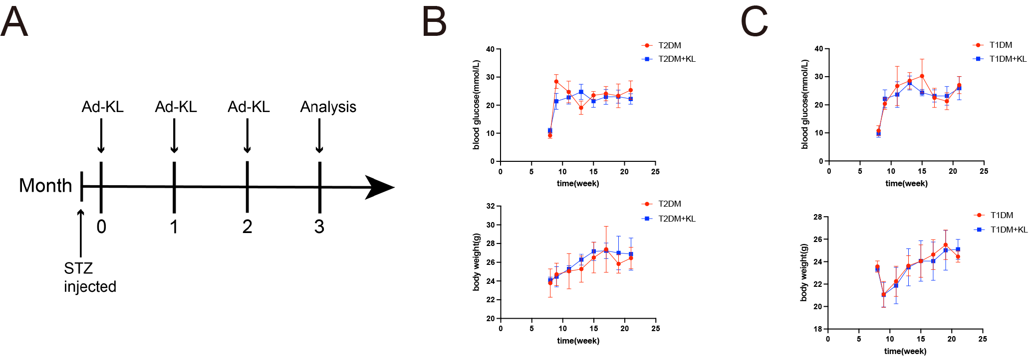
Supplementary Figure. S2: Ad-KL treatment did not cause a significant difference in body weight or blood glucose of diabetic mice. (A) Illustration of the time points of STZ injection and Ad-KL treatment. There was no statistically significant difference in body weight (B) or blood glucose (C) of mice between the DM group and the DM+KL group.

 | serum group |  |  | aqueous humor group
 | Control | PDR | P value | Control | PDR | P value
Age (years) | 62.13±4.49 | 62.25±3.91 | 0.9336 | 61.86±5.26 | 62.14±8.24 | 0.9138
Sex, males (%) | 46.67% | 43.75% | 1 | 42.86% | 64.29% | 0.256
SBP (mmHg) | 137±13.61 | 148.38±16.72 | 0.1149 | 148.36±23.09 | 162.57±32.99 | 0.198
DBP (mmHg) | 77.13±10.37 | 81.63±10.33 | 0.3258 | 86.29±10.67 | 88.71±10.76 | 0.5453
FPG (mmol/L) | 4.6±0.68 | 10.4±4.5 | <0.0001 | 5.5±0.8 | 9.5±4 | <0.0001
Duration (years) | 0 | 14.19±7.11 | <0.0001 | 0 | 17.47±9.85 | <0.0001
HbA1c (%) | 5.6±0.4 | 8.0±2.2 | 0.0008 | 5.8±0.4 | 7.6±1.2 | <0.0001
Supplementary Table S1: Comparison of clinical and biochemical data of subjects. Data are presented as the mean ± standard deviation. Unpaired t‐test were used for comparisons of normally distributed continuous variables between two groups, respectively. SBP, systolic blood pressure; DBP, diastolic blood pressure; FPG, fasting plasma glucose.

antibody | Source | Catalog No. | Type of antibody | Dilution
P53 | Santa Cruz Biotechnology | sc-126 | mouse | IF: 1:250  WB: 1:1000
Klotho | Sigma | SAB3500604 | rabbit | IF: 1:100  WB: 1:1000
HECTD1 | proteintech | 20605-1-AP | rabbit | WB: 1:1000
IRS1 | abcam | ab131487 | rabbit | WB: 1:1000
β-actin | Cell Signaling Technology | 4970 | rabbit | WB: 1:1000
HSP90 | Cell Signaling Technology | 4877 | rabbit | WB: 1:1000
Ki67 | abcam | ab15580 | rabbit | IF: 1:500
F4/80 | Santa Cruz Biotechnology | sc-377009 | mouse | IF: 1:250
IB4 | Vector Laboratories | DL-1207 | rabbit | IF: 1:100
CD34 | abcam | ab81289 | rabbit | IF: 1:100
PI3K | proteintech | 20584-1-AP | rabbit | WB: 1:1000
p-AKT | proteintech | 66444-1-Ig | mouse | WB: 1:1000
AKT | Cell Signaling Technology | 9272 | rabbit | WB: 1:1000
Supplementary Table S2: Antibodies used in the study

CSF2 | Forward | 5'-CCTTGAACATGACAGCCAGCTA-3'
CSF2 | Reverse | 5'-CACAGTCCGTTTCCGGAGTT-3'
CSF3 | Forward | 5'-CCTGCAGGCTCTATCGGGTAT-3'
CSF3 | Reverse | 5'-ATCCAGCTGAAGCAAGTCCAA-3'
VEGFA | Forward | 5'-GTACCTCCACCATGCCAAGTG-3'
VEGFA | Reverse | 5'-TGGGACTTCTGCTCTCCTTCTG-3'
TNF-α | Forward | 5'-GACCCTCACACTCAGATCA-3'
TNF-α | Reverse | 5'-ACTTGGTGGTTTGCTACG-3'
IL-1a | Forward | 5'-AAGAGACCATCCAACCCAGATC-3'
IL-1a | Reverse | 5'-CCTGACGAGCTTCATCAGTTTG-3'
MMP2 | Forward | 5'-GACACCTGCACCACCTTA-3'
MMP2 | Reverse | 5'-AAGGTTGAAGGAAACGAGC-3'
CXCL10 | Forward | 5'-TAAGCTATGTGGAGGTGCGA-3'
CXCL10 | Reverse | 5'-TAGAACTGACGAGCCTGAG-3'
KL | Forward | 5'-TTGGGTCACTGGGTCAATCTC-3'
KL | Reverse | 5'-CCGGCACGATAGGTCATGTT-3'
β-actin | Forward | 5'-TAAGGCCAACCGTGAAAAG-3'
β-actin | Reverse | 5'-ACCAGAGGCATACAGGGACA-3'
Supplementary Table S3: The primer sequences for qRT-PCR.

