- Supplementary Information-
Aβ₄₂ and ROS Dual-targeted Nanocomposite for Combination Therapy of Alzheimer’s Disease
Liding Zhang^{1,2,3†}, Kai Cao^{1,2,†}, Jun Xie^{1,2}, Xiaohan Liang^{1,2}, Qingming Luo^{3,4}, Haiming Luo^{1,2,4*}
¹State Key Laboratory of Digital Medical Engineering, Key Laboratory of Biomedical Engineering of Hainan Province, School of Biomedical Engineering, Hainan University, Haikou 570228, China
²Britton Chance Center for Biomedical Photonics, Wuhan National Laboratory for Optoelectronics, Huazhong University of Science and Technology, Wuhan 430074, China
³MoE Key Laboratory for Biomedical Photonics, Huazhong University of Science and Technology, Wuhan 430074, China
⁴Research Unit of Multimodal Cross Scale Neural Signal Detection and Imaging, Chinese Academy of Medical Sciences, HUST-Suzhou Institute for Brainsmatics, JITRI, Suzhou 215123, China
† These authors contributed equally to this work.

*Correspondence: Haiming Luo, hemluo@hust.edu.cn；
Britton Chance Center for Biomedical Photonics, Wuhan National Laboratory for Optoelectronics, Huazhong University of Science and Technology, 430074, Wuhan, Hubei, China. Fax: +86-27-87792034; Tel: +86-27-87792033;

Supplementary Figures
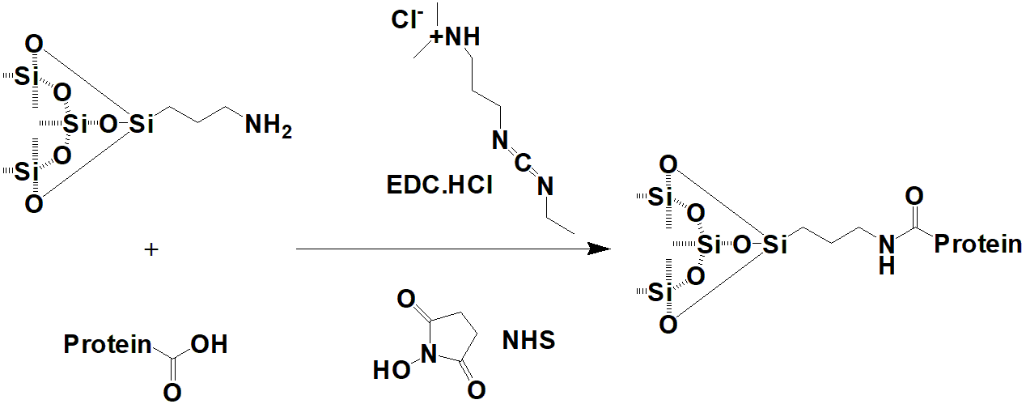
Fig. S1 Synthetic scheme of protein-modified bMSNs@Ce.

Fig. S2 Characterization of Nanoparticles. Hydrodynamic diameters of bMSNs (a), CeNP (b), and bMSNs@Ce (c). Data are presented as means ± SD, n = 3.

Fig. S3 X-ray photoelectron spectroscopy (XPS) analysis of RVG29-bMSNs@Ce-1F12.
Fig. S4 Characterization of RVG29-bMSNs@Ce-1F12. The RVG29 and 1F12 on the surface of nanoparticles were identified by ELISA (a) and SDS-PAGE (b). Data are presented as means ± SD, n = 3. *p < 0.05 and **p < 0.01.

Fig. S5 Biocompatibility assay. (a) The morphology of SH-SY5Y and BV2 cells before and after incubation with RVG29-bMSNs@Ce-1F12. Scale bar = 100 μm. b) H&E staining of the main organs after RVG29-bMSNs@Ce-1F12 treatment. Scale bar = 100 μm.

Fig. S6 Characterization of Aβ plaque stained with 1F12 and RVG29-bMSNs@Ce. Confocal fluorescence images of Aβ plaque stained with 1F12 (a) and RVG29-bMSNs@Ce (b). Thioflavin S (green) was used as the positive control. Scale bar = 100 μm.

Fig. S7 Evaluation of the ability of RVG29-bMSNs@Ce-1F12 to inhibit Aβ aggregation. (a) Dot blot analysis of Aβ₄₂O levels in the treatment groups of PBS, RVG29-bMSNs, 1F12, and RVG29-bMSNs@Ce-1F12. b) Comparison of the particle size of Aβ₄₂ aggregates in the 1F12 and RVG29-bMSNs@Ce-1F12 treatment groups.

Fig. S8 RVG29-bMSNs@Ce-1F12 alleviates Aβ₄₂ aggregates-induced oxidative stress and microgliosis. Morphological changes (a), percentage of long cells (b), and cell viability (c) after exposure to Aβ₄₂ in the presence of PBS and RVG29-bMSNs@Ce-1F12. Scale bar = 100 μm. Data are presented as means ± SD, n = 3. ANOVA was performed for multigroup comparisons, **p < 0.01, ***p < 0.001, and ****p < 0.0001.

Fig. S9 The tissue distribution of 1F12 and RVG29-bMSNs@Ce. Time course fluorescence imaging of organs from C57BL/6J mice after administered with Cy3-labeled 1F12 and RVG29-bMSNs@Ce.

Fig. S10 IP-Western blot analysis of Aβ₄₂ level in blood of APP/PS1 mice after treated with normal saline, RVG29-bMSNs@Ce, 1F12, and RVG29-bMSNs@Ce-1F12.

Fig. S11 RVG29-bMSNs@Ce-1F12 ameliorates learning and memory impairments in APP/PS1 mice. (a) Swimming speed of APP/PS1 mice in the hidden platform learning trials and probe trial. (b) The platform crossing times of APP/PS1 mice in probe trial after treatments. Data are presented as means ± SD, n = 5. *p < 0.05 and **p < 0.01.

