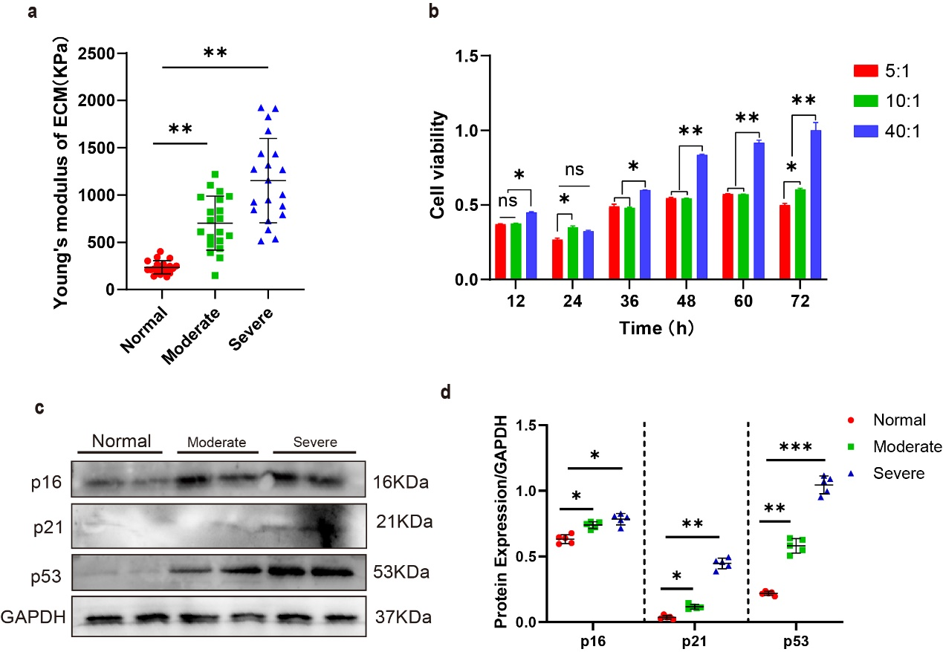

Supplementary Figure 1
ECM stiffening induced chondrocyte senescence in vitro and in mice. (A) Measurement of matrix stiffness (Young’s modulus) for normal and OA patients in moderately damaged and severely damaged using atomic force microscopy (AFM). n=20 per group. (B) Chondrocytes Viability Assessed by CCK-8 at 12, 24, 36, 48, 60, and 72 Hours After cultivated on PDMS substrates with Different Stiffness (40:1,10:1, 5:1). (C, D) Western Blotting analysis of p16 INK4a, p21 and p53 expression in articular cartilage from normal and OA patients in moderately damaged and severely damaged. n=5 per group.

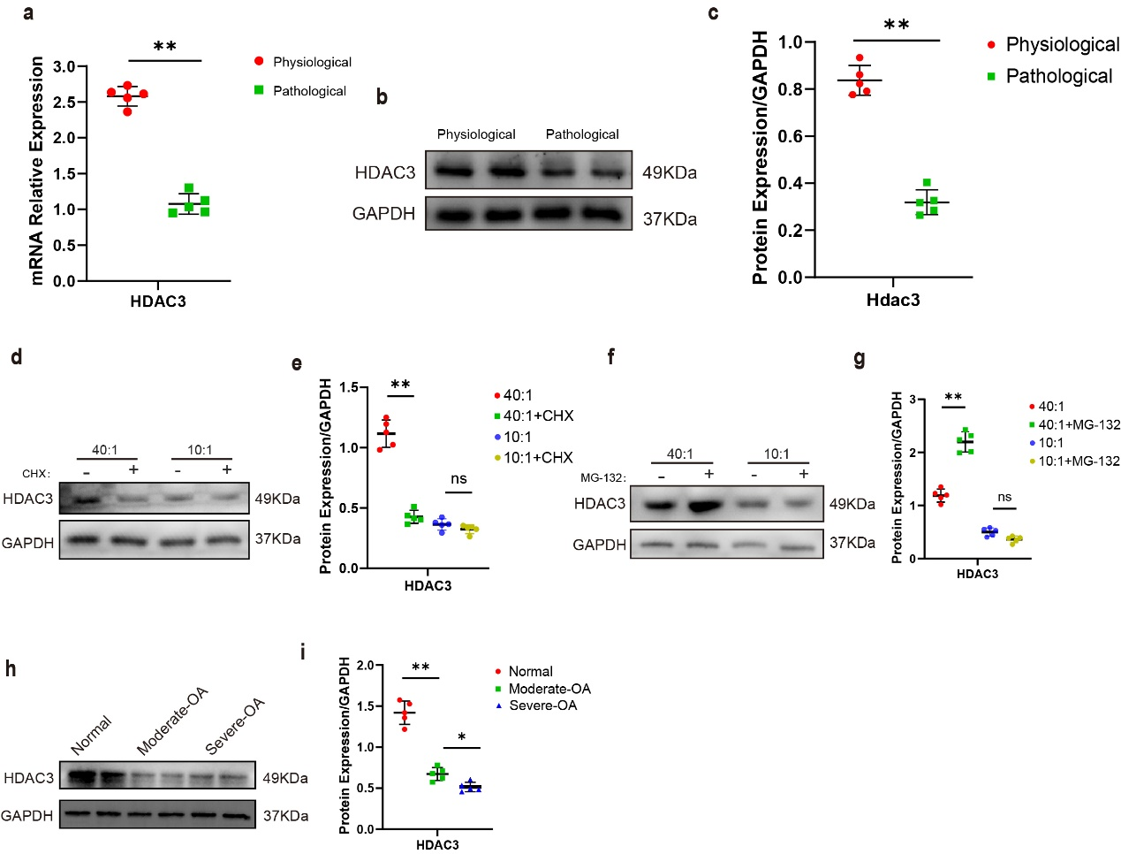

Supplementary Figure 2
Chondrocyte HDAC3 is reduced by ECM stiffening and is decreased in the articular cartilage of OA patients. (A) Quantitative PCR analysis of HDAC3 in the chondrocytes from human cultivated on Physiologic and Pathologic stiffness of PDMS substrates. n=5 per group. (B, C) Western Blotting analysis of HDAC3 expression in chondrocytes from human cultivated on Physiologic and Pathologic stiffness of PDMS substrates. n=5 per group. (D, E) Western Blotting analysis of HDAC3 expression in primary chondrocytes treated with CHX or not cultivated on 40:1 and 10:1 PDMS substrates. n=5 per group. (F, G) Western Blotting analysis of HDAC3 expression in primary chondrocytes treated with MG-132 or not cultivated on 40:1 and 10:1 PDMS substrates. n=5 per group. (H, I) Western Blotting analysis of HDAC3 expression in chondrocytes from normal and OA patients in moderately damaged and severely damaged. n=5 per group.
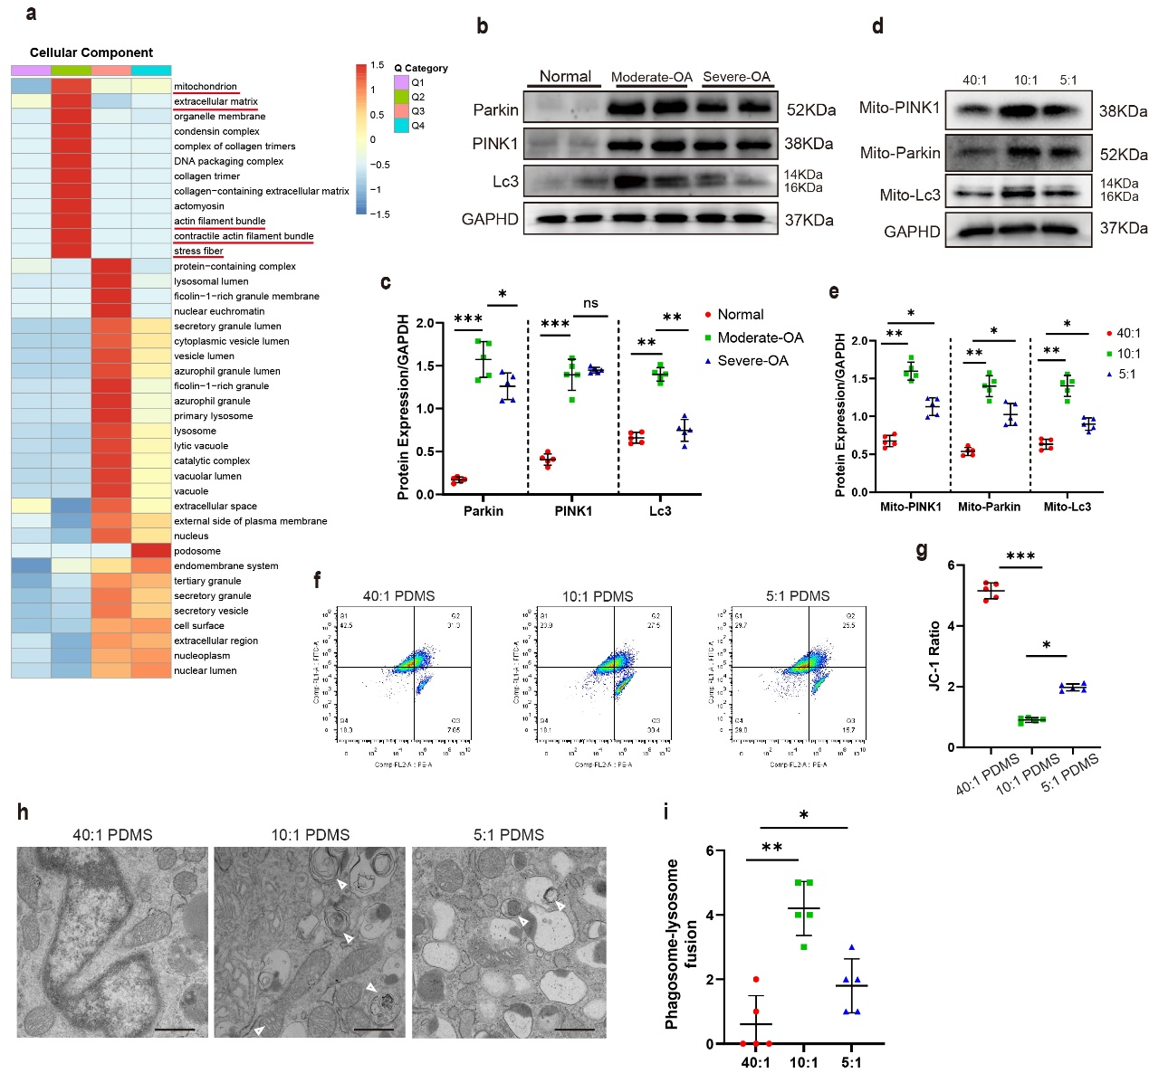

Supplementary Figure 3
ECM stiffening activates PINK1/Parkin mediated mitophagy. (A) Creation of a heatmap using hierarchical clustering to group related functions from different Q groups within cellular component, Based on Fisher's Exact Test P-values obtained from enrichment analysis. The horizontal axis represents different Q groups, while the vertical axis describes the cellular component associated with enriched differentially expressed proteins. (B, C) Western Blotting analysis of PINK1, Parkin and Lc3 expression in articular cartilage from normal and OA patients in moderately damaged and severely damaged. n=5 per group. (D, E) Western Blotting analysis of PINK1, Parkin and Lc3 expression in mitochondria of primary chondrocytes cultivated on 40:1, 10:1 and 5:1 PDMS substrates. n=5 per group. (F, G) Representative images and quantification of mitochondrial membrane potential by flow cytometry in chondrocytes cultivated on 40:1, 10:1 and 5:1 PDMS substrates. n=5 per group. (H) Representative images of morphology and number of chondrocyte mitochondria observed by transmission electron microscopy. Scale bars:1 µm. (I) Quantification of phagosome-lysosome fusion in chondrocytes based on results in (H). n=5 per group.

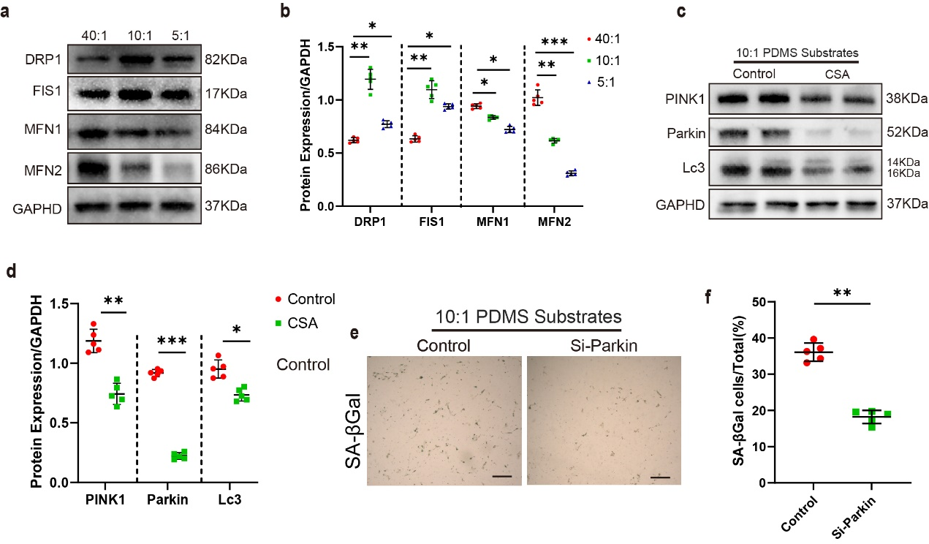

Supplementary Figure 4
The inhibition of PINK1/Parkin mediated mitophagy delays chondrocyte senescence and joint degeneration in mice. (A, B) Western Blotting analysis of DRP1, FIS1, MFN1 and MFN2 expression in primary chondrocytes cultivated on 40:1, 10:1 and 5:1 PDMS substrates. n=5 per group. (C, D) Western Blotting analysis of PINK1, Parkin and Lc3 expression in primary chondrocytes treated with CSA or not cultivated on 40:1 and 10:1 PDMS substrates. n=5 per group (E, F) Representative images and quantification of SA-βGal staining in primary chondrocytes which transfected si-NC or si-Parkin cultivated on 10:1 PDMS substrates. n=5 per group. Scale bar: 50 µm.

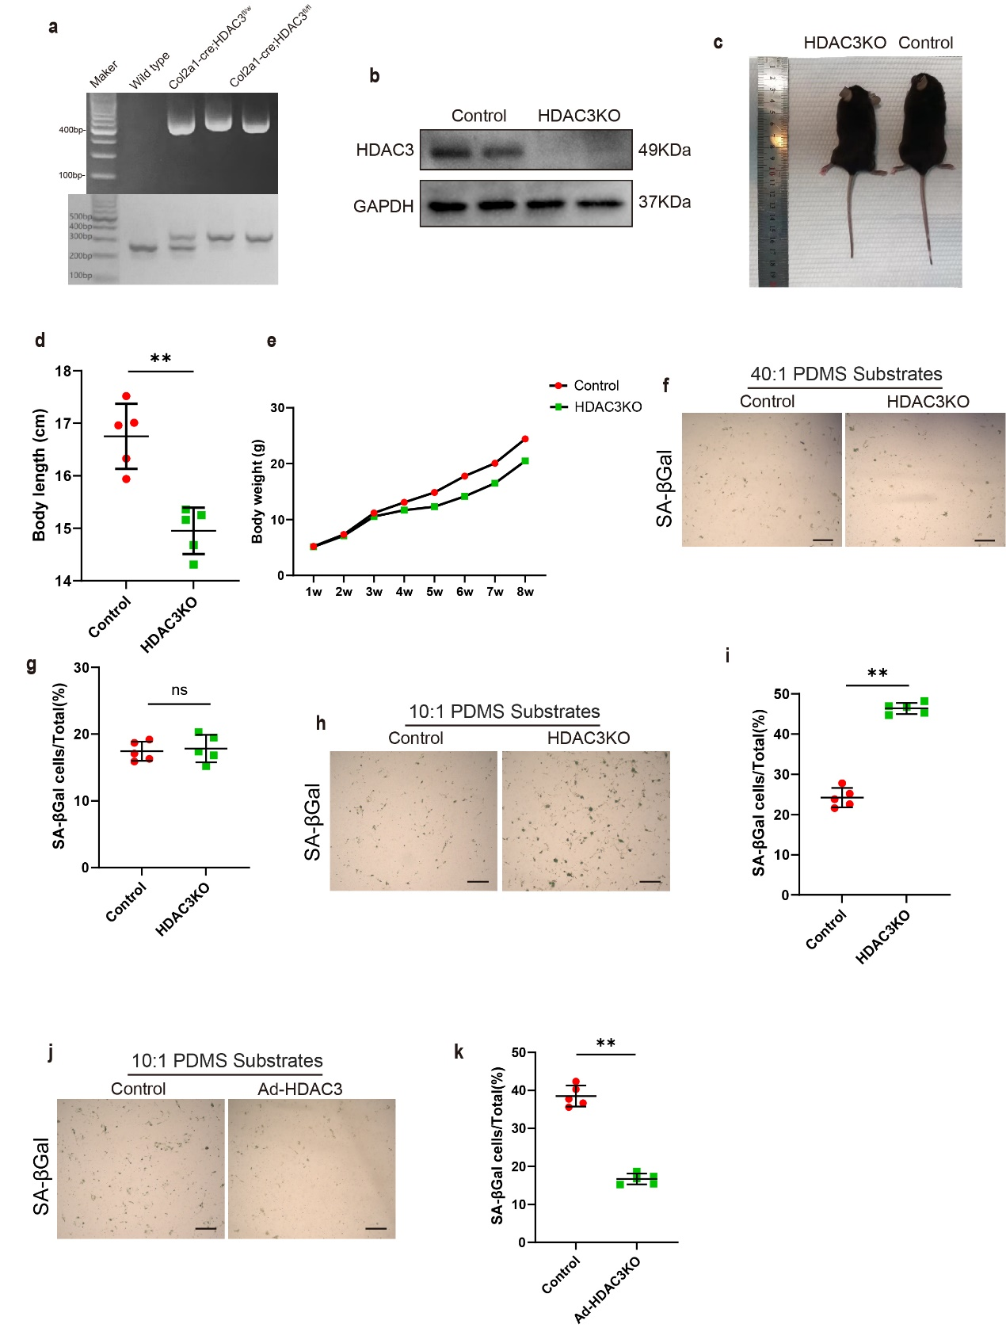

Supplementary Figure 5
Loss of HDAC3 activates PINK1/Parkin signaling to promote chondrocyte senescence and OA progression. (A) Genotyping the offspring after mating transgenic Cre and loxp mice. Original image of agarose gel electrophoresis. Col2a1-HDAC3flox/flox: control mice, Col2a1(+)-HDAC3flox/flox: knockout mice. (B) Western blot of HDAC3 in articular cartilage from HDAC3KO mice and controls. (C) General phenotypes of control and HDAC3KO mice at 8 weeks of age. (D) Quantification of the body length of control and HDAC3KO mice at 8 weeks of age. n = 5 per group. (E) Graph of control and HDAC3KO mice body weights from postnatal week 1 to week 8. n = 5 per group. (F, G) Representative images and quantification of SA-βGal staining in primary chondrocytes of control and HDAC3KO mice cultivated on 40:1 PDMS substrates. n=5 per group. Scale bar: 50 µm. (H, I) Representative images and quantification of SA-βGal staining in primary chondrocytes of control and HDAC3KO mice cultivated on 10:1 PDMS substrates. n=5 per group. Scale bar: 50 µm. (J, K) Representative images and quantification of SA-βGal staining in primary chondrocytes which transfected Ad-NC or Ad-HDAC3 cultivated on 10:1 PDMS substrates. n=5 per group. Scale bar: 50 µm.

