Pharmacovigilance study of Rucaparib based on the FDA Adverse Event Reporting System(FAERS)
Si Fangying, Xue Ying , Lu Xiaojing, Yin Zhao, Du Shu zhang
Department of Pharmacy, First Affiliated Hospital of Zhengzhou University, China,
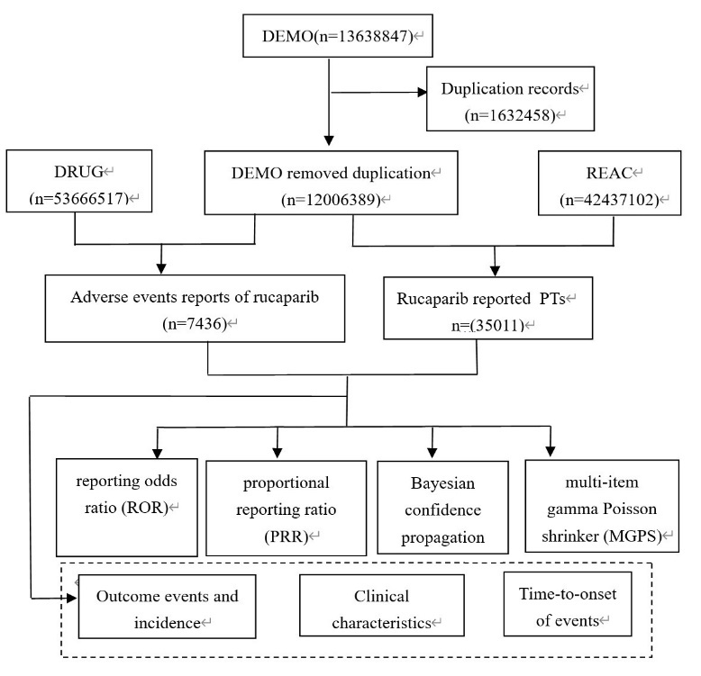
Supplementary Figure S1. The process of selecting AEs reported from FAERS data.

Algorithms | Equation | Criteria
Reporting odds ratio （ROR） | ROR=ad/b/c | lower limit of 95% CI>1, N≥3
Reporting odds ratio （ROR） | 95%CI=eln(ROR)±1.96(1/a+1/b+1/c+1/d)^0.5 | lower limit of 95% CI>1, N≥3
Proportional reporting ratio (PRR) | PRR=a(c+d)/c/(a+b) | PRR≥2, χ²≥4, N≥3
Proportional reporting ratio (PRR) | χ²=[(ad-bc)^2](a+b+c+d)/[(a+b)(c+d)(a+c)(b+d)] | PRR≥2, χ²≥4, N≥3
Bayesian confidence propagation neural network (BCPNN) | IC=log₂a(a+b+c+d)(a+c)(a+b) | IC025>0
Bayesian confidence propagation neural network (BCPNN) | 95%CI= E(IC) ± 2V(IC)^0.5 | IC025>0
Multi-item gamma Poisson shrinker (MGPS) | EBGM=a(a+b+c+d)/(a+c)/(a+b) | EBGM05>2
Multi-item gamma Poisson shrinker (MGPS) | 95%CI=eln(EBGM)±1.96(1/a+1/b+1/c+1/d)^0.5 | EBGM05>2
Supplementary Table S1. Four major algorithms used for signal detection.
Equation: a, number of reports containing both the target drug and target adverse drug reaction; b, number of reports containing other adverse drug reaction of the target drug; c, number of reports containing the target adverse drug reaction of other drugs; d, number of reports containing other drugs and other adverse drug reactions. 95%CI, 95% confidence interval; N, the number of reports; χ2, chi-squared; IC, information component; IC025, the lower limit of 95% CI of the IC; E(IC), the IC expectations; V(IC), the variance of IC; EBGM, empirical Bayesian geometric mean; EBGM05, the lower limit of 95% CI of EBGM.

