Archives of Microbiology
New bioinsecticide based on Streptomyces griseoflavus PAL114 for biocontrol of black bean aphid Aphis fabae
Fatma Zohra Benbelkhir^{1 .} Khadidja Allali^{2,3 .} Abderrahmane Benadjila^{2,4 .} Yacine Goudjal^{2,3 .} Samir Medjekal⁵ . Miyada Zamoum^{2,3}

¹ Laboratory of Biology: Application in Health and Environment, Department of Biochemistry and Microbiology, Faculty of Sciences, University of M'sila, Po. Box 166 Ichebilia, 28000 M'sila, Algeria
² Laboratoire de Biologie des Systèmes Microbiens (LBSM), Ecole Normale Supérieure de Kouba, Alger, Algeria
³ Département d’Agronomie, Faculté Des Sciences, Université Amar Telidji, BP 37G Laghouat, Algeria
⁴ Département de Biologie, Université Ziane Achour, Djelfa 17000, Algeria ⁵ Department of Biochemistry and Microbiology, Faculty of Sciences, University of M'sila, Po. Box 166 Ichebilia, 28000 M'sila, Algeria
() Miyada Zamoum: m.zamoum@lagh-univ.dz
Tel: + 213 5 53 82 19 23; Fax: + 213 21 28 20 67

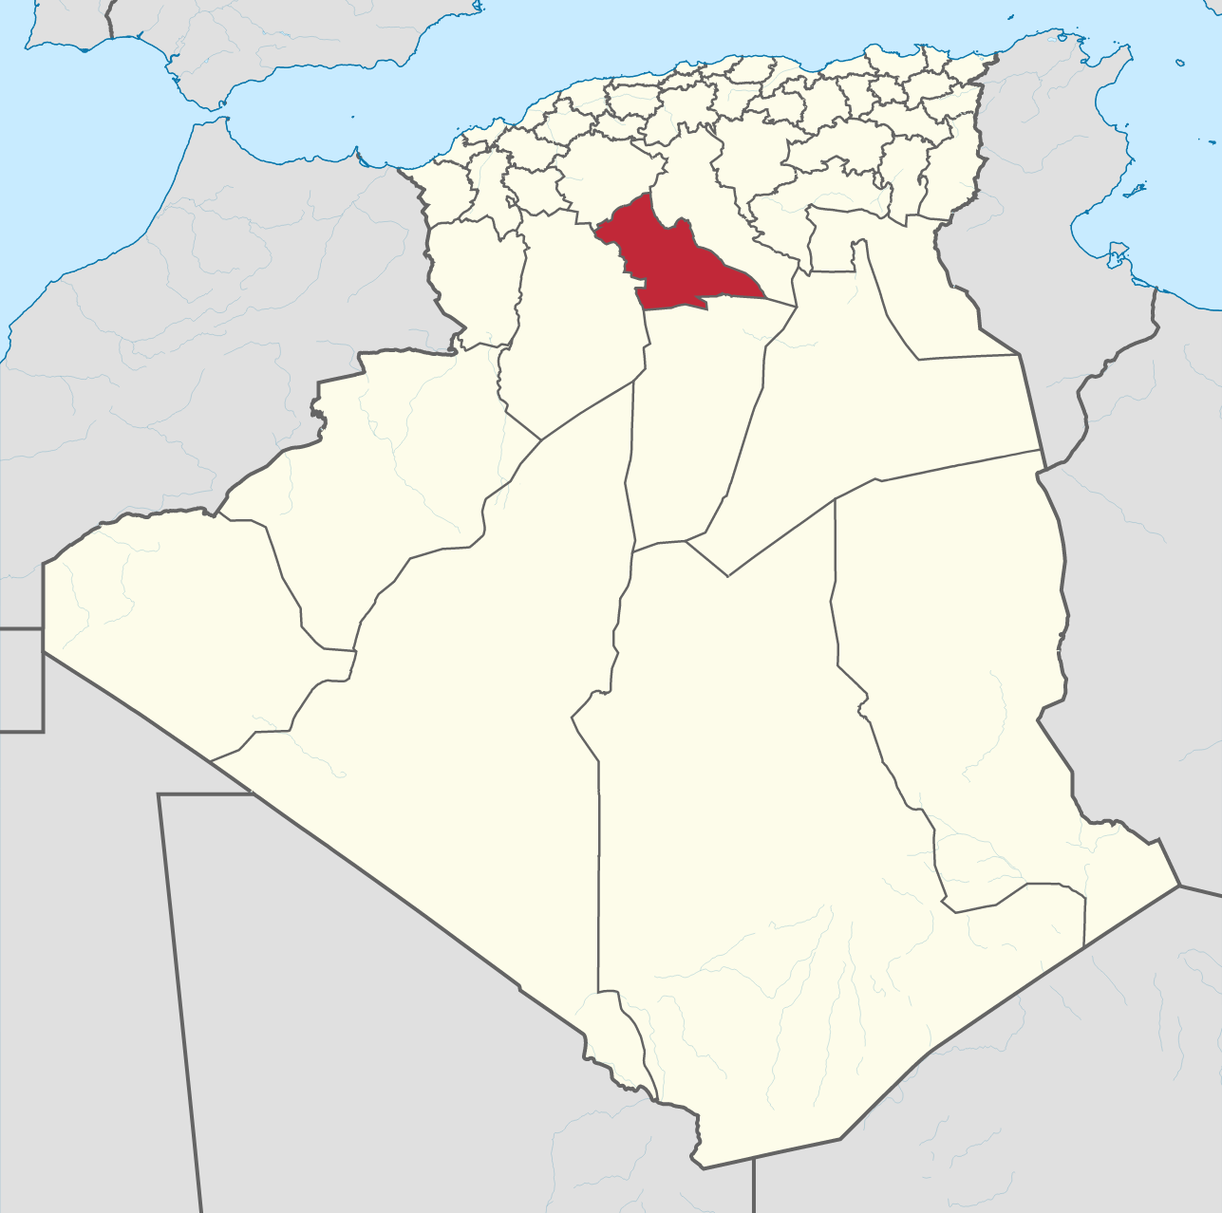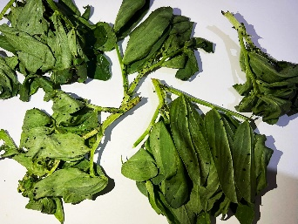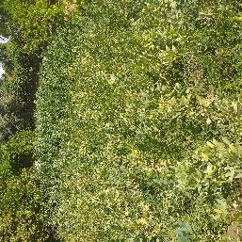
Laghouat
Algeria
a
c
b
Fig. S1 Collection of black bean aphids Aphis fabae. a Geographical location of sampling site. b Photographs of targeted fava bean field. c Photographs of collected samples

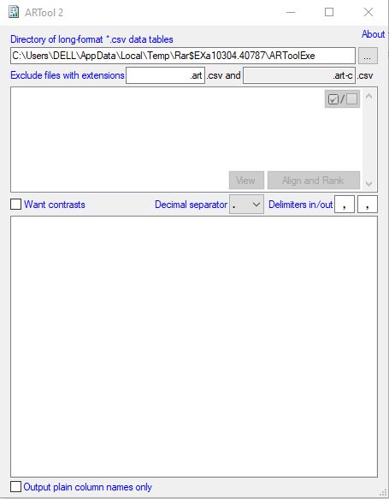

Fig. S2 ARTool.Exe version 2.1.2 for Windows, used for aligned rank transformation for nonparametric multifactorial analysis

Table S1 Composition of nourishing solution for fava bean leaves
Compound | Quantity
Ca(NO3)2 | 20 mM
KNO3 | 30 mM
MgSO4 | 20 mM
H3BO3 | 185 µM
MnCl3 | 36.5 µM
ZnSO4 | 0.3 µM
FeSO4.7H2O | 0.3 µM

Table S2 Results of parametric multifactorial ANOVA for screening for insecticidal activity
Source | Type III Sum of Squares |  | df | Mean Square | F | Sig.
Corrected Model | 27939.730ª | 5 |  | 5587.946 | 15.958 | .000
Intercept | 160954.358 | 1 |  | 160954.358 | 459.640 | .000
Actinobacterial treatment | 5549.745 | 3 |  | 1849.915 | 5.283 | .003
Time | 22389.985 | 2 |  | 11194.993 | 31.970 | .000
Error | 23111.552 | 66 |  | 350.175
Total | 212005.640 | 72
Corrected Total | 51051.282 | 71
a. R Squared = .547 (Adjusted R Squared = .513)

Table S3 a Results of nonparametric multifactorial ANOVA for biocontrol assays, Bioinsecticide density factor
Source | Type III Sum of Squares | df | Mean Square | F | Sig.
Corrected Model | 86278.583ª | 9 | 9586.509 | 7.921 | .000
Intercept | 756900.000 | 1 | 756900.000 | 625.439 | .000
Time | 1354.083 | 7 | 193.440 | .160 | .992
*Bioinsecticide density | 84924.500 | 2 | 42462.250 | 35.087 | .000
Error | 162165.417 | 134 | 1210.190
Total | 1005344.000 | 144
Corrected Total | 248444.000 | 143
a. R Squared = .347 (Adjusted R Squared = .303)
*In this table only the significance result of Bioinsecticide density factor will be considered.
Table S3 b Results of nonparametric multifactorial ANOVA for biocontrol assays, Time factor
Source | Type III Sum of Squares | df | Mean Square | F | Sig.
Corrected Model | 155410.802ª | 9 | 17267.867 | 24.833 | .000
Intercept | 756900.000 | 1 | 756900.000 | 1088.496 | .000
*Time | 154503.083 | 7 | 22071.869 | 31.741 | .000
Bioinsecticide density | 907.719 | 2 | 453.859 | .653 | .522
Error | 93178.698 | 134 | 695.363
Total | 1005489.500 | 144
Corrected Total | 248589.500 | 143
a. R Squared = .625 (Adjusted R Squared = .600)
*In this table, only the significance result of Time factor will be considered.

Table S3 c Results of nonparametric multifactorial ANOVA for biocontrol assays, Interaction Bioinsecticide density×Time

Source | Type III Sum of Squares | df | Mean Square | F | Sig.
Corrected Model | 3537.809ª | 9 | 393.090 | .215 | .992
Intercept | 756900.000 | 1 | 756900.000 | 413.731 | .000
Time | 3253.861 | 7 | 464.837 | .254 | .970
Bioinsecide density | 283.948 | 2 | 141.974 | .078 | .925
Error | 245146.191 | 134 | 1829.449
Total | 1005584.000 | 144
Corrected Total | 248684.000 | 143
a. R Squared = .014 (Adjusted R Squared = -.052)
In this table there was no interaction between the two factors Bioinsecticide density×Time
Table S4 Results of one-factor ANOVA for effect of bioinsecticide on Vicia faba bean
 |  | Sum of Squares | df | Mean Square | F | Sig.
Germination ration | Between Groups | 322.034 | 2 | 161.017 | . | .
 | Within Groups | .000 | 56 | .000
 | Total | 322.034 | 58
Fresh weight | Between Groups | 11.468 | 2 | 5.734 | 2.260 | .114
 | Within Groups | 142.068 | 56 | 2.537
 | Total | 153.536 | 58
Dry weight | Between Groups | .100 | 2 | .050 | 2.510 | .090
 | Within Groups | 1.115 | 56 | .020
 | Total | 1.215 | 58
Plant length | Between Groups | 457.046 | 2 | 228.523 | 4.804 | .012
 | Within Groups | 2663.719 | 56 | 47.566
 | Total | 3120.765 | 58
Root length | Between Groups | 72.743 | 2 | 36.372 | 4.287 | .019
 | Within Groups | 415.697 | 49 | 8.484
 | Total | 488.441 | 51

