Table S1. Distribution of blood (μmol/L) and urine heavy metals concentrations (μg/L) among different percentile.
Heavy metals | Mean (SD) | %>LOD | Percentile
Heavy metals | Mean (SD) | %>LOD | 10th | 25th | 50th | 75th | 90th |  | 95th | 99th
Blood lead | 0.065 (0.005) | 32.8 | <LOD | <LOD | <LOD | 0.076 | 0.113 |  | 0.150 | 0.344
Barium,urine  Cadmium,urine  Cobalt,urine  Manganese,urine  Lead,urine  Antimony,urine  Tin,urine  Thallium,urine  Tungsten,urine  Strontium,urine  Uranium,urine | 1.674(8.74)  0.312(0.167)  0.55(1.45)  0.160(0.336)  0.506(0.78)  0.072(0.028)  1.430(29.50)  0.179(0.018)  0.100(0.032)  119.6(49001.2)  0.012(0.001) | 99.6  92.2  99.8  28.3  99.2  70.9  89.8  99.0  78.8  100  80.7 | 0.278  0.042  0.130  <LOD  0.10  <LOD  <LOD  0.050  <LOD  25.63  <LOD | 0.48  0.083  0.218  <LOD  0.170  <LOD  0.180  0.082  0.021  47.25  0.003 | 0.91  0.185  0.384  <LOD  0.330  0.042  0.400  0.151  0.051  85.5  0.005 | 1.91  0.381  0.649  0.140  0.560  0.074  0.920  0.237  0.111  144.8  0.011 | 3.516  0.713  0.931  0.210  0.922  0.130  2.326  0.340  0.214  226.8  0.024 |  | 5.25  1.01  1.262  0.290  1.321  0.198  4.175  0.417  0.331  304.1  0.040 | 11.9  1.92  3.125  1.2338  3.526  0.68  22.927  0.697  0.829  569.6  0.115
LOD, limit of detection
The value < LOD was imputed with the value of LOD/$\sqrt{2}$ for calculation.

 | β (95% CI) | P-value |  | β (95% CI) | P-value
Lead, blood |  |  | Strontium,urine
Model 1 | -0.01 (-0.05, 0.02) | 0.37 | Model 1 | 0.04 (0.02,0.10) | 0.001**
Model 2 | 0.05 (0.01, 0.10) | 0.03* | Model 2 | 0.04 (0.01,0.10) | 0.01**
Model 3 | 0.04 (-0.02, 0.10) | 0.12 | Model 3 | 0.04 (0.01,0.10) | 0.02*
Lead,urine |  |  | Thallium,urine
Model 1 | -0.005 (-0.03,0.02) | 0.63 | Model 1 | 0.02 (-0.005,0.05) | 0.10
Model 2 | 0.02 (0.01,0.05) | 0.14 | Model 2 | 0.01 (0.01,0.03) | 0.22
Model 3 | 0.02 (-0.01,0.10) | 0.15 | Model 3 | 0.02 (-0.01,0.05) | 0.20
Manganese,urine |  |  | Tin,urine
Model 1 | 0.01 (-0.04,0.03) | 1.00 | Model 1 | -0.03 (-0.05,-0.02) | 0.0002***
Model 2 | 0.0005 (-0.04,0.04) | 1.00 | Model 2 | -0.02 (-0.04,0.01) | 0.02*
Model 3 | 0.01 (-0.05,0.10) | 0.53 | Model 3 | -0.01 (-0.04,0.01) | 0.20
Tungsten,urine  Model 1  Model 2  Model 3  Antimony,urine  Model 1  Model 2  Model 3  Barium,urine  Model 1  Model 2  Model 3  Cadmium urine  Model 1  Model 2  Model 3 | 0.01 (-0.02,0.01)  -0.01 (-0.03,0.005)  0.01 (-0.03,0.02)  0.01 (-0.03,0.01)  -0.01 (-0.04,0.01)  -0.002 (-0.04,0.03)  0.04 (0.03,0.10)  0.03 (0.01,0.05)  0.04 (0.01,0.10)  -0.03 (-0.05,0.01)  0.003 (-0.02,0.03)  0.01 (-0.03,0.04) | 0.40  0.12  0.40  0.50  0.20  1.00  0.0001***  0.003**  0.01*  0.005**  1.00  1.00 | Uranium urine  Model 1  Model 2  Model 3  Cobalt urine  Model 1  Model 2  Model 3  Creatinine,urine  Model 1  Model 2  Model 3 | -0.03 (-0.04,-0.01)  -2.30 (-0.04,0.01)  -0.02 (-0.04,0.004)  -0.003 (-0.03,0.02)  0.01 (-0.03,0.02)  0.004 (-0.03,0.04)  0.01 (-0.02,0.03)  -0.003 (-0.03,0.03)  0.01 (-0.03,0.10) | 0.0002***  0.005**  0.10  1.00  0.63  0.72  0.50  0.82  0.42

Table 2. Generalized linear regression of heavy metals and diabetes in population.

CI: confidence interval; β value were adjusted for four models. Model 1 was unadjusted by any covariant. Model 2 was adjusted by gender, age and race category. Model 3 was adjusted by gender, age, race, BMI, education and income category. Model 4 was adjusted by gender, age, race, BMI, education, income heavy metals. *, p < 0.05; **, p< 0.01.

Table S3 The relationship between WQS regression index and diabetes (N=1617) NHANES, USA, 2013-2018.
Diabetes | β | 95%CI of β | P-value
Unadjusted | 1.02 | （1.01, 1.03） | 4.78×10⁻⁴***
Adjusted | 1.02 | (1.01, 1.03) | 1.07×10⁻⁴***

CI: confidence interval; β estimates represent the mean difference in depression when the WQS index increases by one decile. Model 1 was adjusted by gender, age, race, BMI, education, income and PCA; Model 2 was adjusted by gender, age, race, BMI, education, income, heavy metals. **, p < 0.01.

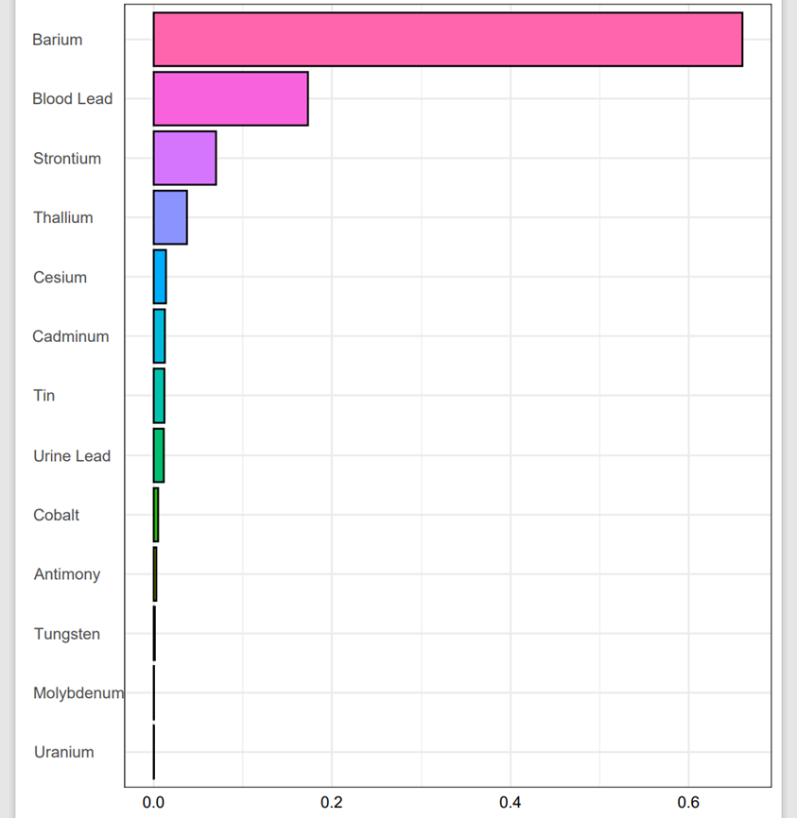

Fig 2.QS regression model weights for various heavy metals in blood or urine.

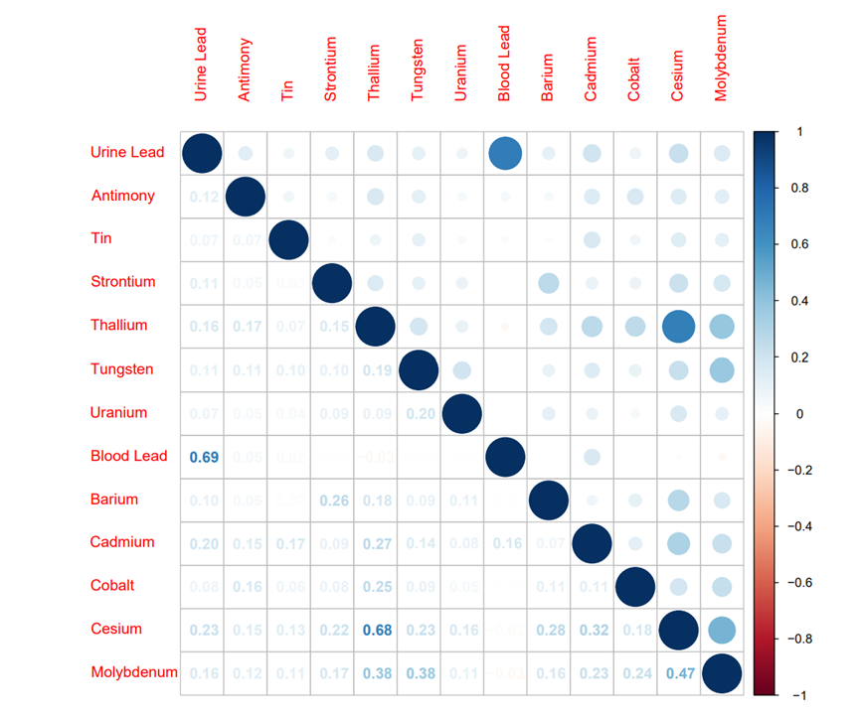
Fig S1.shows the correlation between the level of heavy metals exposed to blood or urine and diabetes, (N = 1617), NHANES, USA, 2013–2018.

