SUPPLEMENTARY FIGURES

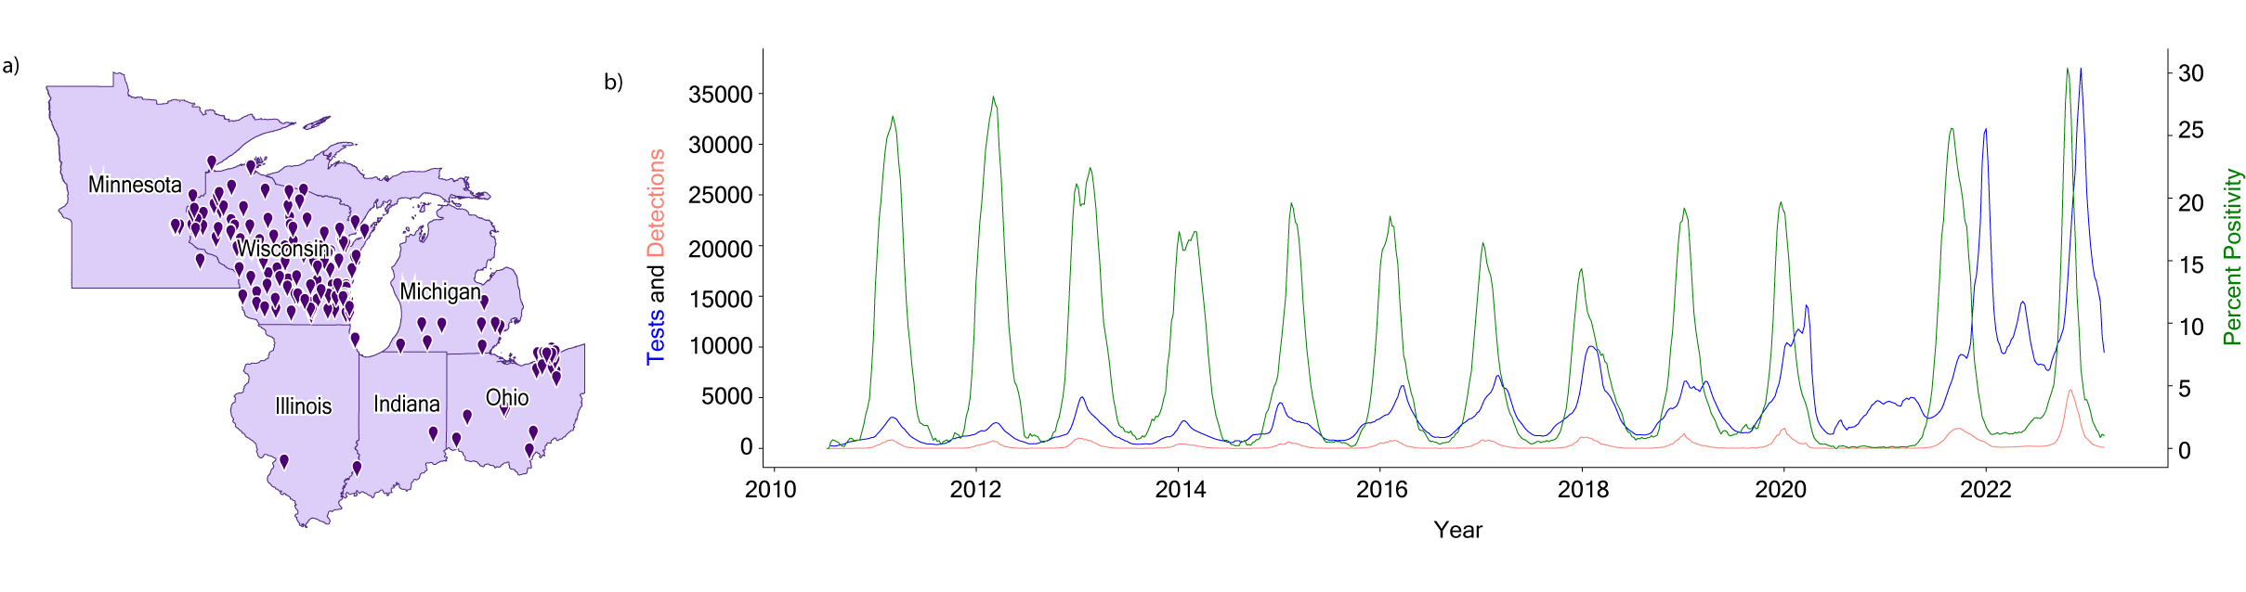

Supplementary Figure 1 | Epidemiology of RSV in the Upper Midwest of the United States. a, Locations of participating laboratories in the Department of Health and Human Services’ (HHS) Region 5 (Illinois, Indiana, Michigan, Minnesota, Ohio, and Wisconsin) that provide RSV testing data to the National Respiratory and Enteric Virus Surveillance System (NREVSS). b, Epidemiology of RSV in HHS Region 5 as represented by a 3-week rolling average of tests (blue), detections (pink), and percent positivity (green) between July 10th, 2010, and June 3rd, 2023 per data provided to the NREVSS.

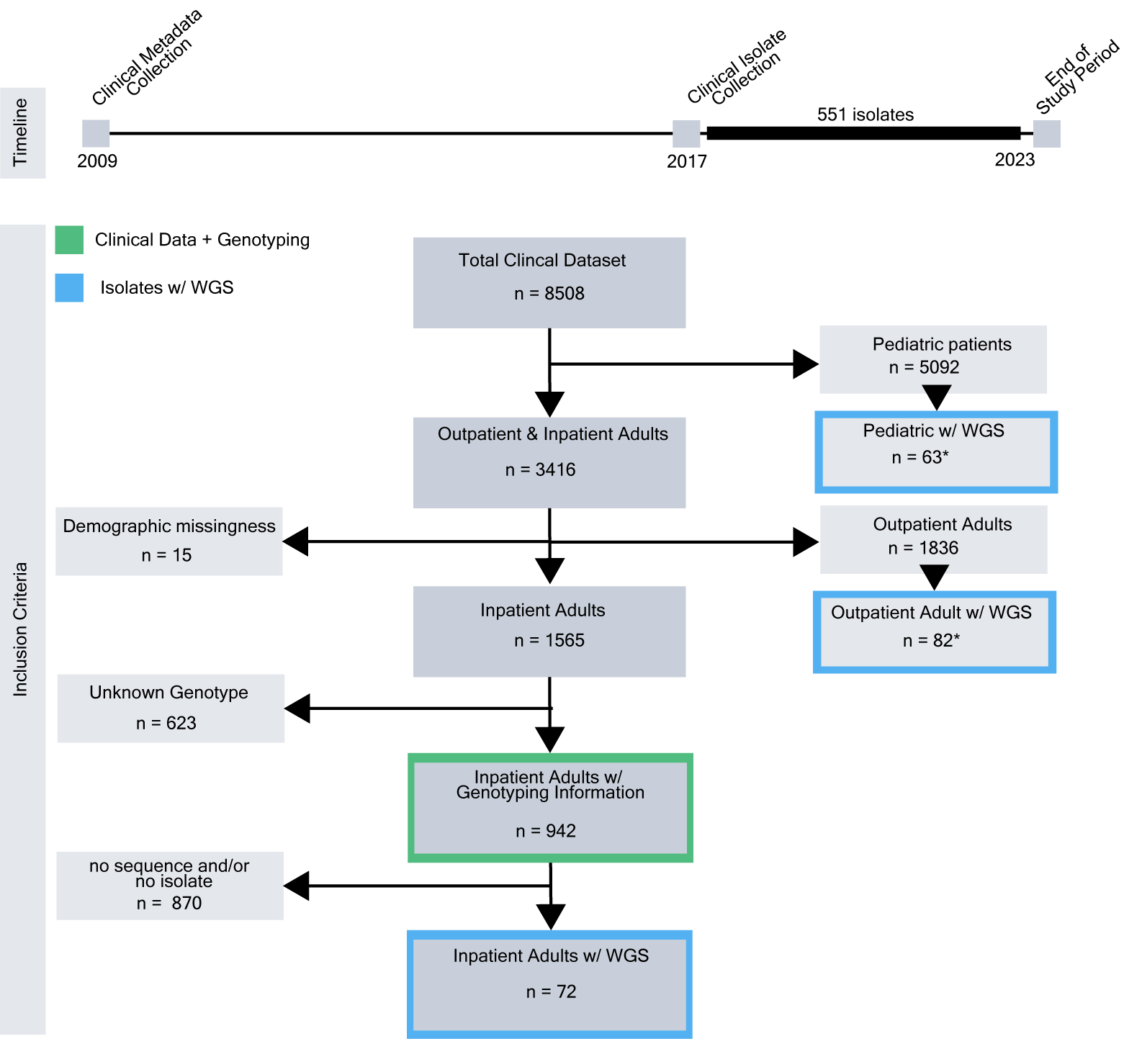

Supplementary Figure 2 | Timeline and Inclusion Criteria of RSV Clinical Metadata and Isolate Collection. a, Timeline of the study, including clinical metadata and isolate collection. b, Inclusion and exclusion criteria of patient metadata and isolates. Patient subsets used for logistic regression modeling or whole genome sequencing are highlighted in green and blue, respectively.

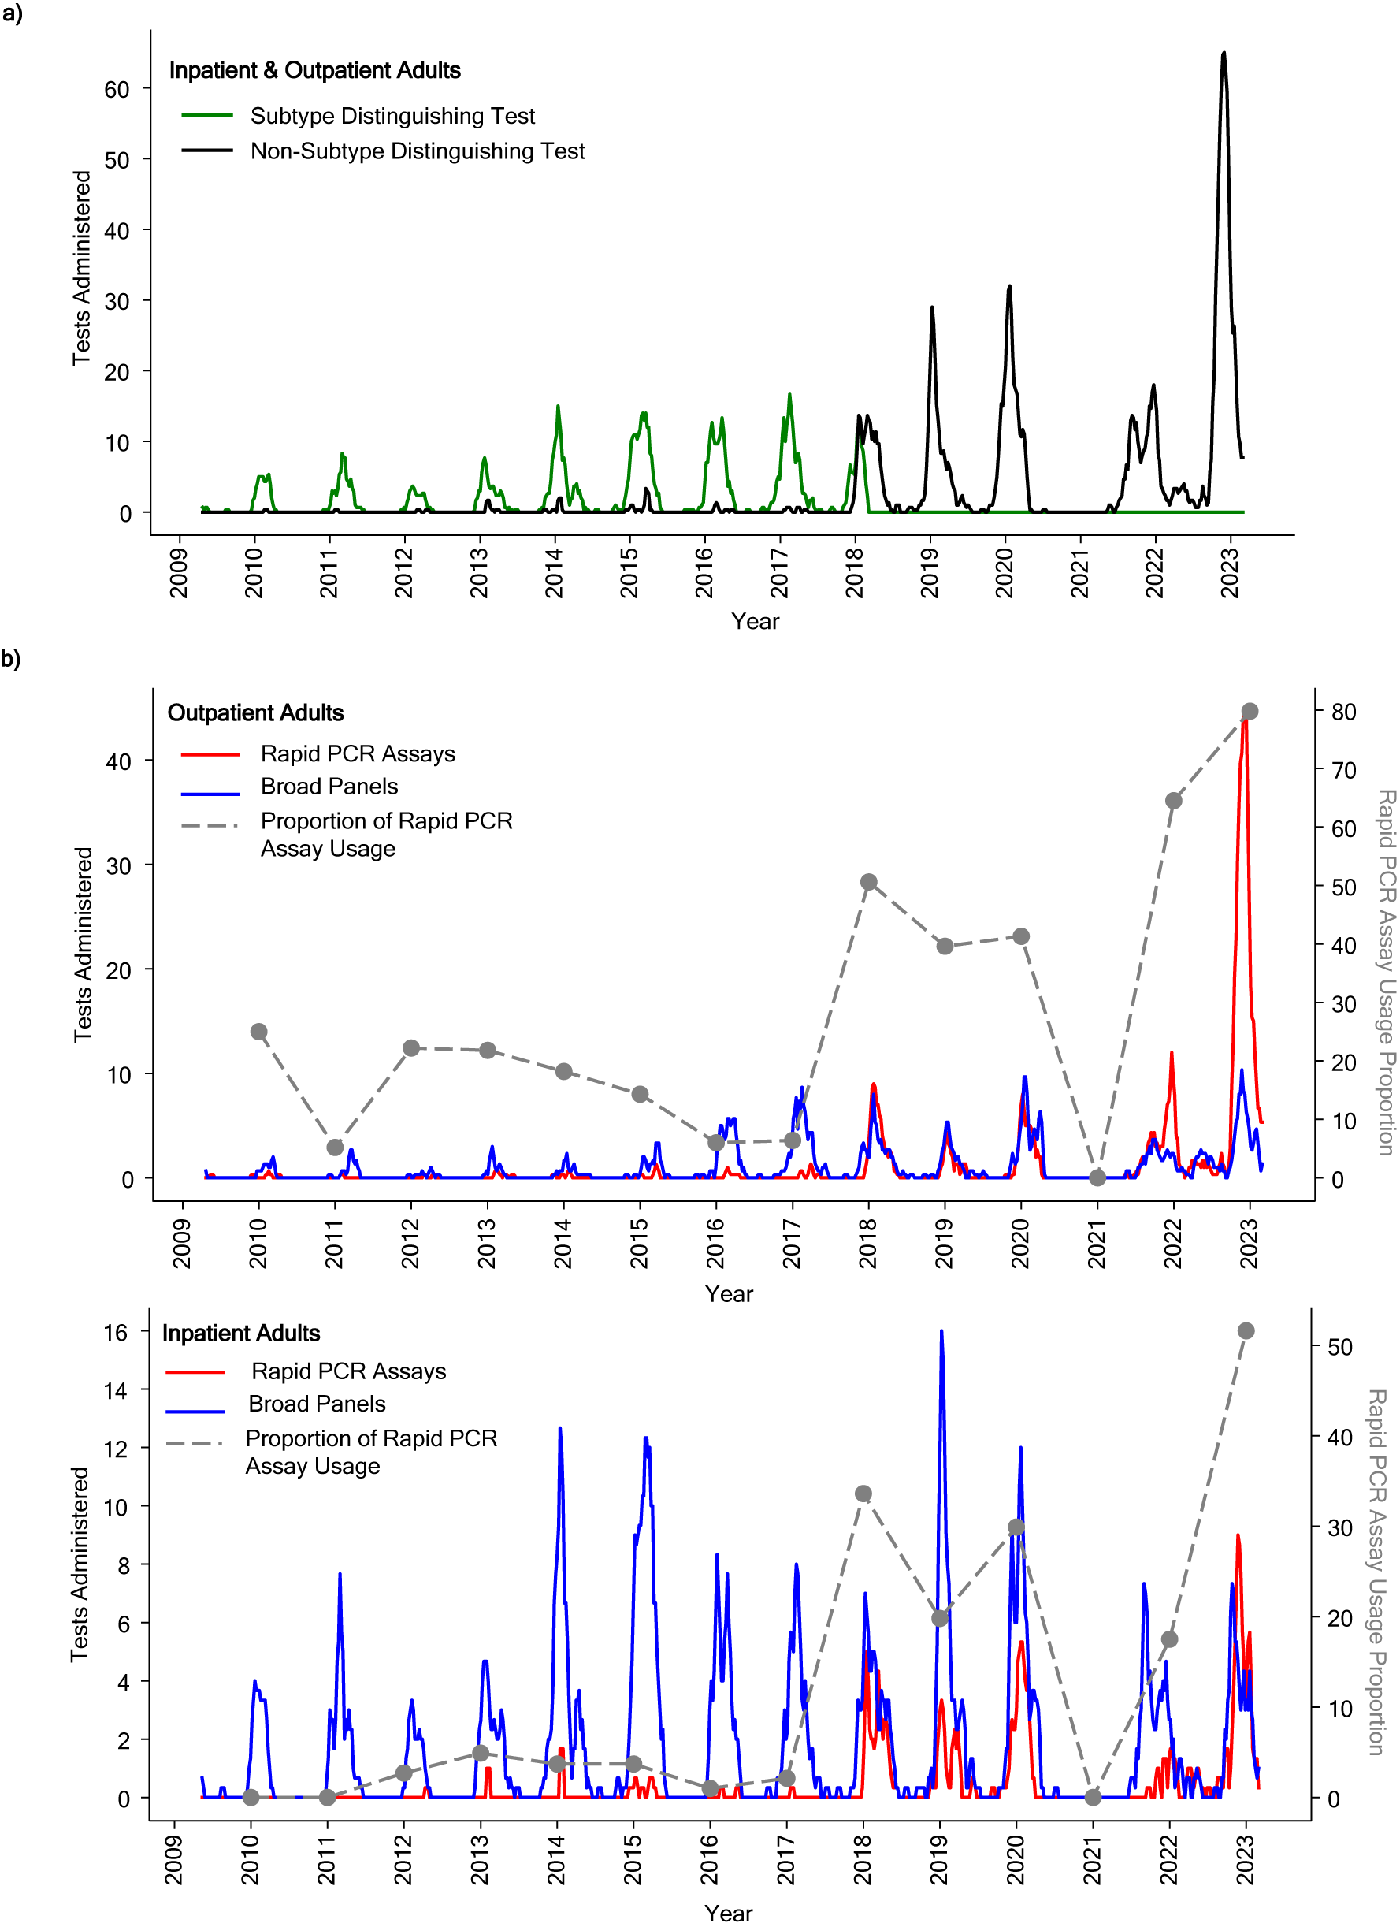
Supplementary Figure 3 | Shifts in Diagnostic Platform Use for Adult Inpatient and Outpatient Encounters from 2010 to 2023 a, Distribution of RSV subtype-distinguishing diagnostic tests as represented by a 3-week rolling average of tests with (green, RSV-A n = 451, RSV-B n = 657) or without (black, n = 2047) subtyping information. b, a 3-week rolling average of rapid (red) and broad panel (blue) tests administered in inpatient adults (top, n = 1567) and outpatient adults (bottom, n = 1644). Encounters with unknown diagnostic types or testing categories representative of less than 1% of the dataset (n = 205) were excluded. The proportion of rapid multiplex diagnostic use ( i.e. Multiplex Panel for Flu + RSV, Rapid Test for flu, RSV, and SARS-CoV-2) for each season is also shown (gray). All inpatient and outpatient encounters for a) and b) are sampled between April 8^{th,} 2009 to March 1^{st,} 2023

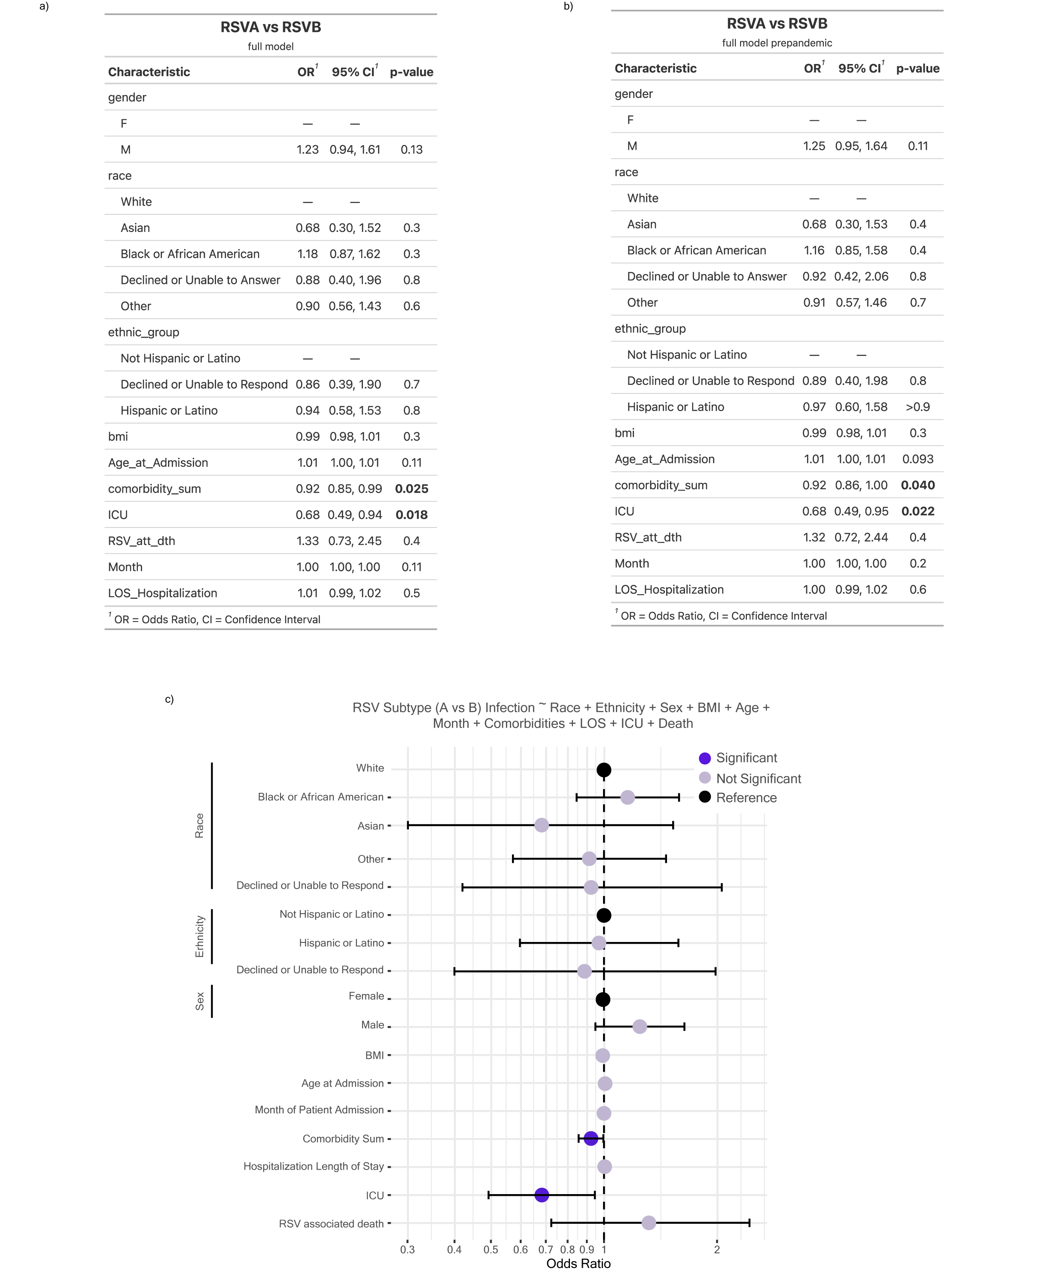

Supplementary Figure 4 | Modeling Inpatient Outcome by RSV Subtype. a, Parameters incorporated in the multivariable logistic regression to model RSV subtype infection among adult inpatients (n = 942). b, Parameters incorporated in the multivariable logistic regression to model RSV infection in adult inpatients, excluding the 2020-2021 season and beyond.c, Odds ratio plot with 95% confidence intervals (CI) as calculated by a multivariable logistic regression model with RSV-A (reference) or RSV-B infection as the outcome variable in adult inpatients, excluding the 2020-2021 season and beyond. Significant features (p-value < 0.05) are highlighted in dark purple, insignificant features (p-value >= 0.05) are shown in light purple, and reference categories for categorical variables are shown in black.

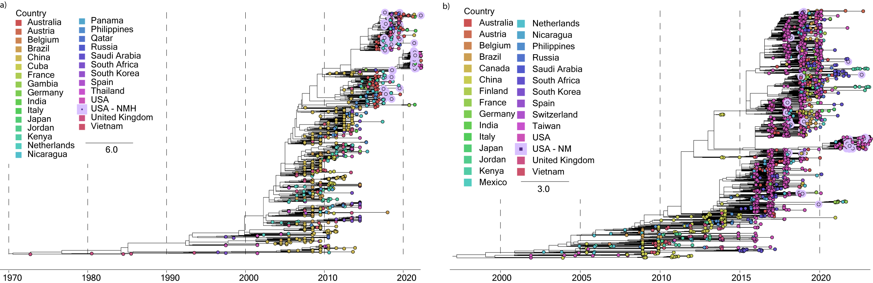

Supplementary Figure 5 | Temporal Analysis of RSV-B F and G. a, Maximum likelihood (ML) phylogenetic temporal tree of unique circulating RSV-B complete G sequence collected from 1976 to 2023 as of October 2023 (n = 983). b, ML phylogenetic temporal tree of unique circulating RSV-B complete F sequences collected from 1997 to 2023 as of October 2023 (n= 2067). Branch tips are colored by country of origin, and scale units are substitutions/site/year.

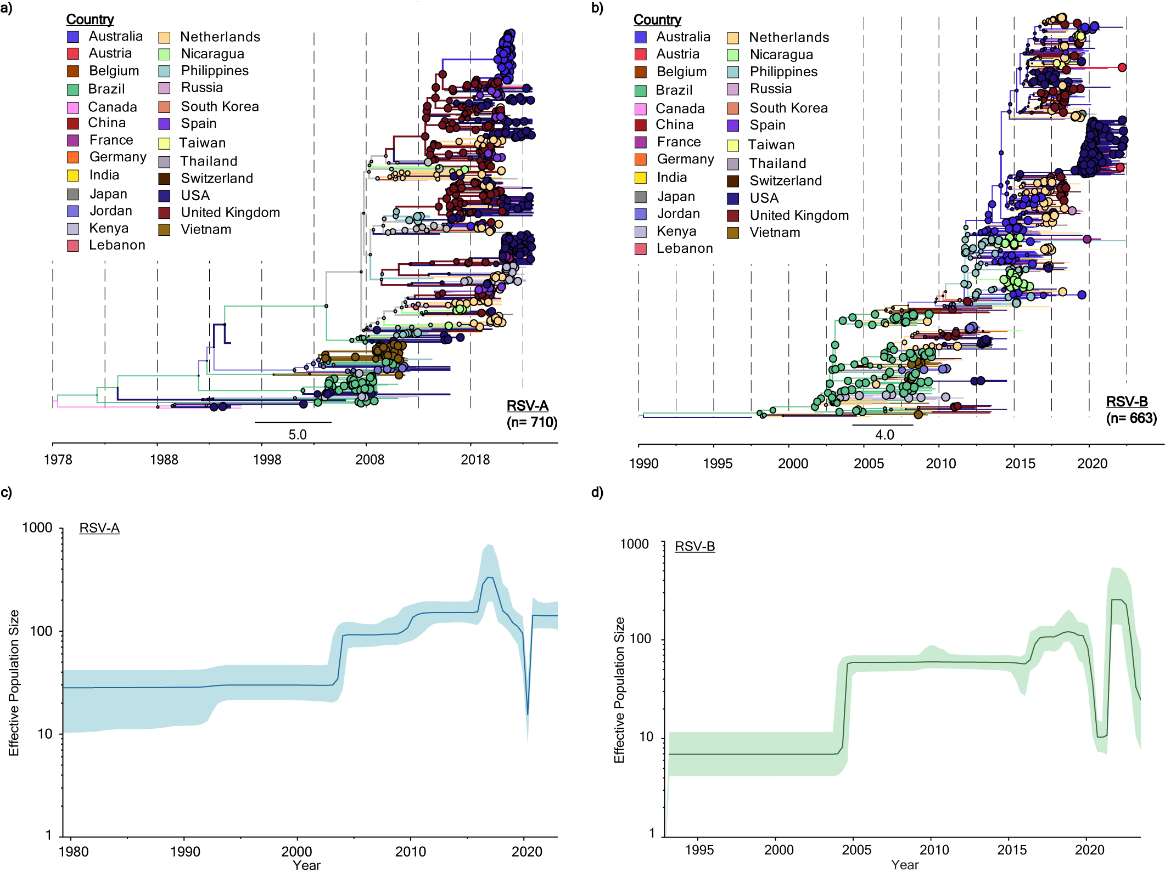
Supplementary Figure 6 | Global Phylogenetic Analysis of RSV-A and RSV-B. Bayesian phylogenetic temporal tree of circulating a, RSV-A (excluding clade’s A.2, A.1.1, & A.2.1.1) (n = 710) and b, all RSV-B (n = 663) complete genome sequences as of May 2023. Each phylogenetic tree corresponds to the maximum clade credibility tree by depicting branch color by the most probable geographical location (i.e. country) of their descendent node. Node circle size corresponds to the probability of probable geographical location defining the nod. c, RSV-A and d, RSV-B population dynamics using Bayesian skyline analyses to show effective population size with respect to time. Shadings in each plot represent the 95% highest posterior density (HPD)

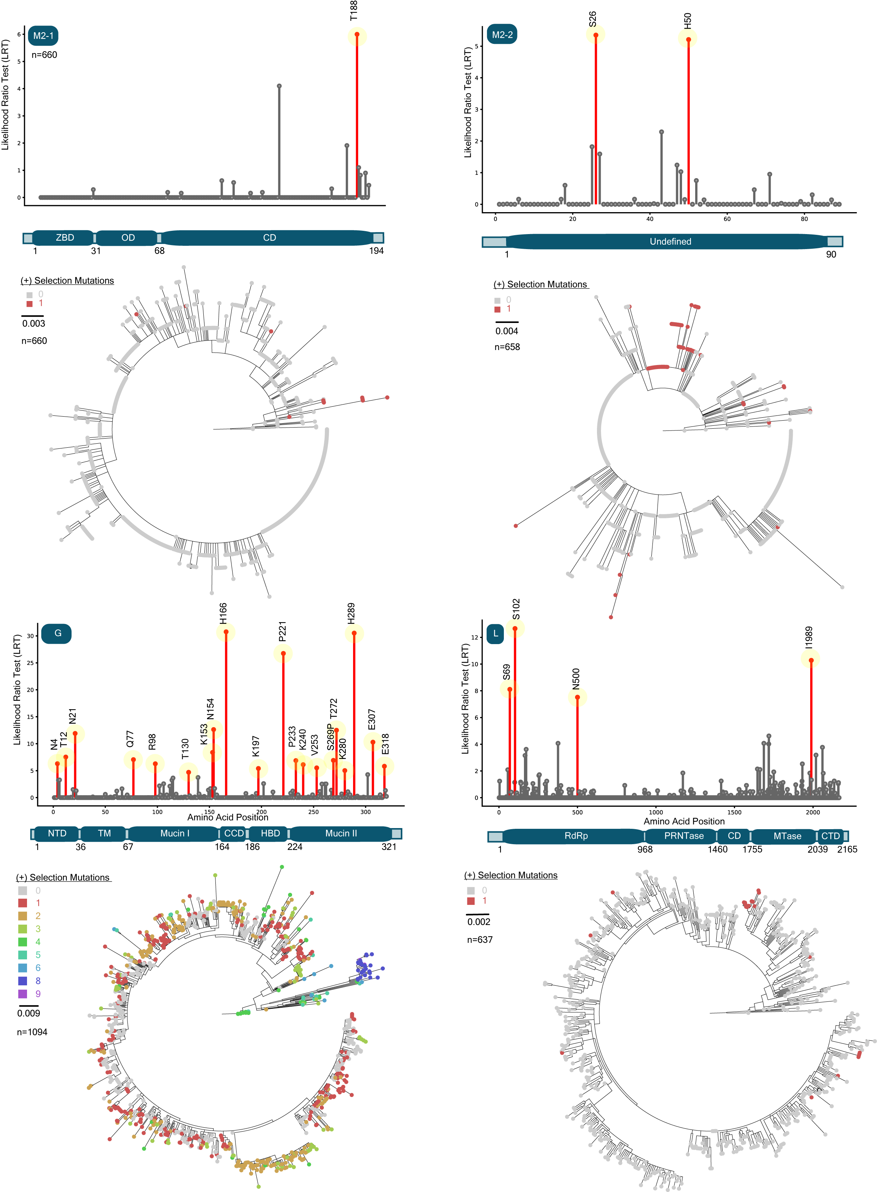
Supplementary Figure 7 | Positive Selection of RSV-B ORFs. Lollipop plots (top) for unique RSV-B open reading frames (ORFs) sequences with statistically significant sites of positive selection. Amino acid positions with statistically significant likelihood ratio test (LRT) (p-value < 0.05) indicating episodic selection by a mixed effects model of evolution (MEME) are colored in red and annotated using a generated most recent common ancestor (MRCA). Nonsignificant LRT and posterior probability are in gray. Maximum likelihood (ML) genetic diversity trees (bottom) for ORFs depicted in lollipop plots to display the isolates that contain mutations at positive selection sites. Branch tips are colored by the number of mutations present at positively selected sites. The ORF sequences used are globally sampled from 1957 to 2023 for a, M2-1 (n = 660), b, M2-2 (n. = 658), c, G (n = 1094), and d, L (n = 637).

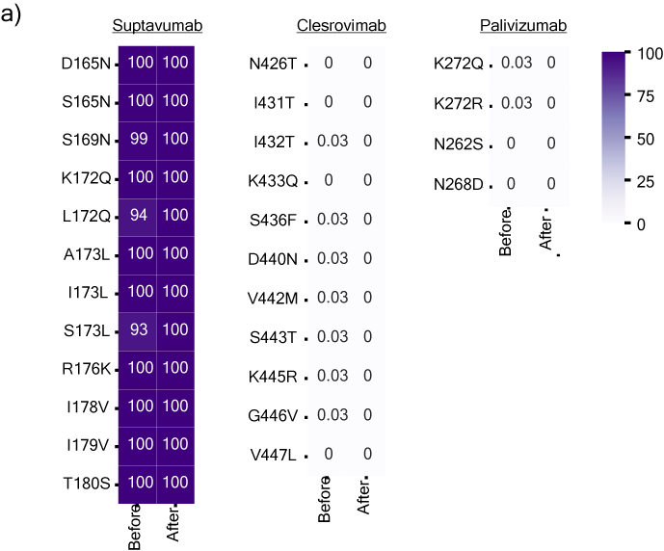
Supplementary Figure 8 | Globally Circulating RSV-B Mutations in Fusion Protein on Mab Binding Site a, Heatmap displaying mutational frequencies at positions within the Suptavumab, Clesrovimab, and Palivizumab binding site before and after May 1, 2020, as compared to generated most-recent-common ancestor (MRCA).

NCBI ID | Nextclade clade | Genotype
RSV-A/human/USA/IL-NM-RSV012/2019 | A.D.1 | GA2.3.5
RSV-A/human/USA/IL-NM-RSV013/2019 | A.D.1 | GA2.3.5
RSV-A/human/USA/IL-NM-RSV016/2019 | A.D.1 | GA2.3.5
RSV-A/human/USA/IL-NM-RSV026/2018 | A.D.1 | GA2.3.5
RSV-A/human/USA/IL-NM-RSV044/2019 | A.D.2.3 | GA2.3.5
RSV-A/human/USA/IL-NM-RSV045/2019 | A.D.1 | GA2.3.5
RSV-A/human/USA/IL-NM-RSV046/2019 | A.D.2.2 | GA2.3.5
RSV-A/human/USA/IL-NM-RSV066/2019 | A.D.1 | GA2.3.5
RSV-A/human/USA/IL-NM-RSV069/2019 | A.D.3 | GA2.3.5
RSV-A/human/USA/IL-NM-RSV078/2018 | A.D.4 | GA2.3.5
RSV-A/human/USA/IL-NM-RSV088/2018 | A.D.3 | GA2.3.5
RSV-A/human/USA/IL-NM-RSV091/2018 | A.D.1 | GA2.3.5
RSV-A/human/USA/IL-NM-RSV094/2019 | A.D.1 | GA2.3.5
RSV-A/human/USA/IL-NM-RSV095/2019 | A.D.2.2 | GA2.3.5
RSV-A/human/USA/IL-NM-RSV103/2019 | A.D.3 | GA2.3.5
RSV-A/human/USA/IL-NM-RSV108/2018 | A.D | GA2.3.5
RSV-A/human/USA/IL-NM-RSV110/2019 | A.D.1 | GA2.3.5
RSV-A/human/USA/IL-NM-RSV124/2019 | A.D.1 | GA2.3.5
RSV-A/human/USA/IL-NM-RSV128/2019 | A.D.4 | GA2.3.5
RSV-A/human/USA/IL-NM-RSV130/2019 | A.D.1 | GA2.3.5
RSV-A/human/USA/IL-NM-RSV148/2019 | A.D.2.3 | GA2.3.5
RSV-A/human/USA/IL-NM-RSV159/2019 | A.D.2.3 | GA2.3.5
RSV-A/human/USA/IL-NM-RSV162/2019 | A.D.4 | GA2.3.5
RSV-A/human/USA/IL-NM-RSV175/2018 | A.D.1 | GA2.3.5
RSV-A/human/USA/IL-NM-RSV180/2018 | A.D.4 | GA2.3.5
RSV-A/human/USA/IL-NM-RSV181/2018 | A.D.1 | GA2.3.5
RSV-A/human/USA/IL-NM-RSV182/2018 | A.D.2.2 | GA2.3.5
RSV-A/human/USA/IL-NM-RSV187/2018 | A.D.1 | GA2.3.5
RSV-A/human/USA/IL-NM-RSV188/2018 | A.D.1 | GA2.3.5
RSV-A/human/USA/IL-NM-RSV194/2019 | A.D.3 | GA2.3.5
RSV-A/human/USA/IL-NM-RSV200/2019 | A.D | GA2.3.5
RSV-A/human/USA/IL-NM-RSV207/2020 | A.D.1 | GA2.3.5
RSV-A/human/USA/IL-NM-RSV209/2020 | A.D.1 | GA2.3.5
RSV-A/human/USA/IL-NM-RSV210/2020 | A.D.1 | GA2.3.5
RSV-A/human/USA/IL-NM-RSV215/2020 | A.D.3 | GA2.3.5
RSV-A/human/USA/IL-NM-RSV216/2020 | A.D.3 | GA2.3.5
RSV-A/human/USA/IL-NM-RSV218/2019 | A.D.1 | GA2.3.5
RSV-A/human/USA/IL-NM-RSV224/2020 | A.D.1 | GA2.3.5
RSV-A/human/USA/IL-NM-RSV228/2020 | A.D.2 | GA2.3.5
RSV-A/human/USA/IL-NM-RSV231/2020 | A.D.5 | GA2.3.5
RSV-A/human/USA/IL-NM-RSV241/2019 | A.D.1 | GA2.3.5
RSV-A/human/USA/IL-NM-RSV294/2018 | A.D.5 | GA2.3.5
RSV-A/human/USA/IL-NM-RSV300/2019 | A.D.2.2 | GA2.3.5
RSV-A/human/USA/IL-NM-RSV302/2019 | A.D.1 | GA2.3.5
RSV-A/human/USA/IL-NM-RSV336/2021 | A.D.3 | GA2.3.5
RSV-A/human/USA/IL-NM-RSV378/2021 | A.D.1 | GA2.3.5
RSV-A/human/USA/IL-NM-RSV403/2022 | A.D.1 | GA2.3.5
RSV-A/human/USA/IL-NM-RSV404/2022 | A.D.1 | GA2.3.5
RSV-A/human/USA/IL-NM-RSV408/2022 | A.D.1 | GA2.3.5
RSV-A/human/USA/IL-NM-RSV409/2022 | A.D.5.2 | GA2.3.5
RSV-A/human/USA/IL-NM-RSV410/2022 | A.D.5.1 | GA2.3.5
RSV-A/human/USA/IL-NM-RSV411/2022 | A.D.1 | GA2.3.5
RSV-A/human/USA/IL-NM-RSV414/2022 | A.D.5.2 | GA2.3.5
RSV-A/human/USA/IL-NM-RSV415/2022 | A.D.5.2 | GA2.3.5
RSV-A/human/USA/IL-NM-RSV416/2022 | A.D.1 | GA2.3.5
RSV-A/human/USA/IL-NM-RSV417/2022 | A.D.3 | GA2.3.5
RSV-A/human/USA/IL-NM-RSV418/2022 | A.D.5.2 | GA2.3.5
RSV-A/human/USA/IL-NM-RSV421/2022 | A.D.5.2 | GA2.3.5
RSV-A/human/USA/IL-NM-RSV422/2022 | A.D.3 | GA2.3.5
RSV-A/human/USA/IL-NM-RSV424/2022 | A.D.1 | GA2.3.5
RSV-A/human/USA/IL-NM-RSV427/2022 | A.D.5.2 | GA2.3.5
RSV-A/human/USA/IL-NM-RSV428/2022 | A.D.1 | GA2.3.5
RSV-A/human/USA/IL-NM-RSV429/2022 | A.D.1 | GA2.3.5
RSV-A/human/USA/IL-NM-RSV430/2022 | A.D.1 | GA2.3.5
RSV-A/human/USA/IL-NM-RSV431/2022 | A.D.5.2 | GA2.3.5
RSV-A/human/USA/IL-NM-RSV434/2022 | A.D.1 | GA2.3.5
RSV-A/human/USA/IL-NM-RSV435/2022 | A.D.1 | GA2.3.5
RSV-A/human/USA/IL-NM-RSV441/2022 | A.D.3 | GA2.3.5
RSV-A/human/USA/IL-NM-RSV443/2022 | A.D.1 | GA2.3.5
RSV-A/human/USA/IL-NM-RSV447/2022 | A.D.5.2 | GA2.3.5
RSV-A/human/USA/IL-NM-RSV448/2022 | A.D.1 | GA2.3.5
RSV-A/human/USA/IL-NM-RSV451/2022 | A.D.1 | GA2.3.5
RSV-A/human/USA/IL-NM-RSV452/2022 | A.D.1 | GA2.3.5
RSV-A/human/USA/IL-NM-RSV454/2022 | A.D.1 | GA2.3.5
RSV-A/human/USA/IL-NM-RSV456/2022 | A.D.3 | GA2.3.5
RSV-A/human/USA/IL-NM-RSV457/2022 | A.D.1 | GA2.3.5
RSV-A/human/USA/IL-NM-RSV464/2022 | A.D.3 | GA2.3.5
RSV-A/human/USA/IL-NM-RSV465/2022 | A.D.1 | GA2.3.5
RSV-A/human/USA/IL-NM-RSV466/2022 | A.D.1 | GA2.3.5
RSV-A/human/USA/IL-NM-RSV468/2022 | A.D.5.1 | GA2.3.5
RSV-A/human/USA/IL-NM-RSV471/2022 | A.D.5.2 | GA2.3.5
RSV-A/human/USA/IL-NM-RSV475/2022 | A.D.5.2 | GA2.3.5
RSV-A/human/USA/IL-NM-RSV480/2022 | A.D.1 | GA2.3.5
RSV-A/human/USA/IL-NM-RSV483/2022 | A.D.1 | GA2.3.5
RSV-A/human/USA/IL-NM-RSV484/2022 | A.D.3 | GA2.3.5
RSV-A/human/USA/IL-NM-RSV485/2022 | A.D.3 | GA2.3.5
RSV-A/human/USA/IL-NM-RSV486/2022 | A.D.5.2 | GA2.3.5
RSV-A/human/USA/IL-NM-RSV489/2022 | A.D.5.2 | GA2.3.5
RSV-A/human/USA/IL-NM-RSV490/2022 | A.D.3.1 | GA2.3.5
RSV-A/human/USA/IL-NM-RSV494/2022 | A.D.1 | GA2.3.5
RSV-A/human/USA/IL-NM-RSV495/2022 | A.D.1 | GA2.3.5
RSV-A/human/USA/IL-NM-RSV501/2022 | A.D.5.2 | GA2.3.5
RSV-A/human/USA/IL-NM-RSV504/2022 | A.D.3 | GA2.3.5
RSV-A/human/USA/IL-NM-RSV505/2022 | A.D.5.2 | GA2.3.5
RSV-A/human/USA/IL-NM-RSV508/2022 | A.D.5.2 | GA2.3.5
RSV-A/human/USA/IL-NM-RSV511/2022 | A.D.5.2 | GA2.3.5
RSV-A/human/USA/IL-NM-RSV513/2022 | A.D.1 | GA2.3.5
RSV-A/human/USA/IL-NM-RSV515/2022 | A.D.1 | GA2.3.5
RSV-A/human/USA/IL-NM-RSV518/2022 | A.D.1 | GA2.3.5
RSV-A/human/USA/IL-NM-RSV524/2022 | A.D.3 | GA2.3.5
RSV-A/human/USA/IL-NM-RSV527/2022 | A.D.3 | GA2.3.5
RSV-A/human/USA/IL-NM-RSV528/2022 | A.D.5.2 | GA2.3.5
RSV-A/human/USA/IL-NM-RSV538/2022 | A.D.3 | GA2.3.5
RSV-A/human/USA/IL-NM-RSV541/2022 | A.D.5.2 | GA2.3.5
RSV-A/human/USA/IL-NM-RSV542/2022 | A.D.1 | GA2.3.5
RSV-A/human/USA/IL-NM-RSV545/2022 | A.D.3 | GA2.3.5
RSV-A/human/USA/IL-NM-RSV547/2022 | A.D.3 | GA2.3.5
RSV-A/human/USA/IL-NM-RSV548/2022 | A.D.5.2 | GA2.3.5
RSV-B/human/USA/IL-NM-RSV015/2018 | B.D.5.2.1 | GB5.0.5a
RSV-B/human/USA/IL-NM-RSV021/2019 | B.D.5.2.1 | GB5.0.5a
RSV-B/human/USA/IL-NM-RSV024/2018 | B.D.5.2.1 | GB5.0.5a
RSV-B/human/USA/IL-NM-RSV039/2018 | B.D.5.2.1 | GB5.0.5a
RSV-B/human/USA/IL-NM-RSV053/2018 | B.D.5.2 | GB5.0.5a
RSV-B/human/USA/IL-NM-RSV055/2019 | B.D.5.2.1 | GB5.0.5a
RSV-B/human/USA/IL-NM-RSV067/2019 | B.D.5.2 | GB5.0.5a
RSV-B/human/USA/IL-NM-RSV081/2019 | B.D.5.2 | GB5.0.5a
RSV-B/human/USA/IL-NM-RSV085/2018 | B.D.5.2.1 | GB5.0.5a
RSV-B/human/USA/IL-NM-RSV106/2017 | B.D.5.2 | GB5.0.5a
RSV-B/human/USA/IL-NM-RSV109/2018 | B.D.5.2.1 | GB5.0.5a
RSV-B/human/USA/IL-NM-RSV111/2017 | B.D.5.2.1 | GB5.0.5a
RSV-B/human/USA/IL-NM-RSV112/2018 | B.D.5.2.1 | GB5.0.5a
RSV-B/human/USA/IL-NM-RSV113/2018 | B.D.5.2.1 | GB5.0.5a
RSV-B/human/USA/IL-NM-RSV115/2017 | B.D.5.2.1 | GB5.0.5a
RSV-B/human/USA/IL-NM-RSV127/2018 | B.D.5.2.1 | GB5.0.5a
RSV-B/human/USA/IL-NM-RSV137/2018 | B.D.5.2.1 | GB5.0.5a
RSV-B/human/USA/IL-NM-RSV140/2018 | B.D.5.2.1 | GB5.0.5a
RSV-B/human/USA/IL-NM-RSV141/2018 | B.D.5.2 | GB5.0.5a
RSV-B/human/USA/IL-NM-RSV142/2019 | B.D.5.2.1 | GB5.0.5a
RSV-B/human/USA/IL-NM-RSV143/2018 | B.D.5.2.1 | GB5.0.5a
RSV-B/human/USA/IL-NM-RSV145/2018 | B.D.5.2.1 | GB5.0.5a
RSV-B/human/USA/IL-NM-RSV149/2019 | B.D.5.2.1 | GB5.0.5a
RSV-B/human/USA/IL-NM-RSV152/2019 | B.D.5.2.1 | GB5.0.5a
RSV-B/human/USA/IL-NM-RSV163/2018 | B.D.5.2 | GB5.0.5a
RSV-B/human/USA/IL-NM-RSV164/2019 | B.D.5.2.1 | GB5.0.5a
RSV-B/human/USA/IL-NM-RSV168/2018 | B.D.5.2.1 | GB5.0.5a
RSV-B/human/USA/IL-NM-RSV171/2018 | B.D.5.2.1 | GB5.0.5a
RSV-B/human/USA/IL-NM-RSV177/2018 | B.D.5.2.1 | GB5.0.5a
RSV-B/human/USA/IL-NM-RSV185/2018 | B.D.5.2 | GB5.0.5a
RSV-B/human/USA/IL-NM-RSV190/2018 | B.D.5.2.1 | GB5.0.5a
RSV-B/human/USA/IL-NM-RSV203/2020 | B.D.5.2.1 | GB5.0.5a
RSV-B/human/USA/IL-NM-RSV208/2020 | B.D.5.2.1 | GB5.0.5a
RSV-B/human/USA/IL-NM-RSV214/2019 | B.D.5.2.1 | GB5.0.5a
RSV-B/human/USA/IL-NM-RSV222/2020 | B.D.5.2 | GB5.0.5a
RSV-B/human/USA/IL-NM-RSV235/2020 | B.D.5.2.1 | GB5.0.5a
RSV-B/human/USA/IL-NM-RSV246/2019 | B.D.5.2.1 | GB5.0.5a
RSV-B/human/USA/IL-NM-RSV247/2018 | B.D.5.2.1 | GB5.0.5a
RSV-B/human/USA/IL-NM-RSV250/2020 | B.D.5.2.1 | GB5.0.5a
RSV-B/human/USA/IL-NM-RSV252/2020 | B.D.5.2.1 | GB5.0.5a
RSV-B/human/USA/IL-NM-RSV253/2019 | B.D.5.2.1 | GB5.0.5a
RSV-B/human/USA/IL-NM-RSV255/2019 | B.D.5.2.1 | GB5.0.5a
RSV-B/human/USA/IL-NM-RSV256/2020 | B.D.5.2.1 | GB5.0.5a
RSV-B/human/USA/IL-NM-RSV260/2018 | B.D.5.2.1 | GB5.0.5a
RSV-B/human/USA/IL-NM-RSV267/2019 | B.D.5.2.1 | GB5.0.5a
RSV-B/human/USA/IL-NM-RSV272/2019 | B.D.5.2.1 | GB5.0.5a
RSV-B/human/USA/IL-NM-RSV280/2018 | B.D.5.2.1 | GB5.0.5a
RSV-B/human/USA/IL-NM-RSV292/2018 | B.D.5.2.1 | GB5.0.5a
RSV-B/human/USA/IL-NM-RSV296/2018 | B.D.5.2.1 | GB5.0.5a
RSV-B/human/USA/IL-NM-RSV298/2019 | B.D.5.2.1 | GB5.0.5a
RSV-B/human/USA/IL-NM-RSV299/2018 | B.D.5.2 | GB5.0.5a
RSV-B/human/USA/IL-NM-RSV303/2018 | B.D.5.2.1 | GB5.0.5a
RSV-B/human/USA/IL-NM-RSV310/2018 | B.D.5.2.1 | GB5.0.5a
RSV-B/human/USA/IL-NM-RSV311/2019 | B.D.5.2.1 | GB5.0.5a
RSV-B/human/USA/IL-NM-RSV313/2021 | B.D.5.2.1.1 | GB5.0.5a
RSV-B/human/USA/IL-NM-RSV314/2021 | B.D.5.2.1.1 | GB5.0.5a
RSV-B/human/USA/IL-NM-RSV316/2021 | B.D.5.2.1.1 | GB5.0.5a
RSV-B/human/USA/IL-NM-RSV317/2021 | B.D.5.2.1.1 | GB5.0.5a
RSV-B/human/USA/IL-NM-RSV320/2021 | B.D.5.2.1.1 | GB5.0.5a
RSV-B/human/USA/IL-NM-RSV321/2021 | B.D.5.2.1.1 | GB5.0.5a
RSV-B/human/USA/IL-NM-RSV323/2021 | B.D.5.2.1.1 | GB5.0.5a
RSV-B/human/USA/IL-NM-RSV324/2021 | B.D.5.2.1.1 | GB5.0.5a
RSV-B/human/USA/IL-NM-RSV326/2021 | B.D.5.2.1.1 | GB5.0.5a
RSV-B/human/USA/IL-NM-RSV327/2021 | B.D.5.2.1.1 | GB5.0.5a
RSV-B/human/USA/IL-NM-RSV329/2021 | B.D.5.2.1.1 | GB5.0.5a
RSV-B/human/USA/IL-NM-RSV333/2021 | B.D.5.2.1.1 | GB5.0.5a
RSV-B/human/USA/IL-NM-RSV335/2021 | B.D.5.2.1.1 | GB5.0.5a
RSV-B/human/USA/IL-NM-RSV337/2021 | B.D.5.2.1.1 | GB5.0.5a
RSV-B/human/USA/IL-NM-RSV340/2021 | B.D.5.2.1 | GB5.0.5a
RSV-B/human/USA/IL-NM-RSV341/2021 | B.D.5.2.1.1 | GB5.0.5a
RSV-B/human/USA/IL-NM-RSV342/2021 | B.D.5.2.1.1 | GB5.0.5a
RSV-B/human/USA/IL-NM-RSV345/2021 | B.D.5.2.1.1 | GB5.0.5a
RSV-B/human/USA/IL-NM-RSV347/2021 | B.D.5.2.1.1 | GB5.0.5a
RSV-B/human/USA/IL-NM-RSV348/2022 | B.D.5.2.1.1 | GB5.0.5a
RSV-B/human/USA/IL-NM-RSV351/2021 | B.D.5.2.1.1 | GB5.0.5a
RSV-B/human/USA/IL-NM-RSV353/2021 | B.D.5.2.1.1 | GB5.0.5a
RSV-B/human/USA/IL-NM-RSV355/2021 | B.D.5.2.1.1 | GB5.0.5a
RSV-B/human/USA/IL-NM-RSV356/2021 | B.D.5.2.1.1 | GB5.0.5a
RSV-B/human/USA/IL-NM-RSV357/2021 | B.D.5.2.1.1 | GB5.0.5a
RSV-B/human/USA/IL-NM-RSV358/2021 | B.D.5.2.1.1 | GB5.0.5a
RSV-B/human/USA/IL-NM-RSV361/2021 | B.D.5.2.1.1 | GB5.0.5a
RSV-B/human/USA/IL-NM-RSV366/2021 | B.D.5.2.1.1 | GB5.0.5a
RSV-B/human/USA/IL-NM-RSV368/2021 | B.D.5.2.1.1 | GB5.0.5a
RSV-B/human/USA/IL-NM-RSV370/2021 | B.D.5.2.1.1 | GB5.0.5a
RSV-B/human/USA/IL-NM-RSV373/2021 | B.D.5.2.1.1 | GB5.0.5a
RSV-B/human/USA/IL-NM-RSV374/2021 | B.D.5.2.1.1 | GB5.0.5a
RSV-B/human/USA/IL-NM-RSV375/2021 | B.D.5.2.1.1 | GB5.0.5a
RSV-B/human/USA/IL-NM-RSV379/2021 | B.D.5.2.1.1 | GB5.0.5a
RSV-B/human/USA/IL-NM-RSV381/2021 | B.D.5.2.1.1 | GB5.0.5a
RSV-B/human/USA/IL-NM-RSV382/2022 | B.D.5.2.1.1 | GB5.0.5a
RSV-B/human/USA/IL-NM-RSV383/2021 | B.D.5.2.1.1 | GB5.0.5a
RSV-B/human/USA/IL-NM-RSV385/2021 | B.D.5.2.1.1 | GB5.0.5a
RSV-B/human/USA/IL-NM-RSV387/2021 | B.D.5.2.1.1 | GB5.0.5a
RSV-B/human/USA/IL-NM-RSV389/2021 | B.D.5.2.1.1 | GB5.0.5a
RSV-B/human/USA/IL-NM-RSV394/2021 | B.D.5.2.1.1 | GB5.0.5a
RSV-B/human/USA/IL-NM-RSV400/2022 | B.D.5.2.1.1 | GB5.0.5a
RSV-B/human/USA/IL-NM-RSV401/2022 | B.D.5.2.1.1 | GB5.0.5a
RSV-B/human/USA/IL-NM-RSV446/2022 | B.D.5.2.1.4 | GB5.0.5a
RSV-B/human/USA/IL-NM-RSV458/2022 | B.D.5.2.1.1 | GB5.0.5a
RSV-B/human/USA/IL-NM-RSV463/2022 | B.D.5.2.1.1 | GB5.0.5a
RSV-B/human/USA/IL-NM-RSV476/2022 | B.D.5.2.1.1 | GB5.0.5a
RSV-B/human/USA/IL-NM-RSV509/2022 | B.D.5.2.1.1 | GB5.0.5a
RSV-B/human/USA/IL-NM-RSV520/2022 | B.D.5.2.1.1 | GB5.0.5a
RSV-B/human/USA/IL-NM-RSV525/2022 | B.D.5.2.1.1 | GB5.0.5a
RSV-B/human/USA/IL-NM-RSV536/2022 | B.D.5.2.1.1 | GB5.0.5a
RSV-B/human/USA/IL-NM-RSV537/2022 | B.D.5.2.1.1 | GB5.0.5a
RSV-B/human/USA/IL-NM-RSV551/2022 | B.D.5.2.1.1 | GB5.0.5a

Supplementary Table 1 | NCBI Accession ID numbers for deposited RSV whole genome sequences.

