Establishment of a real-time recombinase-aided isothermal amplification (RT-RAA) assay for the rapid detection of bovine respiratory syncytial virus
Guanxin Hou¹, Xinyi Sun¹, Rui An¹, Chunxiao Zhang¹, Lili Wang¹, Hong Li¹ , Siping Zhu¹, Quimei Shi¹, Zhiqiang Zhang^{1*}
1 Hebei key laboratory of preventive veterinary medicine, Hebei Normal University of Science &Technology, Qinhuangdao, Hebei, China.
*Corresponding author: E-mail: zhangzhiqiang87@hevttc.edu.cn
Contributing author: hgx3430858@163.com

supplementary material
Screening Primers
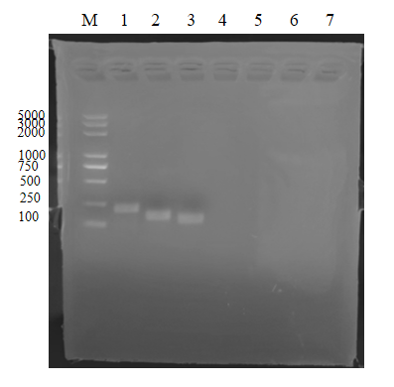
A

Figure 1(A): Screening of BRSV RT-RAA primer pairs targeting F gene (numbers 1-3 correspond to BRSVF1/R1, BRSVF2/R2, and BRSVF3/R3). The assay was incubated at 39°C for 30 minutes. reaction products were detected by 1% (W/V) agarose gel electrophoresis (AGE).

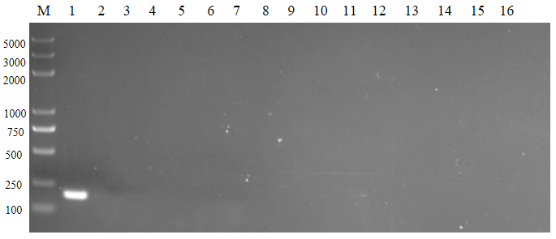
B

Figure 1(B): Results of the initial screening of BRSV basic RT-RAA primer pairs. The primer pairs were selected BRSV F1/R1 and the templates were added (numbers 1-5 correspond to BRSV, BVDV, BPIV, IBRV, BCoV). The assay was incubated at 39°C for 30 minutes. reaction products were detected by 1% (W/V) agarose gel electrophoresis (AGE).

Optimization of Reaction System
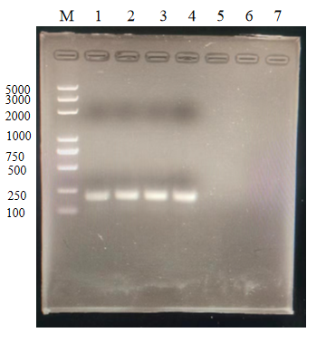
C

Figure 1(C): Results of optimal temperature screening for BRSV basal RT-RAA. Primer pair BRSV F1/R1 was selected for basal-type amplification using BRSV nucleic acid as the template with an incubation time of 30 minutes and different incubation temperatures(numbers 1-4 correspond to 37℃, 38℃, 39℃, and 40℃). Reaction products were detected by 1% (W/V) agarose gel electrophoresis (AGE).

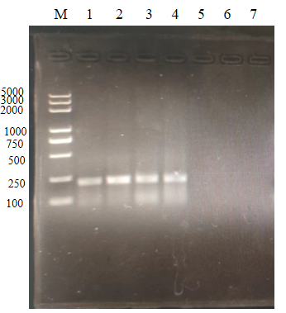
D

Figure 1(D): Results of optimal time screening for BRSV basal RT-RAA. Primer pair BRSV F1/R1 was selected for basal type amplification using BRSV nucleic acid as a template, The incubation temperature was 39℃, and the incubation time was different(numbers 1-4 correspond to 10min, 20min, 30min, and 40min). Reaction products were detected by 1% (W/V) agarose gel electrophoresis (AGE).

Sensitivity Test
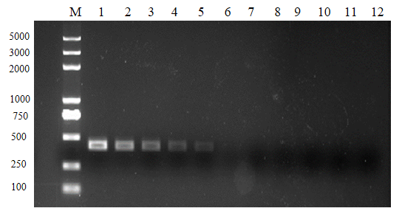

Figure 2(D): RNA standards ranging from 108 to 100 copies/μL were detected using conventional PCR.

