Supporting Information

A molecular T-pentomino for separating BTEX hydrocarbons

Christopher J. Hartwick, Eric W. Reinheimer, Leonard R. MacGillivray*
Department of Chemistry, University of Iowa, Iowa City, IA, 52242

Content:
S1. U-shaped bipyridine synthesis.
S2. Assembly formation.
S3. ¹H NMR spectra.
S4. X-ray powder pattern data.
S5. Molecular modeling.
S6. Thermogravimetric analysis.
S7. 12 possible pentominoes.
S8. Filling of a rectangle using 5 different tetraminoes.
S9. The four 1-isohedral tilings for a T-pentomino.
S10. The two 2-isohedral tilings for a T-pentomino.
S11. References.
S1. U-shaped bipyridine synthesis.
All materials were obtained from commercial sources and used as received unless indicated. Dibromonaphthalene and palladium bis-triphenylphosphine dichloride were purchased from A2B Chem. Catechol, 4-vinyl pyridine, dichloromethane (99%) toluene (99%), and triethylamine were all purchased from Sigma- Aldrich. Xylenes (95%) and ethylbenzene (99%) were purchased from Acros. Phenylboronic acid was purchased from Oakwood chemicals.

DEPN. Literature procedure was followed with changes: 1,8-dibromonaphthalene used instead of 1,8- diiodonaphthalene, Hermann’s catalyst used instead of reported palladium species. Yield: 60.3%, Amber-yellow crystals. ¹H NMR data agree with reported values.¹

S2. Assembly formation
DBP-DEPN
DEPN (0.9 mmols), phenyboronic acid (1.82 mmols), and catechol (1.82 mmols) are first ground with drops of dichloromethane/toluene (1:1 solution). The resulting powder was scraped from the grinding apparatus and placed into a 30 ml scintillation vial. The mortar-and-pestle were rinsed with another 4.0 ml (2 x 2.0 ml) of solution dropwise and ground to agitate any attached material, which was then added to the vial. The resulting suspension was heated until the powder had dissolved. Upon cooling, translucent bright yellow crystals appeared within 20 minutes in near quantitative yield. The resulting powder was oven dried at 80 ºC for a minimum of 4 hours. Use of dichloromethane is not necessary for crystallization to proceed, however it allows for ease of solids separation.
Crystallization Experiments
Aromatic guest free solid was grown in open air from dichloromethane, resulting in a single molecule inclusion species. For each crystallization with a BTEX hydrocarbon, a scintillation vial containing ground DBP-DEPN (0.06-0.08mmols) was filled with 2.0 ml of BTEX hydrocarbon, gently heated, and allow to cool to room temperature.
Competitive crystallization experiments were performed in the same manner as above but with increased DBP-DEPN (0.13-0.16 mmols). Crystallization of DBP-DEPN with a 1:1 w/w mixture of thiophene and benzene (2.0 ml) following heating resulted in crystals containing only benzene, as determined by ¹H NMR spectroscopy. PXRD data matched the host material. The procedure was repeated with both a 1:1 w/w mixture of ethylbenzene and styrene (2.0 ml) as well as a standard mixture (3.0 ml) of commercial xylenes (~2(m):1(p):1(o):1(EB)).
Additionally, competition between guests was undertaken with benzene, toluene, and ethylbenzene being mixed equal parts by mass (0.1mmols of each, equimolar ratio) with 1:1 ratios for competition between benzene and toluene, benzene and ethylbenzene, toluene and ethylbenzene, and a 1:1:1 ratio of the three together. Crystallizations occurred within 5 minutes after a 1:20 mass ratio of host to guest was added to the respective solution in a 30ml scintillation vial and gently heated to ensure dissolution. The crystalline product was removed, and excess solution was allowed to evaporate for 20 minutes.

Aromatic Guest-Free (CH₂Cl₂ solvate)
¹H NMR (400 MHz, CDCl₃) δ 8.56 (d, J = 5.5 Hz, 4H, H_{f}), 8.15 (d, J= 4, 16Hz, 2 H, H_{h}), 7.99 (d, J = 7.4 Hz,4H,H_{j}), 7.75 – 7.73 (m, 4H,H_{c}), 7.72 (d, J = 3.3 Hz, 2H,H_{k}),7.49 (d, J = 5.5 Hz, 4H, H_{g}), 7.37 (m, J = 3.6 Hz, 4H, H_{d}), 6.98 (d, J= 4, 16Hz, 2 H, H_{h}), 6.88 – 6.87 (m, 2H, H_{e}), 6.86 (d, J = 2.0 Hz, 4H,H_{b}), 6.75 (d, J = 2.0 Hz, 4H,H_{a}), 5.36 (s,1H).
Solvate characterization performed using a Exeter Analytical CE-440 addressing carbon, hydrogen, and nitrogen. Analysis calculated for C₄₈H₃₆N₂O₄, C: 79.36 H:4.99 N:3.86. Found: C: 73.44 H: 4.77 N:2.83

Aromatic Guest-Free (Dried in oven)
¹H NMR (400 MHz, CDCl₃) δ 8.49 (d, J = 5.5 Hz, 4H, H_{f}), 8.16 (d, J= 4, 16Hz, 2 H, H_{h}), 7.89 (dd, 4H,H_{c}), 7.65 (d, 2H,H_{J}), 7.52 (t, 2H, H_{k}), 7.45 (m-overlapped, 4H, H_{d}), 7.43 (m-overlapped, 2H,H_{L} ), 7.41 (m-overlapped, 2H, H_{e}), 7.31 (d, J = 5.5 Hz, 4H, H_{g}), 7.17 (m, J = 1.9 Hz, 4H, H_{b}), 6.99 (m, J = 1.9 Hz, 4H, H_{a}), 6.92 (d, J= 4, 16Hz, 2 H, H_{i}).
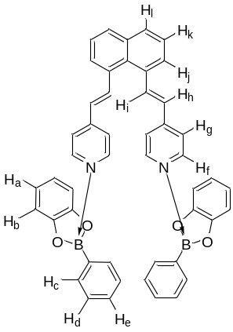

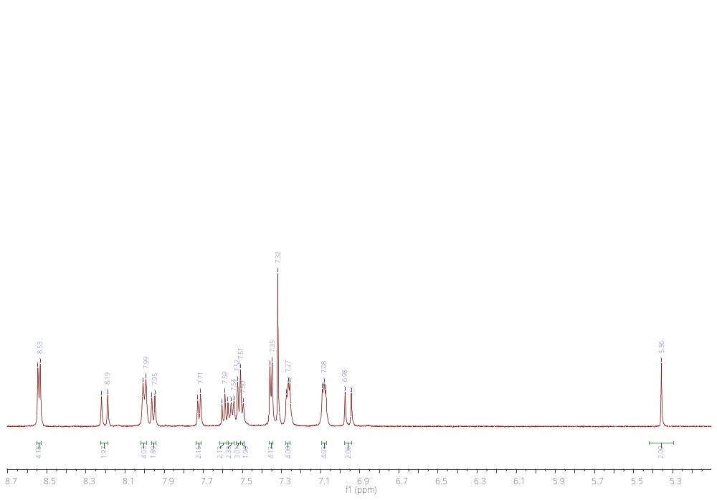
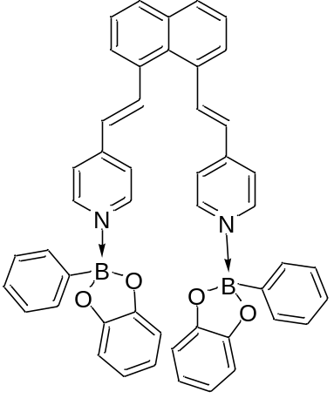S3. ¹H NMR spectra.

*

Figure S1. Assembly in CDCl₃, grown from CH₂Cl₂ (black, 1 included molecule, 5.36 ppm).

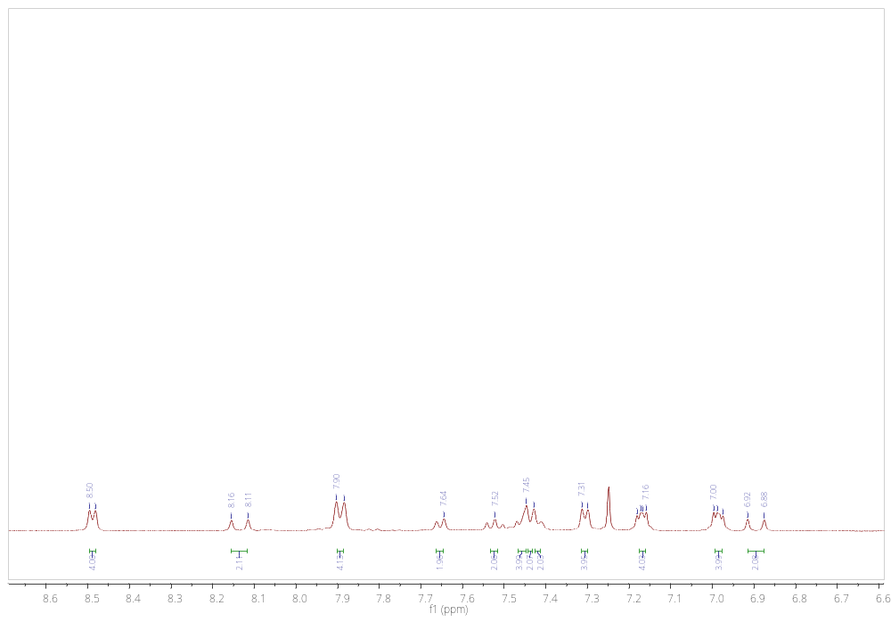
*

Figure S2. Assembly in CDCl₃. Solvent residue: chloroform (black).

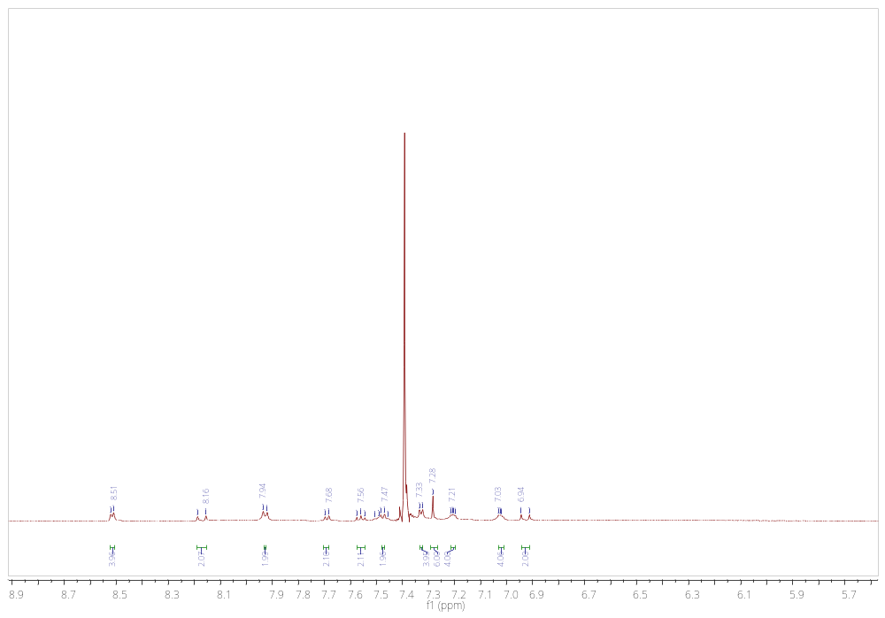
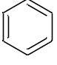
*

*

Figure S3. ¹HNMR spectrum of DBP-DEPN·benzene. Solvent inclusion: benzene (red), solvent residue: chloroform (black).

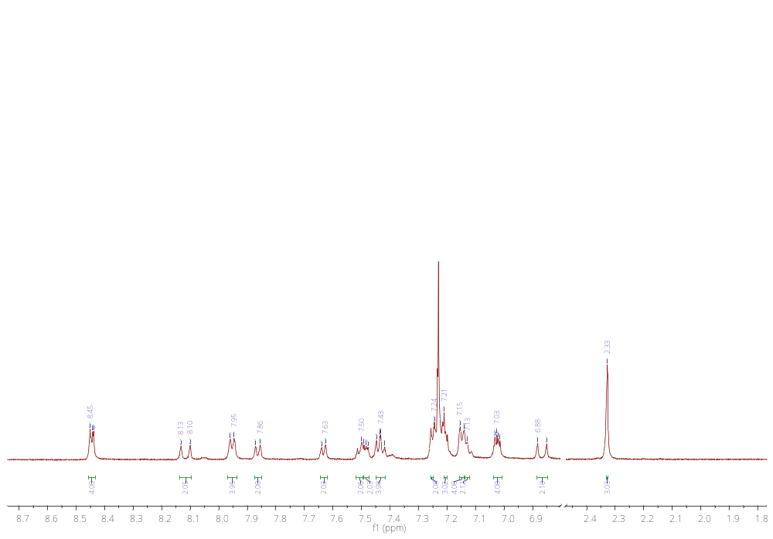
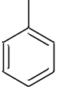Figure S4. ¹HNMR spectrum of DBP-DEPN·toluene. Solvent inclusion: toluene (red), solvent residue: chloroform (black).
*

*

*

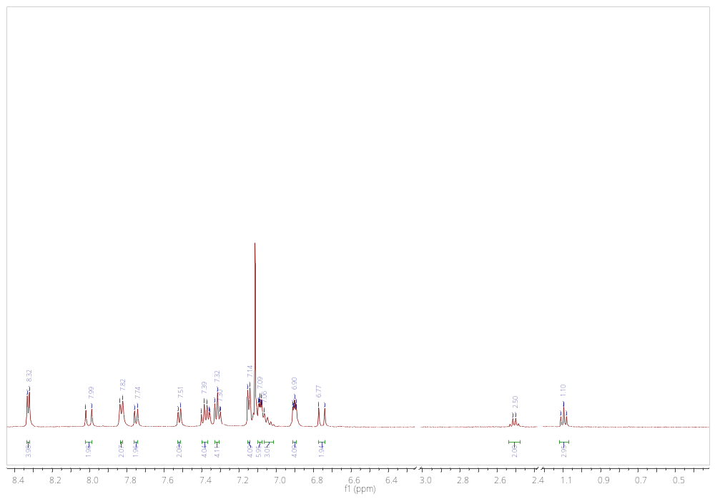
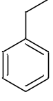
*

*

*

*

Figure S5. ¹HNMR spectrum of DBP-DEPN·ethylbenzene. Solvent inclusion: ethylbenzene (red), solvent residue: chloroform (black).

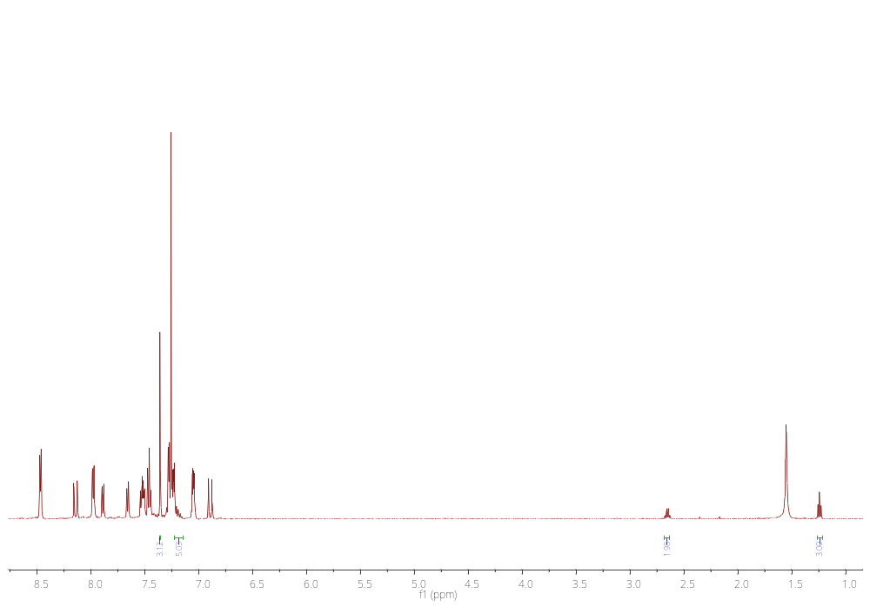Figure S6. ¹HNMR spectrum of competitive crystallization of DBP-DEPN between an equimolar (1:1 ratio, moles) benzene and ethylbenzene solution. Solvent inclusions: ethylbenzene (red), benzene (blue) solvent residue: chloroform (singlet,7.26 ppm).
*

*

*

*

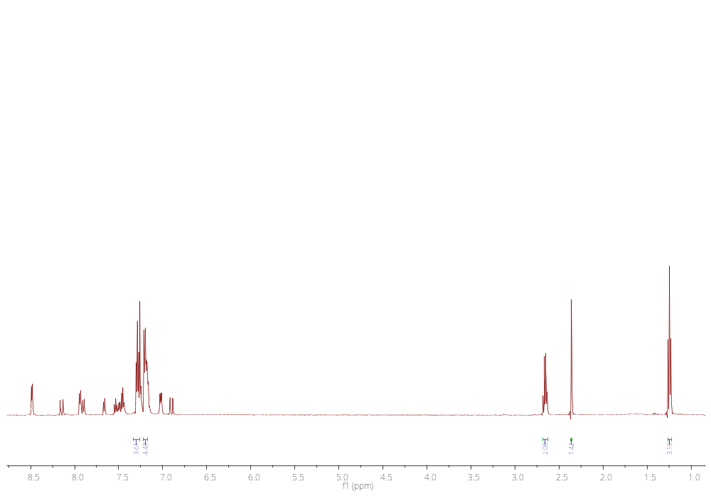
*

*

*

*

*

Figure S7. ¹HNMR spectrum of competitive crystallization of DBP-DEPN between an equimolar (1:1 ratio, moles) toluene and ethylbenzene solution. Solvent inclusions: ethylbenzene (red), toluene (green) solvent residue: chloroform (singlet, 7.26 ppm).

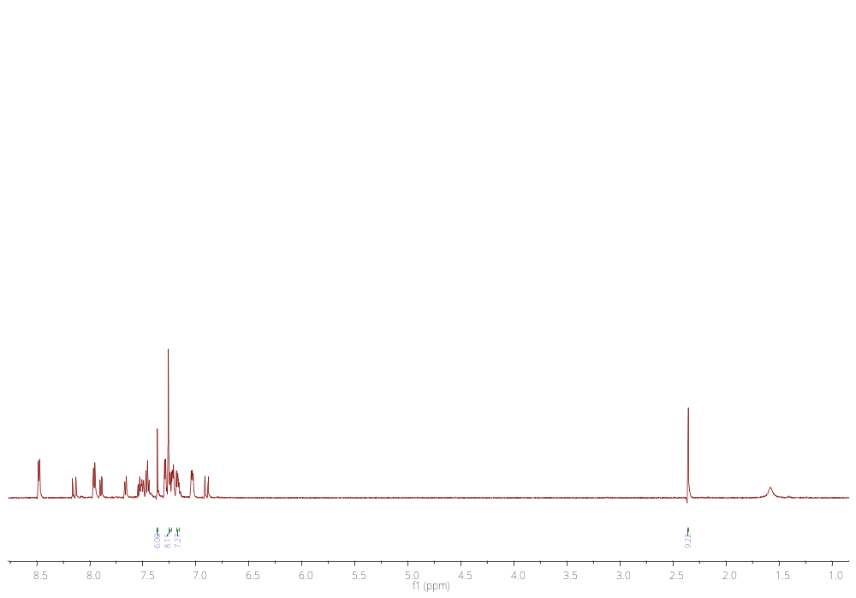
*

*

*

Figure S8. ¹HNMR spectrum of competitive crystallization of DBP-DEPN between an equimolar (1:1 ratio, moles) toluene and benzene solution. Solvent inclusions: benzene (blue), toluene (green) solvent residue: chloroform (singlet, 7.26 ppm).

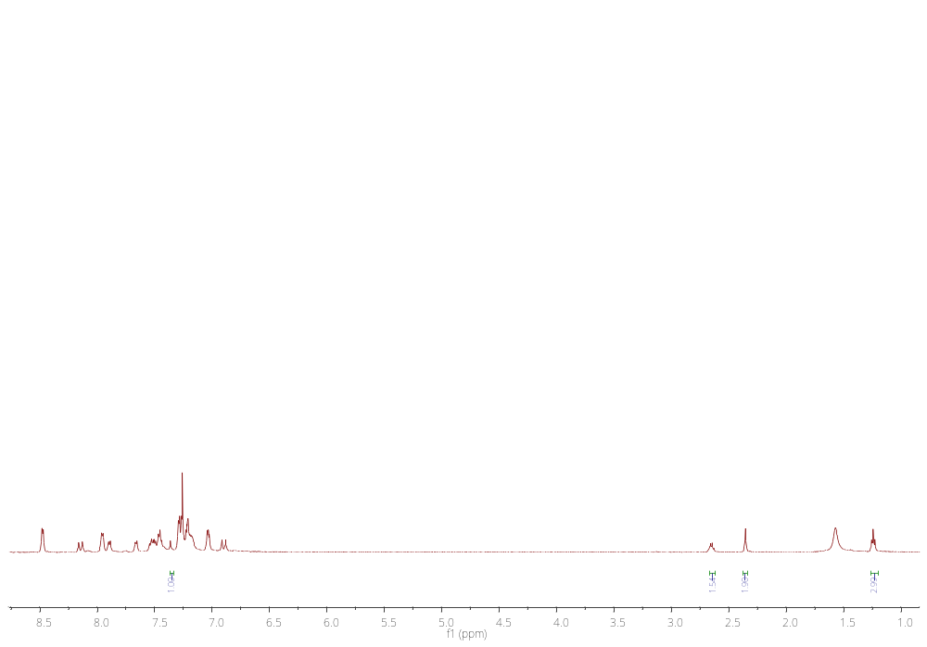
*

*

*

*

Figure S9. ¹HNMR spectrum of competitive crystallization of DBP-DEPN between an equimolar (1:1:1 ratio, moles) ethylbenzene, toluene, and benzene solution. Solvent inclusions: benzene (blue), toluene (green) ethylbenzene (red), solvent residue: chloroform (singlet, 7.26 ppm).
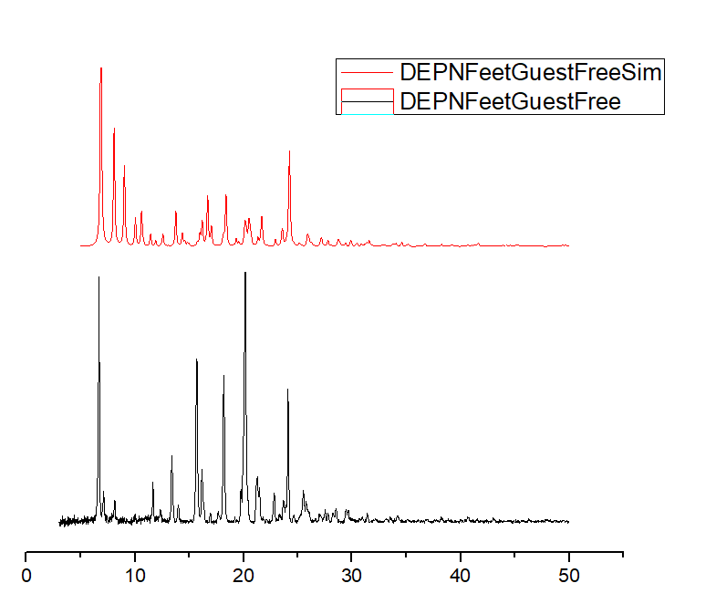
S4. X-ray powder pattern data.
2θ (◦)

Figure S10. Experimental and simulated PXRD of DBP-DEPN (CH₂Cl solvate).

2θ (◦)
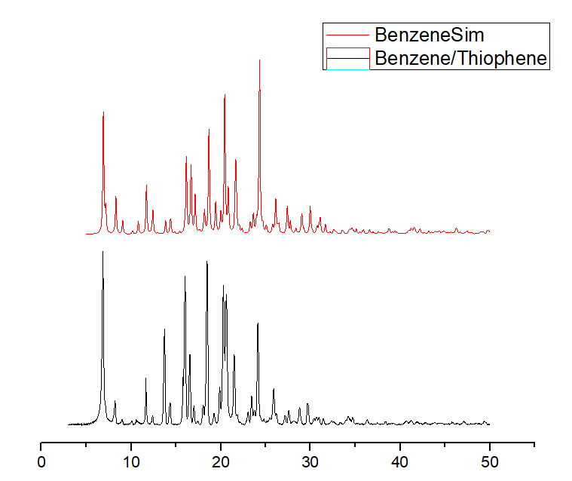
Figure S11. Experimental and simulated PXRD patterns of DBP-DEPN·benzene.

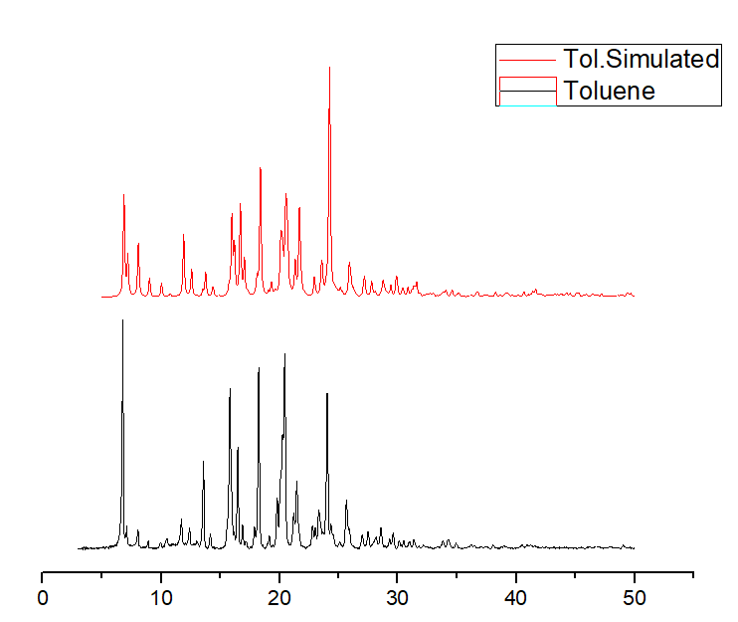
2θ (◦)
Figure S12. Experimental and simulated PXRD patterns of DBP-DEPN·toluene.

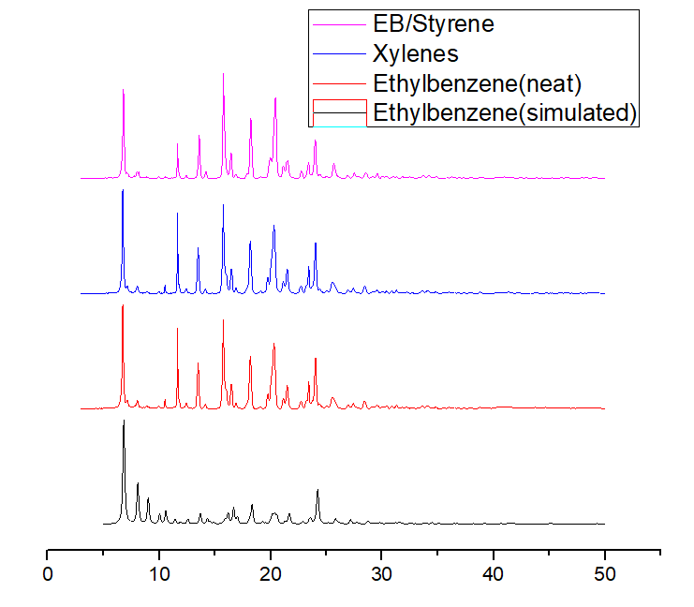
2θ (◦)
Figure S13. Experimental and simulated PXRD patterns of DBP-DEPN·ethylbenzene.

S5. Molecular Modeling
Electrostatic potential maps were generated for each DBP-DEPN complex by calculations at ground state in gas phase using Spartan ’18 V1.2.0 software. Calculations were performed with ωB97X-D/6-31+G* using the density functional model in a vacuum. Charge value ranges were set to a standard range of +/- 200 KJ/mole with isovalues of 0.002 for each. Single crystal lattice data was used to produce atom coordinates with hydrogens relaxed to neutron distances. Solvent inclusions removed to limit complexity.

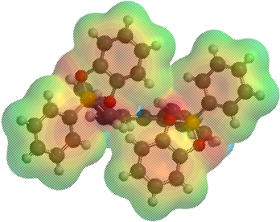
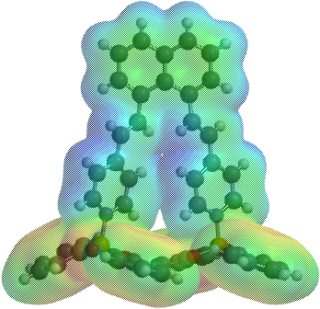
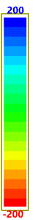

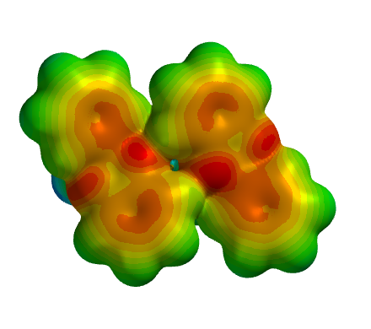
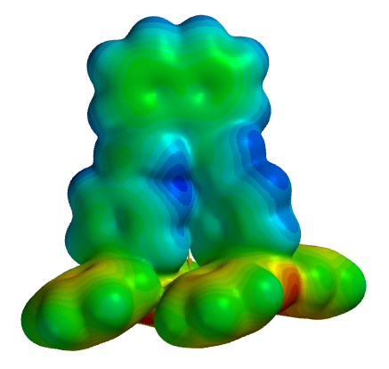

Figure S14. Electrostatic potential of the DB-DEPN molecule.

S6. Thermogravimetric Analysis
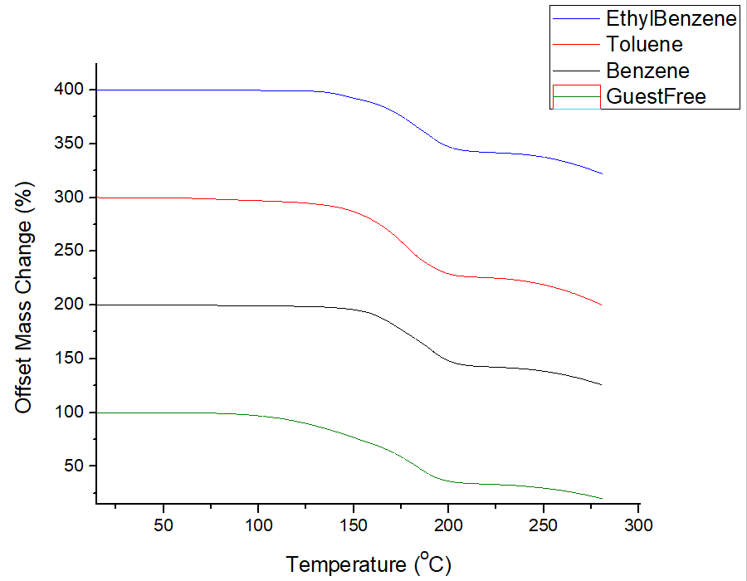
Thermogravimetric analysis data were recorded on a TA Instruments TAQ-500.
Figure S15. TGA data of complexes. Ramp rate 10ºC/minute, performed after drying for 30 minutes at room temperature.

S7. The 12 Possible Pentominos



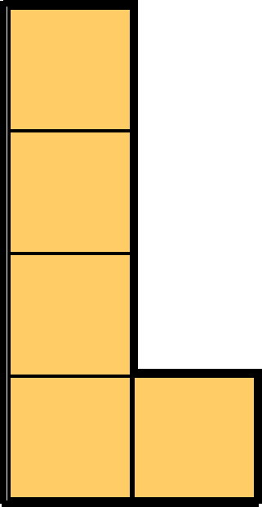
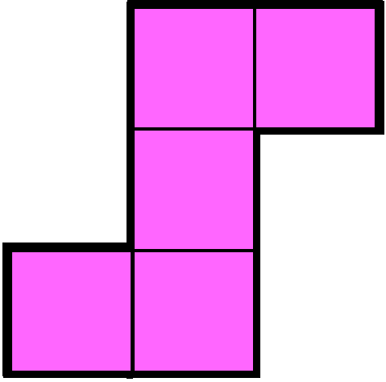


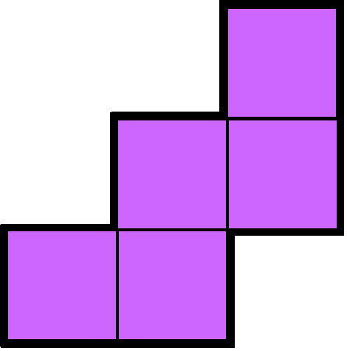
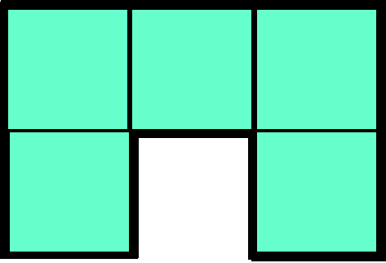
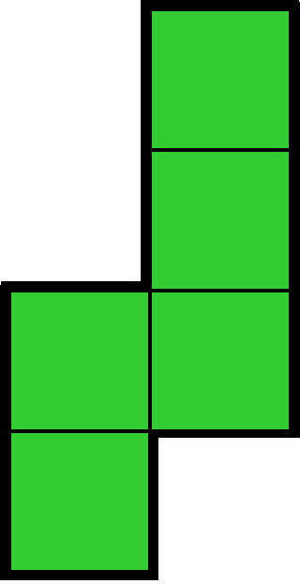
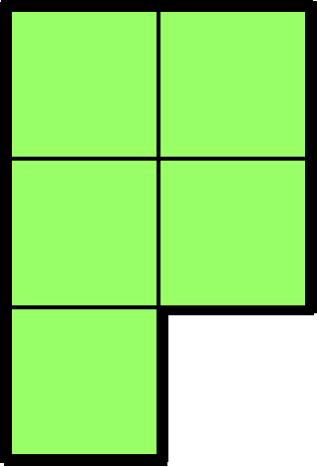
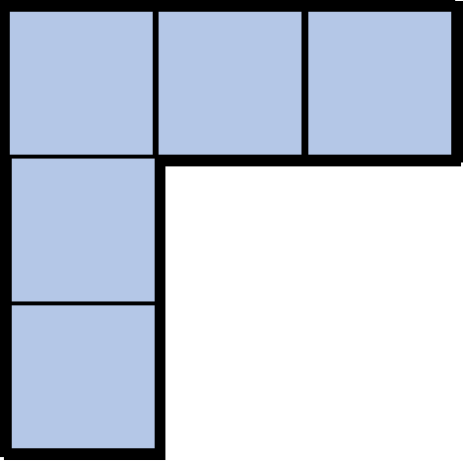
T
X
F
W
U
Z
P
L
N
I
Y
V

S8. Filling of a rectangle using 5-different tetrominoes.²
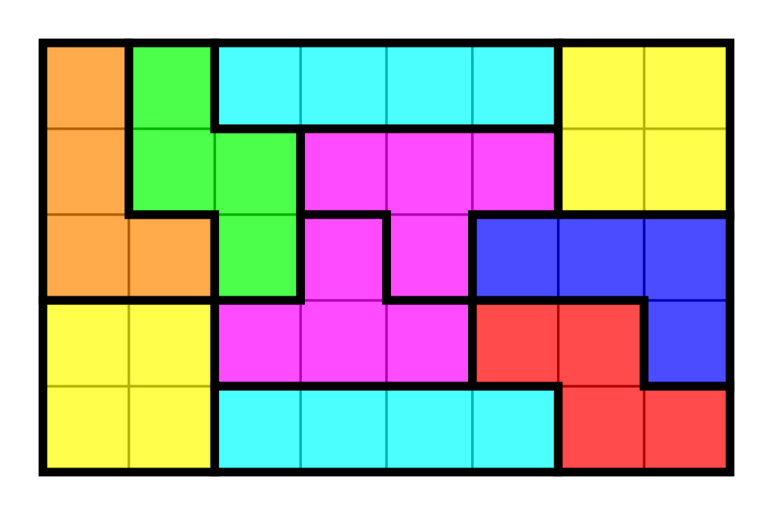
S9. The four 1-isohedral tilings for a T-pentomino.³


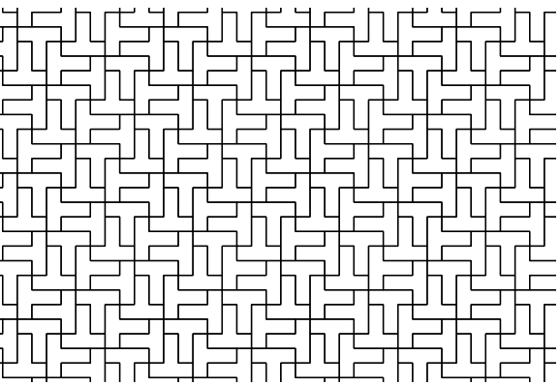

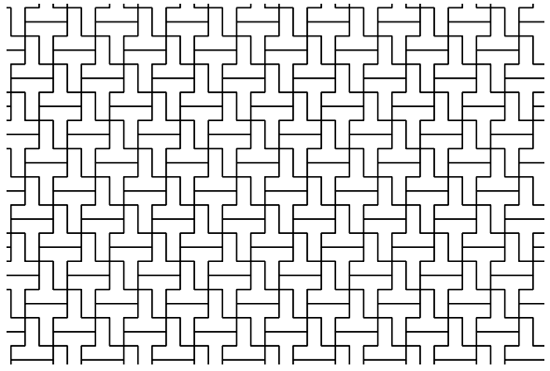

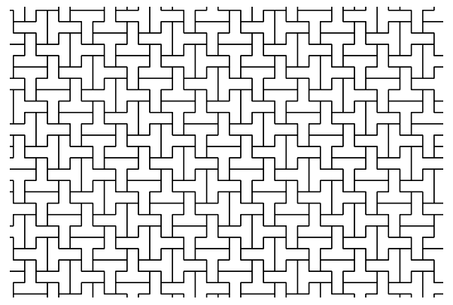

S10. The two 2-isohedral tilings for a T-pentomino.³
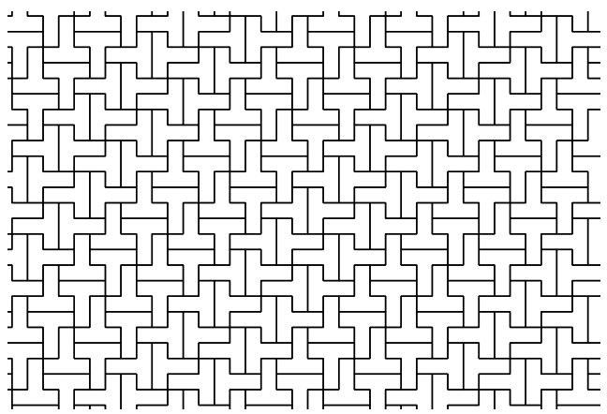
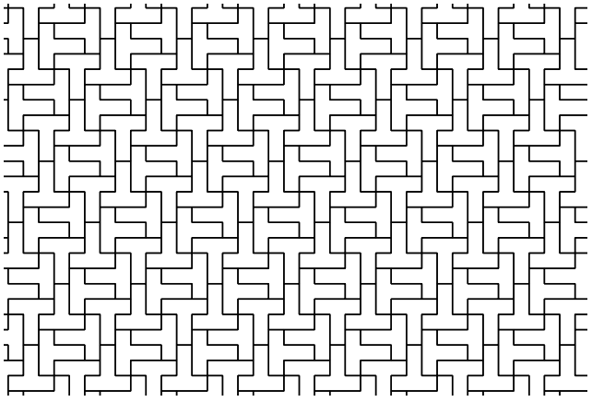
S11. Refences.
1. Laird, R. C.; Sinnwell, M. A.; Nguyen, N. P.; Swenson, D. C.; Mariappan, S. V.; MacGillivray, L. R., Intramolecular [2 + 2] Photodimerization Achieved in the Solid State via Coordination-Driven Self-Assembly. Org Lett 2015, 17 (13), 3233-5.
2. Brandenads, Tiling an 8×5 square with two sets of free tetrominoes. https://commons.wikimedia.org/w/index.php?curid=89396837, 2020.
3. Myers, J. Polyform tiling. (accessed June 15). https://www.polyomino.org.uk/mathematics/polyform-tiling/

