Dataset
Table S1 Disease diagnostic coding based on ICD-9
Comorbidity | ICD-9-CM
Asthma | 493xx
DM | 250xx,249xx
Hypertension | 401x,405xx,459xx
Hyperlipidemia | 2722,2724
CAD | 41400-41407,4143,4144
CHF | 4280
CKD | 586,403xx,404xx,5851-5856,5859
PVD | 4439，44389
Pneumonia | 482xx,4829,483x,484x,485,486,4870
Sepsis | 99591,99592
Note: DM=diabetes mellitus; CAD=chronic renal disease; CHF=congestive heart failure; PVD=peripheral vascular disease; CKD=chronic renal disease.
Table S2 Drug specific information
Drug | Detailed information
LABA | Salmeterol, Formoterol
LAMA | Tiotropium Bromide
Inhaled corticosteroid | Beclomethasone, Budesonide, Fluticasone
Oral corticosteroid | Prednisone, Hydrocortisone, Hydrocortisone
Beta-blockers | Metoprolol, Labetalol, Atenolol, Esmolol, Nadolol, Sotalol, Propranolol, Carvedilol, Bisoprolol, et al.
Calcium-channel blocker | Amlodipine, Nifedipine, Nimodipine, Felodipine, Verapamil, diltiazem
Diuretics | Hydrochlorothiazide, Furosemide (Lasix), Antisterone, Bumetanide, mannitol, et al.
Antiplatelet | Aspirin,Clopidogrel
Nitrates | Nitroglycerin, lsosorbide mononitrate, Isosorbide nitrate
Statins | Atorvastatin, Simvastatin, Pravastatin, Lovastatin, et al
Note: LABA: Long-acting β₂ agonists, LAMA: long-acting muscarinic antagonist

Table S3 Summary of missing data
Variables | Number of missing | Missing ratio | Reserved Variables
Gender | 0 | 0 | Gender
Marital status | 0 | 0 | Marital status
Ethnicity | 0 | 0 | Ethnicity
Insurance | 0 | 0 | Insurance
Smoker | 0 | 0 | Smoker
Diabetes | 0 | 0 | Diabetes
Hypertension | 0 | 0 | Hypertension
Hyperlipidemia | 0 | 0 | Hyperlipidemia
CAD | 0 | 0 | CAD
CHF | 0 | 0 | CHF
PVD | 0 | 0 | PVD
Pneumonia | 0 | 0 | Pneumonia
Sepsis | 0 | 0 | Sepsis
CKD | 0 | 0 | CKD
LABA | 0 | 0 | LABA
LAMA | 0 | 0 | LAMA
Inhaled corticosteroid | 0 | 0 | Inhaled corticosteroid
Oral corticosteroid | 0 | 0 | Oral corticosteroid
Beta blockers | 0 | 0 | Beta blockers
Calcium channel blocker | 0 | 0 | Calcium channel blocker
Diuretics | 0 | 0 | Diuretics
Antiplatelet | 0 | 0 | Antiplatelet
Nitrates | 0 | 0 | Nitrates
Statins | 0 | 0 | Statins
Age | 0 | 0 | Age
Sofa | 122 | 1.823348 | Sofa
Apsiii | 122 | 1.823348 | Apsiii
Oasis | 122 | 1.823348 | Oasis
Sapsii | 122 | 1.823348 | Sapsii
WBC | 66 | 0.9863996 | WBC
Neutrophils | 1343 | 20.0717382 | Neutrophils
Lymphocytes | 1343 | 20.0717382 | Lymphocytes
Platelet | 63 | 0.9415633 | Platelet
Hemoglobin | 65 | 0.9714542 | Hemoglobin
Albumin | 2593 | 38.7535495 | -
Sodium | 65 | 0.9714542 | Sodium
Potassium | 62 | 0.9266178 | Potassium
Calcium | 3081 | 46.0469287 | -
Bicarbonate | 65 | 0.9714542 | Bicarbonate
RBC | 65 | 0.9714542 | RBC
ALT | 2303 | 34.4193693 | -
AST | 2297 | 34.3296966 | -
Creatinine | 59 | 0.8817815 | Creatinine
BUN | 59 | 0.8817815 | BUN
BOS | 3437 | 51.3675086 | -
Glu | 65 | 0.9714542 | Glu
Temperature | 3259 | 48.7072187 | -
Respiratory Rate | 3206 | 47.9151098 | -
Arterial pH | 4135 | 61.7994321 | -
PaCO2 | 4156 | 62.1132865 | -
PaO2 | 4153 | 62.0684505 | -
DP | 4669 | 69.7803019 | -
SP | 4668 | 69.7653564 | -
MAP | 4669 | 69.7803019 | -
Note: WBC=White Blood Cell count; RBC= red blood cell count; ALT= Alanine Transaminase, AST=Aspartate Transaminase; BUN=Serum Blood Urea Nitrogen; pO2=Partial Pressure of Oxygen; pCO2=Partial Pressure of Carbon Dioxide; MAP= mean atrial pressure; SP=systolic pressure; DP=diastolic pressure; DM=diabetes mellitus; CAD=chronic renal disease; CHF=congestive heart failure; PVD=peripheral vascular disease; CKD=chronic renal disease; SOFA=Sequential Organ Failure Assessment score; OASIS=Oxford Acute Severity of Illness Score, SAPS II=Simplified Acute Physiology Score II; APS III=Acute Physiological Score III.
Feature selection
Genetic Algorithm (GA)
GA[1] begin their search from the string set of the problem's solution and can deal with multiple individuals in the population simultaneously, thereby reducing the possibility of falling into a local optimal solution. The mathematical progression of the GA is depicted in the table below:
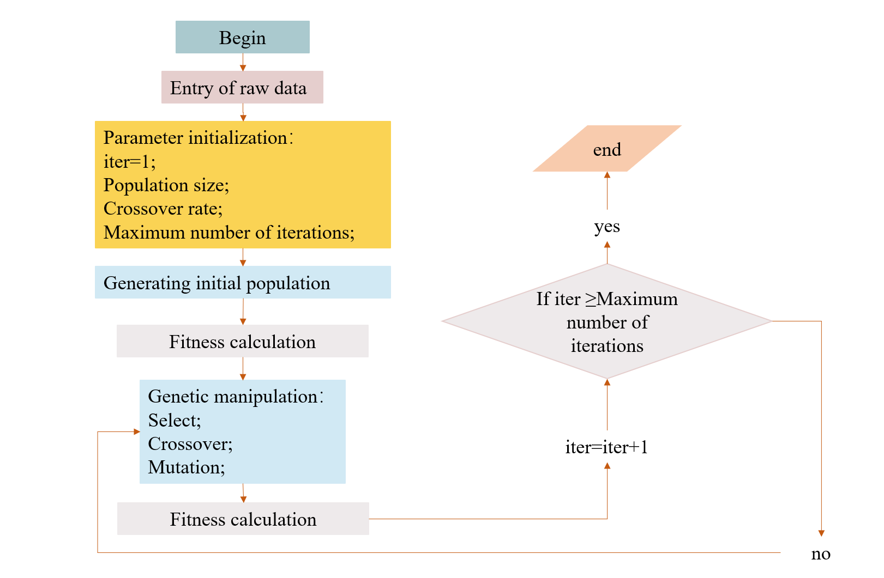
Figure S1. Genetic algorithm flow
In this paper, we use the accuracy of identifying AECOPD as the objective function value, by analyzing the impact of various influencing factors on AECOPD, in order to select the features used to classify the prediction, and thereby achieve the goal of data dimensionality reduction.
The genetic algorithm parameters described in this paper are as follows:

Table S4 parameter settings
Model | parameter setting
GeneticSelectionCV | Estimator=RF
GeneticSelectionCV | cv=5
GeneticSelectionCV | verbose=0
GeneticSelectionCV | scoring="accuracy”
GeneticSelectionCV | max features=25
GeneticSelectionCV | n_population=100
GeneticSelectionCV | Crossover_proba=0.5
GeneticSelectionCV | mutation_proba=0.2
GeneticSelectionCV | n generations=50

Boruta:
Boruta is a feature selection algorithm based on the random forest (RF) classifier. It was proposed by Kursa et al. in 2010[2]. It iteratively addresses the random fluctuation of the importance score of RF and the interaction between independent variables. This method consists primarily of five steps: (1) Create shadow variables and a new feature matrix N: all variables are shuffled to produce new variables, called "shadow variables", which form a feature matrix S and are stitched together with the original data (named "R") to form a new matrix N=[R, S]; (2) The model trained on the new feature matrix N can output variable importance (VIM) score; (3) Compute the Z-scores for the original variables and shadow variables: Z-score = average(VIM)/standard deviation(VIM); (4) Determine if the original variable is significant: take the largest Z-score among shadow variables, label it as Maximum Z Score among shadow attributes (MZSA), and conduct a two-sided test to determine if the Z-score of each original variable is equal to MZSA. Variables with a higher Z-score are labelled as "important variables," whereas variables with a lower Z-score are labelled as "non-important variables"; (5) Delete the original variables marked as "non-important" and all shadow variables; (6) Repeat steps 1-4 until all variables are labelled as "important" or the RF construction times in a given cycle are reached.
Recursive Feature Elimination Method Based on Random Forest (RF-RFE)
The RF-RFE[3] ranks the importance of features to produce a ranked list and determines the optimal subset of features based on the RF's performance. The RF can score the features based on the average reduction in accuracy, which refers to the impact of replacing the value of each feature on the model's accuracy. For each tree in the RF, a tree is constructed from the randomly sampled sample set, and then the prediction error rate is computed using out-of-bag data. The "tree construction" method is repeated, and the prediction error rate calculated after randomly replacing $X_{j}$ observations. The difference between the two prediction error rates was normalized, and the mean of this value was calculated across all trees.
The expression for the replacement significance of variable $X_{j}$ on the ith tree is as follows:
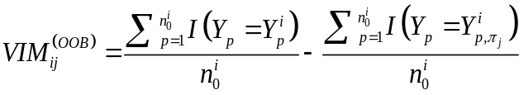 (1)
Where $n_{0}^{i}$ represents the number of out-of-bag observations for tree i. $I_{\left(g\right)}$ represents the indicator function, which returns 1 if the two values are equal and 0 otherwise. $Y_{p}$ ∈ [4] represents the actual result of the observation p, $Y_{p}^{i}$∈ {0,1} represents the predicted result of the observation p of the out-of-bag data for tree i before random permutation, and $Y_{p,π_{j}}^{i}$∈ {0,1} represents the predicted result of the observation p of the out-of-bag data for tree i after random permutation.
If there are n classification trees in the random forest, the replacement importance of variable $X_{j}$can be expressed as follows:
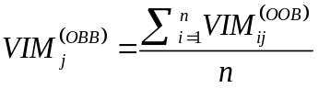 (2)

Univariate analysis
Table S4 Basic description of data and univariate analysis results
Variable | Outcome |  | Z/ | P
Variable | COPD (N=3776) | AECOPD (N=900) |  | P
Gender |  |  | 8.604 | 0.003
Male | 2076(82.3) | 446(17.7)
Female | 1700(78.9) | 454(21.1)
Marital status |  |  | 16.451 | 0.001
Single | 749(77.9) | 212(22.1)
Married | 1715(83.1) | 348(16.9)
Divorced/separated/widowed | 1139(78.9) | 305(21.1)
Unknow | 173(83.2) | 35(16.8)
Ethnicity |  |  | 2.708 | 0.100
White | 2941(81.3) | 678(18.7)
Others | 835(79.0) | 222(21.0)
Insurance |  |  | 25.025 | <0.001
Medicare | 2797(79.3) | 732(20.7)
Medicaid | 272(83.7) | 53(16.3)
Private | 656(86.8) | 100(13.2)
Self pay | 7(77.8) | 2(22.2)
Government | 44(77.2) | 13(22.8)
Smoking |  |  | 6.271 | 0.012
No | 2981(81.5) | 676(18.5)
Yes | 795(78.0) | 224(22.0)
Diabetes |  |  | 0.093 | 0.761
No | 2632(80.6) | 632(19.4)
Yes | 1144(81.0) | 268(19.0)
Hypertension |  |  | 0.178 | 0.673
No | 2081(81.0) | 489(19.0)
Yes | 1695(80.5) | 411(19.5)
hyperlipidemia |  |  | 2.115 | 0.146
No | 3024(80.3) | 740(19.7)
Yes | 752(82.5) | 160(17.5)
CAD |  |  | 26.213 | <0.001
No | 2488(78.7) | 673(21.3)
Yes | 1288(85.0) | 227(15.0)
CHF |  |  | 17.111 | <0.001
No | 2233(82.8) | 464(17.2)
Yes | 1543(78.0) | 436(22.0)
PVD |  |  | 10.883 | 0.001
No | 3588(80.3) | 878(19.7)
Yes | 188(89.5) | 22(10.5)
LAMA |  |  | 52.245 | <0.001
No | 3258(82.5) | 689(17.5)
Yes | 518(71.1) | 211(28.9)
Pneumonia |  |  | 239.253 | <0.001
No | 2980(86.0) | 484(14.0)
Yes | 796(65.7) | 416(34.3)
Sepsis |  |  | 5.676 | 0.017
No | 3326(80.3) | 818(19.7)
Yes | 450(84.6) | 82(15.4)
CKD |  |  | 3.032 | 0.082
No | 3056(80.3) | 751(19.7)
Yes | 720(82.9) | 149(17.1)
LABA |  |  | 151.870 | <0.001
No | 3021(84.7) | 545(15.3)
Yes | 755(68.0) | 355(32.0)
Inhaled corticosteroid |  |  | 147.702 | <0.001
No | 2597(85.9) | 425(14.1)
Yes | 1179(71.3) | 475(28.7)
Oral corticosteroid |  |  | 148.672 | <0.001
No | 3311(83.8) | 642(16.2)
Yes | 465(64.3) | 258(35.7)
Beta blockers |  |  | 47.653 | <0.001
No | 1226(75.3) | 402(24.7)
Yes | 2550(83.7) | 498(16.3)
Calcium channel blocker |  |  | 76.397 | <0.001
No | 2831(83.9) | 544(16.1)
Yes | 945(72.6) | 356(27.4)
Diuretics |  |  | 3.702 | 0.054
No | 1448(82.2) | 314(17.8)
Yes | 2328(79.9) | 586(20.1)
Antiplatelet |  |  | 3.833 | 0.050
No | 1773(82.0) | 390(18.0)
Yes | 2003(79.7) | 510(20.3)
Nitrates |  |  | 16.701 | <0.001
No | 2749(79.4) | 715(20.6)
Yes | 1027(84.7) | 185(15.3)
Statins |  |  | 0.24 | 0.877
No | 2045(80.7) | 490(19.3)
Yes | 1731(80.9) | 410(19.1)
age | 72.475(16.728) | 72.050(16.323) | -0.005 | 0.996
Sofa | 4.000(4.000) | 3.000(3.000) | -3.111 | 0.002
Apsiii | 42.000(22.000) | 44.000(20.000) | -1.845 | 0.065
Oasis | 32.000(12.000) | 35.000(12.000) | -6.647 | <0.001
Sapsii | 37.000(16.000) | 37.000(16.000) | -0.647 | 0.518
WBC | 10.500(7.900) | 11.300(7.400) | -3.910 | <0.001
Neutrophils | 80.813(11.357) | 83.000(14.450) | -5.416 | <0.001
Lymphocytes | 11.201(8.700) | 9.800(9.450) | -5.912 | <0.001
Platelet | 237.000(135.000) | 260.000(140.000) | 5.182 | <0.001
Hemoglobin | 11.300(2.800) | 11.900(3.100) | -6.094 | <0.001
Sodium | 139.000(5.000) | 139.000(6.000) | -3.273 | 0.001
Potassium | 4.300(0.890) | 4.400(0.900) | -5.238 | <0.001
Bicarbonate | 26.000(6.000) | 28.000(8.000) | -13.117 | <0.001
RBC | 3.800(0.950) | 4.030(1.020) | -8.036 | <0.001
Creatinine | 1.100(0.800) | 1.000(0.800) | -3.621 | <0.001
BUN | 23.000(20.000) | 23.000(18.000) | -0.058 | 0.954
Glu | 125.000(57.000) | 133.000(63.000) | -4.392 | <0.001

Table S5 Hyperparameter Setting
Models | Hyperparameter | Range | Hyperparameter value
LR | L | L2 | L2
LR | C | [1,10] | 4.33274
SVM | Gamma | [0.01,1] | 0.0100
SVM | C | [1,10] | 9.32999
SVM | kernel | rbf | rbf
MLP | alpha | [0.01,1] | 0.03419
MLP | max_iter | [100,10000] | 135
RF | n_estimators | [100,10000] | 7638
RF | max_depth | [5,15] | 7
RF | max_features | [0.01,1] | 0.14190
RF | min_samples_split | [0,50] | 4
XGBoost | n_estimators | [100,10000] | 743
XGBoost | max_depth | [1,16] | 2
XGBoost | colsample_bylevel | [0.01,1] | 0.26709
XGBoost | min_child_weight | [0,30] | 0.42377
XGBoost | gamma | [0,1] | 0.10053
XGBoost | reg_lambda | [0,30] | 25.33275
XGBoost | learning_rate | [0.01,1] | 0.31130
Lightgbm | n_estimators | [100,10000] | 320
Lightgbm | max_depth | [1,16] | 3
Lightgbm | colsample_bytree | [0.01,1] | 0.39797
Lightgbm | min_child_samples | [0,50] | 19.02948
Lightgbm | min_child_weight | [0.01,1] | 0.29536
Lightgbm | red_lambda | [0.01,50] | 36.51519
Lightgbm | num_leaves | [2,50] | 43
Lightgbm | subsample | [0.01,1] | 0.07409
Lightgbm | learning_rate | [0.01,1] | 0.13279
GBDT | n_estimators | [100,10000] | 348
GBDT | max_depth | [5,15] | 15
GBDT | min_samples_split | [2,25] | 13.86186
GBDT | max_features | [0.01,1] | 0.10000

Table S6 Average and dispersion of 10 times stratified 10-fold cross-validation results in training set
Models | AUC |  | ACC |  | Recall |  | F1 |  | Spe |  | G_mean
 | Mean | Std | Mean | Std | Mean | Std | Mean | Std | Mean | Std | Mean | Std
SVM | 0.710 | 0.025 | 0.803 | 0.011 | 0.243 | 0.043 | 0.321 | 0.048 | 0.937 | 0.012 | 0.475 | 0.043
LR | 0.785 | 0.024 | 0.827 | 0.009 | 0.252 | 0.036 | 0.359 | 0.041 | 0.964 | 0.010 | 0.492 | 0.035
MLP | 0.751 | 0.029 | 0.812 | 0.014 | 0.219 | 0.117 | 0.293 | 0.107 | 0.953 | 0.036 | 0.439 | 0.112
RF | 0.791 | 0.024 | 0.816 | 0.005 | 0.049 | 0.022 | 0.009 | 0.004 | 0.998 | 0.002 | 0.214 | 0.054
GBDT | 0.779 | 0.027 | 0.826 | 0.011 | 0.243 | 0.043 | 0.348 | 0.052 | 0.966 | 0.009 | 0.482 | 0.044
XGBoost | 0.763 | 0.034 | 0.819 | 0.017 | 0.321 | 0.060 | 0.404 | 0.062 | 0.938 | 0.016 | 0.546 | 0.052
LGBM | 0.786 | 0.025 | 0.829 | 0.01 | 0.282 | 0.045 | 0.386 | 0.048 | 0.959 | 0.011 | 0.518 | 0.041
CatBoost | 0.792 | 0.024 | 0.829 | 0.009 | 0.224 | 0.038 | 0.334 | 0.046 | 0.974 | 0.008 | 0.465 | 0.039
OS_SVM | 0.780 | 0.025 | 0.826 | 0.009 | 0.237 | 0.040 | 0.343 | 0.045 | 0.967 | 0.010 | 0.477 | 0.039
OS_LR | 0.783 | 0.024 | 0.820 | 0.013 | 0.354 | 0.046 | 0.429 | 0.044 | 0.931 | 0.014 | 0.572 | 0.036
OS_MLP | 0.779 | 0.028 | 0.818 | 0.015 | 0.383 | 0.059 | 0.445 | 0.051 | 0.921 | 0.018 | 0.592 | 0.045
OS_RF | 0.789 | 0.025 | 0.828 | 0.009 | 0.173 | 0.038 | 0.277 | 0.053 | 0.984 | 0.007 | 0.409 | 0.045
OS_GBDT | 0.774 | 0.027 | 0.816 | 0.014 | 0.364 | 0.050 | 0.431 | 0.046 | 0.923 | 0.015 | 0.579 | 0.039
OS_XGBoost | 0.763 | 0.025 | 0.802 | 0.015 | 0.419 | 0.044 | 0.449 | 0.039 | 0.893 | 0.016 | 0.611 | 0.033
OS_LGBM | 0.784 | 0.026 | 0.816 | 0.016 | 0.392 | 0.050 | 0.45 | 0.049 | 0.917 | 0.015 | 0.598 | 0.039
OS_CatBoost | 0.790 | 0.025 | 0.826 | 0.013 | 0.323 | 0.047 | 0.416 | 0.048 | 0.946 | 0.013 | 0.551 | 0.040
NC_SVM | 0.714 | 0.024 | 0.733 | 0.017 | 0.479 | 0.053 | 0.408 | 0.037 | 0.794 | 0.019 | 0.615 | 0.034
NC_LR | 0.757 | 0.026 | 0.793 | 0.017 | 0.429 | 0.051 | 0.443 | 0.041 | 0.880 | 0.020 | 0.613 | 0.036
NC_MLP | 0.758 | 0.027 | 0.785 | 0.023 | 0.466 | 0.091 | 0.452 | 0.046 | 0.861 | 0.425 | 0.629 | 0.052
NC_RF | 0.788 | 0.024 | 0.826 | 0.012 | 0.296 | 0.046 | 0.394 | 0.050 | 0.952 | 0.010 | 0.529 | 0.042
NC_GBDT | 0.782 | 0.026 | 0.795 | 0.016 | 0.472 | 0.056 | 0.469 | 0.044 | 0.872 | 0.017 | 0.640 | 0.038
NC_XGBoost | 0.770 | 0.026 | 0.774 | 0.017 | 0.523 | 0.055 | 0.470 | 0.038 | 0.833 | 0.020 | 0.659 | 0.034
NC_LightGBM | 0.782 | 0.024 | 0.783 | 0.017 | 0.506 | 0.053 | 0.472 | 0.038 | 0.849 | 0.019 | 0.654 | 0.034
NC_CatBoost | 0.788 | 0.024 | 0.803 | 0.015 | 0.455 | 0.051 | 0.470 | 0.041 | 0.886 | 0.015 | 0.634 | 0.035
S_SVM | 0.784 | 0.024 | 0.732 | 0.022 | 0.691 | 0.046 | 0.498 | 0.030 | 0.742 | 0.026 | 0.715 | 0.026
S_LR | 0.784 | 0.024 | 0.729 | 0.021 | 0.690 | 0.047 | 0.495 | 0.031 | 0.738 | 0.024 | 0.713 | 0.027
S_MLP | 0.771 | 0.029 | 0.738 | 0.024 | 0.653 | 0.052 | 0.490 | 0.032 | 0.758 | 0.031 | 0.703 | 0.027
S_RF | 0.780 | 0.026 | 0.769 | 0.019 | 0.559 | 0.050 | 0.482 | 0.036 | 0.819 | 0.022 | 0.676 | 0.031
S_GBDT | 0.777 | 0.025 | 0.823 | 0.012 | 0.296 | 0.044 | 0.391 | 0.048 | 0.949 | 0.011 | 0.529 | 0.040
S_XGBoost | 0.769 | 0.027 | 0.817 | 0.014 | 0.340 | 0.050 | 0.416 | 0.051 | 0.931 | 0.013 | 0.561 | 0.042
S_LGBM | 0.778 | 0.025 | 0.820 | 0.014 | 0.347 | 0.048 | 0.425 | 0.049 | 0.932 | 0.013 | 0.568 | 0.040
S_CatBoost | 0.793 | 0.025 | 0.829 | 0.009 | 0.234 | 0.037 | 0.344 | 0.046 | 0.971 | 0.008 | 0.475 | 0.039
SI_SVM | 0.785 | 0.024 | 0.733 | 0.02 | 0.69 | 0.045 | 0.498 | 0.029 | 0.743 | 0.023 | 0.715 | 0.025
SI_LR | 0.784 | 0.024 | 0.729 | 0.021 | 0.689 | 0.050 | 0.495 | 0.031 | 0.739 | 0.024 | 0.713 | 0.028
SI_MLP | 0.771 | 0.029 | 0.741 | 0.024 | 0.652 | 0.051 | 0.493 | 0.034 | 0.762 | 0.030 | 0.704 | 0.029
SI_RF | 0.779 | 0.026 | 0.768 | 0.019 | 0.559 | 0.053 | 0.481 | 0.038 | 0.818 | 0.021 | 0.675 | 0.032
SI_GBDT | 0.776 | 0.025 | 0.824 | 0.013 | 0.305 | 0.048 | 0.399 | 0.052 | 0.947 | 0.011 | 0.536 | 0.043
SI_XGBoost | 0.771 | 0.027 | 0.817 | 0.014 | 0.337 | 0.048 | 0.414 | 0.049 | 0.931 | 0.012 | 0.559 | 0.041
SI_LGBM | 0.780 | 0.025 | 0.818 | 0.013 | 0.343 | 0.047 | 0.419 | 0.046 | 0.931 | 0.013 | 0.564 | 0.039
SI_CatBoost | 0.791 | 0.026 | 0.827 | 0.012 | 0.282 | 0.046 | 0.385 | 0.052 | 0.957 | 0.010 | 0.518 | 0.043
SIC_SVM | 0.706 | 0.030 | 0.757 | 0.019 | 0.439 | 0.057 | 0.41 | 0.045 | 0.833 | 0.018 | 0.603 | 0.040
SIC_LR | 0.764 | 0.026 | 0.729 | 0.020 | 0.645 | 0.049 | 0.478 | 0.031 | 0.749 | 0.023 | 0.694 | 0.028
SIC_MLP | 0.760 | 0.027 | 0.748 | 0.034 | 0.584 | 0.092 | 0.47 | 0.035 | 0.787 | 0.057 | 0.674 | 0.038
SIC_RF | 0.784 | 0.030 | 0.822 | 0.016 | 0.289 | 0.060 | 0.383 | 0.067 | 0.949 | 0.013 | 0.521 | 0.056
SIC_GBDT | 0.788 | 0.026 | 0.831 | 0.010 | 0.258 | 0.044 | 0.369 | 0.051 | 0.968 | 0.009 | 0.498 | 0.043
SIC_XGBoost | 0.773 | 0.032 | 0.823 | 0.016 | 0.311 | 0.061 | 0.401 | 0.065 | 0.945 | 0.013 | 0.539 | 0.055
SIC_LGBM | 0.774 | 0.031 | 0.816 | 0.015 | 0.313 | 0.055 | 0.395 | 0.057 | 0.936 | 0.014 | 0.539 | 0.048
SIC_CatBoost | 0.774 | 0.026 | 0.802 | 0.015 | 0.429 | 0.050 | 0.454 | 0.042 | 0.891 | 0.017 | 0.617 | 0.035
SL_SVM | 0.684 | 0.031 | 0.71 | 0.021 | 0.506 | 0.058 | 0.401 | 0.039 | 0.759 | 0.023 | 0.618 | 0.036
SL_LR | 0.765 | 0.027 | 0.687 | 0.022 | 0.721 | 0.049 | 0.470 | 0.028 | 0.678 | 0.025 | 0.699 | 0.026
SL_MLP | 0.759 | 0.026 | 0.718 | 0.070 | 0.627 | 0.128 | 0.463 | 0.034 | 0.740 | 0.113 | 0.671 | 0.037
SL_RF | 0.791 | 0.024 | 0.800 | 0.017 | 0.477 | 0.054 | 0.478 | 0.044 | 0.877 | 0.017 | 0.645 | 0.037
SL_GBDT | 0.773 | 0.027 | 0.826 | 0.012 | 0.303 | 0.047 | 0.400 | 0.051 | 0.951 | 0.010 | 0.535 | 0.042
SL_XGBoost | 0.742 | 0.028 | 0.782 | 0.018 | 0.447 | 0.049 | 0.441 | 0.041 | 0.862 | 0.018 | 0.620 | 0.035
SL_LGBM | 0.775 | 0.027 | 0.799 | 0.016 | 0.469 | 0.051 | 0.472 | 0.040 | 0.877 | 0.018 | 0.640 | 0.034
SL_CatBoost | 0.773 | 0.026 | 0.820 | 0.015 | 0.385 | 0.050 | 0.451 | 0.047 | 0.924 | 0.015 | 0.595 | 0.039
KS_SVM | 0.749 | 0.029 | 0.781 | 0.026 | 0.345 | 0.103 | 0.37 | 0.091 | 0.885 | 0.042 | 0.538 | 0.114
KS_LR | 0.761 | 0.026 | 0.781 | 0.020 | 0.458 | 0.069 | 0.445 | 0.043 | 0.858 | 0.031 | 0.625 | 0.044
KS_MLP | 0.777 | 0.026 | 0.805 | 0.020 | 0.393 | 0.066 | 0.435 | 0.048 | 0.903 | 0.028 | 0.593 | 0.046
KS_RF | 0.762 | 0.029 | 0.802 | 0.020 | 0.309 | 0.077 | 0.370 | 0.073 | 0.919 | 0.029 | 0.527 | 0.074
KS_GBDT | 0.781 | 0.026 | 0.824 | 0.012 | 0.271 | 0.043 | 0.372 | 0.049 | 0.956 | 0.012 | 0.508 | 0.041
KS_XGBoost | 0.770 | 0.027 | 0.816 | 0.014 | 0.341 | 0.053 | 0.415 | 0.052 | 0.929 | 0.014 | 0.561 | 0.044
KS_LGBM | 0.782 | 0.026 | 0.816 | 0.015 | 0.358 | 0.052 | 0.427 | 0.050 | 0.925 | 0.016 | 0.574 | 0.042
KS_CatBoost | 0.786 | 0.026 | 0.821 | 0.014 | 0.329 | 0.051 | 0.413 | 0.052 | 0.938 | 0.014 | 0.554 | 0.043
MW_SVM | 0.785 | 0.024 | 0.752 | 0.020 | 0.647 | 0.050 | 0.502 | 0.033 | 0.778 | 0.024 | 0.709 | 0.028
MW_LR | 0.785 | 0.024 | 0.730 | 0.021 | 0.688 | 0.049 | 0.495 | 0.031 | 0.740 | 0.024 | 0.713 | 0.027
MW_MLP | 0.771 | 0.027 | 0.789 | 0.018 | 0.528 | 0.056 | 0.491 | 0.038 | 0.851 | 0.022 | 0.670 | 0.034
MW_RF | 0.785 | 0.025 | 0.799 | 0.017 | 0.463 | 0.055 | 0.469 | 0.044 | 0.879 | 0.018 | 0.637 | 0.038
MW_GBDT | 0.780 | 0.026 | 0.824 | 0.011 | 0.303 | 0.043 | 0.398 | 0.046 | 0.948 | 0.011 | 0.535 | 0.038
MW_XGBoost | 0.760 | 0.034 | 0.816 | 0.016 | 0.334 | 0.056 | 0.410 | 0.055 | 0.930 | 0.016 | 0.556 | 0.047
MW_LGBM | 0.783 | 0.026 | 0.823 | 0.014 | 0.328 | 0.048 | 0.416 | 0.051 | 0.941 | 0.012 | 0.554 | 0.041
MW_CatBoost | 0.783 | 0.026 | 0.820 | 0.013 | 0.346 | 0.045 | 0.425 | 0.044 | 0.933 | 0.014 | 0.567 | 0.036
Note：OS= One-Sided Selection, NC=Neighborhood Cleaning Rule, S=SMOTE, SI=SMOTE-IPF, SIC=SMOTE_IPF (CatBoost), SL=Safs_Level_SMOTE, KS=kmeans-SMOTE, MW=MWMOTE.

(A) AUC
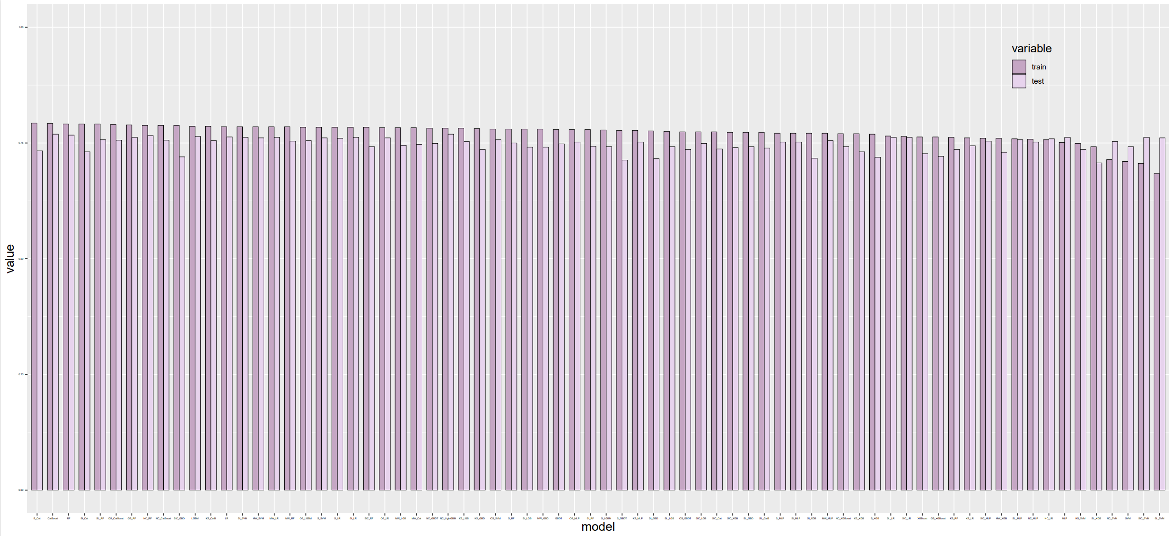
(B) F1
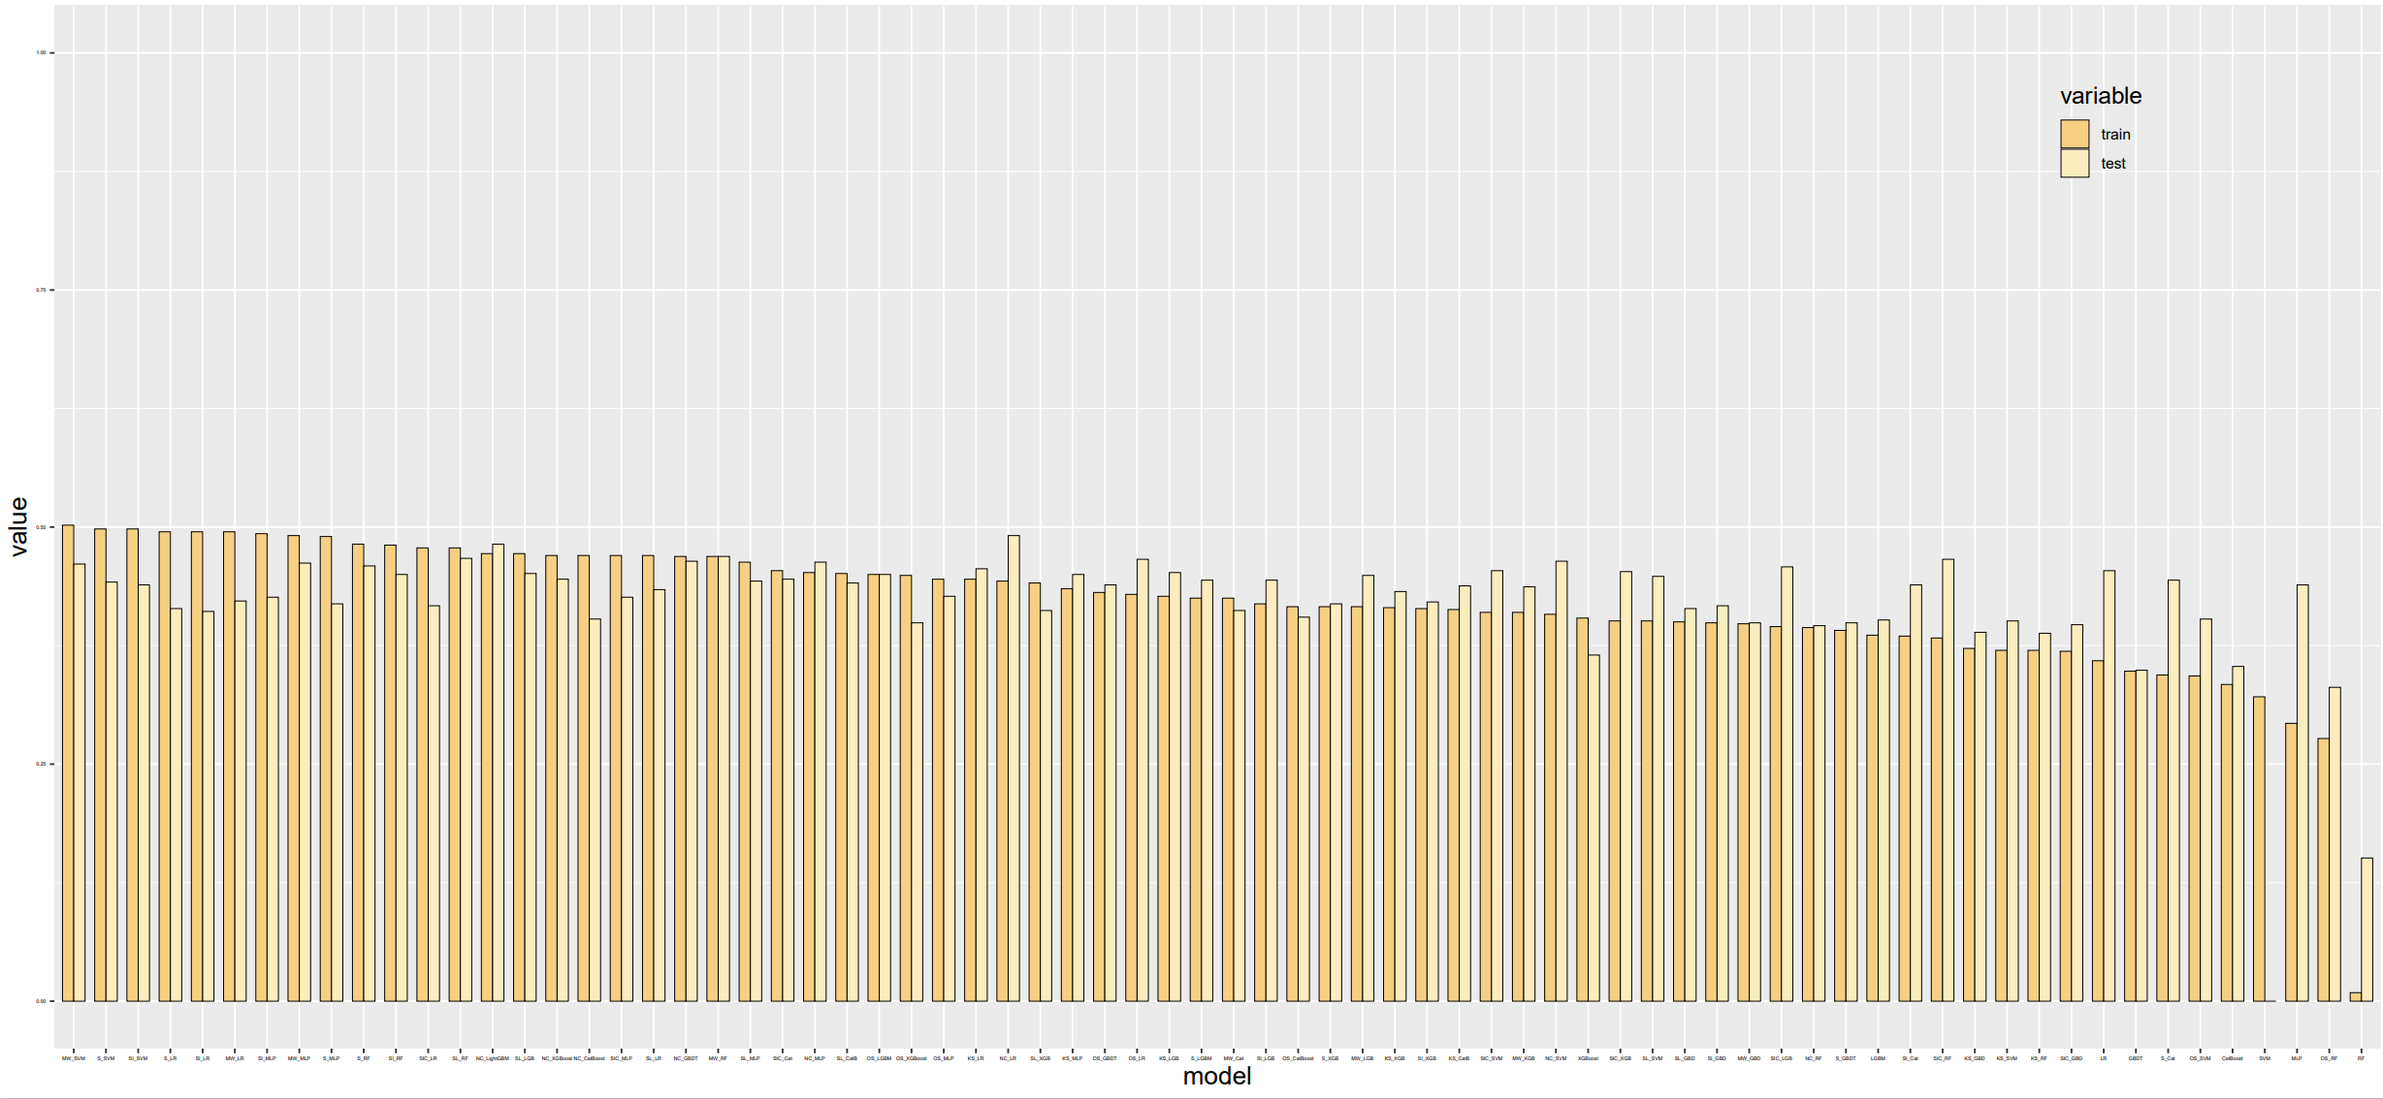
(C) G_mean
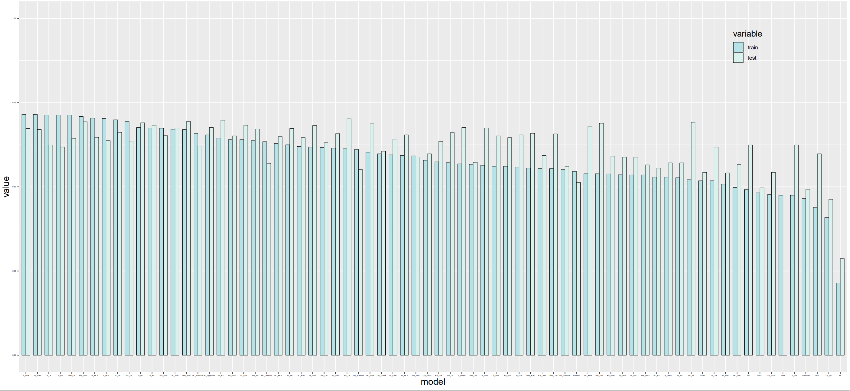
Figure S2 Performance comparison between the training and test sets of different models. (A). Comparison of AUC values for the training and test sets. (B). Comparison of F1-Score values for the training and test sets. (C). Comparison of G-mean values for the training and test sets

Reference
1. Goldberg DEJA-WPC: Genetic Algorithms in Search, Optimization, and Machine Learning. 1989.
2. Kursa MB, Jankowski A, Rudnicki WRJFI: Boruta - A System for Feature Selection. 2010, 101(4):271-285.
3. Chen Q, Meng Z, Liu X, Jin Q, Su R: Decision Variants for the Automatic Determination of Optimal Feature Subset in RF-RFE. Genes 2018, 9(6).
4. Zhe W, Lin LI, Cheng LI, University XMJCDM: Stage Prediction of Chronic Obstructive Pneumonia Based on Machine Learning. 2019, 14(03):38-40.

