Computed Entropy Spectra for Grain Boundary Segregation in Polycrystals
Nutth Tuchinda¹, Christopher A. Schuh^{1*}
¹Department of Materials Science and Engineering, Massachusetts Institute of Technology, 77 Massachusetts Avenue, Cambridge, MA, 02139, USA
Supplementary Material
- Method
We follow our previous work for free energy estimations¹. The minimizations are carried out via the commands^{2–7}:
min_style fire
min_modify integrator verlet tmax 4 tmin 0.0 dmax 0.005 norm max
minimize 0 1e-6 10000 500000
We note that for the EAM potentials used in this work^{8–54}, several potentials^{11,17,36,39} did not reach the force convergence criterion and terminated at approximately 10⁻⁴ eV/K for Al(Cu)¹⁷, Al(Zr)¹⁷, Cu(Ag)¹¹, Cu(Al)¹⁷, Cu(Zr)³⁹, Cu(Zr)¹¹ and Cu(Zr)¹⁷, and 10⁻⁵ eV/K for Ni(Cu)³⁶. The segregation energy spectrum of Al(Pb)²⁶, Al(Sm)²⁷, Cu(Pb)³⁷, Cu(Zr)³⁸, Ni(Pd)¹⁰ and Ni(Zr)⁵⁴ are validated against full spectra in Fig. S1a along with the isotherm prediction in Fig. S1b.
Dynamical matrices are calculated via finite displacements^{1,55–57}. We solve the equations of motion of the system with $M_{i}$ as the atomic mass of atom i, $u_{iα}$ is the displacement of atom i in the α direction:
$$M_{i}{\ddot{u}}_{iα}=-\frac{∂U}{∂u_{iα}}=\sum_{j,β}{Φ_{iαjβ}^{0}u_{jβ}}$$ | (S1)
Where $Φ_{iαjβ}^{0}$ is the force constant of atom i in the direction α when the atom j is displaced in the β direction. By assuming the ansatz:
$$u_{iα}=1/\sqrt{M_{i}}{\tilde{u}}_{iα}exp⁡(2πiυt)$$ | (S2)
We can simplify Eq. (S1) to a matrix diagonalization:
$$v^{2}{\tilde{u}}_{iα}=\sum_{j, β}{\frac{Φ_{iαjβ}^{0}}{4π^{2}\sqrt{M_{i}M_{j}}}{\tilde{u}}_{jβ}}$$ | (S3)
The vibrational frequencies can then be used to estimate vibrational free energy of a given system. Comparisons of the method used in this work (using full harmonic (FH) region near solute atoms and local harmonic (LH) dynamical matrices far from the substitutional sites for buffering) with the LH approach and Monte Carlo sampling for Ni(Pd)¹⁰ from Ref.⁵⁸ have been demonstrated in Fig. 5 of Ref.¹. We also note that the eigenvalues are calculated with double precision routines. We include a report of imaginary parts in the repository⁵⁹. The magnitudes of imaginary parts are very small and the imaginary parts are therefore neglected in this work.
In addition, we find that systems with stronger segregation and a larger potential cutoff radius than the five Ni-based systems studied in our earlier work in Ref.¹ may require higher cutoff radii due to the extent of atomic displacement upon relaxation. We have therefore conducted convergence tests for Al(Pb)²⁶, Al(Sm)²⁷, Cu(Pb)³⁷, Cu(Zr)³⁸, Ni(Pd)¹⁰ and Ni(Zr)⁵⁴ due to their strong segregation (spectra are listed in Supplemental Material 2) and relatively larger EAM cutoff radii. We conservatively choose a large FH cutoff radius of 14 Å and LH cutoff radius of 18 Å which provide better accuracy compared to Ref.¹(which is calculated with a 10 and 13 Å FH and LH cutoff radius respectively) for every system in this work. The choice of FH cutoff radius encapsulates roughly 50% of atoms within the LH cutoff radius. The root mean square errors (RMSEs) are calculated relative to the largest cutoff radius tested with 30 random GB sites (i.e. 23 Å for LH radii and 20 Å for FH radii) and therefore are not absolute errors. The RMSEs are plotted in Fig. S2-7 along with the segregation vibrational entropy of 10 example sites as a function of cutoff radii.
The comparison between the accelerated and full spectra of Ni(Pd, Pt, Ag, Au and Cu)¹⁰ calculated with 10 Å LH and 13 Å FH cutoff radius are shown in Fig. S8-12, with reasonable matches concerning the isotherm prediction accuracy. The polycrystal files are available on the repository⁵⁹.
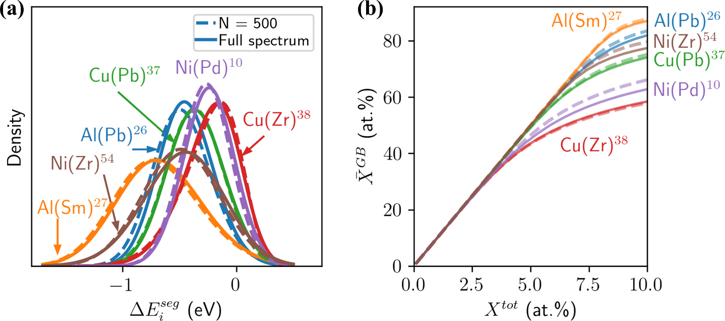
Fig. S1 Validating Accelerated Model. Segregation energy spectra obtained from a full system and the accelerated model are plotted in (a) for Al(Pb)²⁶, Al(Sm)²⁷, Cu(Pb)³⁷, Cu(Zr)³⁸, Ni(Pd)¹⁰ and Ni(Zr)⁵⁴. Isotherms at $T=600$K and $f^{GB}=0.1$ are demonstrated in (b) which follow the conditions used in Ref.⁶⁰.
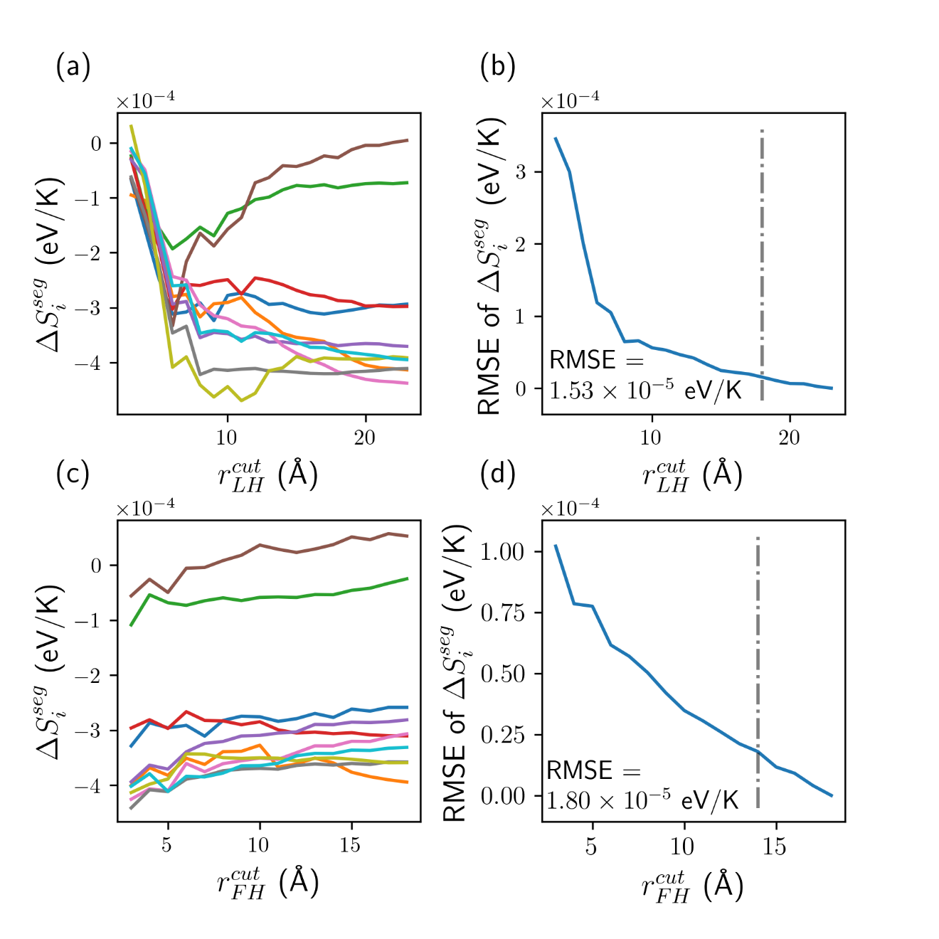
Fig. S2 Convergence of Al(Pb)²⁶.
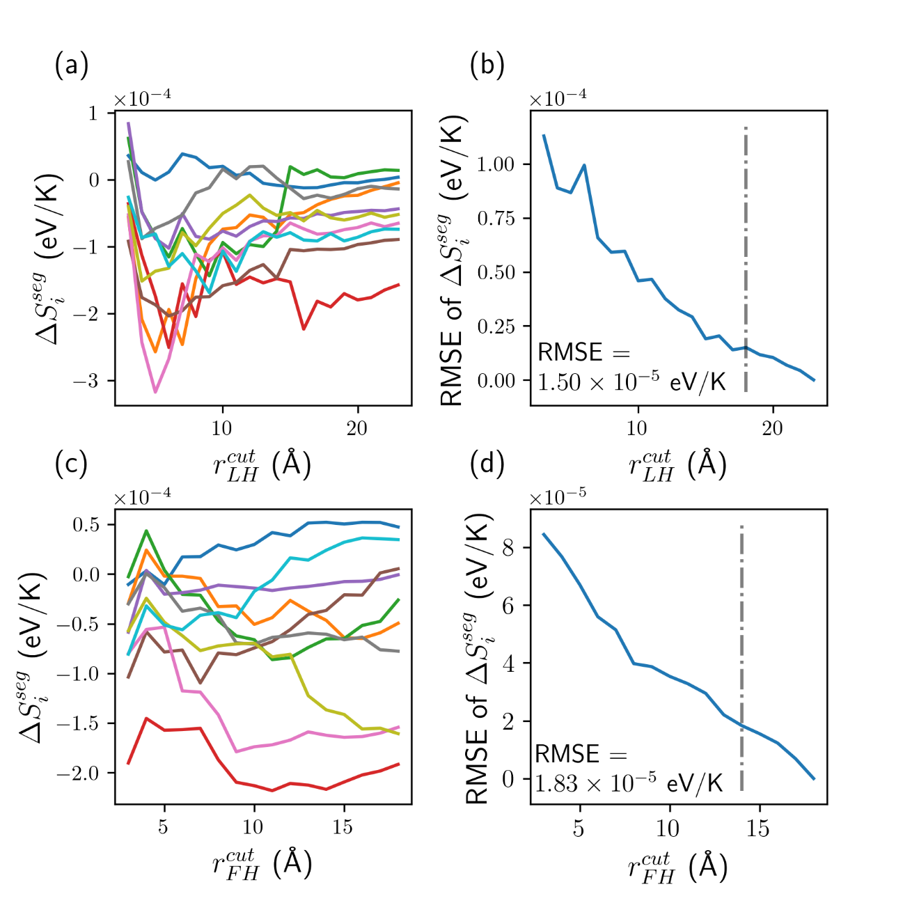

Fig. S3 Convergence of Al(Sm)²⁷.
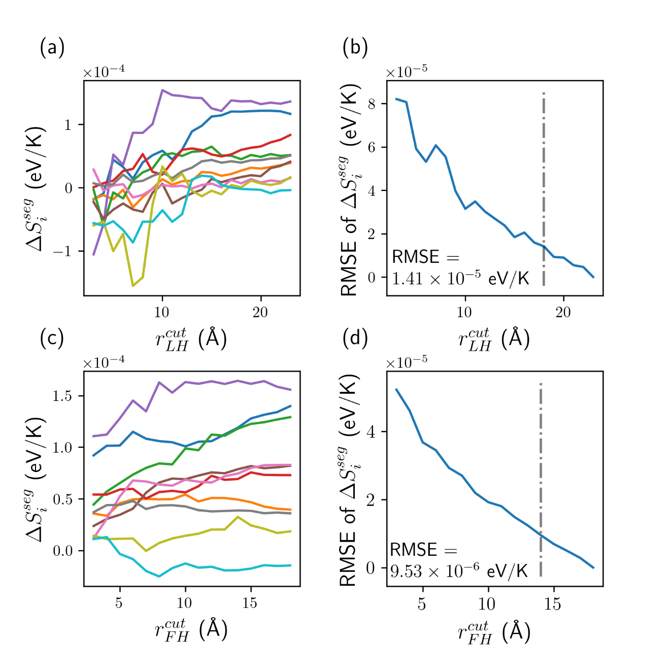
Fig. S4 Convergence of Cu(Pb)³⁷.
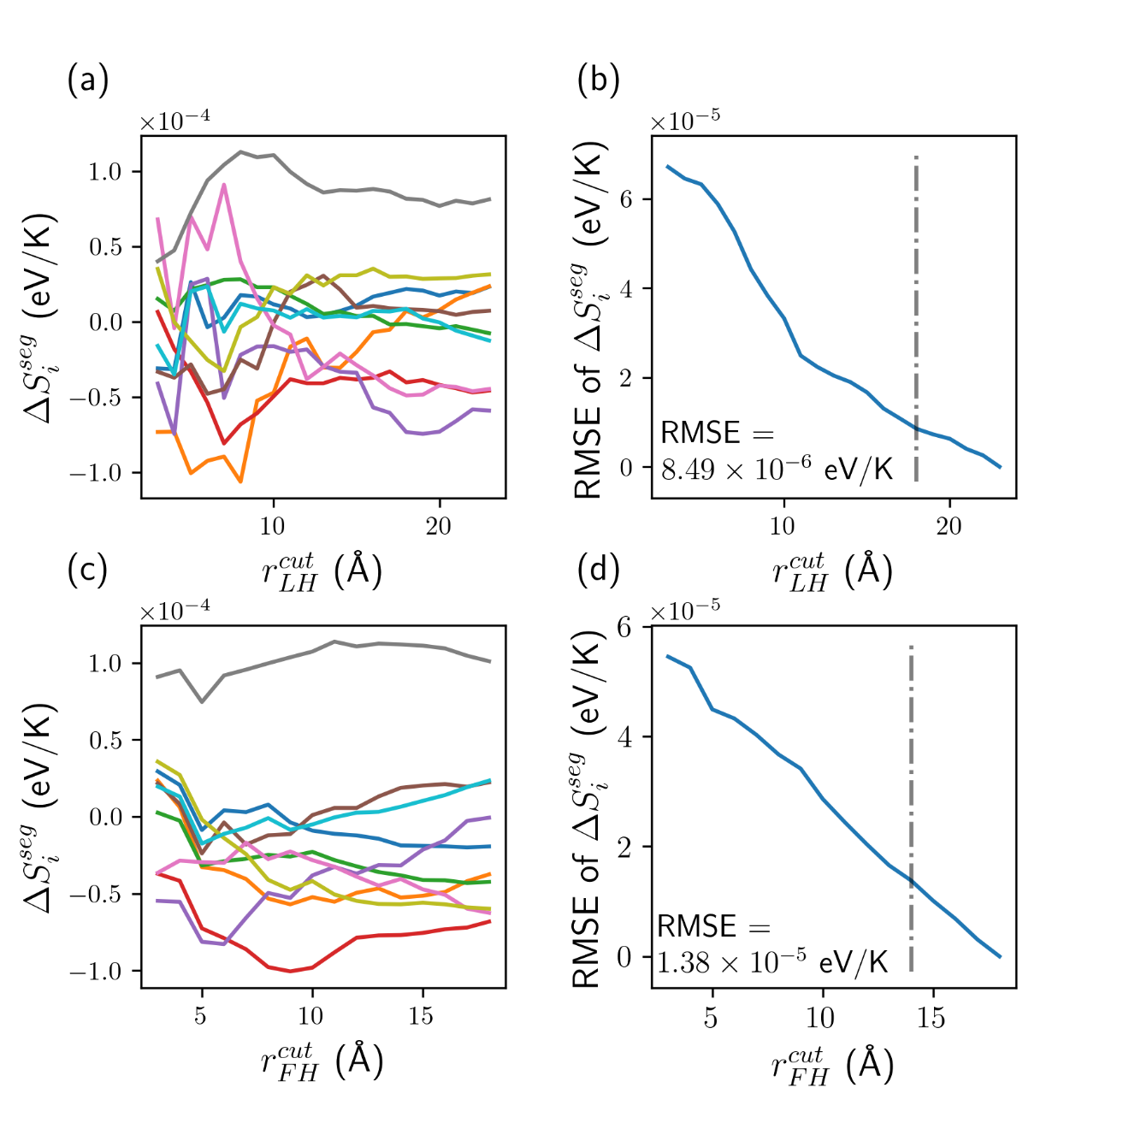
Fig. S5 Convergence of Cu(Zr)³⁸.
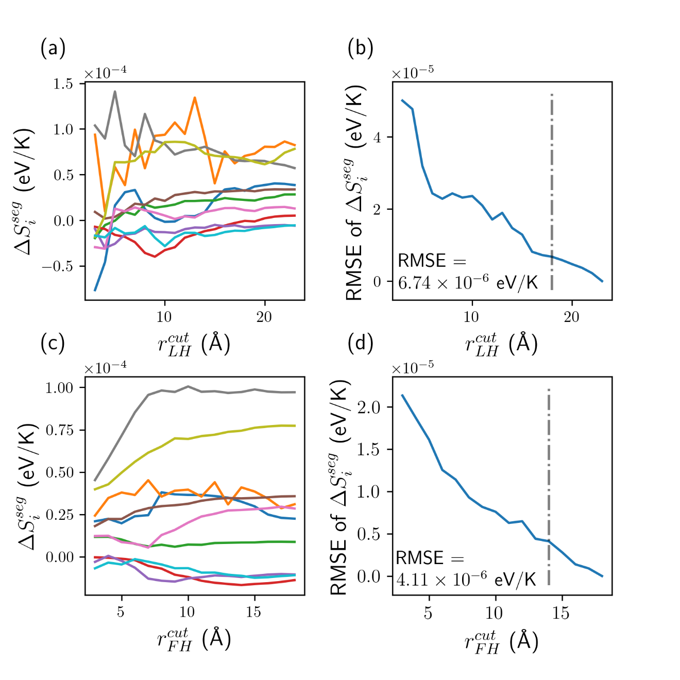
Fig. S6 Convergence of Ni(Pd)¹⁰.
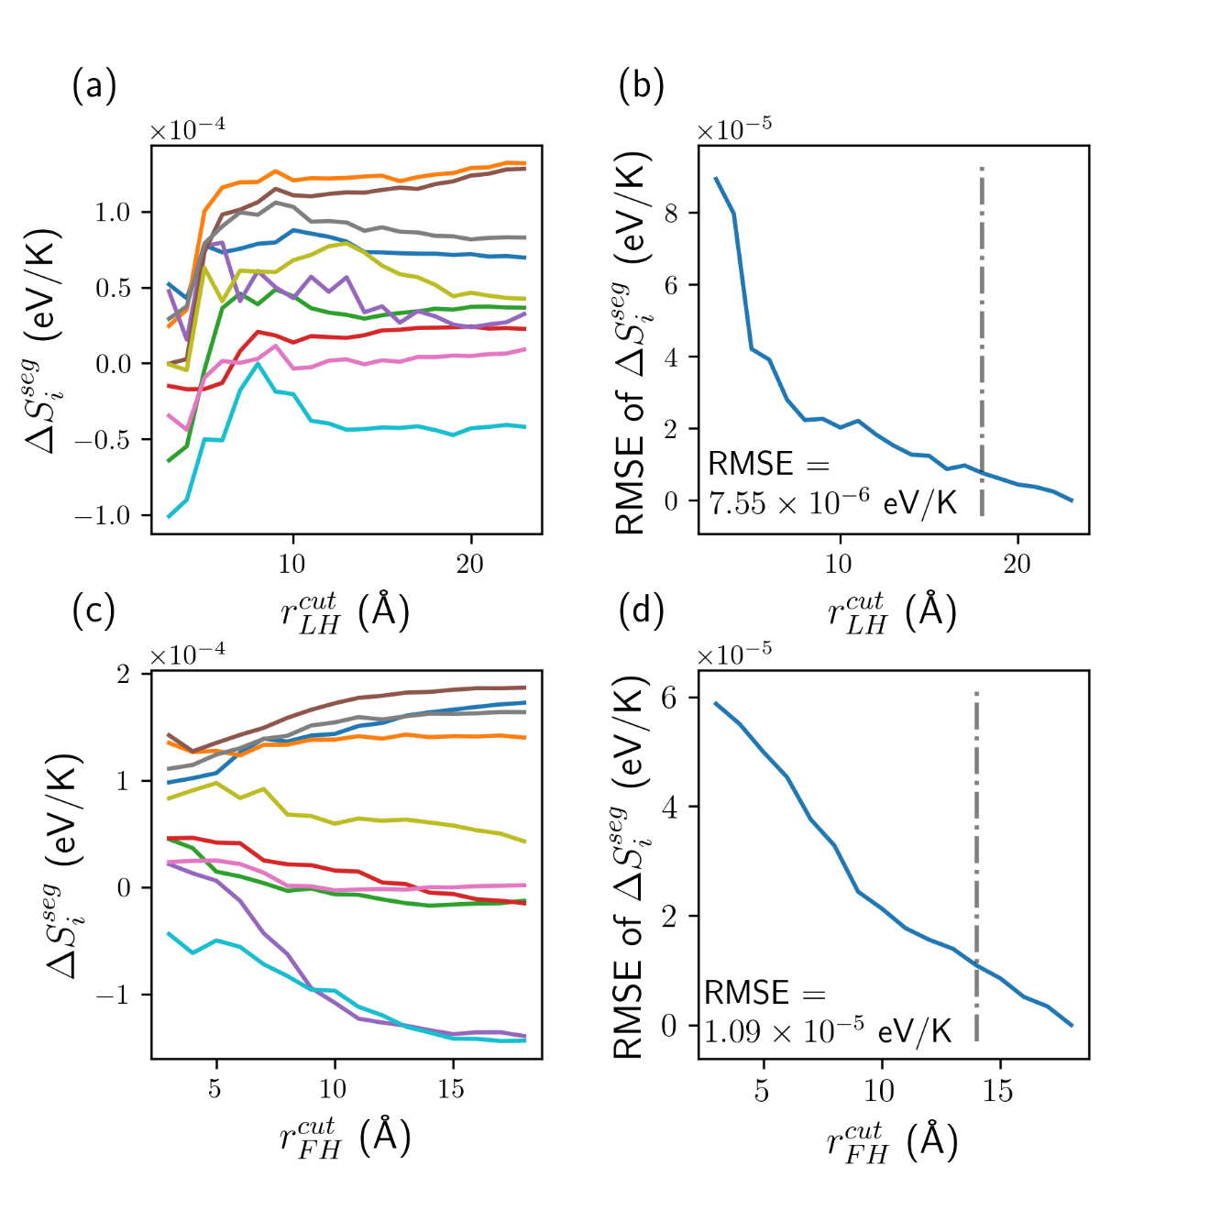
Fig. S7 Convergence of Ni(Zr)⁵⁴.
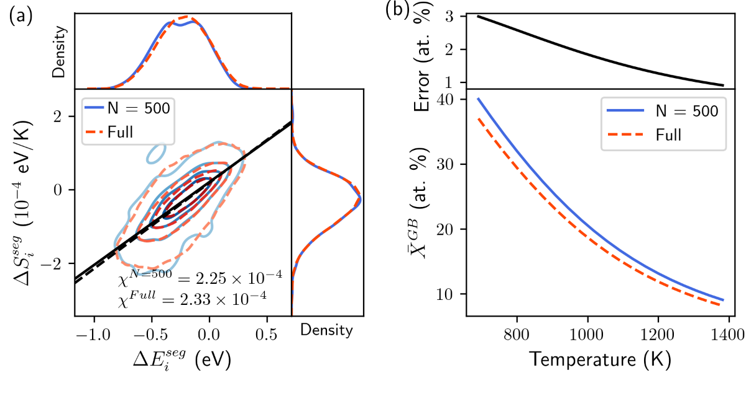
Fig. S8 Ni(Pd) Segregation Energy-Entropy Spectrum. The spectrum from the accelerated model and a 13×13×13-nm polycrystal are plotted in (a). The spectra are estimated via a bivariate Gaussian distribution and used to calculated the GB concentrations shown in (b) at a large grain size limit with X^{tot} = 1 at. %.
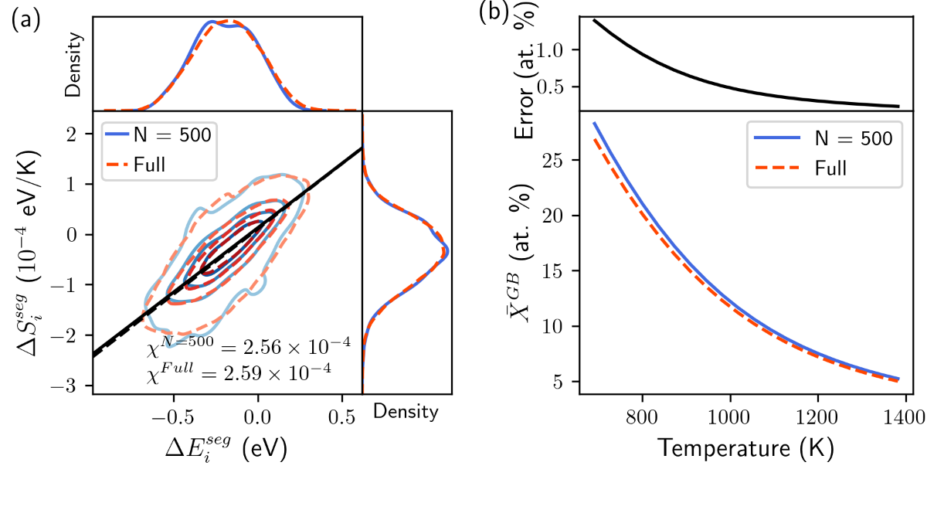
Fig. S9 Ni(Pt) Segregation Energy-Entropy Spectrum. The spectrum from the accelerated model and a 13×13×13-nm polycrystal are plotted in (a). The spectra are estimated via a bivariate Gaussian distribution and used to calculated the GB concentrations shown in (b) at a large grain size limit with X^{tot} = 1 at. %.
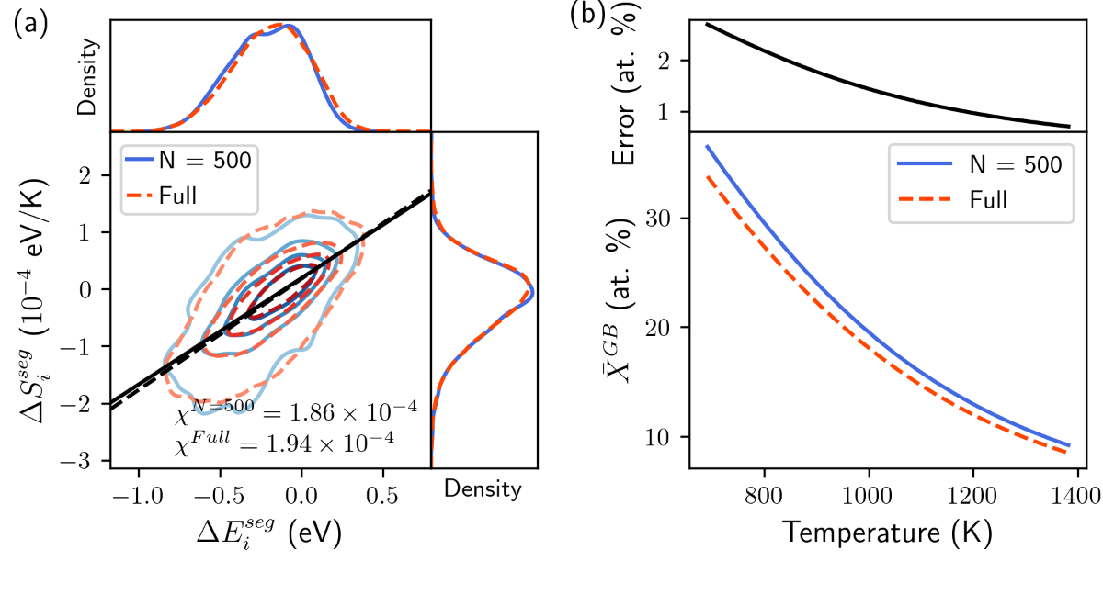
Fig. S10 Ni(Ag) Segregation Energy-Entropy Spectrum. The spectrum from the accelerated model and a 13×13×13-nm polycrystal are plotted in (a). The spectra are estimated via a bivariate Gaussian distribution and used to calculated the GB concentrations shown in (b) at a large grain size limit with X^{tot} = 1 at. %.
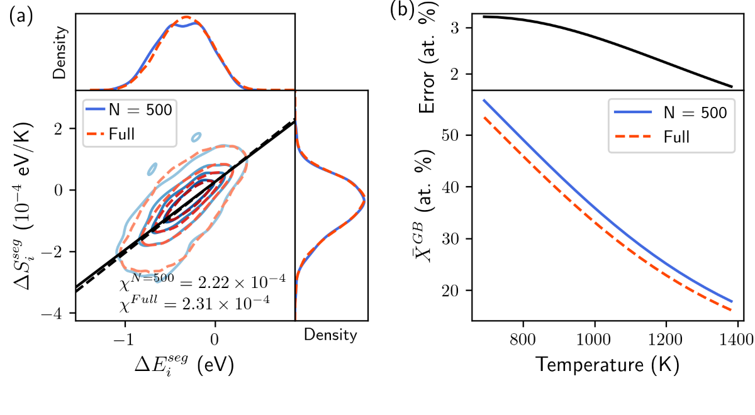
Fig. S11 Ni(Au) Segregation Energy-Entropy Spectrum. The spectrum from the accelerated model and a 13×13×13-nm polycrystal are plotted in (a). The spectra are estimated via a bivariate Gaussian distribution and used to calculated the GB concentrations shown in (b) at a large grain size limit with X^{tot} = 1 at. %.
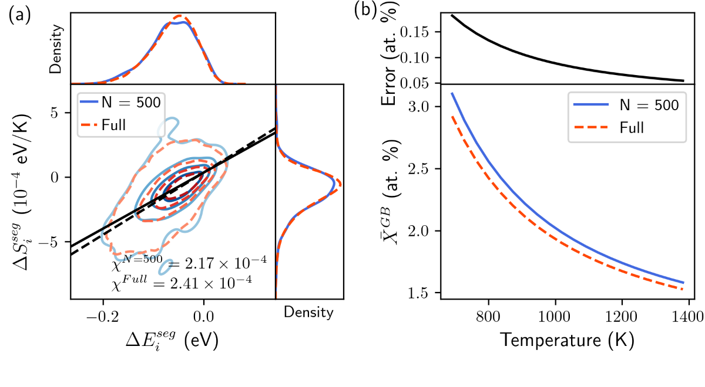
Fig. S12 Ni(Cu) Segregation Energy-Entropy Spectrum. The spectrum from the accelerated model and a 13×13×13-nm polycrystal are plotted in (a). The spectra are estimated via a bivariate Gaussian distribution and used to calculated the GB concentrations shown in (b) at a large grain size limit with X^{tot} = 1 at. %.

- Segregation Energy Validations and Spectra
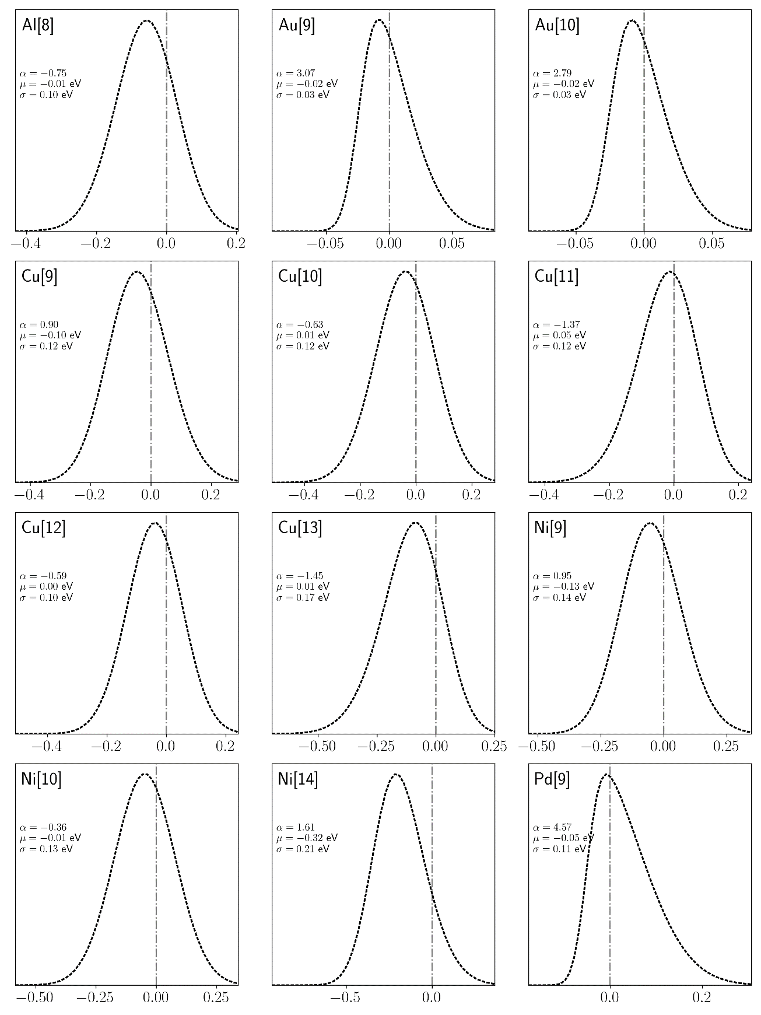

Fig. S13 Segregation Energy Spectra for Ag-based Alloys in eV
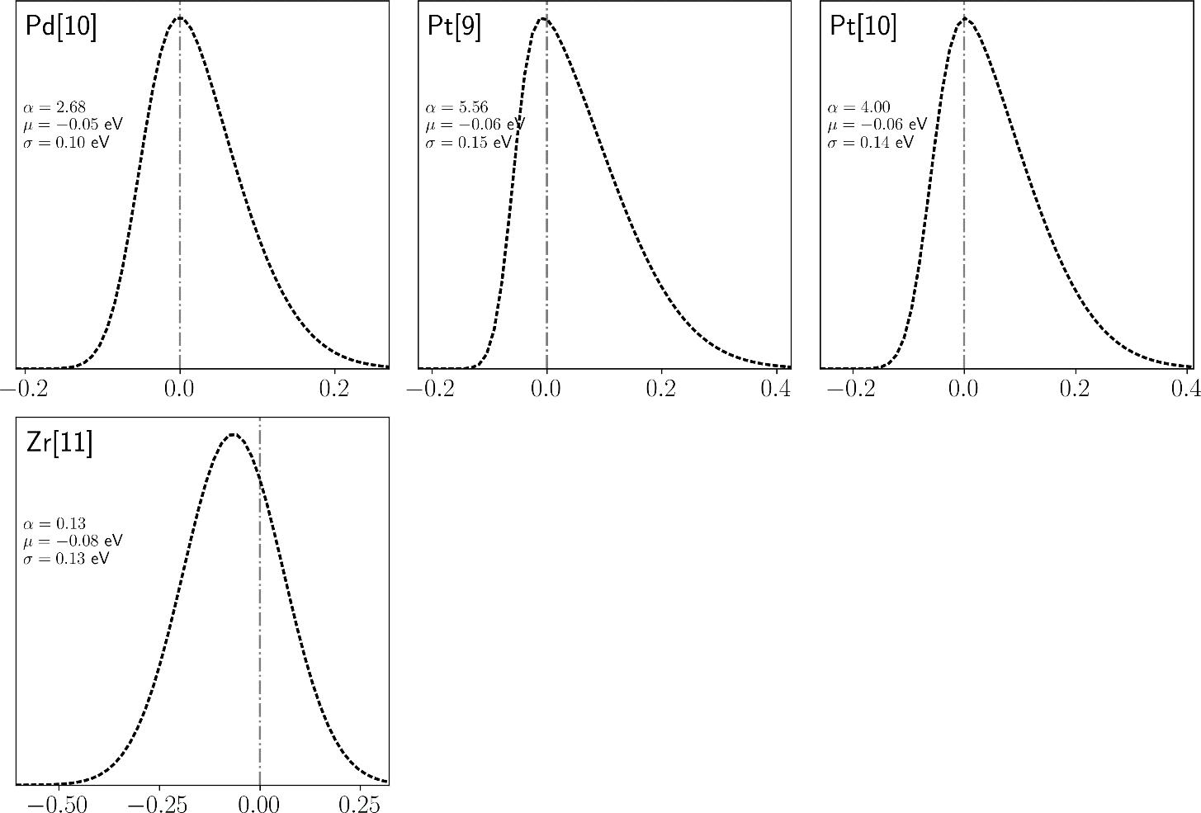
Fig. S14 Segregation Energy Spectra for Ag-based Alloys in eV (cont., 2).
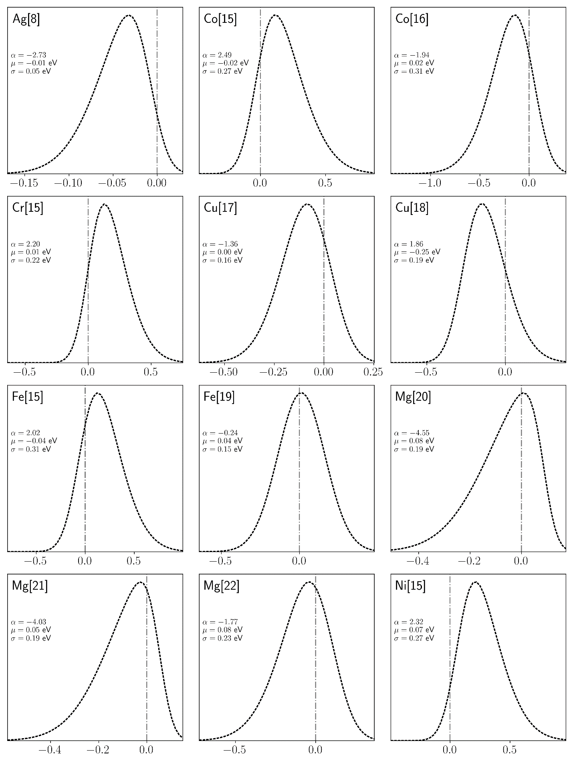
Fig. S15 Segregation Energy Spectra for Al-based Alloys in eV.
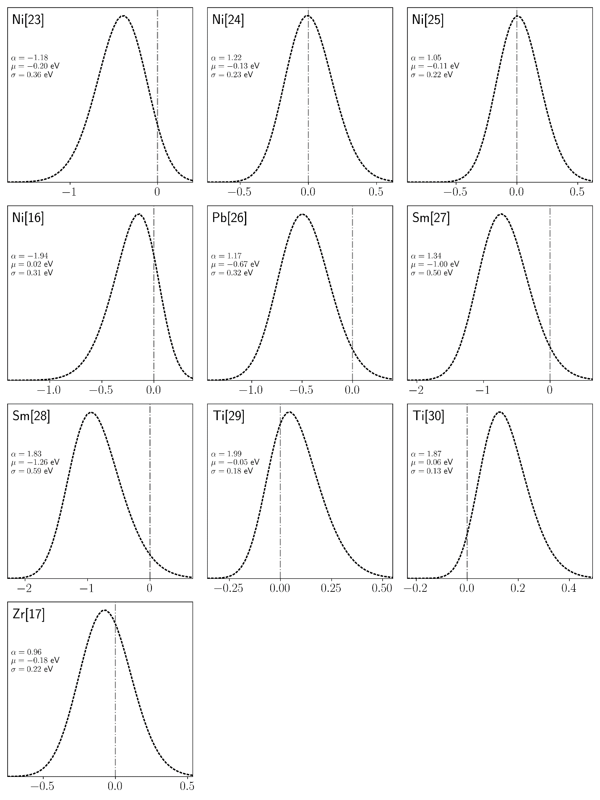
Fig. S16 Segregation Energy Spectra for Al-based Alloys in eV (cont., 2).
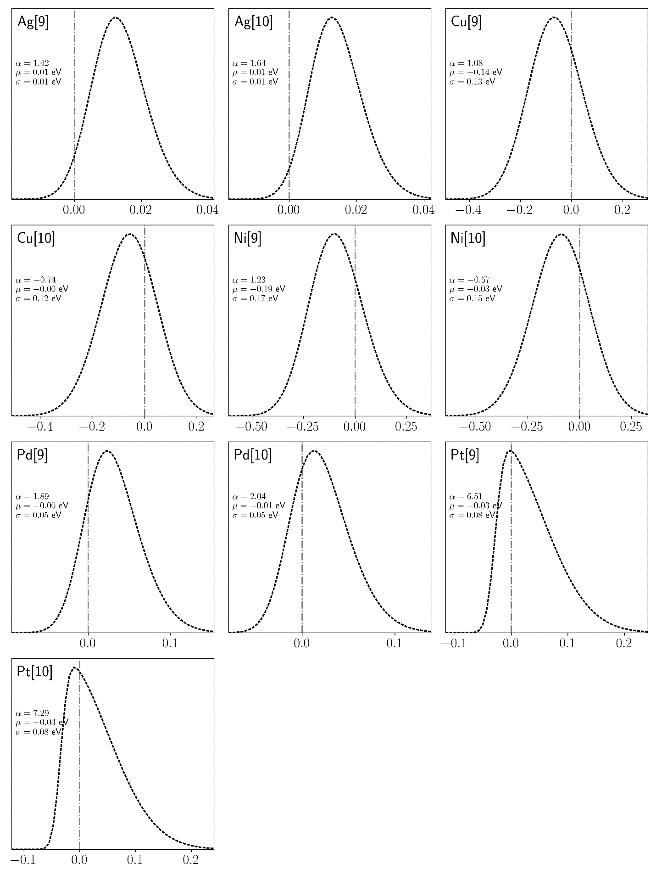
Fig. S17 Segregation Energy Spectra for Au-based Alloys in eV.
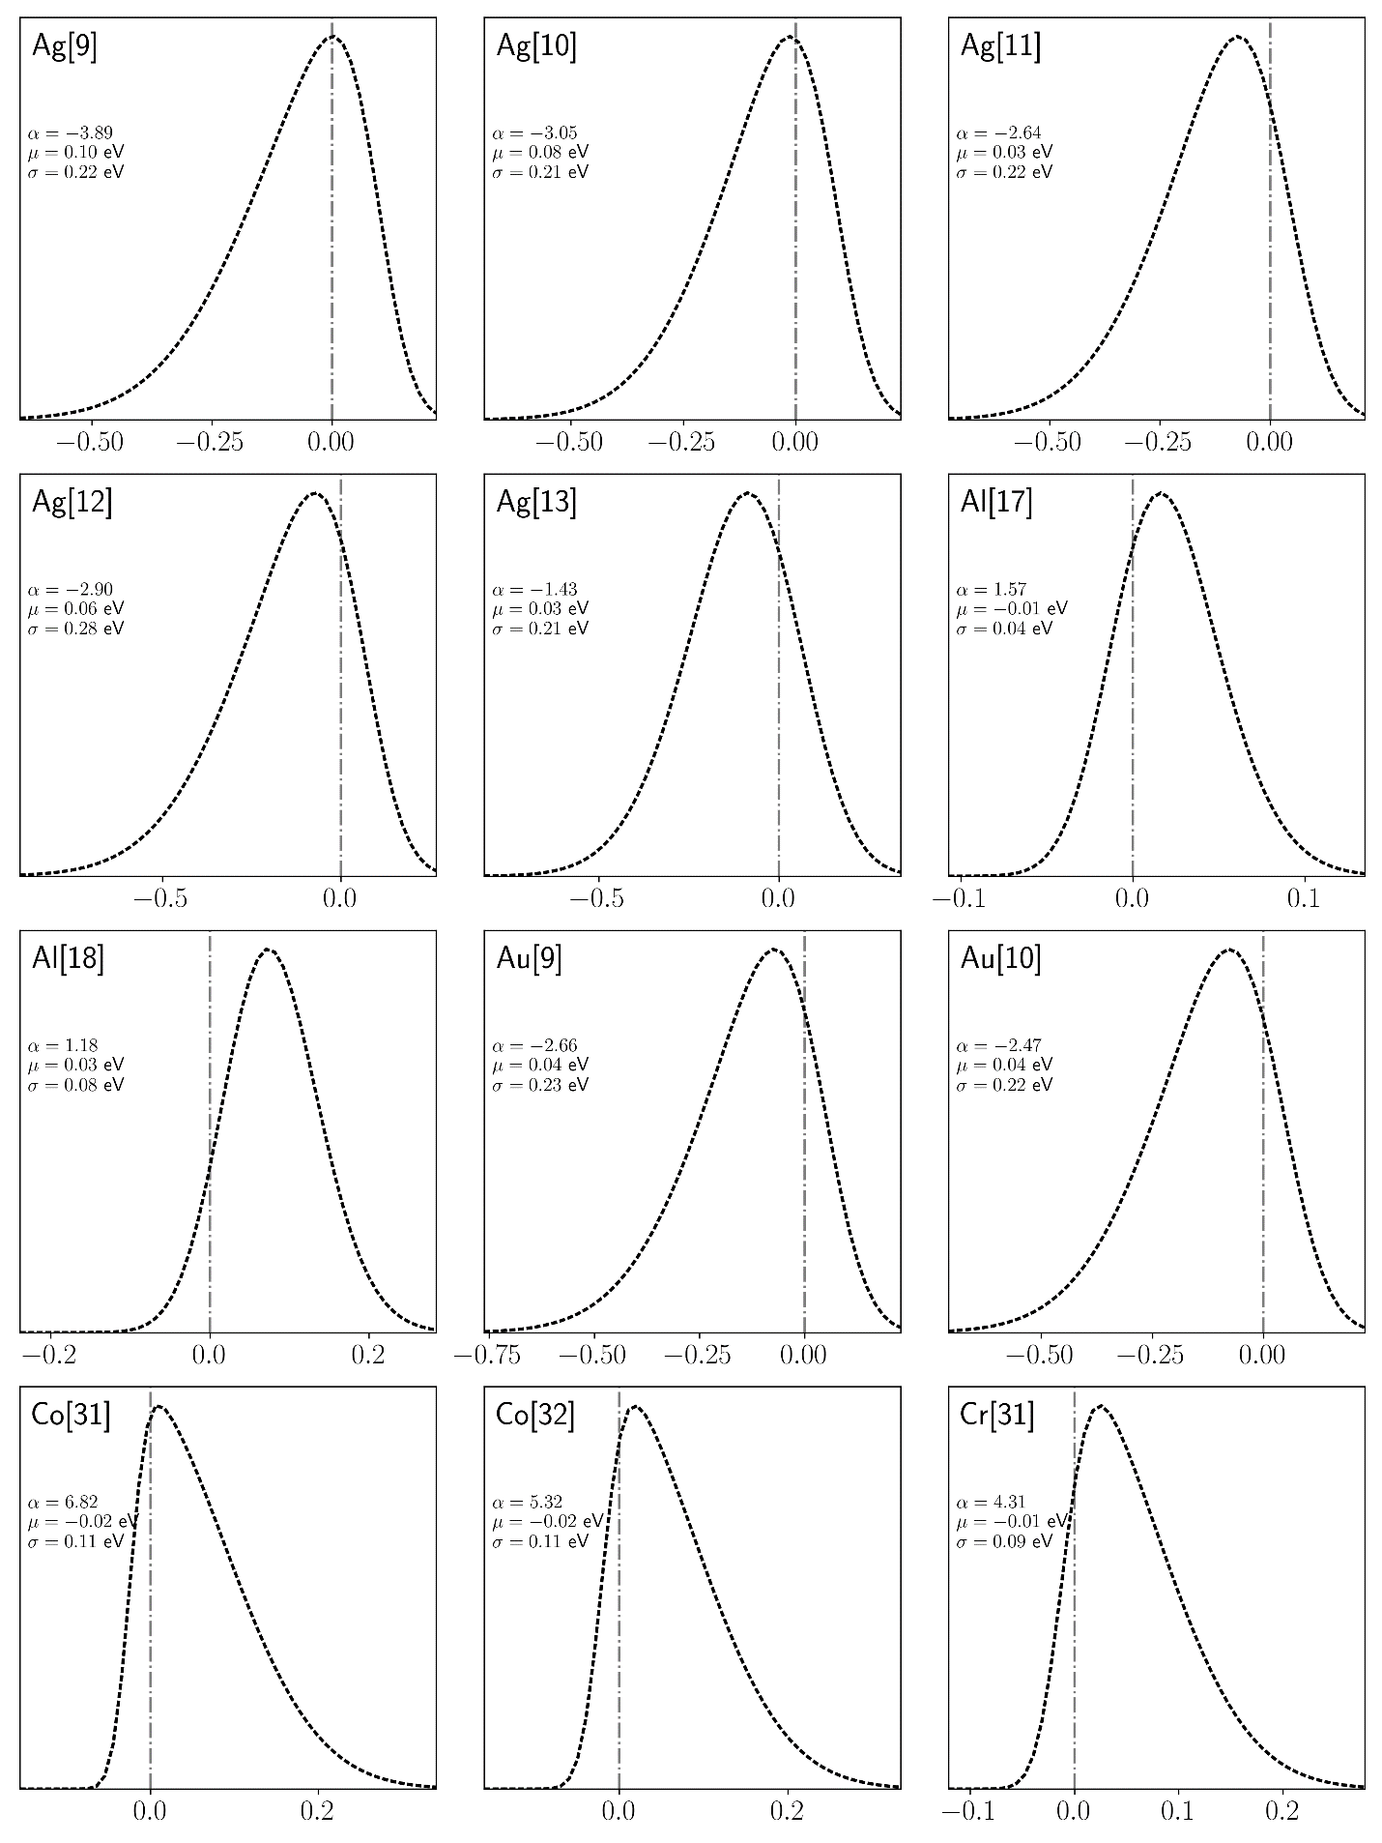
Fig. S18 Segregation Energy Spectra for Cu-based Alloys in eV.
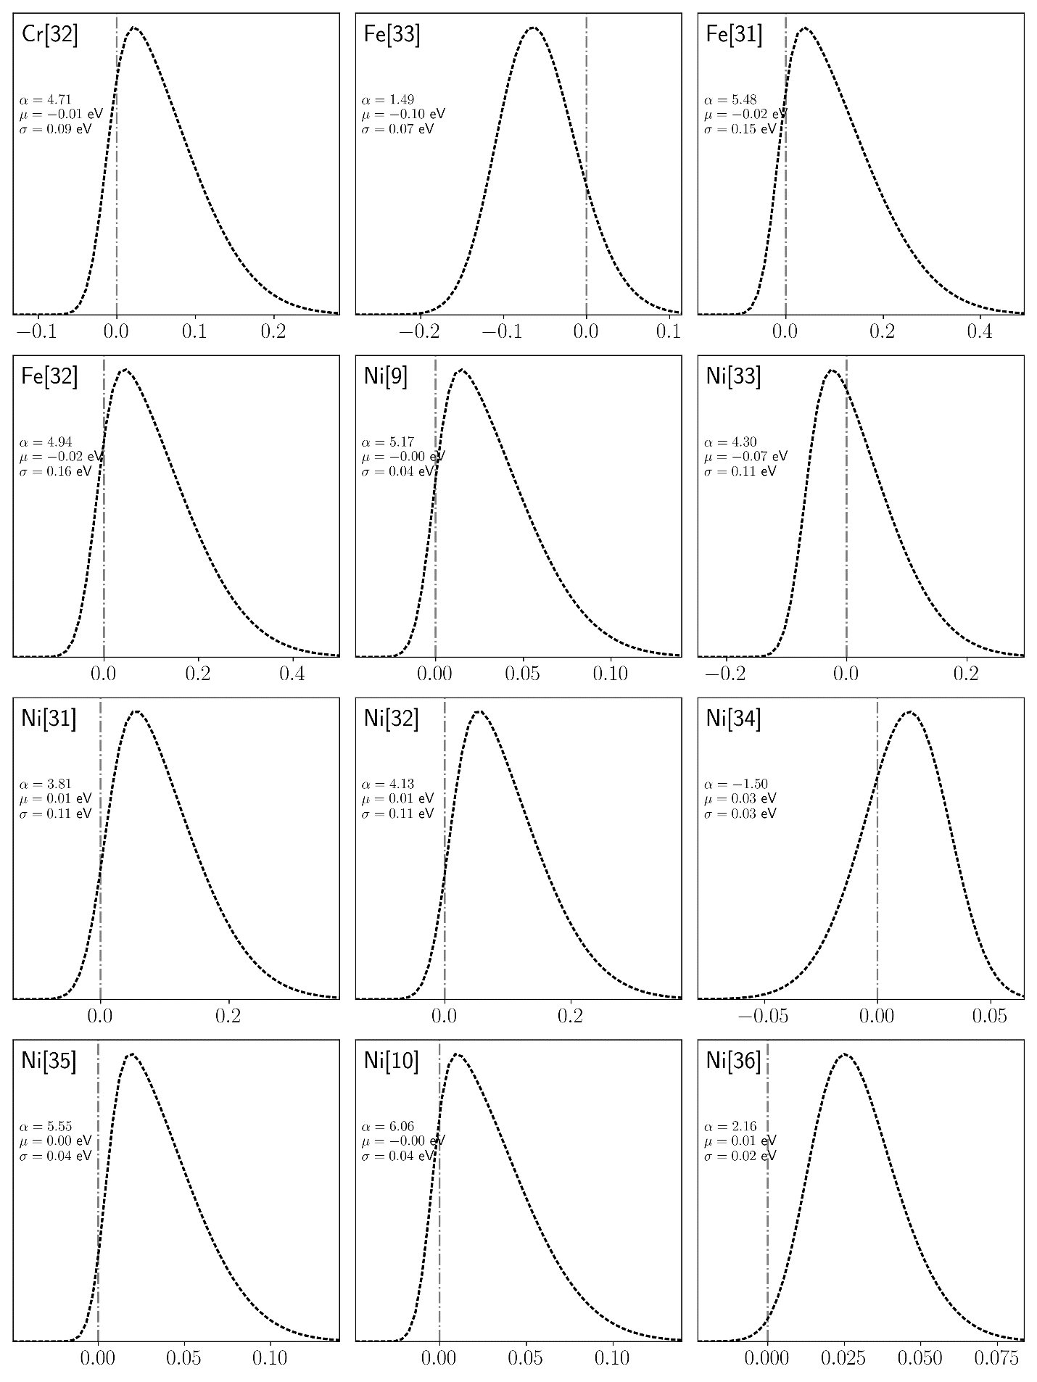
Fig. S19 Segregation Energy Spectra for Cu-based Alloys in eV (cont., 2).
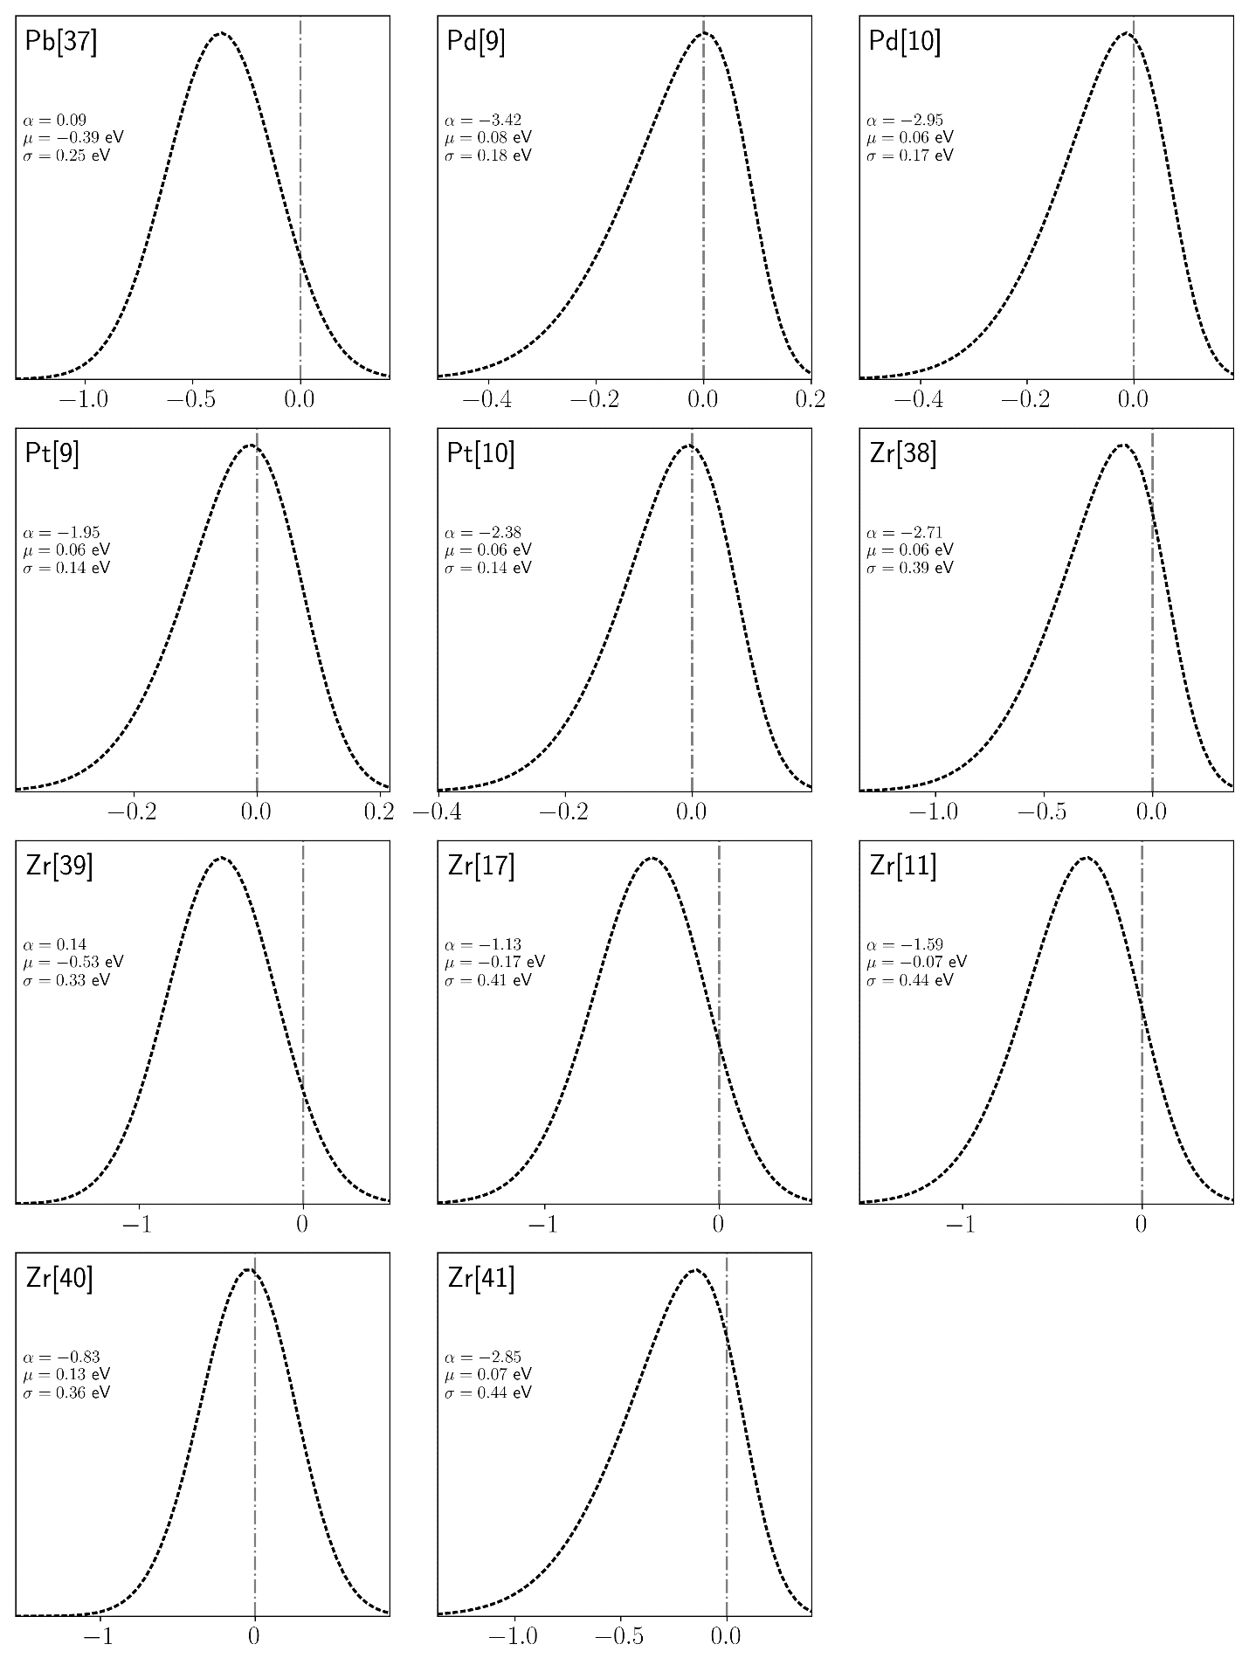
Fig. S20 Segregation Energy Spectra for Cu-based Alloys in eV (cont., 3).
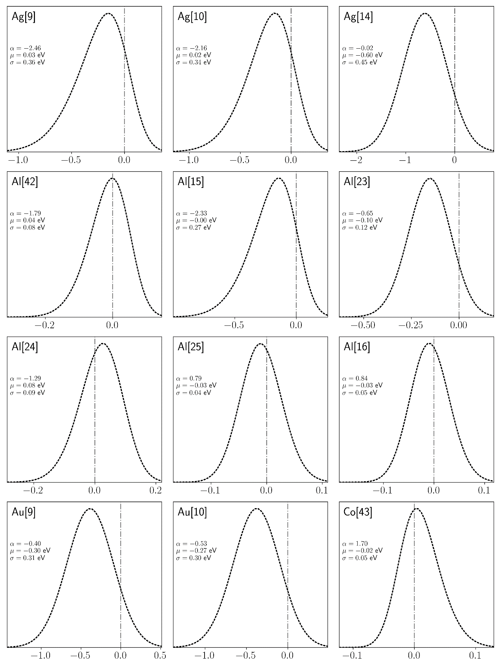
Fig. S21 Segregation Energy Spectra for Ni-based Alloys in eV.
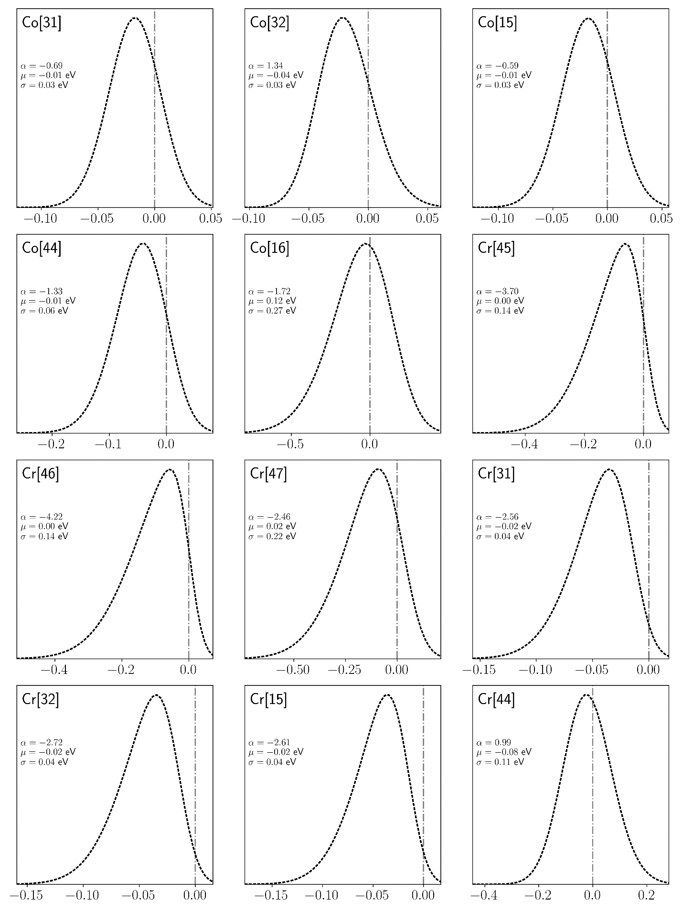
Fig. S22 Segregation Energy Spectra for Ni-based Alloys in eV (cont., 2).
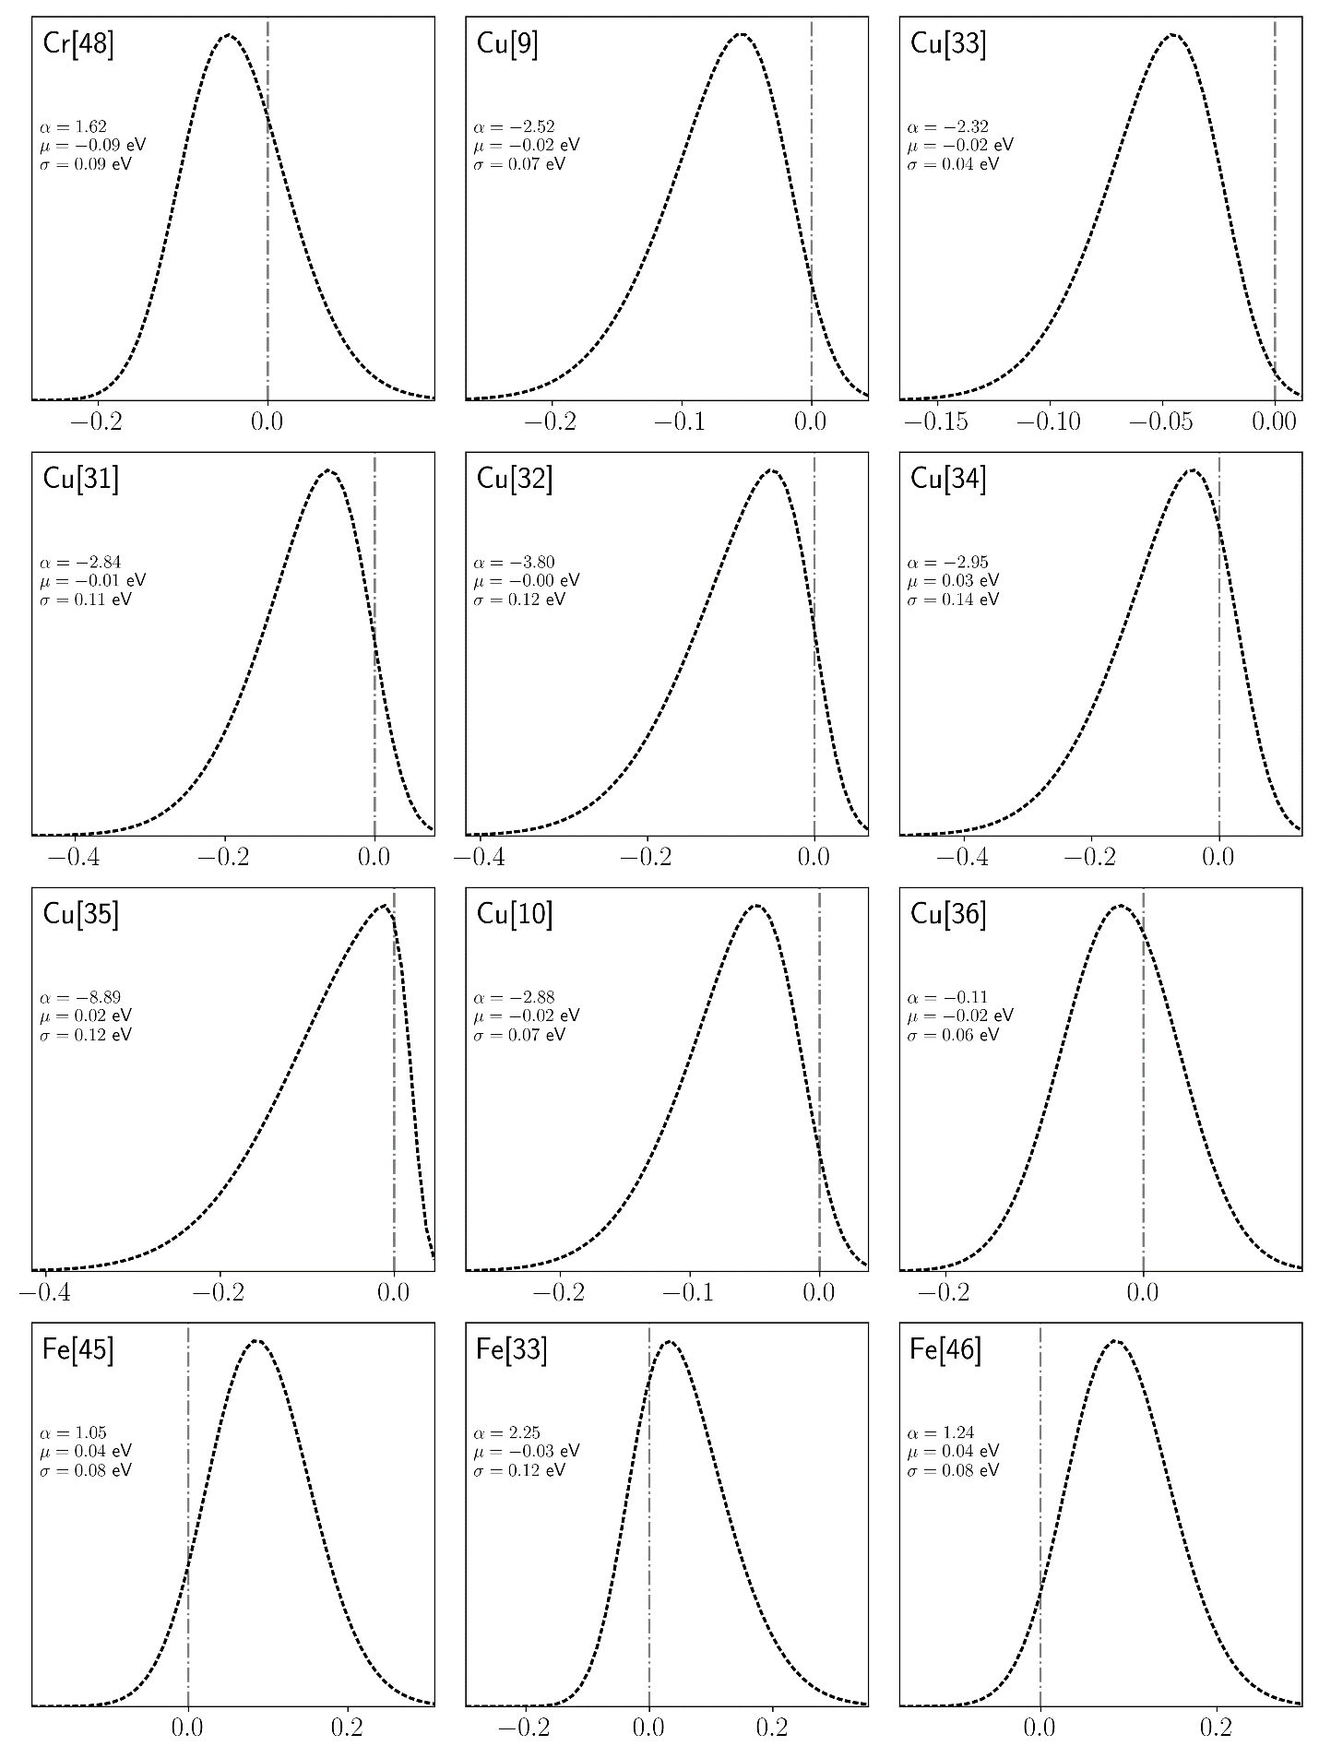
Fig. S23 Segregation Energy Spectra for Ni-based Alloys in eV (cont., 3).
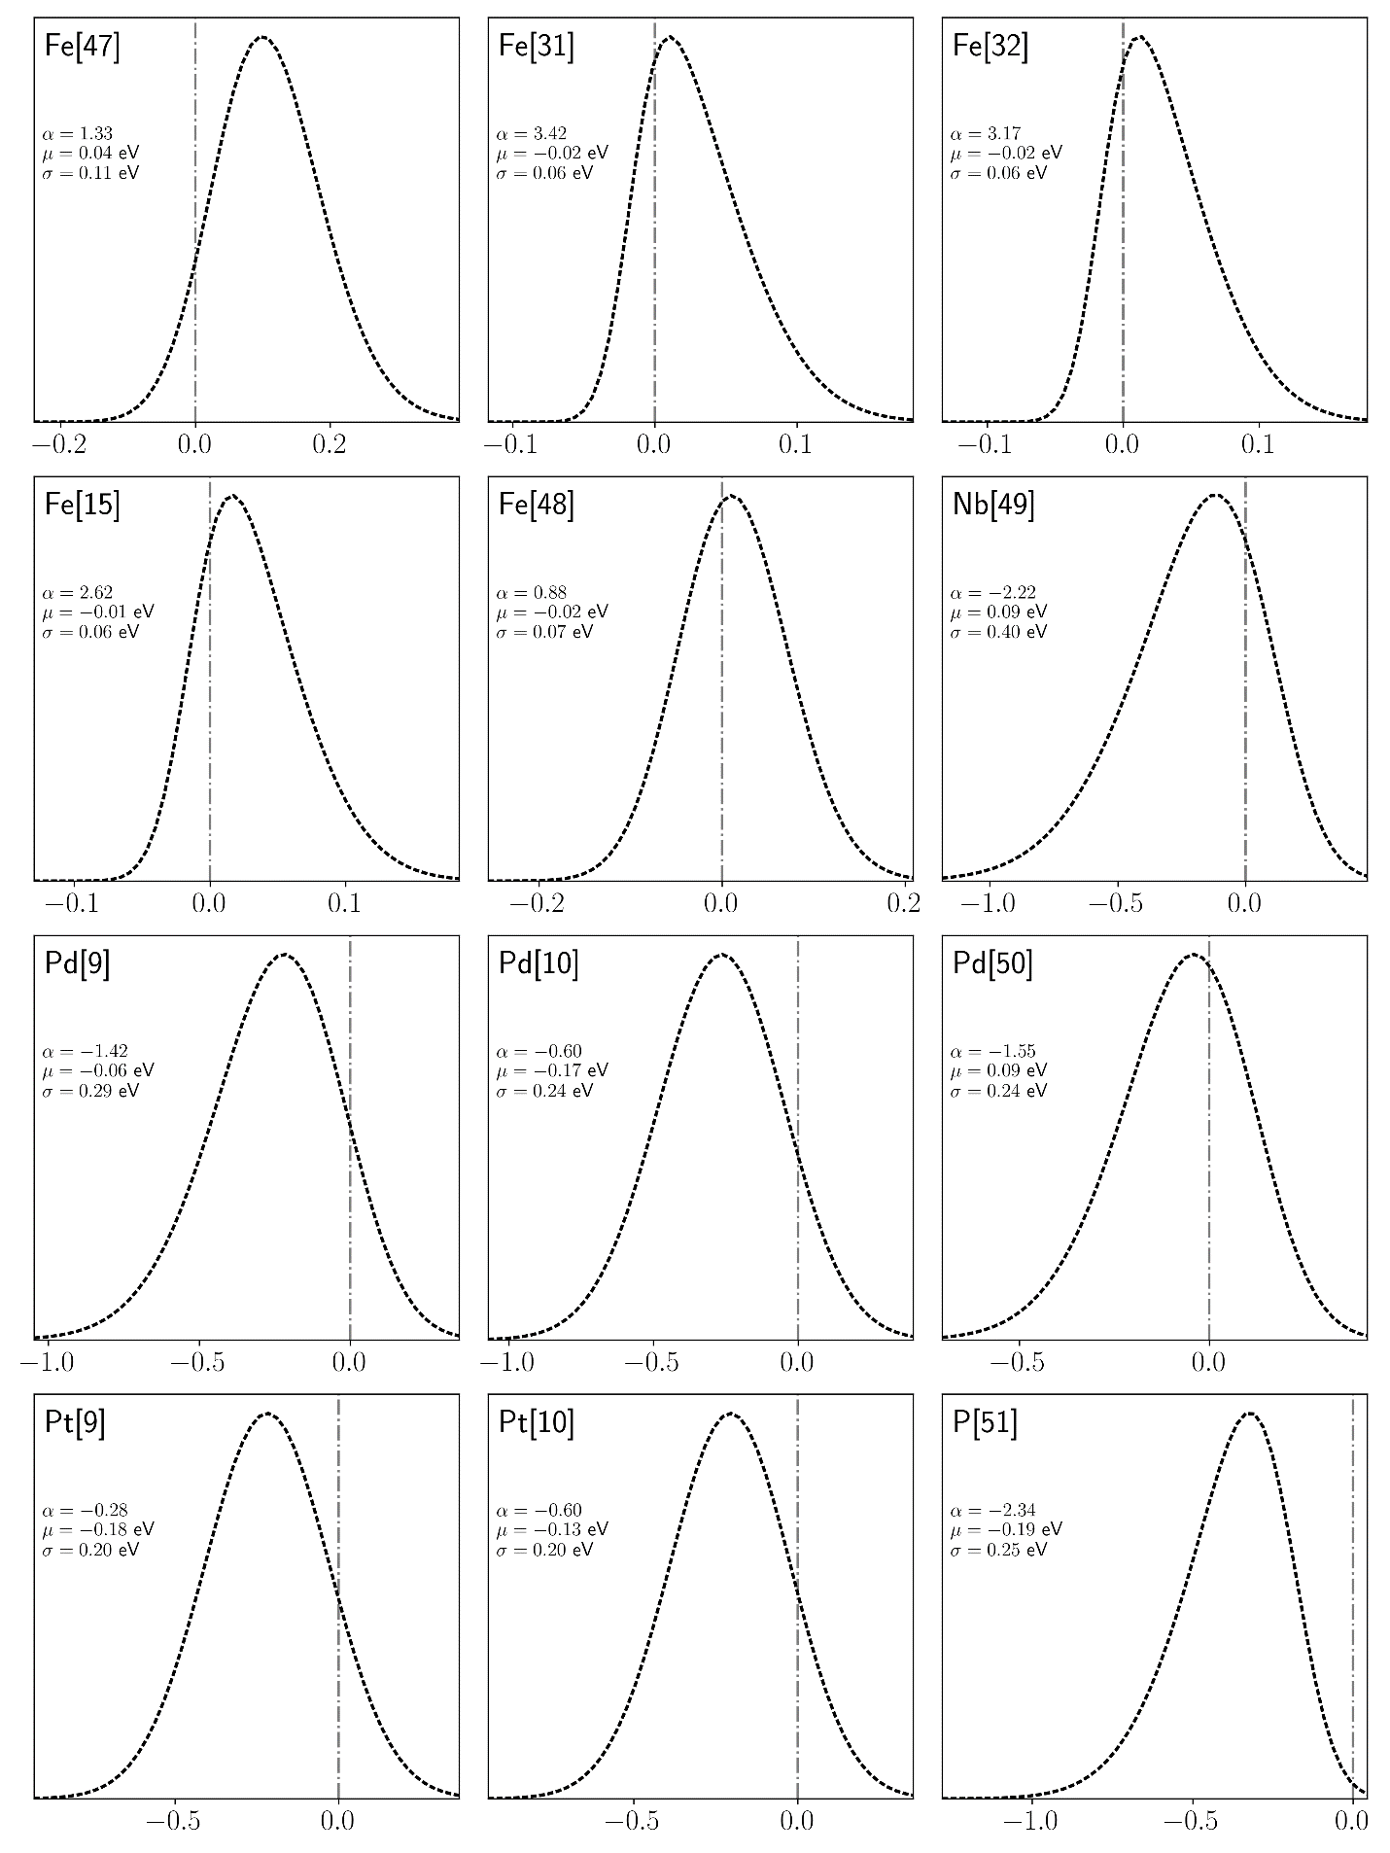
Fig. S24 Segregation Energy Spectra for Ni-based Alloys in eV (cont., 4).
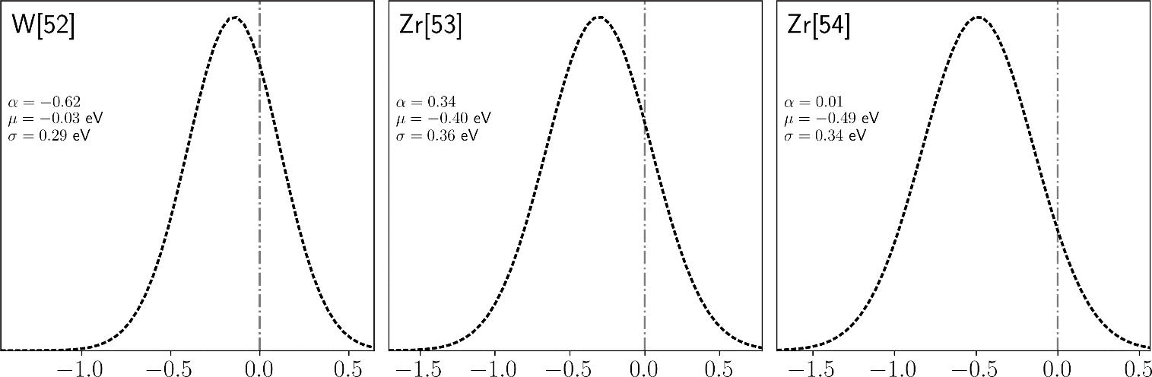Fig. S25 Segregation Energy Spectra for Ni-based Alloys in eV (cont., 5).
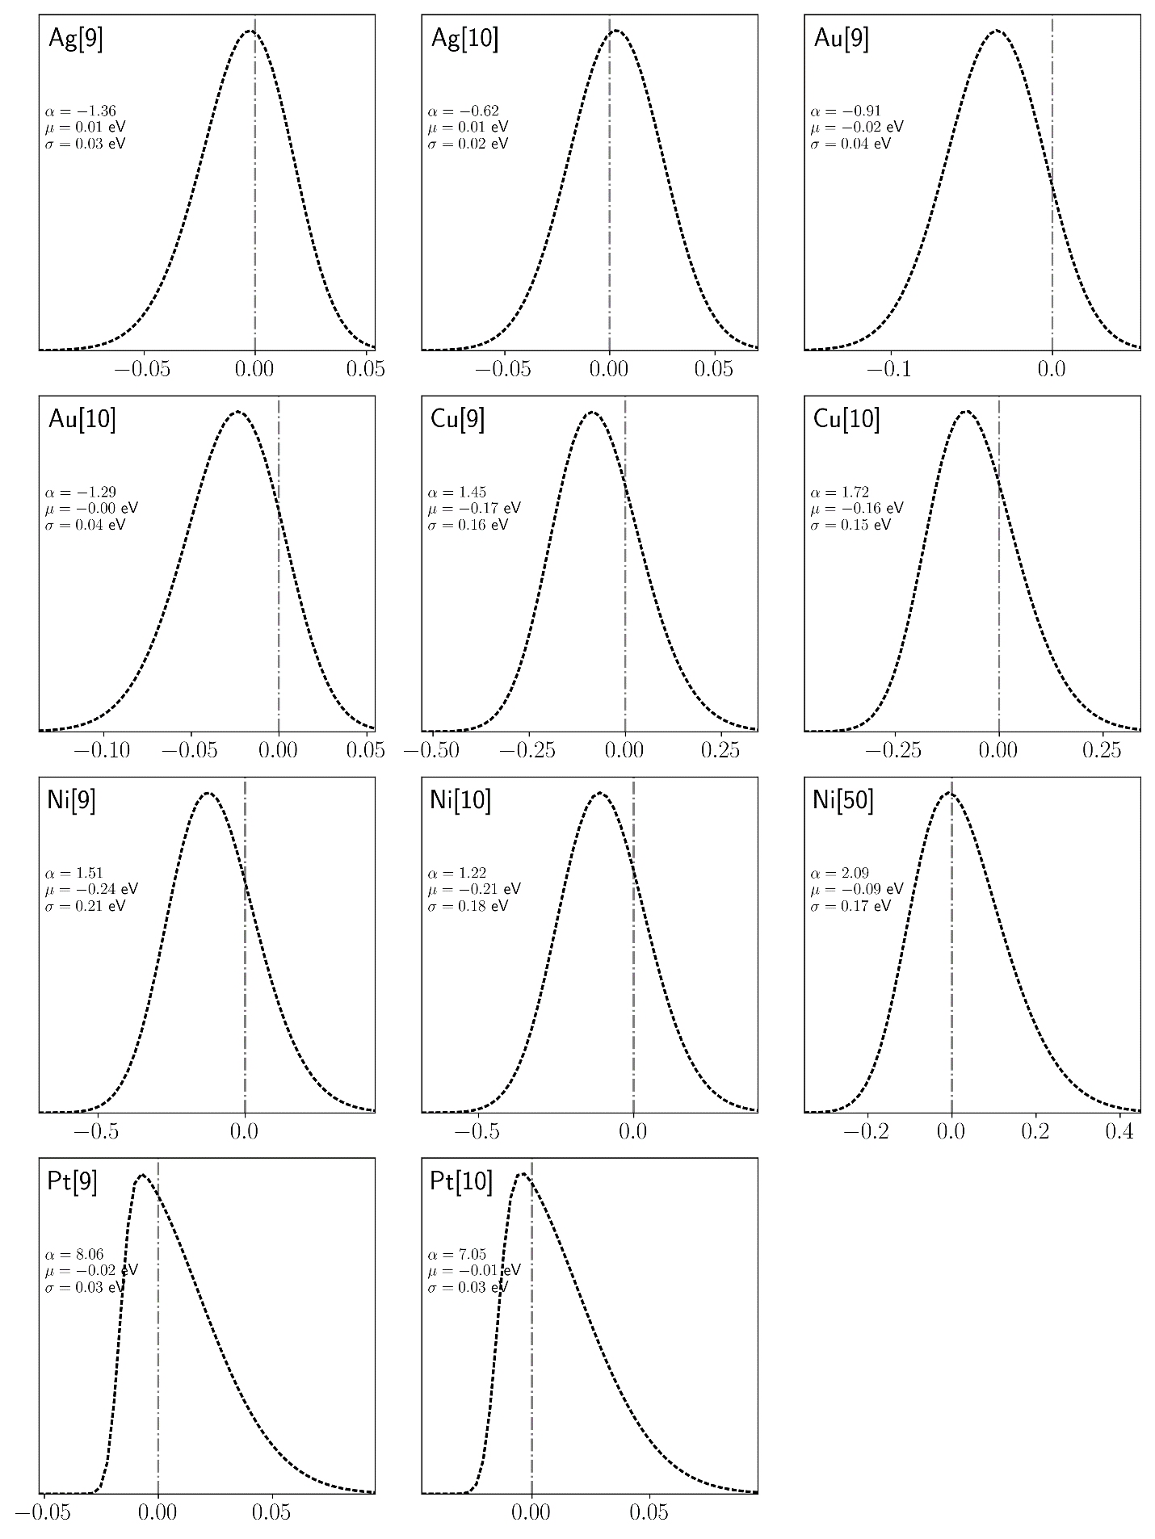
Fig. S26 Segregation Energy Spectra for Pd-based Alloys in eV.
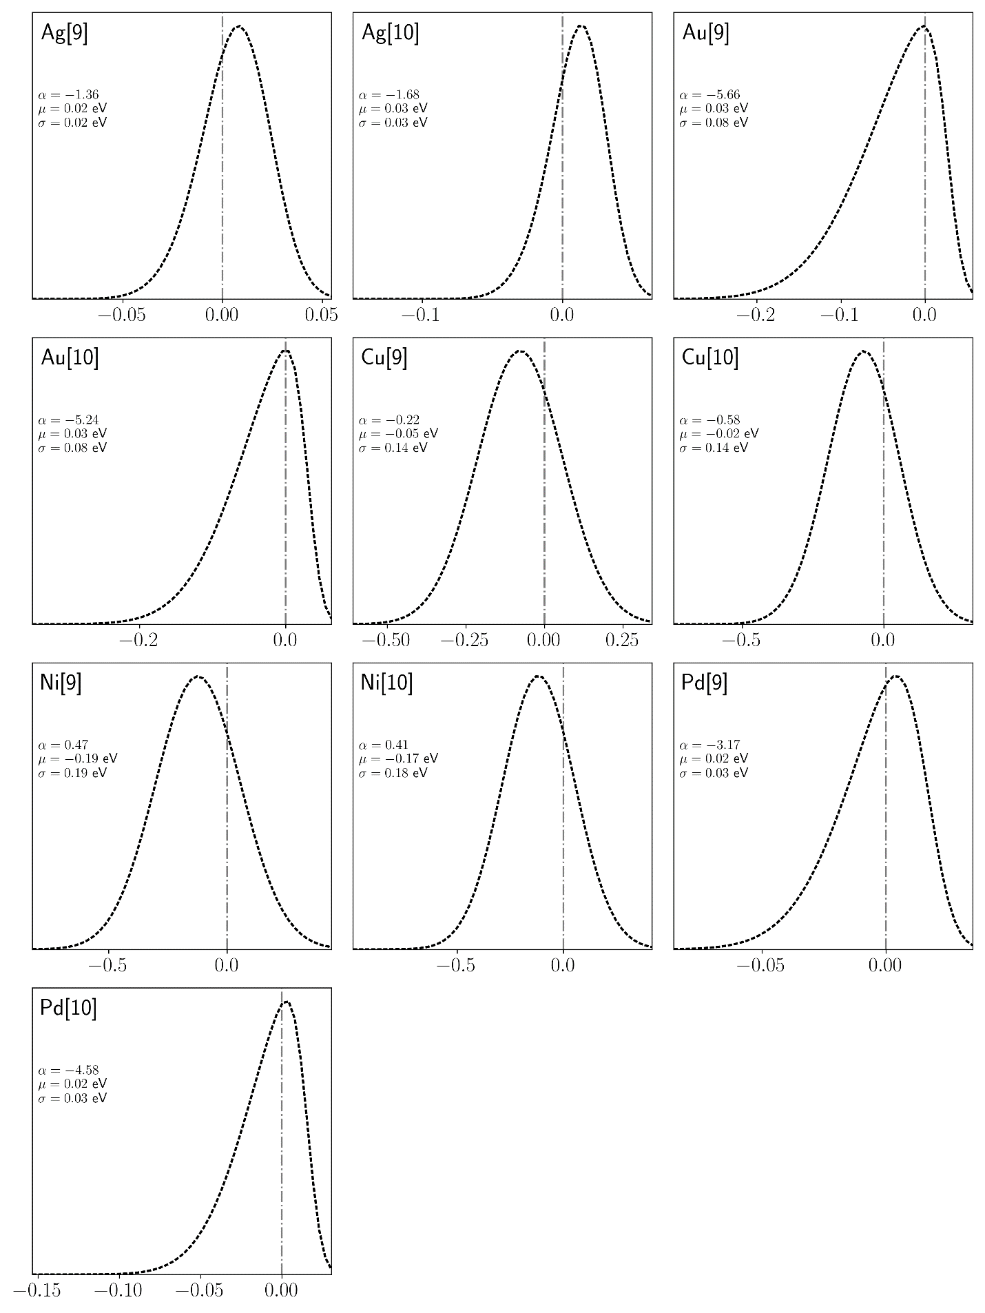
Fig. S27 Segregation Energy Spectra for Pt-based Alloys in eV.
- E-S Relationships
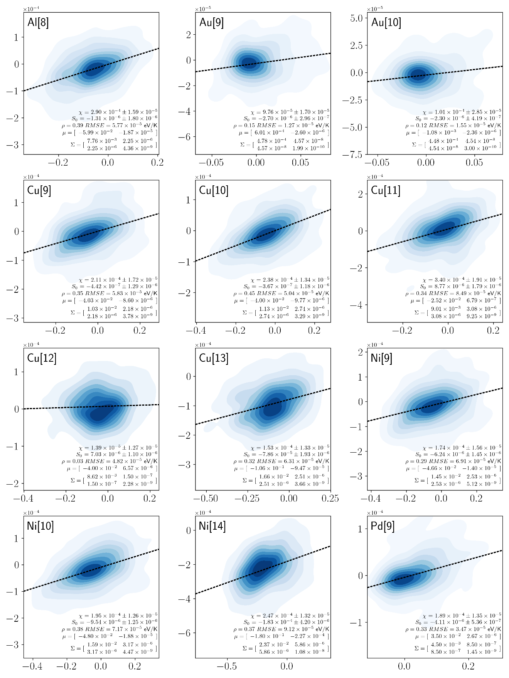
Fig. S28 Segregation Energy-Entropy Spectra for Ag-based Alloys in eV and eV/K respectively.
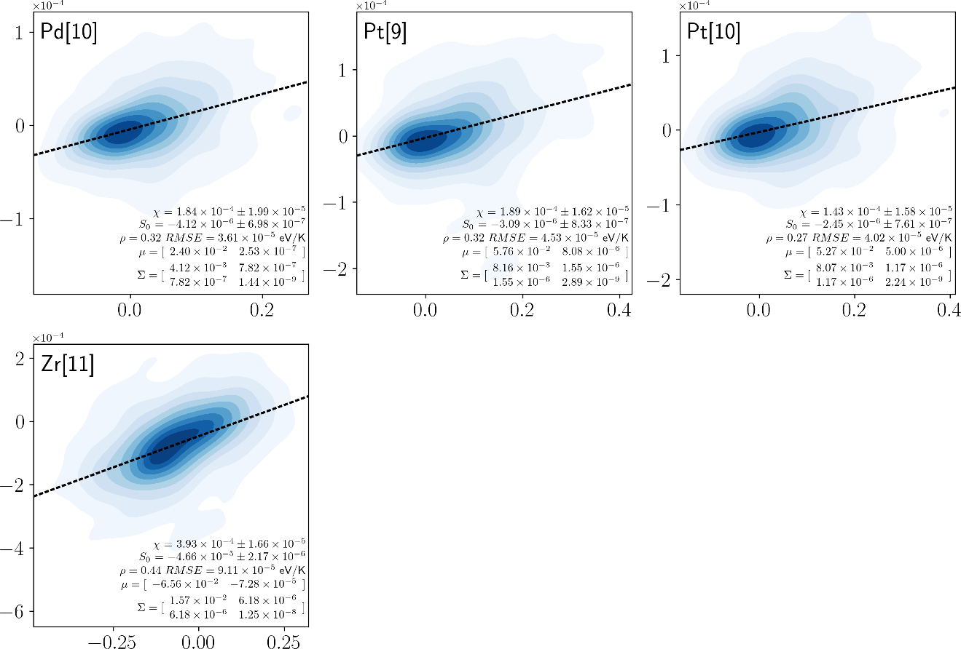
Fig. S29 Segregation Energy-Entropy Spectra for Ag-based Alloys in eV and eV/K respectively.
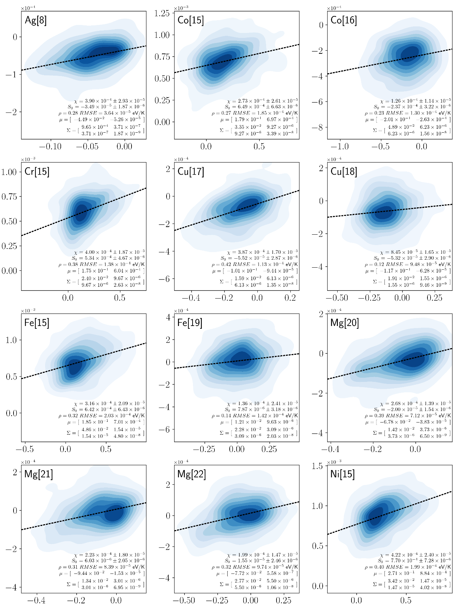

Fig. S30 Segregation Energy-Entropy Spectra for Al-based Alloys in eV and eV/K respectively.

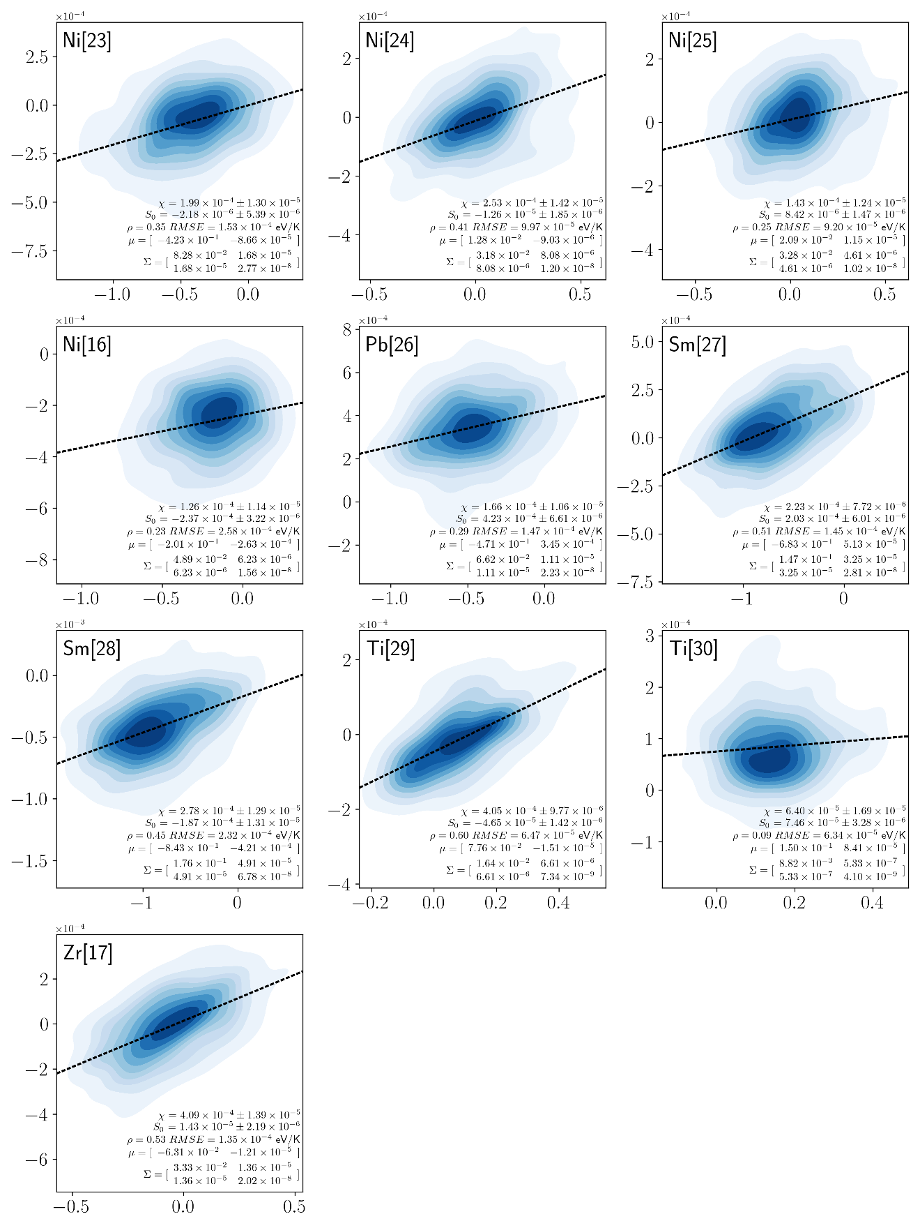
Fig. S31 Segregation Energy-Entropy Spectra for Al-based Alloys in eV and eV/K respectively (cont., 2).
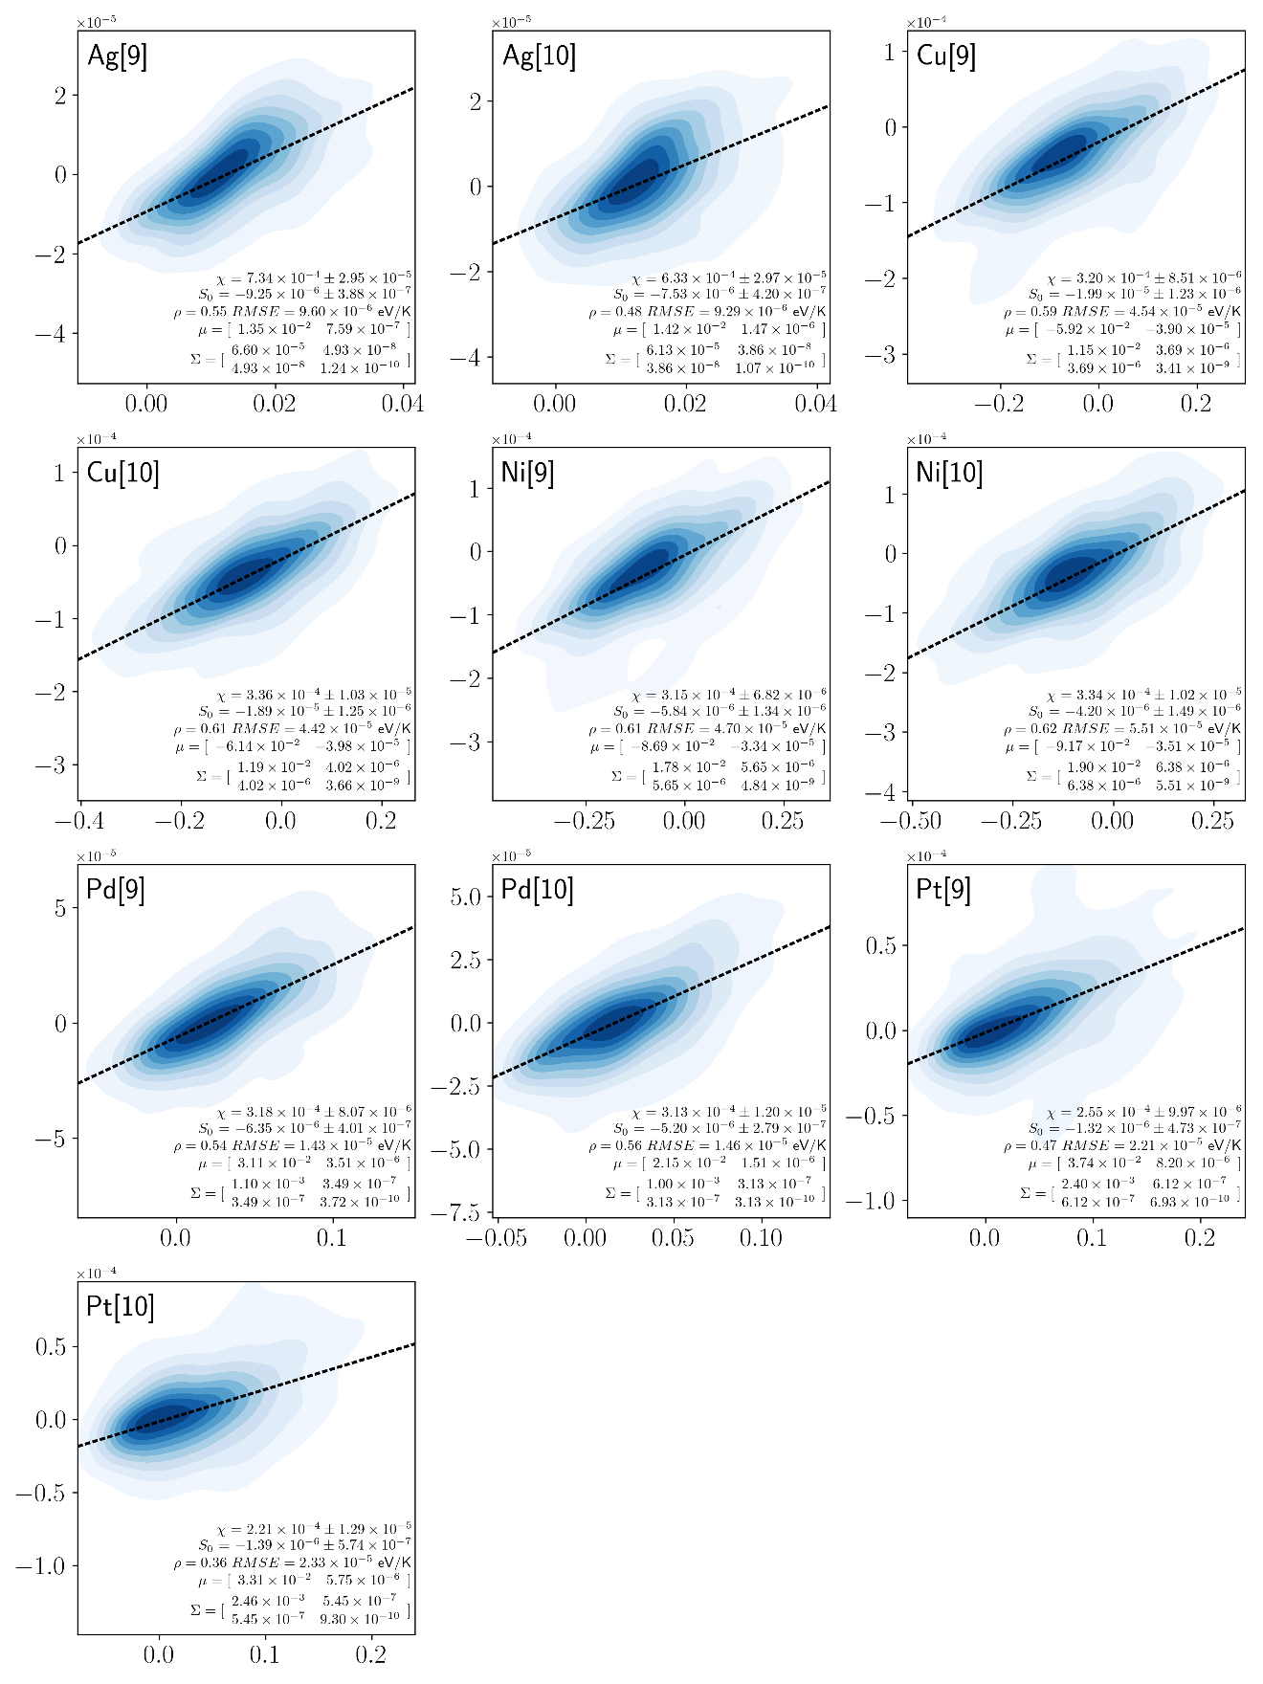
Fig. S32 Segregation Energy-Entropy Spectra for Au-based Alloys in eV and eV/K respectively.
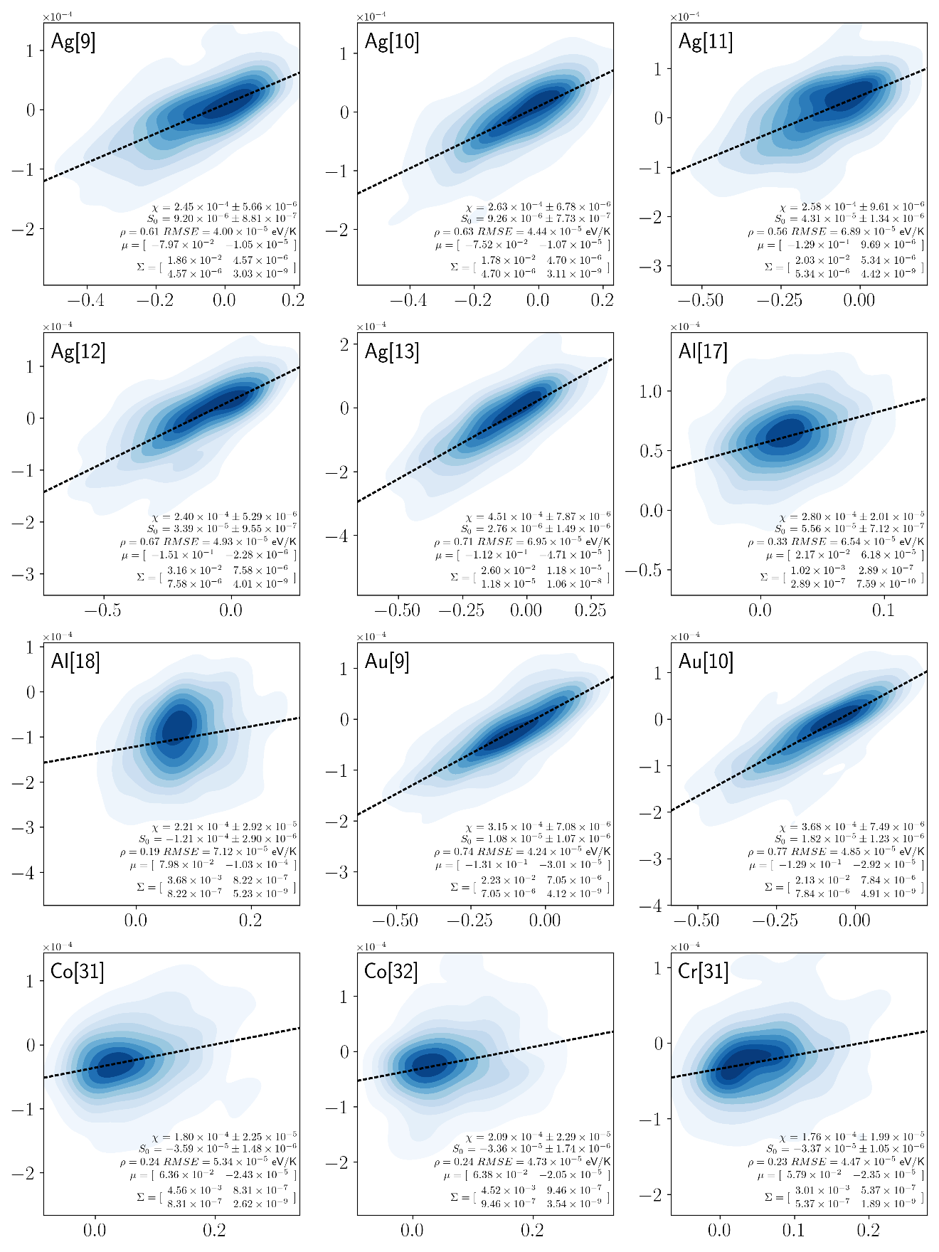
Fig. S33 Segregation Energy-Entropy Spectra for Cu-based Alloys in eV and eV/K respectively
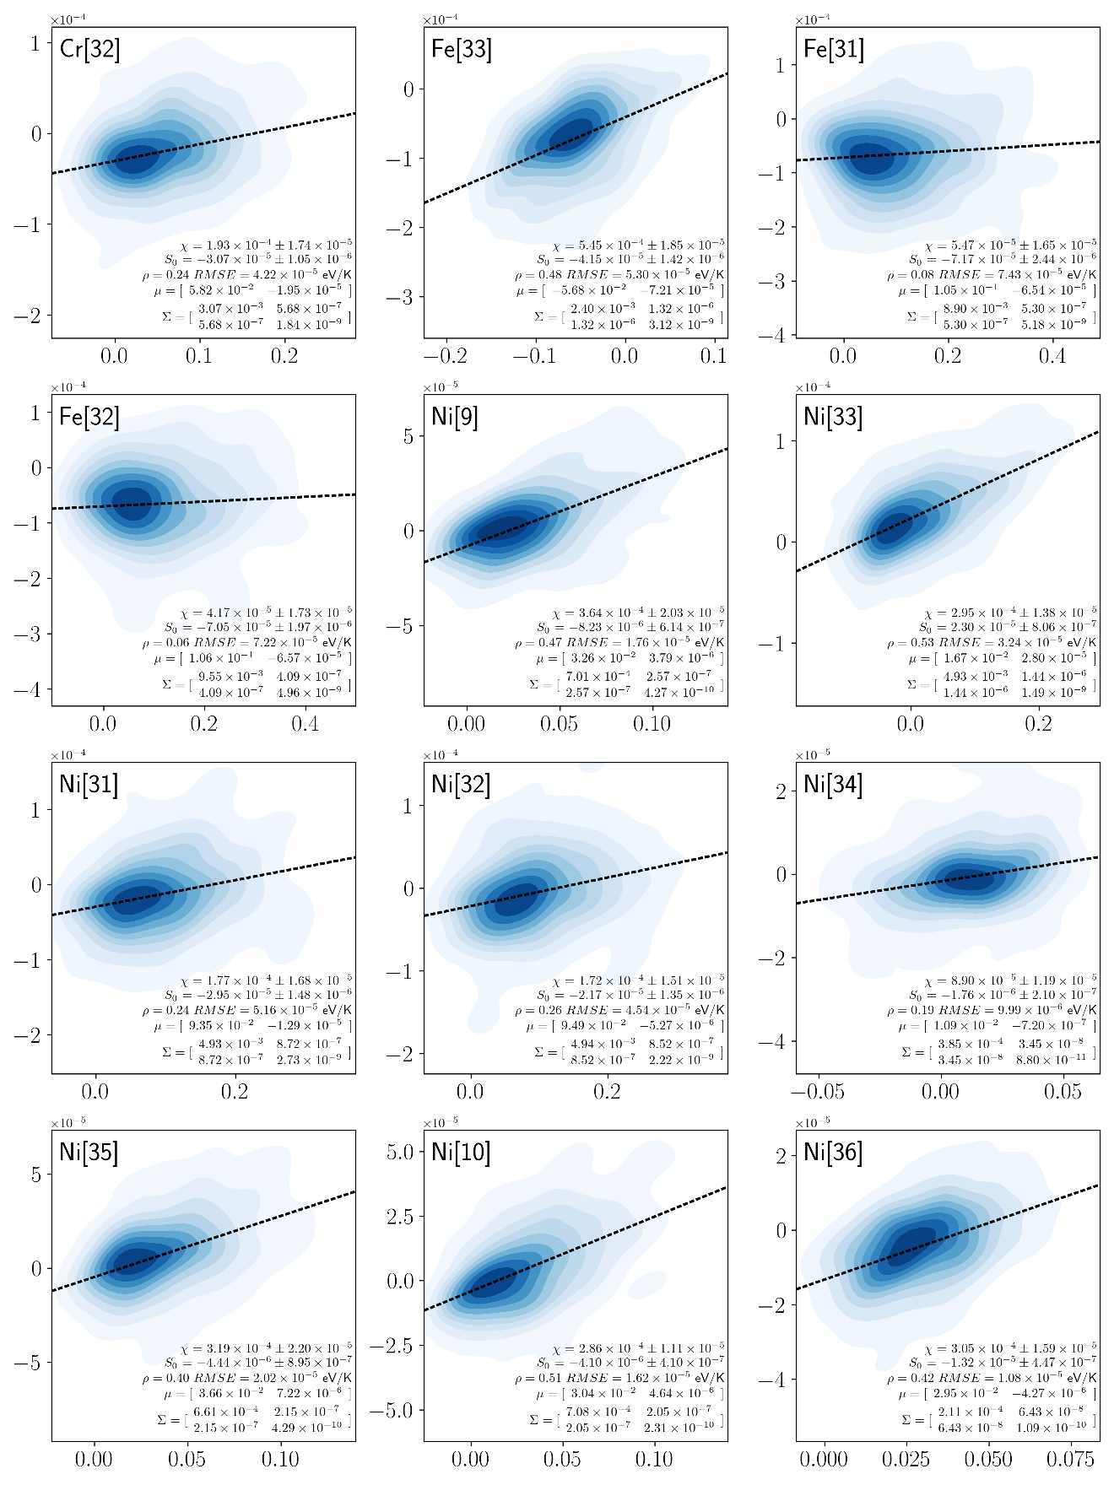
Fig. S34 Segregation Energy-Entropy Spectra for Cu-based Alloys in eV and eV/K respectively (cont., 2).
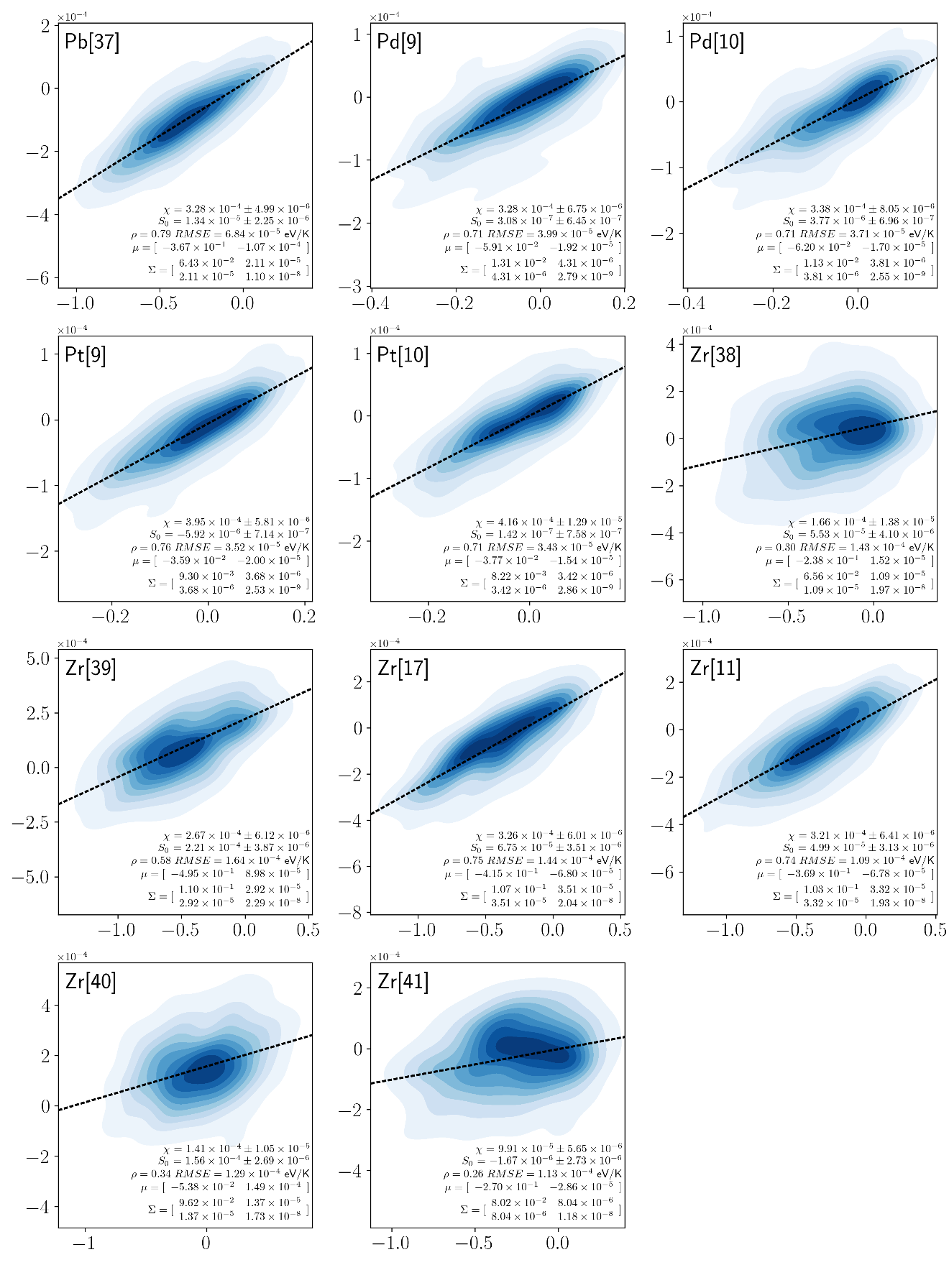
Fig. S35 Segregation Energy-Entropy Spectra for Cu-based Alloys in eV and eV/K respectively (cont., 3).
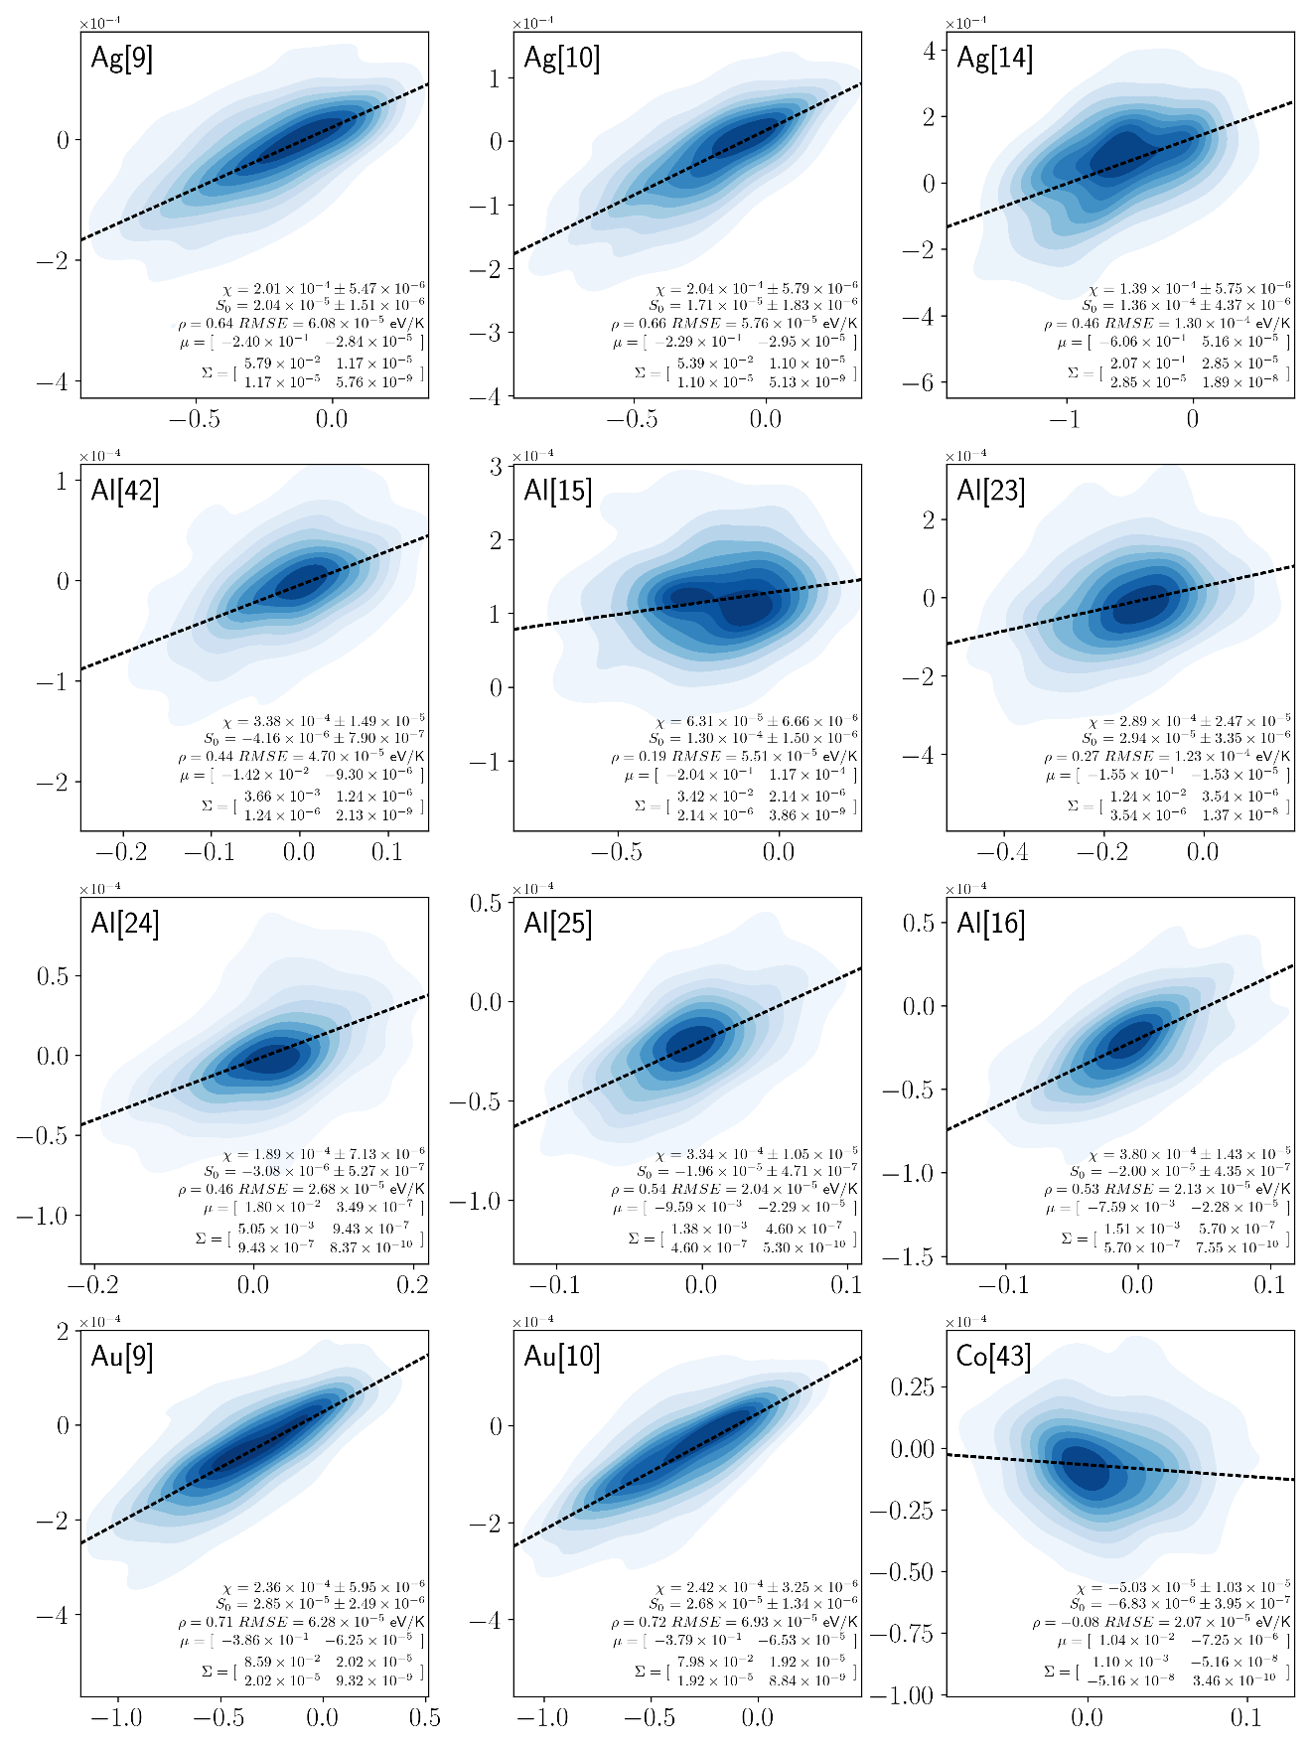
Fig. S36 Segregation Energy-Entropy Spectra for Ni-based Alloys in eV and eV/K respectively.
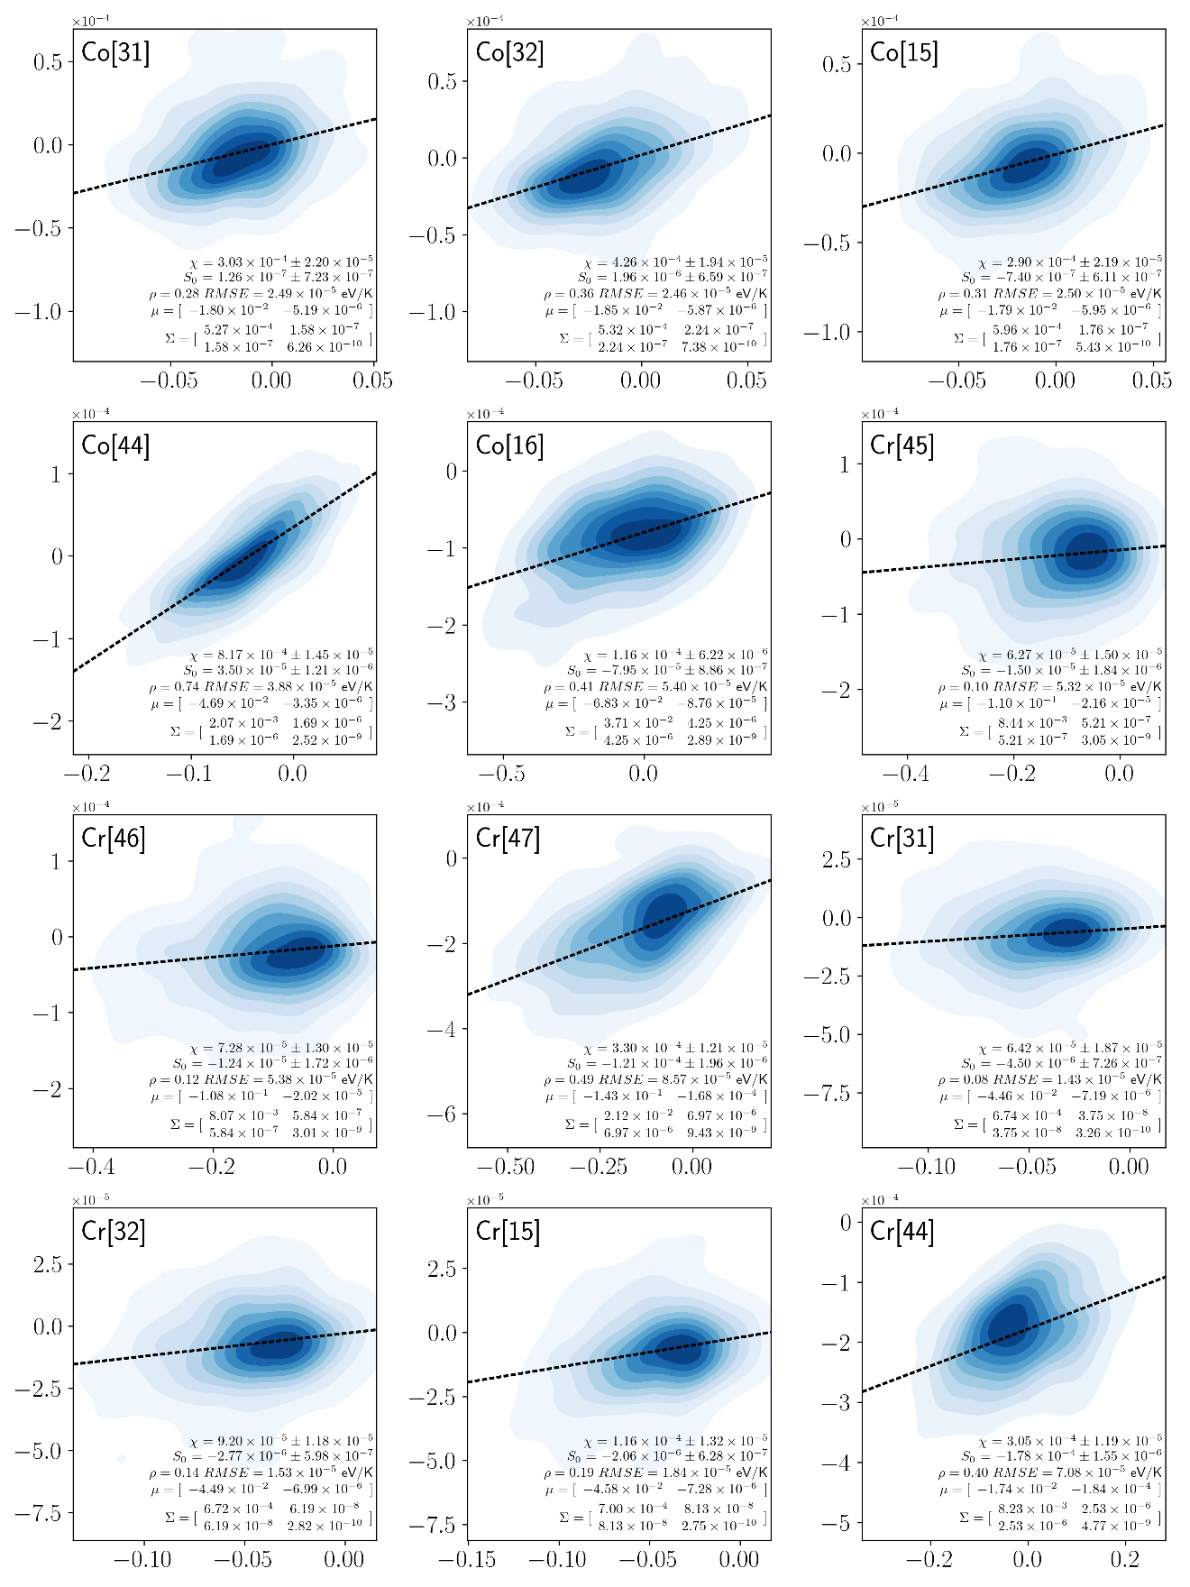
Fig. S37 Segregation Energy-Entropy Spectra for Ni-based Alloys in eV and eV/K respectively (cont., 2).
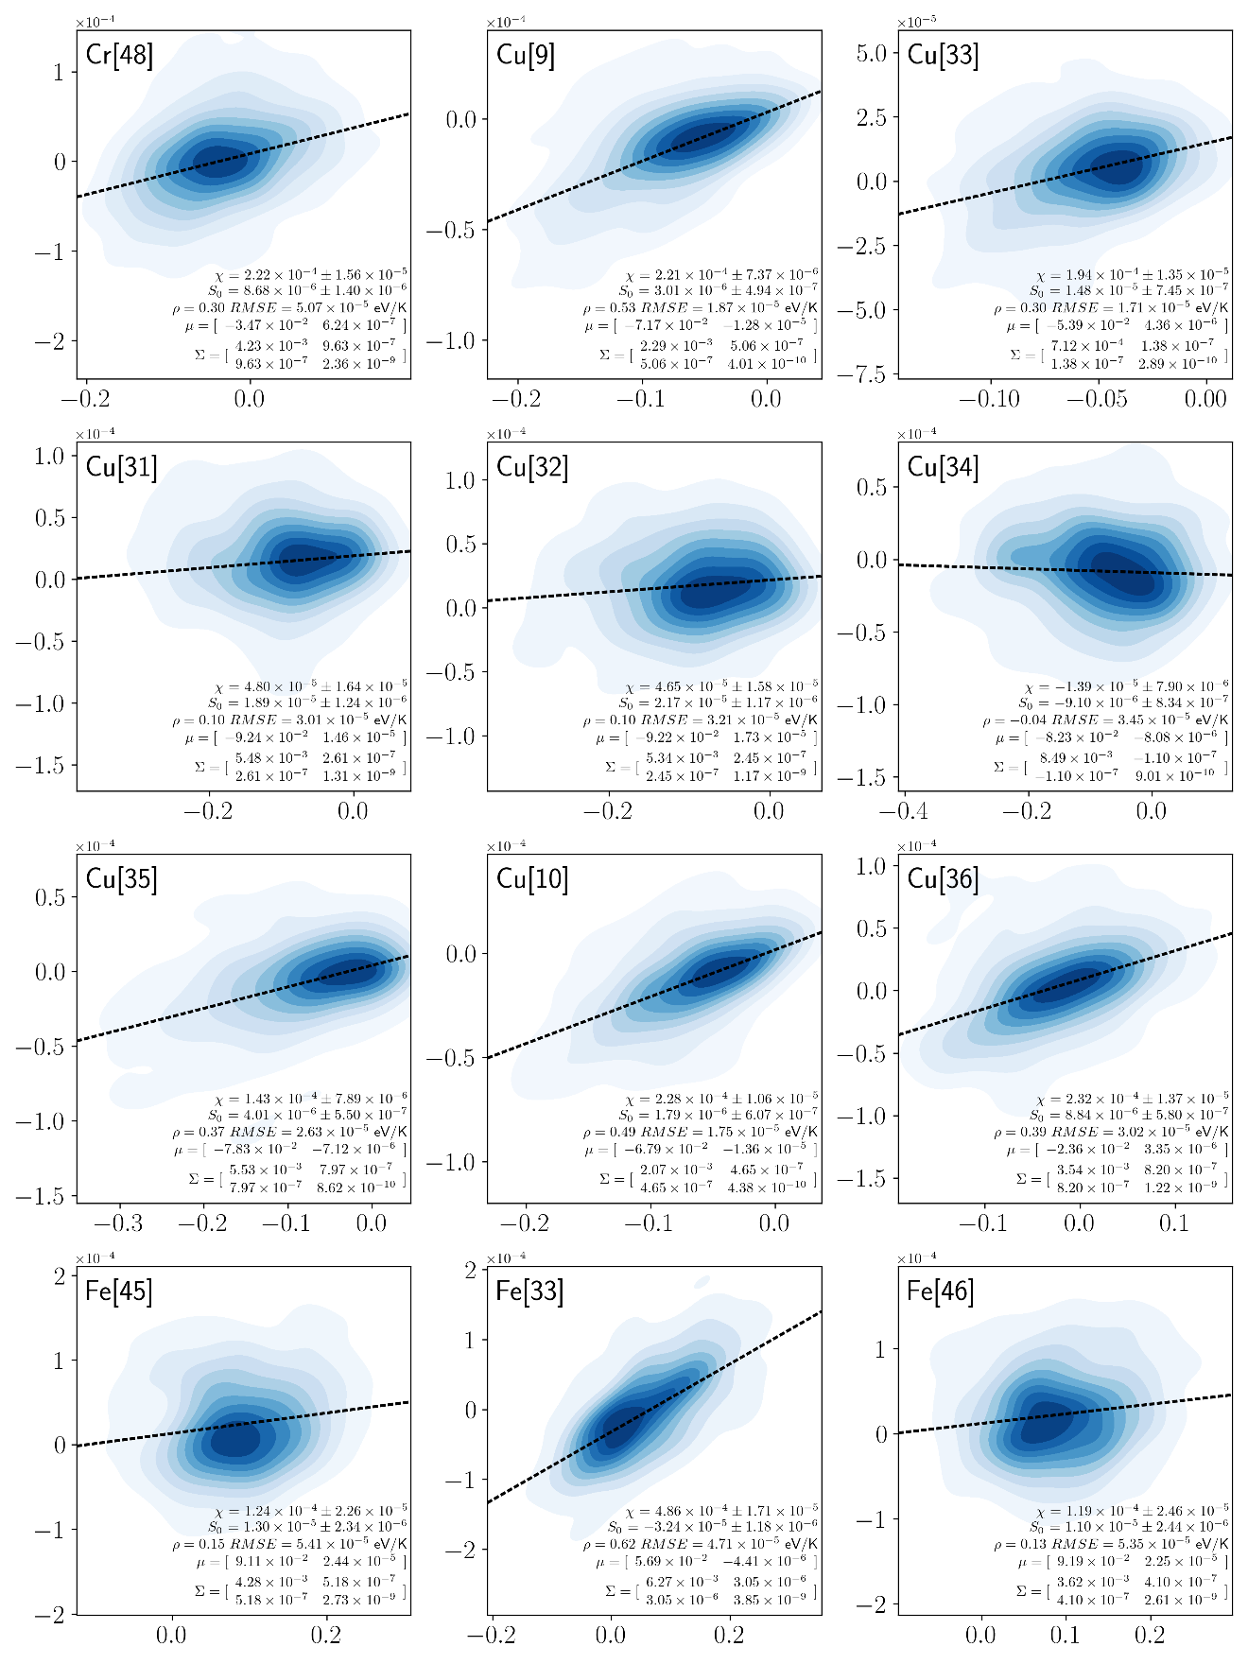
Fig. S38 Segregation Energy-Entropy Spectra for Ni-based Alloys in eV and eV/K respectively (cont., 3).
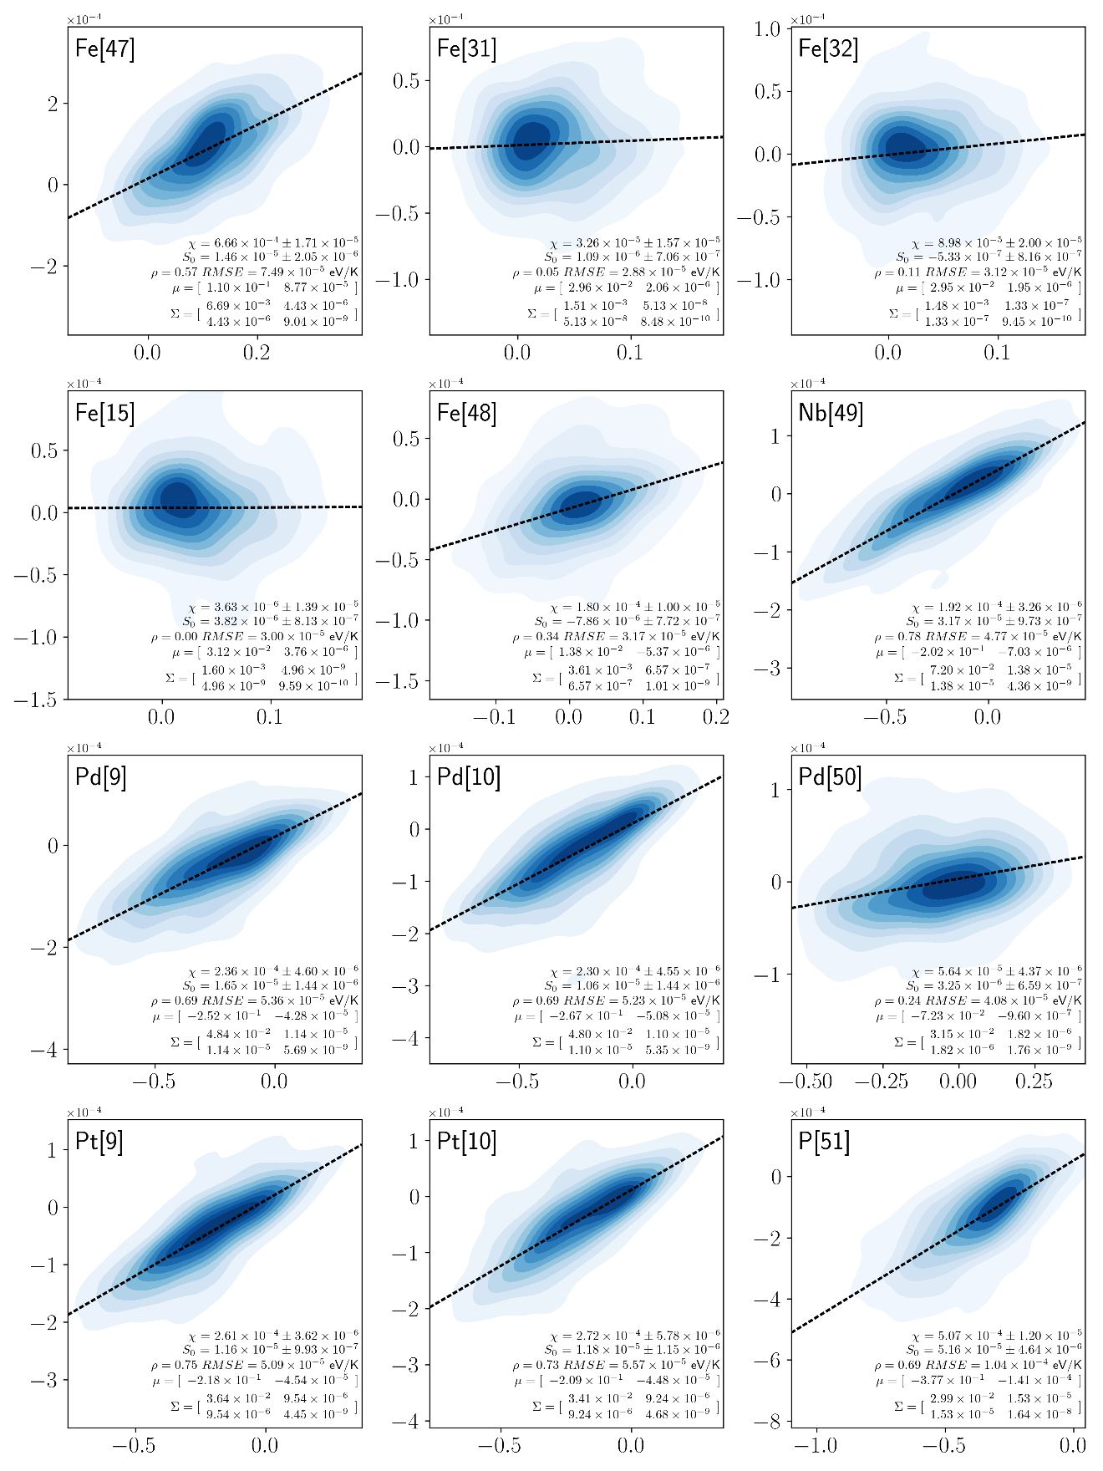
Fig. S39 Segregation Energy-Entropy Spectra for Ni-based Alloys in eV and eV/K respectively (cont., 4).
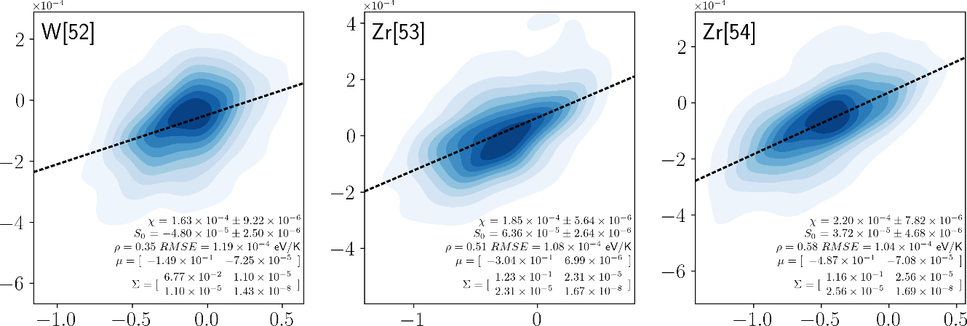
Fig. S40 Segregation Energy-Entropy Spectra for Ni-based Alloys in eV and eV/K respectively (cont., 5).

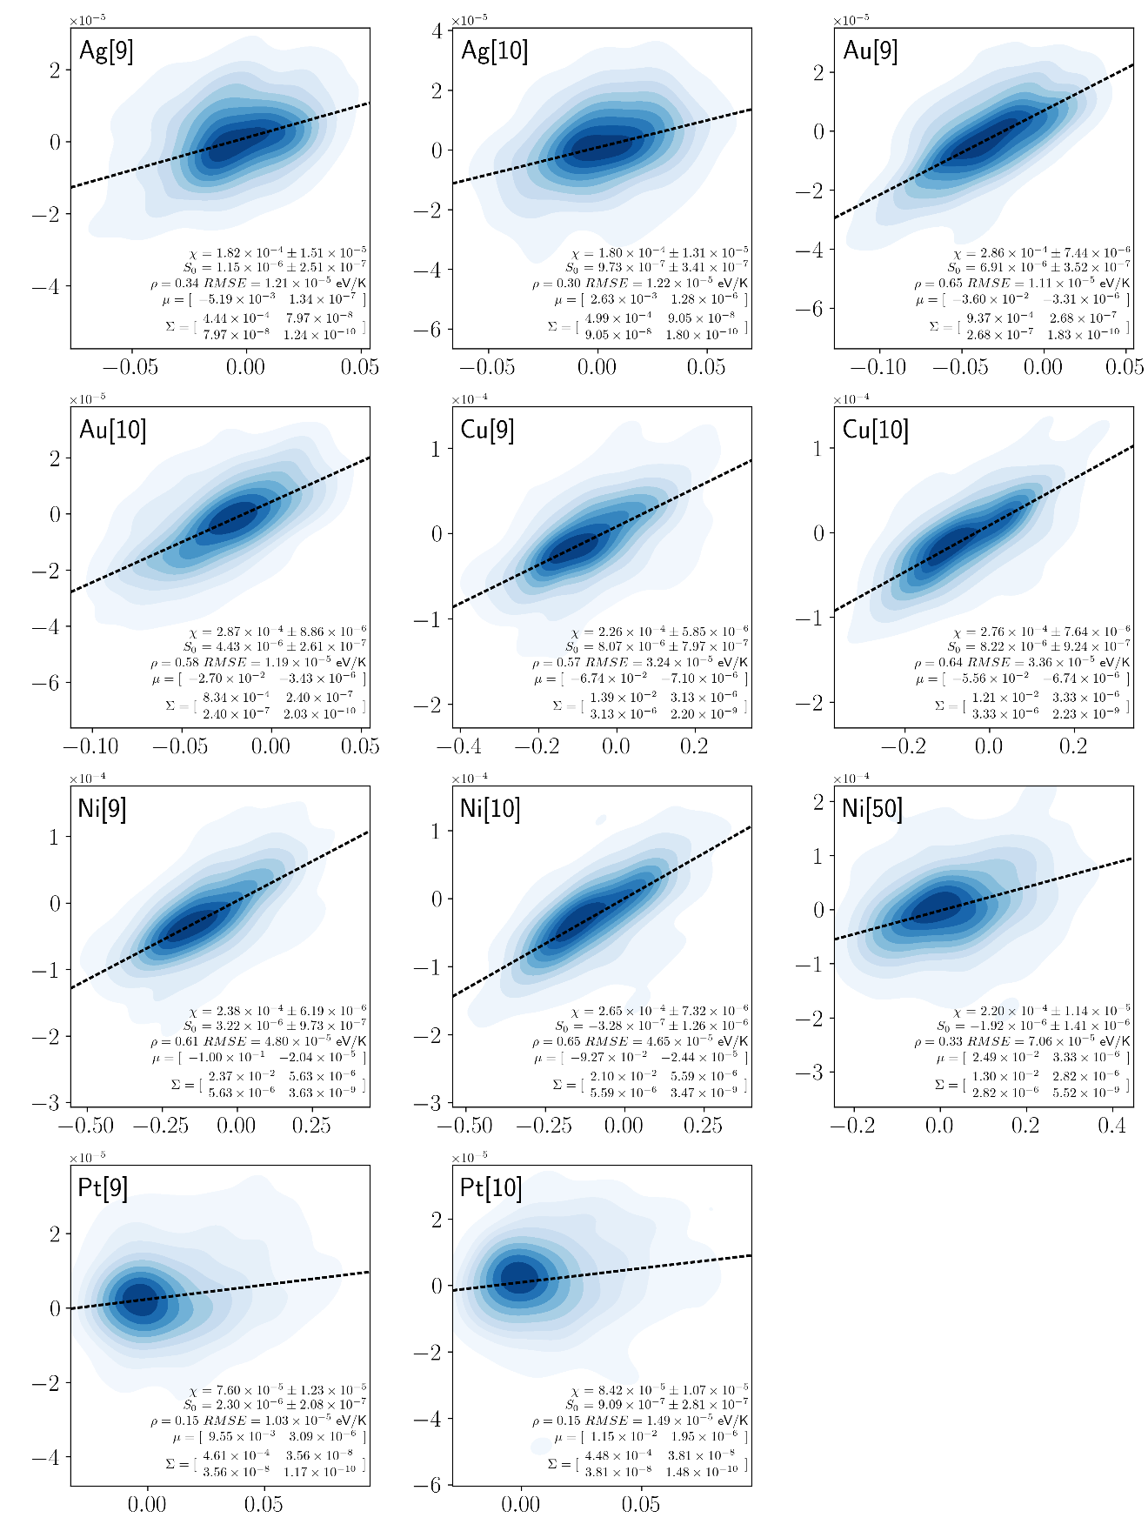
Fig. S41 Segregation Energy-Entropy Spectra for Pd-based Alloys in eV and eV/K respectively.
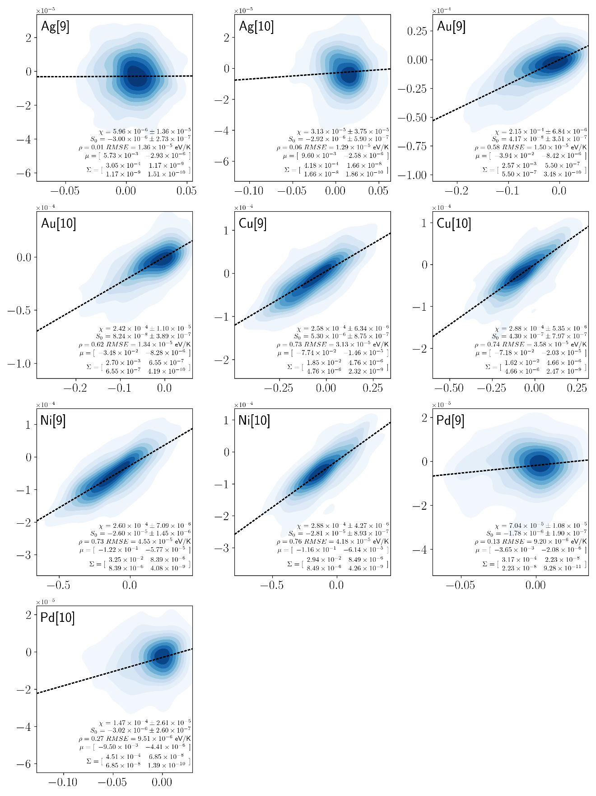
Fig. S42 Segregation Energy-Entropy Spectra for Pt-based Alloys in eV and eV/K respectively.

- Isotherm Software
Two types of solver are included in the attached Jupyter notebook with the Python packages^{61–69}. First, a double integral isotherm solver which takes $X^{tot}$, T, $f^{GB}$, means and a covariance matrix (for a bivariate Gaussian distribution) to solve the following solute balance equation⁷⁰:
$$X^{tot}=\left(1-f^{GB}\right)X^{C}+f^{GB}\int{\int{d∆E_{i}^{seg}}d∆S_{i}^{seg}F_{i}\left(∆E_{i}^{seg},∆S_{i}^{seg}\right)X_{i}^{IG}\left(∆E_{i}^{seg},∆S_{i}^{seg}\right)}$$ |  | (S4)

where $X_{i}^{IG}\left(∆E_{i}^{seg},∆S_{i}^{seg}\right)$ for the full bivariate is^{71,72}:
$$X_{i}^{IG}\left(∆E_{i}^{seg},∆S_{i}^{seg}\right)={\left\{1+\frac{1-X^{C}}{X^{C}}\exp\left[\frac{∆E_{i}^{seg}-T∆S_{i}^{seg}}{k_{B}T}\right]\right\}}^{-1}$$ |  | (S5)

with linear compensation:
$$X_{i}^{IG}\left(∆E_{i}^{seg},∆S_{i}^{seg}\right)={\left\{1+\frac{1-X^{C}}{X^{C}}\exp\left[\frac{∆E_{i}^{seg}-T(χ∆E_{i}^{seg}+{∆S}_{0}^{solute,GB})}{k_{b}T}\right]\right\}}^{-1}$$ |  | (S6)

We also show the cases without ${∆S}_{0}^{solute,GB}$ and without any excess entropy, $χ={∆S}_{0}^{solute,GB}=0$ for comparison.
The second solver is a univariate isotherm solver which takes segregation energy skew-normal distribution parameters as an input and solve a single integral instead of Eqs. (S4-6):
$$X^{tot}=\left(1-f^{GB}\right)X^{C}+f^{GB}\int{d∆E_{i}^{seg}}F_{i}\left(∆E_{i}^{seg}\right)X_{i}^{IG}\left(∆E_{i}^{seg}\right)$$ |  | (S7)
with the site-wise equilibrium concentration:
$$X_{i}^{IG}\left(∆E_{i}^{seg}\right)={\left[1+\frac{1-X^{C}}{X^{C}}exp\left(\frac{∆E_{i}^{seg}-Tχ∆E_{i}^{seg}-T{∆S}_{0}^{solute,GB}}{k_{b}T}\right)\right]}^{-1}$$ |  | (S8)

Large grain size alternatives are also provided where $X^{C}$ is assumed to be $X^{tot}$ which is only valid for large grain sizes. They are identical to setting $f^{GB}$ to a low value (i.e. 10⁻⁶ in the example of Fig. S43) but with a faster runtime. An example is plotted below for Ni(Pd)¹⁰ where we compare bivariate with univariate isotherms.

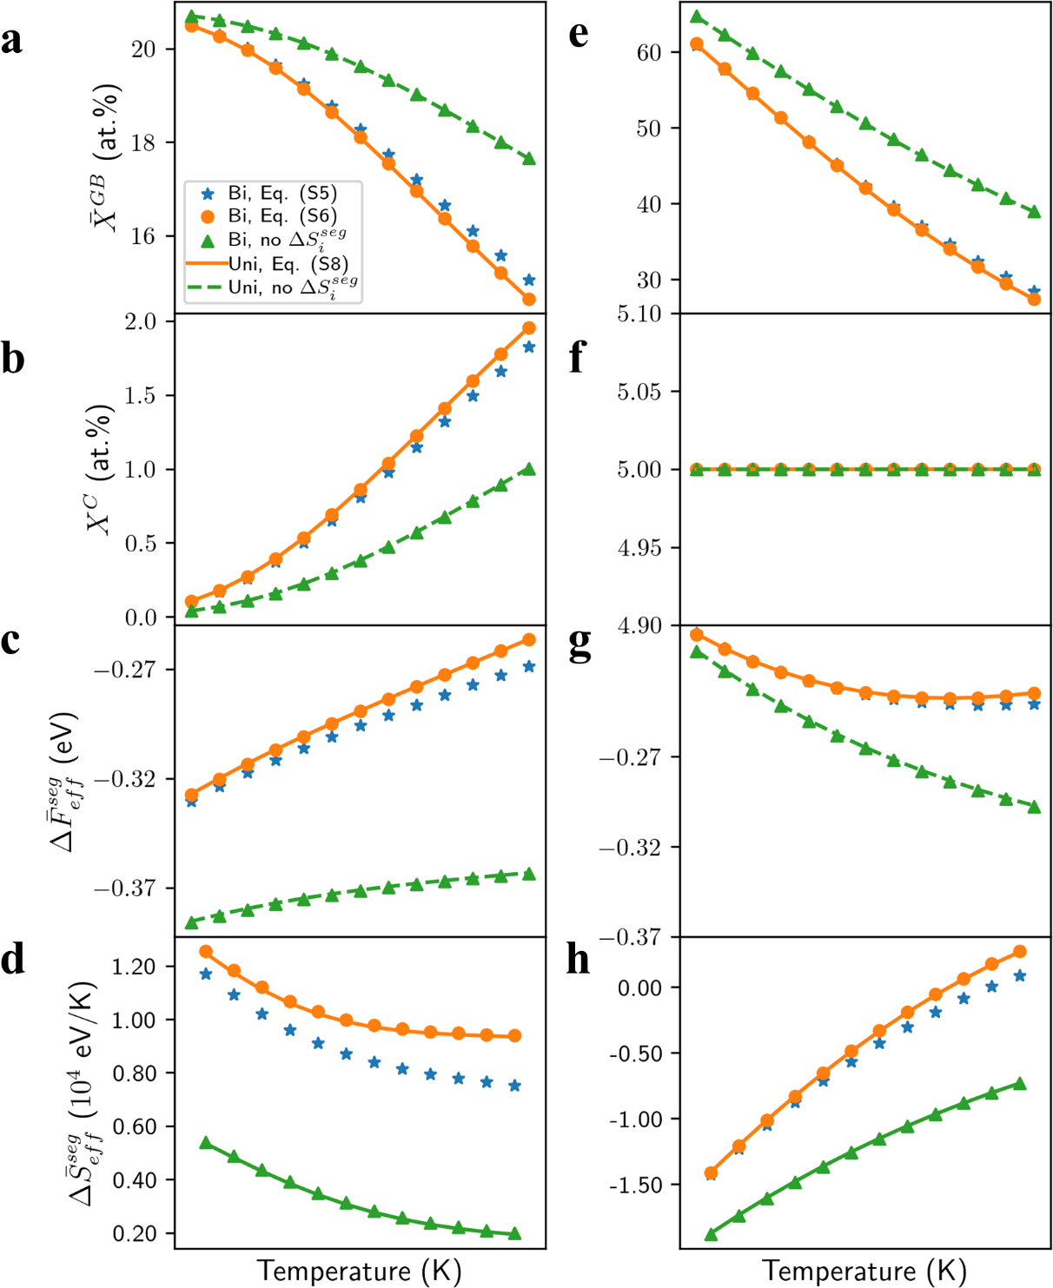
Fig. S43 Example Ni(Pd) Segregation Isotherms. (a-d) are calculated via a finite grain size with f^{GB} of 0.24. This grain size is similar to Ref.¹. (e-h) are calculated with direct integration of the isotherms. The results from the univariate and bivariate are shown for comparisons.

- Temperature Dependent Segregation Isotherms
While the linear model of Eq. (5) is attractive due to its simplicity, it may fail to accurately predict segregation content in the systems shown in Fig. 3 with a weakly correlated spectrum. As an illustration, we evaluate the temperature dependence of the grain boundary enrichment at 1 at.% solute content in the large grain size limit for three example systems. We specifically address four modeled cases with which we evaluate Eq. (2):
- A fitted bivariate Gaussian distribution with $∆F_{i}^{seg}=∆E_{i}^{seg}-T∆S_{i}^{seg}$; this is the most rigorous approach that is inclusive of all of the site-wise variations of both energy and entropy of segregation.
- The identical bivariate distribution to (i) but the excess entropy is replaced with the linear approximation of Eq. (3); this is tantamount to assuming that all site variations are captured by the energy spectrum, and linearly map through to the entropy term.
- Same as (ii) but with ${∆S}_{0}^{solute,GB}=0$; a further reduction in information, forcing solute atoms with no measurable segregation energy to also have no entropy, and influencing the form of Eq. (3).
- The identical bivariate distribution to (i) but without any consideration of site-wise entropy at all; this case considers what happens when site energies but not entropies are taken into account.
We show three examples of Cu(Pb)³⁷ (strong correlation), Ni(Al)¹⁵ and Ni(Cr)⁴⁸ (weak correlation) in Fig. S44a-c, any of the isotherms that include any form of entropy more closely match the best prediction (case i) as compared to case (iv) which neglects entropy. The success of cases (ii) and (iii) indicates that the linear correlation between site energy and entropy (Eq. (3)) holds very well and the intercept in that expression ${∆S}_{0}^{solute,GB}$ plays a small and perhaps negligible role such as Cu(Pb)³⁷ in Fig. S44a. Ni(Al)¹⁵ in Fig. S44b, while showing reasonably good predictive capability from the linear approximation, has non-negligible ${∆S}_{0}^{solute,GB}$ (the differences between (ii) and (iii) are large). This physically means that on average, the solute occupying a GB site with the same energetics as a bulk site shows significant vibrational state changes resulting in the excess entropy. Lastly, Ni(Cr)⁴⁸ in Fig. S44c indicates that the approximation may not hold for every interatomic potential. If a given spectrum is not strictly linear, or the spectrum shape is unknown (for example, fitting the isotherm with experiments) a conservative choice of a bivariate distribution is suggested.

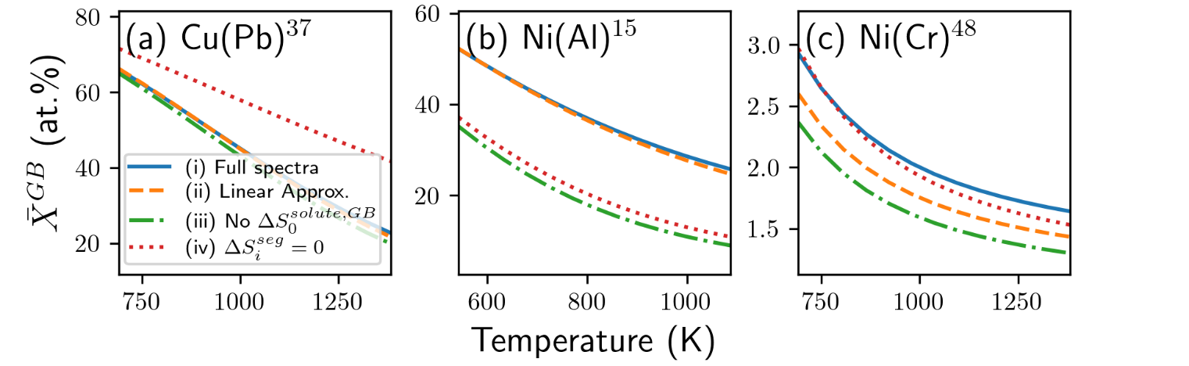
Fig. S44 Isotherms with Linear Entropy Approximation. The isotherms for (a) Cu(Pb)³⁷, (b) Ni(Al)¹⁵ and (c) Ni(Cr)⁴⁸. The Cu(Pb) isotherms demonstrate a system with a strong linear relationship, resulting in good agreement between the full and linear spectrum. Ni(Al) illustrates a system strongly dominated by ${∆S}_{0}^{solute,GB}$. Ni(Cr) has low correlations and thus the full and linear spectrum do not match well compared to the case without excess entropies.

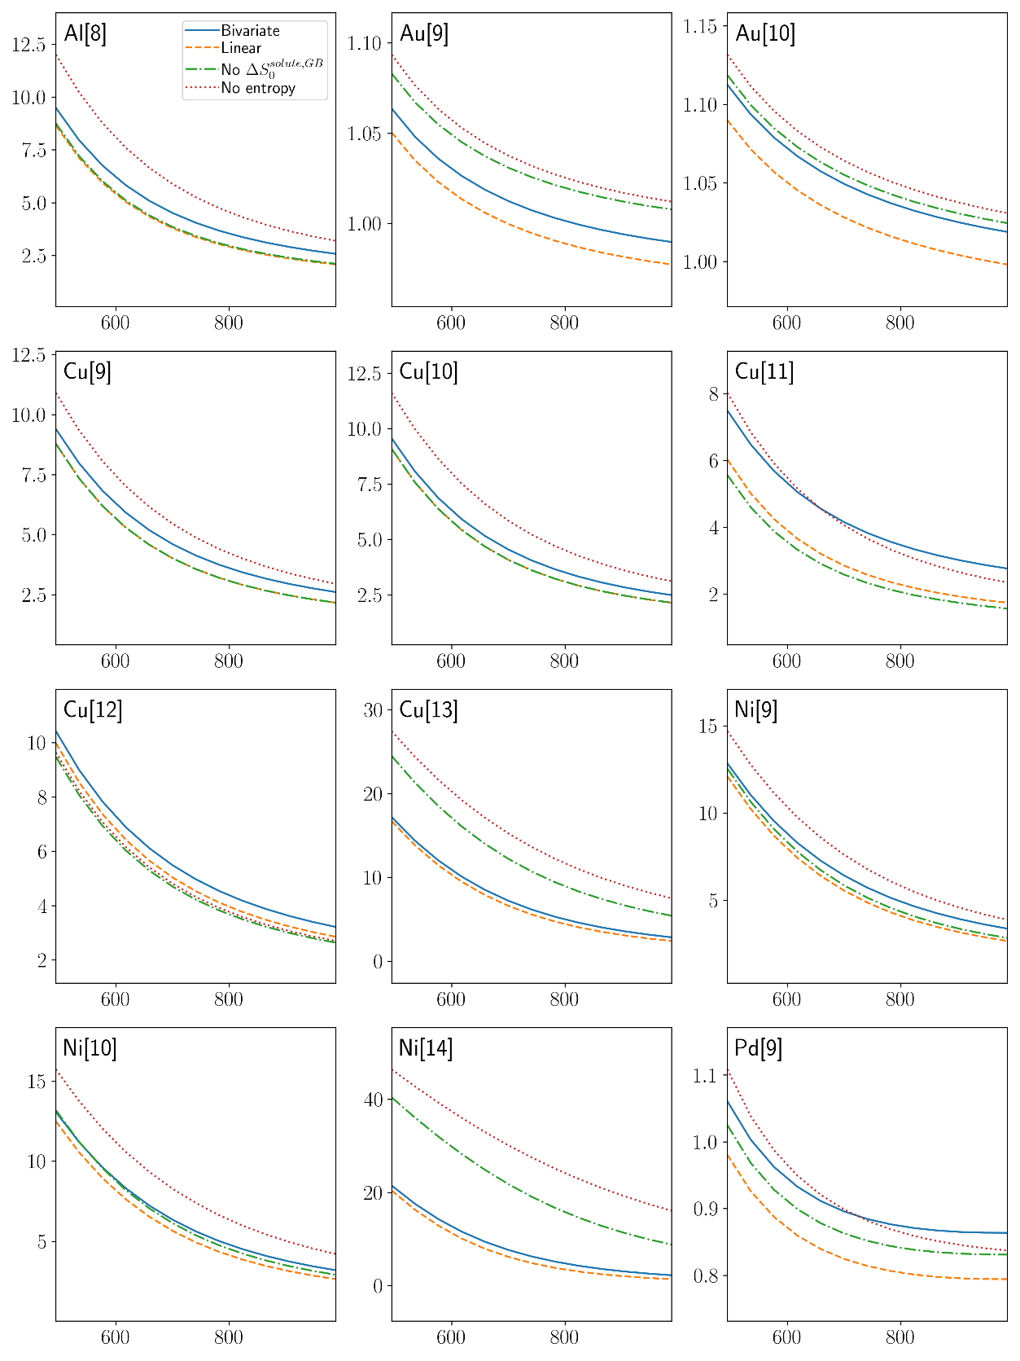
Fig. S45 Temperature dependences of GB concentration (in at.%) predicted with excess entropy from bivariate distribution, linear relationship of Eq. (5) and without excess entropy for Ag-based Alloys.
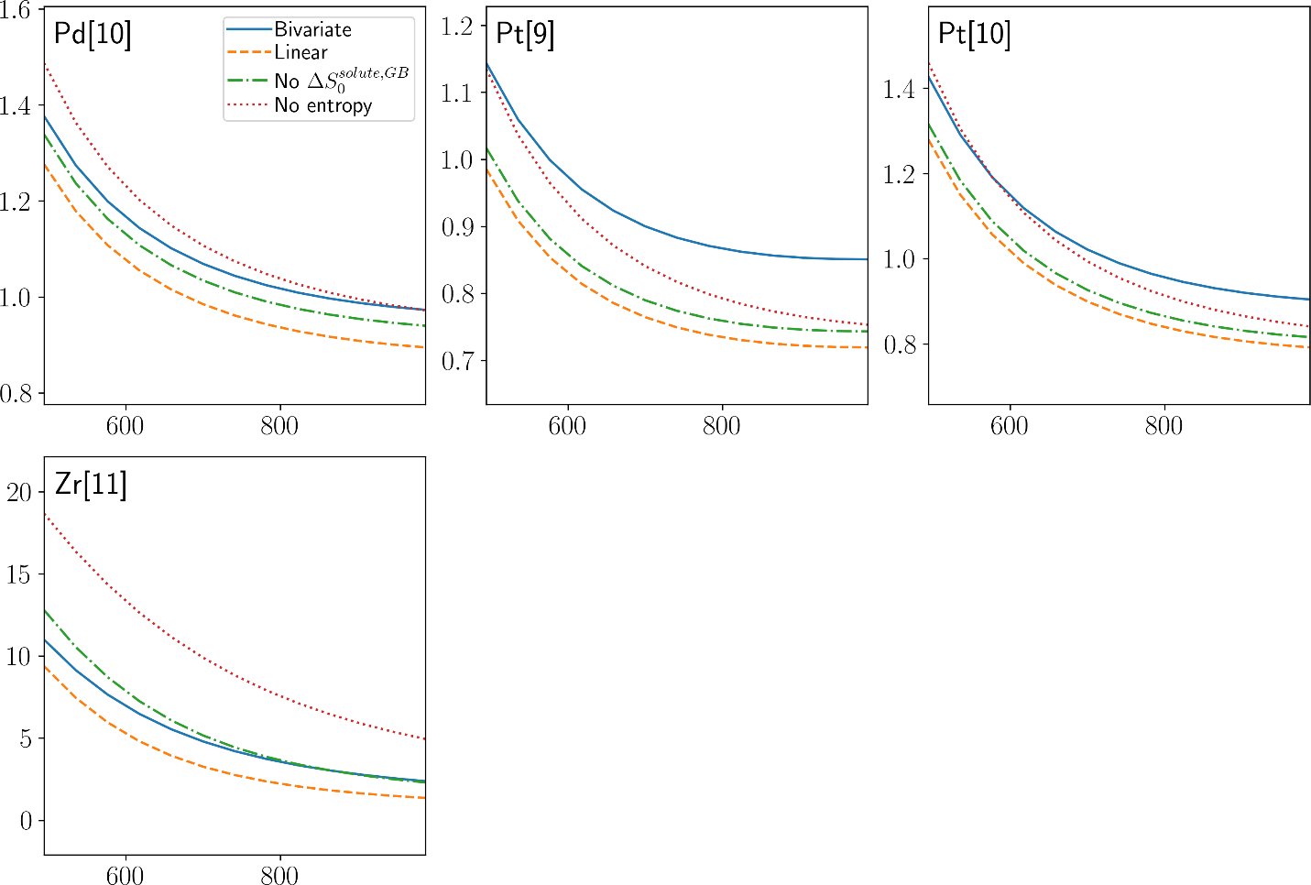
Fig. S46 Temperature dependences of GB concentration (in at.%) predicted with excess entropy from bivariate distribution, linear relationship of Eq. (5) and without excess entropy for Ag-based Alloys (cont., 2).

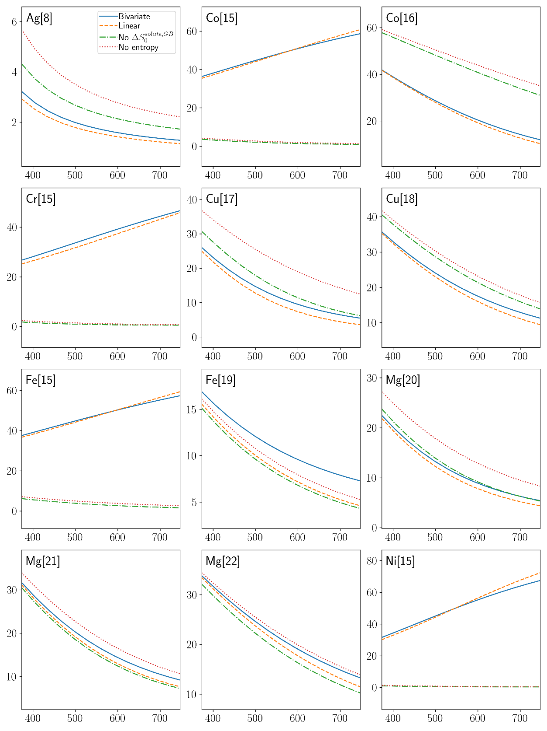
Fig. S47 Temperature dependences of GB concentration (in at.%) predicted with excess entropy from bivariate distribution, linear relationship of Eq. (5) and without excess entropy for Al-based Alloys.
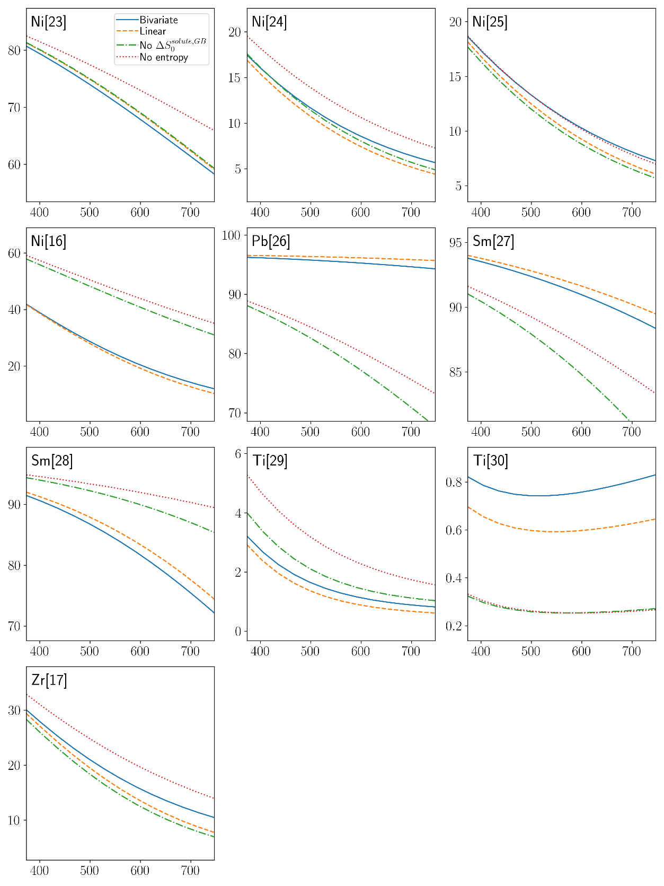
Fig. S48 Temperature dependences of GB concentration (in at.%) predicted with excess entropy from bivariate distribution, linear relationship of Eq. (5) and without excess entropy for Al-based Alloys (cont., 2).
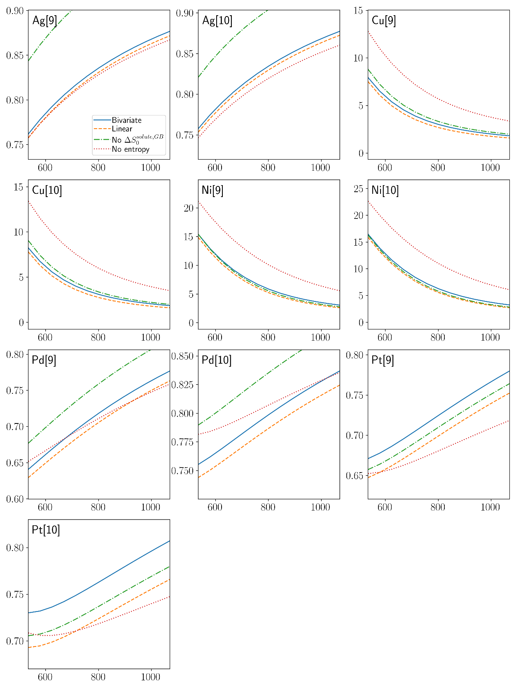
Fig. S49 Temperature dependences of GB concentration (in at.%) predicted with excess entropy from bivariate distribution, linear relationship of Eq. (5) and without excess entropy for Au-based Alloys.

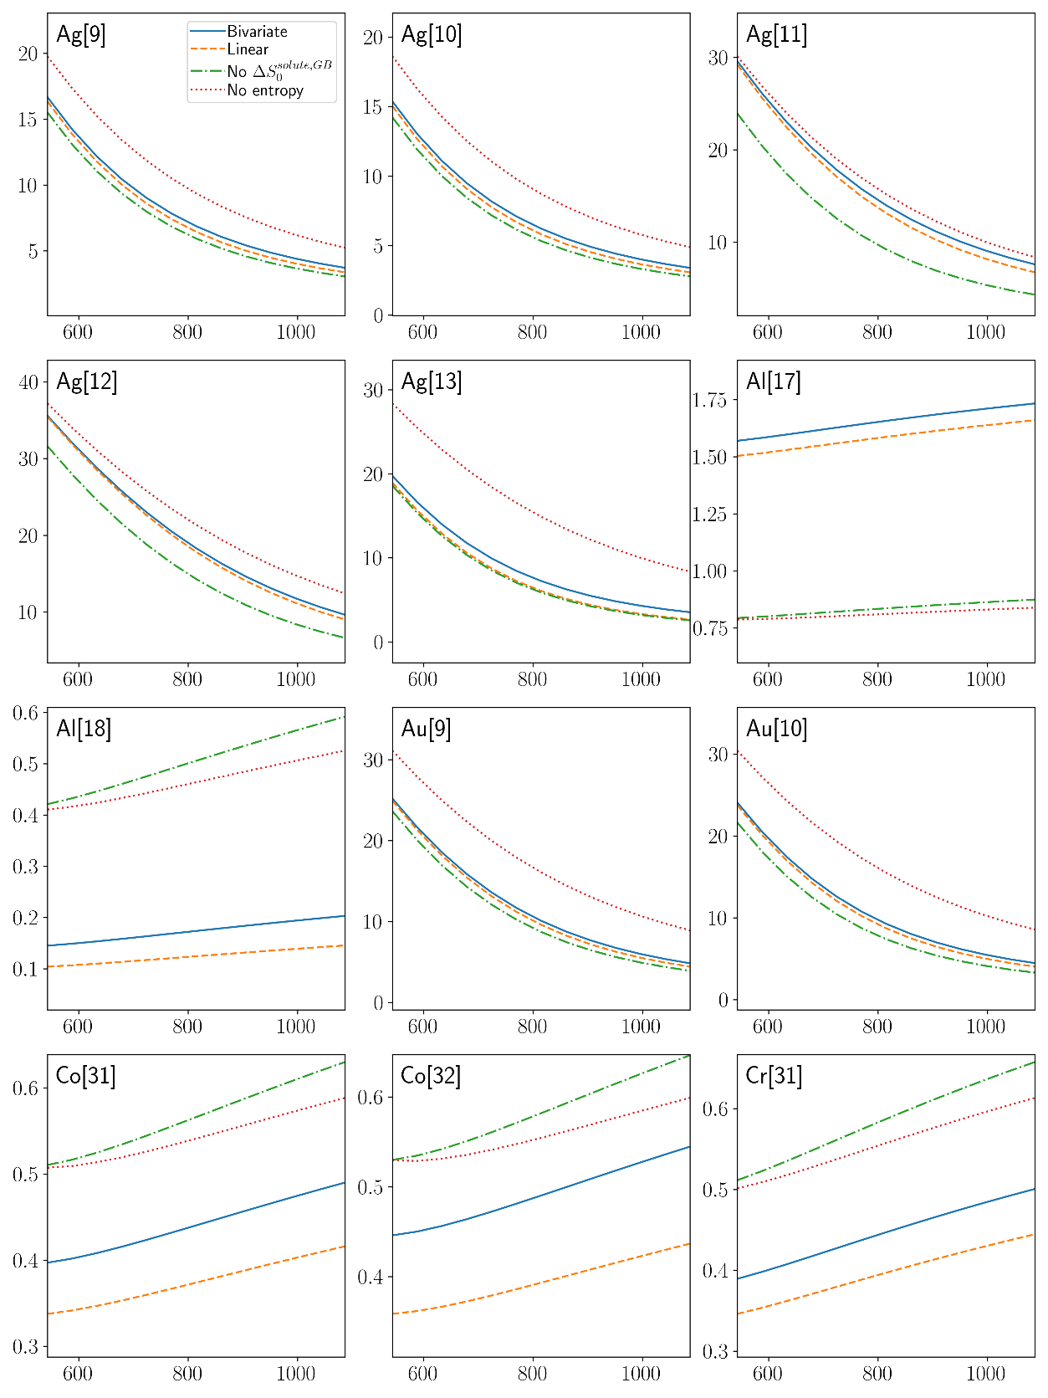
Fig. S50 Temperature dependences of GB concentration (in at.%) predicted with excess entropy from bivariate distribution, linear relationship of Eq. (5) and without excess entropy for Cu-based Alloys.
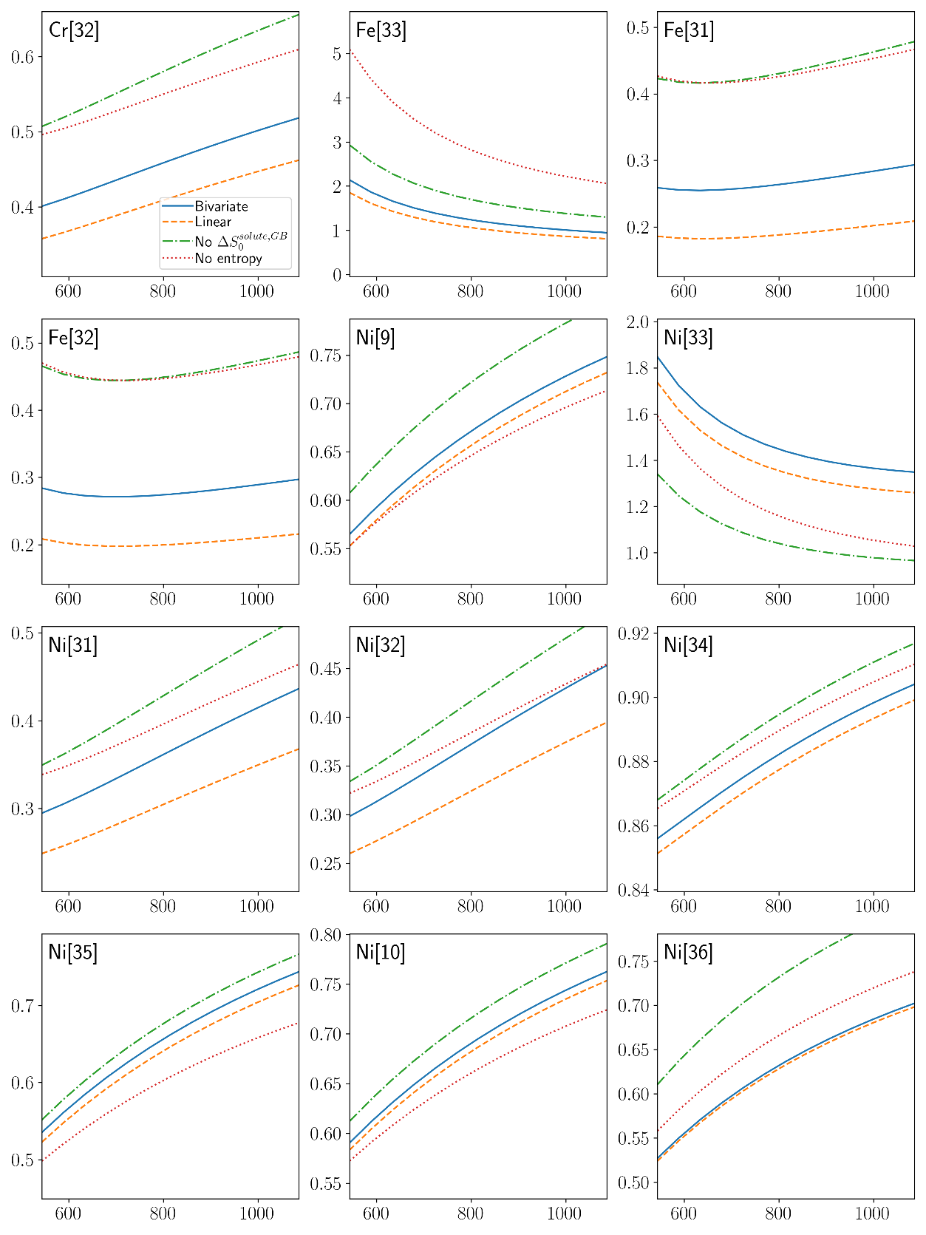
Fig. S51 Temperature dependences of GB concentration (in at.%) predicted with excess entropy from bivariate distribution, linear relationship of Eq. (5) and without excess entropy for Cu-based Alloys (cont., 2).
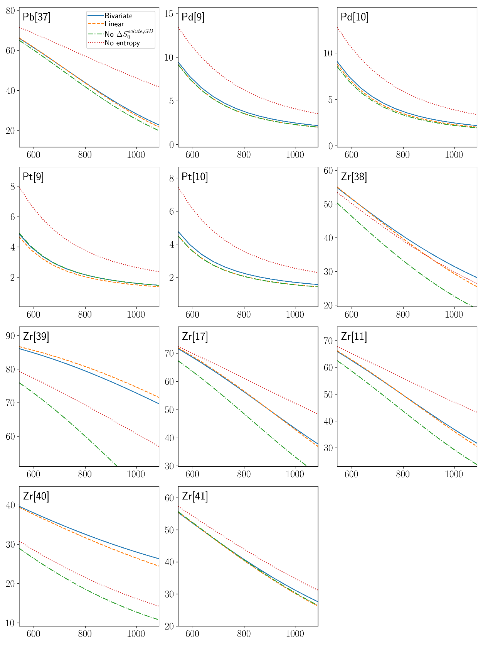
Fig. S52 Temperature dependences of GB concentration (in at.%) predicted with excess entropy from bivariate distribution, linear relationship of Eq. (5) and without excess entropy for Cu-based Alloys (cont., 3).
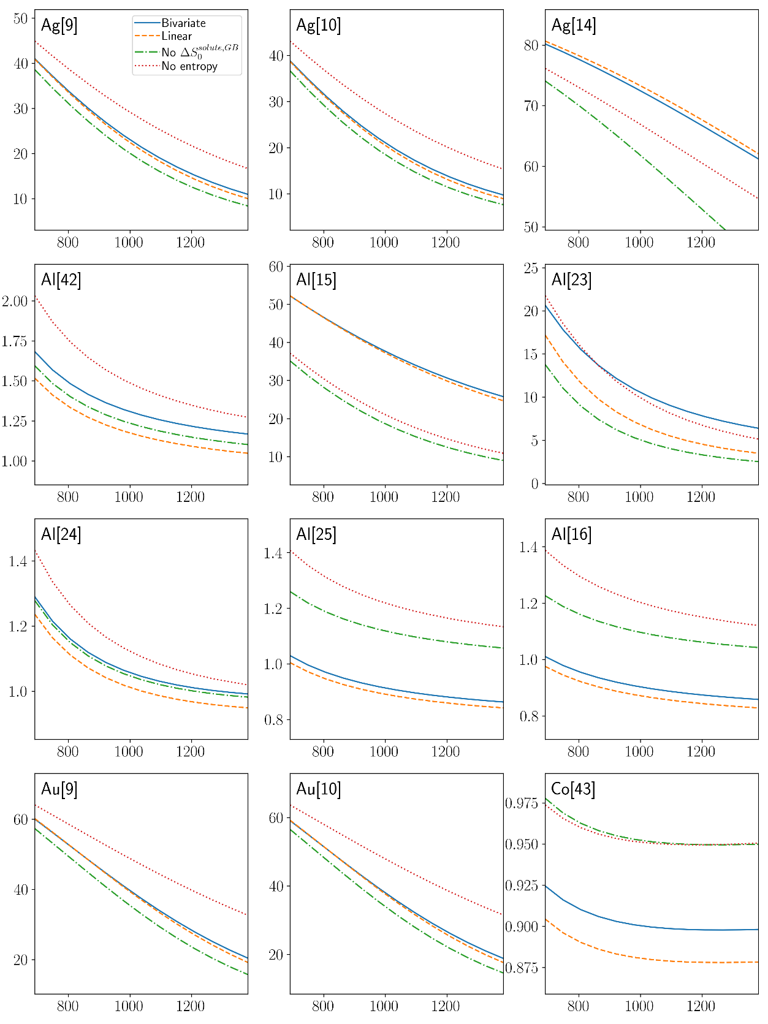
Fig. S53 Temperature dependences of GB concentration (in at.%) predicted with excess entropy from bivariate distribution, linear relationship of Eq. (5) and without excess entropy for Ni-based Alloys.
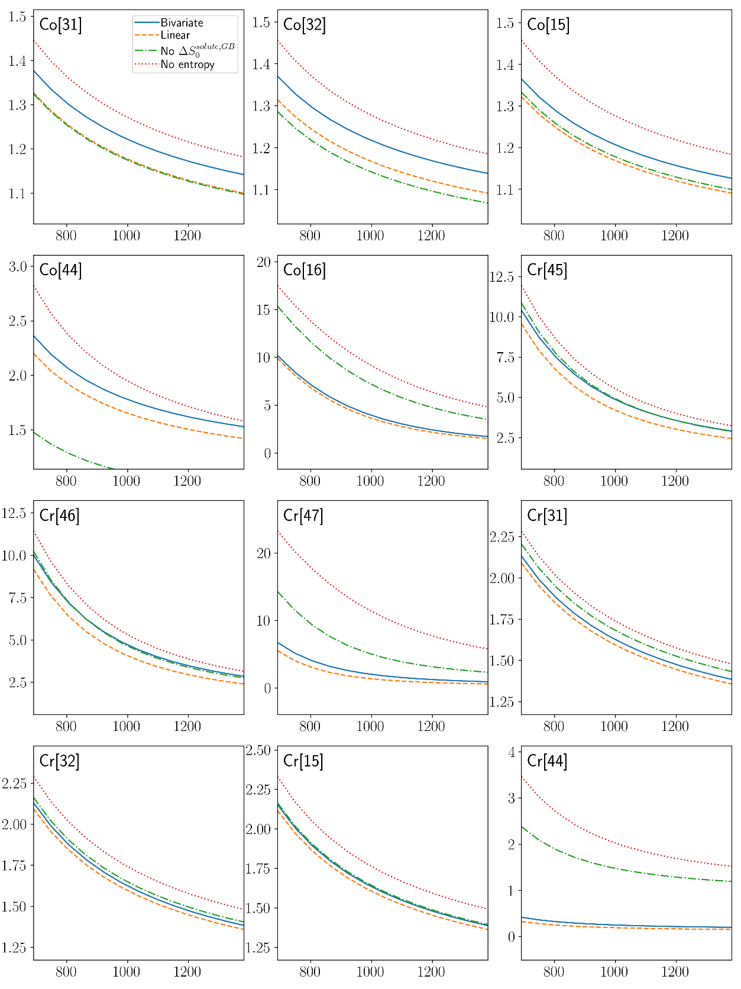
Fig. S54 Temperature dependences of GB concentration (in at.%) predicted with excess entropy from bivariate distribution, linear relationship of Eq. (5) and without excess entropy for Ni-based Alloys (cont., 2).
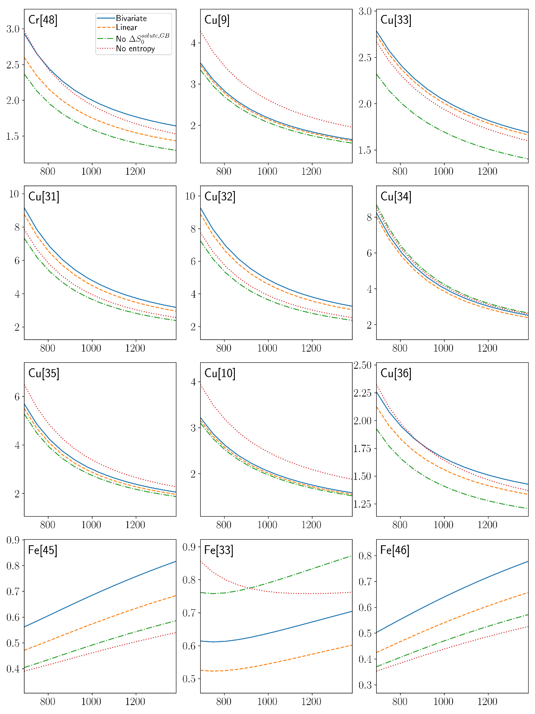
Fig. S55 Temperature dependences of GB concentration (in at.%) predicted with excess entropy from bivariate distribution, linear relationship of Eq. (5) and without excess entropy for Ni-based Alloys (cont., 3).

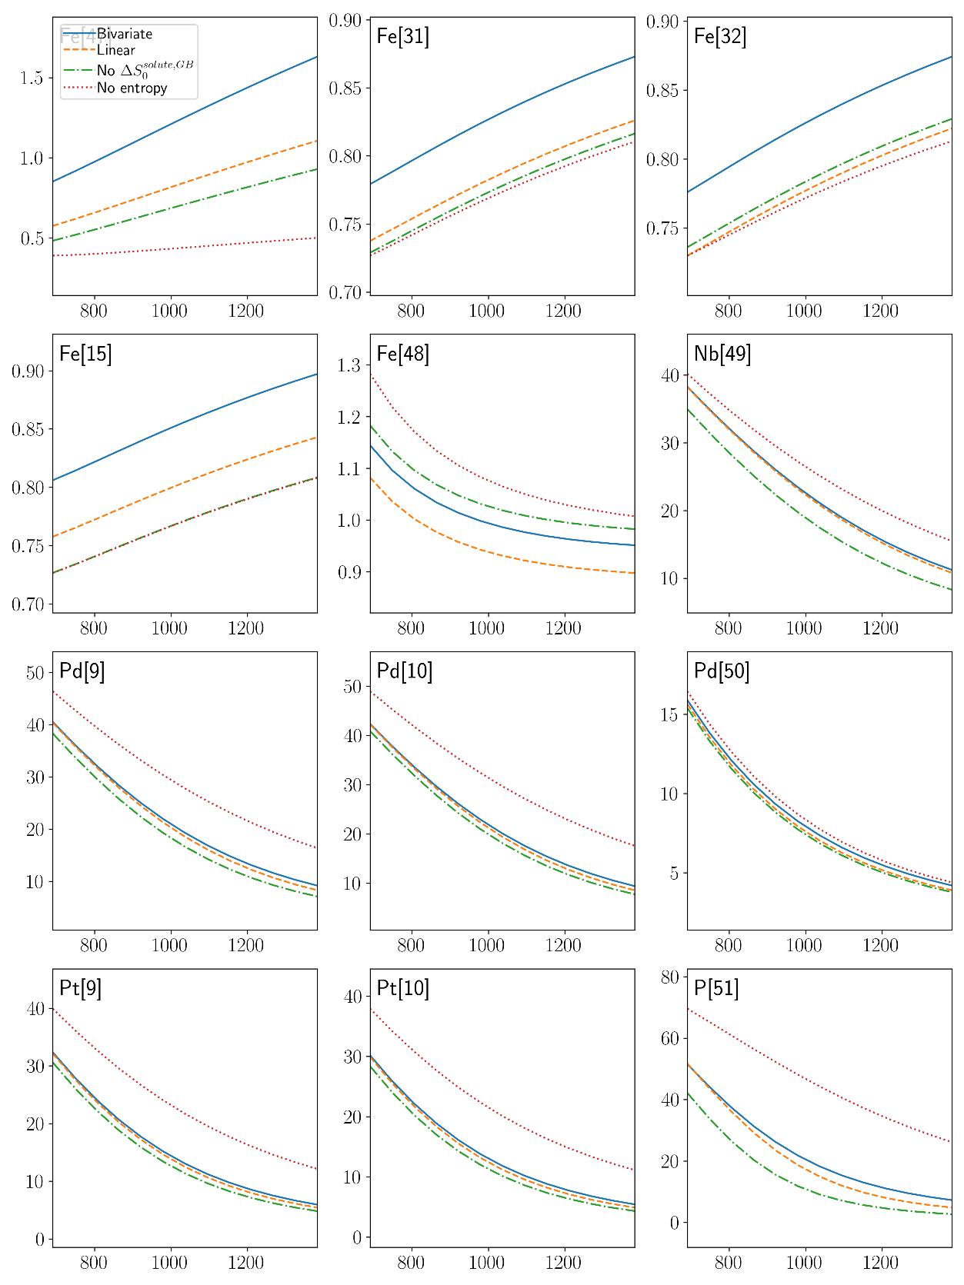
Fig. S56 Temperature dependences of GB concentration (in at.%) predicted with excess entropy from bivariate distribution, linear relationship of Eq. (5) and without excess entropy for Ni-based Alloys (cont., 4).
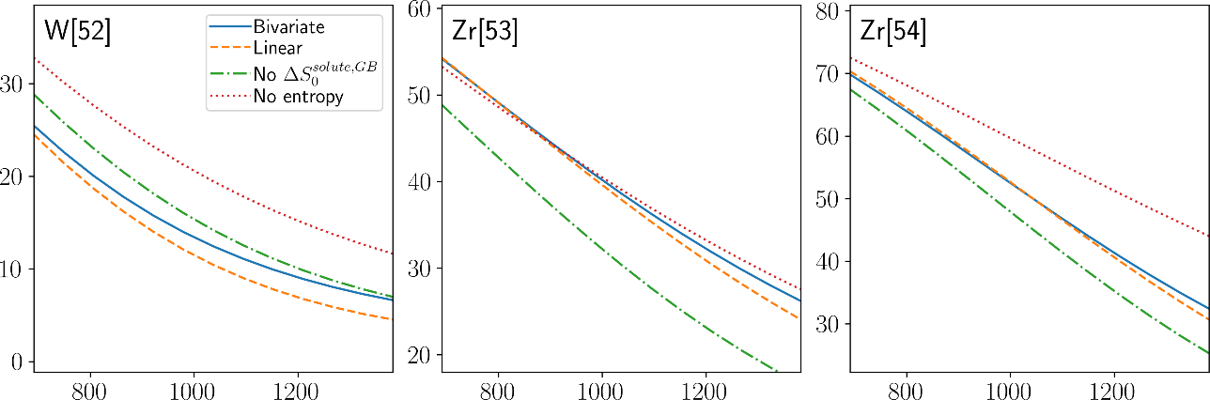
Fig. S57 Temperature dependences of GB concentration (in at.%) predicted with excess entropy from bivariate distribution, linear relationship of Eq. (5) and without excess entropy for Ni-based Alloys (cont., 5).

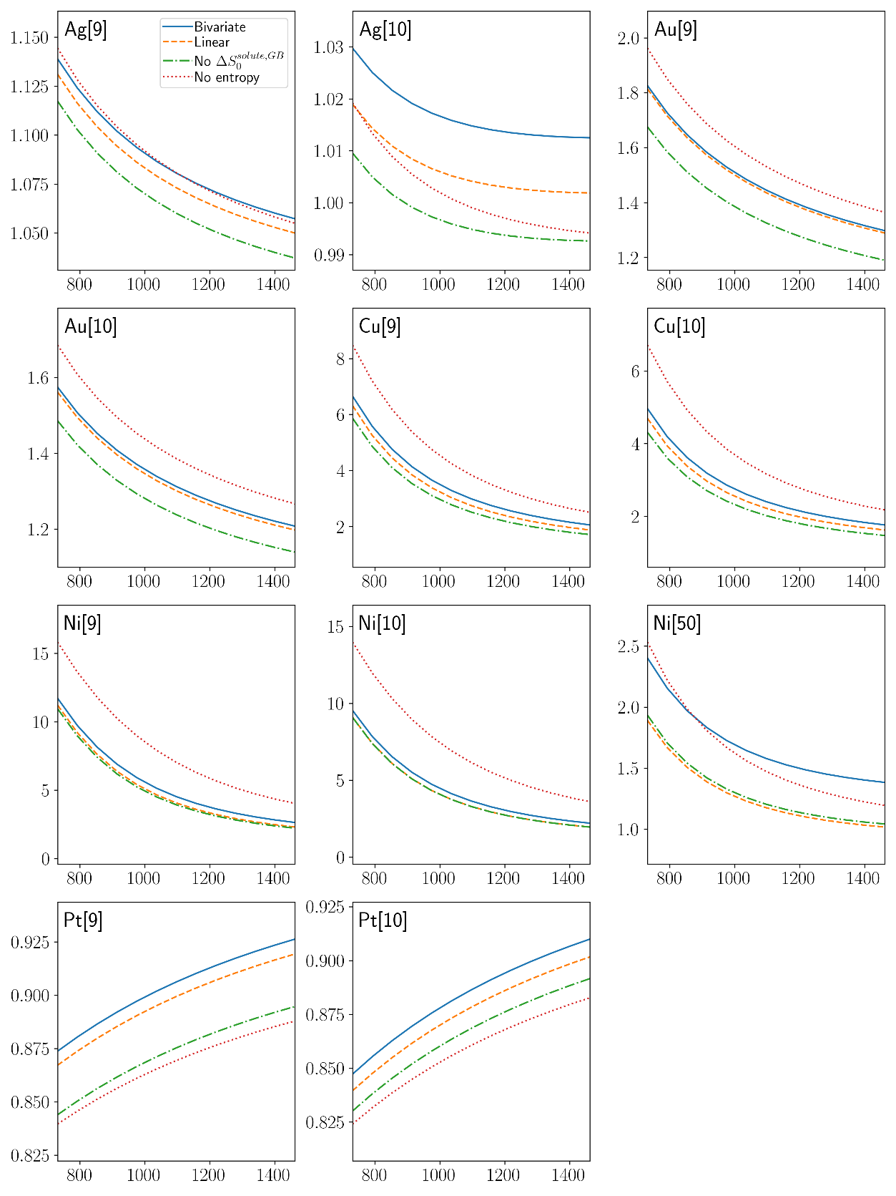
Fig. S58 Temperature dependences of GB concentration (in at.%) predicted with excess entropy from bivariate distribution, linear relationship of Eq. (5) and without excess entropy for Pd-based Alloys.
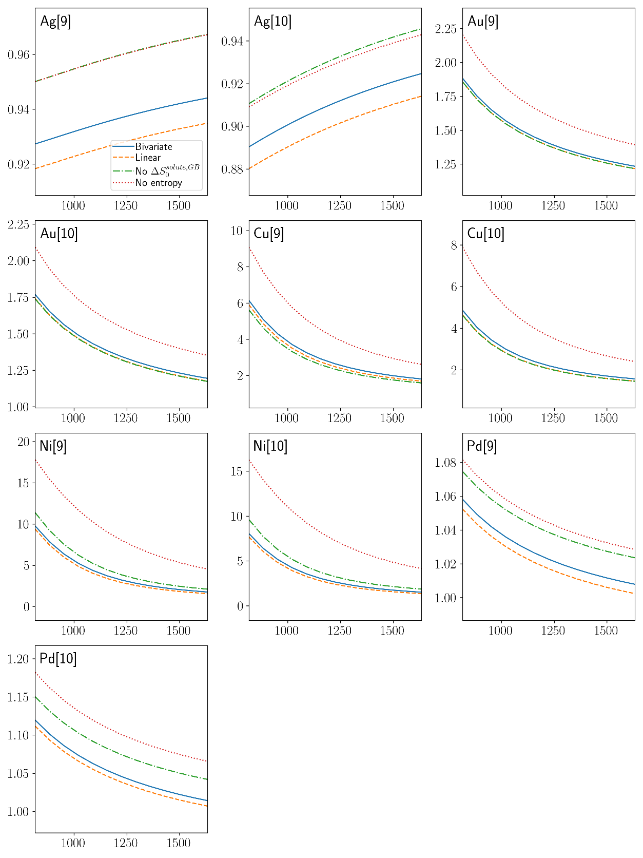
Fig. S59 Temperature dependences of GB concentration (in at.%) predicted with excess entropy from bivariate distribution, linear relationship of Eq. (5) and without excess entropy for Pt-based Alloys.

- References
1. Tuchinda, N. & Schuh, C. A. The vibrational entropy spectra of grain boundary segregation in polycrystals. Acta Mater. 245, 118630 (2023).
2. Plimpton, S. Fast parallel algorithms for short-range molecular dynamics. J. Comput. Phys. 117, 1–19 (1995).
3. Brown, W. M., Wang, P., Plimpton, S. J. & Tharrington, A. N. Implementing molecular dynamics on hybrid high performance computers–short range forces. Comput. Phys. Commun. 182, 898–911 (2011).
4. Brown, W. M., Kohlmeyer, A., Plimpton, S. J. & Tharrington, A. N. Implementing molecular dynamics on hybrid high performance computers–Particle–particle particle-mesh. Comput. Phys. Commun. 183, 449–459 (2012).
5. Brown, W. M. & Yamada, M. Implementing molecular dynamics on hybrid high performance computers—three-body potentials. Comput. Phys. Commun. 184, 2785–2793 (2013).
6. Bitzek, E., Koskinen, P., Gähler, F., Moseler, M. & Gumbsch, P. Structural Relaxation Made Simple. Phys. Rev. Lett. 97, 170201 (2006).
7. Guénolé, J. et al. Assessment and optimization of the fast inertial relaxation engine (fire) for energy minimization in atomistic simulations and its implementation in lammps. Comput. Mater. Sci. 175, 109584 (2020).
8. Sheng, H. Al-Ag EAM Potential, Private communication. https://sites.google.com/site/eampotentials/AlAg (2012).
9. Adams, J. B., Foiles, S. M. & Wolfer, W. G. Self-diffusion and impurity diffusion of fee metals using the five-frequency model and the Embedded Atom Method. J. Mater. Res. 4, 102–112 (1989).
10. Foiles, S. M., Baskes, M. I. & Daw, M. S. Embedded-atom-method functions for the fcc metals Cu, Ag, Au, Ni, Pd, Pt, and their alloys. Phys. Rev. B 33, 7983–7991 (1986).
11. Fujita, T. et al. Coupling between chemical and dynamic heterogeneities in a multicomponent bulk metallic glass. Phys. Rev. B 81, 140204 (2010).
12. Williams, P. L., Mishin, Y. & Hamilton, J. C. An embedded-atom potential for the Cu–Ag system. Model. Simul. Mater. Sci. Eng. 14, 817 (2006).
13. Wu, H. H. & Trinkle, D. R. Cu/Ag EAM potential optimized for heteroepitaxial diffusion from ab initio data. Comput. Mater. Sci. 47, 577–583 (2009).
14. Pan, Z., Borovikov, V., Mendelev, M. I. & Sansoz, F. Development of a semi-empirical potential for simulation of Ni solute segregation into grain boundaries in Ag. Model. Simul. Mater. Sci. Eng. 26, 075004 (2018).
15. Farkas, D. & Caro, A. Model interatomic potentials for Fe–Ni–Cr–Co–Al high-entropy alloys. J. Mater. Res. 35, 3031–3040 (2020).
16. Purja Pun, G. P., Yamakov, V. & Mishin, Y. Interatomic potential for the ternary Ni–Al–Co system and application to atomistic modeling of the B2–L1 ₀ martensitic transformation. Model. Simul. Mater. Sci. Eng. 23, 065006 (2015).
17. Cheng, Y. Q., Ma, E. & Sheng, H. W. Atomic Level Structure in Multicomponent Bulk Metallic Glass. Phys. Rev. Lett. 102, 245501 (2009).
18. Liu, X.-Y., Liu, C.-L. & Borucki, L. J. A new investigation of copper’s role in enhancing Al–Cu interconnect electromigration resistance from an atomistic view. Acta Mater. 47, 3227–3231 (1999).
19. Mendelev, M. I., Srolovitz, D. J., Ackland, G. J. & Han, S. Effect of Fe Segregation on the Migration of a Non-Symmetric Σ5 Tilt Grain Boundary in Al. J. Mater. Res. 20, 208–218 (2005).
20. Liu, X.-Y., Ohotnicky, P. P., Adams, J. B., Rohrer, C. L. & Hyland, R. W. Anisotropic surface segregation in AlMg alloys. Surf. Sci. 373, 357–370 (1997).
21. Liu, X.-Y. & Adams, J. B. Grain-boundary segregation in Al–10%Mg alloys at hot working temperatures. Acta Mater. 46, 3467–3476 (1998).
22. Mendelev, M. I., Asta, M., Rahman, M. J. & Hoyt, J. J. Development of interatomic potentials appropriate for simulation of solid–liquid interface properties in Al–Mg alloys. Philos. Mag. 89, 3269–3285 (2009).
23. Mishin, Y., Mehl, M. J. & Papaconstantopoulos, D. A. Embedded-atom potential for B 2 − NiAl. Phys. Rev. B 65, 224114 (2002).
24. Mishin, Y. Atomistic modeling of the γ and γ′-phases of the Ni–Al system. Acta Mater. 52, 1451–1467 (2004).
25. Purja Pun, G. P. & Mishin, Y. Development of an interatomic potential for the Ni-Al system. Philos. Mag. 89, 3245–3267 (2009).
26. Landa, A. et al. Development of glue-type potentials for the Al–Pb system: phase diagram calculation. Acta Mater. 48, 1753–1761 (2000).
27. Mendelev, M. I. et al. Development of interatomic potentials appropriate for simulation of devitrification of Al90Sm10 alloy. Model. Simul. Mater. Sci. Eng. 23, 045013 (2015).
28. Song, H. & Mendelev, M. I. Molecular Dynamics Study of Mechanism of Solid–Liquid Interface Migration and Defect Formation in Al3Sm Alloy. JOM 73, 2312–2319 (2021).
29. Farkas, D. & Jones, C. Interatomic potentials for ternary Nb - Ti - Al alloys. Model. Simul. Mater. Sci. Eng. 4, 23–32 (1996).
30. Zope, R. R. & Mishin, Y. Interatomic potentials for atomistic simulations of the Ti-Al system. Phys. Rev. B 68, 024102 (2003).
31. Deluigi, O. R. et al. Simulations of primary damage in a High Entropy Alloy: Probing enhanced radiation resistance. Acta Mater. 213, 116951 (2021).
32. Farkas, D. & Caro, A. Model interatomic potentials and lattice strain in a high-entropy alloy. J. Mater. Res. 33, 3218–3225 (2018).
33. Bonny, G., Pasianot, R. C., Castin, N. & Malerba, L. Ternary Fe–Cu–Ni many-body potential to model reactor pressure vessel steels: First validation by simulated thermal annealing. Philos. Mag. 89, 3531–3546 (2009).
34. Fischer, F., Schmitz, G. & Eich, S. M. A systematic study of grain boundary segregation and grain boundary formation energy using a new copper–nickel embedded-atom potential. Acta Mater. 176, 220–231 (2019).
35. Foiles, S. M. Calculation of the surface segregation of Ni-Cu alloys with the use of the embedded-atom method. Phys. Rev. B 32, 7685–7693 (1985).
36. Onat, B. & Durukanoğlu, S. An optimized interatomic potential for Cu–Ni alloys with the embedded-atom method. J. Phys. Condens. Matter 26, 035404 (2013).
37. Hoyt, J. J., Garvin, J. W., Webb, E. B. & Asta, M. An embedded atom method interatomic potential for the Cu Pb system. Model. Simul. Mater. Sci. Eng. 11, 287–299 (2003).
38. Borovikov, V., Mendelev, M. I. & King, A. H. Effects of stable and unstable stacking fault energy on dislocation nucleation in nano-crystalline metals. Model. Simul. Mater. Sci. Eng. 24, 085017 (2016).
39. Cheng, Y. Q., Sheng, H. W. & Ma, E. Relationship between structure, dynamics, and mechanical properties in metallic glass-forming alloys. Phys. Rev. B 78, 014207 (2008).
40. Mendelev, M. I., Sordelet, D. J. & Kramer, M. J. Using atomistic computer simulations to analyze x-ray diffraction data from metallic glasses. J. Appl. Phys. 102, 043501 (2007).
41. Mendelev, M. I. et al. Development of suitable interatomic potentials for simulation of liquid and amorphous Cu–Zr alloys. Philos. Mag. 89, 967–987 (2009).
42. M.I. Baskes, X. Sha, J.E. Angelo, & N.R. Moody. Trapping of hydrogen to lattice defects in nickel. Model. Simul. Mater. Sci. Eng. 5, 651 (1997).
43. Béland, L. K. et al. Features of primary damage by high energy displacement cascades in concentrated Ni-based alloys. J. Appl. Phys. 119, 085901 (2016).
44. Li, Q.-J., Sheng, H. & Ma, E. Strengthening in multi-principal element alloys with local-chemical-order roughened dislocation pathways. Nat. Commun. 10, 3563 (2019).
45. Béland, L. K. et al. Accurate classical short-range forces for the study of collision cascades in Fe–Ni–Cr. Comput. Phys. Commun. 219, 11–19 (2017).
46. Bonny, G., Terentyev, D., Pasianot, R. C., Poncé, S. & Bakaev, A. Interatomic potential to study plasticity in stainless steels: the FeNiCr model alloy. Model. Simul. Mater. Sci. Eng. 19, 085008 (2011).
47. Bonny, G., Castin, N. & Terentyev, D. Interatomic potential for studying ageing under irradiation in stainless steels: the FeNiCr model alloy. Model. Simul. Mater. Sci. Eng. 21, 085004 (2013).
48. Zhou, X. W., Foster, M. E. & Sills, R. B. An Fe-Ni-Cr embedded atom method potential for austenitic and ferritic systems. J. Comput. Chem. 39, 2420–2431 (2018).
49. Zhang, Y., Ashcraft, R., Mendelev, M. I., Wang, C. Z. & Kelton, K. F. Experimental and molecular dynamics simulation study of structure of liquid and amorphous Ni62Nb38 alloy. J. Chem. Phys. 145, 204505 (2016).
50. Samolyuk, G. D., Béland, L. K., Stocks, G. M. & Stoller, R. E. Electron–phonon coupling in Ni-based binary alloys with application to displacement cascade modeling. J. Phys. Condens. Matter 28, 175501 (2016).
51. Sheng, H. W., Ma, E. & Kramer, M. J. Relating Dynamic Properties to Atomic Structure in Metallic Glasses. JOM 64, 856–881 (2012).
52. Kong, L. T., Liu, J. B., Lal, W. S. & Liu, B. X. Correlation of lattice constant versus tungsten concentration of the Ni-based solid solution examined by molecular dynamics simulation. J. Alloys Compd. 337, 143–147 (2002).
53. Mendelev, M. I., Kramer, M. J., Hao, S. G., Ho, K. M. & Wang, C. Z. Development of interatomic potentials appropriate for simulation of liquid and glass properties of NiZr2 alloy. Philos. Mag. 92, 4454–4469 (2012).
54. Wilson, S. R. & Mendelev, M. I. Anisotropy of the solid–liquid interface properties of the Ni–Zr B33 phase from molecular dynamics simulation. Philos. Mag. 95, 224–241 (2015).
55. Creuze, J., Berthier, F., Tétot, R., Legrand, B. & Tréglia, G. Intergranular segregation and vibrational effects: A local analysis. Phys. Rev. B 61, 14470–14480 (2000).
56. LeSar, R., Najafabadi, R. & Srolovitz, D. J. Finite-temperature defect properties from free-energy minimization. Phys. Rev. Lett. 63, 624–627 (1989).
57. Najafabadi, R., Wang, H. Y., Srolovitz, D. J. & LeSar, R. A new method for the simulation of alloys: Application to interfacial segregation. Acta Metall. Mater. 39, 3071–3082 (1991).
58. Rittner, J. D. & Seidman, D. N. Solute-atom segregation to< 110> symmetric tilt grain boundaries. Acta Mater. 45, 3191–3202 (1997).
59. Tuchinda, N. & Schuh, C. A. Dataset - Computed Entropy Spectra for Grain Boundary Segregation in Polycrystals. doi:https://doi.org/10.6084/m9.figshare.23532294 Private Share Link: https://figshare.com/s/5c938da6492c513e4360.
60. Wagih, M., Larsen, P. M. & Schuh, C. A. Learning grain boundary segregation energy spectra in polycrystals. Nat. Commun. 11, 6376 (2020).
61. Virtanen, P. et al. SciPy 1.0: fundamental algorithms for scientific computing in Python. Nat. Methods 17, 261–272 (2020).
62. vanRossum, G. Python reference manual. Dep. Comput. Sci. CS (1995).
63. Kluyver, T. et al. Jupyter Notebooks – a publishing format for reproducible computational workflows. in Positioning and Power in Academic Publishing: Players, Agents and Agendas (eds. Loizides, F. & Schmidt, B.) 87–90 (IOS Press, 2016).
64. Harris, C. R. et al. Array programming with NumPy. Nature 585, 357–362 (2020).
65. Joblib Development Team. Joblib: running Python functions as pipeline jobs. (2022).
66. Azzalini, A. & Capitanio, A. Statistical applications of the multivariate skew normal distribution. J. R. Stat. Soc. Ser. B Stat. Methodol. 61, 579–602 (1999).
67. Brent, R. P. Algorithms for minimization without derivatives. (Courier Corporation, 2013).
68. Piessens, R., de Doncker-Kapenga, E., Überhuber, C. W. & Kahaner, D. K. Quadpack: a subroutine package for automatic integration. vol. 1 (Springer Science & Business Media, 2012).
69. Pedregosa, F. et al. Scikit-learn: Machine Learning in Python. Mach. Learn. PYTHON 6.
70. Ishida, K. Effect of grain size on grain boundary segregation. J. Alloys Compd. 235, 244–249 (1996).
71. White, C. & Stein, D. Sulfur segregation to grain boundaries in Ni 3 Al and Ni 3 (AI, Ti) alloys. Metall. Trans. A 9, 13–22 (1978).
72. Wagih, M. & Schuh, C. A. Spectrum of grain boundary segregation energies in a polycrystal. Acta Mater. 181, 228–237 (2019).

