Supplementary Materials

California
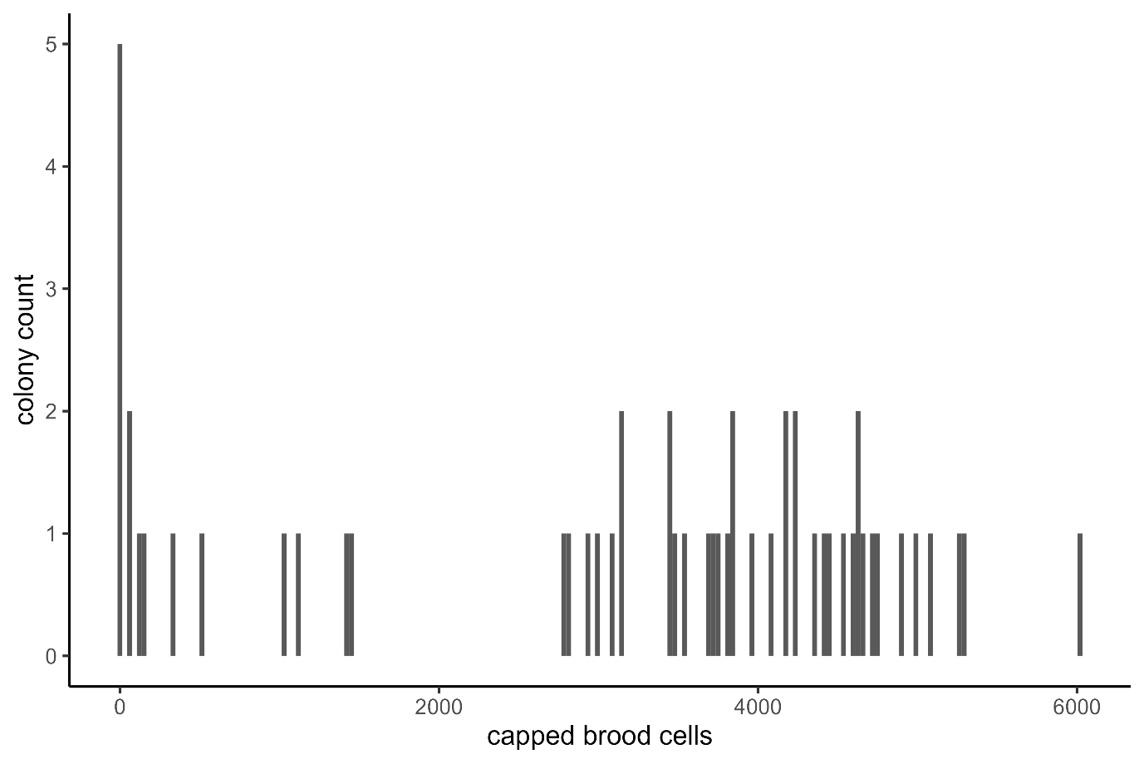
Figure S1: Distribution of brood amounts in colonies of the California dataset, showing a clear bimodal brood distribution with some colonies containing above and below 2000 capped brood cells.

Sydney 2018
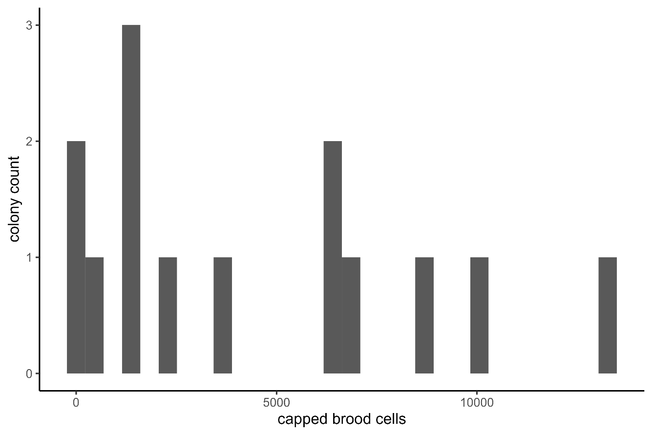
Figure S2: Distribution of brood amounts in colonies of the Sydney 2018 dataset, suggesting a bimodal brood distribution with some colonies containing above and below 5000 capped brood cells.

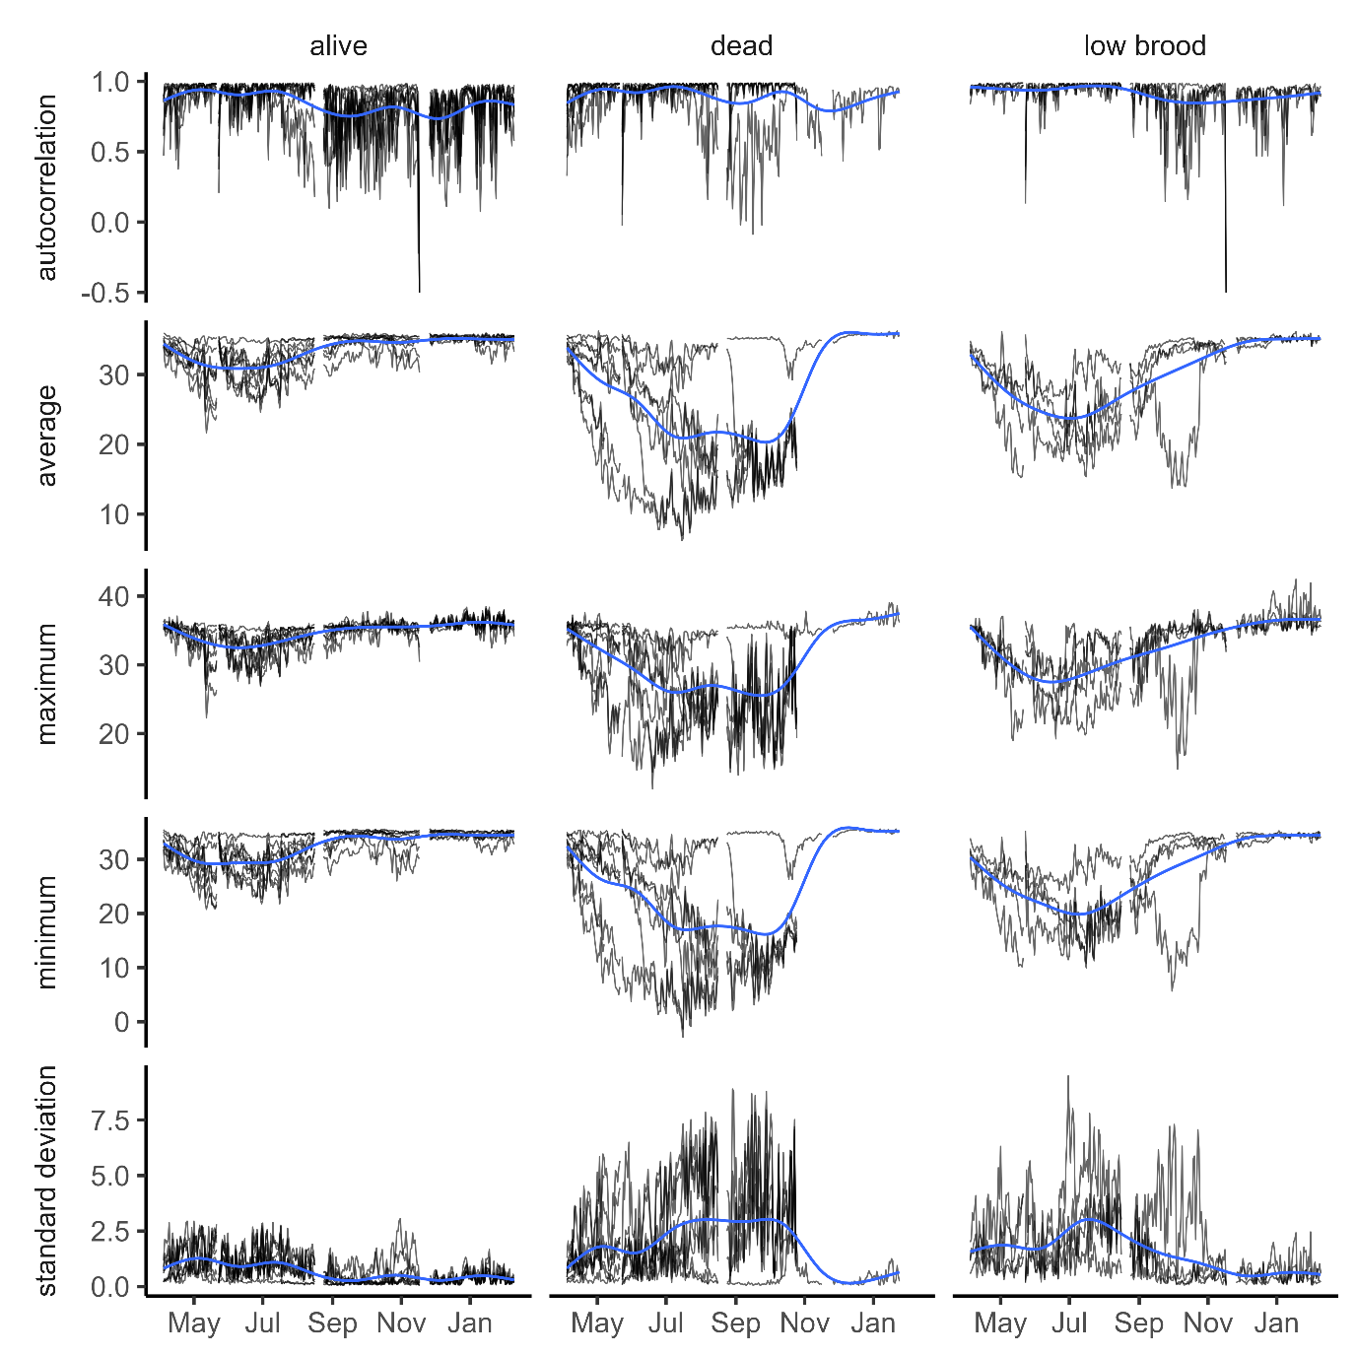
Figure S3: Daily hive temperature parameters for the Sydney 2018 dataset. Bee colonies were either considered alive, dead, or had abnormally low brood levels at the end of the experiment. Daily autocorrelations, daily standard deviations, daily averages, daily minimums and daily maximums suggest differences between alive, dead and low brood bee colonies that increase during winter. Black lines show the daily data, blue lines generalised additive models (default parameters from geom_smooth in R v4.0.0).

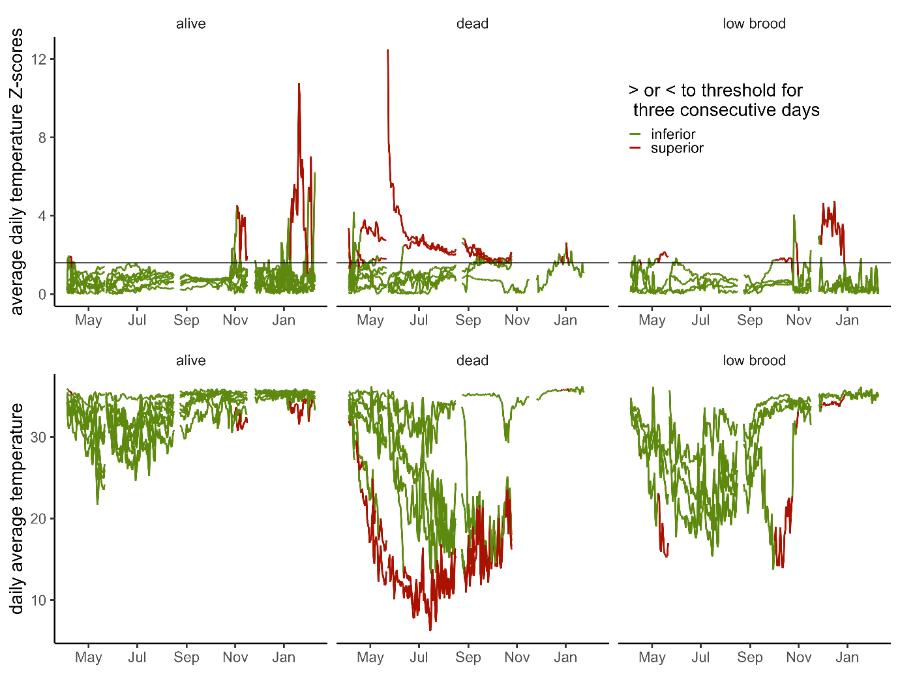
Figure S4: Detection of failing hives with a threshold of 1.6 and >3 consecutive warnings (false-positive conservative) as an example of potential software application for the Sydney 2018. Top panel shows the Z-Scores for the daily average temperature, with colonies shown in red when they cross the threshold (thin black line) for over three consecutive days, or green otherwise. Bottom panel shows the same classification applied to the daily temperature average curves.
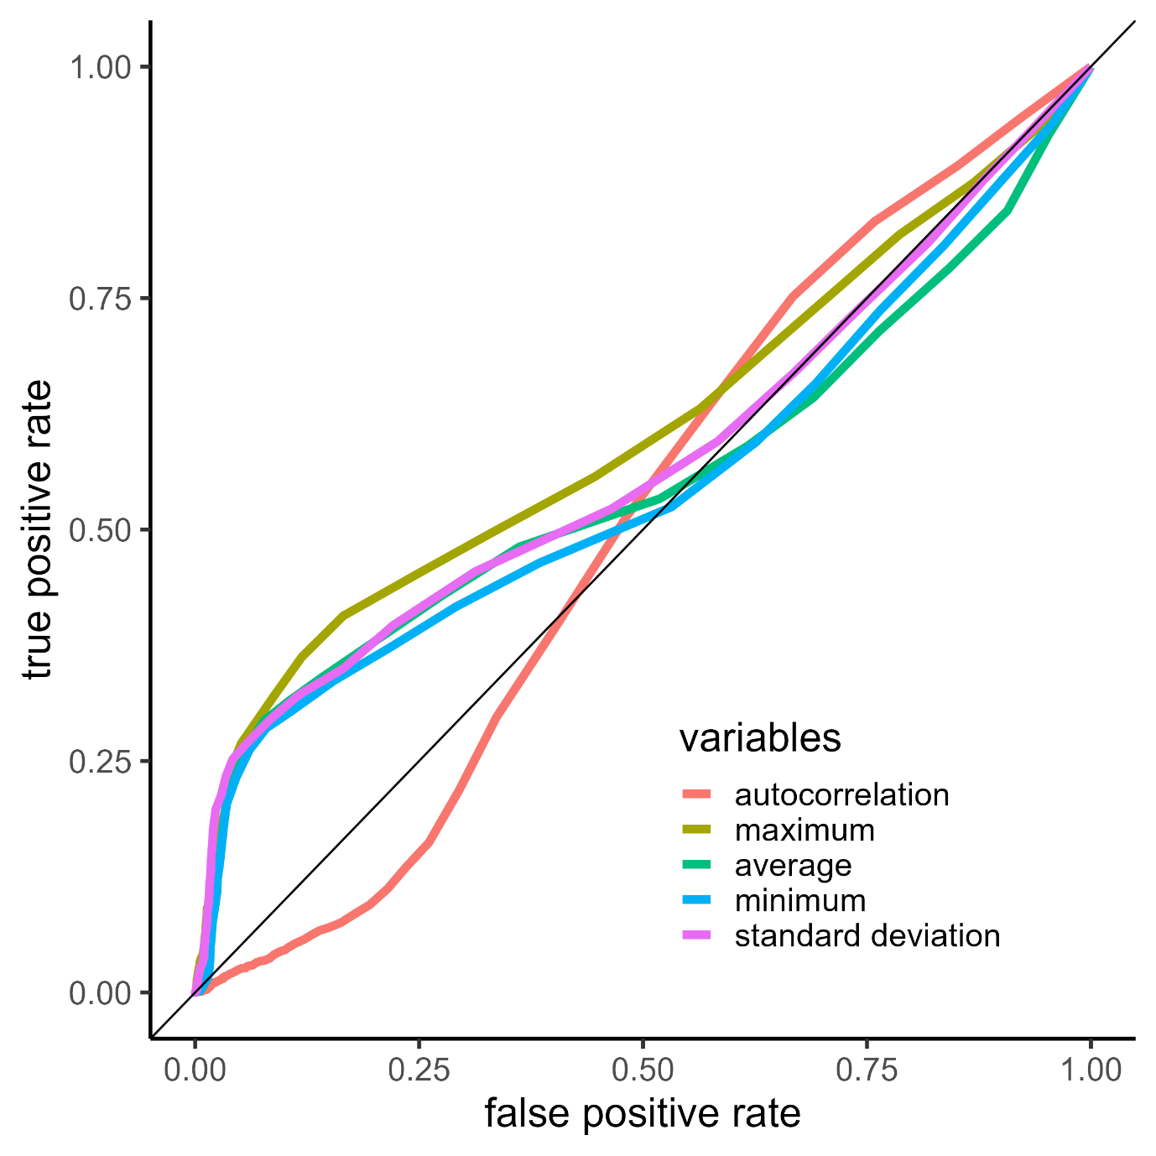
Figure S5: Receiver operating characteristic (ROC) curves showing the relationship between the true positive rate and the false positive rate for the five variables measured for the Sydney 2018 dataset. All measurements perform similarly.

Sydney 2020
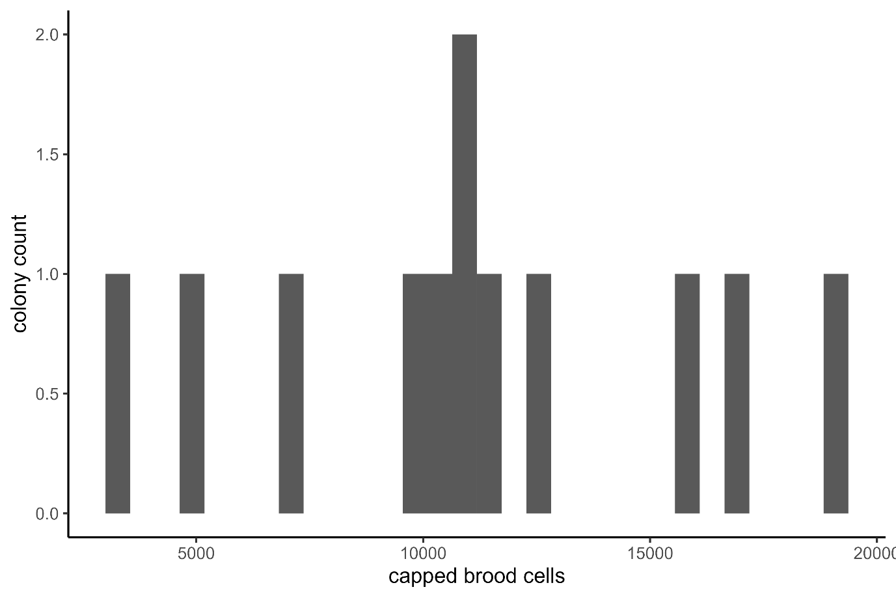
Figure S6: Distribution of brood amounts in colonies of the Sydney 2020 dataset, colonies below 5000 capped brood cells were considered low brood as for the Sydney 2018 dataset.
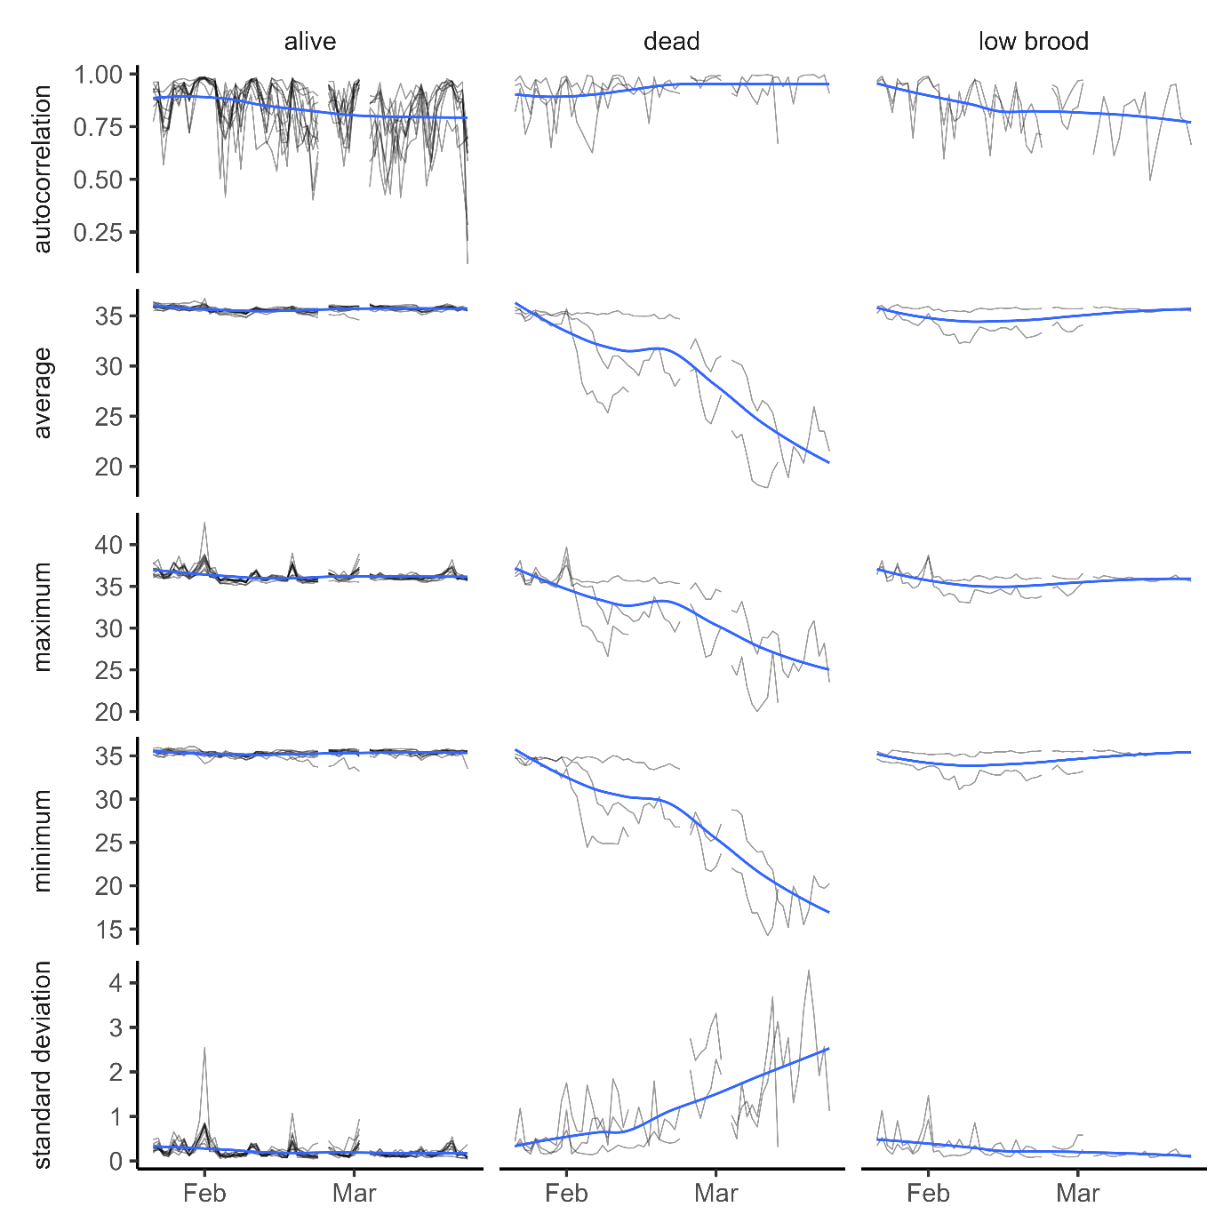
Figure S7: Daily hive temperature parameters for the Sydney 2020 dataset. Bee colonies were either considered alive, dead, or had abnormally low brood levels at the end of the experiment. Daily autocorrelations, daily standard deviations, daily averages, daily minimums and daily maximums suggest differences between alive, dead and low brood bee colonies that increase during winter. Black lines show the daily data, blue lines generalised additive models (default parameters from geom_smooth in R v4.0.0).
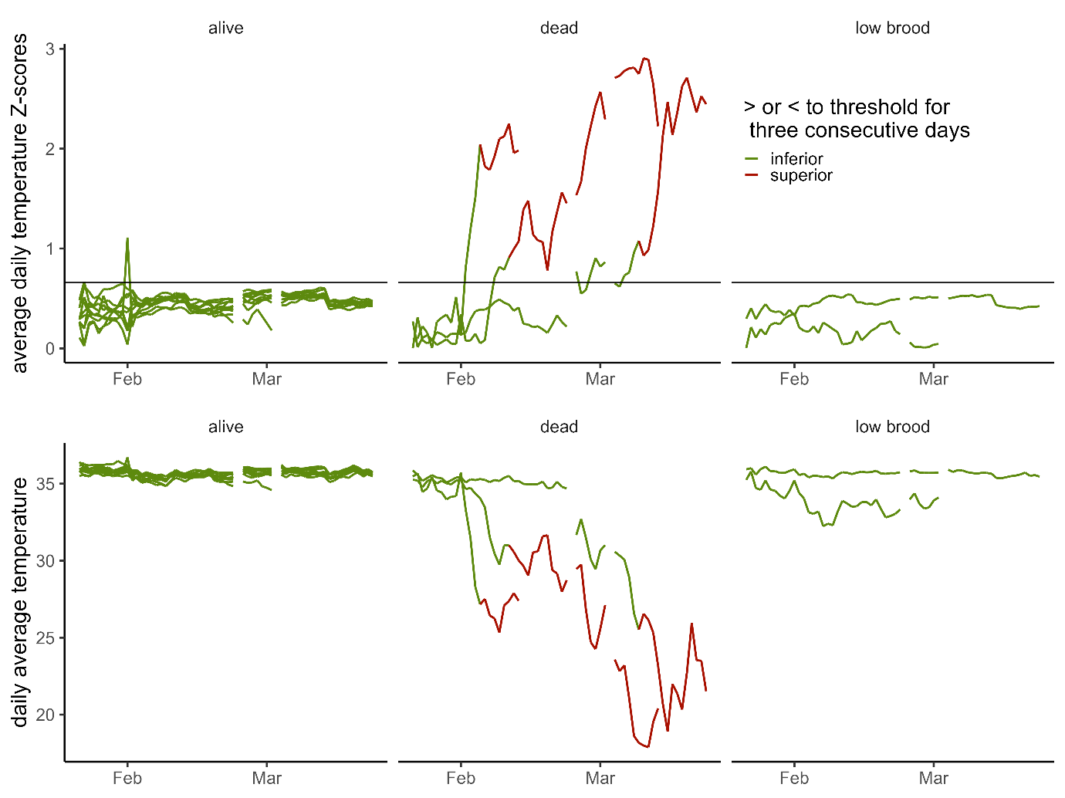
Figure S8: Detection of failing hives with a threshold of 0.66 and >3 consecutive warnings (false-positive conservative) as an example of potential software application for the Sydney 2020 dataset. Top panel shows the Z-Scores for the daily average temperature, with colonies shown in red when they cross the threshold (thin black line) for over three consecutive days, or green otherwise. Bottom panel shows the same classification applied to the daily temperature average curves.
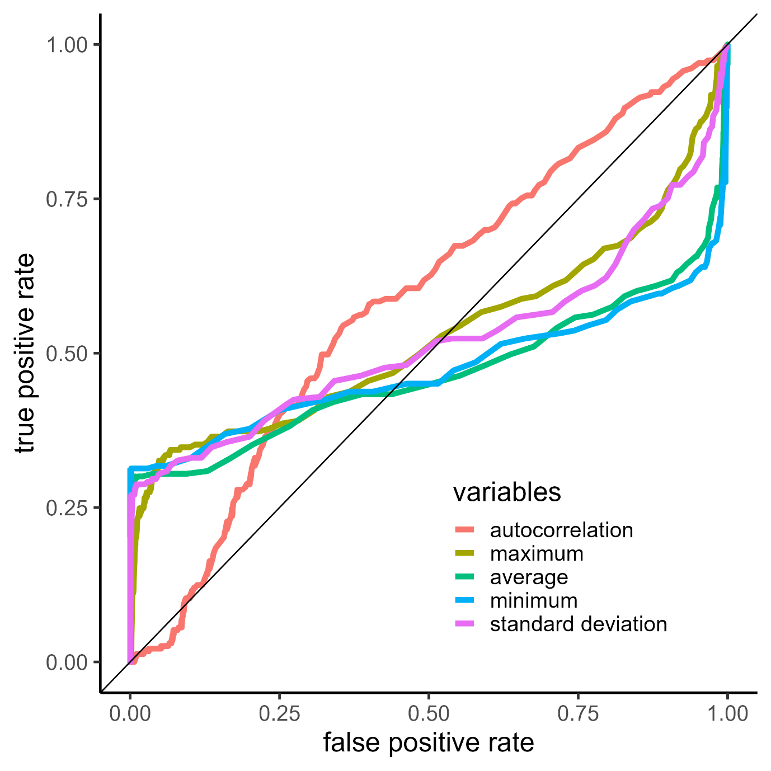
Figure S9: Receiver operating characteristic (ROC) curves showing the relationship between the true positive rate and the false positive rate for the five variables measured for the Sydney 2020 dataset. Although the Area under the curve is higher for the autocorrelation, the positive rate is mainly high when the false positive rate is also high. The other measurements perform similarly.

