The role of neutrophil heterogeneity on T-cell immunity and prognosis
in thyroid cancer patients

Seong Eun Lee, Bon Seok Koo et al.

Supplementary Information

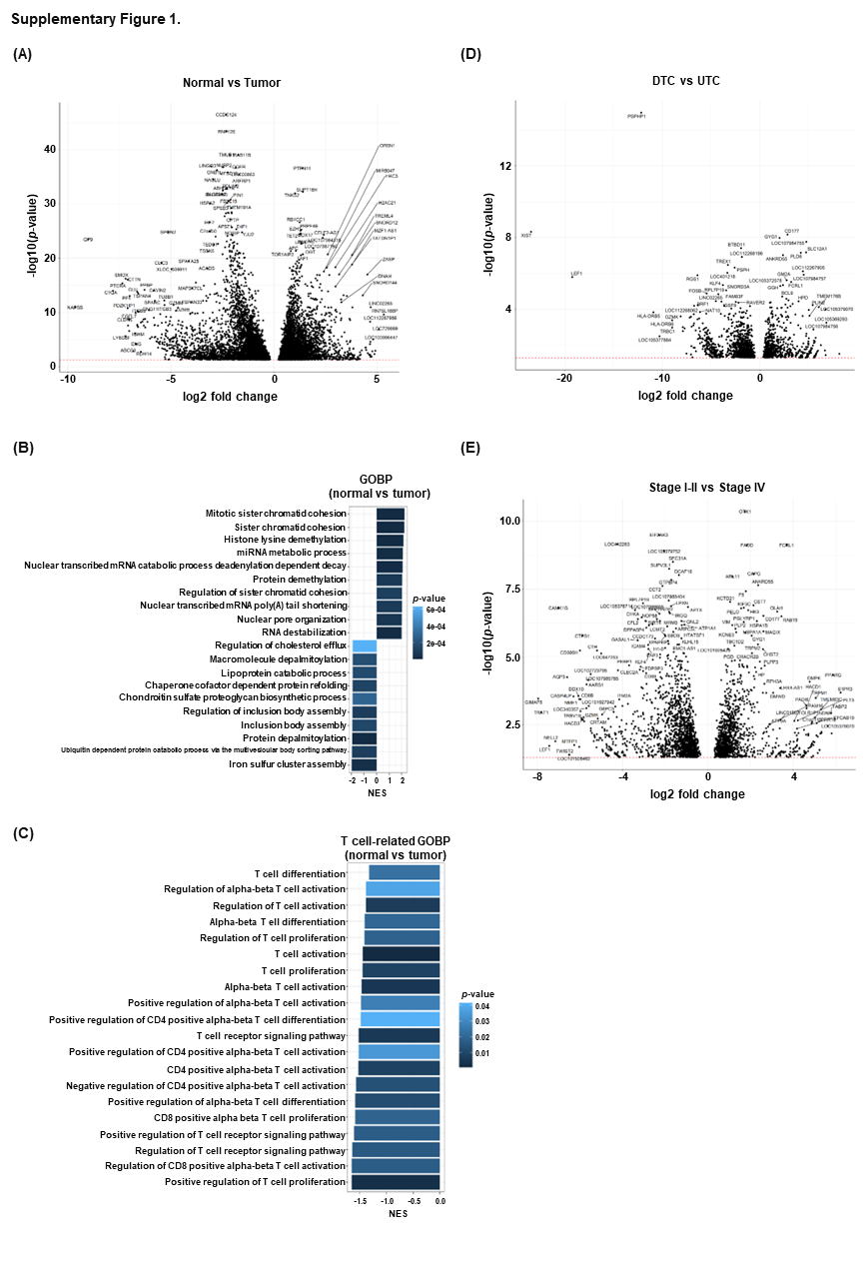Supplementary figure 1. Comparison of gene expressions in HDN using transcriptomic data (A) Volcano plot comparing gene expression in HDN between healthy controls and thyroid cancer patients (B) Differentially enriched Gene Ontology Biological Process (GOBP) pathway from GSEA between normal (n=9) and tumor (n=11) neutrophils. Horizontal axis and color represent normalized enrichment score (NES) and p-value, respectively. (C) Differentially enriched Gene Ontology Biological Process (GOBP) pathway related T cell immunity from GSEA between normal (n=9) and tumor (n=11) neutrophils. (D) Volcano plot comparing gene expression of HDN from DTC (n=9) and UTC (n=2). Horizontal axis and color represent normalized enrichment score (NES) and p-value, respectively. (E) Volcano plot comparing gene expression of HDN from Stage I-II (n=7) and Stage IV (n=4). Horizontal axis and color represent normalized enrichment score (NES) and p-value, respectively.

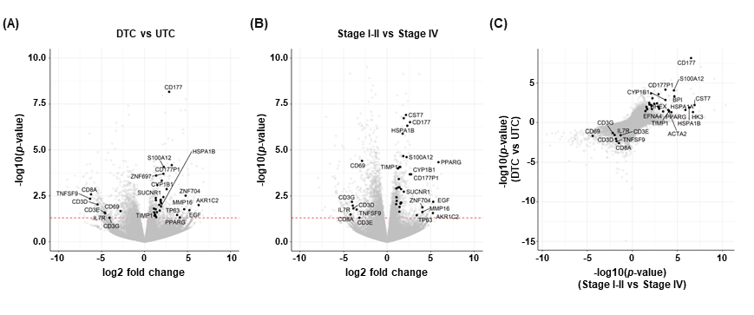
Supplementary figure 2. Neutrophil-T cell interaction related gene expression in HDN in relation to tumor type and tumor stage (A) Volcano plot comparing gene expression of DTC (n=9) and UTC (n=2) neutrophils. Names of neutrophils-related genes are annotated. (B) Volcano plot comparing gene expression of Stage Ⅰ-Ⅱ (n=7) and Stage Ⅳ (n=4) neutrophils. Names of neutrophil-related genes are annotated. (C) Scatterplot showing differentially expressed genes (DEGs) between Stage Ⅰ-Ⅱ versus Stage Ⅳ neutrophils (horizontal axis) and DTC versus UTC neutrophils (vertical axis), simultaneously.

