The Cerebellar Cognitive Affective / Schmahmann Syndrome Scale in Spinocerebellar Ataxias
SUPPLEMENTARY TABLES AND FIGURES

Table S1
Demographic and clinical information by SCA type within the Pre-symptomatic and Symptomatic groups
 | Presymp_SCA1 | Presymp_SCA3 | SCA1 | SCA2 | SCA3 | SCA6 | SCA7 | SCA8
n | 11 | 15 | 58 | 52 | 132 | 47 | 11 | 9
Age
Mean (SD) | 36.7 (5.79) | 40.7 (11.2) | 49.0 (11.5) | 48.4 (14.2) | 49.8 (12.3) | 62.4 (10.7) | 47.5 (15.5) | 53.8 (22.4)
Missing | 0 (0%) | 0 (0%) | 1 (1.7%) | 7 (13.5%) | 6 (4.5%) | 0 (0%) | 4 (36.4%) | 0 (0%)
Gender
Female | 8 (72.7%) | 13 (86.7%) | 28 (48.3%) | 23 (44.2%) | 66 (50.0%) | 27 (57.4%) | 3 (27.3%) | 7 (77.8%)
Male | 3 (27.3%) | 2 (13.3%) | 29 (50.0%) | 22 (42.3%) | 60 (45.5%) | 20 (42.6%) | 5 (45.5%) | 2 (22.2%)
Missing | 0 (0%) | 0 (0%) | 1 (1.7%) | 7 (13.5%) | 6 (4.5%) | 0 (0%) | 3 (27.3%) | 0 (0%)
Genetic mutation | CAG repeat, ATXN1 | CAG repeat, ATXN1 | CAG repeat, ATXN3 | CAG repeat, CACNA1A | CAG repeat, ATXN7 | (CTG.CAG)n repeat, ATXN8OS/ATXN8 | ATTCT repeat, ATXN10 | CAG repeat, ATXN1
Number of repeats, normal allele
Mean (SD) | 28.5 (2.58) | 19.9 (4.87) | 29.5 (2.29) | 22.2 (1.54) | 22.6 (5.34) | 12.5 (1.55) | 10.5 (1.93) | 24.0 (2.38)
Missing | 0 (0%) | 0 (0%) | 4 (6.9%) | 13 (25.0%) | 13 (9.8%) | 5 (10.6%) | 3 (27.3%) | 2 (22.2%)
Number of repeats, expanded allele
Mean (SD) | 43.9 (2.84) | 69.3 (2.28) | 46.1 (4.67) | 39.5 (2.86) | 71.5 (4.49) | 22.4 (1.03) | 50.5 (9.47) | 202 (238)
Missing | 0 (0%) | 0 (0%) | 4 (6.9%) | 10 (19.2%) | 12 (9.1%) | 4 (8.5%) | 3 (27.3%) | 2 (22.2%)
Disease duration
Mean (SD) | N/A | N/A | 10.1 (6.96) | 10.5 (8.06) | 9.90 (9.24) | 9.93 (9.22) | 8.80 (6.90) | 17.9 (10.1)
Missing | 11 (100%) | 15 (100%) | 12 (20.7%) | 16 (30.8%) | 18 (13.6%) | 15 (31.9%) | 6 (54.5%) | 2 (22.2%)
Age at disease onset
Mean (SD) | N/A | N/A | 40.4 (10.9) | 38.2 (10.8) | 39.4 (11.6) | 54.4 (10.8) | 37.5 (11.8) | 36.4 (18.9)
Missing | N/A | N/A | 12 (20.7%) | 16 (30.8%) | 18 (13.6%) | 15 (31.9%) | 5 (45.5%) | 2 (22.2%)
SARA total score
Mean (SD) | 1.25 (1.30) | 0.96 (1.03) | 11.1 (7.27) | 13.8 (6.88) | 9.45 (5.36) | 9.74 (7.01) | 13.8 (12.8) | 11.7 (5.45)
Missing | 1 (9.1%) | 2 (13.3%) | 14 (24.1%) | 29 (55.8%) | 36 (27.3%) | 18 (38.3%) | 5 (45.5%) | 2 (22.2%)

Table S2
The 10 domains of the Cerebellar Cognitive Affective / Schmahmann Syndrome Scale (CCAS-S)
 | Test | Target function | Target domain | Maximum score | Pass/fail cut-off | Comment on potential impact of ataxia-related motor dysfunction on performance/test scoring
1 | Semantic fluency | Word/idea production | Language | 26 | Fail if ≤ 15 | Timed tasks may be impacted by dysarthria/articulatory speed in spinocerebellar ataxias. However, it has been demonstrated that individuals with cerebellar disorders are impaired on verbal fluency tasks relative to controls, over and above any articulatory limitations (Stoodley & Schmahmann, 2009).
2 | Phonemic fluency | Word/idea production | Language | 19 | Fail if ≤ 9
3 | Category switching | Cognitive flexibility and word/idea production | Executive function/Language | 15 | Fail if ≤ 9
4 | Digit span forward | Attention span | Executive function | 8 | Fail if ≤ 5 | No impact – untimed task
5 | Digit span backward | Working memory | Executive function | 6 | Fail if ≤ 3 | No impact – untimed task
6 | Cube draw/copy | Visuo-motor construction | Visuospatial | 15 | Fail if ≤ 11 | Not impacted – inaccuracies/messiness due to poor motor control do not result in a loss of points
7 | Verbal recall (delayed) | Verbal free recall, cued recall, or recognition | Memory | 15 | Fail if ≤ 10 | No impact – untimed task
8 | Similarities | Verbal abstract reasoning | Executive function | 8 | Fail if ≤ 6 | No impact – untimed task
9 | Go no-go | Inhibition | Executive function | 2 | Fail if 0 | No impact- time limit for motor response; quality of motor response not scored
10 | Affect | Presence of neuropsychiatric symptoms observed in cerebellar disorders* | Behavior/emotional regulation | 6 | Fail if ≤ 4 | The presence of motor dysfunction does not result in the endorsement of any of the symptoms listed
 |  |  |  | Total raw score: 0-120 | Total fail score: 0-10
Note that the 3 verbal fluency tasks (semantic, phonemic, and category switching) tap language processing as well as executive control.*As described by Schmahmann, Weilburg, & Sherman (2007) in the five major categories of attentional control, emotional control, autism spectrum, psychosis spectrum, and social skill set. Presence of these symptoms is elicited by examiner observation, examinee self-report, and/or carer report.

Schmahmann, J. D., Weilburg, J. B., & Sherman, J. C. (2007). The neuropsychiatry of the cerebellum—Insights from the clinic. The Cerebellum, 6(3), 254–267. https://doi.org/10.1080/14734220701490995
Stoodley, C. J., & Schmahmann, J. D. (2009). The cerebellum and language: Evidence from patients with cerebellar degeneration. Brain and Language, 110(3), 149–153. https://doi.org/10.1016/j.bandl.2009.07.006

Table S3
Global CCAS performance descriptive statistics by Symptom status
 | Control  n = 37 | Pre-symptomatic  n = 26 | Symptomatic  n = 309
Total raw score | 106.00 ± 7.28, [84, 119] | 101.00 ± 12.0, [68, 118] | 88.50 ± 15.00, [54, 119]
Total fail score | 0.70 ± 0.81, [0, 3] | 0.923 ± 1.32, [0, 5] | 2.60 ± 2.07, [0, 9]
CCAS category n (%)
No CCAS | 17 (45.9%) | 13 (50.0%) | 52 (16.8%)
Possible CCAS | 16 (43.2%) | 8 (30.8%) | 62 (20.1%)
Probable CCAS | 2 (5.4%) | 2 (7.7%) | 53 (17.2%)
Definite CCAS | 2 (5.4%) | 3 (11.5%) | 142 (46.0%)
n (%) raw score < 82 | 0 (0%) | 2 (7.7%) | 103 (33.3%)

Mean ± Standard Deviation, [range]

Table S4
Global CCAS performance descriptive statistics by SCA type

 | SCA1  N = 58 | SCA2  N = 52 | SCA3  N = 132 | SCA6  N = 47 | SCA7  N = 11 | SCA8  N = 9
Total raw score | 83.9 (14.9), [55.0, 118] | 91.3 (15.5), 94.0 [54.0, 118] | 88.4 (14.5), [57.0, 119] | 91.3 (15.9), [55.0, 118] | 89.6 (14.8), [60.0, 112] | 88.9 (13.0), [76.0, 113]
Total fail score | 3.28 (2.27), [0, 9.00] | 2.33 (2.00), [0, 7.00] | 2.58 (2.02), [0, 8.00] | 2.09 (1.92), [0, 8.00] | 2.55 (2.21), [0, 6.00] | 2.78 (1.79), [0, 5.00]
CCAS category n (%)
No CCAS | 6 (10.3%) | 10 (19.2%) | 25 (18.9%) | 7 (14.9%) | 3 (27.3%) | 1 (11.1%)
Possible CCAS | 8 (13.8%) | 13 (25.0%) | 13 (25.0%) | 17 (36.2%) | 1 (9.1%) | 2 (22.2%)
Probable CCAS | 10 (17.2%) | 9 (17.3%) | 23 (17.4%) | 9 (19.1%) | 2 (18.2%) | 0 (0%)
Definite CCAS | 34 (58.6%) | 20 (38.5%) | 63 (47.7%) | 14 (29.8%) | 5 (45.5%) | 6 (66.7%)
n (%) raw score < 82 | 23 (39.7%) | 14 (26.9%) | 46 (34.8%) | 12 (25.5%) | 4 (36.4%) | 4 (44.4%)

Mean ± Standard Deviation, [range]

Table S5
Results of parametric ANCOVAs (one row per ANCOVA), with Symptom status, age and years of education as entered into the model.
Dependent variable | Effect of education |  | Effect of age |  | Effect of symptom status
 | F | p | F | p | F | p
Total raw score | 30.858 | < .001 | 13.076 | < .001 | 7.263 | < .001
Total fail score | 29.612 | < .001 | 10.283 | .002 | 4.580 | .011
Semantic fluency raw score | 14.767 | < .001 | 7.576 | .006 | 3.315 | .038
Phonemic fluency | 13.622 | < .001 | 1.573 | .211 | 6.889 | .001
Category switching | 9.216 | .003 | 5.864 | .016 | 3.659 | .027
Digit span forward | 6.733 | .010 | 2.205 | .139 | 1.008 | .366
Digit span backward | 22.168 | < .001 | 3.453 | .065 | 1.694 | .186
Cube draw/copy | 11.499 | < .001 | 11.693 | < .001 | 0.960 | .385
Verbal recall | 3.236 | .073 | 5.693 | .018 | 1.459 | .235
Similarities | 7.597 | .006 | 0.900 | .344 | 1.305 | .273
Go no-go | 2.027 | .156 | 1.324 | .251 | 0.385 | .681
Affect | 7.964 | .005 | 0.864 | .354 | 0.570 | .566

Significant p-values at < .05 are bolded.
Table S6a
Results of robust ANCOVAs, with Symptom status (Control vs. Symptomatic) as the independent variable, and age as the covariate. Top row indicates the design points at which the dependent variable was compared between groups.

Age design point | 21.75 | 37.74 | 43.91 | 50.11 | 55
Total raw score | 0.002 | < .001 | < .001 | < .001 | < .001
Total fail score | .053 | < .001 | < .001 | < .001 | < .001
Semantic fluency | .221 | < .001 | < .001 | < .001 | .001
Phonemic fluency | < .001 | < .001 | < .001 | < .001 | < .001
Category switching | < .001 | < .001 | < .001 | < .001 | .015
Digit span forward | .937 | .011 | .002 | .004 | .268
Digit span backward | .311 | .004 | .004 | .005 | .031
Cube draw/copy | .058 | .131 | .498 | .175 | .343
Verbal recall | .775 | .040 | .029 | < .001 | .065
Similarities | .920 | .115 | .060 | .040 | .171
Go no-go | .289 | .548 | .009 | 0.002 | 0.011
Affect | Model not valid

Uncorrected p-values; interpret significance at p < .01 (bolded cells)

Table S6b
Results of robust ANCOVAs, with Symptom status (Control vs. Symptomatic) as the independent variable, and years of education as the covariate. Top row indicates the design points at which the dependent variable was compared between groups.

Education design point | 15 | 16 | 17
Total raw score | < .001 | < .001 | < .001
Total fail score | < .001 | < .001 | < .001
Semantic fluency | < .001 | .007 | .006
Phonemic fluency | .009 | < .001 | < .001
Category switching | .007 | .018 | .025
Digit span forward | .034 | .072 | .142
Digit span backward | .393 | .410 | .301
Cube draw/copy | .184 | .570 | .407
Verbal recall | < .001 | .004 | .0013
Similarities | 0.7024 | 0.8130 | 0.4358
Go no-go | 0.2766 | 0.5151 | 0.5026
Affect | Model not valid

Uncorrected p-values; interpret significance at p < .016 (bolded cells)

Table S7. Adjusted p-values from Games-Howell post-hoc tests for the comparison of individual domain scores between Symptom statuses.
Item | Symptomatic vs. Control | Symptomatic vs.  Pre-symptomatic | Pre-symptomatic vs. Control
Semantic fluency | < .001 | .001 | .643
Phonemic fluency | < .001 | .035 | .129
Category switching | < .001 | .033 | .242
Digit span forward | .021 | .256 | .971
Digit span backward | .003 | .354 | .433
Cube draw/copy | < .001 | < .001 | .394
Verbal recall | .007 | .223 | .865
Similarities | .007 | .001 | .961
Go no-go | .339 | .287 | .983
Affect | .394 | .057 | .948

Significant p-values at < .05 are bolded.
Table S8: Descriptive statistics for item-level performance on the CCAS-S, by SCA type within the Symptomatic group.
 |  | SCA1  n = 58 | SCA2  n = 52 | SCA3  n = 132 | SCA6  n = 47 | SCA7  n = 11 | SCA8  n = 9
Semantic fluency | Raw | 16.4 (4.87) | 19.5 (5.00) | 17.8 (5.29) | 18.8 (6.01) | 18.9 (5.47) | 17.7 (5.29)
Semantic fluency | n (%) fail | 24 (41.4%) | 11 (21.2%) | 46 (34.8%) | 15 (31.9%) | 5 (45.5%) | 3 (33.3%)
Phonemic fluency | Raw | 10.2 (4.64) | 11.3 (4.73) | 10.5 (4.77) | 11.6 (4.70) | 12.6 (3.41) | 10.4 (5.25)
Phonemic fluency | n (%) fail | 29 (50.0%) | 23 (44.2%) | 61 (46.2%) | 16 (34.0%) | 3 (27.3%) | 5 (55.6%)
Category switching | Raw | 10.1 (3.18) | 11.0 (3.42) | 10.4 (3.48) | 11.3 (3.39) | 10.1 (3.59) | 10.2 (2.39)
Category switching | n (%) fail | 22 (37.9%) | 17 (32.7%) | 48 (36.4%) | 13 (27.7%) | 4 (36.4%) | 5 (55.6%)
Digit span forward | Raw | 5.93 (1.23) | 6.15 (1.33) | 6.23 (1.38) | 6.34 (1.07) | 6.45 (1.37) | 6.33 (1.12)
Digit span forward | n (%) fail | 15 (25.9%) | 13 (25.0%) | 36 (27.3%) | 9 (19.1%) | 2 (18.2%) | 2 (22.2%)
Digit span backward | Raw | 3.74 (1.25) | 3.96 (1.22) | 3.93 (1.35) | 4.04 (1.20) | 3.73 (1.10) | 3.67 (1.00)
Digit span backward | n (%) fail | 24 (41.4%) | 19 (36.5%) | 47 (35.6%) | 13 (27.7%) | 5 (45.5%) | 4 (44.4%)
Cube | Raw | 12.3 (3.35) | 12.8 (3.61) | 13.3 (2.41) | 12.1 (4.01) | 10.1 (4.99) | 13.4 (1.88)
Cube | n (%) fail | 18 (31.0%) | 12 (23.1%) | 22 (16.7%) | 11 (23.4%) | 5 (45.5%) | 2 (22.2%)
Verbal recall | Raw | 11.7 (3.53) | 12.1 (3.33) | 11.8 (3.06) | 12.2 (2.78) | 12.8 (2.89) | 12.8 (3.23)
Verbal recall | n (%) fail | 18 (31.0%) | 12 (23.1%) | 36 (27.3%) | 11 (23.4%) | 1 (9.1%) | 2 (22.2%)
Similarities | Raw | 6.59 (1.83) | 7.21 (0.696) | 7.10 (1.09) | 7.15 (0.884) | 7.27 (0.647) | 7.33 (0.500)
Similarities | n (%) fail | 18 (31.0%) | 4 (7.7%) | 23 (17.4%) | 5 (10.6%) | 1 (9.1%) | 0 (0%)
Go no-go | Raw | 1.19 (0.888) | 1.54 (0.779) | 1.61 (0.663) | 1.74 (0.607) | 1.82 (0.603) | 1.33 (0.866)
Go no-go | n (%) fail | 18 (31.0%) | 9 (17.3%) | 13 (9.8%) | 4 (8.5%) | 1 (9.1%) | 2 (22.2%)
Affect | Raw | 5.72 (0.744) | 5.75 (0.653) | 5.75 (0.714) | 5.91 (0.351) | 5.82 (0.603) | 5.67 (0.500)
Affect | n (%) fail | 4 (6.9%) | 1 (1.9%) | 8 (6.1%) | 1 (2.1%) | 1 (9.1%) | 0 (0%)

Mean (standard deviation)

Table S9a: Sensitivity and selectivity by total sample and SCA type
Sensitivity
Participant group | n | Possible CCAS | Probable CCAS | Definite CCAS
All SCAs | 309 | 83.2% | 63.1% | 46.0%
SCA1 | 58 | 89.6% | 75.9% | 58.6%
SCA2 | 52 | 80.8% | 55.8% | 38.5%
SCA3 | 132 | 81.1% | 65.2% | 47.7%
SCA6 | 47 | 85.1% | 48.9% | 29.8%
SCA7 | 11 | 72.7% | 63.6% | 45.5%
SCA8 | 9 | 88.9% | 66.7% | 66.7%
Selectivity
Controls | 37 | 45.9% | 89.2% | 94.6%

Table S9b: Sensitivity and specificity by total sample and SCA type, participants under age 65 only
Sensitivity (Symptomatic individuals aged < 65)
Participant group | n | Possible CCAS | Probable CCAS | Definite CCAS
All SCAs | 238 | 81.5% | 62.6% | 45.4%
SCA1 | 53 | 88.7% | 79.2% | 60.4%
SCA2 | 37 | 78.4% | 48.6% | 32.4%
SCA3 | 113 | 80.5% | 64.6% | 46.9%
SCA6 | 24 | 83.3% | 37.5% | 16.7%
SCA7 | 6 | 50% | 50% | 50.0%
SCA8 | 5 | 80% | 80% | 80%
Selectivity (Controls aged < 65 = all Controls)
Controls | 37 | 45.9% | 89.2% | 94.6%

Figure S1
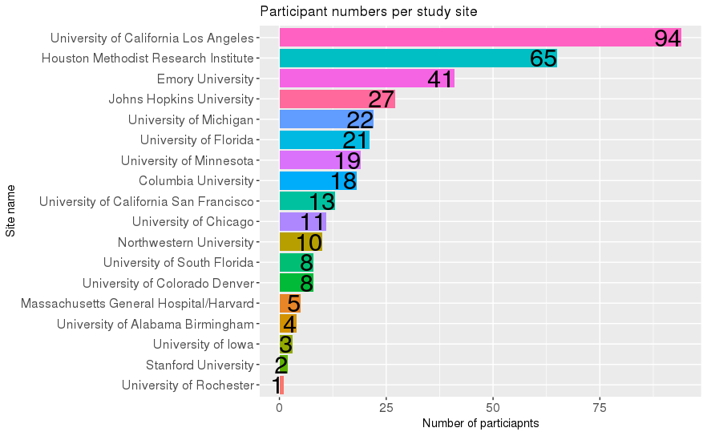
Number of participants per study site included in the analysis

Figure S2
Scatterplots of Age against a) CCAS-S total raw score and b) fail score in the subset of Symptomatic individuals within the same age range as the Control group.
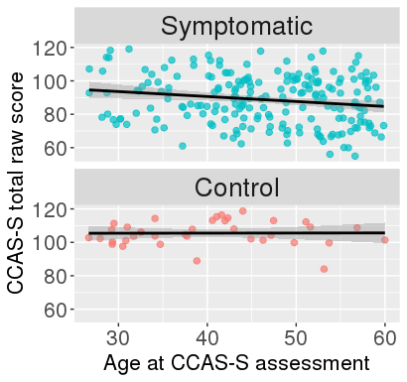
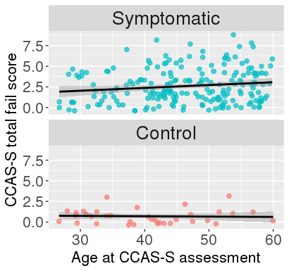
a)
b)

r(204) = 0.15, p = .036

r(204) = -0.18, p = .011

r(35) = -0.05, p = 0.790

r(35) = 0.01, p = 0.965

Figure S3
Proportion of participants in each CCAS category, by SCA type
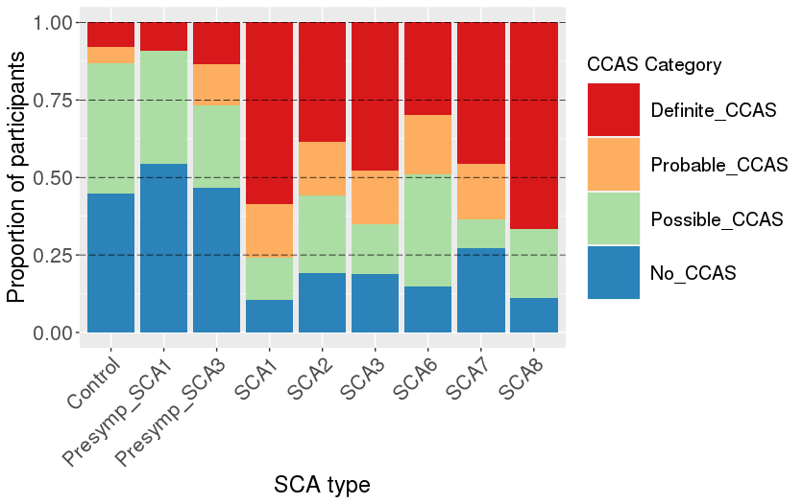

Figure S4: Receiver operating curve – all SCAs vs. Controls, for a) CCAS-S Total Raw Score and b) CCAS-S Fail Score.
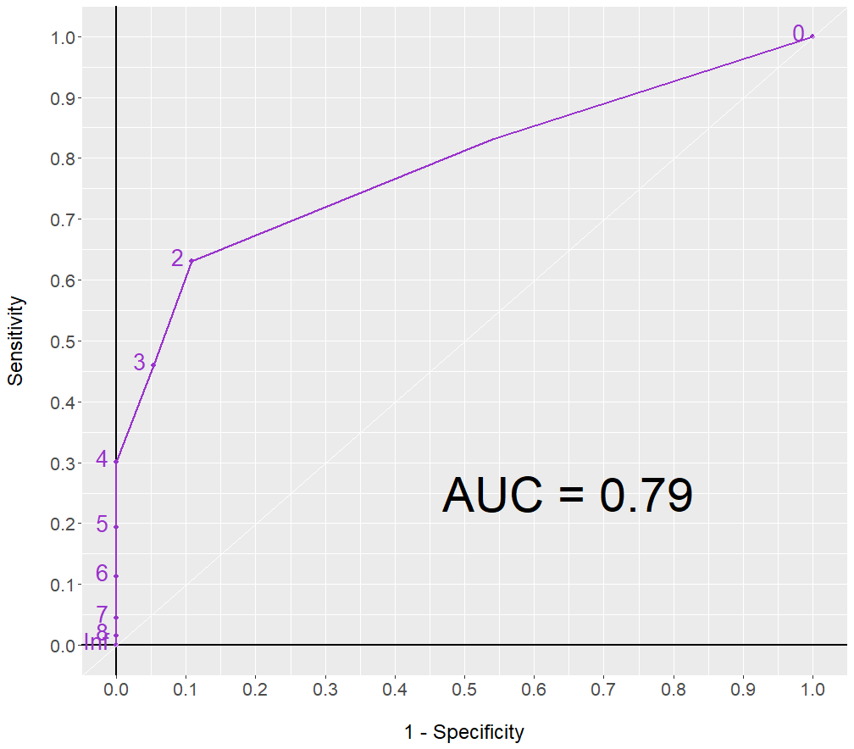
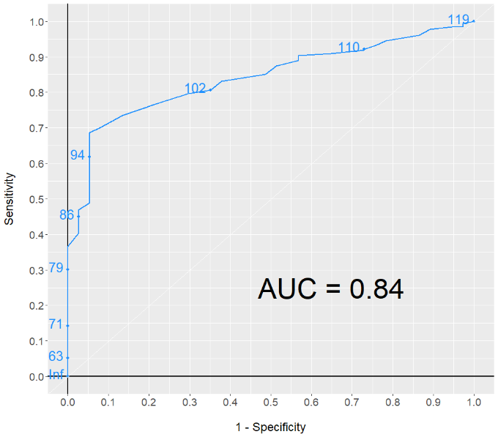

AUC = Area under the Curve

