Probing Phonon Focusing, Thermomechanical Behavior, and Moiré Patterns
in van der Waals Architectures Using Surface Acoustic Waves

Nitish Baradwaj, ^{[a]} Anikeya Aditya,^{[a]} Ankit Mishra,^{[a]} Kory Burns,^{[b]} Eric Lang, ^{[c]} Jordan A. Hachtel,^{[d]} Khalid Hattar,^{[e]} Assel Aitkaliyeva,^{[f]} Aiichiro Nakano, ^{[a]} Priya Vashishta, ^{[a]} Rajiv Kalia^{[a,*]}

[a] Collaboratory for Advanced Computing and Simulations, University of Southern California, Los Angeles, CA
[b] Department of Materials Science & Engineering, University of Virginia, Charlottesville, VA
[c] Department of Nuclear Engineering, University of New Mexico, Albuquerque, NM
[d] Center for Nanophase Materials Sciences, Oak Ridge National Laboratory, Oak Ridge, TN
[e] Department of Nuclear Engineering, University of Tennessee, Knoxville, TN
[f] Department of Materials Science & Engineering, University of Florida, Gainesville, FL

- Relationship between SAW Velocity, Young’s Modulus and Poisson’s Ratio
Using the well-known relation,
$E=\frac{2\left(1+ν\right)}{η}, η = {\left(\frac{V}{V_{s}}\right)}^{2}$ (1)
where V_{s} is the shear velocity, Mileschewsky¹ showed that a function of Poisson’s ratio,
$γ= \frac{1-2ν}{2(1-ν)}$ , (2)
is related to $η$ through,
$η= \frac{2}{3} \left(4- ∛(h_{3} (γ) )+ 2(1-6γ)/∛(h_{3}(γ)\right),$ (3a)
where
$h_{3}\left(γ\right)=17-45γ+ h_{1}\left(γ\right)$ (3b)
and
$h_{1}\left(γ\right)=3\sqrt{33-186γ+321γ^{2}-192γ^{3}}$, (3c)
One can compute $γ$for any value of Poisson’s ratio and determine $η$ from Eqs. (3a) – (3c) and E from Eq. (1). Malischewsky and Tuan² showed that a linear ansatz,
$B=a+bν,$ (4)
with a = 2.61803 and b = 1.3389 agrees very well with the exact results for B in the range $ν ∈\left[0, 0.5\right]$. The linear ansatz fails only for auxetic materials with negative Poisson ratio.

- Forcefield Parameterization and Validation

Stillinger-Weber Force Field (SWFF)³ used in the simulations consists of two- and three-body interaction terms that incorporate energy profiles for bond-stretching and bond-bending. The total potential energy of a system of N atoms is given by,

$$V\left(r_{1}, r_{2},….., r_{N}\right)= \sum_{i<j}{V_{2}\left(r_{ij}\right)}+ \sum_{i<j<k}{V_{3}\left(r_{ij},r_{ik},θ_{ijk}\right)} (5)$$

where $r_{ij}=|r_{i}$ - $r_{j}|$, and $θ_{jik}$is the angle between the i^{th} atom located at r_{i} and its two nearest neighbors j and k at locations r_{j} and r_{k} respectively. The pairwise interaction, V₂, has the following form:

$V_{2}\left(r_{ij}\right)=A \left(\frac{B}{r_{ij}^{4}}-1\right)exp\left(\frac{γ}{r_{ij}-r_{cut}}\right) (6)$

where A, B and γ are optimizable parameters. The 3-body term,

$$V_{3}\left(r_{ij},r_{jk},θ_{ijk}\right)= λ exp\left(\frac{γ_{1}}{r_{ij}-r_{cut1}}- \frac{γ_{2}}{r_{ik}-r_{cut2}}\right){\left(\cos\left(θ\right)-cos⁡(θ_{0})\right)}^{2} (7)$$

also has three optimizable parameters (λ, γ₁ and γ₂) and interaction cutoff distances, r_{cut}, r_{cut1} and r_{cut2}. The angle, θ₀, and cutoff distances are held fixed during optimization of other parameters.
Low-energy acoustic phonons play a significant role in thermal properties over the temperature range relevant to the present study, so the forcefield must reproduce the low-energy acoustic phonons correctly. Ground-truth values of the lattice constant and phonon spectra are taken from density functional theory (DFT) calculations for the 2H phase of the MoS₂ monolayer to optimize forcefield parameters. The optimized forcefield accurately reproduces those values⁴. PBE form of the GGA functionals were used to perform the DFT simulations in the VASP program⁵⁻⁷. The forces on all ions in the system are kept below 0.05 eV/A and all components of the residual stress tensor are less than 0.2 GPa. The dispersion relations for normal vibration modes were calculated using the open source phonopy package.
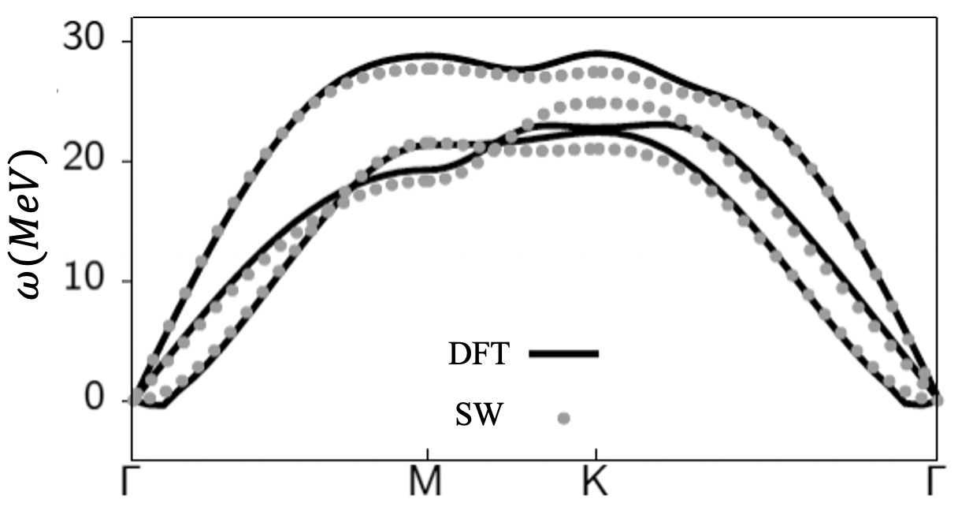
Figure S1: Shows the comparison of the phonon dispersion between DFT and the optimized Stilinger-Weber forcefield.

- Convolutional Neural Network (CNN)

CNN was used to classify 2H and 1T phases and defects⁸. The CNN architecture consists of 3 CNN layers each consisting of LeakyRELU and MaxPool filters. A fully connected layer after the CNN layers performs the classification on the output generated by the CNN layers. The accuracy of the model exceeds 97% for the test data set^{4, 9}.

- Pixelated Images of the MoS₂ bilayer

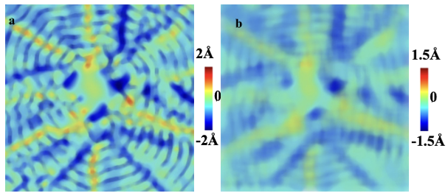

Figure S2: Shows out-of-plane displacements in pixels containing on average 11 and 31 atoms, respectively. Based on the paper by Malischewsky and Tuan², we have calculated the value of the parameter B to be 3.15 and the value of Young’s modulus (E) mentioned in the manuscript, which is close to the experimental value.¹⁰
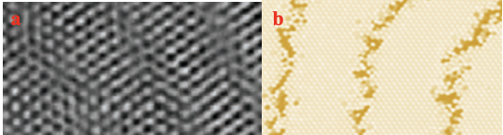
Figure S3: (a) is an HR-TEM image showing traces left behind by the passage of a surface acoustic wave. Here ordered regions are separated by disordered regions. S3(b) is an MD snapshot showing ordered 2H structures separated by disordered regions containing 5- and 7-fold coordinated Mo atoms and 4-fold coordinated S atoms.

IV. Multiple Nanopores in MoS₂ bilayer

An MoS₂ bilayer of 300 x 300 nm² was heated to 77K and three irregular-shaped nanopores were added to the bottom layer. The system was allowed to evolve at 77K in the NVT ensemble and we observed SAW emanating from the three nanopores. Figure S4 (a) shows the structure of the bottom layer with nanopores and S4 (b) shows the size and shape of nanopores and the separation between them. Figure S4 (c) shows the out-of-plane displacement generated by SAWs originating from the nanopores. The dark brown lines show phonon focusing and cuspidal structures in the bilayer.
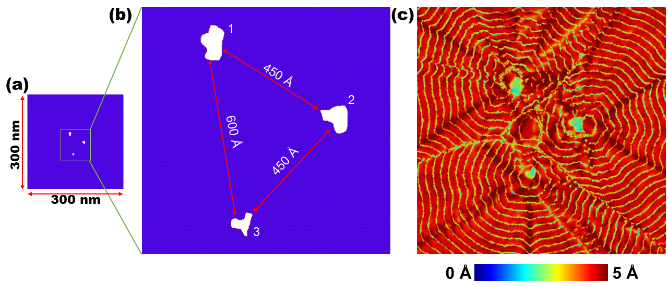
Figure S4: Surface acoustic waves from multiple nanopores. Panel (a) shows the bottom layer with three nanopores of random shape and panel (b) shows the zoomed-in view of the region with the nanopores. The two larger nanopores marked 1 and 2 will fit a circular region of diameter 130 Å, and the smaller nanopore is about 100 Å. The figure also shows the separation between the nanopores. Panel (c) shows out-of-plane displacements from SAWs originating from the three nanopores and the interference pattern created by SAWs. Dark brown lines show phonon focusing and the green wavefront shows cuspidal structures.
V. Local Rearrangements in Structures

The propagation of SAW leads to local rearrangements of atoms in the MoS₂ layers. The local rearrangements are quantified from the atomic positions and relative displacements and the local strain is computed using the formula¹¹,

$D^{2}\left(t,Δt\right)= \sum_{n=1}^{N}{\sum_{i=1}^{3}{{\left\{r_{n}^{i}\left(t\right)-r_{0}^{i}\left(t\right)-\sum_{j=1}^{3}{\left[\left(δ_{ij}+ϵ_{ij}\right)\left(r_{n}^{i}\left(t-Δt\right)-r_{0}^{i}\left(t-Δt\right)\right)\right]}\right\}}^{2}}}$(8)

where,

$$ϵ_{ij}= \sum_{k}{X_{ik}Y_{ik}^{-1}-δ_{ij}}$$

$$X_{ij}= \sum_{n}{\left[[r_{n}^{i}\left(t\right)-r_{0}^{i}(t)]\left[r_{n}^{j}\left(t-Δt\right)-r_{0}^{j}(t-Δt)\right]\right]}$$

$$Y_{ij}= \sum_{n}{\left[[r_{n}^{j}\left(t\right)-r_{0}^{j}(t)]\left[r_{n}^{j}\left(t-Δt\right)-r_{0}^{j}(t-Δt)\right]\right]}$$

Figure S5 shows D² calculated after the passage of SAW from a single pore in a bilayer system at relative rotations 0°, 0.5° and 5°, respectively between the two layers.
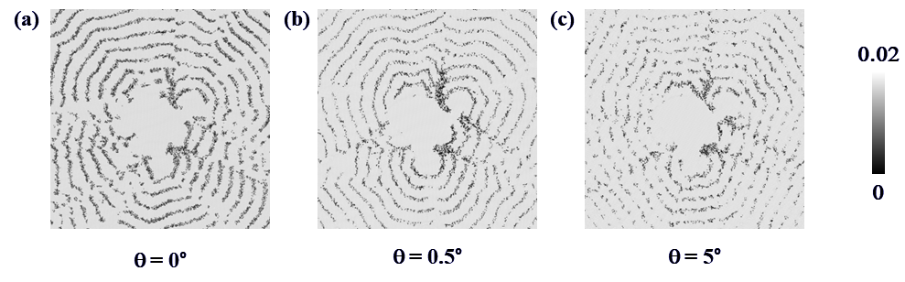

Figure S5: Local rearrangement in an MoS₂ bilayer as SAWs propagate from the irregular shaped nanopore in the bottom layer. The bilayers in panels (a) through (c) are at relative rotations of 0°, 0.5° and 5°, respectively. The dark regions show regions of low atomic strain while the white regions are at higher strain.

VI. Movie for MD Simulations

We have provided a movie of the MD simulation which shows the formation of cusps in SAW originating from a nanopore.

VII. Experimental Images of Nanopores
Phase contrast transmission electron microscopy (TEM) images of deformed MoS₂ sheets. Fig S6 presents nanoscale-sized pores seen abundantly in the irradiated sheets. Accordingly, Fig. S7 is a representation of the largest nanopore complexes observed. It is likely that these were formed as a result of multiple vacancy complexes agglomerating within a small distance to one another.

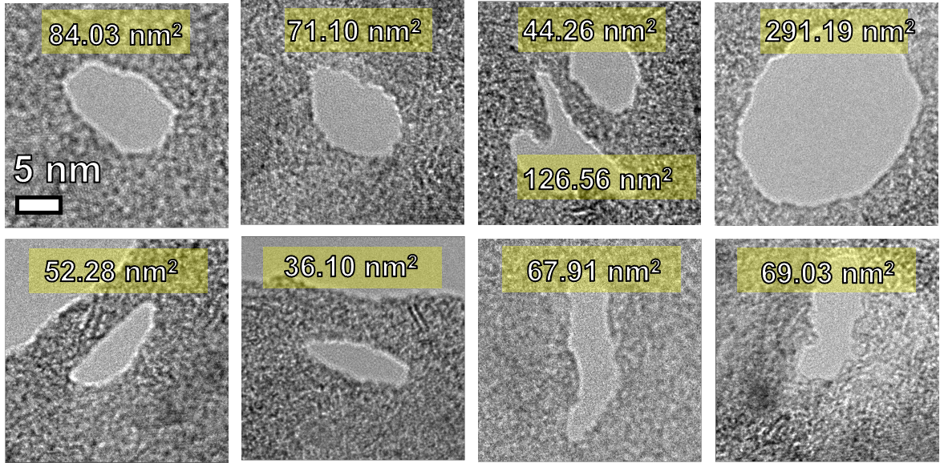
Figure S6: TEM images of nanopores found in MoS2, ranging in various sizes, shapes, and relative displacements from other nanopores. All images are displayed on the same scale while the area of each pore is projected at the top of each image.

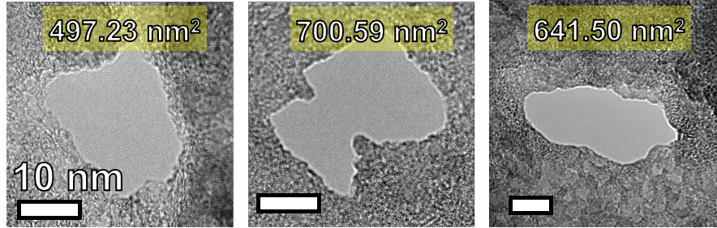

Figure S7: Large pores observed in MoS₂ seen in highly deformed sheets. All scale bars represent 10 nm.

References
(1) Auning, P. G. M. A note on Rayleigh-wave velocities as a function of the material parameters. Geofísica internacional 2004, 43 (3), 507-509.
(2) Malischewsky, P. G.; Tuan, T. T. A special relation between Young’s modulus, Rayleigh-wave velocity, and Poisson’s ratio. The Journal of the Acoustical Society of America 2009, 126 (6), 2851-2853.
(3) Stillinger, F. H.; Weber, T. A. Computer simulation of local order in condensed phases of silicon. Physical review B 1985, 31 (8), 5262.
(4) Burns, K.; Tan, A. M. Z.; Hachtel, J. A.; Aditya, A.; Baradwaj, N.; Mishra, A.; Linker, T.; Nakano, A.; Kalia, R.; Lang, E. J. Tailoring the Angular Mismatch in MoS2 Homobilayers through Deformation Fields. Small 2023, 2300098.
(5) Kresse, G.; Furthmüller, J. Efficient iterative schemes for ab initio total-energy calculations using a plane-wave basis set. Physical Review B 1996, 54 (16), 11169-11186. DOI: 10.1103/PhysRevB.54.11169.
(6) Kresse, G.; Furthmüller, J. Efficiency of ab-initio total energy calculations for metals and semiconductors using a plane-wave basis set. Computational Materials Science 1996, 6 (1), 15-50. DOI: https://doi.org/10.1016/0927-0256(96)00008-0.
(7) Blöchl, P. E. Projector augmented-wave method. Physical Review B 1994, 50 (24), 17953-17979. DOI: 10.1103/PhysRevB.50.17953.
(8) Krizhevsky, A.; Sutskever, I.; Hinton, G. E. Imagenet classification with deep convolutional neural networks. Advances in neural information processing systems 2012, 25.
(9) Aditya, A.; Mishra, A.; Baradwaj, N.; Nomura, K.-i.; Nakano, A.; Vashishta, P.; Kalia, R. K. Wrinkles, Ridges, Miura-Ori, and Moiré Patterns in MoSe2 Using Neural Networks. The Journal of Physical Chemistry Letters 2023, 14 (7), 1732-1739.
(10) Li, Y.; Yu, C.; Gan, Y.; Jiang, P.; Yu, J.; Ou, Y.; Zou, D.-F.; Huang, C.; Wang, J.; Jia, T.; et al. Mapping the elastic properties of two-dimensional MoS₂ via bimodal atomic force microscopy and finite element simulation. npj Computational Materials 2018, 4 (1). DOI: 10.1038/s41524-018-0105-8.
(11) Falk, M. Molecular-dynamics study of ductile and brittle fracture in model noncrystalline solids. Physical Review B 1999, 60 (10), 7062.

