Supplementary Materials

Estimating the carbon footprint of post-flood urban road network restoration efforts: A case study in Carlisle

Table S1. Variables in the integrated model
Classification | Variable | Item |  |  | Value (Range) | Unit | Data source
Structural | Thickness | Main road | Surface course |  | 40 | mm | (Lu 2020)
Structural | Thickness | Main road | Binder course |  | 120 | mm | (Lu 2020)
Structural | Thickness | Main road | Base course |  | 150 | mm | (Lu 2020)
Structural | Thickness | Main road | Sub-base course |  | 600 | mm | (Lu 2020)
Structural | Thickness | Low-volume road | Surface course |  | 40 | mm | (Lu 2020)
Structural | Thickness | Low-volume road | Binder course |  | 80 | mm | (Lu 2020)
Structural | Thickness | Low-volume road | Base course |  | 150 | mm | (Lu 2020)
Structural | Thickness | Low-volume road | Sub-base course |  | 400 | mm | (Lu 2020)
Structural | Diesel consumption rate | Clearing and grubbing | Bulldozer |  | 0.083 | L / m² | (Chong and Wang 2017)
Structural | Diesel consumption rate | Cut | Excavator |  | 0.113 | L / m³ | (Chong and Wang 2017)
Structural | Diesel consumption rate | Subgrade preparation | Motor grader |  | 0.002 | L / m² | (Chong and Wang 2017)
Structural | Diesel consumption rate | Subgrade preparation | Water sprayer |  | 0.0007 | L / m² | (Chong and Wang 2017)
Structural | Diesel consumption rate | Subgrade preparation | Soil compactor |  | 0.03 | L / m² | (Chong and Wang 2017)
Structural | Diesel consumption rate | Subgrade treatment | Water sprayer |  | 0.0014 | L / m² | (Chong and Wang 2017)
Structural | Diesel consumption rate | Granular base | Motor grader |  | 0.0089 | L / m³ | (Chong and Wang 2017)
Structural | Diesel consumption rate | Binder course | Asphalt paver |  | 0.34 | L / m³ | (Chong and Wang 2017)
Structural | Diesel consumption rate | Binder course | Asphalt compactor |  | 0.3 | L / m³ | (Chong and Wang 2017)
Structural | Diesel consumption rate | Tack coat | Bitumen spreader |  | 0.03 | L / m³ | (Chong and Wang 2017)
Parameterized | Width | Main road |  |  | 12 (10~15) | m | (Darren 2017)
Parameterized | Width | Low-volume road |  |  | 8 (6~10) | m | (Darren 2017)
Parameterized | Density | Asphalt concrete |  |  | 2460 (2200~2500) | kg/m³ | (Lu 2020)
Parameterized | Density | Unbound material |  |  | 2000 (1800~2200) | kg/m³ | (Lu 2020)
Parameterized | Carbon emission coefficient | Asphalt concrete |  |  | 10.3 (9.27~11.33)* | kgCO₂e/t | (OHMPA 2010)  *The range is ±10% of the typical value
Parameterized | Carbon emission coefficient | Unbound material type A |  |  | 8 (7.2~8.8) | kgCO₂e/t | (OHMPA 2010)  *The range is ±10% of the typical value
Parameterized | Carbon emission coefficient | Unbound material type B |  |  | 5.3 (4.77~5.83) | kgCO₂e/t | (OHMPA 2010)  *The range is ±10% of the typical value
Parameterized | Loading capacity | Rigid short |  |  | 14 | t | (TARMAC 2017)
Parameterized | Loading capacity | Rigid long |  |  | 28 | t | (TARMAC 2017)
Parameterized | Loading capacity | Articulated |  |  | 28 | t | (TARMAC 2017)
Parameterized | Delivery distance | Asphalt concrete |  |  | 53.31 (39.05~69.4) | km | Survey of suppliers
Parameterized | Delivery distance | Unbound material |  |  | 53.34 (41.23~71.18) | km | Survey of suppliers
Parameterized | Carbon emission coefficient | Rigid (7.5~17t) |  | 100% laden | 0.71483 | kgCO₂e/km | (BEIS 2022)  **The increase in the carbon emission coefficient of HGVs is directly proportional to the load weight, and the ratio is the growth rate.
Parameterized | Carbon emission coefficient |  |  | 0% laden | 0.55763 | kgCO₂e/km
Parameterized | Carbon emission coefficient |  |  | Growth rate** | 0.1572 | -
Parameterized | Carbon emission coefficient | Rigid (>17t) |  | 100% laden | 1.13291 | kgCO₂e/km
Parameterized | Carbon emission coefficient |  |  | 0% laden | 0.79097 | kgCO₂e/km
Parameterized | Carbon emission coefficient |  |  | Growth rate | 0.3419 | -
Parameterized | Carbon emission coefficient | Articulated (3.5~33t) |  | 100% laden | 0.96112 | kgCO₂e/km
Parameterized | Carbon emission coefficient |  |  | 0% laden | 0.64531 | kgCO₂e/km
Parameterized | Carbon emission coefficient |  |  | Growth rate | 0.3158 | -
Parameterized | Carbon emission coefficient | Average biofuel blend |  |  | 2.56 | kgCO₂e/L
Parameterized | Carbon emission coefficient | 100% mineral diesel |  |  | 2.7 | kgCO₂e/L

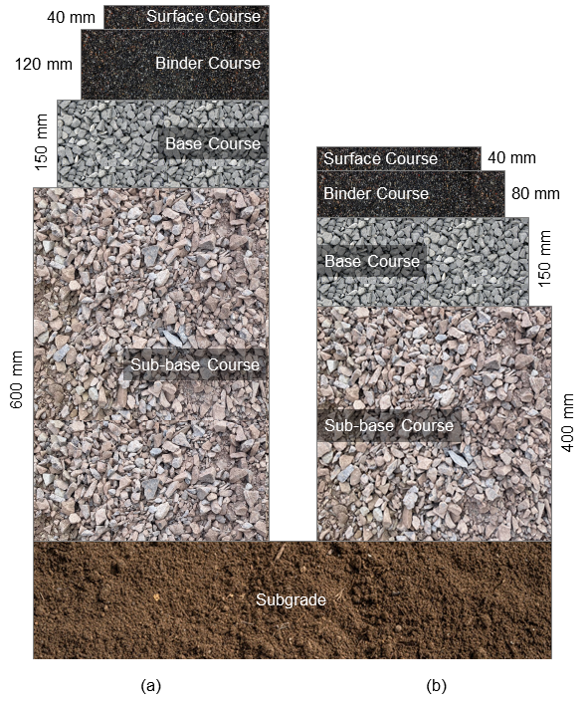
Figure S1. Cross-sectional structures of (a) main roads and (b) low-volume roads

Reference
Chong D, Wang Y (2017) Impacts of flexible pavement design and management decisions on life cycle energy consumption and carbon footprint. Int J Life Cycle Assess 22(6):952–971. https://doi.org/10.1007/s11367-016-1202-x
Darren C (2017) How wide are roads? In: Highw. Code Resour. https://mocktheorytest.com/resources/how-wide-are-roads/. Accessed 26 Feb 2024
Department for Business, Energy & Industrial Strategy (2022) Greenhouse gas reporting: conversion factors 2022
Lu D (2020) Pavement Flooding Risk Assessment and Management in the Changing Climate. Doctoral Thesis, University of Waterloo
Ontario Hot Mix Producers Association (OHMPA)) (2010) Carbon Footprint: How does asphalt stack up? Ontario Hot Mix Producers Association
TARMAC (2017) Delivery Vehicle Options

