Supplementary Information
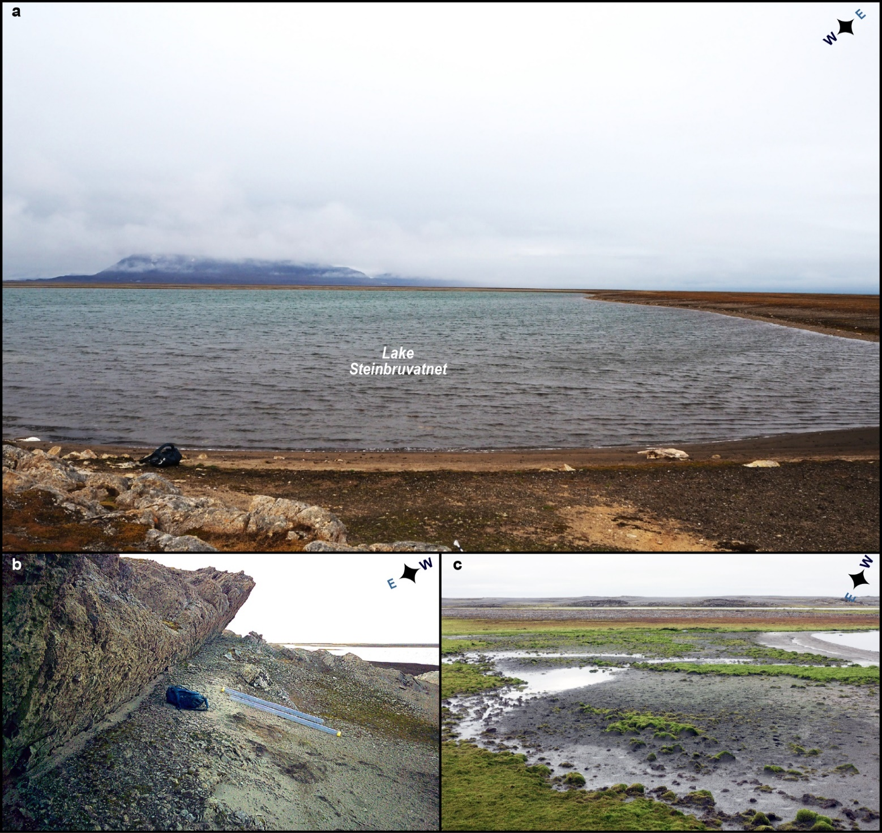
Figure S1. Catchment geomorphology. a View over Lake Steinbruvatnet from the southwest (photo by M. C. Strzelecki). b The base of the rocky ridge that shelters Lake Steinbruvatnet from the westerlies with the shadow dune sampled for CS 2 (see setting and Fig. S4; photo by C. J. Hein). c Silty sheet sampled for CS 1 (see Fig. S4) to the East of Lake Steinbruvatnet. Also note the numerous cushion-like tundra plants growing in beach ridge swales and shaped like miniature parabolic dunes (photo by S. Lindhorst).

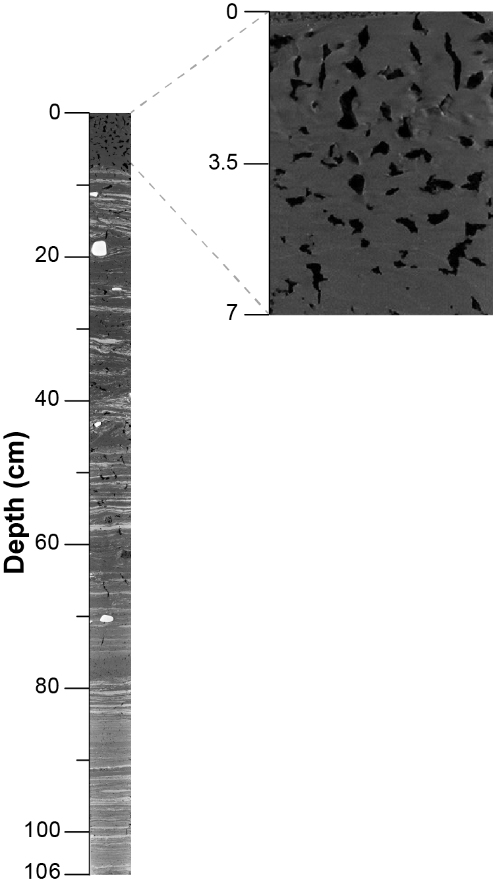
Figure S2. CT orthoslice of analyzed core 601-21-6-GC and a close-up of the top 7 cm. Visual assessment reveals a porous and homogenized composition, which is markedly different from the underlying 99 cm (see results).

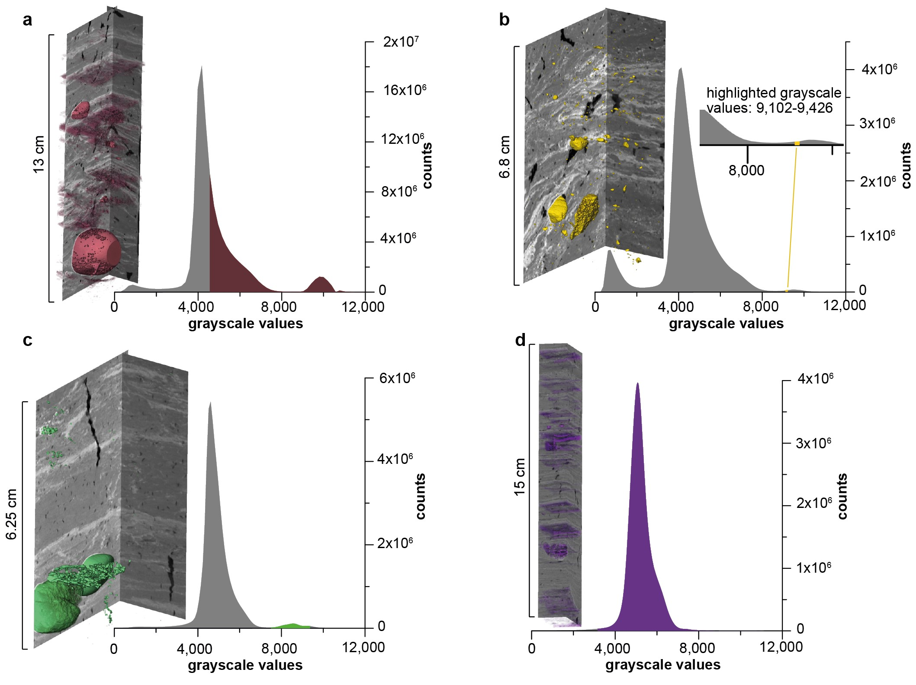Figure S3. CT scan visualizations with grayscale values highlighted in histograms. The grayscale threshold was iteratively set to highlight the coarser and denser minerogenic input. Characteristic of dropstones and facies 2 layers in selected intervals: a 0-13 cm, b 31.2-38 cm, c 58-64.25 cm, and d 83.2-98.2 cm.

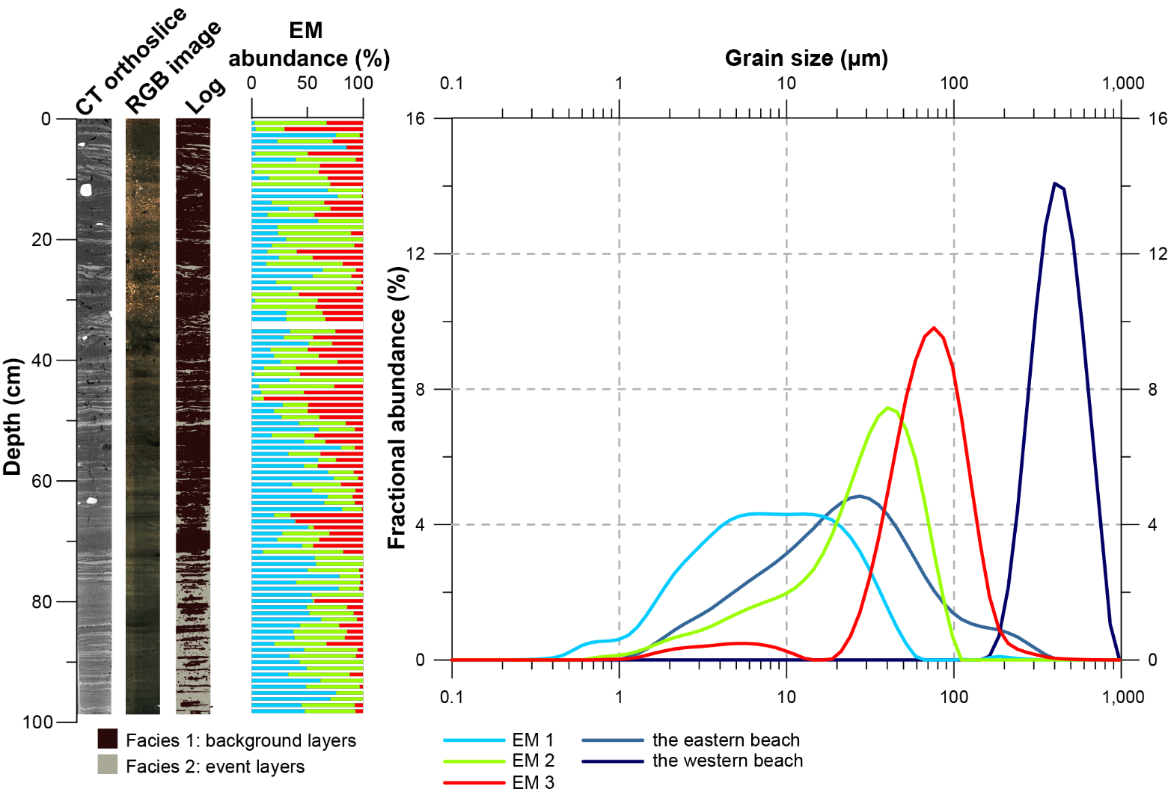
Figure S4. End-Member Modelling Analysis (EMMA) results¹. From left to right: CT and RGB imagery of investigated core 601-21-6 GC, a log with facies 1 and 2 highlighted, down-core variability in EM abundance (%), the particle size distributions (PSDs) of each EM as well as catchment samples (CS) 1 and 2 from the eastern and the western shores, respectively (see the Holocene evolution of Lake Steinbruvatnet).

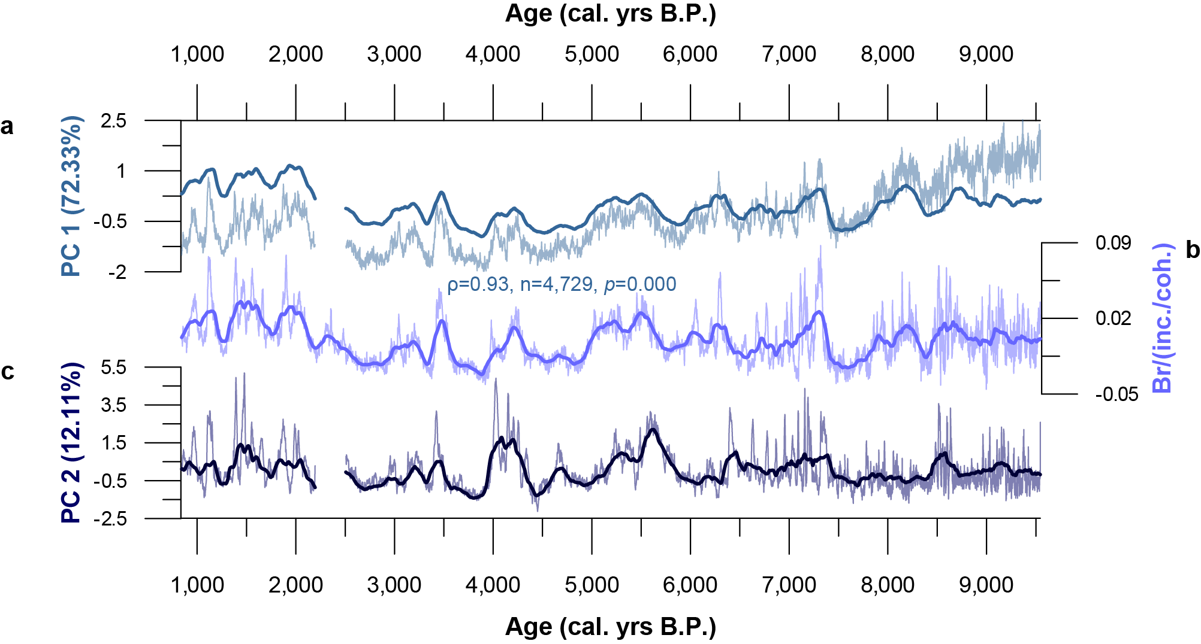
Figure S5. Selected storminess indicators. a-b the polar Easterlies as captured by PC 1 and Br/(inc./coh.) values. c Westerly storm tracks captured by PC 2 values. 150-year moving averages are shown in bold, while the raw data has not been detrended as in Fig. 5 of the main manuscript to highlight the consistency between these timeseries. Spearman's rank correlation coefficient (ρ) was calculated for the correlation between PC 1 and Br/ (inc./coh.) values.

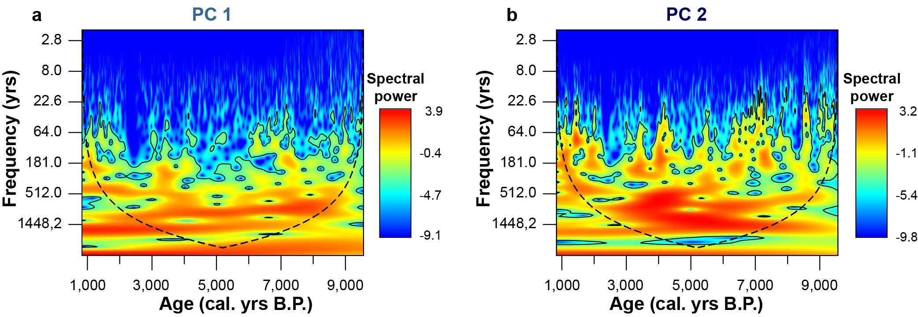 Figure S6. Continuous wavelet transform (CWT) analysis. The scalograms highlight the dominance of a ~1,500 cyclicity in our a PC 1 (polar Easterlies) and b PC 2 (Westerlies) data. The dashed black line marks the cone of influence – signals outside this area might be distorted². The 95% significance interval is highlighted using the black contour.

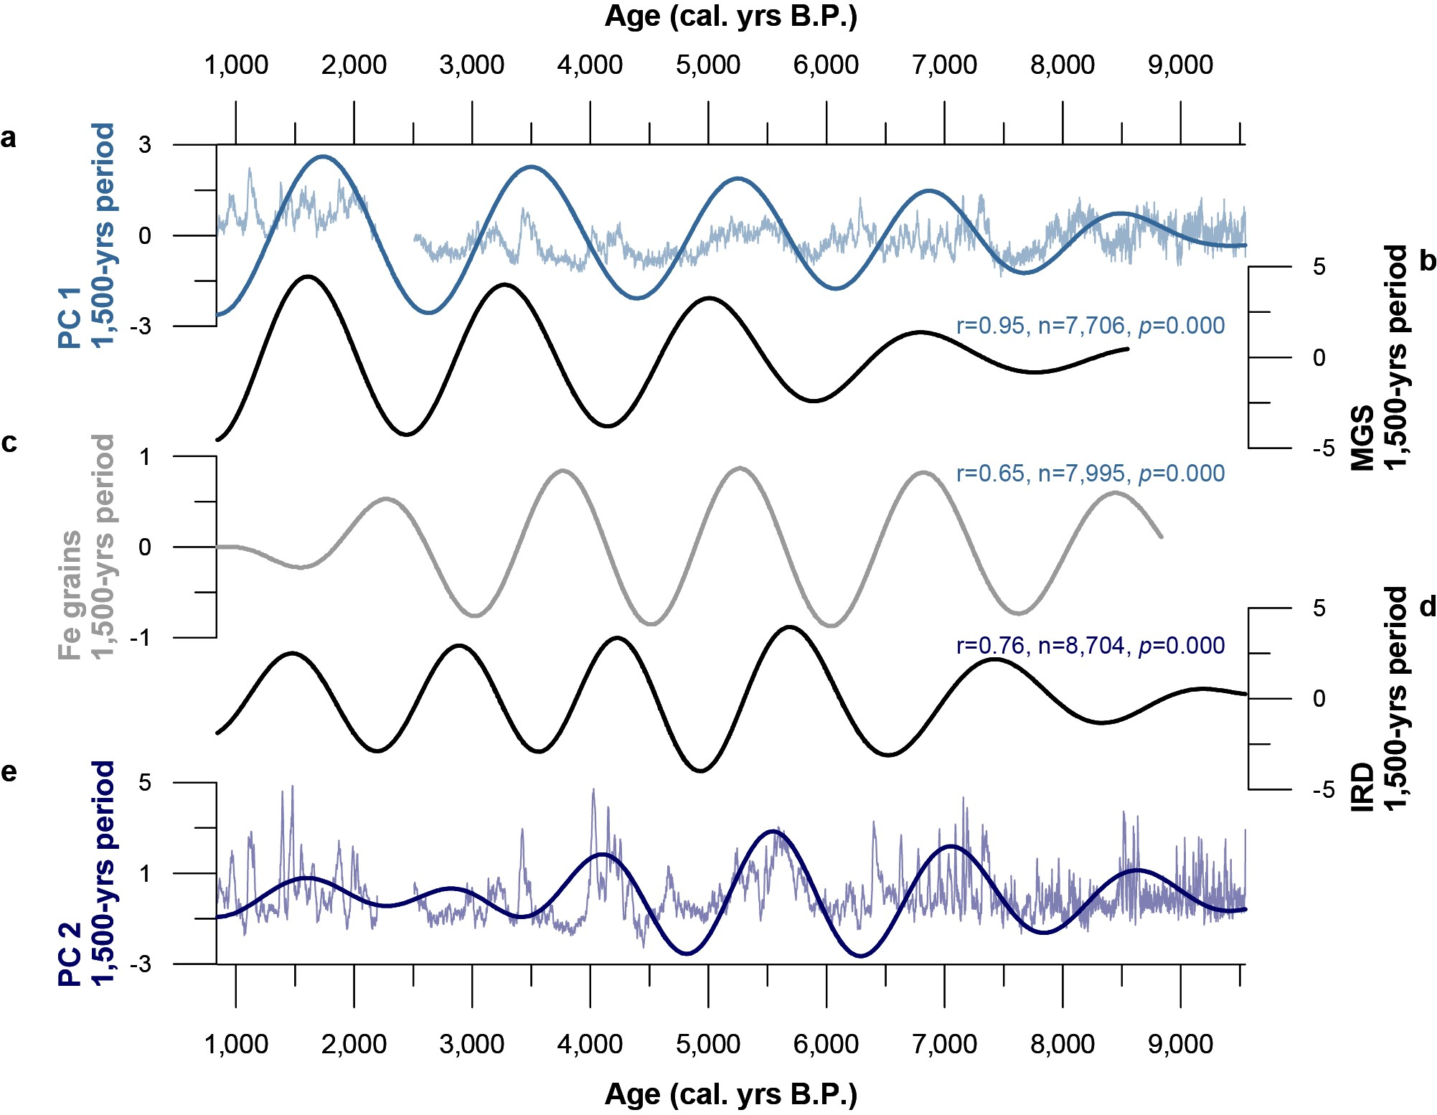
Figure S7. The dominant ~1,500-year wavelength extracted. a PCA 1 data presented in this study, showing the raw detrended data in the background for context. b Mean grain size (MGS) data reflecting eolian loess deposition in northern Iceland³. c Iron (Fe) grain counts from the Kara Sea that capture the Arctic Oscillation (AO)⁴. d PC 2 data presented in this study, showing the raw detrended data in the background for context. e An Ice Rafted Debris (IRD) stack series from the North Atlantic (see Fig. 1a)^{5,6}. We list cross-correlation values (r) are placed near the target in the colour of the source (PC).
References:
1. Prins, M. A. & Weltje, G. J. End-member modeling of siliciclastic grain-size distributions: The late Quaternary record of aeolian and fluvial sediment supply to the Arabian Sea and its paleoclimatic significance. in Numerical experiments in stratigraphy: Recent advances in stratigraphic and sedimentologic computer simulations (ed. Harbaugh, J.) 91–111 (Society for Sedimentary Geology, 1999).
2. Torrence, C. & Compo, G. P. A Practical Guide to Wavelet Analysis. Bull. Amer. Meteor. Soc. 79, 61–78 (1998).
3. Jackson, M. G. et al. Holocene loess deposition in Iceland: Evidence for millennial-scale atmosphere-ocean coupling in the North Atlantic. Geology 33, 509–512 (2005).
4. Darby, D. A., Ortiz, J. D., Grosch, C. E. & Lund, S. P. 1,500-year cycle in the Arctic Oscillation identified in Holocene Arctic sea-ice drift. Nature Geosci 5, 897–900 (2012).
5. Bond, G. et al. Persistent solar influence on North Atlantic climate during the Holocene. Science 294, 2130–2136 (2001).
6. Evans, M. N. et al. NOAA/WDS Paleoclimatology - Bond et al. 2001 North Atlantic Holocene Drift Ice Proxy Data. doi:10.25921/BGVH-NB23.

