Supporting figures and tables

Title
Continental-Scale Paddy Soil Bacterial Community Structure, Function and Biotic Interaction

Authors
Hong-Yi Li^{1#}, Hang Wang^{1,2#}, Xing-Hua Tao¹, Xian-Zhe Wang¹, Wei-Zheng Jin³, Jack A Gilbert⁴, Yong-Guan Zhu^{5*}, and Zhi-Jian Zhang^{1,6*}
#: Contributing equally to this work.

Institutional addresses
¹College of Environmental and Resource Sciences, Zhejiang University, 866 Yuhangtang Ave, Hangzhou, 310058, China;
²National Plateau Wetlands Research Center, Southwest Forestry University, 300 Bailongsi, Kunming, 650224, China;
³Hangzhou GuSheng Biotechnology Co. Ltd, HangZhou 311108, China;
⁴Scripps Institution of Oceanography and Department of Pediatrics, University of California San Diego, La Jolla, CA, 92093, USA;
⁵Key Lab of Urban Environment and Health, Institute of Urban Environment, Chinese Academy of Sciences, Xiamen 361021, China;
⁶China Academy of West Region Development, Zhejiang University, 866 Yuhangtang Ave, Hangzhou, 310058, China.
*Corresponding authors: Yong-Guan Zhu and Zhi-Jian Zhang

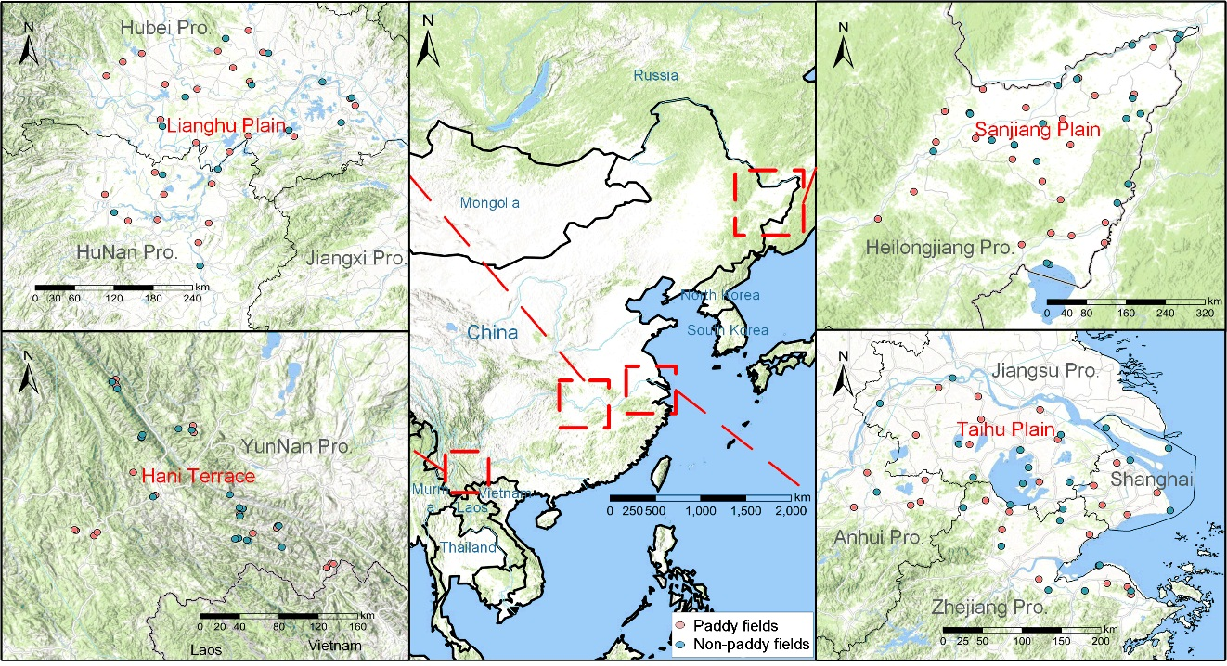
Figure S1 Geographical locations of sampling sites in four typical rice-growing regions in China: Sanjiang Plain, Lianghu Plain, Taihu Plain, and Hani Terrace. In each region, red dots represent paddy soils, and blue dots represent non-paddy soils.

Figure S2 Boxplots showing differential partitioning of the top 20 genera’s relative abundances. Upper panel illustrates the comparisons of paddy soils and adjacent soils from other lands across four typical rice-growing regions in China; Lower panel illustrates the comparisons of paddy soils and adjacent soils from other lands in each of four regions. Cross-regional and intraregional differences of each genera’s relative abundance are tested using a Wilcoxon rank sum test (*, P < 0.05; **, P < 0.01; ***, P < 0.001).

Figure S3 PCoA plots of samples based on other distance matrices, including Bray-Curtis and Weighted UniFrac. For each group, a filled confidence ellipse was superimposed over the data, and the added centroid (diamond) illustrating the mean distances between each pair of groups. With all indices measured, R² and F statistics of PERMANOVA on microbial dataset were compared. Samples were partitioned into groups using a combination of soil type and sampling region.

Figure S4 The extended information of Venn diagram illustrated in Figure 2A. For unique OTUs in each sampling region and the overlapped OTUs between regions, the relative abundance of OTUs and OTU occurrence frequency at both phylum (top 10%) and genus levels (top 20%) are shown.

Figure S5 Jitter plots of betaNTI distributions for paddy soils collected from four sampling regions. This analysis is a complement to the calculated stochasticity ratio shown in Figure 3, aiming to reveal the strong homogeneous selection (betaNTI < -2) in paddy samples
.
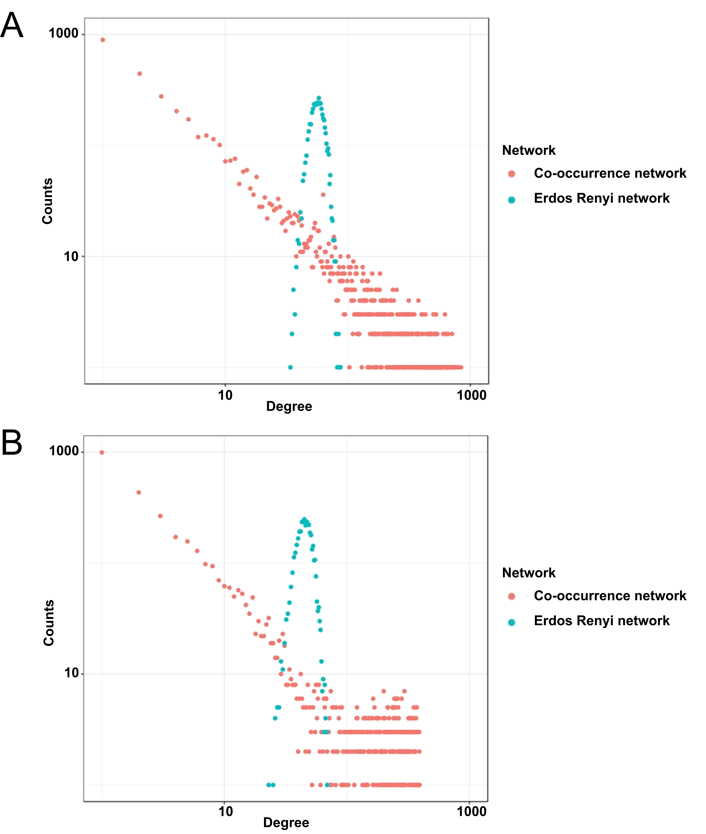
Figure S6 The distributions of the degree for co-occurrence network of paddy field soils (A) and the adjacent soils from other lands (B). For the ease of comparison, Erdos-Renyi random networks are also illustrated.

Figure S7 Different taxonomic patterns (at the order level) within the co-occurrence networks of paddy soils and adjacent soils from the other lands. (A) Circos plots showing inter-relationships of the taxonomic orders in paddy soils. (B) Circos plots showing inter-relationships of the orders in non-paddy soils. In each circle, the different colors of segments and arcs indicate the top 39 orders, and the ribbons connecting two segments indicate copresence (left panel) and exclusion (right panel) links. For all subplots, the size of the segment is proportional to the relative abundance of the order normalized by averaging the values of each region for each soil type. The size of the arcs is proportional to OTU numbers for each order. The size of the ribbon is proportional to the number of links (copresence and exclusion), and the color is the same as to the segment with more total links (with color opacity of 0.8).

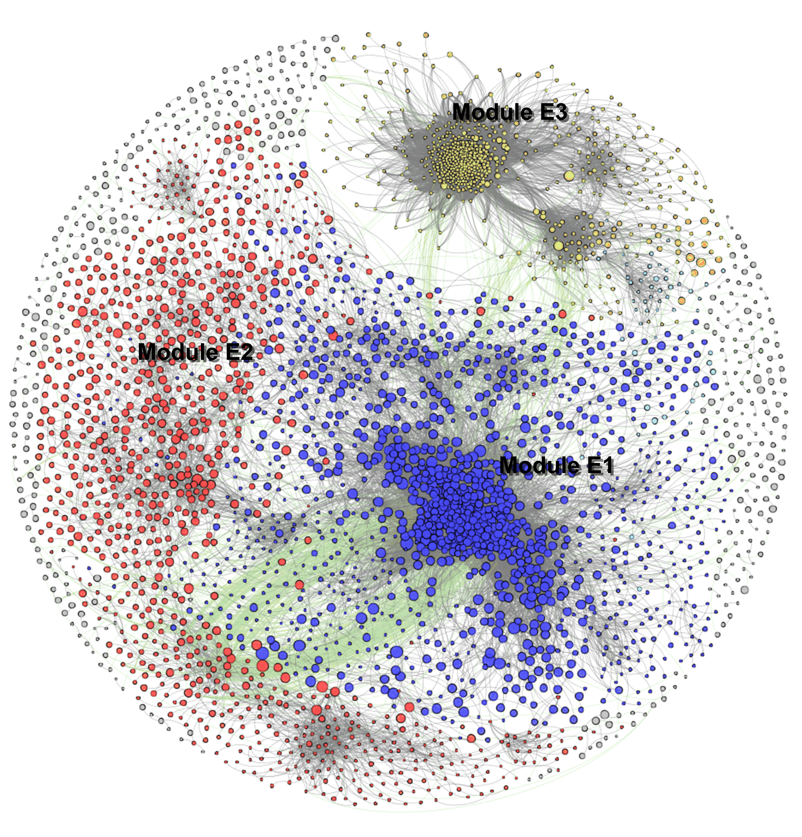
Figure S8 Co-occurrence network of the non-paddy soils. The nodes in network represent OTUs, which are colored according to the top 5 modularity classes (ranked by node numbers, and the top 3 of them are labeled). The size of the node is proportional to the base-10 logarithm of the OTU abundance, normalized by averaging the values of each region. A connection between two nodes represents that there is a strong and significant (P < 0.001) correlation between each OTU pair. The edge color indicates significantly positive (grey) or negative (green) correlations.

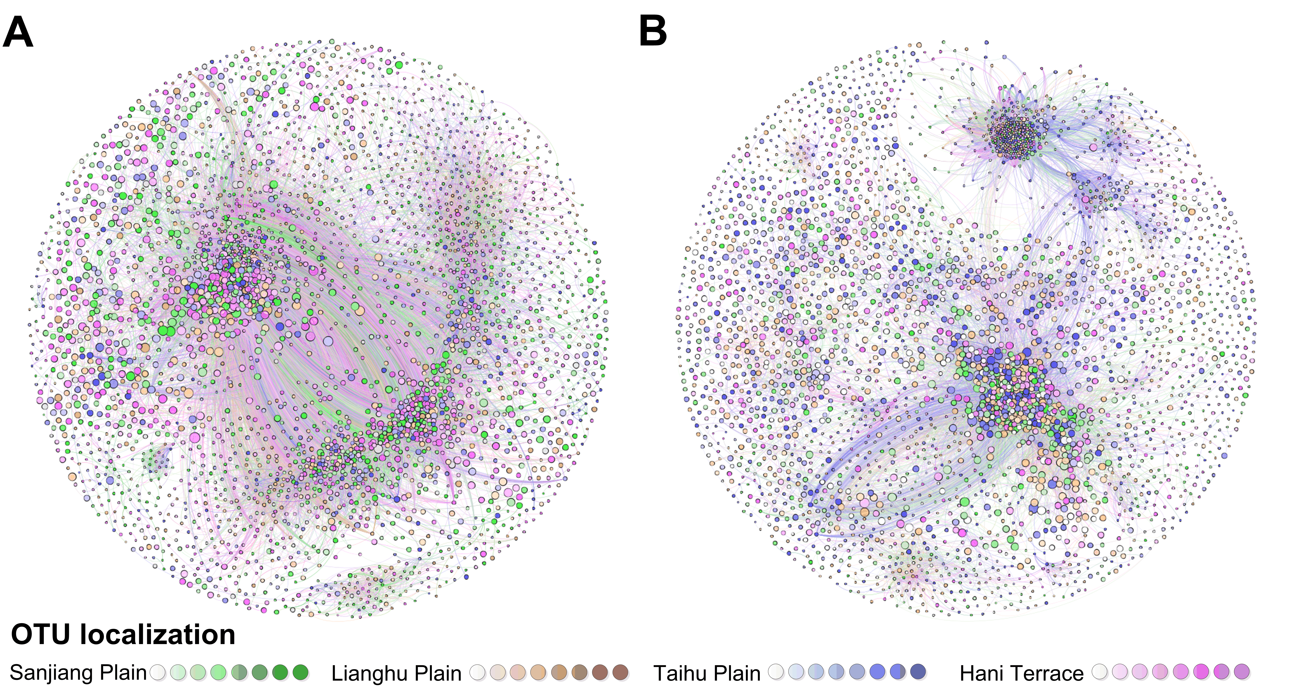
Figure S9 Co-occurrence network of microbial community in paddy soils (A) and the non-paddy soils (B). Each node is colored according to each of four regions where it has the highest relative abundance. The deeper in darkness, the higher in abundance ratio (from 0.25 to 1.00). The abundance ratio here is the ratio of node abundance in a specific region to that in all regions. Edge color is the mix of the colors of the nodes it connects.

Table S1 Two indices (betaNTI and RC.bray) determined for paddy samples. The relative mean contribution (%) of each scenario to the overall bacterial community assembly is shown. The betaNTI (beta nearest-taxon index) is based on a null model test of the phylogenetic diversity index betaMNTD (beta mean nearest-taxon distance), and RC.bray (modified Raup-Crick index) is based on a null model test of the Bray-Curtis taxonomic beta-diversity index. |betaNTI| < 2 indicates the community phylogenetic turnover is undifferentiated from expected turnover and the community assembly is dominated by stochastic processes. The betaNTI < -2 indicates the community assembly is determined by homogeneous selection, and betaNTI > +2 indicates variable selection. |RC.bray| < 0.95 indicates the community composition turnover is undifferentiated from expected turnover, and the community assembly is governed by ecological drift. RC.bray > +0.95 or < −0.95 indicates dispersal limitation or homogenizing dispersal, respectively. Since we had used the normalized stochasticity ratio to quantify the relative contribution of deterministic and stochastic processes, these two indices determined here were only used to quantify the subtypes within either deterministic or stochastic processes, respectively.
Percentage, % | Continental | inter-regional | intra-regional | Sanjiang Plain | Lianghu Plain | Taihu Plain | Hani Terrace
betaNTI < -2 | 95.5 | 94.6 | 98.0 | 99.6 | 100.0 | 95.4 | 96.8
|betaNTI| < 2 | 4.4 | 5.3 | 2.0 | 0.4 | 0.0 | 4.3 | 3.2
betaNTI > +2 | 0.1 | 0.1 | 0.1 | 0.0 | 0.0 | 0.3 | 0.0
 | Continental | inter-regional | intra-regional | Sanjiang Plain | Lianghu Plain | Taihu Plain | Hani Terrace
RC.bray < -0.95 | 7.0 | 5.2 | 12.7 | 8.0 | 12.3 | 17.2 | 12.6
|RC.bray| < 0.95 | 23.4 | 12.3 | 55.0 | 89.1 | 51.7 | 46.8 | 32.8
RC.bray > +0.95 | 69.4 | 81.4 | 32.1 | 2.9 | 36.0 | 36.0 | 54.2

Table S2 Hubs (keystone taxa) identified in paddy soil bacterial network implemented with PageRank algorithm.
ID | Module class | PageRank score | Relative abundance (%) in paddy soil | Taxonomy
OTU1597 | P1 | 0.954 | 0.86 | Proteobacteria; Betaproteobacteria; DQ395705_o; EU786132_f; AF467301_g; EF126238_s
OTU686 | P1 | 0.912 | 0.68 | Chlorobi; Ignavibacteriae; GQ472436_o; GQ472436_f; GQ472436_g
OTU298 | P1 | 0.938 | 0.58 | Chlorobi; Ignavibacteriae; HQ014634_o; HQ014634_f; AY118151_g; AY118151_s
OTU714 | P1 | 1.000 | 0.34 | Acidobacteria; Solibacteres; Solibacterales; Solibacteraceae; EU589264_g; AM162424_s
OTU343 | P1 | 0.920 | 0.32 | Proteobacteria; Deltaproteobacteria; EU617842_o; EU617842_f; EU881182_g; HQ864112_s
OTU641 | P1 | 0.962 | 0.30 | Proteobacteria; Deltaproteobacteria; Desulfobacterales; HM243977_f; HM243977_g
OTU299 | P1 | 0.950 | 0.28 | Proteobacteria; Deltaproteobacteria; EU617842_o; FM253643_f; FM253643_g; FM253643_s
OTU688 | P1 | 0.912 | 0.11 | Gemmatimonadetes; GU568020_c; GU568020_o; GU568020_f; GU568020_g; EF540394_s
OTU22819 | P1 | 0.965 | 0.09 | Aminicenantes_OP8; AQSP_c; AQSP_o; AQSP_f; HQ183973_g; AB364867_s
OTU12122 | P1 | 1.000 | 0.05 | Chloroflexi; Dehalococcoidia; Dehalococcoidales; DQ811888_f; DQ811888_g; HM243964_s
OTU5 | P2 | 0.915 | 8.72 | Bacteroidetes; Bacteroidia; Bacteroidales; GU454901_f; GU454901_g; EU644258_s
OTU260 | P2 | 0.911 | 2.73 | Bacteroidetes; Bacteroidia; Bacteroidales; GU454901_f; GU454901_g; JN540128_s
OTU255 | P2 | 0.929 | 0.93 | Chloroflexi; Anaerolineae; Anaerolinaeles; Anaerolinaceae; GQ500701_g; AB240513_s
OTU7574 | P2 | 0.918 | 0.80 | Acidobacteria; HQ645210_c; HQ645210_o; HQ645210_f; HQ645210_g
OTU2587 | P2 | 1.000 | 0.06 | Chloroflexi; Anaerolineae; Anaerolinaeles; Anaerolinaceae; Anaerolinea

Table S3 Statistic information of metagenomic assembly.
Sample ID | Contig number | Total length (bp) | Max length (bp) | Average length (bp) | N50 length (bp)
Paddy soil samples (16 samples)
H02 | 2587530 | 1275665469 | 46567 | 493 | 467
H18 | 2558383 | 1309067092 | 65029 | 512 | 486
H22 | 2507353 | 1146657033 | 40423 | 457 | 433
H47 | 2135909 | 929902885 | 45758 | 435 | 416
L01 | 2249344 | 998042577 | 84482 | 444 | 420
L07 | 2801559 | 1330043117 | 97939 | 475 | 449
L20 | 2196284 | 975794312 | 23774 | 444 | 420
L28 | 2617731 | 1188269304 | 48927 | 454 | 431
T09 | 2260603 | 1089028679 | 69317 | 482 | 450
T17 | 2389447 | 1015595069 | 76553 | 425 | 404
T31 | 2960139 | 1327155096 | 26183 | 448 | 425
T48 | 2710590 | 1250488423 | 91701 | 461 | 433
Y04 | 2060816 | 868893384 | 25504 | 422 | 402
Y24 | 2195857 | 936881259 | 79024 | 427 | 405
Y30 | 2858013 | 1274011529 | 93346 | 446 | 421
Y43 | 3036408 | 1415714077 | 71460 | 466 | 442
Non-paddy soil samples (8 samples)
HE13 | 3125000 | 1689563826 | 66433 | 541 | 526
HE23 | 2333508 | 1147283727 | 80150 | 492 | 470
LE01 | 2596496 | 1316772615 | 116907 | 507 | 485
LE11 | 2784916 | 1419918407 | 237102 | 510 | 492
TE08 | 2227348 | 1134295555 | 42961 | 509 | 486
TE12 | 2956559 | 1577646887 | 59059 | 534 | 517
YE06 | 2665700 | 1300357070 | 24901 | 488 | 471
YE13 | 3869349 | 2106013433 | 55377 | 544 | 539

