Supplementary material 1: Characteristics of the study Participants

Recruitment site | N | Position
Ministry of Health | 2 | -General Director of Nursing affairs  -Director of Human Resources
SCHFS | 2 | -Chairman of the Professional Council  -Chairman of the Scientific Council
Health Academy of Saudi Commission for Health Specialties | 1 | -Chairman of the heath academy
Health Cluster 1 | 2 | -Director of the academic affairs  -Nursing lead in the Academic affairs

Supplementary material 2: Semi-structured questions for the in-depth interview

- What is the current status of a diploma prepared nurses?
- What is the career path of a diploma prepared nurses?
- What are the problems and concerns they face?
- What are the challenges they face?
- What are the solutions proposed to address the challenges?
- Are there new regulations or suggestions for diploma prepared nurses?
- What is the strategic plan for professional development for diploma prepared nurses? What are the goals and objectives?
- Is there an executive plan and who is responsible for following it?
- What performance indicators are used to verify the arrival of goals or targets in the executive plan?
- Do you have any additional comments on this subject?

Supplementary material 3: Themes derived from the analysis of the interview

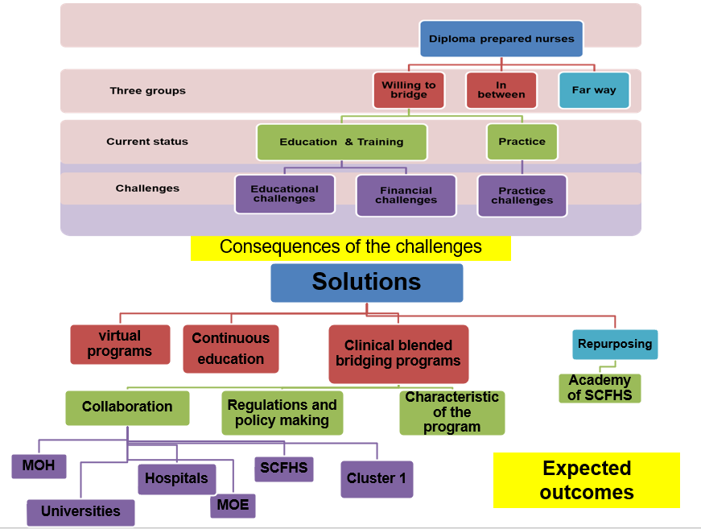
Supplementary material 4: Framework for Current Status, Challenges and Future Career Pathways of Diploma-prepared-Nurses from the Stakeholders’ Perspective.

