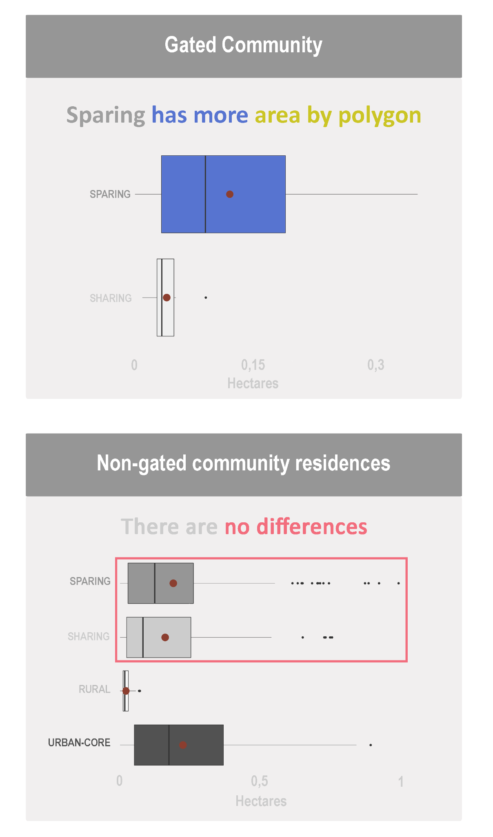
Online Resource 13 – Mean area by polygon for residential land uses.

