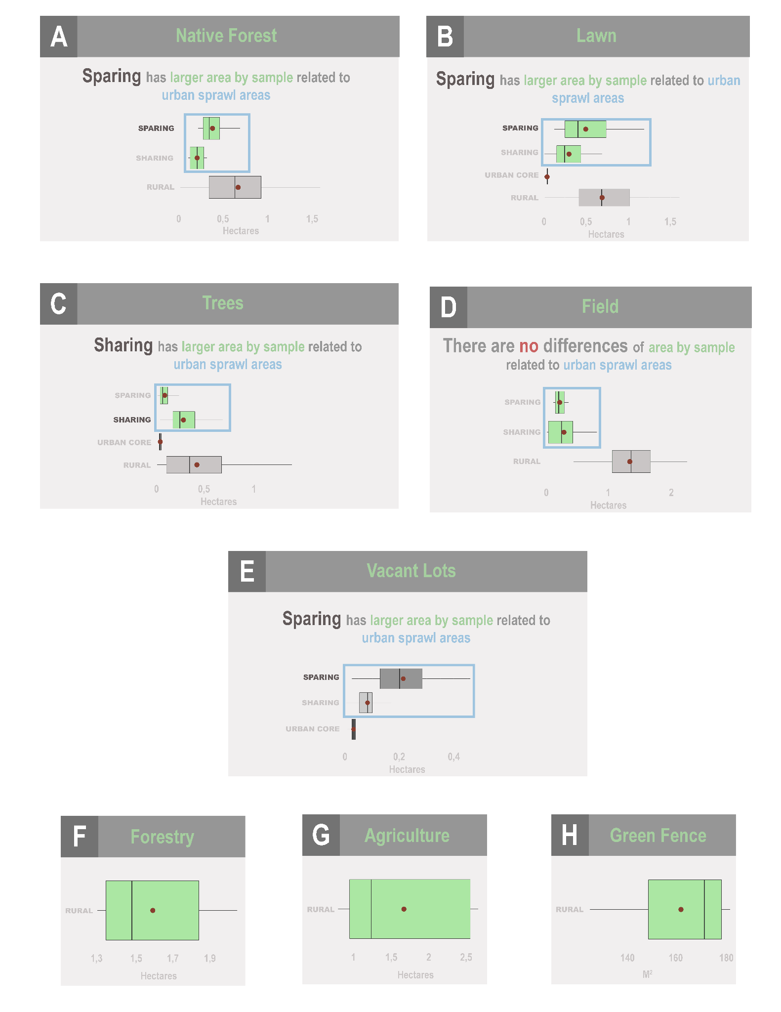
Online Resource 10 – Mean sampled area for land uses separated by sites for green infrastructures. The highlighted boxes indicate the existence of relationship or not between the urban sprawl models for the respective land use. A) Native forest; B) Lawn; C) Trees; D) Field; E) Vacant Lots; F) Forestry; G) Agriculture; H) Green fence.

